Support Information
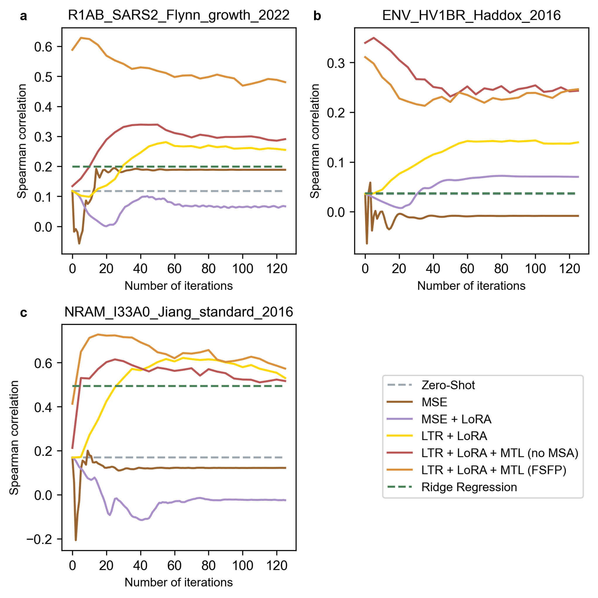
Fig.S1 Learning curves of different strategies. The performance curves of different strategies recorded on the test set of a) SARS-CoV-2 main protease, b) envelope protein Env from HIV and c) neuraminidase during training. The test scores here are only used for comparison and we do not access them for early stopping. The training data size is 40 in these examples.

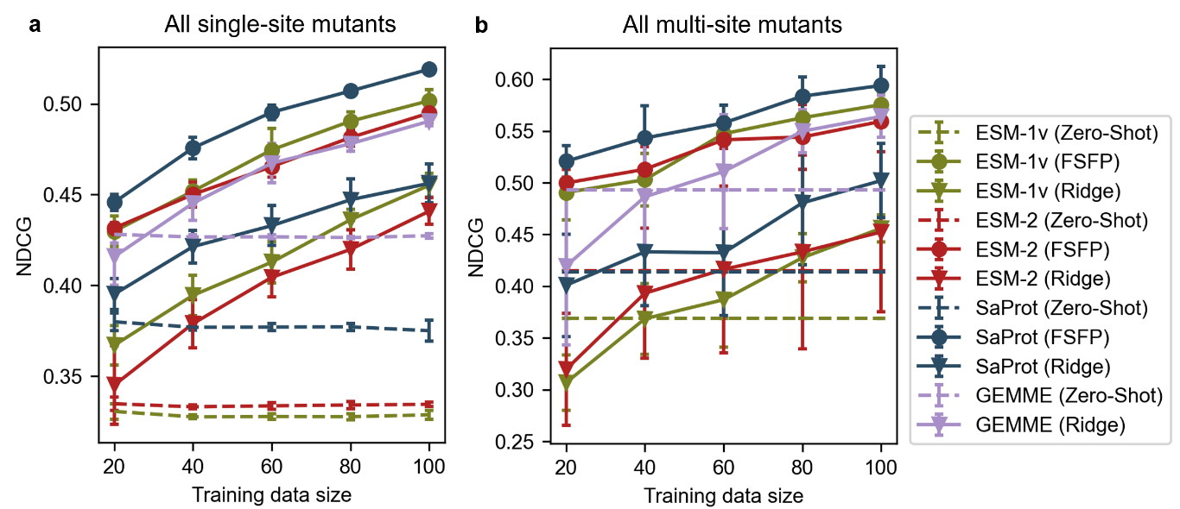
Fig.S2 Overall performance on single-site and multi-site mutants. a) Average model performance tested on single-site mutants across all 87 datasets, evaluated by NDCG. b) Average model performance tested on multi-site mutants across 11 datasets, evaluated by NDCG.
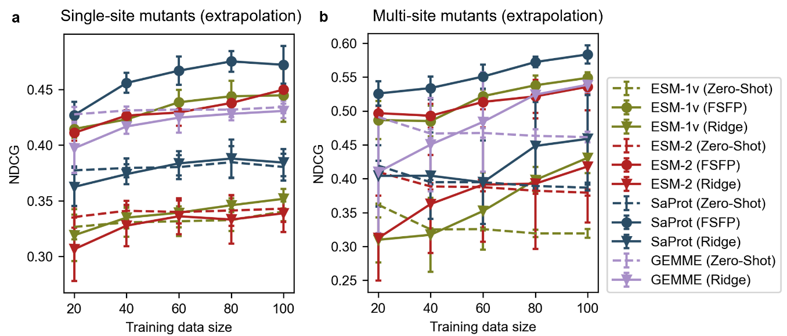
Fig.S3 Extrapolative performance on single-site and multi-site mutants. a) Extrapolating to single-site mutants whose mutated positions are not occurred in the training set, evaluated by NDCG. b) Extrapolating to multi-site mutants whose individual mutations have no overlap with the mutations in the training data, evaluated by NDCG.

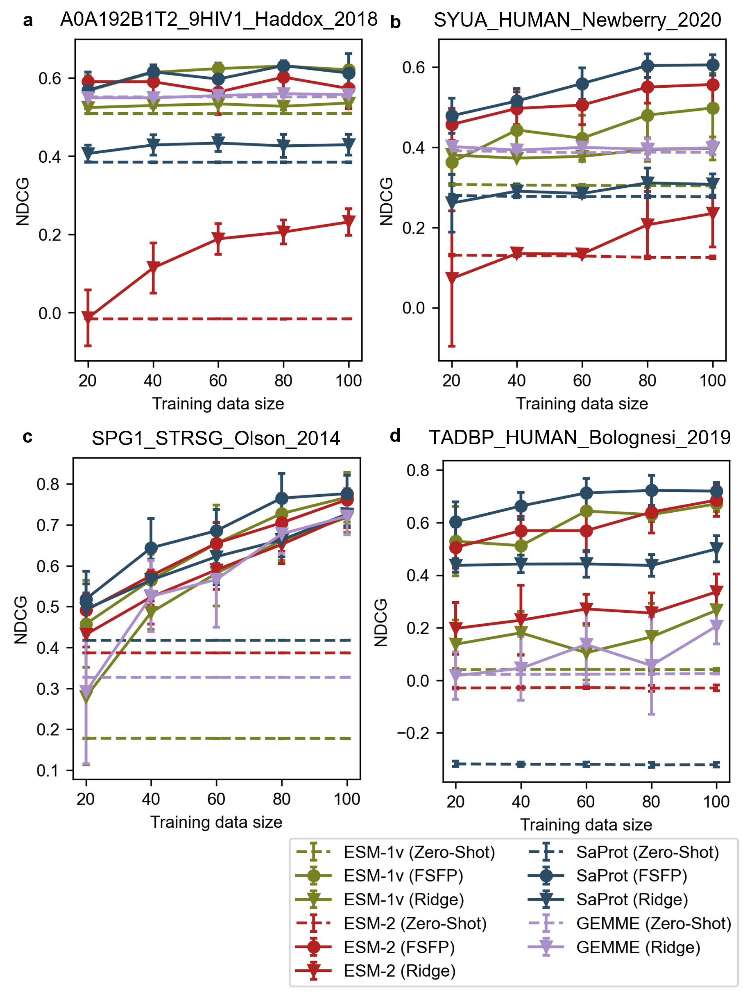
Fig.S4 Comparison results of different approaches on four proteins evaluated by NDCG. a) The envelope protein Env from HIV. b) The human α-synuclein. c) Protein G (GB1). d) The human TDP-43. The models are trained on single-site mutants and tested on all remaining data using NDCG.

