Supplementary Materials for
A phosphorylation switch of Huluwa receptor for embryonic axis induction
Yao Li, Yun Yan, Bo Gong, Qianwen Zheng, Haiyan Zhou, Jiarui Sun, Zhao Wang, Yaohui Li, Yunjing Wan, Weixi Chen, Shiqian Qi, Xianming Mo, Bo Xiang, Anming Meng, Jing Chen

*Correspondence to: jingchen@scu.edu.cn (J.C.)

This file includes:
Figs. S1 to S10

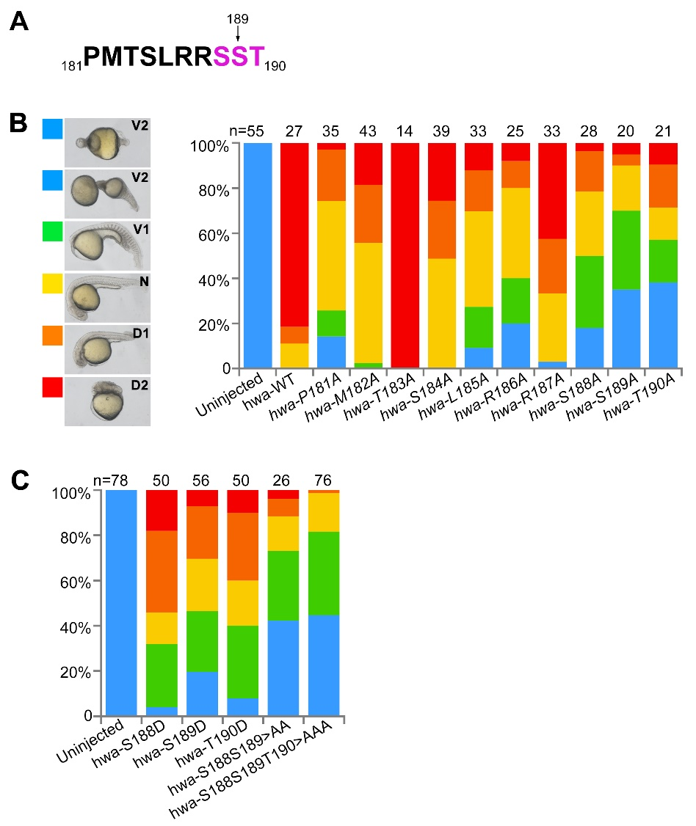
Fig. S1. Sequential mutation assay of the RRSST motif and surrounding sites.
(A) Amino acid sequence (181-190) around the RRSST motif of Hwa. (B) The left panel, rescued phenotypes at 24 hpf were grouped into five classes from ventralized to dorsalized (V2<V1<N<D1<D2; V, ventralized; N, normal; D, dorsalized) and indicated by squares with different colors; the right panel, the rescue efficiency was plotted for point mutated mRNAs of hwa (181-190Aa). (C) Rescue efficiency of S188D, S189D, T190D, S189A/S199A double and S189A/S199A/T190A triple mutations of hwa mRNA. 100 pg of each hwa-Flag mutant mRNA was injected at the 1-cell stage in Mhwa^{tsu01sm/tsu01sm} mutant embryos.
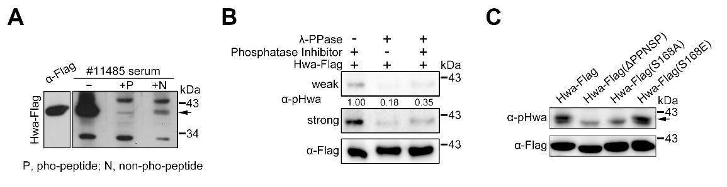
Fig. S2. Validation of the specificity of the pHwa antibody.
(A) Immunoblotting of the phosphorylated Hwa with NO.11485 antiserum supplied with competitive pho-peptide (VNTVPPN(p)SPVLR) or non-pho-peptide (VNTVPPNSPVLR). (B) Immunoblotting of pHwa from samples treated with λ-PPase or λ-PPase & phosphatase inhibitor. (C) Immunoblotting of pHwa in HEK293T cells transfected with wild type or mutants of Hwa-Flag. Arrows (A, C) indicate the band of phosphorylated Hwa.

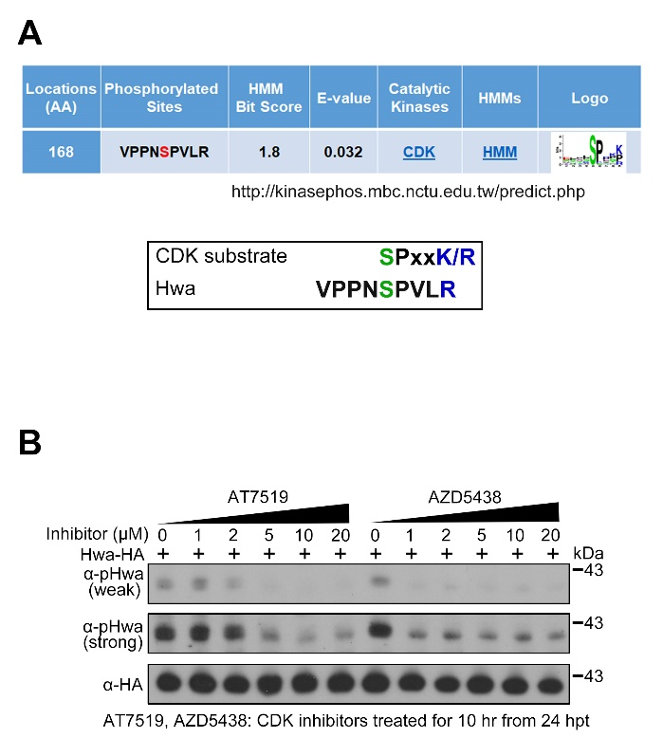
Fig. S3. AT7519 and AZD5438 decreased pHwa in HEK293T cells.
(A) The upper panel shows the predicted protein kinase that may be involved in phosphorylation at Ser168; the lower panel indicates the consensus amino acid sequence of CDK substrates and that of Hwa. (B) Immunoblotting of pHwa and total Hwa-HA protein in HEK293T cells treated with different doses of CDK inhibitors (AT7519 and AZD5438) from 10 to 24 hours post transfection.

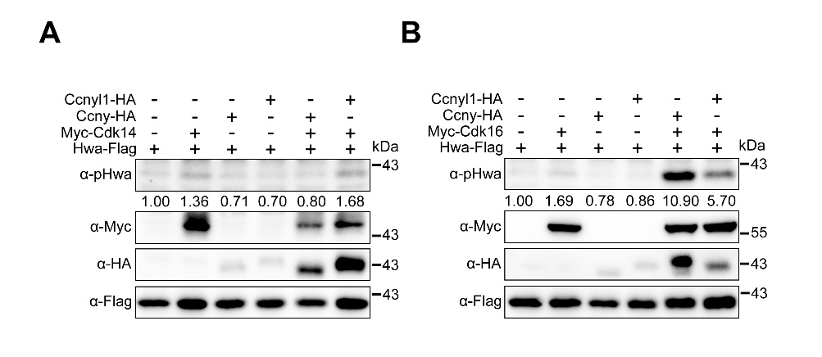
Fig. S4. Cdk16, but not Cdk14, elevated pHwa with Ccny/Ccnyl1.
(A) Immunoblotting of pHwa in HEK293T cells transfected with Hwa-Flag and Myc-Cdk14, in the absence or presence of Cyclin Y proteins (Ccny/Ccnyl1-HA). (B) Immunoblotting of pHwa in HEK293T cells transfected with Hwa-Flag and Myc-Cdk16, in the absence or presence of Cyclin Y (Ccny/Ccnyl1-HA). Total Hwa-Flag was applied as the loading control.

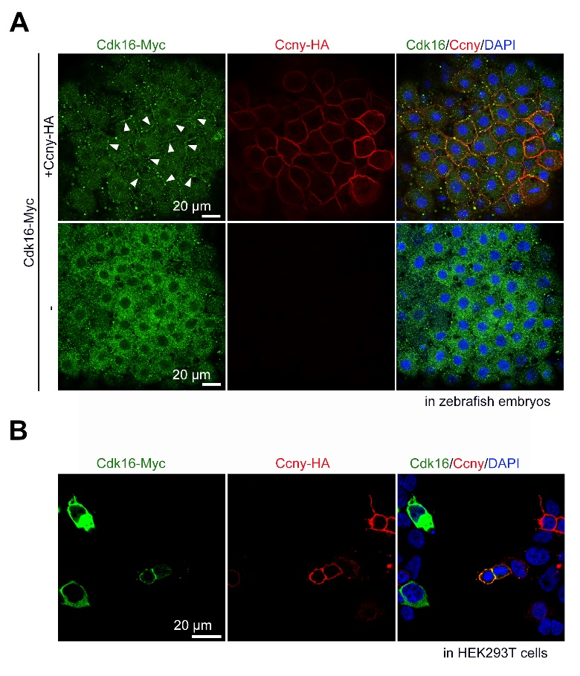
Fig. S5. Cdk16 was recruited to plasm membrane by Ccny.
(A) Immunofluorescence of Cdk16-Myc and Ccny-HA in zebrafish embryos, with arrowheads indicating the plasm membrane located Cdk16-Myc. (B) Immunofluorescence of Cdk16-Myc and Ccny-HA in HEK293T cells. Cells were stained with DAPI in blue; Scale bar, 20 μm.

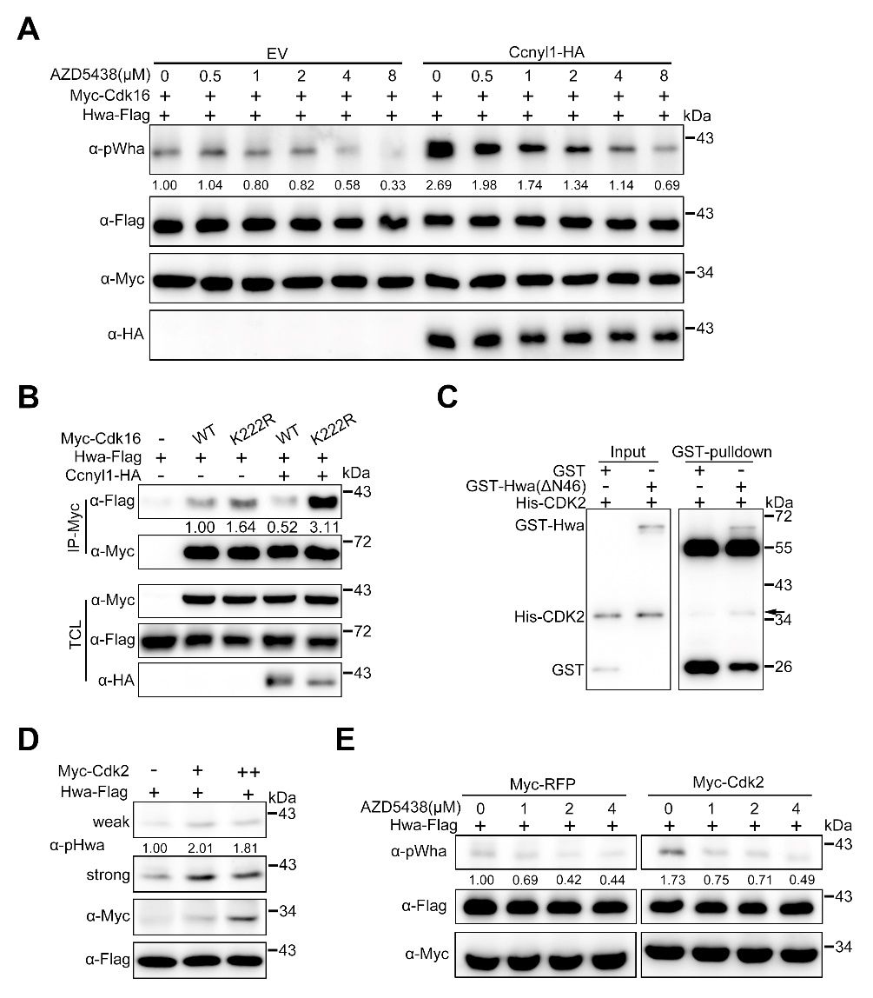
Fig. S6. Cdk16 and Cdk2 interacted with and phosphorylated Hwa.
(A) Immunoblotting of pHwa from HEK293T cells cotransfected with Myc-Cdk16 and Ccnyl1-HA, followed by treatment with different doses of the CDK inhibitor AZD5438 (0-8 μM). (B) Coimmunoprecipitation of Hwa-Flag with wild-type and K222R mutant Myc-Cdk16 in the absence or presence of Ccnyl1-HA. The kinase-dead form Cdk16 showed a stronger interaction with Hwa in the presence of Ccnyl1-HA. (C) In vitro GST-pulldown assay of His-CDK2 with GST-Hwa(ΔN46) or GST. The arrow indicated the His-CDK2 protein. (E) Immunoblotting of pHwa from HEK293T cells transfected with Hwa-Flag and Myc-Cdk2. (F) Immunoblotting of pHwa from HEK293T cells cotransfected Hwa-Flag with Myc-RFP or Myc-Cdk2, followed by treatment with different doses of the CDK inhibitor AZD5438 (0-4 μM). Total Hwa-Flag (A, D and E) or Myc-Cdk16 (B) was applied as the inter loading control.

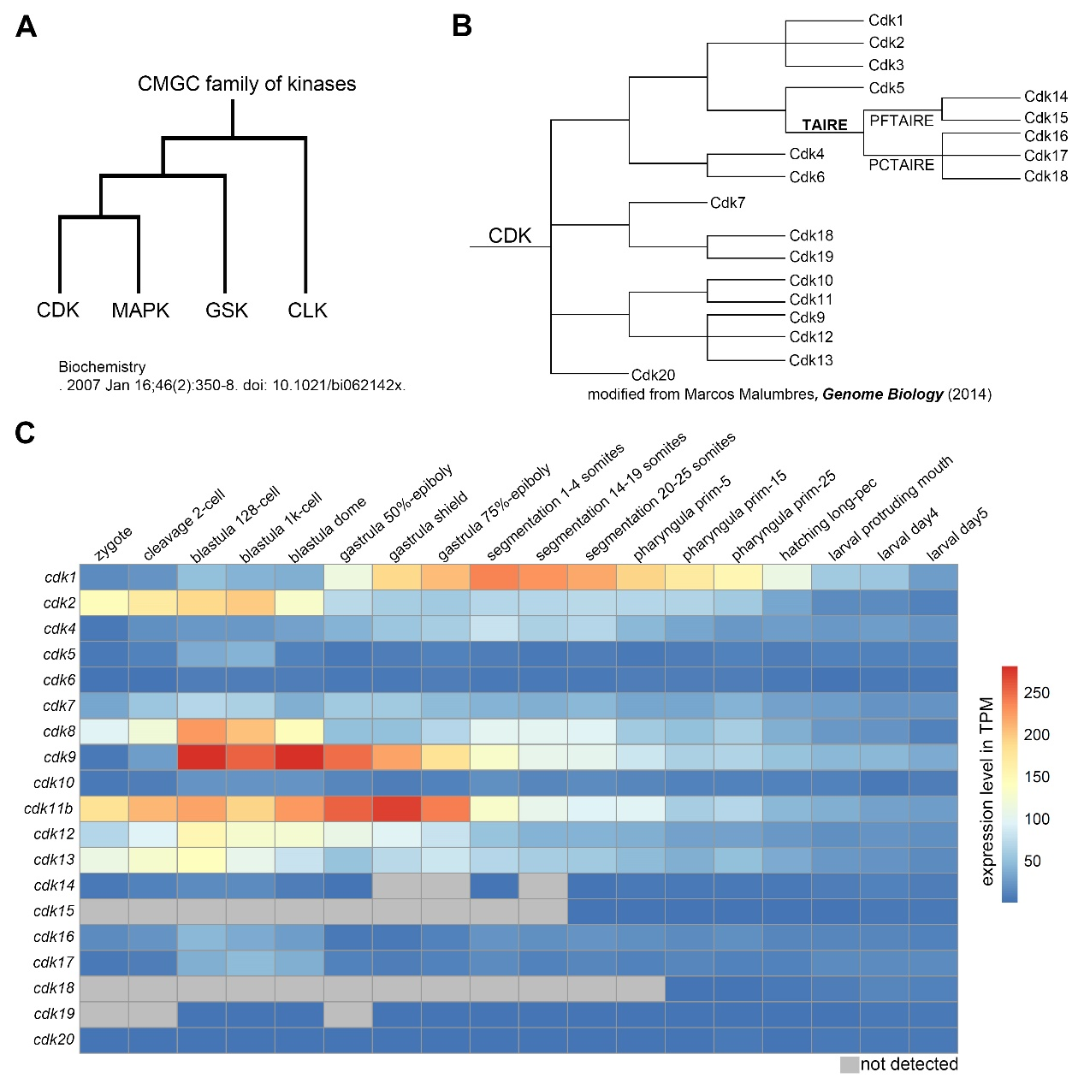 Fig. S7. CMGC kinase family and expression profile of cdk genes in zebrafish.
(A) The classification of the CMGC kinase family. (B) Members of the CDK subfamily, derived from Marcos Malumbres, Genome Biology (2014). (C) Expression levels of different cdk genes during zebrafish early developmental stages were plotted with data from Expression Atlas. Expression levels are displayed in TPM (transcripts per million) with color coding, while gray color indicates “not detected”.

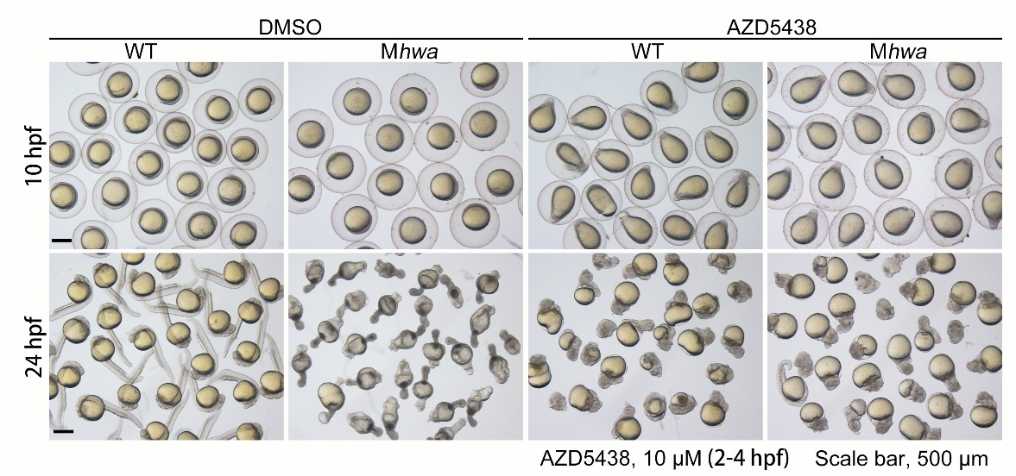

Fig. S8. AZD5438 treatment in WT and Mhwa embryos.
WT and Mhwa^{tsu01sm/tsu01sm} embryos were treated with DMSO or AZD5438 (10 μM) from 2 to 4 hours post fertilization (hpf) and photographed at 10 hpf and 24 hpf. AZD5438 treated embryos displayed elongated and dorsalized phenotypes from 10 hpf. Scale bar, 500 μm.
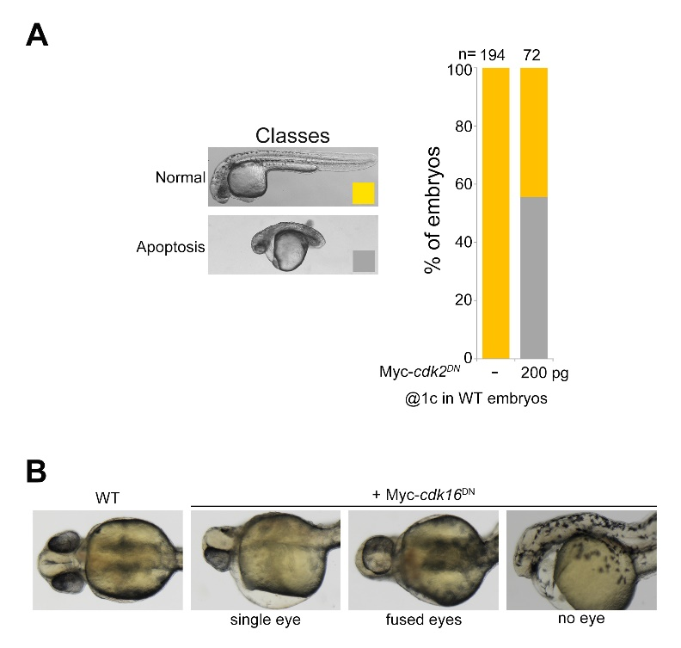
Fig. S9. Phenotypes of Myc-cdk2^{DN} and Myc-cdk16^{DN} overexpression in WT embryos
(A) Effects of overexpression of 200 pg dominant negative cdk2 (cdk2^{DN}) mRNA in wild-type embryos. (B) Injection of 200 pg Myc-cdk16^{DN} mRNA in WT embryos at the 1-cell stage resulted in some embryos with single-eye/fused-eyes/no-eye phenotypes, which was similar to that of blocking nodal signaling.
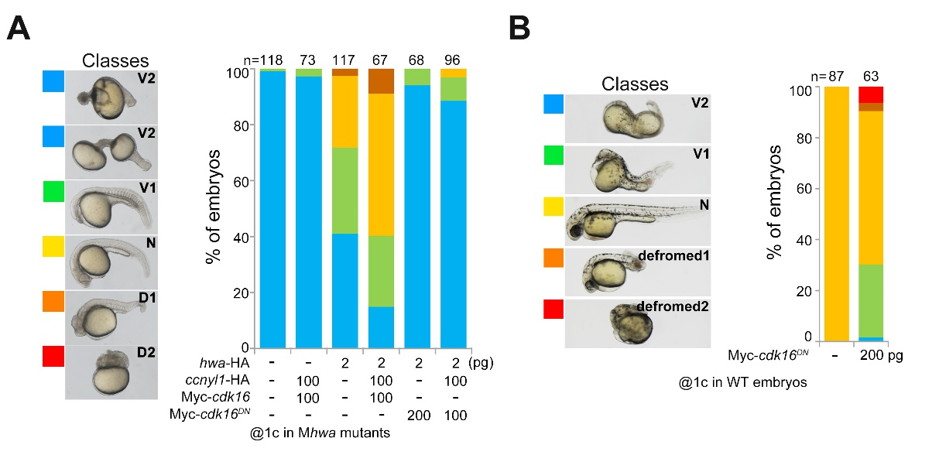
Fig. S10. Cdk16^{DN} hindered the axis-inducing function of Hwa.
(A) Rescue efficiency of Mhwa^{tsu01sm} mutant embryos with a low dosage of hwa mRNA (2 pg) together with wild-type and the dominant negative form of Myc-cdk16^{DN} mRNA. (B) Effects of overexpression of dominant negative cdk16 (cdk16^{DN}) mRNAs in wild type embryos. Some embryos shown deformed phenotypes. V2<V1<N<D1<D2; V, ventralized; N, normal; D, dorsalized.

