Appendix
Appendix-A: Mathematical Expression of Bayesian Mixed-Effects model and prior estimation

- Bayesian Procedure for estimating mixed-effects model
We estimated our models using the BRMS ^{1–3} package which uses the probabilistic language Stan⁴ in the backend. We used informed priors derived from the Canadian Labor Force Survey (LFS)^{5,6} and Census 2016 data⁷ to obtain the posterior distributions. The standard deviations for the coefficients of the informed priors were decided based on prior predictive checks (SD = 0.05 for “no work” model and SD=1 for rest). The default [student t(3, 0, 2.5)] distribution was used for variance parameters. The mathematical expression of the model and informed priors’ estimation process is explained in detail below.

For all our Bayesian models, we set iterations to 10,000 and warmup samples to 5000 to derive stable estimates. We conducted graphical prior and posterior predictive checks to assess the efficiency of our prior specification in predicting the model estimates.⁸ The Rhat values (Rhat=1) were assessed for model convergence. Additionally, in the spirit of “Multiverse Analysis,”⁹ we derived multiple models for each job category. The model comparisons for each job category are presented in Appendix-H.

We followed Logical Explanations & Visualizations of Estimates in Linear mixed models (LEVEL) recommendations¹⁰ and Bayesian reporting guidelines¹¹ to explain our Bayesian model results. We report mean values from the posterior distribution along with 95% High Density Intervals (HDI) and other measures of model fit.¹² However, we mainly discus the interaction effects (odds ratios and associated 95% credible intervals) adjusted for participant’s education as we were interested in understanding the impact of COVID-19 pandemic on job status of our population. Also, predicted probabilities averaged over the educational status are presented as a post-hoc analysis. We used gtsummary,¹³ flextable,¹⁴ ggplot2,¹⁵ grafify,¹⁶ ggeffects,¹⁷ emmeans,¹⁸ ggthemes,¹⁹ sjPlot,²⁰ ggtext,²¹ ggpattern,²² and dplyr²³ packages for data wrangling, visualizations, and reporting. All the analyses were performed using R statistical software (v.4.1.2).²⁴

- Bayesian Mixed-Effects Model Mathematical Expression

A representative mathematical equation for our Bayesian mixed-effects model is presented below:

$$Y_{i} \sim Binomial(P_{i}, σ_{e})$$
where

$${logit(P}_{i})=β_{0}+b_{Respondent[i]}+β_{x}{ Predictors}_{i}$$

$$β_{0} \sim Normal(μ_{0} , {SD}_{0})$$

$$β_{x} \sim Normal\left(μ_{x} , {SD}_{x}\right)$$

$${ σ}_{Respondent}= student_t(3, 0, 2.5)$$

$${ σ}_{e}= student_t(3, 0, 2.5)$$

and
$$β_{x}{ Predictors}_{i}= β_{1}{Time Period}_{i}+β_{2}{Sex}_{i}+β_{3δ}{Ethnicity}_{i}+β_{4}{Sex*Time Period}_{i}+β_{5δ}{Ethnicity*Time Period}_{i}+β_{6}{Education}_{i}$$

Here, $Y_{i}$ represents dichotomous response by the i^{th} respondent for each outcome (no work, full-time, part-time, multiple response, other work) taking value of 1 if the outcome is recorded and 0 otherwise. It follows a binomial distribution around mean $P_{i}$ and error term $σ_{e}$. The distribution of $P_{i}$ is estimated on logit scale from our predictors of interest. The ${logit(P}_{i})$ represents the estimation equation for the predictors where $β_{0}$ is fixed-effect coefficient for the intercept, $b_{Respondent[i]}$is random effect coefficient for the grouping variable (Respondent ID) capturing the within-subjects variability, $β_{x}$ represents coefficients for predictors. Here, in $β_{3δ}$ and $β_{5δ}$, d represents ethnic groups namely African Caribbean Black (ACB), Indigenous, and Other. As noted, the parameters of interests are Time Period ($β_{1}$), Sex*Time Period ($β_{1}+β_{2}+β_{4}$), and Ethnicity*Time Period ($β_{1}+β_{3δ}+β_{5δ}$).

We assume the prior distributions of the intercept $β_{0}$ and fixed effects coefficients $β_{x}$ follow normal distributions with the mean (SD) $μ_{0}$(${SD}_{0}$) and $μ_{x}({SD}_{x})$, respectively. The variance terms (${ σ}_{Respondent}$ and ${ σ}_{e}$) follow student-t distribution. The estimation process for the priors is described below.

- Estimating Informed Priors
Our job status question captured transitivity in employment for the period between September 2019 and December 2021. Therefore, we estimated our priors based on the labor force characteristics obtained from Canadian Labor Force Survey (LFS) for the period between September 2019 and December 2021 for Ontario specific data.⁵ For this data, the Before COVID-19 time-period was defined as the period between September 2019 to February 2020 and During COVID-19 period was defined as the duration between March 2020 and December 2021. The prior distributions for $β_{0}, β_{1}, β_{2}, β_{4} ,$ and $β_{6}$ were obtained by running logistic regressions using this data. A mathematical expression of these logistic regressions is given below:

$$Y_{i}=β_{0}+β_{1}{Time Period}_{i}+β_{2}{Sex}_{i}+β_{4}{Sex*Time Period}_{i}+β_{6}{Education}_{i}+ε_{i}$$

Here, $Y_{i}$ represents the probability of each outcome coded as 1 if the outcome is observed and 0 otherwise and $ε_{i}$ is the error term. The rest of the covariates’ description is same as our main model. Three separate models for unemployment (no-work), full-time work, and part-time work were estimated. As we did not have data for “multiple responses” and “other type of work”, same estimates as from “part-time” data were used by assuming these categories will mimic the distribution of part-time employment.

Unfortunately, the pre-pandemic monthly labour force participation information for Indigenous group is not available. Therefore, for these priors we relied on LFS-2019 one-year data.⁵ For $β_{3Indigenous}$, we calculated odds ratios of unemployed vs not-unemployed and employed vs not-employed for Indigenous vs non-Indigenous population using epiR package.²⁵ These ratios were then back transformed into the logit estimates. In LFS-2019 the full-time or part-time status is not reported. Therefore, for our full-time, part-time, multiple responses, and other work models, we used logit coefficient for employment status.

We used unemployment, full-time, and part-time data for visible minorities from Census 2016⁷ to estimate $β_{3Black}$ and $β_{3Other}$ priors as monthly/yearly LFS data was not available for our specified period. Similar to Indigenous priors, odds ratios for the three work categories were derived for ACB and Other visible minorities separately and then back transformed to logits. Estimates from part-time category were used to define visible minority priors for “multiple responses” and “other type of work” models.

In lieu of sufficient data, for interaction coefficient $β_{5δ}$, we assumed it followed the same distribution as of $β_{1}$; that is, the following odds ratios were equal:

$$\frac{{Odds}_{White male with education higher than highschool during pandemic}}{{Odds}_{White male with education higher than highschool before pandemic}}$$

$$= \frac{{Odds}_{Black male with education higher than highschool during pandemic}}{{Odds}_{White male with education higher than highschool before pandemic}}$$

$$= \frac{{Odds}_{Indigenous male with education higher than highschool during pandemic}}{{Odds}_{White male with education higher than highschool before pandemic}}$$

$$= \frac{{Odds}_{Other ethncity male with education higher than highschool during pandemic}}{{Odds}_{White male with education higher than highschool before pandemic}}$$

In other words, we assumed the odds of outcome of interest During COVID-19 for the males with education higher than high school were the same irrespective of their ethnicity.

Following the above-mentioned process, the estimated priors along with their sources are given in the table below.

Table: Prior distributions: Mean Logits
Priors | No Work | Full-time | Part-Time | Multiple Responses | Other Work
Intercept ($β_{0}$) | -3.0648 | 1.8028 | -2.2026 | Same as Part-Time model | Same as Part-Time model
Time Period: During COVID ($β_{1}$) | 0.5590 | -0.1763 | -0.1010 | Same as Part-Time model | Same as Part-Time model
Sex:Female ($β_{2}$) | -0.0222 | -0.7440 | 0.8996 | Same as Part-Time model | Same as Part-Time model
Ethnicity: ACB ($β_{3Black}$) | 0.6259384 | -0.4004776 | -0.3435897 | Same as Part-Time model | Same as Part-Time model
Ethnicity:Indigenous ($β_{3Indigenous}$) | 0.65752 | -0.3011051 | -0.3011051 | Same as Part-Time model | Same as Part-Time model
Ethnicity:Other ($β_{3Other}$) | 0.1823216 | -0.2357223 | 0.2231436 | Same as Part-Time model | Same as Part-Time model
Time Period: During COVID X Sex:Female ($β_{4}$) | 0.1145 | 0.1421 | -0.1089 | Same as Part-Time model | Same as Part-Time model
Time Period: During COVID X Ethnicity: ACB ($β_{5Black}$) | Same as ($β_{1}$) | Same as ($β_{1}$) | Same as ($β_{1}$) | Same as Part-Time model | Same as Part-Time model
Time Period: During COVID X Ethnicity: Indigenous ($β_{5Indigeous}$) | Same as ($β_{1}$) | Same as ($β_{1}$) | Same as ($β_{1}$) | Same as Part-Time model | Same as Part-Time model
Time Period: During COVID X Ethnicity:Other ($β_{5Other}$) | Same as ($β_{1}$) | Same as ($β_{1}$) | Same as ($β_{1}$) | Same as Part-Time model | Same as Part-Time model
Education ($β_{6}$) | 0.5794 | -0.7509 | 0.7175 | Same as Part-Time model | Same as Part-Time model

References
1 Bürkner P-C. Bayesian Item Response Modeling in R with brms and Stan. Journal of Statistical Software 2021; 100: 1–54.
2 Bürkner P-C. Advanced Bayesian Multilevel Modeling with the R Package brms. .
3 Bürkner P-C. brms: An R Package for Bayesian Multilevel Models Using Stan. Journal of Statistical Software 2017; 80: 1–28.
4 R Interface to Stan • rstan. https://mc-stan.org/rstan/ (accessed April 5, 2022).
5 Statistics Canada. Table 14-10-0019-01 Labour force characteristics by educational attainment, monthly, unadjusted for seasonality. 2022; published online Jan 7. DOI:https://doi.org/10.25318/1410001901-eng.
6 Statistics Canada. Table 14-10-0364-01 Labour force characteristics by province, region and Indigenous group. 2022; published online Jan 7. DOI:https://doi.org/10.25318/1410036401-eng.
7 Statistics Canada. 2016 Census Data tables – Visible Minority (15), Age (15A), Sex (3) and Selected Demographic, Cultural, Labour Force, Educational and Income Characteristics (900) for the Population in Private Households of Canada, Provinces and Territories, Census Metropolitan Areas and Census Agglomerations, 2016 Census - 25% Sample Data. Statistics Canada Catalogue no. 98-400-X2016192. 2016. https://www12.statcan.gc.ca/census-recensement/2016/dp-pd/dt-td/Rp-eng.cfm?LANG=E&APATH=3&DETAIL=0&DIM=0&FL=A&FREE=0&GC=0&GID=0&GK=0&GRP=1&PID=112451&PRID=10&PTYPE=109445&S=0&SHOWALL=0&SUB=0&Temporal=2017&THEME=120&VID=0&VNAMEE=&VNAMEF= (accessed May 3, 2022).
8 Schad DJ, Betancourt M, Vasishth S. Toward a principled Bayesian workflow in cognitive science. Psychol Methods 2021; 26: 103–26.
9 Steegen S, Tuerlinckx F, Gelman A, Vanpaemel W. Increasing Transparency Through a Multiverse Analysis. Perspectives on Psychological Science 2016; 11: 702–12.
10 Monsalves MJ, Bangdiwala AS, Thabane A, Bangdiwala SI. LEVEL (Logical Explanations & Visualizations of Estimates in Linear mixed models): recommendations for reporting multilevel data and analyses. BMC Medical Research Methodology 2020; 20: 3.
11 Kruschke J. Bayesian Analysis Reporting Guidelines. Nature Human Behaviour 2021; 5. DOI:10.1038/s41562-021-01177-7.
12 Nakagawa S, Schielzeth H. A general and simple method for obtaining R2 from generalized linear mixed-effects models. Methods in Ecology and Evolution 2013; 4: 133–42.
13 Sjoberg DD, Whiting K, Curry M, Lavery JA, Larmarange J. Reproducible Summary Tables with the gtsummary Package. The R Journal 2021; 13: 570–80.
14 Gohel D. flextable: Functions for Tabular Reporting. 2021. https://CRAN.R-project.org/package=flextable (accessed April 4, 2022).
15 Wickham H. ggplot2. 2016. DOI:10.1007/978-3-319-24277-4.
16 Shenoy A. grafify: an R package for easy graphs, ANOVAs and post-hoc comparisons. 2021. DOI:10.5281/zenodo.5136508.
17 Lüdecke D. ggeffects: Tidy Data Frames of Marginal Effects from Regression Models. Journal of Open Source Software 2018; 3: 772.
18 Lenth R v. emmeans: Estimated Marginal Means, aka Least-Squares Means. 2022. https://CRAN.R-project.org/package=emmeans (accessed April 5, 2022).
19 Arnold JB. ggthemes: Extra Themes, Scales and Geoms for “ggplot2.” 2021. https://CRAN.R-project.org/package=ggthemes (accessed April 4, 2022).
20 Lüdecke D. sjPlot: Data Visualization for Statistics in Social Science. 2021. https://CRAN.R-project.org/package=sjPlot (accessed April 21, 2022).
21 Wilke CO. ggtext: Improved Text Rendering Support for “ggplot2.” 2020. https://CRAN.R-project.org/package=ggtext (accessed April 4, 2022).
22 Mike FC, Trevor LD, ggplot2 authors. ggpattern: “ggplot2” Pattern Geoms. 2022. https://CRAN.R-project.org/package=ggpattern (accessed April 4, 2022).
23 Hadley W, Romain F, Lionel H, Kirill M. dplyr: A Grammar of Data Manipulation. 2022. https://CRAN.R-project.org/package=dplyr (accessed April 4, 2022).
24 R Core Team. R: A language and environment for statistical computing. 2021. https://www.R-project.org/ (accessed Aug 4, 2022).
25 Stevenson M, Sergeant E, Nunes T, Heuer C. epiR: Tools for the Analysis of Epidemiological Data. 2022. https://CRAN.R-project.org/package=epiR (accessed April 5, 2022).

Appendix-B: Extended Analysis of Social Assistance

The types of social assistance reported include Child Support, Employment Insurance, Familial Support/Allowance, Ontario Disability Support Program (ODSP), Old Age Pension/GIS (Guaranteed Income Supplement) , GST/HST (goods and services tax/harmonized sales tax) credits, Ontario Trillium, Ontario Works, Ontario Student Assistance Program (OSAP), Canada Emergency Response Benefit (CERB) / Canada Emergency Student Benefit (CESB) /Other COVID Relief (only for During COVID-19) and any other type of assistance reported.

B1: Change in social assistance (SA) recipients across time (N=404)
 | During COVID-19*
 | No SA (n=37) | On SA (n=330)
Before COVID-19
No Social Assistance | 34 (91.9%) | 18(5.4%)
On Social Assistance | 3 (8.1%) | 312(94.6%)

B2: Demographics for those who gained or lost social assistance (SA) During COVID-19

Characteristics | Gained (n = 43) * | Lost (n = 7) †
Gender
Female | 31 (72.1%) | 4 (57.1%)
Male | 12 (27.9%) | 3 (42.9%)
Other (Specify) ‡ | 0 (0.0%) | 0 (0.0%)
Ethnicity
Caucasian | 2 (4.7%) | 2 (28.6%)
Black | 31 (72.1%) | 2 (28.6%)
Indigenous | 3 (7.0%) | 2 (28.6%)
Other‡ | 7 (16.3%) | 1 (14.3%)
Age Group
16-25 yrs. | 13 (30.3%) | 0 (0.0%)
26-35 yrs. | 5 (11.6%) | 0 (0.0%)
36-45 yrs. | 3 (7.0%) | 4 (57.1%)
46-55 yrs. | 2 (4.6%) | 2 (28.6%)
56 yrs. and above | 2 (4.6%) | 0 (0.0%)
(Missing) | 18(41.9%) | 1(14.3%)
Employment status During COVID-19
No Work | 15 (34.9%) | 1 (14.3%)
Full-Time | 9 (20.9%) | 3 (42.9%)
Part-Time | 5 (11.6%) | 0 (0.0%)
Multiple Responses§ | 4 (9.3%) | 1 (14.3%)
Other Work¶ | 5 (11.6%) | 1 (14.3%)
(Missing) | 5(11.6%) | 1(14.3%)
*Includes respondents who did not report any social assistance Before COVID-19 (September 2019 to February 2020) but report getting it during the COVID-19 pandemic (March 2020 to November 2021).
†Includes respondents who report any social assistance Before COVID-19 (September 2019 to February 2020) but did not receive it during the COVID-19 pandemic (March 2020 to November 2021).
‡Other Ethnicity includes Arab, Latino, Asians (South and East), Mixed, and any other ethnicities not included in the main categories. Other gender includes ‘2 spirited’, ‘non-binary’, ‘trans female’, ‘transgender male to female’.
§Multiple responses include combinations of rest of the main categories.
¶Other employment includes street-based, temporary/seasonal jobs or any other jobs which are not classified under the main categories.

B3: Financial Assistance for those who lost employment During COVID-19 but were previously employed (n=59)

Characteristic | Female  (n = 29) | Male  (n = 30)
Received no financial assistance | 3 (10.7%) | 4 (13.3%)
Only CERB*/similar covid relief | 8 (28.6%) | 1 (3.3%)
CERB*/similar covid relief and other support | 5 (17.9%) | 2 (6.7%)
Only Other Support | 12 (42.9%) | 23 (76.7%)
Note: *CERB = Canada Emergency Response Benefit
https://www.google.com/url?sa=t&rct=j&q=&esrc=s&source=web&cd=&ved=2ahUKEwiu15vU5ob6AhVcj4kEHaFIAuoQFnoECAIQAQ&url=https://www.canada.ca/en/services/benefits/ei/cerb-application.html&usg=AOvVaw0mwvIAZgXXUKinhxmLx0sh

Appendix-C: Change in Employment Status and Social Assistance During the Pandemic

Figure C1: Change in employment status across time and ethnicity: Panel-A (Female) and B (Male)

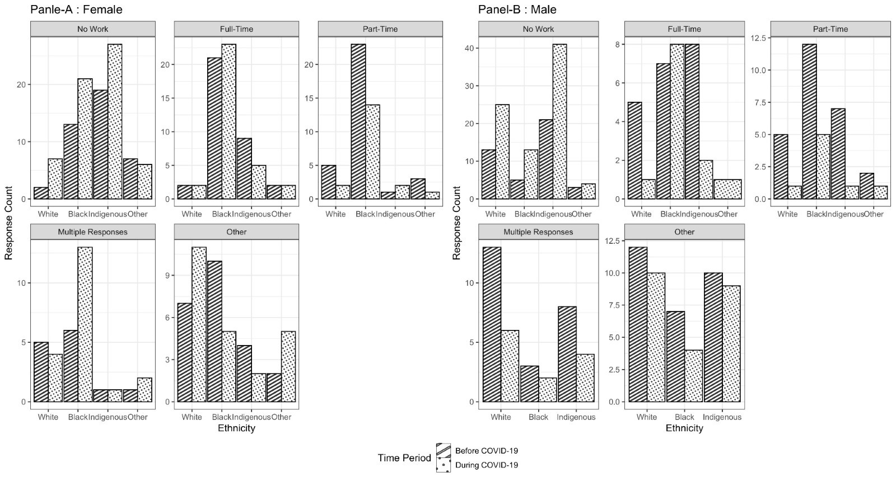

Note:
- Other Ethnicity includes Arab, Latino, Asians (South and East), Mixed, and any other ethnicities not included in main categories.
- Before COVID-19: September 2019 to February 2020, During COVID-19: March 2020 to November 2021.
- Missing values on job status are excluded from the graph.
- Non-binary gender responses are not included in the graph.
Table C2: Bayesian mixed-effects model results (mean of posterior distribution) showing impact of pandemic on employment status (n=340)

 | No Work* |  | Full-time Work* |  | Part-time Work* |  | Multiple Responses*† |  | Other Work*†
Predictors | Odds Ratios | CI (95%) | Odds Ratios | CI (95%) | Odds Ratios | CI (95%) | Odds Ratios | CI (95%) | Odds Ratios |  | CI (95%)
Intercept | 0.01 | 0.01 – 0.02 | 0.10 | 0.03 – 0.23 | 0.16 | 0.06 – 0.31 | 0.08 | 0.01 – 0.21 | 0.12 |  | 0.03 – 0.30
Before COVID-19 ‡
During COVID-19 | 1.81 | 1.64 – 1.99 | 0.49 | 0.16 – 1.14 | 0.34 | 0.12 – 0.75 | 0.49 | 0.17 – 1.09 |  | 1.29 |  | 0.49 – 2.73
Ethnicity = White
African Caribbean Black | 1.83 | 1.66 – 2.02 | 2.56 | 0.87 – 6.06 | 3.08 | 1.34 – 6.37 | 0.47 | 0.13 – 1.20 |  | 0.49 |  | 0.15 – 1.19
Indigenous | 1.97 | 1.78 – 2.17 | 2.21 | 0.72 – 5.23 | 0.62 | 0.23 – 1.35 | 0.44 | 0.12 – 1.13 |  | 0.43 |  | 0.13 – 1.06
Other§ | 1.20 | 1.09 – 1.33 | 0.91 | 0.19 – 2.73 | 1.90 | 0.56 – 4.74 | 0.66 | 0.11 – 2.12 |  | 0.73 |  | 0.15 – 2.28
Gender = Male¶
Female | 0.97 | 0.88 – 1.06 | 1.75 | 0.70 – 3.70 | 1.11 | 0.54 – 2.02 | 0.89 | 0.29 – 2.12 |  | 1.13 |  | 0.41 – 2.58
Education = More than High School
High-School or less | 1.82 | 1.65 – 2.00 | 0.32 | 0.13 – 0.62 | 0.85 | 0.45 – 1.47 | 1.12 | 0.41 – 2.53 |  | 1.23 |  | 0.49 – 2.66
Interactions
During COVID-19 X Female | 1.12 | 1.01 – 1.23 | 1.37 | 0.45 – 3.19 | 1.40 | 0.49 – 3.23 | 2.54 | 0.73 – 6.37 |  | 1.22 |  | 0.39 – 2.89
During COVID-19 X African Caribbean Black | 1.74 | 1.58 – 1.92 | 2.66 | 0.80 – 6.67 | 1.33 | 0.42 – 3.23 | 2.42 | 0.64 – 6.45 |  | 0.39 |  | 0.11 – 1.01
During COVID-19 X Indigenous | 1.79 | 1.62 – 1.98 | 0.63 | 0.16 – 1.69 | 1.04 | 0.24 – 2.94 | 0.74 | 0.17 – 2.11 |  | 0.68 |  | 0.19 – 1.75
During COVID-19 X Other | 1.75 | 1.58 – 1.93 | 1.75 | 0.28 – 5.79 | 1.04 | 0.19 – 3.17 | 1.33 | 0.20 – 4.62 |  | 1.72 |  | 0.31 – 5.46
Random Effects
ICC# | 0.88 |  | 0.55 |  | 0.19 |  | 0.67 |  |  | 0.66
N | 340 |  | 340 |  | 340 |  | 340 |  |  | 340
Marginal R² / Conditional R² | 0.007 / 0.578 |  | 0.067 / 0.411 |  | 0.075 / 0.175 |  | 0.004 / 0.424 |  |  | 0.016 / 0.436
Note: * Results shown are with standard deviation = 0.05 and 1.00 for “No Work” and rest of the models, respectively.
† Other work includes Street-based, temporary/seasonal jobs/or any other jobs which are not classified under the main categories. Multiple responses for work include combinations of the main categories.
‡Before COVID-19: September 2019 to February 2020, During COVID-19: March 2020 to November 2021.
§Other Ethnicity includes Arab, Latino, Asians (South and East), Mixed, and any other ethnicities not included in main categories.
¶Participants confirming non-binary gender status are excluded from the analysis due to small sample size.
#ICC: Intraclass Correlation Coefficient.

Appendix-D: MCMC Chains Trace plots for Models with Informed Priors

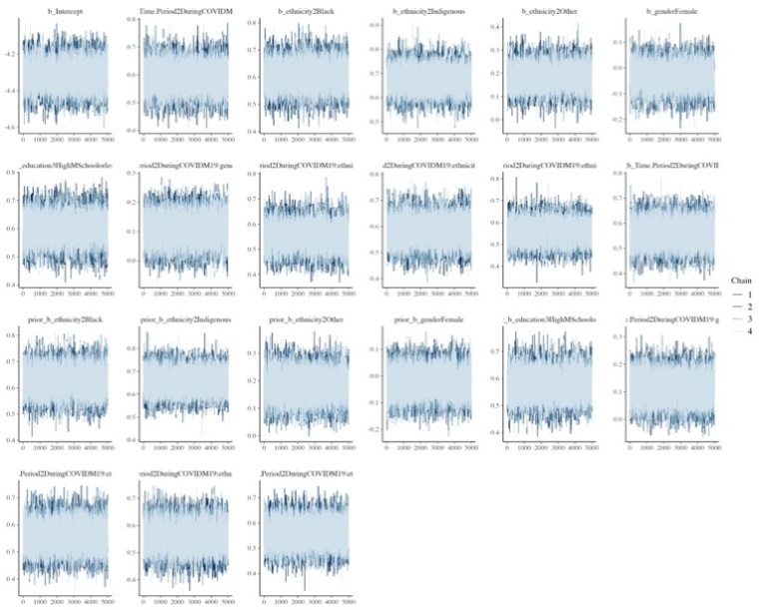 | 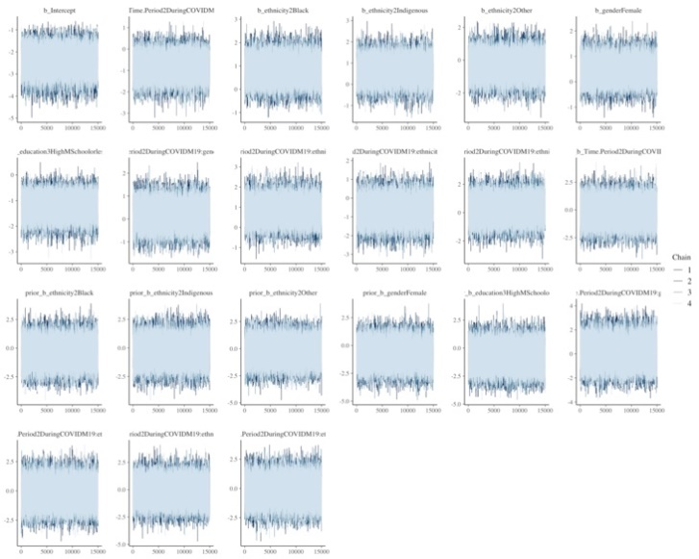
- No Work | - Full-Time Work
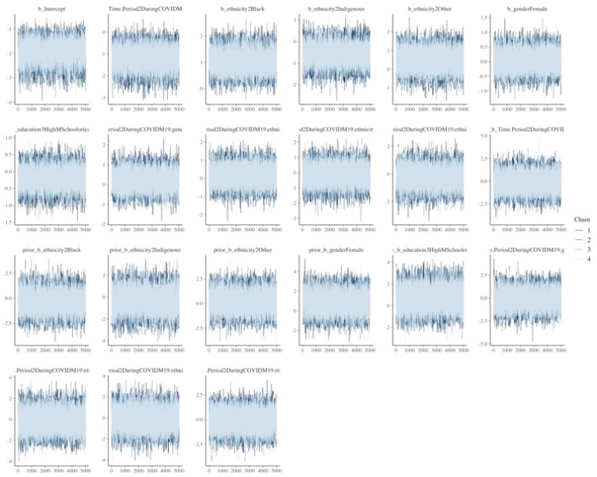 | 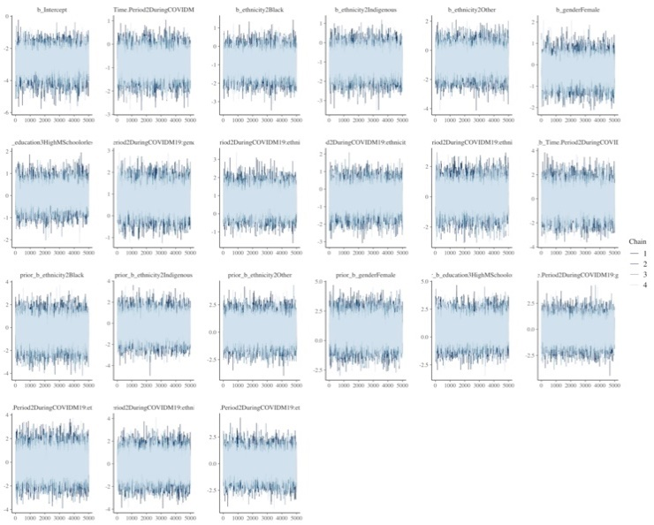
- Part-Time Work | - Multiple Responses
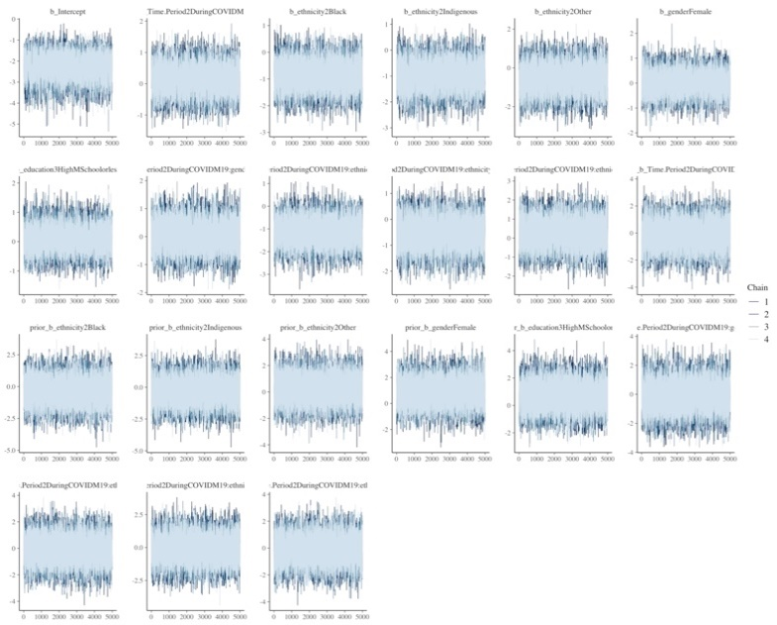
- Other Work

Appendix-E: Prior Predictive Checks for Models with Informed Priors

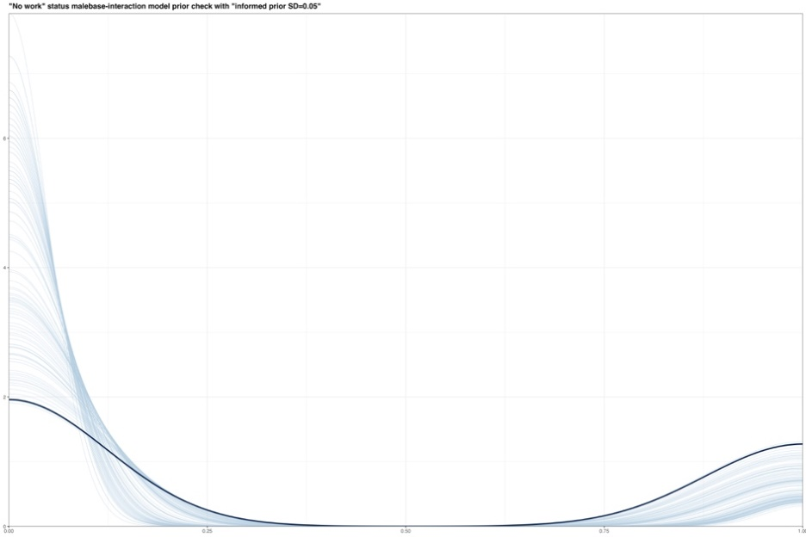 | 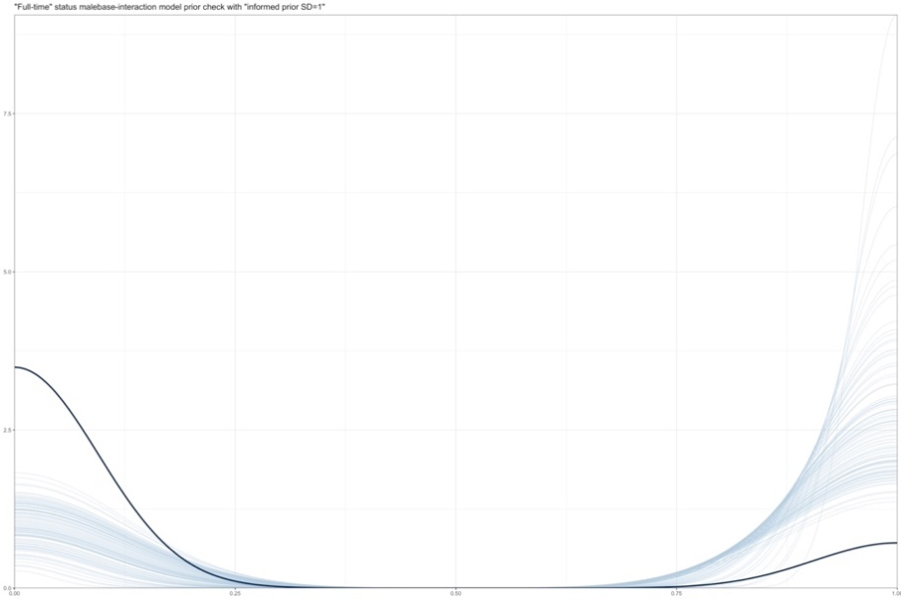
- No Work | - Full-Time Work
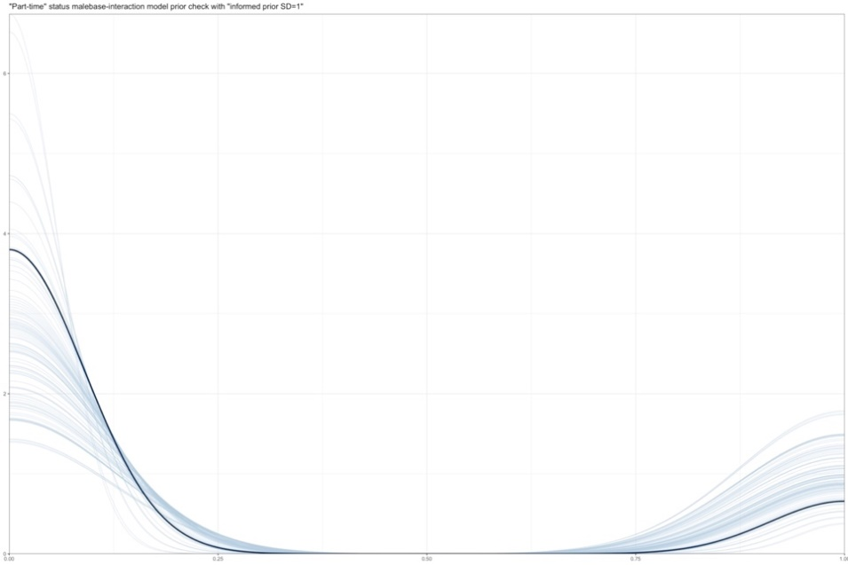 | 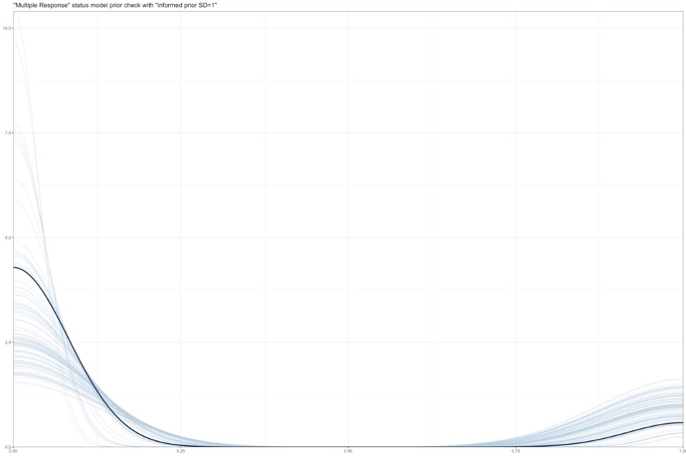
- Part-Time Work | - Multiple Responses
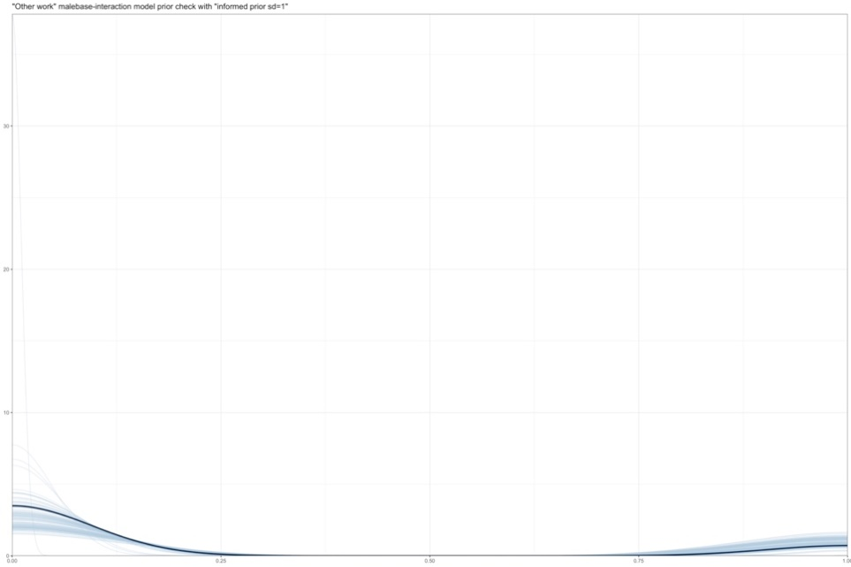
- Other Work

Appendix-F: Posterior Predictive Checks for Models with Informed Priors

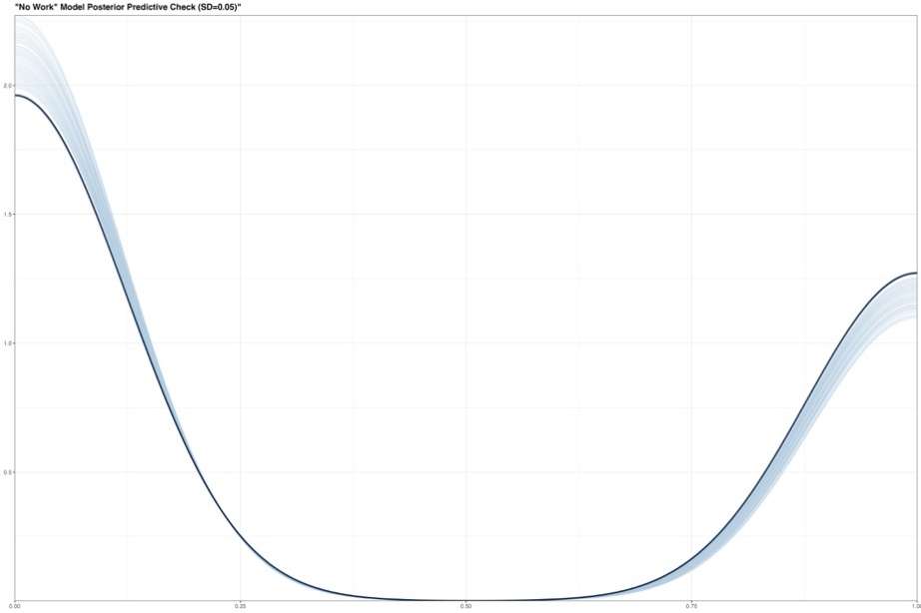 | 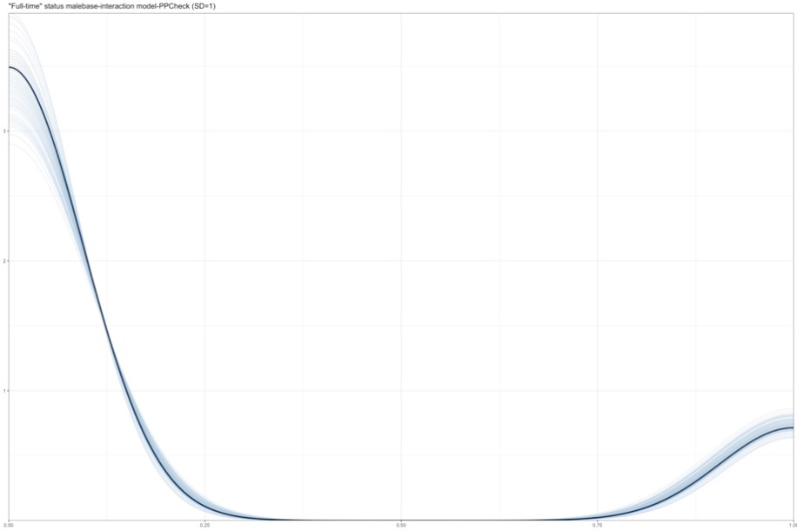
- No Work | - Full-Time Work
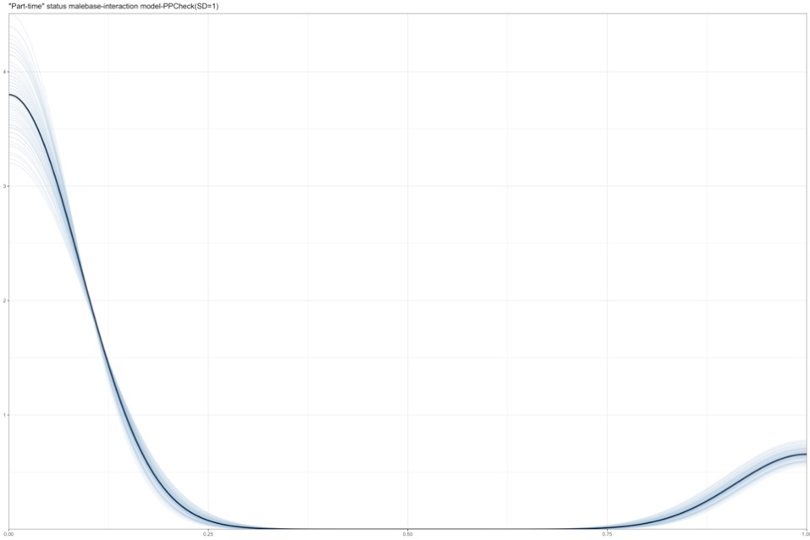 | 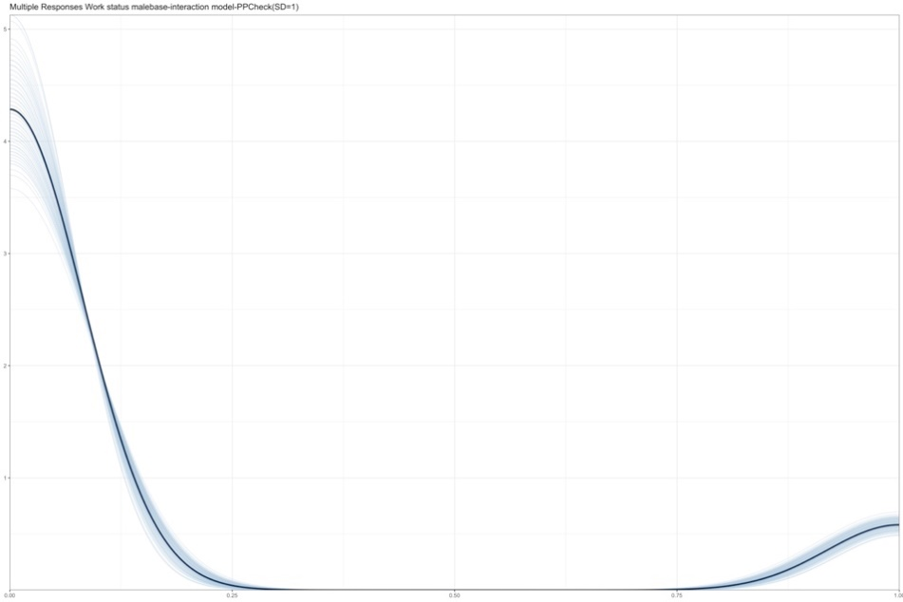
- Part-Time Work | - Multiple Responses
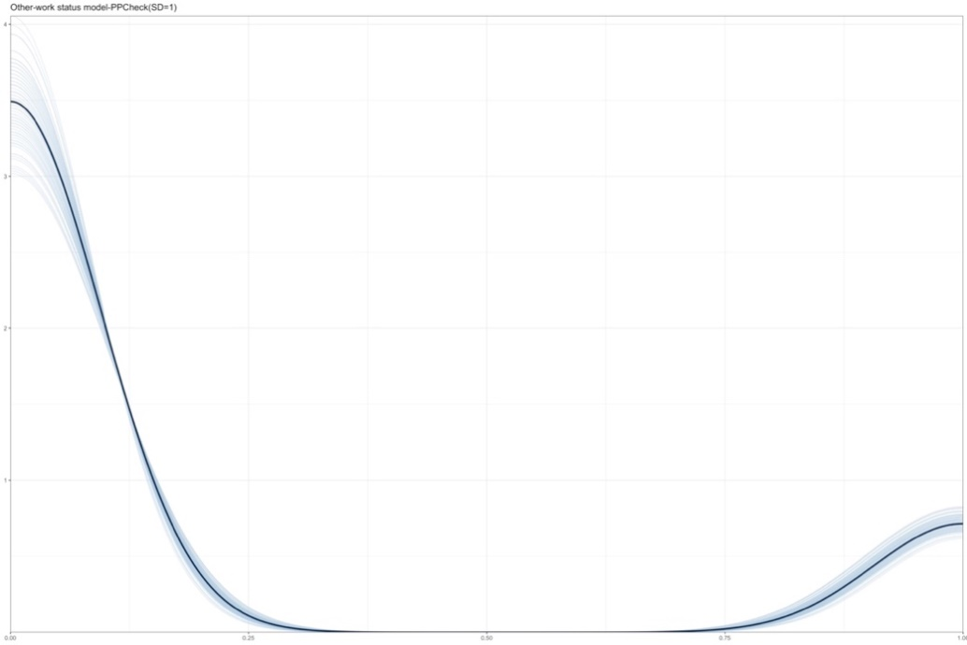
- Other Work

Appendix-G: Marginal Effects for Time-Period X Ethnicity interaction across sex averaged over education

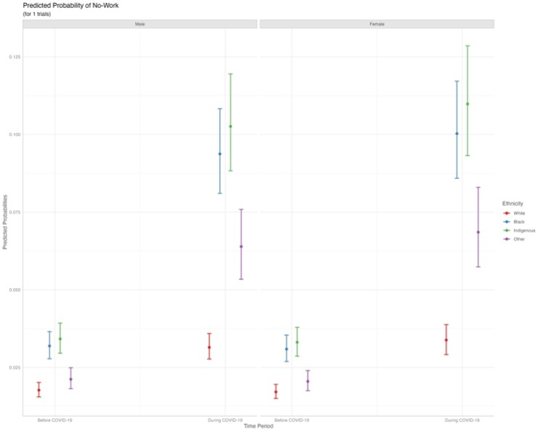 | 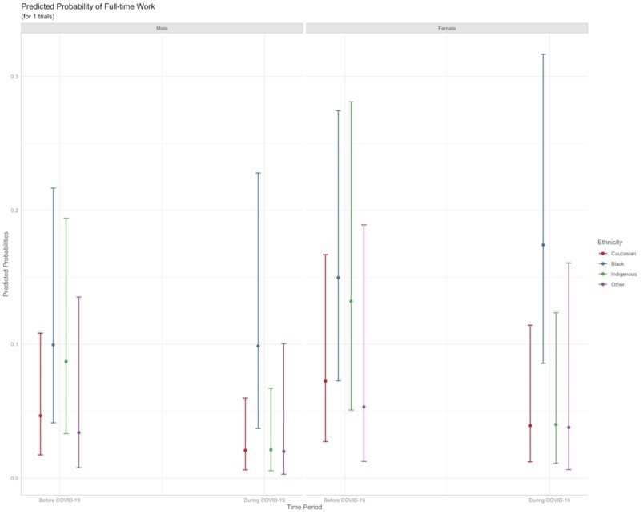
- No Work | - Full-Time Work
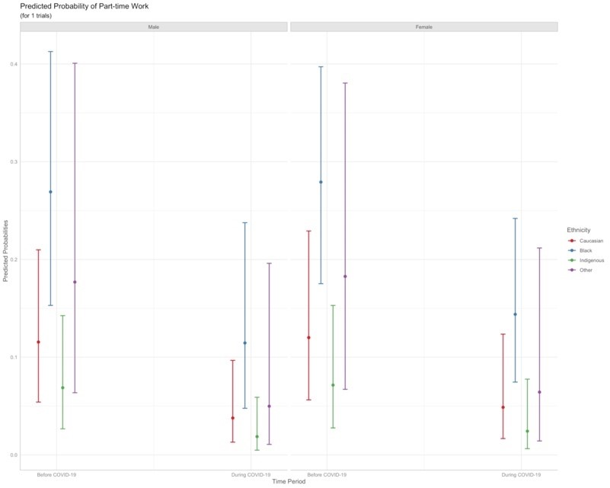 | 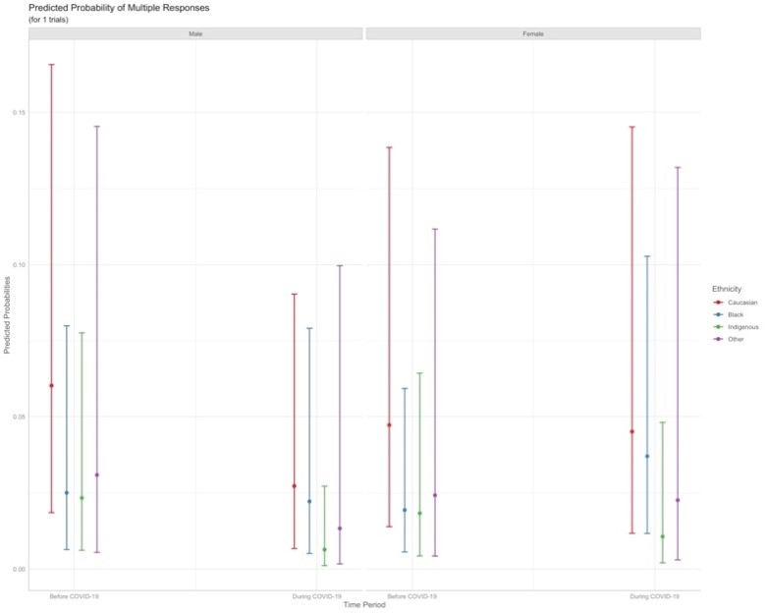
iii. Part-Time Work | iv. Multiple Responses
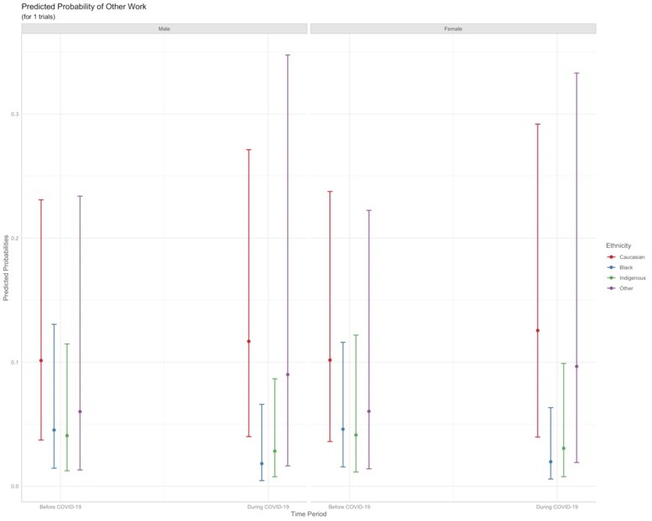
v. Other Work

Appendix-H: Model Comparisons
- No Work

 | Flat Prior |  | BRMS Default Prior |  | Informed Prior (SD=0.5) |  | Informed Prior  (SD=1)
Predictors | Odds Ratios | CI (95%) | Odds Ratios | CI (95%) | Odds Ratios | CI (95%) | Odds Ratios | CI (95%)
Intercept | 0.05 | 0.01 – 0.15 | 0.05 | 0.01 – 0.15 | 0.10 | 0.04 – 0.19 | 0.09 | 0.03 – 0.20
Time Period (Base Category = Before COVID-19)*
During COVID-19 | 15.67 | 3.61 – 49.96 | 15.37 | 3.60 – 48.54 | 3.37 | 1.82 – 5.80 | 5.43 | 2.28 – 11.45
Ethnicity (Base Category = White)
African Caribbean Black | 1.05 | 0.22 – 3.25 | 1.05 | 0.21 – 3.23 | 0.82 | 0.41 – 1.47 | 0.72 | 0.25 – 1.60
Indigenous | 7.64 | 1.72 – 24.69 | 7.57 | 1.72 – 23.99 | 3.08 | 1.54 – 5.68 | 3.68 | 1.40 – 8.19
Other† | 21.56 | 1.72 – 102.34 | 21.11 | 1.71 – 98.80 | 1.96 | 0.82 – 3.98 | 3.65 | 0.91 – 10.16
Gender (Base Category = Male)‡
Female | 1.27 | 0.41 – 3.00 | 1.26 | 0.41 – 3.04 | 0.86 | 0.45 – 1.49 | 1.07 | 0.45 – 2.12
Education (Base Category = More than High-School)
High-School or less | 4.87 | 1.99 – 10.97 | 4.87 | 1.99 – 11.03 | 3.32 | 1.84 – 5.65 | 3.87 | 1.89 – 7.53
Interactions
During COVID-19 X Female | 0.34 | 0.09 – 0.88 | 0.34 | 0.09 – 0.90 | 0.64 | 0.33 – 1.15 | 0.45 | 0.17 – 0.97
During COVID-19 X African Caribbean Black | 0.94 | 0.16 – 3.02 | 0.96 | 0.16 – 3.11 | 1.37 | 0.66 – 2.54 | 1.38 | 0.46 – 3.22
During COVID-19 X Indigenous | 1.37 | 0.24 – 4.40 | 1.38 | 0.24 – 4.41 | 2.39 | 1.14 – 4.49 | 2.20 | 0.74 – 5.19
During COVID-19 X Other | 0.33 | 0.02 – 1.52 | 0.33 | 0.02 – 1.53 | 1.53 | 0.62 – 3.19 | 1.05 | 0.22 – 3.08
Random Effects
ICC§ | 0.61 |  | 0.62 |  | 0.52 |  | 0.54
N | 340 |  | 340 |  | 340 |  | 340
Marginal R² / Conditional R² | 0.297 / 0.505 |  | 0.297 / 0.506 |  | 0.227 / 0.438 |  | 0.261 / 0.463
Note: *Before COVID-19: September 2019 to February 2020, During COVID-19: March 2020 to November 2021.
†Other Ethnicity includes Arab, Latino, Asians (South and East), Mixed, and any other ethnicities not included in main categories.
‡Participants confirming non-binary gender status are excluded from the analysis due to small sample size.
§ICC: Intraclass Correlation Coefficient.

- Full-Time Work

 | Flat Prior |  |  | BRMS Default Prior |  |  | Informed Prior (SD=0.5) |  |  | Informed Prior (SD=1)
Predictors | Odds Ratios |  | CI (95%) | Odds Ratios |  | CI (95%) | Odds Ratios | CI (95%) |  | Odds Ratios |  | CI (95%)
Intercept | 0.03 |  | 0.00 – 0.11 | 0.03 |  | 0.00 – 0.11 | 0.24 | 0.12 – 0.42 |  | 0.10 |  | 0.03 – 0.23
Time Period (Base Category = Before COVID-19)*
During COVID-19 | 0.22 | 0.01 – 1.04 |  |  | 0.22 | 0.01 – 1.06 | 0.62 |  | 0.33 – 1.08 |  | 0.49 | 0.16 – 1.14
Ethnicity (Base Category = White)
African Caribbean Black | 9.94 | 0.75 – 47.34 |  |  | 10.45 | 0.75 – 49.52 | 1.59 |  | 0.83 – 2.79 |  | 2.56 | 0.87 – 6.06
Indigenous | 10.62 | 0.77 – 50.55 |  |  | 11.25 | 0.76 – 53.61 | 1.28 |  | 0.64 – 2.28 |  | 2.21 | 0.72 – 5.23
Other† | 1.81 | 0.01 – 11.01 |  |  | 1.82 | 0.01 – 10.88 | 0.81 |  | 0.33 – 1.64 |  | 0.91 | 0.19 – 2.73
Gender (Base Category = Male)‡
Female | 3.87 | 0.69 – 13.69 |  |  | 3.91 | 0.69 – 14.06 | 1.22 |  | 0.67 – 2.03 |  | 1.75 | 0.70 – 3.70
Education (Base Category = More than High-School)
High-School or less | 0.20 | 0.03 – 0.57 |  |  | 0.20 | 0.03 – 0.56 | 0.40 |  | 0.22 – 0.64 |  | 0.32 | 0.13 – 0.62
Interactions
During COVID-19 X Female | 1.31 | 0.19 – 4.56 |  |  | 1.30 | 0.19 – 4.58 | 1.37 |  | 0.68 – 2.47 |  | 1.37 | 0.45 – 3.19
During COVID-19 X African Caribbean Black | 52.73 | 1.06 – 230.92 |  |  | 40.68 | 1.06 – 226.22 | 1.58 |  | 0.77 – 2.92 |  | 2.66 | 0.80 – 6.67
During COVID-19 X Indigenous | 1.93 | 0.04 – 10.61 |  |  | 1.89 | 0.04 – 10.98 | 0.72 |  | 0.32 – 1.37 |  | 0.63 | 0.16 – 1.69
During COVID-19 X Other | 200.74 | 0.32 – 822.49 |  |  | 178.22 | 0.33 – 882.36 | 1.04 |  | 0.40 – 2.23 |  | 1.75 | 0.28 – 5.79
Random Effects
ICC§ | 0.79 |  |  |  | 0.79 |  | 0.33 |  |  |  | 0.55
N | 340 |  |  |  | 340 |  | 340 |  |  |  | 340
Marginal R² / Conditional R² | 0.053 / 0.551 |  |  |  | 0.053 / 0.553 |  | 0.069 / 0.282 |  |  |  | 0.067 / 0.411
Note: *Before COVID-19: September 2019 to February 2020, During COVID-19: March 2020 to November 2021.
†Other Ethnicity includes Arab, Latino, Asians (South and East), Mixed, and any other ethnicities not included in main categories.
‡Participants confirming non-binary gender status are excluded from the analysis due to small sample size.
§ICC: Intraclass Correlation Coefficient.

- Part-Time Work

 | Flat Prior |  | BRMS Default Prior |  | Informed Prior (SD=0.5) |  | Informed Prior (SD=1)
Predictors | Odds Ratios | CI (95%) | Odds Ratios | CI (95%) | Odds Ratios | CI (95%) | Odds Ratios | CI (95%)
Intercept | 0.15 | 0.04 – 0.35 | 0.15 | 0.04 – 0.35 | 0.15 | 0.07 – 0.26 | 0.16 | 0.06 – 0.31
Time Period (Base Category = Before COVID-19)*
During COVID-19 | 0.21 | 0.02 – 0.68 | 0.21 | 0.03 – 0.68 | 0.48 | 0.25 – 0.85 | 0.34 | 0.12 – 0.75
Ethnicity (Base Category = White)
African Caribbean Black | 4.51 | 1.41 – 12.04 | 4.56 | 1.43 – 12.58 | 2.14 | 1.16 – 3.64 | 3.08 | 1.34 – 6.37
Indigenous | 0.68 | 0.17 – 1.78 | 0.68 | 0.17 – 1.78 | 0.57 | 0.28 – 1.02 | 0.62 | 0.23 – 1.35
Other† | 3.25 | 0.47 – 11.63 | 3.23 | 0.49 – 11.34 | 1.42 | 0.62 – 2.79 | 1.90 | 0.56 – 4.74
Gender (Base Category = Male)‡
Female | 0.83 | 0.34 – 1.66 | 0.82 | 0.34 – 1.65 | 1.49 | 0.84 – 2.43 | 1.11 | 0.54 – 2.02
Education (Base Category = More than High-School)
High-School or less | 0.82 | 0.39 – 1.49 | 0.81 | 0.38 – 1.51 | 0.95 | 0.56 – 1.51 | 0.85 | 0.45 – 1.47
Interactions
During COVID-19 X Female | 2.58 | 0.60 – 7.62 | 2.61 | 0.63 – 7.61 | 0.93 | 0.45 – 1.72 | 1.40 | 0.49 – 3.23
During COVID-19 X African Caribbean Black | 2.25 | 0.29 – 9.17 | 2.20 | 0.29 – 8.71 | 1.15 | 0.55 – 2.13 | 1.33 | 0.42 – 3.23
During COVID-19 X Indigenous | 2.42 | 0.16 – 11.45 | 2.40 | 0.15 – 11.76 | 0.84 | 0.35 – 1.70 | 1.04 | 0.24 – 2.94
During COVID-19 X Other | 1.91 | 0.05 – 10.64 | 1.85 | 0.05 – 9.50 | 0.93 | 0.35 – 2.00 | 1.04 | 0.19 – 3.17
Random Effects
ICC§ | 0.26 |  | 0.27 |  | 0.14 |  | 0.19
N | 340 |  | 340 |  | 340 |  | 340
Marginal R² / Conditional R² | 0.088 / 0.222 |  | 0.088 / 0.222 |  | 0.060 / 0.136 |  | 0.075 / 0.175
Note: *Before COVID-19: September 2019 to February 2020, During COVID-19: March 2020 to November 2021.
†Other Ethnicity includes Arab, Latino, Asians (South and East), Mixed, and any other ethnicities not included in main categories.
‡Participants confirming non-binary gender status are excluded from the analysis due to small sample size.
§ICC: Intraclass Correlation Coefficient.

- Multiple Responses*

 | Flat Prior |  | BRMS Default Prior |  |  | Informed Prior (SD=0.5) |  |  |  | Informed Prior (SD=1)
Predictors | Odds Ratios | CI (95%) | Odds Ratios | CI (95%) |  | Odds Ratios | CI (95%) |  |  | Odds Ratios |  | CI (95%)
Intercept | 0.14 | 0.01 – 0.54 | 0.14 | 0.01 – 0.51 |  | 0.06 | 0.02 – 0.14 |  |  | 0.08 |  | 0.01 – 0.21
Time Period (Base Category = Before COVID-19)†
During COVID-19 | 0.12 | 0.01 – 0.44 | 0.12 |  | 0.01 – 0.44 | 0.74 |  |  | 0.37 – 1.33 | 0.49 | 0.17 – 1.09
Ethnicity (Base Category = White)
African Caribbean Black | 0.14 | 0.01 – 0.60 | 0.14 |  | 0.01 – 0.60 | 0.63 |  |  | 0.29 – 1.23 | 0.47 | 0.13 – 1.20
Indigenous | 0.14 | 0.01 – 0.61 | 0.14 |  | 0.01 – 0.57 | 0.56 |  |  | 0.26 – 1.07 | 0.44 | 0.12 – 1.13
Other‡ | 0.08 | 0.00 – 0.55 | 0.08 |  | 0.00 – 0.61 | 0.94 |  |  | 0.36 – 2.01 | 0.66 | 0.11 – 2.12
Gender (Base Category = Male)§
Female | 0.61 | 0.07 – 2.32 | 0.59 |  | 0.06 – 2.22 | 1.33 |  |  | 0.64 – 2.51 | 0.89 | 0.29 – 2.12
Education (Base Category = More than High-School)
High-School or less | 0.86 | 0.14 – 2.83 | 0.88 |  | 0.14 – 2.93 | 1.35 |  |  | 0.66 – 2.48 | 1.12 | 0.41 – 2.53
Interactions
During COVID-19 X Female | 11.45 | 1.07 – 51.10 | 11.70 |  | 1.07 – 52.77 | 1.36 |  | 0.62 – 2.59 |  | 2.54 | 0.73 – 6.37
During COVID-19 X African Caribbean Black | 15.46 | 1.09 – 74.48 | 15.46 |  | 1.06 – 74.60 | 1.49 |  | 0.66 – 2.90 |  | 2.42 | 0.64 – 6.45
During COVID-19 X Indigenous | 3.04 | 0.13 – 15.28 | 2.88 |  | 0.13 – 14.48 | 0.72 |  | 0.30 – 1.46 |  | 0.74 | 0.17 – 2.11
During COVID-19 X Other | 4325.61 | 0.23 – 4569.11 | 5370.05 |  | 0.22 – 4469.96 | 0.97 |  | 0.36 – 2.14 |  | 1.33 | 0.20 – 4.62
Random Effects
ICC¶ | 0.82 |  | 0.82 |  |  | 0.57 |  |  |  | 0.67
N | 340 |  | 340 |  |  | 340 |  |  |  | 340
Marginal R² / Conditional R² | 0.006 / 0.541 |  | 0.006 / 0.542 |  |  | 0.005 / 0.357 |  |  |  | 0.004 / 0.424
Note: *Multiple responses for work include combinations of the main categories.
† Before COVID-19: September 2019 to February 2020, During COVID-19: March 2020 to November 2021.
‡Other Ethnicity includes Arab, Latino, Asians (South and East), Mixed, and any other ethnicities not included in main categories.
§Participants confirming non-binary gender status are excluded from the analysis due to small sample size.
¶ICC: Intraclass Correlation Coefficient.

- Other Work*

 | Flat Prior |  | BRMS Default Prior |  | Informed Prior (SD=0.5) |  |  | Informed Prior (SD=1)
Predictors | Odds Ratios | CI (95%) | Odds Ratios | CI (95%) | Odds Ratios | CI (95%) |  |  | Odds Ratios |  |  | CI (95%)
Intercept | 0.16 | 0.02 – 0.47 | 0.16 | 0.02 – 0.48 | 0.10 | 0.03 – 0.21 |  |  | 0.12 |  |  | 0.03 – 0.30
Time Period (Base Category = Before COVID-19) †
During COVID-19 | 1.62 | 0.38 – 4.73 | 1.63 | 0.37 – 4.81 | 1.09 |  | 0.57 – 1.89 |  |  | 1.29 | 0.49 – 2.73
Ethnicity (Base Category = White)
African Caribbean Black | 0.38 | 0.05 – 1.30 | 0.38 | 0.05 – 1.35 | 0.55 |  | 0.25 – 1.04 |  |  | 0.49 | 0.15 – 1.19
Indigenous | 0.31 | 0.04 – 1.05 | 0.31 | 0.04 – 1.07 | 0.54 |  | 0.25 – 1.02 |  |  | 0.43 | 0.13 – 1.06
Other‡ | 0.22 | 0.00 – 1.30 | 0.23 | 0.00 – 1.33 | 1.03 |  | 0.41 – 2.18 |  |  | 0.73 | 0.15 – 2.28
Gender (Base Category = Male)§
Female | 1.08 | 0.24 – 3.15 | 1.08 | 0.24 – 3.14 | 1.42 |  | 0.69 – 2.62 |  |  | 1.13 | 0.41 – 2.58
Education (Base Category = More than High-School)
High-School or less | 1.07 | 0.30 – 2.81 | 1.06 | 0.29 – 2.79 | 1.46 |  | 0.72 – 2.65 |  |  | 1.23 | 0.49 – 2.66
Interactions
During COVID-19 X Female | 1.59 | 0.30 – 4.94 | 1.60 | 0.30 – 5.10 | 0.96 |  | 0.45 – 1.80 |  |  | 1.22 | 0.39 – 2.89
During COVID-19 X African Caribbean Black | 0.27 | 0.03 – 0.99 | 0.27 | 0.03 – 1.01 | 0.58 |  | 0.26 – 1.14 |  |  | 0.39 | 0.11 – 1.01
During COVID-19 X Indigenous | 0.69 | 0.09 – 2.55 | 0.70 | 0.09 – 2.59 | 0.78 |  | 0.34 – 1.52 |  |  | 0.68 | 0.19 – 1.75
During COVID-19 X Other | 26.89 | 0.28 – 166.78 | 28.86 | 0.26 – 174.54 | 1.16 |  | 0.45 – 2.47 |  |  | 1.72 | 0.31 – 5.46
Random Effects
ICC¶ | 0.73 |  | 0.73 |  | 0.60 |  |  | 0.66
N | 340 |  | 340 |  | 340 |  |  | 340
Marginal R² / Conditional R² | 0.025 / 0.485 |  | 0.025 / 0.486 |  | 0.012 / 0.399 |  |  | 0.016 / 0.436
Note: *Other work includes Street-based, temporary/seasonal jobs/or any other jobs which are not classified under the main categories.
† Before COVID-19: September 2019 to February 2020, During COVID-19: March 2020 to November 2021.
‡Other Ethnicity includes Arab, Latino, Asians (South and East), Mixed, and any other ethnicities not included in main categories.
§Participants confirming non-binary gender status are excluded from the analysis due to small sample size.
¶ICC: Intraclass Correlation Coefficient.

Visible minority refers to whether a person is a visible minority or not, as defined by the Employment Equity Act. The Employment Equity Act defines visible minorities as "persons, other than Aboriginal peoples, who are non-Caucasian in race or non-white in colour". The visible minority population consists mainly of the following groups: South Asian, Chinese, Black, Filipino, Arab, Latin American, Southeast Asian, West Asian, Korean and Japanese. (ref. https://www23.statcan.gc.ca/imdb/p3Var.pl?Function=DEC&Id=45152)

