Additional File 5: Stratified Figures for Odds of Emergency Dept Visit
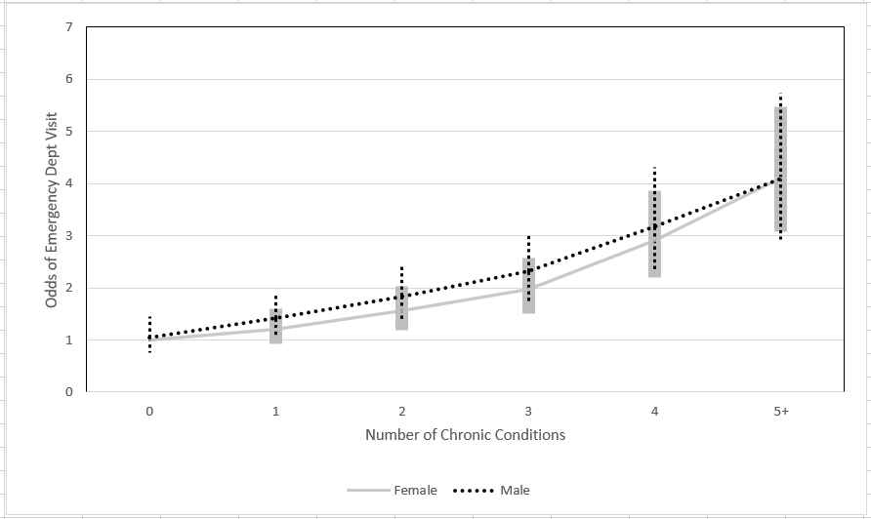
Figure 5a: Odds of Emergency Department Visits by Sex and Number of Chronic Conditions
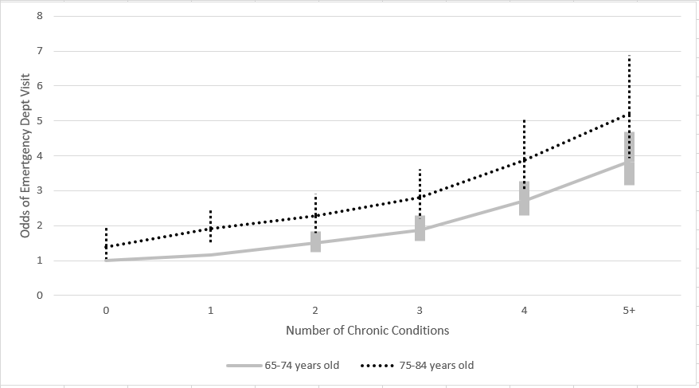
Figure 5b: Odds of Emergency Department Visits by Age and Number of Chronic Conditions

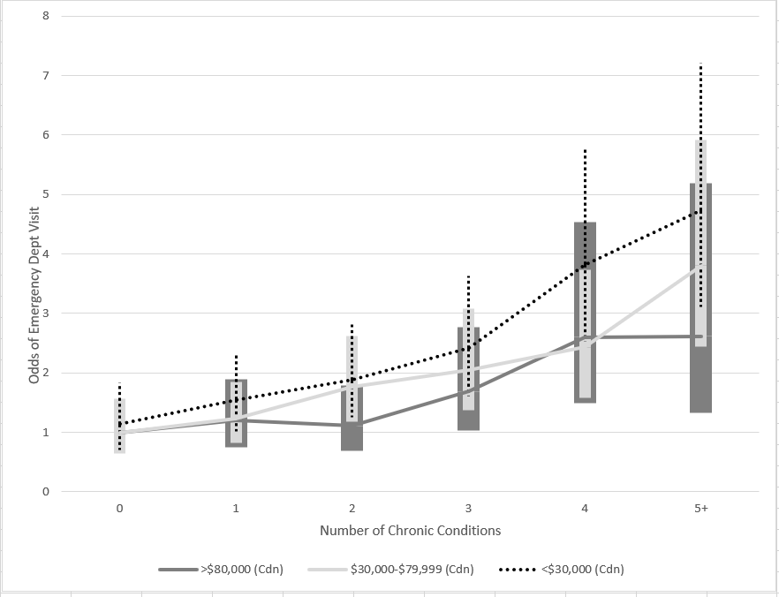
Figure 5c: Odds of Emergency Department Visits by Household Income and Number of Chronic Conditions
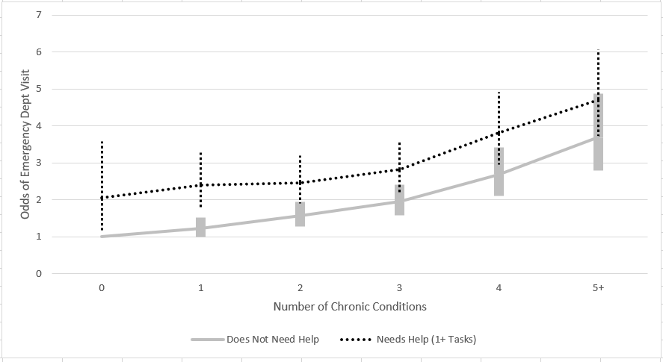
Figure 5d: Odds of Emergency Department Visits by Needs Help and Number of Chronic Conditions
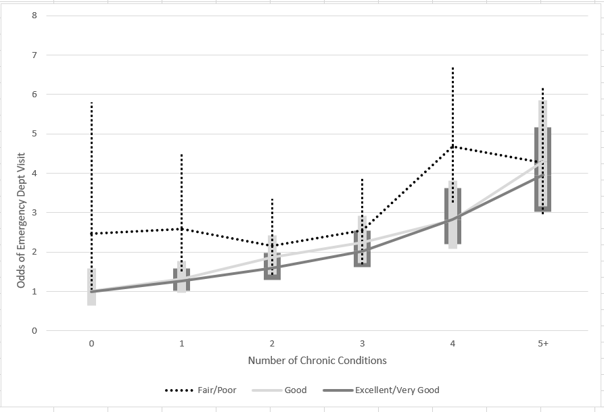
Figure 5e: Odds of Emergency Department Visits Self-Perceived Mental Health by Number of Chronic Conditions

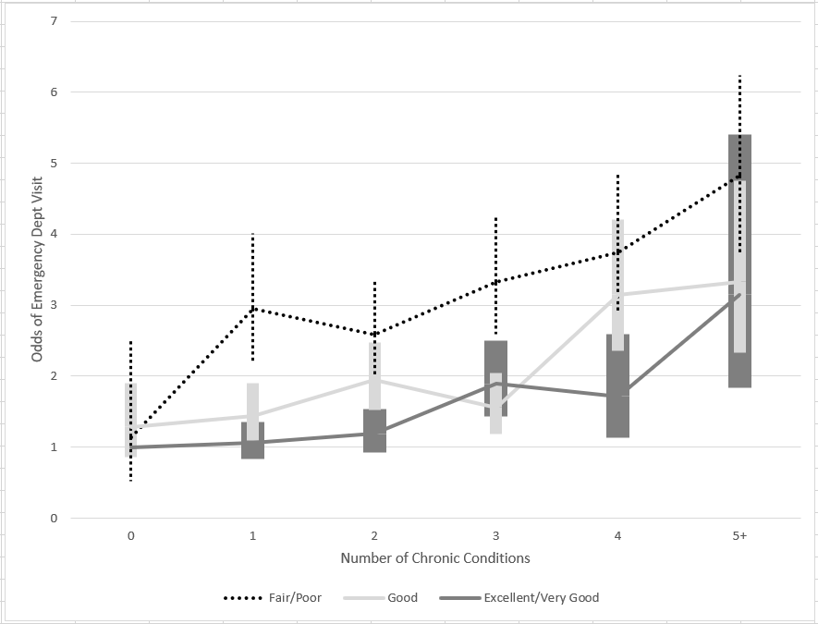
Figure 5f: Odds of Emergency Department Visits by Self-Perceived Physical Health and Number of Chronic Conditions
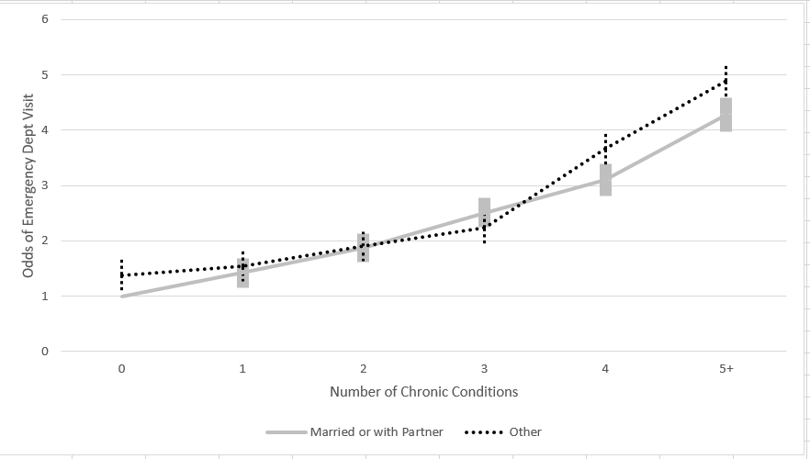
Figure 5g: Odds of Emergency Department Visits by Marital Status and Number of Chronic Conditions
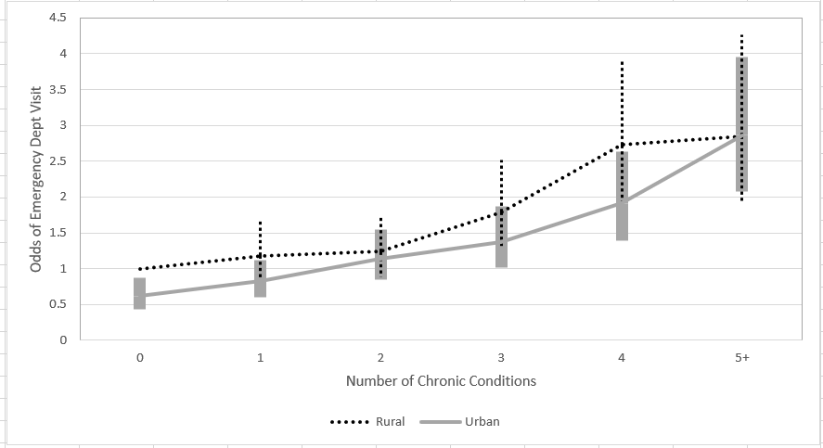
Figure 5h: Odds of Emergency Department Visits by Rural Residency and Number of Chronic Conditions

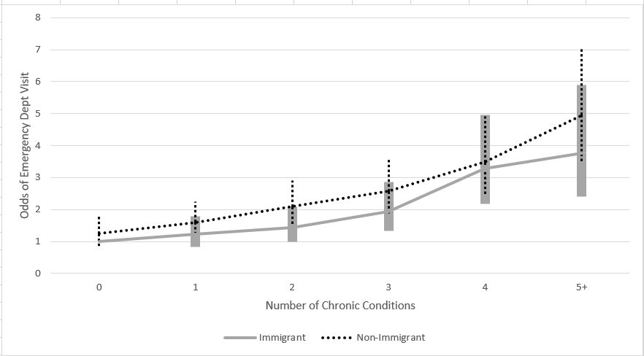
Figure 5i: Odds of Emergency Department Visits by Immigrant Status and Number of Chronic Conditions
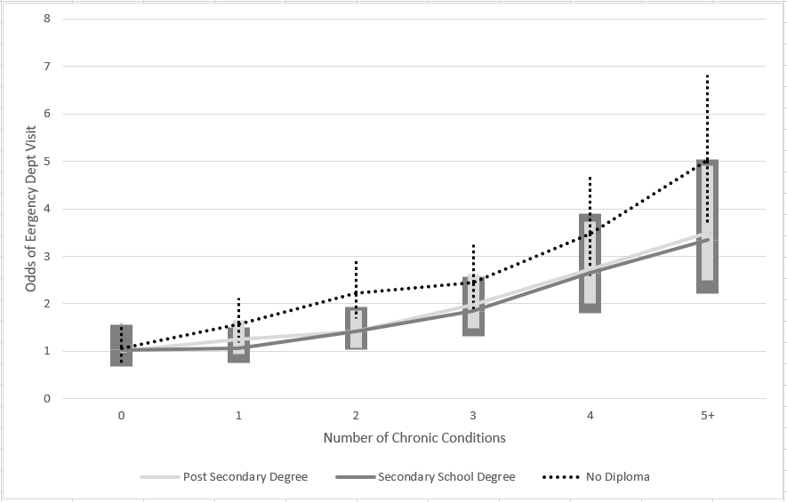
Figure 5j: Odds of Emergency Department Visits by Education Level and Number of Chronic Conditions
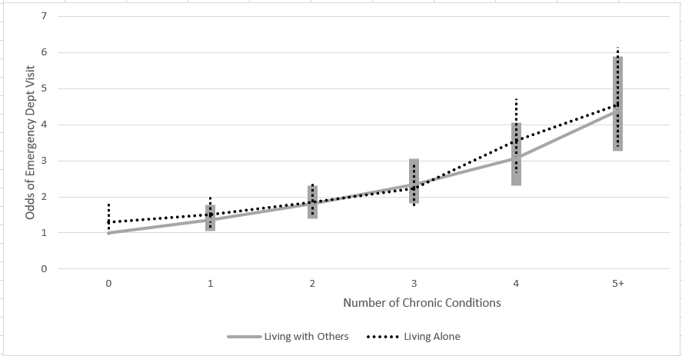
Figure 5k: Odds of Emergency Department Visits by Household Composition and Number of Chronic Conditions

