Additional File 5: Remaining Stratified Figures for Odds of Hospitalization
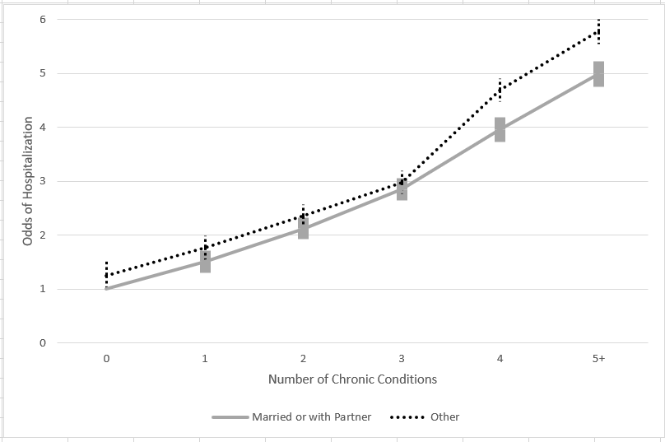
Figure 4a: Odds of Hospitalization by Marital Status and Number of Chronic Conditions
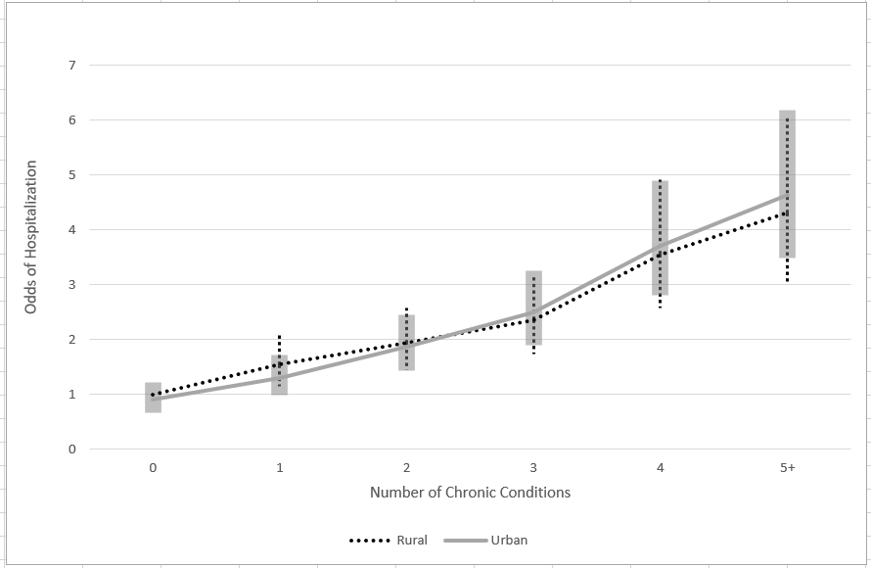
Figure 4b: Odds of Hospitalizations by Rural Residence and Number of Chronic Conditions
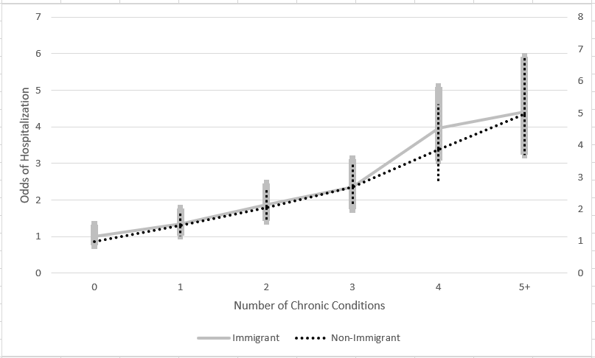
Figure 4c: Odds of Hospitalizations by Immigrant Status and Number of Chronic Conditions
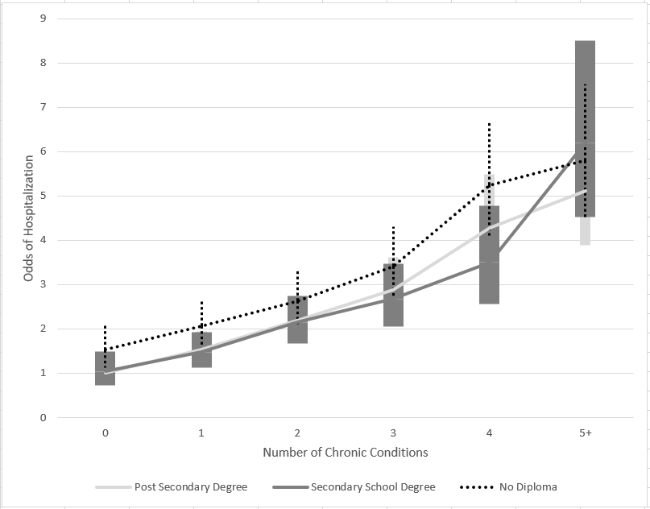
Figure 4d: Odds of Hospitalizations by Education Level and Number of Chronic Conditions
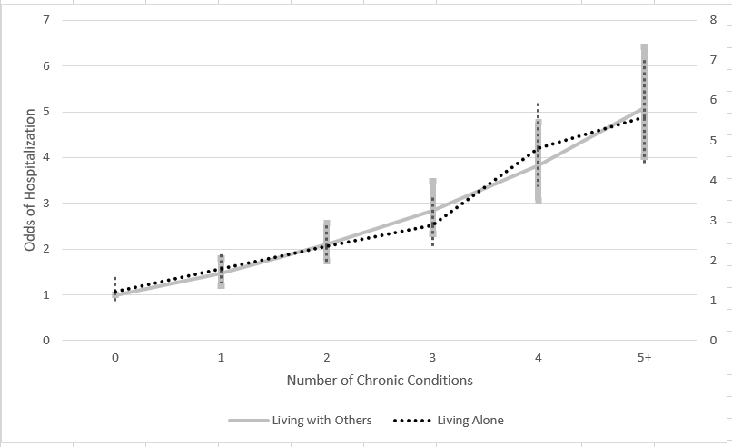
Figure 4e: Odds of Hospitalizations by Household Composition and Number of Chronic Conditions

