Supplemental Material

Akkermansia muciniphila modifies the association between metal exposure during pregnancy and depressive symptoms in late childhood
Vishal Midya¹*, Kiran Nagdeo¹, Jamil M. Lane¹, Libni A. Torres-Olascoaga², Gabriela Gil Martínez², Megan K. Horton¹, Chris Gennings¹, Martha Maria Téllez-Rojo², Robert O. Wright¹, Manish Arora¹, Shoshannah Eggers^{1,3}
1. Department of Environmental Medicine and Public Health, Icahn School of Medicine at Mount Sinai, New York, New York, USA;
2. Center for Research on Nutrition and Health, National Institute of Public Health, Cuernavaca, Mexico;
3. Department of Epidemiology, University of Iowa College of Public Health, Iowa City, Iowa, USA
* Corresponding author

Table of Content

- Supplemental Table 1: Median (Inter Quartile Range) of Concentrations (ug/L) of Prenatal Exposures to Metals in the 2nd and 3rd trimesters
- Supplemental Table 2: Median (Inter Quartile Range) of Concentrations (ug/L) of Prenatal Exposures to Metals in the 2nd and 3rd trimesters by the presence of Akkermansia muciniphila
- Supplemental Table 3: List of top ten metal combinations with stability scores
- Supplemental Table 4: Comparison between Model-based and Randomization-based p-values from Figure 2C
- Supplemental Figure 1: Spearman correlation between the metal concentrations at second and third trimesters
- Supplementary Figure 2: Closed-looped network for forced-directed graph
- Supplementary Figure 3: Covariate-balanced love plot
- Association between log(t-CDI) and metal-microbial cliques (increase each threshold by 10 percentiles)
- Supplementary Figure 4: Association between log(t-CDI) and metal cliques and absence of Akkermansia muciniphila (decrease each threshold by 10 percentiles)
- Supplementary Figure 5: Association between log(t-CDI) and metal cliques and absence of Akkermansia muciniphila (increase each threshold by 10 percentiles)
- Supplementary Figure 6: Association between binarized t-CDI score and metal cliques and absence of Akkermansia muciniphila

Supplementary Table 1: Median (Inter Quartile Range) of Concentrations (ug/L) of Prenatal Exposures to Metals in the 2nd and 3rd trimesters

 | Second Trimester | Third Trimester
Pb | 25.48 (21.33) | 27.72 (24.97)
As | 0.68 (0.25) | 0.70 (0.45)
Cd | 0.23 (0.16) | 0.22 (0.17)
Mn | 13.26 (6.23) | 17.77 (9.15)
Co | 0.18 (0.12) | 0.25 (0.20)
Zn | 5,928.96 (1,220.87) | 6,214.53 (1,139.77)
Cr | 0.45 (0.49) | 0.52 (0.41)
Cs | 2.71 (1.28) | 2.52 (0.99)
Cu | 1,515.92 (237.58) | 1,588.37 (263.31)
Sb | 3.57 (1.25) | 3.61 (1.59)
Se | 241.08 (35.20) | 239.02 (35.93)
Metals included are lead (Pb), arsenic (As), cadmium (Cd), manganese (Mn), cobalt (Co), zinc (Zn), chromium (Cr), cesium (Cs), copper (Cu), antimony (Sb), and selenium (Se).; The sample size is 112

Supplementary Table 2: Median (Inter Quartile Range) of Concentrations (ug/L) of Prenatal Exposures to Metals in the 2nd and 3rd trimesters by the presence of Akkermansia muciniphila

 | Second Trimester |  | Third Trimester
 | A. muciniphila  absent | A. muciniphila  present | A. muciniphila  absent | A. muciniphila  present
Pb | 27.49 (22.97) | 21.39 (13.85) | 30.35 (24.84) | 23.79 (18.86)
As | 0.70 (0.24) | 0.64 (0.37) | 0.70 (0.44) | 0.70 (0.60)
Cd | 0.23 (0.16) | 0.25 (0.14) | 0.21 (0.16) | 0.23 (0.17)
Mn | 13.42 (6.23) | 12.69 (5.31) | 17.60 (7.74) | 19.38 (10.09)
Co | 0.19 (0.11) | 0.14 (0.12) | 0.25 (0.18) | 0.24 (0.20)
Zn | 5,931.43 (1,285.40) | 5,909.98 (923.37) | 6,238.85 (1,195.80) | 6,190.04 (566.07)
Cr | 0.43 (0.51) | 0.48 (0.41) | 0.54 (0.39) | 0.49 (0.50)
Cs | 2.75 (1.26) | 2.38 (1.09) | 2.53 (1.15) | 2.51 (0.71)
Cu | 1,517.88 (234.43) | 1,513.96 (220.26) | 1,584.31 (253.11) | 1,603.42 (325.42)
Sb | 3.60 (1.19) | 3.06 (1.23) | 3.49 (1.59) | 3.86 (1.82)
Se | 242.33 (30.54) | 235.82 (42.55) | 239.51 (35.11) | 237.06 (37.81)
Metals included are lead (Pb), arsenic (As), cadmium (Cd), manganese (Mn), cobalt (Co), zinc (Zn), chromium (Cr), cesium (Cs), copper (Cu), antimony (Sb), and selenium (Se). The sample size is 112

Supplementary Table 3: list of top ten metal combinations with stability scores
Combinations | Stability, n (%)
Co at 3rd trimester – Zn at 2nd trimester | 1271 (16.0)
Cr at 2nd trimester – Zn at 2nd trimester | 842 (10.6)
Co at 3rd trimester – Cr at 2nd trimester | 666 (8.4)
Cr at 3rd trimester – Zn at 2nd trimester | 436 (5.5)
Mn at 3rd trimester – Zn at 2nd trimester | 336 (4.2)
As at 3rd trimester – Zn at 2nd trimester | 319 (4.0)
As at 3rd trimester – Co at 3rd trimester | 289 (3.6)
Co at 3rd trimester – Cr at 3rd trimester | 273 (3.4)
Se at 3rd trimester – Zn at 2nd trimester | 224 (2.8)
Co at 3rd trimester – Mn at 3rd trimester | 209 (2.6)
These listed combinations can be converted to cliques by estimating their thresholds. In total, rh-SiRF generated 123 unique combinations. The top three combinations were chosen for further analysis, since their stability is more than 5% and they form a closed-looped network.

Supplementary Table 4: Comparison between Model-based and Randomization-based p-values from Figure 2C
Associations | Model-based p-value | Randomization-based p-value
Metal-clique | 0.00697 | < 1e-05
No A. muciniphila | 0.00304 | < 1e-05
Children with Metal-clique but No A. muciniphila | 0.000326 | < 1e-05
Children with Metal clique & A. muciniphila | 0.367 | 0.3709

Supplementary Figure 1: Spearman correlation between the metal concentrations at second and third trimesters for study participants (n = 112)
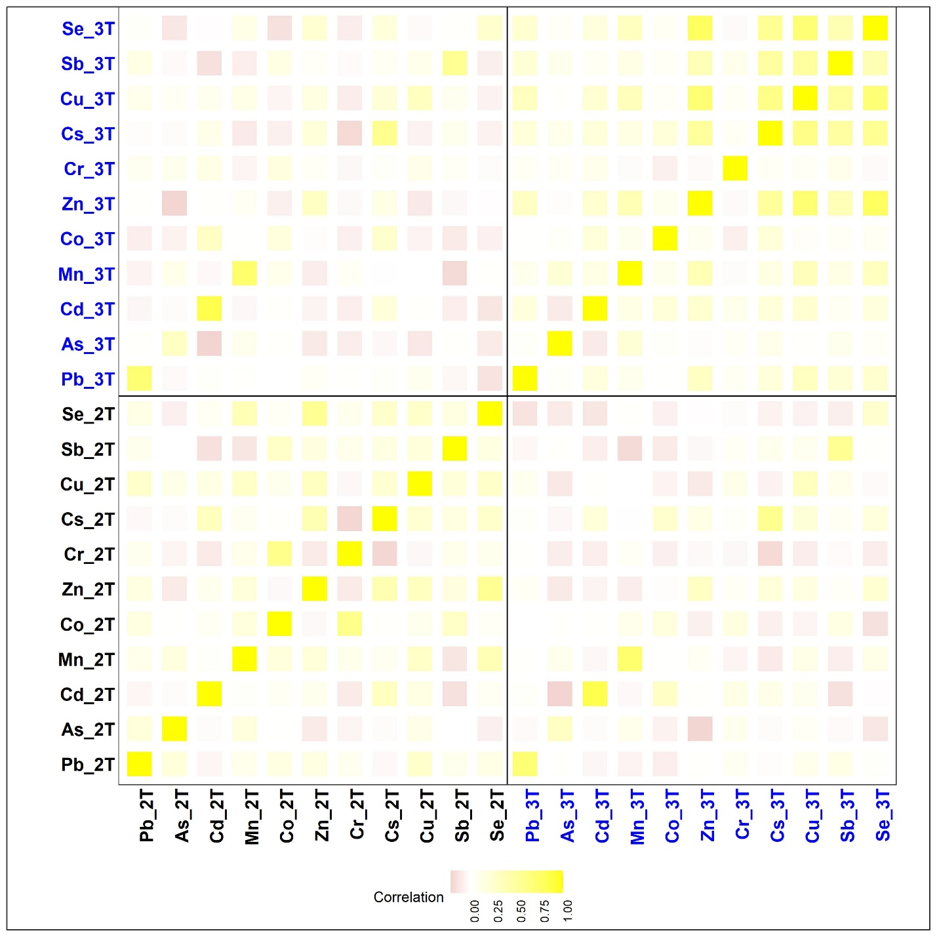Metals included are lead (Pb), arsenic (As), cadmium (Cd), manganese (Mn), cobalt (Co), zinc (Zn), chromium (Cr), cesium (Cs), copper (Cu), antimony (Sb), and selenium (Se). 2T: second trimester, and 3T: third trimester.

Supplementary Figure 2: Closed-looped network for forced-directed graph
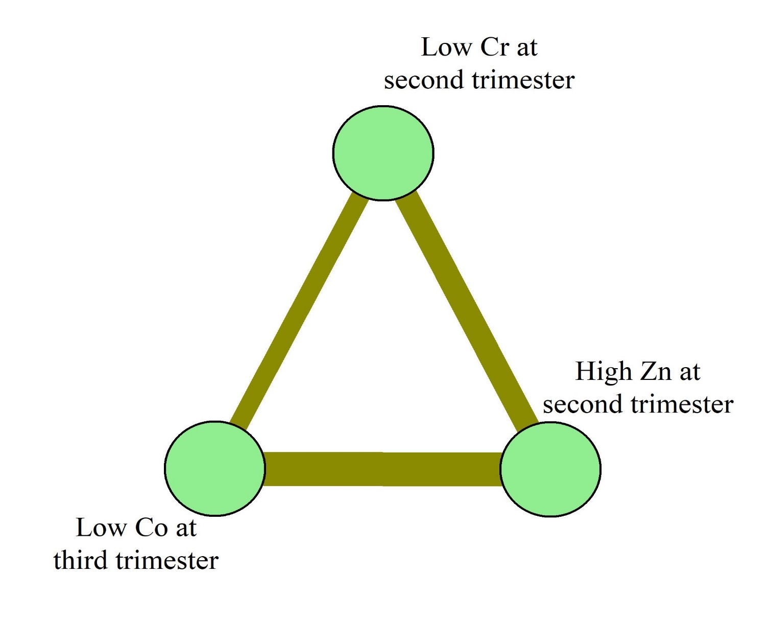

Supplementary Figure 3: Covariate-balanced love plot
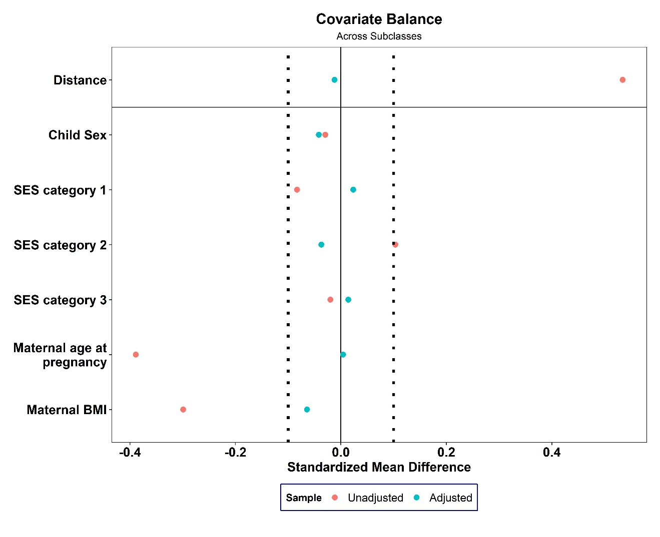Covariate-balancing was achieved using subclass matching procedure with the propensity score

Supplementary Figure 4: Association between log(t-CDI) and metal cliques and absence of Akkermansia muciniphila (decrease each threshold by 10 percentiles)

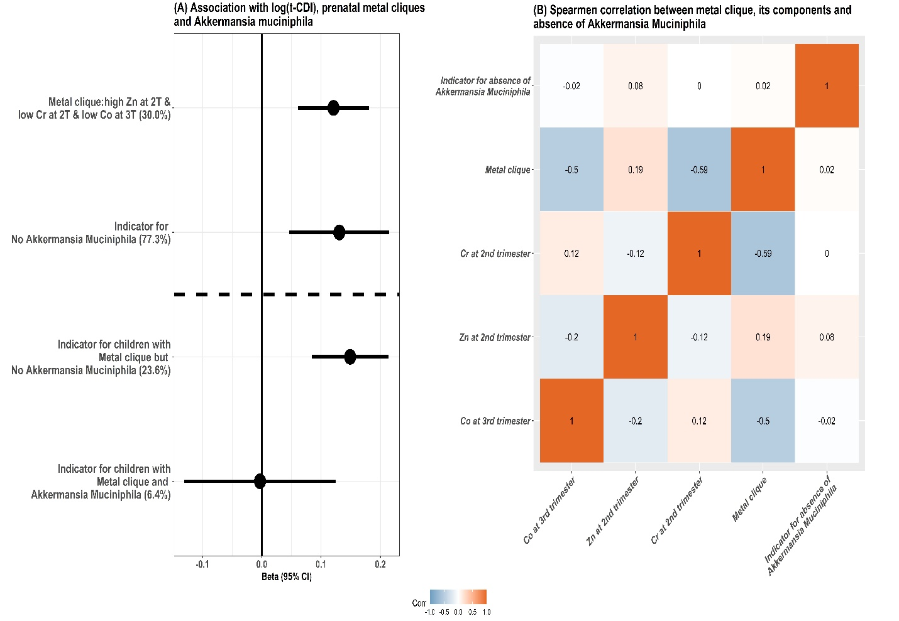Figure shows the beta coefficients and 95% CIs for the association with prenatal metal-clique (while decreasing each threshold by 10 percentile) and log-tCDI scores and the effect modification by the absence of A. muciniphila; the proportions of the sample characterized by the clique are shown in brackets on the y-axis.

Supplementary Figure 5: Association between log(t-CDI) and metal cliques and absence of Akkermansia muciniphila (increase each threshold by 10 percentiles)

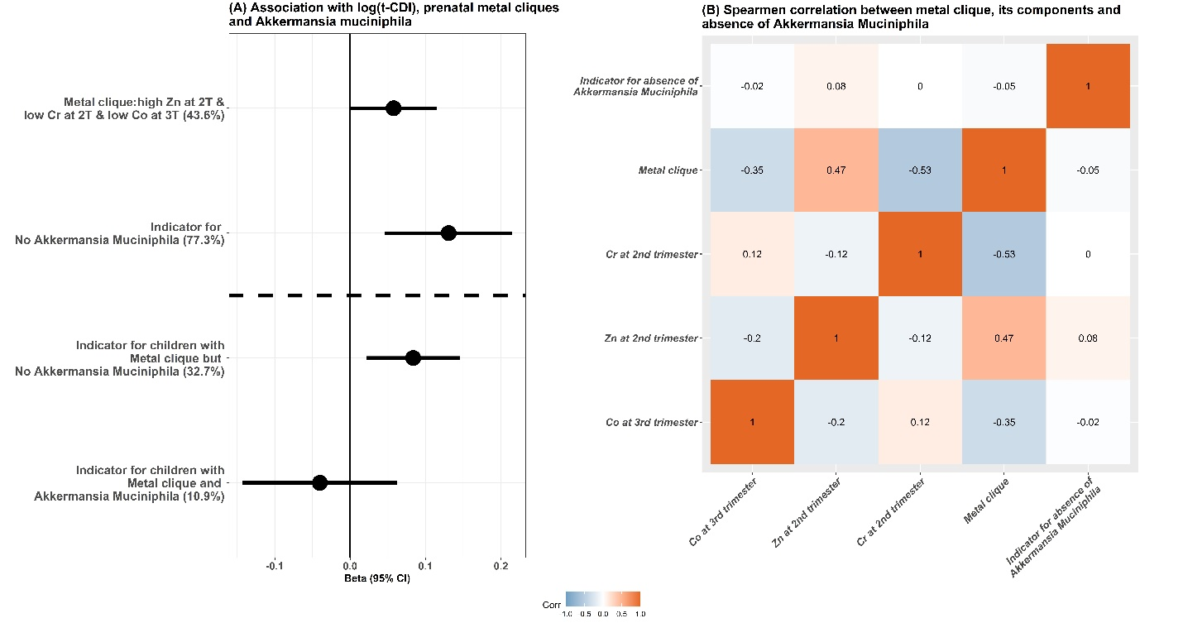Figure shows the beta coefficients and 95% CIs for the association with prenatal metal-clique (while increasing each threshold by 10 percentile) and log-tCDI scores and the effect modification by the absence of A. muciniphila; the proportions of the sample characterized by the clique are shown in brackets on the y-axis.

Supplementary Figure 6: Association between binarized t-CDI score and metal cliques and absence of Akkermansia muciniphila

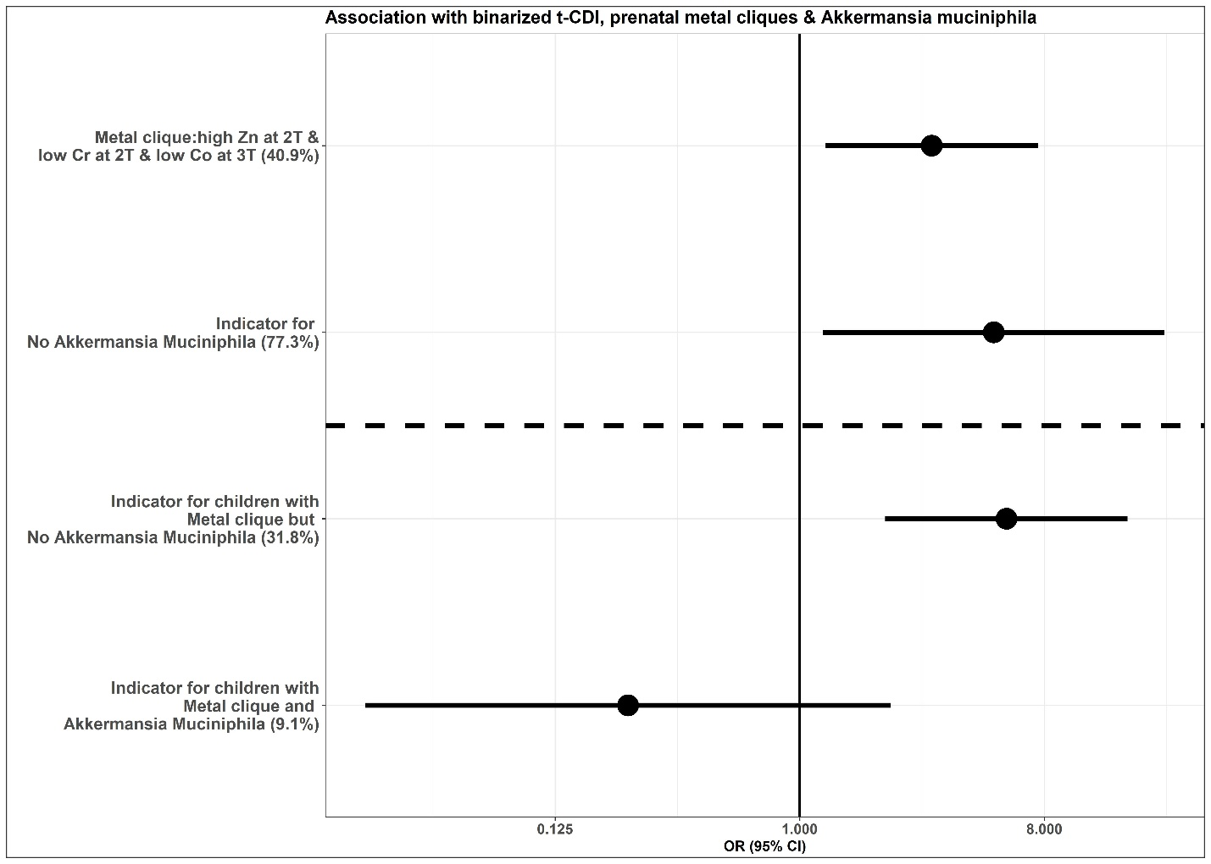Figure shows the association with prenatal metal-clique and binarized t-CDI scores (>= 75th percentile) and the effect modification by the absence of A. muciniphila in childhood gut microbiome.

