Supplementary information
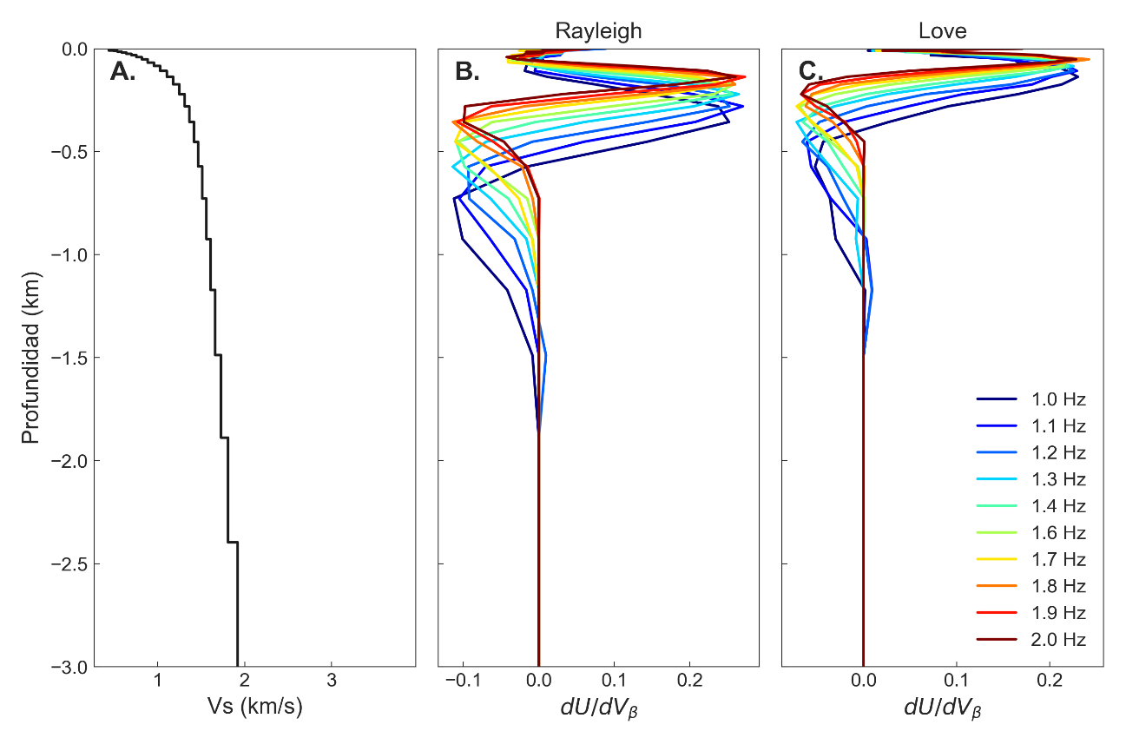
Figure S1. A.) S-wave velocity model calculated for the region below Volcán de Colima crater (De Plaen et al., 2022). Sensitivity kernels for the band frequency between 1 and 2 Hz for Rayleigh (B.) and Love (C.) waves.
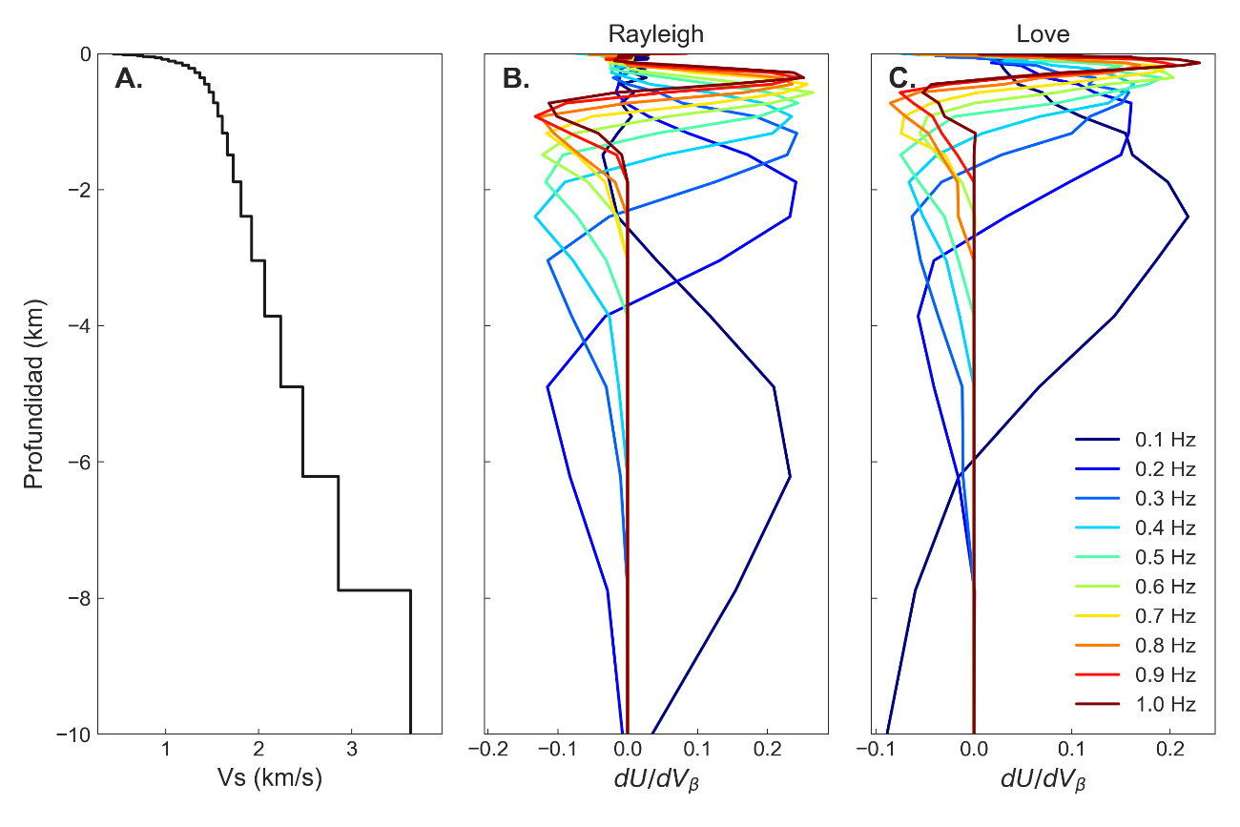
Figure S2. A.) S-wave velocity model calculated for the region below Volcán de Colima crater (De Plaen et al., 2022). Sensitivity kernels for the band frequency between 0.1 and 1 Hz for Rayleigh (B.) and Love (C.) waves.

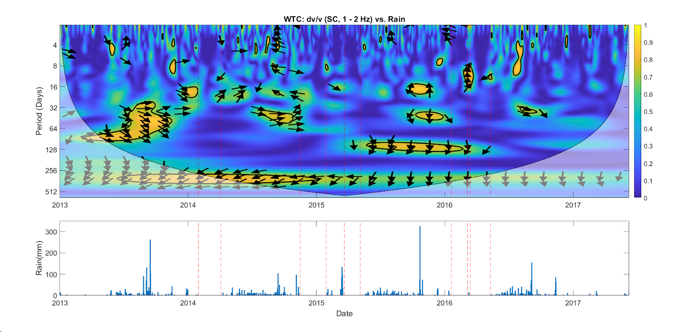
Figure S3. Wavelet transform coherence calculated between the dv/v 1 - 2 Hz and the rainfall record shown below. Red lines highlight the periods where there is no rain for periods longer than a month and where the WTC coherence falls to zero for periods equal or smaller than the duration of the lack of rain.

