Supplementary Information for

Isotopologues of Potassium 2,2,2-Trifluoroethoxide for Applications in Positron Emission Tomography and Beyond
Qunchao Zhao, Sanjay Telu*, Susovan Jana, Cheryl L. Morse, Victor W. Pike*
Molecular Imaging Branch, National Institute of Mental Health, National Institutes of Health, Building 10, Rm B3C346, 10 Center Drive, Bethesda, MD 20892, USA.
*Corresponding authors: sanjay.telu@nih.gov; pikev@mail.nih.gov

Contents

General Information S2
Non-radioactive Experiments S3
1. Optimization of 2,2,2-trifluoroethanol synthesis S3
2. The synthesis of precursors and standards S4
Radiochemistry Procedures S48
3. General HPLC methods S48
4. Synthesis of [¹¹C]fluoroform and [¹⁸F]fluoroform S49
5. General procedure to produce [¹¹C/¹⁸F]2,2,2-trifluoroethanol S52
6. General procedure for radio-1,1,1-trifluoroethoxylation S55
7. HPLC analysis of ¹¹C- and ¹⁸F- labeled products S59
8. Abbreviations S151
9. References S152

10. NMR spectra of precursors and standards……………………………………………………S153

General Information
Fluoroform was purchased from Sigma-Aldrich. Other commercially available chemicals, reagents, and solvents were purchased primarily from Sigma-Aldrich, Alfa Aesar, TCI, AmBeed, and Chemscene, and used as received. ¹H (400.13 MHz), ¹³C (100.62 MHz), and ¹⁹F (376.47 MHz) NMR spectra were recorded on an Avance 400 instrument (Bruker) at RT in deuterated solvents. All spectra are reported with chemical shifts in parts per million. NMR data are reported as follows: chemical shift (δ (ppm), multiplicity (s = singlet, d = doublet, t = triplet, q = quartet, quint = quintet, sept = septet, dd = doublet of doublets, dt = doublet of triplets, dq = doublet of quartets, qd = quartet of doublets, td = triplet of doublets, tt = triplet of triplets, ddd = doublet of doublet of doublets, dtd = doublet of triplet of doublets, tdd = triplet of doublet of doublets, m = multiplet, app = apparent), coupling constants (J in Hz), and integration. TMS (δ = 0 ppm) was used as an internal standard for ¹H and ¹³C-NMR spectroscopy and 1,1,1-trifluorobenzene (δ = ‒62 ppm) as internal standard for ¹⁹F-NMR spectroscopy. NMR data were processed using MestReNova. HRMS data (ESI-TOF) were obtained at the Bioorganic Chemistry Laboratory of NIDDK (NIH). Melting points were measured with a digital SMP20 (Stuart) melting point apparatus. Radiochemistry was performed in a lead-shielded hot-cell for protection of personnel from radiation. HPLC analyses were performed on Shimadzu HPLC systems, which were also coupled with UV absorbance and radioactivity detectors. The HPLC chromatograms were processed using GraphPad Prism 8. Flash chromatography was performed on silica gel; eluent compositions are reported as v/v.

Non-radioactive Experiments

1. Optimization of 2,2,2-trifluoroethanol synthesis.
1.1. Optimization.
Paraformaldehyde (y mmol) and t-BuOK (z mmol), followed by DMF (3.0 mL) were added. to a round-bottomed flask equipped with a magnetic stirrer bar under argon. Then fluoroform (x mmol in DMF; 0.3 M) was added. The flask was capped loosely, and the contents stirred at RT for t h. The reaction was then quenched with water (0.5 mL). The yield of 2,2,2-trifluoroethoxide (δ ‒76.3 ppm) from fluoroform (δ ‒78.9 ppm) was determined by ¹⁹F NMR spectroscopy on the crude reaction mixture.
Table S1. Optimization of the yield of 2,2,2-trifluoroethanol from the reaction of fluoroform with paraformaldehyde.
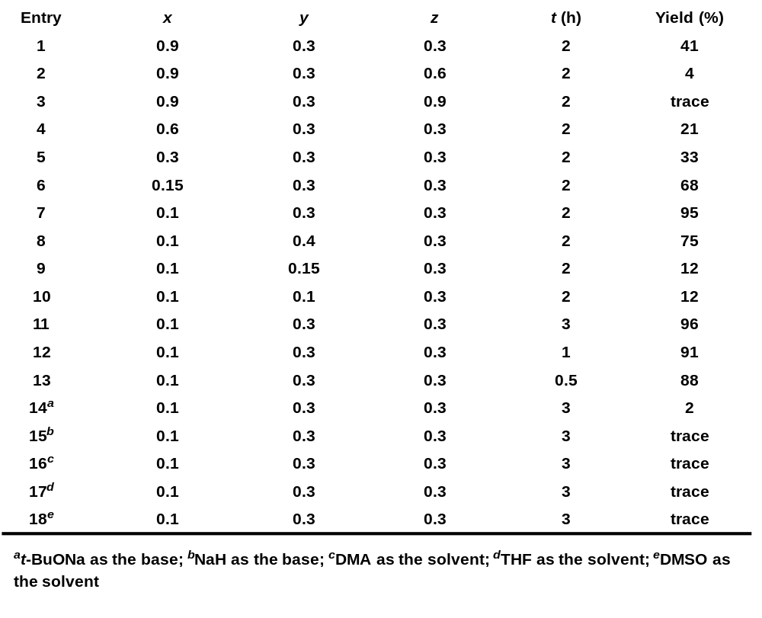
1.2. One-pot 2,2,2-trifluoroethoxylation of 2-chloropyrimidine (1).
To a round-bottomed flask equipped with a magnetic stirrer bar was added paraformaldehyde (0.5 mmol) and t-BuOK (0.5 mmol), followed by DMF (3 mL) under argon. A DMF solution (0.6 mL) of fluoroform (0.17 mmol; 0.3 M) was added and the solution was stirred at RT for 3 h. 2-Chloropyrimidine (0.5 mmol) in DMF (0.5 M) was then added and the reaction mixture was stirred either at RT or at 60 ºC for another 2 h. The reaction was then quenched with water (0.5 mL). The yield of 2-(2,2,2-trifluoroethoxy)pyrimidine (1) (δ ‒73.8 ppm) was determined by ¹⁹F NMR spectroscopy on the crude reaction mixture.
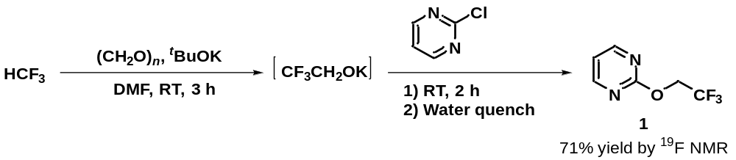
Figure S1. One-pot 2,2,2-trifluoroethoxylation of 2-chloropyrimidine to give 1.
1.3. One-pot 2,2,2-trifluoroethoxylation of naphthalen-1-yl iodonium-(2,2-dimethyl-1,3-dioxane-4,6-dione)ylide (2).
The procedure used for the 2,2,2-trifluoroethoxylation of 2-chloropyrimidine was used instead with naphthalen-1-yl iodonium-(2,2-dimethyl-1,3-dioxane-4,6-dione)ylide (0.5 mmol). The yield of 1-(2,2,2-trifluoroethoxy)naphthalene (2) (δ ‒73.5 ppm) was determined by ¹⁹F-NMR spectroscopy.
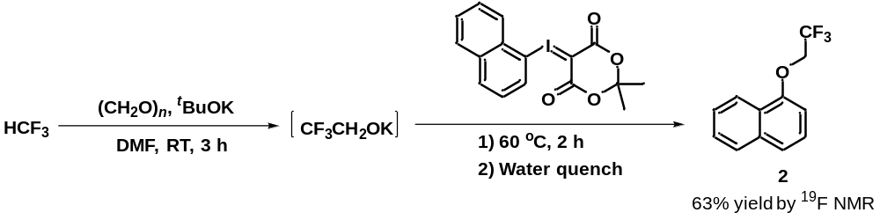
Figure S2. One-pot 2,2,2-trifluoroethoxylation of naphthalen-1-yl iodonium-(2,2-dimethyl-1,3-dioxane-4,6-dione)ylide to give 2.

2. The synthesis of precursors and standards.
2.1. General procedure 1 for the synthesis of heterocycle precursors and standards.
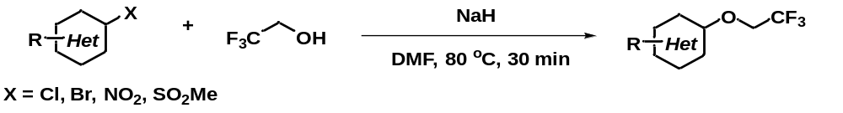
Figure S3. General procedure 1 for the synthesis of 2,2,2-trifluoroethyl heterocyclic ethers.
To a round-bottomed flask equipped with a magnetic stirrer bar was added dry NaH (1 equiv.) and DMF (0.5 M) under argon. 2,2,2-Trifluoroethanol (2 equiv.) was then added dropwise, and the reaction mixture was stirred at RT for 5 min under argon. Precursor (1 equiv.) was then added and stirred vigorously at 80 ºC for 30 min. After completion of the reaction, as assessed with TLC, the reaction mixture was cooled to RT, poured onto water, and extracted with DCM (2 × 25 mL). The organic phase was dried (Mg₂SO₄) and concentrated in vacuo. The residue was purified by silica gel flash chromatography using hexane-ethyl acetate to afford the corresponding 2,2,2-trifluoroethyl heterocyclic ether.
2-(2,2,2-Trifluoroethoxy)pyrimidine (1).
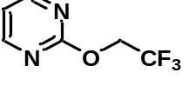 General procedure 1 with 2-chloropyrimidine on a 2.0 mmol scale followed by flash chromatography (ethyl acetate/n-hexane,1: 4) gave 1 as a colorless oil (274 mg, 77% yield). ¹H NMR (400 MHz, CDCl₃) δ (ppm): 8.54 (d, J = 4.8 Hz, 2H), 7.04 (t, J = 4.8 Hz, 1H), 4.79 (q, J = 8.4 Hz, 2H); ¹⁹F NMR (376 MHz, CDCl₃) δ (ppm): –73.85 (t, J = 8.2 Hz, 3F); ¹³C NMR (101 MHz, CDCl₃) δ (ppm): 163.85, 159.70, 123.39 (q, J = 277.6 Hz), 116.52, 63.57 (q, J = 36.5 Hz). MS (ESI): 179.1 [M+H]⁺. HRMS (ESI) for C₆H₆N₂OF₃ [M+H]⁺: calc’d: 179.0432; found: 179.0430.
6-(2,2,2-Trifluoroethoxy)nicotinaldehyde (3).
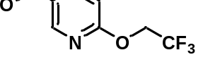General procedure 1 with 6-chloronicotinaldehyde on a 2.0 mmol scale followed by flash chromatography (ethyl acetate/n-hexane, 1: 5) gave 3 as a pale-yellow solid (353 mg, 86% yield). Mp: 52–54 ºC. ¹H NMR (400 MHz, CDCl₃) δ (ppm): 9.99 (s, 1H), 8.63 (d, J = 2.2 Hz, 1H), 8.14 (dd, J = 8.6, 2.2 Hz, 1H), 6.98 (d, J = 8.6 Hz, 1H), 4.85 (q, J = 8.4 Hz, 2H); ¹⁹F NMR (376 MHz, CDCl₃) δ (ppm): –73.77 (t, J = 8.3 Hz, 3F); ¹³C NMR (101 MHz, CDCl₃): δ (ppm) 189.36, 165.30, 152.10, 138.70, 128.12, 123.51 (q, J = 277.4 Hz), 112.32, 62.91 (q, J = 36.3 Hz). MS (ESI): 206.0 [M+H]⁺. HRMS (ESI) for C₈H₇NO₂F₃ [M+H]⁺: calc’d: 206.0429; found: 206.0426.
5-Bromo-2-(2,2,2-trifluoroethoxy)pyridine (4).
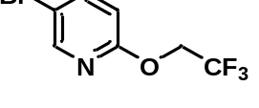 General procedure 1 with 5-bromo-2-nitropyridine on a 2.0 mmol scale followed by flash chromatography (ethyl acetate/n-hexane, 1: 10) gave 4 as a colorless oil (342 mg, 67% yield). ¹H NMR (400 MHz, CDCl₃) δ (ppm): 8.19 (d, J = 2.4 Hz, 1H), 7.72 (dd, J = 8.7, 2.5 Hz, 1H), 6.78 (d, J = 8.7 Hz, 1H), 4.72 (q, J = 8.5 Hz, 2H); ¹⁹F NMR (376 MHz, CDCl₃) δ (ppm): –73.84 (t, J = 8.6 Hz, 3F); ¹³C NMR (101 MHz, CDCl₃) δ (ppm): 160.78, 147.49, 142.06, 123.73 (q, J = 277.5 Hz), 113.56, 112.93, 62.57 (q, J = 36.1 Hz). (Known compound).¹
4,6-Dimethyl-2-(2,2,2-trifluoroethoxy)nicotinonitrile (5).
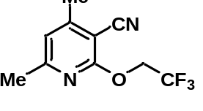 General procedure 1 with 2-chloro-3-cyano-4,6-dimethylpyridine on a 1.0 mmol scale followed by flash chromatography (ethyl acetate/n-hexane, 1: 10) gave 5 as a white solid (201 mg, 87% yield). Mp: 54–56 ºC. ¹H NMR (400 MHz, CDCl₃) δ (ppm): 6.80 (s, 1H), 4.85 (q, J = 8.4 Hz, 2H), 2.47 (s, 3H), 2.45 (s, 3H); ¹⁹F NMR (376 MHz, CDCl₃) δ (ppm) –73.71 (t, J = 8.2 Hz, 3F); ¹³C NMR (101 MHz, CDCl₃) δ (ppm): 161.84, 160.71, 155.41, 123.39 (q, J = 277.6 Hz), 119.32, 114.09, 94.53, 62.64 (q, J = 36.6 Hz), 24.52, 20.26. MS (ESI): 231.1 [M+H]⁺. HRMS (ESI) for C₁₀H₁₀N₂OF₃ [M+H]⁺: calc’d: 231.0745; found: 231.0742.
3-Benzyl-6–bromo-2-(2,2,2-trifluoroethoxy)quinoline (6).
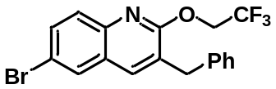General procedure 1 with 3-benzyl-6-bromo-2-chloroquinoline on a 1.0 mmol scale followed by flash chromatography (ethyl acetate-n-hexane, 1: 20) gave 6 as a white solid (313 mg, 79% yield). Mp: 90–92 ºC .¹H NMR (400 MHz, CDCl₃) δ (ppm): 7.77 (d, J = 1.7 Hz, 1H), 7.70–7.56 (m, 3H), 7.37–7.28 (m, 2H), 7.26–7.21 (m, 3H), 4.88 (q, J = 8.5 Hz, 2H), 4.04 (s, 2H); ¹⁹F NMR (376 MHz, CDCl₃) δ (ppm): –73.46 (t, J = 8.7 Hz, 3F); ¹³C NMR (101 MHz, CDCl₃) δ (ppm): 158.78, 143.58, 138.53, 136.91, 132.58, 129.45, 129.37, 128.83, 127.42, 126.91, 126.82, 123.95 (q, J = 277.3 Hz), 118.27, 62.71 (q, J = 36.1 Hz), 36.21. MS (ESI): 396.0 [M+H]⁺. HRMS (ESI) for C₁₈H₁₄NOF₃Br [M+H]⁺: calc’d: 396.0211; found: 396.0208.
6-Methoxy-1-(2,2,2-trifluoroethoxy)isoquinoline (7).
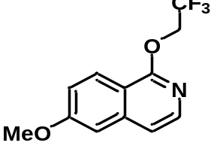 General procedure 1 with 1-chloro-6-methoxyisoquinoline on a 2.0 mmol scale followed by flash chromatography (ethyl acetate/n-hexane, 1: 4) gave 7 as a white solid (473 mg, 92% yield). Mp: 80–82 ºC. ¹H NMR (400 MHz, CDCl₃) δ (ppm): 8.16 (d, J = 9.1 Hz, 1H), 7.90 (d, J = 5.9 Hz, 1H), 7.19 (dd, J = 12.8, 4.0 Hz, 2H), 7.03 (d, J = 2.2 Hz, 1H), 4.92 (q, J = 8.6 Hz, 2H), 3.93 (s, 3H); ¹⁹F NMR (376 MHz, CDCl₃) δ (ppm): –73.67 (t, J = 8.3 Hz, 3F); ¹³C NMR (101 MHz, CDCl₃) δ (ppm): 161.68, 158.62, 140.48, 139.96, 125.92, 124.09 (q, J = 277.3 Hz), 119.44, 116.22, 114.23, 104.86, 62.56 (q, J = 36.0 Hz), 55.63. MS (ESI): 258.1 [M+H]⁺. HRMS (ESI) for C₁₂H₁₁NO₂F₃ [M+H]⁺: calc’d: 258.0742; found: 258.0740.
3-(2,2,2-Trifluoroethoxy)-1,2-benzisothiazole (8).
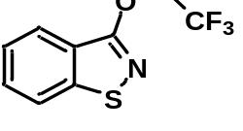General procedure 1 with 3-chloro-1,2-benzisothiazole on a 1.0 mmol scale followed by flash chromatography (ethyl acetate/n-hexane, 1: 10) gave 8 as a colorless oil (178 mg, 76% yield). ¹H NMR (400 MHz, CDCl₃) δ (ppm): 7.97 (d, J = 8.1 Hz, 1H), 7.79 (d, J = 8.2 Hz, 1H), 7.56 (t, J = 7.6 Hz, 1H), 7.43 (t, J = 7.5 Hz, 1H), 4.95 (q, J = 8.3 Hz, 2H); ¹⁹F NMR (376 MHz, CDCl₃) δ (ppm): –73.91 (t, J = 8.3 Hz, 3F); ¹³C NMR (101 MHz, CDCl₃) δ (ppm): 160.95, 152.42, 129.29, 125.04, 124.54, 123.41 (q, J = 277.3 Hz), 123.24, 120.43, 65.00 (q, J = 36.5 Hz). MS (ESI): 234.0 [M+H]⁺. HRMS (ESI) for C₉H₇NOF₃S [M+H]⁺: calc’d: 234.0200; found: 234.0197.
tert-Butyl 2-(2,2,2-trifluoroethoxy)-7,8-dihydropyrido[4,3-d]pyrimidine-6(5H)-carboxylate (9).
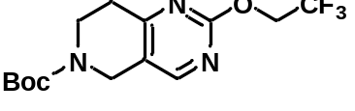General procedure 1 with tert-butyl 2-(methylsulfonyl)-7,8-dihydropyrido[4,3-d]pyrimidine-6(5H)-carboxylate on a 1.0 mmol scale followed by flash chromatography (ethyl acetate/n-hexane, 1: 4) gave 9 as a white solid (301 mg, 90% yield). Mp: 65–67 ºC. ¹H NMR (400 MHz, CDCl₃) δ (ppm): 8.24 (s, 1H), 4.75 (q, J = 8.4 Hz, 1H), 4.51 (s, 1H), 3.70 (t, J = 6.0 Hz, 1H), 2.86 (t, J = 5.9 Hz, 1H), 1.45 (s, 1H); ¹⁹F NMR (376 MHz, CDCl₃) δ (ppm): –73.86 (t, J = 8.3 Hz); ¹³C NMR (101 MHz, CDCl₃) δ (ppm): 166.73, 162.33, 156.93, 154.65, 123.37 (q, J = 277.8 Hz), 122.14, 80.76, 63.49 (q, J = 36.3 Hz), 42.22, 40.85, 31.81, 28.48. MS (ESI): 334.2 [M+H]⁺. HRMS (ESI) for C₁₄H₁₉N₃O₃F₃ [M+H]⁺: calc’d: 334.1379; found: 334.1376.
4-Phenyl-2-(2,2,2-trifluoroethoxy)quinazoline (10).
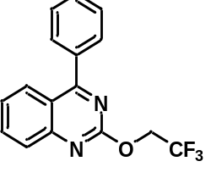General procedure 1 with methyl 2-chloro-3-quinolinecarboxylate on a 1.0 mmol scale followed by flash chromatography (ethyl acetate/n-hexane, 1: 10) gave 10 as a white solid (273 mg, 90% yield). Mp: 86–88 ºC. ¹H NMR (400 MHz, CDCl₃) δ (ppm): 8.07 (d, J = 8.4 Hz, 1H), 7.90 (d, J = 8.4 Hz, 1H), 7.84 (t, J = 7.6 Hz, 1H), 7.80–7.75 (m, 2H), 7.62–7.51 (m, 3H), 7.45 (t, J = 7.6 Hz, 1H), 5.00 (q, J = 8.5 Hz, 2H); ¹⁹F NMR (376 MHz, CDCl₃) δ (ppm): –73.49 (t, J = 8.5 Hz, 3F); ¹³C NMR (101 MHz, CDCl₃) δ (ppm): 172.76, 160.39, 152.87, 136.65, 134.67, 130.57, 130.19, 128.75, 127.79, 127.50, 125.84, 123.63 (q, J = 277.7 Hz), 120.72, 63.69 (q, J = 36.2 Hz). MS (ESI): 305.1 [M+H]⁺. HRMS (ESI) for C₁₆H₁₂N₂OF₃ [M+H]⁺: calc’d: 305.0902; found: 305.0903.
4-(2,2,2-Trifluoroethoxy)furo[2,3-d]pyrimidine (11).
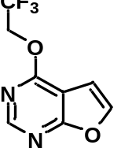General procedure 1 with 4-chlorofuro[2,3-d]pyrimidine on a 1.0 mmol scale followed by flash chromatography (ethyl acetate/petroleum ether, 1: 4) gave 11 as a colorless oil (193 mg, 89% yield). ¹H NMR (400 MHz, CDCl₃) δ (ppm): 8.56 (s, 1H), 7.65 (d, J = 2.5 Hz, 1H), 6.88 (d, J = 2.5 Hz, 1H), 4.97 (q, J = 8.4 Hz, 2H); ¹⁹F NMR (376 MHz, CDCl₃) δ (ppm): –73.69 (t, J = 8.2 Hz, 3F); ¹³C NMR (101 MHz, CDCl₃) δ (ppm): 168.74, 162.29, 152.81, 143.81, 123.38 (q, J = 277.4 Hz), 104.80, 103.36, 62.86 (q, J = 36.7 Hz). MS (ESI): 219.0 [M+H]⁺. HRMS (ESI) for C₈H₆N₂O₂F₃ [M+H]⁺: calc’d: 219.0381; found: 219.0380.
3-Phenyl-6-(2,2,2-trifluoroethoxy)pyridazine (12)
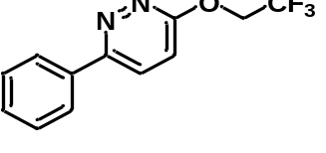General procedure 1 with 3-chloro-6-phenylpyridazine on a 1.0 mmol scale followed by flash chromatography (ethyl acetate/n-hexane, 1: 10) gave 12 as a white solid (132 mg, 52% yield). Mp: 132–134 ºC.¹H NMR (400 MHz, CDCl₃) δ (ppm): 7.99 (dd, J = 7.6, 1.5 Hz, 2H), 7.86 (d, J = 9.2 Hz, 1H), 7.64–7.39 (m, 3H), 7.18 (d, J = 9.2 Hz, 1H), 5.00 (q, J = 8.4 Hz, 2H); ¹⁹F NMR (376 MHz, CDCl₃) δ (ppm): –73.80 (t, J = 8.7 Hz, 3F); ¹³C NMR (101 MHz, CDCl₃) δ (ppm): 162.64, 156.86, 135.88, 130.02, 129.22, 128.09, 126.87, 123.52 (q, J = 277.2 Hz), 117.86, 63.56 (q, J = 36.5 Hz). MS (ESI): 255.1 [M+H]⁺. HRMS (ESI) for C₁₂H₁₀N₂OF₃ [M+H]⁺: calc’d: 255.0745; found: 255.0744.
2,4-Diphenyl-6-(2,2,2-trifluoroethoxy)-1,3,5-triazine (13).
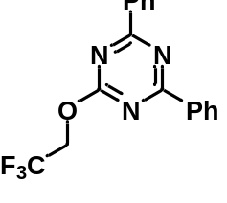General procedure 1 with 2-bromo-4,6-diphenyl-1,3,5-triazine on a 0.5 mmol scale followed by flash chromatography (ethyl acetate/n-hexane, 1: 20) gave 13 as a white solid (123 mg, 74% yield). Mp: 118–120 ºC. ¹H NMR (400 MHz, CDCl₃) δ (ppm): 8.69–8.56 (m, 4H), 7.66–7.58 (m, 2H), 7.58–7.47 (m, 4H), 5.02 (q, J = 8.3 Hz, 2H); ¹⁹F NMR (376 MHz, CDCl₃) δ (ppm): –73.33 (t, J = 8.2 Hz, 3F); ¹³C NMR (101 MHz, CDCl₃) δ (ppm): 174.24, 170.66, 135.23, 133.36, 129.39, 128.89, 123.24 (q, J = 277.8 Hz), 63.60 (q, J = 36.9 Hz). MS (ESI): 332.1 [M+H]⁺. HRMS (ESI) for C₁₇H₁₃N₃OF₃ [M+H]⁺: calc’d: 332.1011; found: 332.1005.
2,7-Bis(2,2,2-trifluoroethoxy)-1,8-naphthyridine (14).
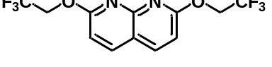General procedure 1 with 2-chloro-7-(2,2,2-trifluoroethoxy)-1,8-naphthyridine on a 0.5 mmol scale followed by flash chromatography (ethyl acetate/petroleum ether, 1: 5) gave 14 as a white solid (110 mg, 67% yield). Mp: 165–167 ºC. ¹H NMR (400 MHz, CDCl₃) δ (ppm): 8.04 (d, J = 8.6 Hz, 2H), 7.01 (d, J = 8.6 Hz, 2H), 4.97 (q, J = 8.5 Hz, 4H); ¹⁹F NMR (376 MHz, CDCl₃) δ (ppm): –73.70 (t, J = 8.7 Hz, 3F); ¹³C NMR (101 MHz, CDCl₃) δ (ppm): 163.30, 153.60, 139.96, 123.77 (q, J = 277.1 Hz), 116.71, 111.46, 63.05 (q, J = 36.1 Hz). MS (ESI): 327.1 [M+H]⁺. HRMS (ESI) for C₁₂H₉N₂O₂F₆ [M+H]⁺: calc’d: 327.0568; found: 327.0564.
4-Chloro-1-isobutyl-1H–imidazo[4,5-c]quinoline.
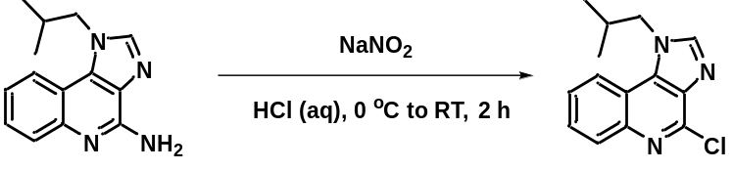
A dried round bottomed flask equipped with a stirrer bar was loaded with Imiquimod (1-isobutyl-1H-imidazo[4,5-c]quinolin-4-amine; 721 mg, 3.0 mmol, 1 equiv.), followed by concentrated hydrochloric acid (11 mL). The flask was cooled to 0 ºC, and then a cold (0 ºC) aqueous solution (10 mL) of NaNO₂ (3.45 g, 50 mmol, 16.7 equiv.) was added in three portions. The mixture was stirred at bath temperature for 30 min and then at RT for 2 h. Water (50 mL) and DCM (50 mL) were then added to the reaction mixture. The organic layer was separated off, washed with brine, dried (Mg₂SO₄), and concentrated in vacuo. The residue was purified by silica gel chromatography (ethyl acetate/DCM, 1: 1) to give the title compound as a white solid (343 mg, 44% yield). Mp: 140–142 ºC. ¹H NMR (400 MHz, CDCl₃) δ (ppm): 8.09 (dd, J = 8.3, 1.2 Hz, 1H), 7.98 (dd, J = 8.1, 1.3 Hz, 1H), 7.86 (s, 1H), 7.59 (dtd, J = 15.0, 7.1, 1.4 Hz, 2H), 4.28 (d, J = 7.4 Hz, 2H), 2.27 (sept, J = 13.8, 6.9 Hz, 1H), 0.99 (d, J = 6.7 Hz, 6H); ¹³C NMR (101 MHz, CDCl₃) δ (ppm): 144.28, 144.10, 135.26, 134.04, 130.12, 128.05, 126.99, 120.18, 117.75, 55.37, 28.91, 19.88. MS (ESI): 260.1 [M+H]⁺. HRMS (ESI) for C₁₄H₁₅N₃Cl [M+H]⁺: calc’d: 260.0955; found: 260.0950.
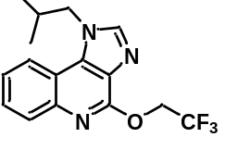1-Isobutyl-4-(2,2,2-trifluoroethoxy)-1H-imidazo[4,5-c]quinoline (15).
General procedure 1 with 4-chloro-1-isobutyl-1H–imidazo[4,5-c]quinoline (prepared as described immediately above) on a 1.0 mmol scale followed by flash chromatography (ethyl acetate/n-hexane, 2: 1) gave 15 as a white solid (179 mg, 55% yield). Mp: 136–138 ºC. ¹H NMR (400 MHz, CDCl₃) δ (ppm): 7.98 (d, J = 8.4 Hz, 1H), 7.82 (s, 1H), 7.59 (ddd, J = 8.4, 7.2, 1.2 Hz, 1H), 7.53–7.41 (m, 1H), 5.13 (q, J = 8.6 Hz, 2H), 4.29 (d, J = 7.4 Hz, 2H), 2.32 (sept, J = 13.8, 6.9 Hz, 1H), 1.01 (d, J = 6.7 Hz, 6H); ¹⁹F NMR (376 MHz, CDCl₃) δ (ppm): –73.12 (t, J = 8.8 Hz, 3F); ¹³C NMR (101 MHz, CDCl₃) δ (ppm): 153.44, 143.73, 142.82, 135.22, 128.98, 128.50, 127.72, 124.89, 123.94 (q, J = 277.6 Hz), 120.18, 117.15, 62.04 (q, J = 36.2 Hz), 55.21, 28.98, 19.90. MS (ESI): 324.1 [M+H]⁺. HRMS (ESI) for C₁₆H₁₇N₃OF₃ [M+H]⁺: calc’d: 324.1324; found: 324.1324.
9-(Tetrahydro-2H-pyran-2-yl)-6-(2,2,2-trifluoroethoxy)-9H-purine (16).
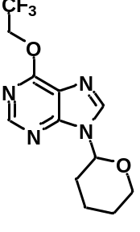 General procedure 1 with 6-chloro-9-(tetrahydro-2H-pyran-2-yl)-9H-purine on a 1.0 mmol scale followed by flash chromatography (ethyl acetate/n-hexane, 1: 2) gave 16 as a white solid (287 mg, 95% yield). Mp: 113–115 ºC. ¹H NMR (400 MHz, CDCl₃) δ (ppm): 8.53 (s, 1H), 8.19 (s, 1H), 5.76 (dd, J = 10.1, 2.5 Hz, 1H), 5.27–4.85 (m, 2H), 4.16 (dd, J = 12.7, 2.9 Hz, 1H), 3.77 (td, J = 11.6, 2.7 Hz, 1H), 2.18–1.95 (m, 3H), 1.87–1.59 (m, 3H); ¹⁹F NMR (376 MHz, CDCl₃) δ (ppm): –73.40 (t, J = 8.6 Hz, 3F); ¹³C NMR (101 MHz, CDCl₃) δ (ppm): 158.90, 152.32, 151.75, 141.12, 123.35 (q, J = 277.9 Hz), 121.36, 82.45, 69.03, 62.51 (q, J = 36.9 Hz), 32.01, 25.01, 22.92. MS (ESI): 303.1 [M+H]⁺. HRMS (ESI) for C₁₂H₁₄N₄O₂F₃ [M+H]⁺: calc’d: 303.1069; found: 303.1068.
tert-Butyl 3,6-dichloropicolinate.
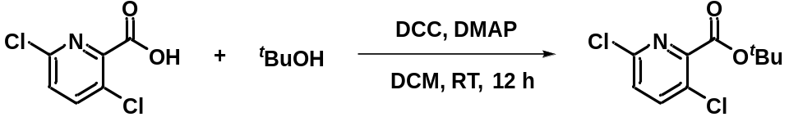
To a dried round-bottomed flask equipped with a stirrer bar were added Clopyralid (3,6-dichloropicolinic acid; 960 mg, 5.0 mmol, 1 equiv.), tert-butanol (740 mg, 10.0 mmol, 2 equiv.), DCC (1.55 g, 7.5 mmol, 1.5 equiv.), and DMAP (916 mg, 7.5 mmol, 1.5 equiv.). DCM (30 mL) was then added. The reaction mixture was stirred for 12 h at RT and then water (50 mL) and DCM (50 mL) were added. The organic phase was washed with brine, dried (Mg₂SO₄), and concentrated in vacuo. The residue was purified with silica gel chromatography (ethyl acetate/n-hexane, 1: 20) to give the title compound (1.17 g, 92% yield) as a white solid. Mp: 61–63 ºC. ¹H NMR (400 MHz, CDCl₃) δ (ppm): 7.69 (d, J = 8.5 Hz, 1H), 7.33 (d, J = 8.5 Hz, 1H), 1.61 (s, 9H); ¹³C NMR (101 MHz, CDCl₃) δ (ppm): 162.89, 149.88, 149.19, 140.78, 128.41, 126.68, 84.47, 28.22. MS (ESI): 270.0 [M+Na]⁺. HRMS (ESI) for C₁₀H₁₁NO₂Cl₂Na [M+Na]⁺: calc’d: 270.0065; found: 270.0062.
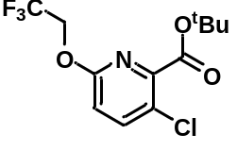tert-Butyl 3-chloro-6-(2,2,2-trifluoroethoxy)picolinate (17).
General procedure 1 with tert-butyl 3,6-dichloropicolinate (prepared as described immediately above) on a 1.0 mmol scale followed by flash chromatography (ethyl acetate/n-hexane, 1: 20) afforded 17 as a colorless oil (128 mg, 41% yield). ¹H NMR (400 MHz, CDCl₃) δ (ppm): 7.66 (d, J = 8.8 Hz, 1H), 6.89 (d, J = 8.8 Hz, 1H), 4.75 (q, J = 8.5 Hz, 2H), 1.62 (s, 9H); ¹⁹F NMR (376 MHz, CDCl₃) δ (ppm): –73.80 (t, J = 8.2 Hz, 3F); ¹³C NMR (101 MHz, CDCl₃) δ (ppm): 163.47, 159.39, 145.91, 141.53, 123.42 (q, J = 277.2 Hz), 123.34, 113.98, 83.67, 62.76 (q, J = 36.2 Hz), 28.07.
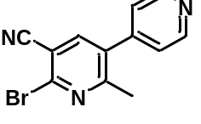6-Bromo-2-methyl-3,4'-bipyridine-5-carbonitrile.
Phosphorus oxybromide (4.30 g, 15 mmol, 3 equiv.) was dissolved in anhydrous MeCN (15 mL). Milrinone (2-methyl-6-oxo-1,6-dihydro-[3,4'-bipyridine]-5-carbonitrile; 1.06 g, 5.0 mmol, 1 equiv.) and DMF (365 mg, 5.0 mmol, 1 equiv.) were added under argon and the resultant mixture was stirred at 85 ºC for 12 h. The reaction mixture was cooled to RT, poured onto ice-water, and basified with saturated sodium carbonate solution until the pH was between 8 and 9. The mixture was extracted with DCM (2 × 15 mL), washed with brine, dried (Mg₂SO₄), and concentrated under reduced pressure. The residue was purified by silica gel chromatography (ethyl acetate/n-hexane: 8: 1) to give the title compound as a white solid (692 g, 51% yield). Mp: 141–143 ºC. ¹H NMR (400 MHz, CDCl₃) δ (ppm): 8.73 (d, J = 4.5 Hz, 2H), 7.75 (s, 1H), 7.24 (d, J = 4.5 Hz, 2H), 2.55 (s, 3H); ¹³C NMR (101 MHz, CDCl₃) δ (ppm): 161.38, 150.63, 144.35, 142.46, 142.40, 133.91, 123.54, 115.67, 111.79, 23.77. MS (ESI): 274.0 [M+H]⁺. HRMS (ESI) for C₁₂H₉N₃Br [M+H]⁺: calc’d: 273.9980; found: 273.9976.
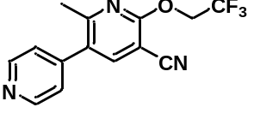2-Methyl-6-(2,2,2-trifluoroethoxy)-3,4'-bipyridine-5-carbonitrile (18).
General procedure 1 with 6-bromo-2-methyl-3,4'-bipyridine-5-carbonitrile (prepared as described immediately above) on 0.5 mmol scale followed by flash chromatography (ethyl acetate/n-hexane, 8: 1) gave 18 as a white solid (112 mg, 76% yield). Mp: 135–137 ºC. ¹H NMR (400 MHz, CDCl₃) δ (ppm): 8.70 (d, J = 5.8 Hz, 2H), 7.79 (s, 1H), 7.22 (d, J = 5.8 Hz, 2H), 4.92 (q, J = 8.3 Hz, 2H), 2.48 (s, 3H); ¹⁹F NMR (376 MHz, CDCl₃) δ (ppm): –73.56 (t, J = 8.2 Hz, 3F); ¹³C NMR (101 MHz, CDCl₃) δ (ppm): 160.50, 159.27, 150.47, 145.21, 144.11, 129.48, 123.98, 123.19 (q, J = 277.8 Hz), 114.06, 94.77, 62.90 (q, J = 36.8 Hz), 23.63. MS (ESI): 294.1 [M+H]⁺. HRMS (ESI) for C₁₄H₁₁N₃OF₃ [M+H]⁺: calc’d: 294.0854; found: 294.0857.
6,7-Bis(2-methoxyethoxy)-4-(2,2,2-trifluoroethoxy)quinazoline (19).
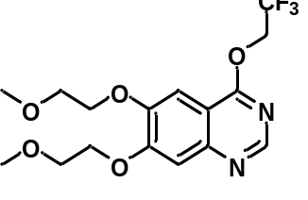 General procedure 1 with 4-chloro-6,7-bis(2-methoxyethoxy)quinazoline on a 0.5 mmol scale followed by flash chromatography (ethyl acetate/petroleum ether, 9: 1) gave 19 as a white solid (123 mg, 65% yield). Mp: 93–95 ºC. ¹H NMR (400 MHz, CDCl₃) δ (ppm): 8.60 (s, 1H), 7.33 (s, 1H), 7.23 (s, 1H), 4.94 (q, J = 8.4 Hz, 2H), 4.32–4.16 (m, 4H), 3.84 (m, 4H), 3.46–3.45 (m, 6H); ¹⁹F NMR (376 MHz, CDCl₃) δ (ppm): –73.54 (t, J = 8.2 Hz, 3F); ¹³C NMR (101 MHz, CDCl₃) δ (ppm): 163.55, 155.64, 152.35, 149.83, 149.09, 123.54 (q, J = 277.3 Hz), 110.26, 107.89, 102.48, 70.80, 70.57, 68.90, 68.64, 62.57 (q, J = 36.5 Hz), 59.47, 59.44. MS (ESI): 377.2 [M+H]⁺. HRMS (ESI) for C₁₆H₂₀N₂O₅F₃ [M+H]⁺: calc’d: 377.1324; found: 377.1328.
2-Fluoro-5-(3-((5-(4-fluorophenyl)thiophen-2-yl)methyl)-4-methylphenyl)pyridine.
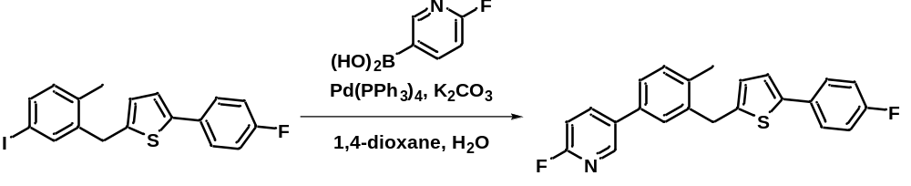
A mixture of 2-fluoropyridine-5-boronic (845 mg, 6.0 mmol, 1.2 equiv.), 2-(4-fluorophenyl)-5-[(5-iodo-2-methylphenyl)methyl]thiophene (2.04 g, 5.0 mmol, 1 equiv.), Pd(PPh₃)₄ (289 mg, 0.25 mmol, 5 mol%), K₂CO₃ (2.07 g, 15 mmol, 3 equiv.) in 1,4–dioxane (25 mL) and water (5 mL) was degassed for 15 min under argon. The reaction mixture was then heated at 100 ºC overnight. The reaction mixture was cooled to RT and diluted with DCM (300 mL). The organic layer was washed with water (200 mL), dried (Mg₂SO₄), filtered, and concentrated. The residue was purified by silica gel chromatography (ethyl acetate/n-hexane, 1: 10) to give the title compound as a white solid (1.12 g, 59% yield). Mp: 118–120 ºC.¹H NMR (400 MHz, CDCl₃) δ (ppm): 8.41 (d, J = 2.4 Hz, 1H), 7.95 (td, J = 8.1, 2.6 Hz, 1H), 7.56–7.44 (m, 2H), 7.43–7.33 (m, 2H), 7.29 (d, J = 7.8 Hz, 1H), 7.11–6.93 (m, 4H), 6.72 (d, J = 3.6 Hz, 1H), 4.20 (s, 2H), 2.39 (s, 3H); ¹⁹F NMR (376 MHz, CDCl₃) δ (ppm): –70.83 (d, J = 6.0 Hz, 1F), –111.96 to –121.23 (m, 1F); ¹³C NMR (101 MHz, CDCl₃) δ (ppm): 163.96 (d, J = 83.7 Hz), 161.54 (d, J = 91.6 Hz), 145.85 (d, J = 14.7 Hz), 142.97, 141.96, 139.73 (d, J = 7.7 Hz), 139.32, 136.77, 134.85, 134.78 (d, J = 4.8 Hz), 131.50, 130.92 (d, J = 3.2 Hz), 128.21, 127.32 (d, J = 8.0 Hz), 126.33, 125.67, 122.91, 115.92 (d, J = 21.7 Hz), 109.54 (d, J = 37.5 Hz), 34.34, 19.41. MS (ESI): 378.1 [M+H]⁺. HRMS (ESI) for C₂₃H₁₈NF₂S [M+H]⁺: calc’d: 378.1128; found: 378.1123.
5-(3-((5-(4-Fluorophenyl)thiophen-2-yl)methyl)-4-methylphenyl)-2-(2,2,2-trifluoroethoxy) pyridine (20).
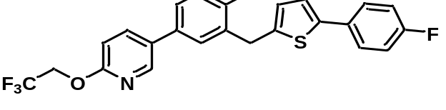General procedure 1 with 2-fluoro-5-(3-((5-(4-fluorophenyl)thiophen-2-yl)methyl)-4-methylphenyl)pyridine (prepared as described immediately above) on 0.5 mmol scale followed by flash chromatography (ethyl acetate/n-hexane, 1: 10) gave 20 as a white solid (201 mg, 88% yield). Mp: 98–100 ºC ¹H NMR (400 MHz, CDCl₃) δ (ppm): 8.25 (d, J = 2.0 Hz, 1H), 7.74 (dd, J = 8.5, 2.2 Hz, 1H), 7.38 (dd, J = 8.5, 5.3 Hz, 2H), 7.33–7.22 (m, 2H), 7.22–7.13 (m, 1H), 6.93 (dd, J = 14.7, 6.0 Hz, 3H), 6.82 (d, J = 8.6 Hz, 1H), 6.62 (d, J = 3.3 Hz, 1H), 4.71 (q, J = 8.6 Hz, 2H), 4.09 (s, 2H), 2.28 (s, 3H); ¹⁹F NMR (376 MHz, CDCl₃) δ (ppm): –73.78 (t, J = 8.6 Hz, 3F), –103.87 to –127.09 (m, 1F); ¹³C NMR (101 MHz, CDCl₃) δ (ppm): 162.33 (d, J = 246.9 Hz), 161.21, 144.67, 143.16, 141.93, 139.20, 138.22, 136.18, 135.60, 131.69, 131.42, 130.98 (d, J = 3.2 Hz), 128.01, 127.33 (d, J = 7.9 Hz), 126.31, 125.44, 123.96 (q, J = 277.6 Hz), 122.92, 115.93 (d, J = 21.7 Hz), 111.14, 62.40 (q, J = 35.8 Hz), 34.38, 19.39. MS (ESI): 458.1 [M+H]⁺. HRMS (ESI) for C₂₅H₂₀NOF₄S [M+H]⁺: calc’d: 458.1202; found: 458.1208.
N,2,3-Trimethyl-N-(2-(2,2,2-trifluoroethoxy)pyrimidin-4-yl)-2H-indazol-6-amine (21).
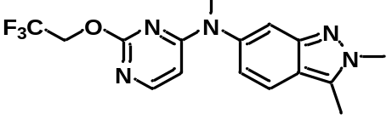General procedure 1 with N-(2-chloropyrimidin-4-yl)-N,2,3-trimethyl-2H-indazol-6-amine on a 1.0 mmol scale followed by flash chromatography (ethyl acetate) gave 21 as a white solid (301 mg, 86% yield). Mp: 145–147 ºC. ¹H NMR (400 MHz, CDCl₃) δ (ppm): 7.79 (d, J = 6.0 Hz, 1H), 7.61 (d, J = 8.8 Hz, 1H), 7.45 (d, J = 1.2 Hz, 1H), 6.82 (dd, J = 8.8, 1.7 Hz, 1H), 6.00 (d, J = 6.0 Hz, 1H), 4.76 (q, J = 8.6 Hz, 2H), 4.10 (s, 3H), 3.50 (s, 3H), 2.61 (s, 3H); ¹⁹F NMR (376 MHz, CDCl₃) δ (ppm): –73.57 (t, J = 8.2 Hz, 3F); ¹³C NMR (101 MHz, CDCl₃) δ (ppm): 164.41, 163.58, 156.10, 147.98, 142.11, 132.31, 123.67 (q, J = 277.9 Hz), 121.95, 120.28, 120.04, 114.88, 100.71, 63.06 (q, J = 36.0 Hz), 38.26, 37.67, 10.09. MS (ESI): 352.1 [M+H]⁺. HRMS (ESI) for C₁₆H₁₇N₅OF₃ [M+H]⁺: calc’d: 352.1385; found: 352.1380.
6-Bromo-8-cyclopentyl-5-methyl-2-(2,2,2-trifluoroethoxy)pyrido[2,3-d]pyrimidin-7(8H)-one (22).
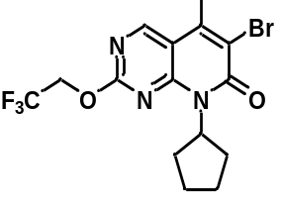General procedure 1 with 6-bromo-2–chloro-8-cyclopentyl-5-methylpyrido[2,3-d]pyrimidin-7(8H)-one on a 0.5 mmol scale followed by flash chromatography (ethyl acetate/n-hexane, 1: 4) gave 22 as a white solid (158 mg, 78% yield). Mp: 205–207 °C. ¹H NMR (400 MHz, CDCl₃) δ (ppm): 8.84 (s, 1H), 6.66–5.64 (m, 1H), 4.87 (q, J = 8.2 Hz, 2H), 2.64 (s, 3H), 2.26–2.20 (m, 2H), 2.16–2.02 (m, 2H), 1.93–1.88 (m, 2H), 1.76–1.59 (m, 2H); ¹⁹F NMR (376 MHz, CDCl₃) δ (ppm): –73.52 (t, J = 8.3 Hz, 3F); ¹³C NMR (101 MHz, CDCl₃) δ (ppm): 162.78, 158.68, 157.45, 155.92, 143.06, 123.19 (q, J = 277.9 Hz), 120.23, 110.72, 64.04 (q, J = 36.6 Hz), 55.49, 28.53, 26.17, 18.56. MS (ESI): 406.0 [M+H]⁺. HRMS (ESI) for C₁₅H₁₆N₃O₂F₃⁷⁹Br [M+H]⁺: calc’d: 406.0378; found: 406.0374.
2.2. Syntheses of benzenoid precursors and standards.
2.2.1. General procedure 2 for diaryliodonium precursors synthesis.²
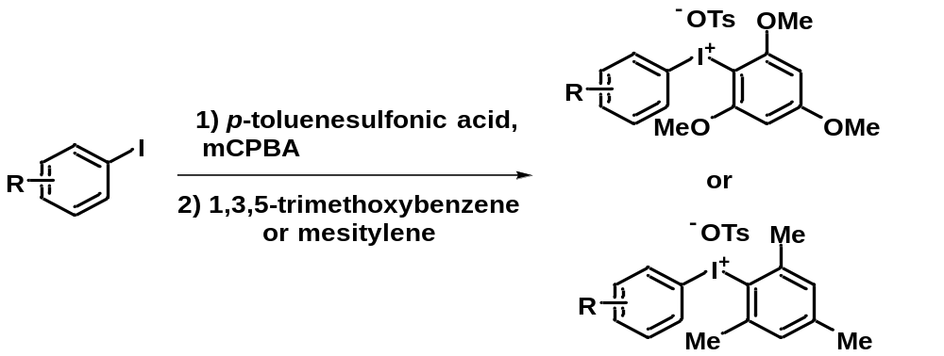
Figure S4. General procedure 2 for the synthesis of diaryliodonium salts.
Aryl(trimethoxyphenyl)iodonium or aryl(trimethylphenyl)iodonium tosylates were prepared by known literature procedures.² In a closed reaction vessel, iodoarene (1 equiv.) was dissolved in acetonitrile (1 mL/mmol of iodoarene). p-Toluenesulfonic acid monohydrate (1 equiv.) was then added in one portion, followed by mCPBA (1 equiv.) in one portion. The reaction mixture was stirred vigorously at 75 ºC. After 30 min, the flask was raised from the oil bath and 1,3,5-trimethoxybenzene or 1,3,5-trimethylbenzene (1 equiv.) was added in one portion. The flask was returned to the oil bath and stirring was continued at 75 ºC for 5 min (in the case of 1,3,5–trimethylbenzene, the second stage of the reaction was allowed to proceed for 3 h). The reaction was removed from heat and triturated with diethyl ether until precipitation ceased. The precipitate was isolated by vacuum filtration and washed with diethyl ether to give a white or light beige solid. Diaryliodonium salts were isolated in moderate yield. If needed, precursors were purified via recrystallization in a minimal amount of methanol and crystallized by addition of diethyl ether.
2.2.2. General procedure 3 for iodonium ylide precursors synthesis.³
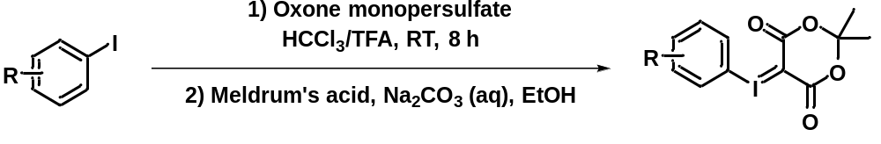
Figure S5. General procedure 3 for the synthesis of aryliodonium ylides.
A solution of iodoarene (1 equiv.) in chloroform (1 mL/mmol of iodoarene) was treated with trifluoroacetic acid (1.1 mL/mmol) followed by oxone monopersulfate (1.6 equiv.). The heterogeneous mixture was stirred at RT for 8 h and then concentrated under reduced pressure. The residue was suspended in ethanol (4 mL/mmol) and treated with Meldrum’s acid (1 equiv.) and a solution of 10% sodium carbonate in water, which was used to adjust the pH to ~10. The reaction was stirred at RT for 3 h and then diluted with water and extracted with DCM. The combined organic layers were dried over anhydrous sodium sulfate, filtered, and concentrated. The residue was recrystallized in a minimal amount of methanol and diethyl ether to give the corresponding aryliodonium ylide.
2.2.3. General procedure 4 for synthesis of reference compounds.⁴
Figure S6. General procedure 4 for the synthesis of 2,2,2-trifluoroethyl aryl ethers.
The iodoarene (1 equiv.), CuI (5 mol%), and t-BuONa (1.2 equiv.) were placed in a round- bottomed flask with a magnetic stirrer bar. DMF (1 M) and 2,2,2-trifluoroethanol (2 equiv.) were added under argon. The reaction mixture was stirred at 60 ºC for 12 h, then quenched with water, and diluted with DCM (30 mL). The organic layer was washed with brine, dried (Mg₂SO₄) and concentrated in vacuo. The residue was purified by silica gel flash chromatography to afford the corresponding 2,2,2-trifluoroethyl aryl ether.
2.2.4. General procedure 5 for synthesis of reference compounds.
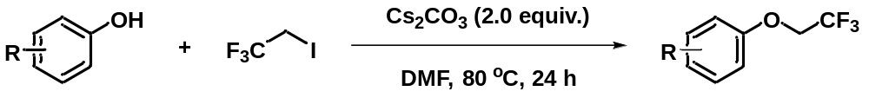
Figure S7. General procedure 5 for the synthesis of 2,2,2-trifluoroethyl aryl ethers.
Hydroxy precursor (1 equiv.), Cs₂CO₃ (2 equiv.) 2-iodo-1,1,1-trifluoroethane (3 equiv.) and DMF (0.2 M) were added under argon to the reaction vessel. The reaction vessel was capped loosely and stirred vigorously at 80 ºC for 12 h. The mixture was cooled to RT, poured onto water, and extracted with DCM (2 × 15 mL). The organic phase was dried (Mg₂SO₄) and concentrated in vacuo. The residue was then purified by silica gel flash chromatography to afford the corresponding 2,2,2-trifluoroethyl aryl ether.
(4-Benzyloxyphenyl)(2,4,6-trimethoxyphenyl)iodonium tosylate.
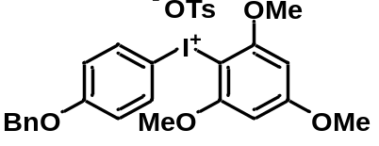General procedure 2 on a 3.0 mmol scale gave the title compound as a white solid (1.27 g, 65% yield). Mp: 212–214 ºC. ¹H NMR (400 MHz, DMSO-d₆) δ (ppm): 7.84 (d, J = 9.0 Hz, 2H), 7.47 (d, J = 8.1 Hz, 2H), 7.44–7.29 (m, 5H), 7.09 (t, J = 9.0 Hz, 4H), 6.45 (s, 2H), 5.14 (s, 2H), 3.94 (s, 6H), 3.86 (s, 3H), 2.28 (s, 3H); ¹³C NMR (101 MHz, DMSO-d₆) δ (ppm): 165.98, 160.60, 159.23, 145.83, 137.49, 136.45, 136.17, 128.48, 128.06, 127.99, 127.78, 125.47, 117.96, 105.30, 91.97, 87.57, 69.58, 57.27, 56.11, 20.74. MS (ESI): 477.0 [M–OTs]⁺. HRMS (ESI) for C₂₂H₂₂O₄I [M–OTs]⁺: calc’d: 477.0563; found: 477.0564.
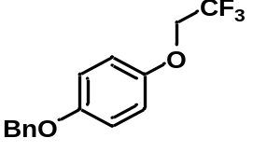1-(Benzyloxy)-4-(2,2,2-trifluoroethoxy)benzene (23).
General procedure 4 on a 2.0 mmol scale gave 23 as a white solid (167 mg, 30% yield). ¹H NMR (400 MHz, CDCl₃) δ (ppm): 7.52–7.31 (m, 5H), 6.97–6.90 (m, 4H), 5.05 (s, 2H), 4.31 (q, J = 8.2 Hz, 2H); ¹⁹F NMR (376 MHz, CDCl₃) δ (ppm): –74.04 (t, J = 8.2 Hz, 3F); ¹³C NMR (101 MHz, CDCl₃) δ (ppm): 154.48, 152.03, 137.19, 128.79, 128.19, 127.66, 123.63 (q, J = 278.4 Hz), 116.54, 116.12, 70.77, 67.05 (q, J = 35.3 Hz). (Known compound).⁵
(p-Tolyl)iodonium-(2,2-dimethyl-1,3-dioxane-4,6-dione)ylide.
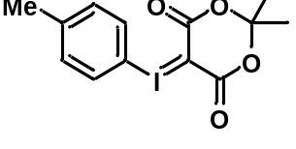General procedure 3 on a 6.0 mmol scale gave the title compound as a white solid (630 mg, 29% yield). Mp: dec.135 ºC. ¹H NMR (400 MHz, DMSO–d₆) δ (ppm): 7.67 (d, J = 8.2 Hz, 2H), 7.26 (d, J = 8.2 Hz, 2H), 2.33 (s, 3H), 1.55 (s, 6H); ¹³C NMR (101 MHz, DMSO–d₆) δ (ppm): 162.83, 140.79, 132.64, 131.55, 112.87, 102.63, 58.03, 25.57, 20.69. MS (ESI): 743.0 [2M+Na]⁺. HRMS (ESI) for C₂₆H₂₆O₈I₂Na [2M+Na]⁺: calc’d: 742.9615; found: 742.9614.
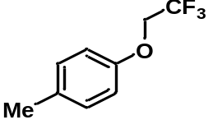1-Methyl-4-(2,2,2-trifluoroethoxy)benzene (24).
General procedure 4 on a 2.0 mmol scale gave 24 as a colorless oil (201 mg, 53% yield). ¹H NMR (400 MHz, CDCl₃) δ (ppm): 7.13 (d, J = 8.2 Hz, 2H), 6.86 (d, J = 8.2 Hz, 2H), 4.33 (q, J = 8.2 Hz, 2H), 2.32 (s, 3H); ¹⁹F NMR (376 MHz, CDCl₃) δ (ppm): –74.05 (t, J = 8.3 Hz, 3F); ¹³C NMR (101 MHz, CDCl₃) δ (ppm): 155.61, 132.16, 130.37, 123.66 (q, J = 278.0 Hz), 115.07, 66.32 (q, J = 35.4 Hz), 20.69. (Known compound).⁶
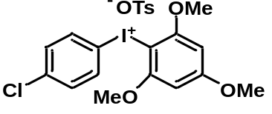(4-Chlorophenyl)(2,4,6-trimethoxyphenyl)iodonium tosylate.
General procedure 2 on a 3.0 mmol scale gave the title compound as a white solid (1.34 g, 77% yield). Mp: 226–230 ºC. ¹ H NMR (400 MHz, DMSO-d₆) δ (ppm): 7.91 (d, J = 8.7 Hz, 2H), 7.53 (d, J = 8.7 Hz, 2H), 7.47 (d, J = 8.1 Hz, 2H), 7.10 (d, J = 7.9 Hz, 2H), 6.47 (s, 2H), 3.94 (s, 6H), 3.87 (s, 3H), 2.28 (s, 3H); ¹³C NMR (101 MHz, DMSO-d₆) δ (ppm): 166.27, 159.33, 145.74, 137.56, 136.67, 136.11, 131.49, 128.02, 125.47, 113.92, 92.08, 87.21, 57.35, 56.18, 20.76. MS (ESI): 405.0 [M–OTs]⁺. HRMS (ESI) for C₁₅H₁₅O₃ClI [M–OTs]⁺: calc’d: 404.9754; found: 404.9758.
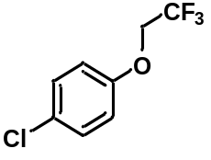1-Chloro-4-(2,2,2-trifluoroethoxy)benzene (25).
General procedure 4 on a 2.0 mmol scale gave 25 as a white solid (408 mg, 92% yield). ¹H NMR (400 MHz, CDCl₃) δ (ppm): 7.28 (d, J = 8.6 Hz, 2H), 6.88 (d, J = 8.6 Hz, 2H), 4.32 (q, J = 8.1 Hz, 2H); ¹⁹F NMR (376 MHz, CDCl₃) δ (ppm): –73.95 (t, J = 8.1 Hz, 3F); ¹³C NMR (101 MHz, CDCl₃) δ (ppm): 156.19, 129.89, 127.85, 123.38 (q, J = 278.0 Hz), 116.52, 66.33 (q, J = 35.8 Hz). (Known compound).⁷
(2-Bromophenyl)(2,4,6-trimethoxyphenyl)iodonium tosylate.
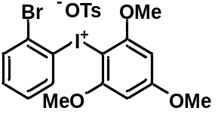General procedure 2 on a 3.0 mmol scale gave the title compound as a white solid (1.42 g, 76% yield). Mp: 142–145 ºC. ¹H NMR (400 MHz, CD₃CN) δ (ppm): 7.90 (d, J = 7.9 Hz, 1H), 7.75 (d, J = 7.9 Hz, 1H), 7.46–7.43 (m, 3H), 7.32 (t, J = 7.7 Hz, 1H), 7.11 (d, J = 8.0 Hz, 2H), 6.29 (s, 2H), 3.87 (s, 6H), 3.85 (s, 3H), 2.32 (s, 3H); ¹³C NMR (101 MHz, CD₃CN) δ (ppm): 168.31, 161.21, 145.17, 140.26, 139.13, 134.71, 134.60, 131.09, 129.46, 127.08, 126.68, 121.12, 93.03, 86.44, 58.04, 57.09, 21.37. MS (ESI): 450.9 [M–OTs]⁺. HRMS (ESI) for C₁₅H₁₅O₃BrI [M–OTs]⁺: calc’d: 448.9249; found: 48.9254.
1-Bromo-2-(2,2,2-trifluoroethoxy)benzene (26).
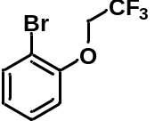General procedure 5 on a 3.0 mmol scale gave 26 as a colorless oil (246 mg, 32% yield). ¹H NMR (400 MHz, CDCl₃) δ (ppm): 7.58 (d, J = 7.9 Hz, 1H), 7.29 (t, J = 7.8 Hz, 1H), 6.98–6.94 (m, 2H), 4.40 (q, J = 8.1 Hz, 2H); ¹⁹F NMR (376 MHz, CDCl₃) δ (ppm): –73.90 (t, J = 8.0 Hz, 3F); ¹³C NMR (101 MHz, CDCl₃) δ (ppm): 154.40, 134.12, 128.85, 124.44, 123.34 (q, J = 278.4 Hz), 115.48, 113.37, 67.46 (q, J = 35.8 Hz). (Known compound).⁸
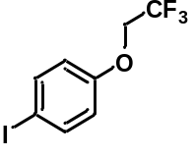1-Iodo-4-(2,2,2-trifluoroethoxy)benzene (27).
General procedure 5 on a 3.0 mmol scale gave 27 as a white solid (367 mg, 41% yield). ¹H NMR (400 MHz, CDCl₃) δ (ppm): 7.61 (d, J = 8.6 Hz, 2H), 6.72 (d, J = 8.7 Hz, 2H), 4.32 (q, J = 8.1 Hz, 2H); ¹⁹F NMR (376 MHz, CDCl₃) δ (ppm): –73.91 (t, J = 8.1 Hz, 3F); ¹³C NMR (101 MHz, CDCl₃) δ (ppm): 157.48, 138.80, 123.35 (q, J = 278.1 Hz), 117.45, 85.26, 66.06 (q, J = 35.9 Hz). (Known compound).⁹
(4-Methylbenzenesulfonate)(2,4,6-trimethoxyphenyl)iodonium tosylate.
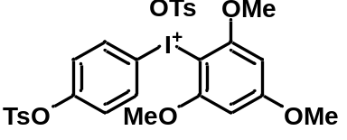General procedure 2 on a 5.0 mmol scale gave the title compound as a white solid (2.54 g, 71% yield). Mp: 191–192 ºC. ¹H NMR (400 MHz, DMSO) δ (ppm): 7.93 (d, J = 8.9 Hz, 2H), 7.73 (d, J = 8.3 Hz, 2H), 7.47 (dd, J = 7.9, 6.6 Hz, 4H), 7.12 (dd, J = 17.2, 8.4 Hz, 4H), 6.46 (s, 2H), 3.91 (s, 6H), 3.87 (s, 3H), 2.41 (s, 3H), 2.28 (s, 3H); ¹³C NMR (101 MHz, DMSO) δ (ppm): 166.28, 159.32, 150.84, 146.24, 145.71, 137.60, 136.47, 130.93, 130.38, 128.20, 128.03, 125.48, 125.17, 113.86, 92.10, 87.17, 57.33, 56.17, 21.17, 20.76. MS (ESI): 541.0 [M–OTs]⁺. HRMS (ESI) for C₂₂H₂₂O₆SI [M–OTs]⁺: calc’d: 541.0182; found: 541.0184.
4-(2,2,2-Trifluoroethoxy)phenyl 4-methylbenzenesulfonate (28).
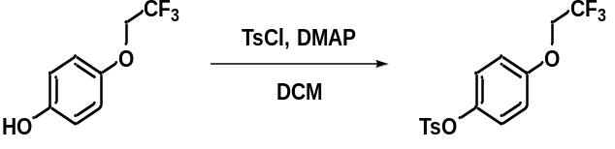
To a round-bottomed flask with a magnetic stirrer bar was added 4-(2,2,2-trifluoroethoxy)phenol (96 mg, 0.5 mmol, 1.0 equiv.), DMAP (122 mg, 1.0 mmol, 2.0 equiv.) and DCM (3 mL) under argon. Tosyl chloride (114 mg, 0.6 mmol, 1.2 equiv.) in DCM (1 mL) was added dropwise at 0 ºC and the reaction mixture was stirred at RT for 12 h. After completion of the reaction, the reaction mixture was poured onto water and extracted with DCM (2 × 15 mL). The organic phase was separated, dried over Mg₂SO₄, and concentrated in vacuo. The residue was purified by flash chromatography (ethyl acetate/n-hexane, 1: 10) to give 28 as a colorless oil (156 mg, 90% yield). Mp: 75–77 ºC. ¹H NMR (400 MHz, CDCl₃) δ (ppm): 7.67 (d, J = 8.3 Hz, 1H), 7.30 (d, J = 8.0 Hz, 2H), 6.9. 8–6.87 (m, 2H), 6.87–6.76 (m, 2H), 4.30 (q, J = 8.1 Hz, 2H), 2.44 (s, 3H); ¹⁹F NMR (376 MHz, CDCl₃) δ (ppm): –73.96 (t, J = 8.0 Hz, 3F); ¹³C NMR (101 MHz, CDCl₃) δ (ppm): 156.04, 145.71, 144.51, 132.24, 129.97, 128.66, 123.87, 123.31 (q, J = 278.0 Hz), 115.87, 66.21 (q, J = 35.8 Hz), 21.82.
(4-Nitrophenyl)iodonium-(2,2-dimethyl-1,3-dioxane-4,6–dione)ylide.
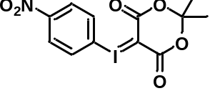General procedure 3 on a 3.0 mmol scale gave the title compound as a white solid (895 mg, 38% yield). Mp: dec. 131 ºC. ¹H NMR (400 MHz, DMSO-d₆) δ (ppm): 8.28 (d, J = 8.4 Hz, 2H), 8.05 (d, J = 8.4 Hz, 2H), 1.59 (s, 6H); ¹³C NMR (101 MHz, DMSO-d₆) δ (ppm): 162.93, 148.91, 133.51, 125.63, 122.94, 103.04, 58.45, 25.63. MS (ESI): 804.9 [2M+Na]⁺. HRMS (ESI) for C₂₄H₂₀N₂O₁₂I₂Na [2M+Na]⁺: calc’d: 804.9003; found: 804.9008.
1-Nitro-4-(2,2,2-trifluoroethoxy)benzene (29).
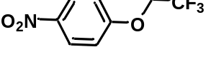General procedure 4 on a 2.0 mmol scale gave 29 as a pale-yellow solid (408 mg, 92% yield). ¹H NMR (400 MHz, CDCl₃) δ (ppm): 8.25 (d, J = 8.9 Hz, 2H), 7.04 (d, J = 8.9 Hz, 2H), 4.46 (q, J = 7.8 Hz, 2H); ¹⁹F NMR (376 MHz, CDCl₃) δ (ppm): –73.72 (t, J = 8.0 Hz, 3F); ¹³C NMR (101 MHz, CDCl₃) δ (ppm): 161.96, 143.04, 126.26, 122.99 (q, J = 278.1 Hz), 115.06, 65.98 (q, J = 36.5 Hz). (Known compound).¹⁰
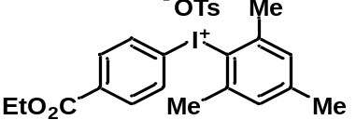(4-Ethoxycarbonylphenyl)(mesityl)iodonium tosylate.
General procedure 2 on a 5.0 mmol scale gave the title compound as a white solid (1.98 g, 70% yield). Mp: 165–167 ºC. ¹H NMR (400 MHz, CDCl₃) δ (ppm): 7.86 (d, J = 8.2 Hz, 2H), 7.75 (d, J = 8.2 Hz, 2H), 7.37 (d, J = 7.8 Hz, 2H), 6.97–6.95 (m, 2H), 4.32 (q, J = 7.1 Hz, 2H), 2.53 (s, 6H), 2.28 (s, 6H), 1.33 (t, J = 7.1 Hz, 3H); ¹³C NMR (101 MHz, CDCl₃) δ (ppm): 165.24, 143.54, 142.45, 142.38, 139.50, 133.23, 132.78, 132.14, 129.89, 128.52, 126.02, 122.57, 118.73, 61.69, 27.17, 21.40, 21.21, 14.33. MS (ESI): 395.0 [M–OTs]⁺. HRMS (ESI) for C₁₈H₂₀O₂I [M–OTs]⁺: calc’d: 395.0508; found: 395.0508.
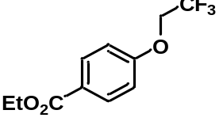Ethyl 4-(2,2,2-trifluoroethoxy)benzoate (30).
General procedure 4 on a 2.0 mmol scale gave 30 as a white solid (412 mg, 83% yield). ¹H NMR (400 MHz, CDCl₃) δ (ppm): 8.02 (d, J = 8.5 Hz, 2H), 6.95 (d, J = 8.5 Hz, 2H), 4.67–4.07 (m, 4H), 1.38 (t, J = 7.1 Hz, 2H); ¹⁹F NMR (376 MHz, CDCl₃) δ (ppm): –73.90 (t, J = 8.1 Hz, 3F); ¹³C NMR (101 MHz, CDCl₃) δ (ppm): 166.14, 160.85, 131.91, 125.02, 123.30 (q, J = 277.9 Hz), 114.51, 65.72 (d, J = 36.2 Hz), 61.08 (s), 14.51. (Known compound).⁶
(4-Cyanophenyl)(2,4,6-trimethoxyphenyl)iodonium tosylate.
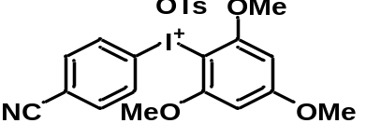 General procedure 2 on a 3.0 mmol scale gave the title compound as a pink solid (0.73 g, 43% yield). Mp: dec. 201 ºC. ¹H NMR (400 MHz, DMSO-d₆) δ (ppm): 8.06 (d, J = 8.4 Hz, 2H), 7.90 (d, J = 8.4 Hz, 2H), 7.47 (d, J = 8.0 Hz, 2H), 7.11 (d, J = 7.8 Hz, 2H), 6.48 (s, 2H), 3.93 (s, 6H), 3.88 (s, 3H), 2.28 (s, 3H); ¹³C NMR (101 MHz, DMSO-d₆) δ (ppm): 166.49, 159.43, 145.57, 137.68, 134.81, 128.07, 125.48, 120.96, 117.54, 114.09, 92.18, 86.99, 57.40, 56.23, 20.78. MS (ESI): 396.0 [M–OTs]⁺. HRMS (ESI) for C₁₆H₁₅NO₃I [M–OTs]⁺: calc’d: 396.0097; found: 396.0093.

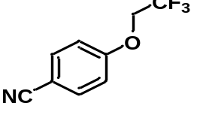4-(2,2,2-Trifluoroethoxy)benzonitrile (31).
General procedure 4 on a 2.0 mmol scale gave 31 as a white solid (330 mg, 82% yield). ¹H NMR (400 MHz, CDCl₃) δ (ppm): 7.63 (d, J = 8.2 Hz, 2H), 7.01 (d, J = 8.2 Hz, 2H), 4.41 (q, J = 7.9 Hz, 2H); ¹⁹F NMR (376 MHz, CDCl₃) δ (ppm): –73.77 (t, J = 8.2 Hz, 3F); ¹³C NMR (101 MHz, CDCl₃) δ (ppm): 160.40, 134.40, 123.05 (q, J = 278.0 Hz), 118.74, 115.67, 106.25, 65.68 (q, J = 36.4 Hz). (Known compound).¹⁰
(3-Cyanophenyl) (2,4,6-trimethoxyphenyl)iodonium tosylate.
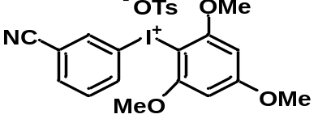General procedure 2 on a 3.0 mmol scale gave the title compound as a white solid (1.13 g, 66% yield). Mp: 212–214 ºC. ¹H NMR (400 MHz, CDCl₃) δ (ppm): 8.25 (d, J = 8.3 Hz, 1H), 7.91 (s, 1H), 7.64 (d, J = 7.8 Hz, 1H), 7.52 (d, J = 8.1 Hz, 2H), 7.39 (t, J = 8.0 Hz, 1H), 7.06 (d, J = 8.0 Hz, 2H), 6.12 (s, 2H), 3.83 (s, 9H), 2.32 (s, 3H); ¹³C NMR (101 MHz, CDCl₃) δ (ppm): 167.18, 160.53, 142.86, 139.57, 138.95, 136.79, 134.34, 131.56, 128.66, 126.11, 116.99, 116.12, 114.78, 91.84, 86.06, 57.18, 56.11, 21.47. MS (ESI): 396.0 [M–OTs]⁺. HRMS (ESI) for C₁₆H₁₅NO₃I [M–OTs]⁺: calc’d: 396.0097; found: 396.0097.
3-(2,2,2-Trifluoroethoxy)benzonitrile (32).
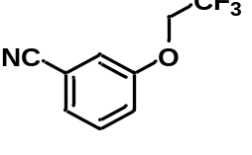General procedure 4 on a 2.0 mmol scale gave 32 as a white solid (235 mg, 58% yield). ¹H NMR (400 MHz, CDCl₃) δ (ppm): 7.49–7.40 (m, 1H), 7.34 (d, J = 7.6 Hz, 1H), 7.23–7.15 (m, 2H), 4.39 (q, J = 8.0 Hz, 2H); ¹⁹F NMR (376 MHz, CDCl₃) δ (ppm): –73.86 (t, J = 8.1 Hz, 3F); ¹³C NMR (101 MHz, CDCl₃) δ (ppm): 157.51, 130.95, 126.50, 123.13 (q, J = 278.0 Hz), 120.14, 118.28, 118.23, 113.80, 66.05 (q, J = 36.1 Hz). (Known compound).¹¹
(3-Chloro-4-(methoxycarbonyl)phenyl)(2,4,6-trimethoxyphenyl) tosylate.
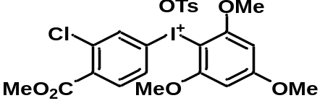General procedure 2 on a 3.0 mmol scale gave the title compound as a white solid (1.53 g, 81% yield). Mp: 214–216 ºC. ¹H NMR (400 MHz, CDCl₃) δ (ppm): 8.27 (d, J = 2.3 Hz, 1H), 7.96 (dd, J = 8.7, 2.3 Hz, 1H), 7.52 (d, J = 8.1 Hz, 2H), 7.29 (d, J = 8.7 Hz, 1H), 7.03 (d, J = 7.9 Hz, 2H), 6.11 (s, 2H), 3.87 (s, 3H), 3.84 (s, 6H), 3.82 (s, 3H), 2.30 (s, 3H); ¹³C NMR (101 MHz, CDCl₃) δ (ppm): 167.11, 164.16, 160.50, 142.91, 139.45, 138.43, 137.50, 137.28, 133.63, 132.08, 128.56, 126.10, 112.96, 91.78, 85.54, 57.11, 56.13, 53.01, 21.46. MS (ESI): 463.0 [M–OTs]⁺. HRMS (ESI) for C₁₇H₁₇O₅ClI [M–OTs]⁺: calc’d: 462.9809; found: 462.9814.
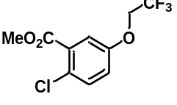Methyl 2-chloro-5-(2,2,2-trifluoroethoxy)benzoate (33).
General procedure 4 on a 2.0 mmol scale gave 33 as a white solid (230 mg, 43% yield).¹H NMR (400 MHz, CDCl₃) δ (ppm): 7.38 (s, 1H), 7.37 (d, J = 5.8 Hz, 1H), 7.02 (dd, J = 8.8, 3.2 Hz, 1H), 4.36 (q, J = 8.0 Hz, 2H), 3.92 (s, 3H); ¹⁹F NMR (376 MHz, CDCl₃) δ (ppm): –73.93 (t, J = 8.1 Hz, 3F); ¹³C NMR (101 MHz, CDCl₃) δ (ppm): 165.63, 155.76, 132.48, 131.03, 127.35, 123.21 (d, J = 278.0 Hz), 120.00, 117.36, 66.28 (q, J = 36.1 Hz), 52.78. (Known compound).¹²
Naphthalen-1-yl(2,4,6-trimethoxyphenyl)iodonium tosylate.
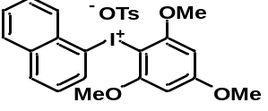General procedure 2 on a 3.0 mmol scale gave the title compound as a white solid (1.23 g, 69% yield). Mp: 189–191 ºC. ¹H NMR (400 MHz, DMSO-d₆) δ (ppm): 8.47 (d, J = 6.7 Hz, 1H), 8.28–8.13 (m, 2H), 8.02 (d, J = 8.1 Hz, 1H), 7.87–7.77 (m, 1H), 7.70 (t, J = 7.2 Hz, 1H), 7.56 (t, J = 7.8 Hz, 1H), 7.47 (d, J = 8.0 Hz, 2H), 7.10 (d, J = 7.8 Hz, 2H), 6.39 (s, 2H), 3.95 (s, 6H), 3.80 (s, 3H), 2.28 (s, 3H); ¹³C NMR (101 MHz, DMSO-d₆) δ (ppm): 165.92, 159.36, 145.83, 137.49, 137.42, 134.01, 132.99, 130.98, 129.21, 129.19, 129.17, 128.00, 127.75, 127.37, 125.47, 119.24, 92.01, 87.00, 57.18, 56.06, 20.75. MS (ESI): 421.0 [M–OTs]⁺. HRMS (ESI) for C₁₉H₁₈O₃I [M–OTs]⁺: calc’d: 421.0301; found: 421.0300.
1-(2,2,2-Trifluoroethoxy)naphthalene (2).
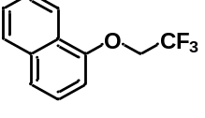General procedure 4 on a 2.0 mmol scale gave 2 as a white solid (312 mg, 69% yield). ¹H NMR (400 MHz, CDCl₃) δ (ppm): 8.53–8.22 (m, 1H), 7.95–7.77 (m, 1H), 7.58–7.56 (m, 3H), 7.40 (t, J = 8.0 Hz, 1H), 6.79 (d, J = 7.6 Hz, 1H), 4.53 (q, J = 8.0 Hz, 2H); ¹⁹F NMR (376 MHz, CDCl₃) δ (ppm): –73.71 (t, J = 8.0 Hz, 3F); ¹³C NMR (101 MHz, CDCl₃) δ (ppm): 153.31, 134.78, 127.72, 127.07, 126.07, 125.58, 123.71 (q, J = 277.9 Hz), 122.42, 121.98, 105.62, 66.23 (q, J = 35.8 Hz). (Known compound).¹⁰
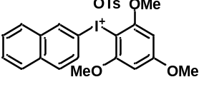Naphthalen-2-yl(2,4,6-trimethoxyphenyl)iodonium tosylate.
General procedure 2 on a 3.0 mmol scale gave the title compound as a white solid (1.26 g, 71% yield). Mp: 217–220 ºC. ¹H NMR (400 MHz, DMSO-d₆) δ (ppm): 8.65 (d, J = 1.3 Hz, 1H), 8.12–8.02 (m, 1H), 8.00 (d, J = 8.9 Hz, 2H), 7.91 (dd, J = 8.8, 1.8 Hz, 1H), 7.71–7.58 (m, 2H), 7.47 (d, J = 8.1 Hz, 2H), 7.09 (d, J = 7.9 Hz, 2H), 6.46 (s, 2H), 3.97 (s, 6H), 3.85 (s, 3H), 2.27 (s, 3H); ¹³C NMR (101 MHz, DMSO-d₆) δ (ppm): 166.11, 159.39, 145.76, 137.53, 135.16, 133.77, 133.20, 131.13, 129.81, 128.62, 128.15, 128.00, 127.98, 127.70, 125.47, 113.07, 92.07, 87.12, 57.33, 56.13, 20.75. MS (ESI): 421.0 [M–OTs]⁺. HRMS (ESI) for C₁₉H₁₈O₃I [M–OTs]⁺: calc’d: 421.0301; found: 421.0302.
2-(2,2,2-Trifluoroethoxy)naphthalene (34).
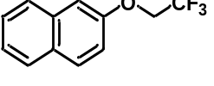General procedure 4 on a 2.0 mmol scale gave 34 as a white solid (253 mg, 56% yield). ¹H NMR (400 MHz, CDCl₃) δ (ppm): 7.91–7.68 (m, 3H), 7.54 (t, J = 7.5 Hz, 1H), 7.46 (t, J = 7.5 Hz, 1H), 7.26 (dd, J = 9.0, 2.0 Hz, 1H), 7.18 (s, 1H), 4.49 (q, J = 8.1 Hz, 2H); ¹⁹F NMR (376 MHz, CDCl₃) δ (ppm): –73.73 (t, J = 8.1 Hz, 3F); ¹³C NMR (101 MHz, CDCl₃) δ (ppm): 155.43, 134.31, 130.17, 129.87, 127.95, 127.12, 126.97, 124.72, 123.61 (q, J = 277.9 Hz), 118.49, 107.69, 65.90 (q, J = 35.7 Hz). (Known compound).¹⁰
(Quinolin-6-yl)iodonium-(2,2-dimethyl-1,3-dioxane-4,6-dione)ylide.
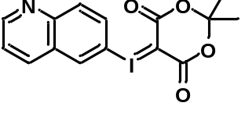General procedure 3 on a 5.0 mmol scale gave the title compound as a white solid (640 mg, 32% yield). Mp: dec. 165 ºC. ¹H NMR (400 MHz, DMSO-d₆) δ (ppm): 9.01 (dd, J = 4.2, 1.6 Hz, 1H), 8.74–8.37 (m, 2H), 8.27–7.88 (m, 2H), 7.65 (dd, J = 8.4, 4.2 Hz, 1H), 1.57 (s, 6H); ¹³C NMR (101 MHz, DMSO-d₆) δ (ppm): 162.92, 152.56, 147.60, 136.27, 133.41, 132.32, 131.78, 128.81, 122.69, 113.88, 102.80, 58.49, 25.58. (Known compound).³
6-(2,2,2-Trifluoroethoxy)quinoline (35).
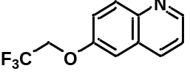 General procedure 4 on a 1.0 mmol scale gave 35 as a white solid (86 mg, 38% yield). Mp: 76–78 ºC. ¹H NMR (400 MHz, CDCl₃) δ (ppm): 8.81 (dd, J = 4.2, 1.6 Hz, 1H), 8.20–7.81 (m, 2H), 7.39 (ddd, J = 20.8, 8.8, 3.5 Hz, 2H), 7.07 (d, J = 2.8 Hz, 1H), 4.46 (q, J = 8.0 Hz, 2H); ¹⁹F NMR (376 MHz, CDCl₃) δ (ppm): –73.73 (t, J = 8.1 Hz, 3F); ¹³C NMR (101 MHz, CDCl₃) δ (ppm): 155.47, 149.11, 145.14, 135.13, 131.74, 129.06, 123.41 (q, J = 277.9 Hz), 121.91, 121.90, 107.23, 66.04 (q, J = 36.0 Hz). MS (ESI): 228.1 [2M+Na]⁺. HRMS (ESI) for C₂₄H₂₀N₂O₁₂I₂Na [2M+Na]⁺: calc’d: 228.0636; found: 228.0636.
(R)-5-((4-Chloro-3-(4-((tetrahydrofuran-3-yl)oxy)benzoyl)phenyl) iodonium-(2,2-dimethyl-1,3-dioxane-4,6-dione)ylide.
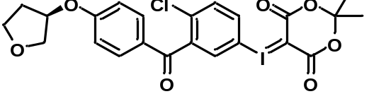General procedure 3 on a 5.0 mmol scale gave the title compound as a pale–yellow solid (860 mg, 30% yield). Mp: dec. 140 ºC. ¹H NMR (400 MHz, CDCl₃) δ (ppm): 7.96–7.76 (m, 2H), 7.68 (d, J = 8.8 Hz, 2H), 7.44 (d, J = 8.6 Hz, 1H), 6.88 (d, J = 8.9 Hz, 2H), 4.99 (dd, J = 5.8, 4.2 Hz, 1H), 4.11–3.93 (m, 3H), 3.89 (td, J = 8.4, 4.3 Hz, 1H), 2.25 (td, J = 14.3, 8.3 Hz, 1H), 2.17–2.03 (m, 1H), 1.63 (s, 6H); ¹³C NMR (101 MHz, CDCl₃) δ (ppm): 191.07, 163.86, 162.85, 141.85, 135.57, 135.33, 133.36, 133.30, 132.90, 128.35, 115.62, 111.97, 104.95, 78.12, 73.08, 67.34, 56.72, 33.12, 26.02 .
(R)-(2-Chloro-5-(2,2,2-trifluoroethoxy)phenyl)(4-((tetrahydrofuran-3-yl)oxy)phenyl)methanone (36).
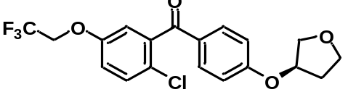General procedure 4 on a 1.0 mmol scale gave 36 as a white solid (232 mg, 58% yield). Mp: 91–93 ºC. ¹H NMR (400 MHz, CDCl₃) δ (ppm): 7.77 (d, J = 8.8 Hz, 2H), 7.38 (d, J = 8.8 Hz, 1H), 7.01 (dd, J = 8.8, 3.0 Hz, 1H), 6.97–6.80 (m, 3H), 5.00 (td, J = 4.2, 2.2 Hz, 1H), 4.35 (q, J = 8.0 Hz, 2H), 4.21–3.95 (m, 3H), 3.91 (td, J = 8.4, 4.4 Hz, 1H), 2.26 (dtd, J = 14.4, 8.3, 6.2 Hz, 1H), 2.19–2.00 (m, 1H); ¹⁹F NMR (376 MHz, CDCl₃) δ (ppm): –73.85 (t, J = 8.2 Hz, 3F); ¹³C NMR (101 MHz, CDCl₃) δ (ppm): 193.04, 162.36, 156.05, 140.23, 132.77, 131.40, 129.29, 124.54, 123.21 (q, J = 278.1 Hz), 117.94, 115.35, 115.17, 78.01, 73.15, 67.37, 66.29 (q, J = 36.0 Hz), 33.18. MS (ESI): 401.1 [M+H]⁺. HRMS (ESI) for C₁₉H₁₇O₄F₃Cl [2M+Na]⁺: calc’d: 401.0767; found: 401.0773.
3-(2-Chloro-6-2,2,2-trifluoroethoxy)phenyl)-5-methylisoxazole-4-carbonitrile (37).
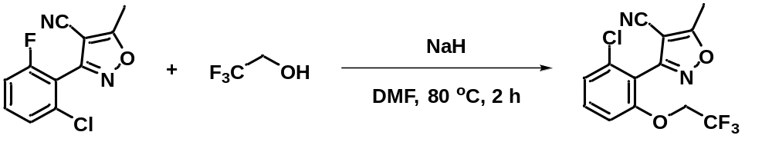
To a round bottomed flask equipped with a magnetic stirrer bar was added dry NaH (27 mg, 1.0 mmol, 2 equiv.) and DMF (2 mL, 0.5 M) under argon, and then 2,2,2-trifluoroethanol (100 mg, 1.0 mmol, 2 equiv.) in DMF (1 mL) at 0 ºC. The reaction mixture was stirred for 20 min under argon and (3-(5-(2-fluorophenyl)-1,2,4-oxadiazol-3-yl)phenyl)methanol (237 mg, 1.0 mmol, 1 equiv.) in DMF (2 mL) was added dropwise at RT. The reaction flask was capped loosely and stirred vigorously at 80 °C for 2 h. The reaction mixture was then poured onto water and extracted with DCM (2 × 15 mL). The organic phase was dried (Mg₂SO₄) and concentrated in vacuo. The residue was purified by silica gel flash chromatography (ethyl acetate/n-hexane, 1: 4) to give 37 as a colorless oil (235 mg, 74% yield). ¹H NMR (400 MHz, CDCl₃) δ (ppm): 7.36 (t, J = 8.3 Hz, 1H), 7.18 (d, J = 8.5 Hz, 1H), 6.86 (d, J = 8.4 Hz, 1H), 4.32 (q, J = 7.9 Hz, 2H), 2.63 (s, 3H); ¹⁹F NMR (376 MHz, CDCl₃) δ (ppm): –73.76 (t, J = 8.2 Hz, 3F); ¹³C NMR (101 MHz, CDCl₃) δ (ppm): 177.15, 157.33, 156.57, 135.71, 132.73, 124.48, 122.90 (q, J = 278.3 Hz), 116.23, 111.49, 110.71, 93.77, 66.87 (q, J = 36.3 Hz), 12.69.
(3-(5-(2-Fluorophenyl)-1,2,4-oxadiazol-3-yl)phenyl)methanol.
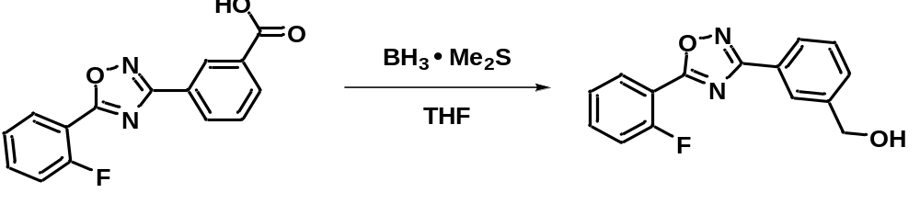
Ataluren (2.84 g, 10 mmol, 1.0 equiv.) was dissolved in THF (20 mL) and BH₃·Me₂S (1.52 g, 20 mmol, 2.0 equiv.) was added dropwise at 0 ºC under argon. The mixture was stirred at RT for 12 h and then quenched with methanol, washed with saturated NH₄Cl, and extracted with EtOAc (2 × 20 mL). The organic layer was dried (Mg₂SO₄), filtered, and concentrated under reduced pressure. The residue was purified by silica gel chromatography (ethyl acetate-n-hexane, 1: 2) to give the title compound as a white solid (2.34 g, 87% yield). Mp: 102–104 ºC. ¹H NMR (400 MHz, CDCl₃) δ (ppm): 8.26–8.11 (m, 2H), 8.06 (d, J = 7.4 Hz, 1H), 7.64–7.54 (m, 1H), 7.49 (dt, J = 15.1, 7.6 Hz, 2H), 7.29 (dt, J = 19.4, 7.8 Hz, 2H), 4.76 (s, 2H), 2.49 (s, 1H); ¹⁹F NMR (376 MHz, CDCl₃) δ (ppm): –108.25 (m, 1F), ¹³C NMR (101 MHz, CDCl₃) δ (ppm): 172.91 (d, J = 4.4 Hz), 168.74, 160.90 (d, J = 260.5 Hz), 141.97, 134.80 (d, J = 8.7 Hz), 131.08, 129.92, 129.27, 126.99, 126.86, 126.12, 124.87 (d, J = 3.7 Hz), 117.31 (d, J = 21.1 Hz), 112.91 (d, J = 11.5 Hz), 64.93. MS (ESI): 271.1 [M+H]⁺. HRMS (ESI) for C₁₅H₁₂N₂O₂F [M+H]⁺: calc’d: 271.0883; found: 271.0884.

(3-(5-(2-(2,2,2-trifluoroethoxy)phenyl)-1,2,4-oxadiazol-3-yl)phenyl)methanol (38).
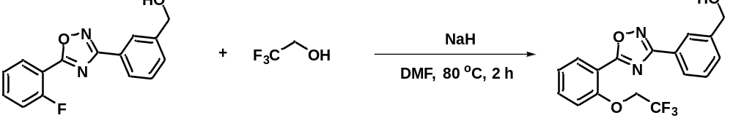
To a round bottomed flask equipped with a magnetic stirrer bar was added dry NaH (27 mg, 1.0 mmol, 2 equiv.) and DMF (2 mL, 0.5 M) under argon, followed by 2,2,2-trifluoroethanol (100 mg, 1.0 mmol, 2 equiv.) in DMF (1 mL) at 0 ºC. The reaction mixture was stirred for 20 min under argon. (3-(5-(2-Fluorophenyl)-1,2,4-oxadiazol-3-yl)phenyl)methanol (135 mg, 1.0 mmol, 1 equiv.) in DMF (2 mL) was then added dropwise at RT. The reaction flask was loosely capped and stirred vigorously at 80 ºC for 2 h. The reaction mixture was poured onto water and extracted with DCM (2 ×15 mL). The organic phase was dried (Mg₂SO₄), filtered, and concentrated in vacuo. The residue was purified by silica gel flash chromatography (ethyl acetate/n-hexane, 1: 1) to give 38 as a white solid (117 mg, 67% yield). Mp: 100–102 ºC.¹H NMR (400 MHz, CD₃CN) δ (ppm): 8.14 (dd, J = 7.8, 1.7 Hz, 2H), 8.10 (s, 1H), 8.00 (dt, J = 6.5, 1.9 Hz, 1H), 7.63 (ddd, J = 8.6, 7.5, 1.7 Hz, 1H), 7.55–7.44 (m, 2H), 7.32–7.13 (m, 1H), 5.04–4.37 (m, 4H), 3.44 (t, J = 5.9 Hz, 1H); ¹⁹F NMR (376 MHz, CD₃CN) δ (ppm): –74.45 (t, J = 8.3 Hz, 3F); ¹³C NMR (101 MHz, CD₃CN) δ (ppm): 175.57, 169.26, 157.05, 144.24, 135.55, 132.57, 130.54, 130.08, 127.95, 126.84, 126.34, 124.80 (q, J = 277.1 Hz), 123.94, 115.83, 115.19, 67.38 (q, J = 35.4 Hz), 64.37. MS (ESI): 351.1 [M+H]⁺. HRMS (ESI) for C₁₇H₁₄N₂O₃F₃ [M+H]⁺: calc’d: 351.0957; found: 351.0963.
2.3. The synthesis of alkyl precursors and standards.
2.3.1. General procedure 6 for precursors synthesis.
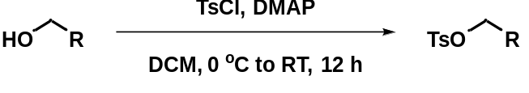
Figure S8. General procedure 6 for the synthesis of alkyl 4–methylbenzenesulfonates.
To a round-bottomed flask equipped with a magnetic stirrer bar was added the alcohol (RCH₂OH; 1.0 equiv.), DMAP (1.5 equiv.), and DCM (20 mL) under argon. Tosyl chloride (1.2 equiv.) in DCM (3 mL) was then added dropwise at 0 ºC. The reaction mixture was then stirred at RT for 12 h, poured onto water, and extracted with DCM (2 × 15 mL). The organic phase was dried (Mg₂SO₄) and concentrated in vacuo. The residue was purified by silica gel flash chromatography to give the desired alkyl 4-methylbenzenesulfonate in moderate to high yield.
2.3.2. General procedure 7 for synthesis of reference standards.
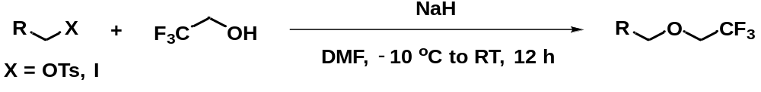
Figure S9. General procedure 7 for the synthesis of 2,2,2-trifluoroethyl alkyl ethers.
To a round-bottomed flask equipped with a magnetic stirrer bar was added dry NaH (2 equiv.) and DMF (0.5 M) under argon, followed by 2,2,2-trifluoroethanol (2.0 equiv.) in DMF (1.0 mL) at 0 ºC. The reaction mixture was stirred for 20 min under argon. An alkyl p-toluenesulfonate or iodoalkane (1 equiv.) in DMF (1 mL) was then added dropwise and the reaction temperature was kept under –10 ºC. The reaction flask was loosely capped. The were contents stirred vigorously below –10 ºC for 1 h, warmed to RT, and stirred for another 10 h. The reaction mixture was then poured into water and extracted with DCM (2 × 15 mL). The organic phase was dried (Mg₂SO₄), filtered and concentrated in vacuo. The residue was purified by silica gel flash chromatography to give the corresponding 2,2,2-trifluoroethyl alkyl ether.
3-(1,3-Dioxoisoindolin-2-yl)propyl 4-methylbenzenesulfonate.
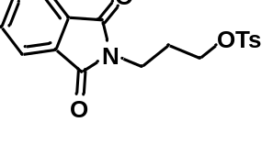General procedure 6 with 2-(3-hydroxypropyl)isoindoline-1,3-dione on 5.0 mmol followed by flash chromatography (ethyl acetate/n-hexane, 1: 2) gave the title compound as a white solid (1.58 g, 88% yield). Mp: 105–107 ºC. ¹H NMR (400 MHz, CDCl₃) δ (ppm): 7.80 (dt, J = 7.0, 3.5 Hz, 2H), 7.76 (d, J = 8.3 Hz, 2H), 7.73–7.65 (m, 2H), 7.31 (d, J = 8.0 Hz, 2H), 4.09 (t, J = 6.3 Hz, 2H), 3.72 (t, J = 7.0 Hz, 2H), 2.42 (s, 3H), 2.04 (quint, J = 6.5 Hz, 2H); ¹³C NMR (101 MHz, CDCl₃) δ (ppm): 168.23, 145.00, 134.21, 132.99, 132.11, 130.02, 128.11, 123.47, 67.94, 34.76, 28.14, 21.81. MS (ESI): 360.1 [M+H]⁺. HRMS (ESI) for C₁₈H₁₈NO₅S [M+H]⁺: calc’d: 360.0906; found: 360.0903.

2-(3-(2,2,2-Trifluoroethoxy)propyl)isoindoline-1,3-dione (39).
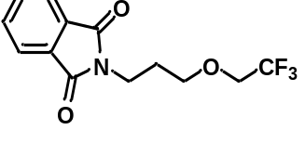General procedure 7 with 3-(1,3-dioxoisoindolin-2-yl)propyl 4-methylbenzenesulfonate on a 1.0 mmol scale followed by flash chromatography (ethyl acetate/n-hexane, 1: 4) gave 39 as a colorless oil (64 mg, 22% yield). ¹H NMR (400 MHz, CDCl₃) δ (ppm): 7.84–7.72 (m, 2H), 7.70–7.54 (m, 2H), 3.72 (dt, J = 13.6, 7.7 Hz, 4H), 3.59 (t, J = 5.9 Hz, 2H), 1.92 (quint, J = 6.4 Hz, 2H); ¹⁹F NMR (376 MHz, CDCl₃) δ (ppm): –74.16 (t, J = 8.6 Hz, 3F); ¹³C NMR (101 MHz, CDCl₃) δ (ppm): 168.59, 134.12, 132.31, 124.11 (q, J = 279.6 Hz), 123.38, 70.51, 68.68 (q, J = 34.0 Hz), 35.34, 28.85. MS (ESI): 288.1 [M+H]⁺. HRMS (ESI) for C₁₃H₁₃NO₃F₃ [M+H]⁺: calc’d: 288.0848; found: 288.0848.
2-(2-(Benzyloxy)ethoxy)ethyl 4-methylbenzenesulfonate.
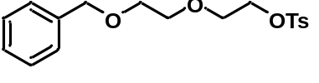General procedure 6 with 2-[2-(benzyloxy)ethoxy]ethanol on a 5.0 mmol scale followed by flash chromatography (ethyl acetate/n-hexane, 1: 3) gave the title product as a colorless oil (1.61 g, 92% yield). ¹H NMR (400 MHz, CDCl₃) δ (ppm): 7.79 (d, J = 8.3 Hz, 2H), 7.50–7.00 (m, 7H), 4.52 (s, 2H), 4.27–4.04 (m, 2H), 3.84–3.64 (m, 2H), 3.63–3.41 (m, 2H), 2.41 (s, 3H); ¹³C NMR (101 MHz, CDCl₃) δ (ppm): 144.92, 138.28, 133.13, 129.95, 128.53, 128.10, 127.85, 127.78, 73.40, 70.94, 69.50, 69.42, 68.82, 21.76. MS (ESI): 351.1 [M+H]⁺. HRMS (ESI) for C₁₈H₂₃O₅S [M+H]⁺: calc’d: 351.1266; found: 351.1266.
((2-(2-(2,2,2-Trifluoroethoxy)ethoxy)ethoxy)methyl)benzene (40).
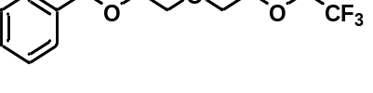General procedure 7 with 2-(2-(benzyloxy)ethoxy)ethyl 4-methylbenzenesulfonate on a 1.0 mmol scale followed by flash chromatography (ethyl acetate-n-hexane, 1: 4) gave 40 as a colorless oil (234 mg, 84% yield). ¹H NMR (400 MHz, CDCl₃) δ (ppm): 7.75–6.75 (m, 5H), 4.56 (s, 2H), 3.90 (q, J = 8.8 Hz, 2H), 3.83–3.73 (m, 2H), 3.73–3.57 (m, 6H); ¹⁹F NMR (376 MHz, CDCl₃) δ (ppm): –74.30 (t, J = 8.8 Hz, 3F); ¹³C NMR (101 MHz, CDCl₃) δ (ppm): 138.39, 128.54, 127.89, 127.80, 124.23 (q, J = 279.6 Hz), 73.41, 72.13, 70.95, 70.87, 69.57, 68.94 (q, J = 33.9 Hz). MS (ESI): 279.1 [M+H]⁺. HRMS (ESI) for C₁₃H₁₈O₃F₃ [M+H]⁺: calc’d: 279.1208; found: 279.1207.

7,8-Dimethoxy-3-(3-(2,2,2-trifluoroethoxy)propyl)-1H-benzo[d]azepin-2(3H)-one (41).
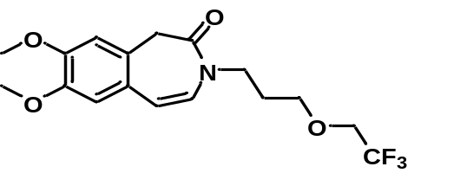To a round-bottomed flask equipped with a magnetic stirrer bar was added dry NaH (53 mg, 2.0 mmol, 2.0 equiv.) and DMF (4.0 mL, 0.5 M) under argon, followed by 2,2,2-trifluoroethanol (200 mg, 2.0 mmol, 2 equiv. in 1 mL DMF) at 0 ºC. The reaction mixture was stirred for 20 min under argon. 3-(3-Iodopropyl)-7,8-dimethoxy-1H-benzo[d]azepin-2(3H)-one (387 mg, 1.0 mmol, 1 equiv.) in DMF (2 mL) was then added dropwise at 0 ºC. The reaction flask was capped loosely, and the contents were stirred vigorously at 0 ºC for 1 h, warmed to 80 ºC, and stirred for another 12 h. The reaction mixture was then poured onto water and extracted with DCM (2 ×15 mL). The organic phase was dried (Mg₂SO₄) and concentrated in vacuo. The residue was purified by silica gel flash chromatography (ethyl acetate/n-hexane, 1: 4) to give 41 as a colorless oil (172 mg, 48% yield). ¹H NMR (400 MHz, CDCl₃) δ (ppm): 6.77 (s, 1H), 6.72 (s, 1H), 6.33 (d, J = 9.1 Hz, 1H), 6.20 (d, J = 9.1 Hz, 1H), 3.88 (s, 3H), 3.87 (s, 3H), 3.72 (q, J = 8.8 Hz, 2H), 3.65 (t, J = 6.8 Hz, 2H), 3.47 (t, J = 6.0 Hz, 2H), 3.42 (s, 2H), 1.81 (quint, J = 6.4 Hz, 2H); ¹⁹F NMR (376 MHz, CDCl₃) δ (ppm): –74.13 (t, J = 8.8 Hz, 3F); ¹³C NMR (101 MHz, CDCl₃) δ (ppm): 167.86, 150.05, 148.22, 128.89, 126.51, 124.92, 124.13 (q, J = 279.6 Hz), 117.08, 111.35, 109.60, 69.75, 68.45 (q, J = 33.9 Hz), 56.13, 45.34, 43.37, 28.67. MS (ESI): 360.2 [M+H]⁺. HRMS (ESI) for C₁₇H₂₁NO₄F₃ [M+H]⁺: calc’d: 360.1423; found: 360.1425.
4-Methyl-2-((2,2,2-trifluoroethoxy)methyl)quinazoline (42).
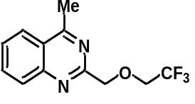 To a round-bottomed flask equipped with a magnetic stirrer bar was added dry NaH (53 mg, 2.0 mmol, 2.0 equiv.) and DMF (4.0 mL, 0.5 M) under argon, followed by 2,2,2-trifluoroethanol (200 mg, 2.0 mmol, 2.0 equiv.) in DMF (1.0 mL) at 0 ºC. The reaction mixture was stirred for 20 min under argon. 2-(Chloromethyl)-4-methylquinazoline (193 mg, 1.0 mmol, 1.0 equiv.) in DMF (2.0 mL) was then added dropwise at 0 ºC. The flask was capped loosely, and the contents stirred vigorously at 0 ºC for 1 h and then 80 ºC for 2 h. The reaction mixture was then poured onto water and extracted with DCM (2 × 15 mL). The organic phase was dried (Mg₂SO₄) and concentrated in vacuo. The residue was purified by flash chromatography (ethyl acetate-n-hexane, 1: 2) to give 42 as a white solid (238 mg, 93% yield). Mp: 75–77 ºC. ¹H NMR (400 MHz, CDCl₃) δ (ppm): 8.14–7.92 (m, 2H), 7.84 (ddd, J = 8.4, 7.0, 1.3 Hz, 1H), 7.59 (ddd, J = 8.2, 7.0, 1.1 Hz, 2H), 4.98 (s, 2H), 4.13 (q, J = 8.8 Hz, 2H), 2.91 (s, 3H); ¹⁹F NMR (376 MHz, CDCl₃) δ (ppm): –73.89 (t, J = 8.7 Hz, 3F); ¹³C NMR (101 MHz, CDCl₃) δ (ppm): 169.13, 161.19, 149.78, 134.01, 129.06, 127.72, 125.12, 124.25 (q, J = 279.7 Hz), 123.35, 75.22, 68.58 (q, J = 34.0 Hz), 21.88. MS (ESI): 257.1 [M+H]⁺. HRMS (ESI) for C₁₂H₁₂N₂OF₃ [M+H]⁺: calc’d: 257.0902; found: 257.0901.
2-(4-Chloro-2-methylphenoxy)ethan-1-ol.
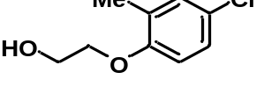2-Methyl-4-chlorophenoxyacetic acid (2.01 g, 10 mmol, 1 equiv.) was dissolved in THF (20 mL) and BH₃·Me₂S (1.52 g, 20 mmol, 2 equiv.) was added dropwise at 0 ºC under argon. The mixture was stirred at RT for 12 h, quenched with methanol, washed with saturated aq. NH₄Cl, and extracted with ethyl acetate (2 × 20 mL). The organic phase was dried (Mg₂SO₄), filtered, and concentrated under reduced pressure. The residue was purified by silica gel chromatography (ethyl acetate-n-hexane, 1: 2) to give the title compound as a white solid (1.47 g, 79% yield). Mp: 56–58 ºC. ¹H NMR (400 MHz, CDCl₃) δ (ppm): 7.11–7.02 (m, 2H), 6.72 (d, J = 8.4 Hz, 1H), 4.18–4.00 (m, 2H), 3.98 (d, J = 8.1 Hz, 2H), 2.20 (s, 4H); ¹³C NMR (101 MHz, CDCl₃) δ (ppm): 155.50, 130.70, 128.88, 126.59, 125.68, 112.54, 69.86, 61.67, 16.28.
2-(4-Chloro-2-methylphenoxy)ethyl 4-methylbenzenesulfonate
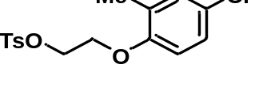General procedure 6 with 2-(4-chloro-2-‘methylphenoxy)ethan-1-ol on a 5.0 mmol followed by flash chromatography (ethyl acetate/n-hexane, 1: 3) gave the title compound as a colorless oil (1.56 g, 92% yield). Mp: 58–60 ºC. ¹H NMR (400 MHz, CDCl₃) δ (ppm): 7.80 (d, J = 8.3 Hz, 2H), 7.32 (d, J = 8.0 Hz, 2H), 7.15–6.92 (m, 2H), 6.60 (d, J = 8.5 Hz, 1H), 4.50–4.27 (m, 2H), 4.25–3.95 (m, 2H), 2.44 (s, 3H), 2.09 (s, 3H); ¹³C NMR (101 MHz, CDCl₃) δ (ppm): 154.93, 145.22, 133.03, 130.78, 130.08, 129.19, 128.10, 126.50, 126.01, 112.39, 68.26, 65.98, 21.84, 16.13. MS (ESI): 358.1 [M+NH₄]⁺. HRMS (ESI) for C₁₆H₂₁NO₄SCl [M+NH₄]⁺: calc’d: 358.0880; found: 358.0880.
4-Chloro-2-methyl-1-(2-(2,2,2-trifluoroethoxy)ethoxy)benzene (43).
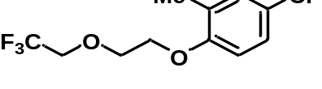General procedure 7 with 2-(4-chloro-2-methylphenoxy)ethyl 4-methylbenzenesulfonate on a 1.0 mmol scale followed by flash chromatography (ethyl acetate/n-hexane, 1: 10) gave 43 as a colorless oil (183 mg, 68% yield). ¹H NMR (400 MHz, CDCl₃) δ (ppm): 7.11 (dt, J = 8.6, 2.3 Hz, 2H), 6.72 (d, J = 8.5 Hz, 1H), 4.12 (dd, J = 5.5, 3.7 Hz, 2H), 4.05–3.83 (m, 4H), 2.21 (s, 3H); ¹⁹F NMR (376 MHz, CDCl₃) δ (ppm): –74.40 (t, J = 8.8 Hz, 3F); ¹³C NMR (101 MHz, CDCl₃) δ (ppm): 155.52, 130.77, 129.08, 126.59, 125.79, 124.14 (q, J = 279.7 Hz), 112.46, 71.29, 69.19 (q, J = 33.9 Hz), 68.18, 16.27 .
3-(Benzo[d][1,3]dioxol-5-yl)-2-methylpropan-1-ol.
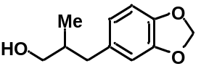Helional (2-methyl-3-(3,4-methylenedioxyphenyl)propionaldehyde; 1.92 g, 10 mmol, 1 equiv.) was added over a period of 2 min at 0 ºC to a suspension of NaBH₄ (0.76 g, 20 mmol, 2 equiv.) in ethanol (200 proof, 20 mL), The reaction mixture was stirred for 6 h at RT, quenched with ice–cold aq. HCl (1 M), and extracted with DCM (2 × 15 mL). The organic phase was dried (Mg₂SO₄) and then concentrated in vacuo. The residue was purified by silica gel flash chromatography (ethyl acetate/n-hexane, 1: 4) to give the product as a colorless oil (1.73 g, 89% yield). ¹H NMR (400 MHz, CDCl₃) δ (ppm): 6.72 (d, J = 7.9 Hz, 1H), 6.67 (d, J = 1.6 Hz, 1H), 6.61 (dd, J = 7.9, 1.6 Hz, 1H), 5.91 (s, 2H), 3.48 (qd, J = 10.6, 5.9 Hz, 1H), 2.67 (dd, J = 13.6, 6.4 Hz, 1H), 2.34 (dd, J = 13.6, 8.0 Hz, 1H), 1.97–1.77 (m, 1H), 1.56 (s, 1H), 0.90 (d, J = 6.8 Hz, 3H); ¹³C NMR (101 MHz, CDCl₃) δ (ppm): 147.68, 145.83, 134.60, 122.07, 109.64, 108.21, 100.93, 67.69, 39.57, 38.07, 16.58.
3-(Benzo[d][1,3]dioxol-5-yl)-2-methylpropyl 4-methylbenzenesulfonate.
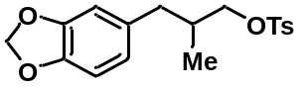General procedure 6 with 3-(benzo[d][1,3]dioxol-5-yl)-2-methylpropan-1-ol on a 5.0 mmol followed by flash chromatography (ethyl acetate/n-hexane, 1: 4) gave the title compound as a colorless oil (1.38 g, 79% yield). ¹H NMR (400 MHz, CDCl₃) δ (ppm): 7.78 (d, J = 8.3 Hz, 2H), 7.34 (d, J = 8.1 Hz, 2H), 6.66 (d, J = 7.8 Hz, 1H), 6.59–6.38 (m, 2H), 5.90 (s, 2H), 3.95–3.72 (m, 2H), 2.58 (dd, J = 13.7, 6.7 Hz, 1H), 2.45 (s, 3H), 2.33 (dd, J = 13.7, 7.7 Hz, 1H), 2.00 (td, J = 13.0, 6.7 Hz, 1H), 0.88 (d, J = 6.8 Hz, 3H); ¹³C NMR (101 MHz, CDCl₃) δ (ppm): 147.74, 146.07, 144.93, 133.23, 133.12, 130.03, 128.10, 122.14, 109.52, 108.26, 101.00, 74.20, 38.85, 35.18, 21.83, 16.39. MS (ESI): 371.1 [M+Na]⁺. HRMS (ESI) for C₁₈H₂₀O₅SNa [M+Na]⁺: calc’d: 371.0929; found: 371.0934.

5-(2-Methyl-3-(2,2,2-trifluoroethoxy)propyl)benzo[d][1,3]dioxole (44).
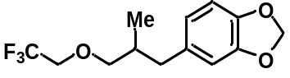To a round-bottomed flask equipped with a magnetic stirrer bar was added dry NaH (53 mg, 2.0 mmol, 2 equiv.) and DMF (4 mL, 0.5 M) under argon followed by adding 2,2,2-trifluoroethanol (200 mg, 2.0 mmol, 2 equiv.) in DMF (1.0 mL) at 0 ºC. The reaction mixture was stirred for 20 min under argon. 3-(Benzo[d][1,3]dioxol-5-yl)-2-methylpropyl 4-methylbenzenesulfonate (348 mg, 1.0 mmol, 1 equiv.) in DMF (2 mL) was added dropwise at 0 ºC, The flask was loosely capped, stirred vigorously at 0 ºC for 1 h, and heated at 80 ºC for 12 h. The reaction mixture was then poured onto water and extracted with DCM (2 × 15 mL). The organic phase was dried (Mg₂SO₄) and concentrated in vacuo. Silica gel flash chromatography (ethyl acetate/n-hexane, 1: 10) of the residue gave 44 as a colorless oil (173 mg, 63% yield). ¹H NMR (400 MHz, CDCl₃) δ (ppm): 6.73 (d, J = 7.9 Hz, 1H), 6.65 (d, J = 1.6 Hz, 1H), 6.60 (dd, J = 7.9, 1.6 Hz, 1H), 5.92 (s, 2H), 3.79 (q, J = 8.8 Hz, 1H), 3.53–3.30 (m, 2H), 2.67 (dd, J = 13.6, 6.4 Hz, 1H), 2.37 (dd, J = 13.6, 7.8 Hz, 1H), 1.99 (dq, J = 12.9, 6.4 Hz, 1H), 0.92 (d, J = 6.8 Hz, 3H); ¹⁹F NMR (376 MHz, CDCl₃) δ (ppm): –74.12 (d, J = 8.7 Hz, 3F); ¹³C NMR (101 MHz, CDCl₃) δ (ppm): 147.72, 145.92, 134.23, 124.31 (q, J = 279.7 Hz), 122.20, 109.69, 108.23, 100.97, 77.19, 68.74 (q, J = 33.8 Hz), 39.37, 35.81, 16.72.
1-(((2R,4R)-2-(2,4-Difluorophenyl)-4-((2,2,2-trifluoroethoxy)methyl)tetrahydrofuran-2-yl)methyl)-1H-1,2,4-triazole (45).
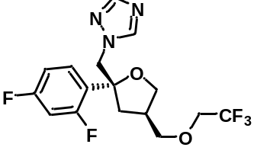 General procedure 7 with ((3S,5R)-5-((1H-1,2,4-triazol-1-yl)methyl)-5-(2,4-difluorophenyl)tetrahydrofuran-3-yl)methyl 4-methylbenzenesulfonate on a 0.5 mmol scale followed by flash chromatography (ethyl acetate/DCM: 3: 1) gave 45 as a colorless oil (87 mg, 46% yield). ¹H NMR (400 MHz, CDCl₃) δ (ppm): 8.07 (s, 1H), 7.79 (s, 1H), 7.33 (td, J = 8.7, 6.6 Hz, 1H), 6.81 (tdd, J = 11.1, 8.4, 2.5 Hz, 2H), 4.53 (dd, J = 46.3, 14.4 Hz, 2H), 4.20–3.88 (m, 1H), 3.69 (ddd, J = 15.2, 13.0, 7.5 Hz, 3H), 3.40 (dd, J = 8.9, 5.3 Hz, 1H), 3.33–3.21 (m, 1H), 2.67–2.21 (m, 2H), 1.93 (td, J = 11.6, 4.8 Hz, 1H); ¹⁹F NMR (376 MHz, CDCl₃) δ (ppm): –74.14 (t, J = 8.4 Hz, 3F), –109.02 (dd, J = 18.7, 9.6 Hz, 1F), –109.93 – –111.27 (m, 1F); ¹³C NMR (101 MHz, CDCl₃) δ (ppm): 162.97 (dd, J = 249.6, 11.9 Hz), 159.16 (dd, J = 247.5, 11.9 Hz), 151.26, 144.74, 128.75 (dd, J = 9.5, 5.5 Hz), 125.47 (dd, J = 13.1, 3.7 Hz), 123.99 (q, J = 279.7 Hz), 111.49 (dd, J = 20.7, 3.5 Hz), 104.79 (t, J = 26.0 Hz), 84.15 (d, J = 4.3 Hz), 73.60, 70.72, 68.68 (q, J = 33.9 Hz), 56.05 (d, J = 4.1 Hz), 39.16, 37.40 (d, J = 3.5 Hz). MS (ESI): 378.1 [M+H]⁺. HRMS (ESI) for C₁₆H₁₇N₃O₂F₅ [M+H]⁺: calc’d: 378.1241; found: 378.1238.
1-(((2R,4R)-2-(2,4-Dichlorophenyl)-4-((2,2,2-trifluoroethoxy)methyl)-1,3-dioxolan-2-yl)methyl)-1H-imidazole (46).
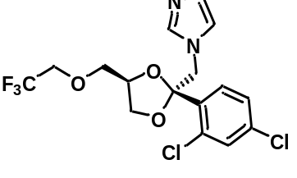General procedure 7 with ((2R,4S)-2-((1H-imidazol-1-yl)methyl)-2-(2,4-dichlorophenyl)-1,3-dioxolan-4-yl)methyl 4-methylbenzenesulfonate on a 1.0 mmol scale followed by flash chromatography (ethyl acetate) gave 46 as a colorless oil (345 mg, 84% yield). ¹H NMR (400 MHz, CDCl₃) δ (ppm): 7.53 (d, J = 8.4 Hz, 1H), 7.47 (s, 1H), 7.43 (d, J = 2.0 Hz, 1H), 7.22 (dd, J = 8.4, 2.0 Hz, 1H), 6.98 (s, 1H), 6.94 (s, 1H), 4.41 (dd, J = 49.1, 14.8 Hz, 2H), 4.24–4.07 (m, 1H), 3.94–3.63 (m, 3H), 3.56 (dd, J = 8.4, 5.2 Hz, 1H), 3.27 (dd, J = 10.0, 6.0 Hz, 1H), 3.17 (dd, J = 10.0, 5.5 Hz, 1H); ¹⁹F NMR (376 MHz, CDCl₃) δ (ppm): –74.22 (t, J = 8.4 Hz, 3F); ¹³C NMR (101 MHz, CDCl₃) δ (ppm): 138.91, 136.08, 134.62, 133.09, 131.53, 129.71, 128.67, 127.40, 123.91 (q, J = 279.6 Hz), 121.25, 108.27, 75.19, 72.32, 68.81 (q, J = 34.3 Hz), 67.14, 51.33. MS (ESI): 411.1 [M+H]⁺. HRMS (ESI) for C₁₆H₁₆N₂O₃F₃Cl₂ [M+H]⁺: calc’d: 411.0490; found: 411.0494.
(3-(5-(2-Methoxyphenyl)-1,2,4-oxadiazol-3-yl)phenyl)methanol.
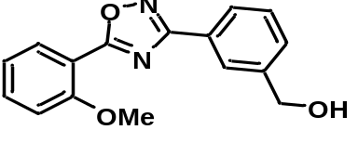To a round-bottomed flask equipped with a magnetic stirrer bar was added dry NaH (267 mg, 10.0 mmol, 2 equiv.) and DMF (20 mL) under argon, followed by addition of MeOH (2 mL) at 0 ºC. The reaction mixture was stirred for 20 min under argon. (3-(5-(2-Fluorophenyl)-1,2,4-oxadiazol-3-yl)phenyl)methanol (1.35 g, 5.0 mmol, 1.0 equiv.) in DMF (3 mL) was then added dropwise at RT. The flask was loosely capped, and the contents stirred vigorously at 80 ºC for 12 h. The reaction mixture was then poured onto water and extracted with DCM (2 × 15 mL). The organic phase was dried (Mg₂SO₄) and concentrated in vacuo. The residue was purified by silica gel flash chromatography (ethyl acetate/n-hexane, 1: 2) to give the title compound as a white solid (901 mg, 64% yield). Mp: 98–100 ºC. ¹H NMR (400 MHz, CDCl₃) δ (ppm): 8.37–7.96 (m, 3H), 7.72–7.38 (m, 3H), 7.22–6.86 (m, 2H), 4.78 (d, J = 5.9 Hz, 2H), 4.00 (s, 3H), 2.06 (t, J = 6.0 Hz, 1H); ¹³C NMR (101 MHz, CDCl₃) δ (ppm): 175.36, 168.42, 158.73, 141.85, 134.34, 131.86, 129.71, 129.26, 127.54, 126.94, 126.20, 120.98, 113.65, 112.32, 65.13, 56.27. MS (ESI): 283.1 [M+H]⁺. HRMS (ESI) for C₁₆H₁₅N₂O₃ [M+H]⁺: calc’d: 283.1083; found: 283.1078. .
3-(3-(Bromomethyl)phenyl)-5-(2-methoxyphenyl)-1,2,4-oxadiazole.
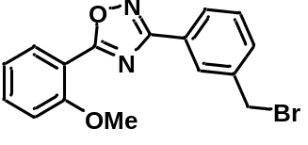 (3-(5-(2-Methoxyphenyl)-1,2,4-oxadiazol-3-yl)phenyl)methanol (0.85 g, 3.0 mmol, 1 equiv.) was dissolved in anhydrous DCM (20 mL) and PBr₃ (0.97 g, 3.6 mmol, 1.2 equiv.) was added dropwise at 0 ºC. The mixture was stirred at RT for 2 h, quenched with saturated aq. NaHCO₃ solution, and extracted with DCM (2 × 15 mL). The organic layer was separated off, dried (Mg₂SO₄), filtered, and concentrated under reduced pressure. The residue was purified by silica gel chromatography (ethyl acetate/n-hexane, 1/5) to give the title compound as a white solid (0.59 g, 57% yield). Mp: 137–139 ºC. ¹H NMR (400 MHz, CDCl₃) δ (ppm): 8.22 (d, J = 1.6 Hz, 1H), 8.19–8.05 (m, 2H), 7.69–7.52 (m, 2H), 7.49 (t, J = 7.7 Hz, 1H), 7.18–7.01 (m, 2H), 4.57 (s, 2H), 4.01 (s, 3H); ¹³C NMR (101 MHz, CDCl₃) δ (ppm): 175.49, 168.08, 158.77, 138.74, 134.40, 131.89, 131.85, 129.58, 128.31, 127.97, 127.70, 121.01, 113.64, 112.35, 56.30, 32.93. MS (ESI): 345.0 [M+H]⁺. HRMS (ESI) for C₁₆H₁₄N₂O₂⁷⁹Br [M+H]⁺: calc’d: 345.0239; found: 345.0242.
5-(2-Methoxyphenyl)-3-(3-((2,2,2-trifluoroethoxy)methyl)phenyl)-1,2,4-oxadiazole (47).
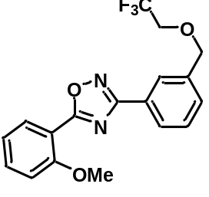To a round-bottomed flask equipped with a magnetic stirrer bar was added dry NaH (27 mg, 1.0 mmol, 2 equiv.) and DMF (1 mL, 0.5 M) under argon, followed by 2,2,2-trifluoroethanol (100 mg, 1.0 mmol, 2.0 equiv.) in DMF (1 mL) at 0 ºC. The reaction mixture was stirred for 20 min under argon. 3-(3-(Bromomethyl)phenyl)-5-(2-methoxyphenyl)-1,2,4-oxadiazole (173 mg, 0.5 mmol, 1 equiv.) in DMF (2 mL) was then added dropwise at RT. The flask was capped loosely capped, and the contents stirred vigorously at 80 ºC for 2 h. The reaction mixture was then poured onto water and extracted with DCM (2 × 15 mL). The organic phase was separated off, dried (Mg₂SO₄), filtered, and concentrated in vacuo. The residue was purified by silica gel flash chromatography (ethyl acetate/n-hexane, 1: 5) to give 47 as a white solid (147 mg, 81% yield). Mp: 66–68 ºC. ¹H NMR (400 MHz, CDCl₃) δ (ppm): 8.34–7.90 (m, 3H), 7.90–7.43 (m, 3H), 7.20–6.74 (m, 2H), 4.75 (s, 2H), 3.99 (s, 3H), 3.88 (q, J = 8.7 Hz, 2H); ¹⁹F NMR (376 MHz, CDCl₃) δ (ppm): –73.82 (t, J = 8.8 Hz, 3F); ¹³C NMR (101 MHz, CDCl₃) δ (ppm): 175.42, 168.21, 158.70, 137.50, 134.33, 131.79, 130.46, 129.35, 127.70, 127.54, 127.01, 124.21 (q, J = 279.3 Hz), 120.92, 113.56, 112.28, 73.86, 67.54 (q, J = 34.2 Hz), 56.17. MS (ESI): 365.1 [M+H]⁺. HRMS (ESI) for C₁₈H₁₆N₂O₃F₃ [M+H]⁺: calc’d: 365.1113; found: 365.1117.
2-Cyclopropyl-4-(4-fluorophenyl)-3-((2,2,2-trifluoroethoxy)methyl)quinoline (48).
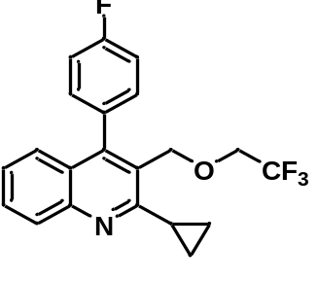To a round-bottomed flask equipped with a magnetic stirrer bar was added dry NaH (53 mg, 2.0 mmol, 2 equiv.) and DMF (4 mL, 0.5 M) under argon, followed by 2,2,2-trifluoroethanol (200 mg, 2.0 mmol, 2 equiv.) in DMF (1 mL) at 0 ºC. The reaction mixture was stirred for 20 min under argon. 3-(Bromomethyl)-2-cyclopropyl-4-(4-fluorophenyl)quinoline (356 mg, 1.0 mmol, 1 equiv.) in DMF (2 mL) was then added dropwise at RT. The flask was capped loosely and stirred vigorously at 80 ºC for 2 h. The reaction mixture was then poured onto water and extracted with DCM (2 x 15 mL). The organic phase was separated, dried (Mg₂SO₄), filtered, and concentrated in vacuo. Flash chromatography (ethyl acetate/n-hexane, 1: 4) of the residue gave 48 as a colorless oil (278 mg, 74% yield). ¹H NMR (400 MHz, CDCl₃) δ (ppm): 7.97 (d, J = 8.4 Hz, 1H), 7.61 (ddd, J = 8.4, 5.6, 2.6 Hz, 1H), 7.38–7.26 (m, 4H), 7.22 (dt, J = 8.7, 2.4 Hz, 2H), 4.67 (s, 2H), 3.75 (q, J = 8.7 Hz, 2H), 2.48 (tt, J = 8.1, 4.9 Hz, 1H), 1.46–1.26 (m, 2H), 1.19– 0.89 (m, 2H); ¹⁹F NMR (376 MHz, CDCl₃) δ (ppm): –73.69 (t, J = 8.8 Hz, 3F), –105.26 – –117.40 (m, 1F); ¹³C NMR (101 MHz, CDCl₃) δ (ppm): 162.90 (d, J = 247.7 Hz), 162.62, 147.90, 132.29 (d, J = 3.5 Hz), 131.67 (d, J = 8.0 Hz), 129.68, 129.21, 126.66, 126.12, 125.93, 125.78, 124.11 (q, J = 279.7 Hz), 115.61 (d, J = 21.5 Hz), 69.09, 67.94 (q, J = 34.2 Hz), 14.73, 9.90. MS (ESI): 376.1 [M+H]⁺. HRMS (ESI) for C₂₁H₁₈NOF₄ [M+H]⁺: calc’d: 376.1325; found: 376.1328.
2-(1-Benzyl-1H-indazol-3-yloxy)ethanol.
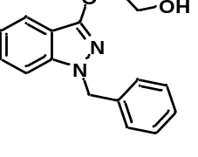Bendazac (2-((1-benzyl-1H-indazol-3-yl)oxy)acetic acid; 2.82 g, 10 mmol, 1 equiv.) was dissolved in THF (20 mL) and BH₃·Me₂S (1.52 g, 20 mmol, 2 equiv.) was added dropwise at 0 ºC under argon. The mixture was stirred at RT for 12 h and then quenched with MeOH, washed with saturated aq. NH₄Cl, and extracted with ethyl acetate (2 × 20 mL). The organic layer was dried (Mg₂SO₄), filtered, and concentrated under reduced pressure. The residue was purified with silica gel chromatography (ethyl acetate/n-hexane, 1/3) to give the title compound as a white solid (2.34 g, 87% yield). Mp: 89–91 ºC. ¹H NMR (400 MHz, CDCl₃) δ (ppm): 7.58 (d, J = 8.1 Hz, 1H), 7.29–7.13 (m, 4H), 7.09 (t, J = 7.2 Hz, 3H), 6.96 (t, J = 7.5 Hz, 1H), 5.28 (s, 2H), 4.66–4.28 (m, 2H), 3.92 (d, J = 3.1 Hz, 2H), 3.17 (t, J = 5.3 Hz, 1H); ¹³C NMR (101 MHz, CDCl₃) δ (ppm): 156.13, 141.84, 137.31, 128.83, 127.89, 127.81, 127.30, 120.30, 119.61, 113.00, 109.14, 71.59, 62.49, 52.55. MS (ESI): 269.1 [M+H]⁺. HRMS (ESI) for C₁₆H₁₇N₂O₂ [M+H]⁺: calc’d: 269.1290; found: 269.1290.
2-(1-Benzyl-1H-indazol-3-yloxy)ethyl 4-methylbenzenesulfonate.
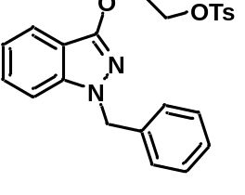General procedure 6 with 2-(1-benzyl-1H-indazol-3-yloxy)ethanol on a 5.0 mmol followed by flash chromatography (ethyl acetate/n-hexane, 1: 3) gave the title compound as a white solid (1.75 g, 83% yield). Mp: 61–63 ºC. ¹H NMR (400 MHz, CDCl₃) δ (ppm): 7.68 (d, J = 8.0 Hz, 2H), 7.44 (d, J = 8.1 Hz, 1H), 7.20 (dt, J = 17.2, 8.8 Hz, 4H), 7.07 (dd, J = 14.8, 7.2 Hz, 5H), 6.94 (t, J = 7.5 Hz, 1H), 5.23 (s, 2H), 4.59–4.44 (m, 2H), 4.42–4.30 (m, 2H), 2.23 (s, 3H); ¹³C NMR (101 MHz, CDCl₃) δ (ppm): 155.06, 144.89, 141.70, 137.45, 133.02, 129.90, 128.79, 128.11, 127.76, 127.67, 127.23, 120.20, 119.46, 112.82, 108.99, 68.34, 66.17, 52.47, 21.73. MS (ESI): 423.1 [M+H]⁺. HRMS (ESI) for C₂₃H₂₃N₂O₄S [M+H]⁺: calc’d: 423.1379; found: 423.1378.
1-Benzyl-3-(2-(2,2,2-trifluoroethoxy)ethoxy)-1H-indazole (49).
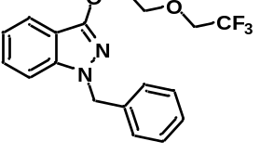General procedure 7 with 2-(1-benzyl-1H-indazol-3-yloxy)ethyl 4-methylbenzenesulfonate on a 1.0 mmol scale followed by flash chromatography (ethyl acetate/n-hexane, 1: 4) gave 49 as a colorless oil (178 mg, 51% yield). ¹H NMR (400 MHz, CDCl₃) δ (ppm): 7.59 (d, J = 8.1 Hz, 1H), 7.40–7.12 (m, 4H), 7.08 (t, J = 7.3 Hz, 3H), 6.95 (t, J = 7.5 Hz, 1H), 5.29 (s, 2H), 4.48 (dd, J = 4.9, 3.8 Hz, 2H), 4.10–3.94 (m, 2H), 3.88 (q, J = 8.7 Hz, 2H); ¹⁹F NMR (376 MHz, CDCl₃) δ (ppm): –74.21 (t, J = 8.8 Hz, 3F); ¹³C NMR (101 MHz, CDCl₃) δ (ppm): 155.72, 141.85, 137.58, 128.79, 127.73, 127.69, 127.19, 124.22 (q, J = 279.7 Hz), 120.26, 119.49, 113.08, 109.07, 71.22, 69.03 (q, J = 33.9 Hz), 68.36, 52.52. MS (ESI): 351.1 [M+H]⁺. HRMS (ESI) for C₁₈H₁₈N₂O₂F₃ [M+H]⁺: calc’d: 351.1320; found: 351.1323.
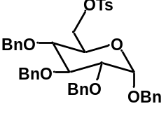((2R,3R,4S,5R,6S)-3,4,5,6-tetrakis(benzyloxy)tetrahydro-2H-pyran-2-yl)methyl 4-methylbenzenesulfonate.
General procedure 6 with ((2R,3R,4S,5R,6S)-3,4,5,6-tetrakis(benzyloxy)tetrahydro-2H-pyran-2-yl)methanol on a 4.0 mmol scale followed by flash chromatography (ethyl acetate/n-hexane, 1: 3) gave the title compound as a colorless oil (2.34 g, 84% yield). ¹H NMR (400 MHz, CDCl₃) δ (ppm): 7.68 (d, J = 8.3 Hz, 2H), 7.37–7.13 (m, 20H), 7.07 (dd, J = 7.0, 2.4 Hz, 2H), 4.91 (d, J = 10.9 Hz, 1H), 4.84–4.61 (m, 3H), 4.54 (dd, J = 13.8, 12.2 Hz, 2H), 4.48–4.29 (m, 3H), 4.11 (dd, J = 10.6, 4.2 Hz, 1H), 4.06–3.86 (m, 2H), 3.71 (ddd, J = 10.1, 4.1, 1.9 Hz, 1H), 3.46–3.28 (m, 2H), 2.31 (s, 3H); ¹³C NMR (101 MHz, CDCl₃) δ (ppm): 145.00, 138.82, 138.17, 137.95, 137.10, 133.11, 129.98, 128.63, 128.60, 128.58, 128.19, 128.17, 128.13, 128.10, 128.05, 128.03, 127.82, 95.67, 82.03, 79.93, 77.15, 75.86, 75.23, 73.22, 69.59, 68.97, 68.70, 21.81. MS (ESI): 712.3 [M+NH₄]⁺. HRMS (ESI) for C₄₁H₄₆NO₈S [M+NH₄]⁺: calc’d: 712.2944; found: 712.2946.
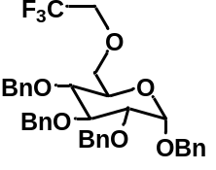(2S,3R,4S,5R,6R)-2,3,4,5-tetrakis(benzyloxy)-6-((2,2,2-trifluoroethoxy)methyl)tetrahydro-2H-pyran (50).
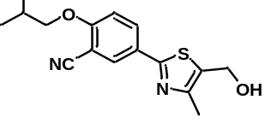General procedure 7 with ((2R,3R,4S,5R,6S)-3,4,5,6-tetrakis(benzyloxy)tetrahydro-2H-pyran-2-yl)methyl 4-methylbenzenesulfonate on a 0.5 mmol scale followed by flash chromatography (ethyl acetate/n-hexane, 1: 4) gave 50 as a white solid (240 mg, 77% yield). Mp: 85–87 ºC. ¹H NMR (400 MHz, CDCl₃) δ (ppm): 7.55–7.27 (m, 20H), 5.08 (d, J = 10.8 Hz, 1H), 4.97 (d, J = 10.9 Hz, 1H), 4.90 (dd, J = 7.2, 3.6 Hz, 2H), 4.74 (d, J = 12.0 Hz, 2H), 4.64 (dd, J = 19.5, 11.4 Hz, 3H), 4.12 (t, J = 9.3 Hz, 1H), 4.02–3.73 (m, 4H), 3.75–3.53 (m, 3H); ¹⁹F NMR (376 MHz, CDCl₃) δ (ppm): –73.87 (t, J = 8.7 Hz, 3F); ¹³C NMR (101 MHz, CDCl₃) δ (ppm): 138.93, 138.38, 138.29, 137.25, 128.63, 128.57, 128.12, 128.09, 127.97, 127.77, 124.11 (q, J = 279.7 Hz), 95.81, 82.23, 80.14, 77.42, 75.91, 75.23, 73.23, 71.14, 70.62, 69.49, 69.08 (q, J = 34.1 Hz). MS (ESI): 640.3 [M+H]⁺. HRMS (ESI) for C₃₆H₄₁NO₆F₃ [M+H]⁺: calc’d: 640.2886; found: 640.2892.
5-(5-(Hydroxymethyl)-4-methylthiazol-2-yl)-2-isobutoxybenzonitrile
Febuxostat (2-(3-cyano-4-isobutoxyphenyl)-4-methylthiazole-5-carboxylic acid; 1.58 g, 5.0 mmol, 1 equiv.) was dissolved in THF (20 mL) and BH₃·Me₂S (0.76 g, 10 mmol, 2 equiv.) was added dropwise at 0 ºC under argon. The mixture was stirred at RT for 12 h, quenched with MeOH, washed with saturated aq. NH₄Cl, and extracted with ethyl acetate (2 × 20 mL). The organic layer was dried (Mg₂SO₄), filtered, and concentrated under reduced pressure. The residue was purified by silica gel chromatography (ethyl acetate/n-hexane, 1: 1) to give the title compound as a white solid (1.15 g, 74% yield). Mp: 106–108 ºC. ¹H NMR (400 MHz, CDCl₃) δ (ppm): 8.02 (d, J = 2.3 Hz, 1H), 7.95 (dd, J = 8.8, 2.3 Hz, 1H), 6.94 (d, J = 8.9 Hz, 1H), 4.78 (s, 2H), 3.84 (d, J = 6.5 Hz, 2H), 2.86 (s, 1H), 2.38 (s, 3H), 2.16 (sept, J = 13.3, 6.7 Hz, 1H), 1.06 (d, J = 6.7 Hz, 6H); ¹³C NMR (101 MHz, CDCl₃) δ (ppm): 163.60, 161.89, 150.41, 132.23, 131.77, 131.56, 126.86, 115.87, 112.70, 102.72, 75.74, 56.79, 28.32, 19.22, 15.20. MS (ESI): 303.1 [M+H]⁺. HRMS (ESI) for C₁₆H₁₉N₂O₂S [M+H]⁺ : calc’d: 303.1167; found: 303.1172.
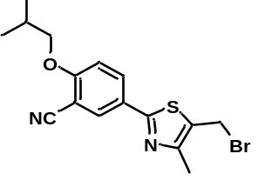5-(5-(Bromomethyl)-4-methylthiazol-2-yl)-2-isobutoxybenzonitrile.
5-(5-(Hydroxymethyl)-4-methylthiazol-2-yl)-2-isobutoxybenzonitrile (0.91 g, 3.0 mmol, 1 equiv.) was dissolved in anhydrous DCM (20 mL) and PBr₃ (0.34 mL, 0.97 g, 3.6 mmol, 1.2 equiv.) was added dropwise at 0 ºC. The mixture was stirred at RT for 2 h , quenched with saturated aq. NaHCO₃ solution, and extracted with DCM (2 × 15 mL). The organic layer was dried (Mg₂SO₄), filtered, and concentrated under reduced pressure. The residue was purified by flash chromatography (ethyl acetate/n-hexane, 1: 3) to give the title compound as a white solid (0.73 g, 67% yield). Mp: 96–98 ºC. ¹H NMR (400 MHz, CDCl₃) δ (ppm): 8.09 (d, J = 2.2 Hz, 1H), 8.01 (dd, J = 8.8, 2.3 Hz, 1H), 6.98 (d, J = 8.9 Hz, 1H), 4.70 (s, 2H), 3.88 (d, J = 6.5 Hz, 2H), 2.43 (s, 3H), 2.19 (sept, J = 13.3, 6.7 Hz, 1H), 1.08 (d, J = 6.7 Hz, 6H); ¹³C NMR (101 MHz, CDCl₃) δ (ppm): 164.24, 162.16, 153.25, 132.29, 131.77, 128.39, 126.67, 115.75, 112.76, 103.01, 75.81, 28.35, 23.86, 19.26, 15.25. MS (ESI): 365.0 [M+H]⁺. HRMS (ESI) for C₁₆H₁₈N₂OS⁷⁹Br [M+H]⁺: calc’d: 365.0323; found: 365.0329.
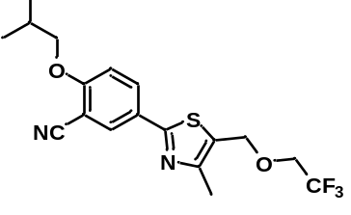2-Isobutoxy-5-(4-methyl-5-((2,2,2-trifluoroethoxy)methyl)thiazol-2-yl)benzonitrile (51).
To a round-bottomed flask with a magnetic stirrer bar was added dry NaH (53 mg, 2.0 mmol, 2 equiv.) and DMF (2 mL, 0.5 M) under argon, followed by 2,2,2-trifluoroethanol (200 mg, 2.0 mmol, 2 equiv.) in DMF (1 mL) at 0 ºC. The reaction mixture was stirred for 20 min under argon. 5-(5-(Bromomethyl)-4-methylthiazol-2-yl)-2-isobutoxybenzonitrile (183 mg, 1.0 mmol, 1 equiv.) in DMF (2 mL) was then added dropwise at R. The reaction was loosely capped and stirred vigorously at 80 ºC for 2 h. The reaction mixture was poured onto water and extracted with DCM. The organic phase was dried (Mg₂SO₄), filtered, and concentrated in vacuo. Flash chromatography (ethyl acetate/n-hexane, 1: 3) of the residue gave 51 as a white solid (132 mg, 69% yield). Mp: 86–88 ºC .¹H NMR (400 MHz, CDCl₃) δ (ppm): 8.10 (d, J = 2.3 Hz, 1H), 8.02 (dd, J = 8.8, 2.3 Hz, 1H), 6.98 (d, J = 8.9 Hz, 1H), 4.81 (s, 2H), 4.07–3.52 (m, 4H), 2.45 (s, 3H), 2.19 (dp, J = 13.3, 6.7 Hz, 1H), 1.08 (d, J = 6.7 Hz, 6H); ¹⁹F NMR (376 MHz, CDCl₃) δ (ppm): –73.72 (t, J = 9.2 Hz, 3F); ¹³C NMR (101 MHz, CDCl₃) δ (ppm): 164.69, 162.10, 152.74, 132.32, 131.78, 126.78, 126.54, 124.08 (q, J = 279.3 Hz), 115.80, 112.74, 102.97, 75.80, 67.02 (q, J = 34.3 Hz), 65.45, 28.36, 19.25, 15.36. MS (ESI): 385.1 [M+H]⁺. HRMS (ESI) for C₁₈H₂₀N₂O₂F₃S [M+H]⁺: calc’d: 385.1198; found: 385.1203.
N-(2,6-Diethylphenyl)-N-(2-propoxyethyl)-2-(2,2,2-trifluoroethoxy)acetamide (52).
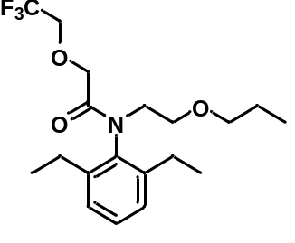To a round-bottomed flask equipped with a magnetic stirrer bar was added Cs₂CO₃ (652 mg, 2.0 mmol, 2 equiv.) and DMF (4 mL) under argon. The reaction mixture was stirred for 5 min. Pretilachlor (2-chloro-N-(2,6-diethylphenyl)-N-(2-propoxyethyl)acetamide; 312 mg, 1.0 mmol, 1 equiv.) was then added under argon. The reaction mixture was stirred vigorously at RT for 12 h, poured onto water, and extracted with DCM (2 × 15 mL). The organic phase was dried (Mg₂SO₄), filtered, and concentrated in vacuo. The residue was purified by flash chromatography (ethyl acetate/n-hexane, 1: 10) to afford the product as a colorless oil (301 mg, 80% yield). ¹H NMR (400 MHz, CDCl₃) δ (ppm): 7.25 (t, J = 7.7 Hz, 1H), 7.13 (d, J = 7.7 Hz, 2H), 3.90 (q, J = 8.8 Hz, 2H), 3.74–3.64 (m, 4H), 3.53 (t, J = 6.1 Hz, 2H), 3.25 (t, J = 6.7 Hz, 2H), 2.64–2.30 (m, 4H), 1.50–1.36 (m, 2H), 1.18 (t, J = 7.5 Hz, 6H), 0.78 (t, J = 7.4 Hz, 3H); ¹⁹F NMR (376 MHz, CDCl₃) δ (ppm): –74.33 (t, J = 8.8 Hz, 3F); ¹³C NMR (101 MHz, CDCl₃) δ (ppm): 169.44, 141.54, 137.20, 129.26, 126.99, 124.01 (q, J = 279.6 Hz), 72.85, 69.53, 68.53 (q, J = 34.2 Hz), 67.52, 49.69, 23.37, 22.95, 14.28, 10.63. MS (ESI): 376.2 [M+H]⁺. HRMS (ESI) for C₁₉H₂₉NO₃F₃ [M+H]⁺: calc’d: 376.2100; found: 376.2107.

3-(4,5-Diphenyloxazol-2-yl)propan-1-ol.
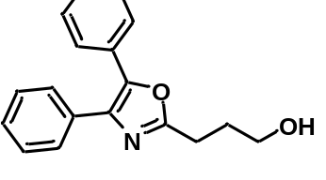 Oxaprozin (3-(4,5-diphenyloxazol-2-yl)propanoic acid; 2.93 g, 10 mmol, 1 equiv.) was dissolved in THF (20 mL) and BH₃·Me₂S (1.52 g, 20 mmol, 2 equiv.) was added dropwise at 0 ºC under argon. The mixture was stirred at RT for 12 h, quenched with MeOH, and washed with saturated aq. NH₄Cl. The aqueous phase was further extracted with ethyl acetate (2 × 15 mL). The combined organic phase was dried (Mg₂SO₄), filtered and concentrated under reduced pressure. The residue was purified by flash chromatography (ethyl acetate/n-hexane, 1: 2) to give the title compound as a white solid (2.01 g, 72% yield). Mp: 98–100 ºC. ¹H NMR (400 MHz, CDCl₃) δ (ppm): 7.60 (dd, J = 20.6, 7.1 Hz, 4H), 7.43–7.28 (m, 6H), 3.80 (t, J = 5.6 Hz, 2H), 3.11 (s, 1H), 2.99 (t, J = 7.1 Hz, 2H), 2.19–2.02 (m, 2H); ¹³C NMR (101 MHz, CDCl₃) δ (ppm): 163.72, 145.51, 135.01, 132.48, 129.14, 128.85, 128.77, 128.67, 128.29, 128.06, 126.67, 62.21, 29.66, 25.58. MS (ESI): 280.1 [M+H]⁺. HRMS (ESI) for C₁₈H₁₈NO₂ [M+H]⁺: calc’d: 280.1338; found: 280.1337.
3-(4,5-Diphenyloxazol-2-yl)propyl 4-methylbenzenesulfonate.
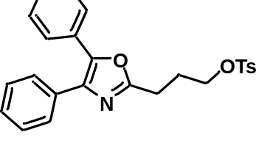General procedure 6 from 3-(4,5-diphenyloxazol-2-yl)propan-1-ol on a 5.0 mmol scale followed by flash chromatography (ethyl acetate/n-hexane, 1: 2) gave the title compound as a colorless oil (1.93 g, 89% yield). ¹H NMR (400 MHz, CDCl₃) δ (ppm): 7.81 (d, J = 8.2 Hz, 2H), 7.59 (dd, J = 16.0, 7.1 Hz, 4H), 7.43–7.32 (m, 6H), 7.30 (d, J = 8.2 Hz, 2H), 4.25 (t, J = 6.1 Hz, 2H), 2.93 (t, J = 7.3 Hz, 2H), 2.39 (s, 3H), 2.25 (p, J = 6.7 Hz, 2H); ¹³C NMR (101 MHz, CDCl₃) δ (ppm): 161.91, 145.55, 145.01, 135.22, 133.06, 132.59, 130.04, 129.09, 128.86, 128.75, 128.69, 128.28, 128.09, 128.04, 126.62, 69.34, 26.30, 24.27, 21.79. MS (ESI): 434.1 [M+H]⁺. HRMS (ESI) for C₂₅H₂₄NO₄S [M+H]⁺: calc’d: 434.1426; found: 434.1431.
4,5-Diphenyl-2-(3-(2,2,2-trifluoroethoxy)propyl)oxazole (53).
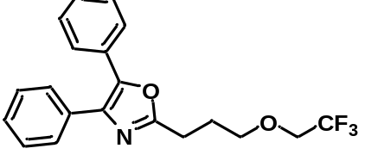General procedure 7 with 3-(4,5-diphenyloxazol-2-yl)propyl 4-methylbenzenesulfonate on a 1.0 mmol scale followed by flash chromatography (ethyl acetate/n-hexane, 1: 4) gave 53 as a colorless oil (280 mg, 78% yield). ¹H NMR (400 MHz, CDCl₃) δ (ppm): 7.62 (dd, J = 25.1, 6.9 Hz, 4H), 7.45–7.28 (m, 6H), 3.85 (q, J = 8.7 Hz, 2H), 3.77 (t, J = 6.1 Hz, 2H), 2.98 (t, J = 7.5 Hz, 2H), 2.50–1.99 (m, 2H); ¹⁹F NMR (376 MHz, CDCl₃) δ (ppm): –74.15 (t, J = 8.8 Hz, 3F); ¹³C NMR (101 MHz, CDCl₃) δ (ppm): 162.95, 145.45, 135.28, 132.76, 129.26, 128.82, 128.75, 128.58, 128.21, 128.09, 126.62, 124.21 (q, J = 279.6 Hz), 71.70, 68.58 (q, J = 34.0 Hz), 27.16, 24.83. MS (ESI): 362.1 [M+H]⁺. HRMS (ESI) for C₂₀H₁₉NO₂F₃ [M+H]⁺: calc’d: 362.1368; found: 362.1370.
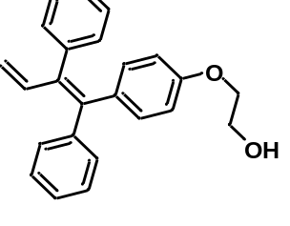(Z)-2-(4-(1,2-Diphenylbuta-1,3-dien-1-yl)phenoxy)ethan-1-ol.
Ospemifene ((Z)-2-(4-(4-chloro-1,2-diphenylbut-1-en-1-yl)phenoxy)ethan-1-ol; 2.27 g, 6.0 mmol, 1 equiv.) and DMF (30 mL) were added to a round-bottomed flask equipped with a magnetic stirrer bar under argon. Then potassium tert-butoxide (1.35 g, 12 mmol, 2 equiv.) was added at 0 ºC and the reaction mixture was stirred at RT for 12 h. The reaction mixture was then poured onto water and extracted with DCM (2 × 15 mL). The organic phase was dried (Mg₂SO₄), filtered, and concentrated in vacuo. The residue was purified by silica gel flash chromatography (ethyl acetate/n-hexane, 1: 4) to give the title compound as a white solid (1.95 g, 95% yield). Mp: 114–116 ºC. ¹H NMR (400 MHz, CDCl₃) δ (ppm): 7.41–7.08 (m, 10H), 6.83–6.64 (m, 3H), 6.61–6.49 (m, 2H), 5.12 (dd, J = 10.7, 1.7 Hz, 1H), 4.90 (dd, J = 17.3, 1.7 Hz, 1H), 3.93 (dd, J = 5.1, 3.7 Hz, 2H), 3.89–3.65 (m, 2H), 2.05 (t, J = 6.1 Hz, 1H); ¹³C NMR (101 MHz, CDCl₃) δ (ppm): 157.06, 142.72, 141.91, 140.35, 138.76, 138.54, 135.74, 132.41, 131.59, 131.14, 128.13, 128.06, 127.37, 126.65, 117.71, 113.52, 69.06, 61.59. MS (ESI): 343.2 [M+H]⁺. HRMS (ESI) for C₂₄H₂₃O₂ [M+H]⁺: calc’d: 343.1698; found: 343.1704.
(Z)-2-(4-(1,2-Diphenylbuta-1,3-dien-1-yl)phenoxy)ethyl 4-methylbenzenesulfonate.
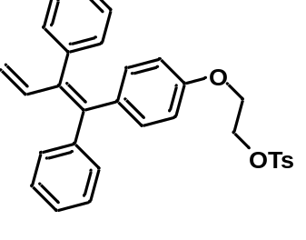General procedure 6 with (Z)-2-(4-(1,2-diphenylbuta-1,3-dien-1-yl)phenoxy)ethan-1-ol on a 5.0 mmol scale followed by flash chromatography (ethyl acetate/n-hexane, 1: 4) gave the title compound as a pale–yellow solid (1.93 g, 78% yield). Mp: 52–54 ºC. ¹H NMR (400 MHz, CDCl₃) δ (ppm): 7.76 (d, J = 8.0 Hz, 2H), 7.45–7.01 (m, 12H), 6.90–6.55 (m, 3H), 6.41 (d, J = 8.4 Hz, 2H), 5.11 (d, J = 10.8 Hz, 1H), 4.89 (d, J = 17.2 Hz, 1H), 4.49–4.13 (m, 2H), 3.97–3.99 (m, 2H), 2.40 (s, 3H); ¹³C NMR (101 MHz, CDCl₃) δ (ppm): 156.41, 145.06, 142.60, 141.77, 140.23, 138.66, 138.59, 135.94, 132.98, 132.30, 131.53, 131.07, 129.99, 128.14, 128.11, 128.03, 127.36, 126.66, 117.77, 113.48, 68.26, 65.26, 21.79. MS (ESI): 514.2 [M+NH₄]⁺. HRMS (ESI) for C₃₁H₃₂NO₄S [M+ NH₄]⁺: calc’d: 514.2052; found: 514.2045.
(Z)-(1-(4-(2-(2,2,2-trifluoroethoxy)ethoxy)phenyl)buta-1,3-diene-1,2-di-yl)dibenzene (54).
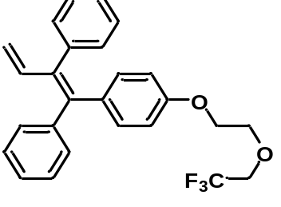General procedure 7 with (Z)-2-(4-(1,2-diphenylbuta-1,3-dien-1-yl)phenoxy)ethyl 4-methylbenzenesulfonate on a 0.5 mmol scale followed by flash chromatography (ethyl acetate/n-hexane, 1: 20) gave 54 as a colorless oil (84 mg, 40% yield). ¹H NMR (400 MHz, CDCl₃) δ (ppm): 7.41–7.01 (m, 10H), 6.86–6.64 (m, 3H), 6.60–6.44 (m, 2H), 5.12 (dd, J = 10.7, 1.7 Hz, 1H), 4.90 (dd, J = 17.3, 1.7 Hz, 1H), 4.01 (dd, J = 5.5, 3.6 Hz, 2H), 3.96–3.73 (m, 4H); ¹⁹F NMR (376 MHz, CDCl₃) δ (ppm): –74.27 (t, J = 8.8 Hz, 3F); ¹³C NMR (101 MHz, CDCl₃) δ (ppm): 156.95, 142.74, 141.94, 140.36, 138.77, 138.59, 135.81, 132.41, 131.62, 131.16, 128.15, 128.07, 127.38, 126.67, 124.14 (q, J = 279.8 Hz), 117.72, 113.58, 71.24, 69.11 (q, J = 34.1 Hz), 67.36 . MS (ESI): 425.2 [M+H]⁺. HRMS (ESI) for C₂₆H₂₄O₂F₃ [M+H]⁺: calc’d: 425.1728; found: 425.1728.
(E)-2-(2-(4-(3,5-Dimethoxystyryl)phenoxy)ethoxy)ethanol.
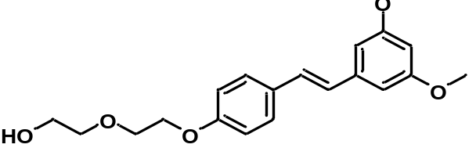 Pterostilbene (4-[(1E)-2-(3,5-dimethoxyphenyl)ethenyl]phenol; 2.56 g, 10.0 mmol, 1 equiv.), Cs₂CO₃ (4.89 g, 15.0 mmol, 1.5 equiv.) and DMF (30 mL) were added to a round-bottomed flask equipped with a magnetic stirrer bar under argon. The reaction mixture was stirred at 60 ºC for 12 h. The reaction mixture was then poured onto water and extracted with DCM (2 × 15 mL). The organic phase was dried (Mg₂SO₄), filtered, and concentrated in vacuo. The residue was purified by flash chromatography (ethyl acetate/n-hexane, 2: 1) to give the title compound as a colorless oil (1.41 g, 41% yield). ¹H NMR (400 MHz, CDCl₃) δ (ppm): 7.43 (d, J = 8.7 Hz, 2H), 7.10–6.76 (m, 4H), 6.65 (d, J = 2.2 Hz, 2H), 6.38 (t, J = 2.2 Hz, 1H), 4.24–4.09 (m, 2H), 3.87 (dd, J = 5.4, 4.0 Hz, 2H), 3.82 (s, 6H), 3.80–3.74 (m, 2H), 3.70–3.64 (m, 2H), 2.33 (t, J = 6.1 Hz, 1H); ¹³C NMR (101 MHz, CDCl₃) δ (ppm): 161.13, 158.62, 139.81, 130.43, 128.81, 127.99, 126.92, 114.99, 104.52, 99.82, 72.79, 69.82, 67.62, 61.95, 55.52. MS (ESI): 345.2 [M+H]⁺. HRMS (ESI) for C₂₀H₂₅O₅ [M+H]⁺: calc’d: 345.1702; Found: 345.1708.
(E)-2-(2-(4-(3,5-Dimethoxystyryl)phenoxy)ethoxy)ethyl 4-methylbenzenesulfonate
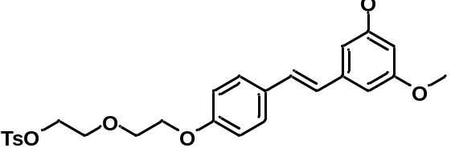 General procedure 6 with (E)-2-(2-(4-(3,5-dimethoxystyryl)phenoxy)ethoxy)ethanol on a 4.0 mmol followed by flash chromatography (ethyl acetate/n-hexane, 1: 1) gave the title compound as a colorless oil (1.62 g, 81% yield). ¹H NMR (400 MHz, CDCl₃) δ (ppm): 7.80 (d, J = 8.3 Hz, 2H), 7.43 (d, J = 8.7 Hz, 2H), 7.30 (d, J = 8.1 Hz, 2H), 7.12–6.81 (m, 4H), 6.65 (d, J = 2.2 Hz, 2H), 6.38 (t, J = 2.2 Hz, 1H), 4.28–4.15 (m, 2H), 4.14–3.97 (m, 2H), 3.83 (s, 6H), 3.82–3.73 (m, 4H), 2.41 (s, 3H); ¹³C NMR (101 MHz, CDCl₃) δ (ppm): 161.16, 158.63, 145.01, 139.82, 133.15, 130.41, 130.00, 128.84, 128.17, 127.98, 126.93, 114.99, 104.54, 99.84, 70.05, 69.44, 69.10, 67.62, 55.55, 21.81. MS (ESI): 499.2 [M+NH₄]⁺. HRMS (ESI) for C₂₇H₃₁O₇S [M+NH₄]⁺: calc’d: 499.1790; found: 499.1786.
(E)-1,3-Dimethoxy-5-(4-(2-(2-(2,2,2-trifluoroethoxy)ethoxy)ethoxy)styryl)benzene (55).
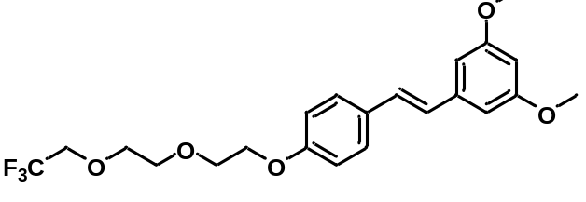General procedure 7 with (E)-2-(2-(4-(3,5-dimethoxystyryl)phenoxy)ethoxy)ethyl 4-methylbenzenesulfonate on a 0.5 mmol scale followed by flash chromatography (ethyl acetate/n-hexane, 1: 2) gave 55 as a colorless oil (185 mg, 87% yield). ¹H NMR (400 MHz, CDCl₃) δ (ppm): 7.44 (d, J = 8.7 Hz, 2H), 6.96 (dt, J = 13.1, 10.3 Hz, 4H), 6.66 (d, J = 2.2 Hz, 2H), 6.39 (t, J = 2.2 Hz, 1H), 4.24–4.09 (m, 2H), 3.92 (q, J = 8.8 Hz, 2H), 3.87 (dd, J = 5.4, 4.1 Hz, 2H), 3.84–3.79 (m, 8H), 3.79–3.72 (m, 2H); ¹⁹F NMR (376 MHz, CDCl₃) δ (ppm): –74.23 (t, J = 8.8 Hz, 3F); ¹³C NMR (101 MHz, CDCl₃) δ (ppm): 161.15, 158.72, 139.84, 130.34, 128.86, 127.97, 126.86, 124.22 (q, J = 279.6 Hz), 115.00, 104.52, 99.81, 72.14, 71.06, 70.04, 68.98 (q, J = 33.9 Hz), 67.61, 55.51.
(R)-3-fluoro-4-(4-(1-hydroxypropan-2-yloxy)phenoxy)benzonitrile.
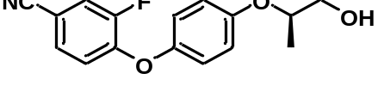To a round-bottomed flask equipped with a magnetic stirrer bar was added CaCl₂ (666 mg, 6.0 mmol, 1 equiv.) and ethanol (200 proof, 30 mL), followed by NaBH₄ (681 mg, 18 mmol, 3 equiv.) at 0 ºC. The reaction mixture was stirred for 10 min. Butyl (R)-2-(4-(4-cyano-2-fluorophenoxy)phenoxy)propanoate (2.14 g, 6.0 mmol, 1 equiv.) was then added and the reaction mixture was stirred at 60 ºC for 3 h. The reaction mixture was quenched with water and extracted with DCM (2 × 15 mL). The organic phase was dried (Mg₂SO₄), filtered, and concentrated in vacuo. The residue was purified by flash chromatography (ethyl acetate/n-hexane, 1: 2) to give the title compound as a white solid (1.21 g, 70% yield). Mp: 86–88 ºC. ¹H NMR (400 MHz, CDCl₃) δ (ppm): 7.44 (dd, J = 10.2, 1.9 Hz, 1H), 7.36–7.28 (m, 1H), 7.04–6.91 (m, 4H), 6.87 (t, J = 8.3 Hz, 1H), 4.46 (m, , 1H), 3.91–3.56 (m, 2H), 2.19 (s, 1H), 1.28 (d, J = 6.2 Hz, 3H); ¹⁹F NMR (376 MHz, CDCl₃) δ (ppm): –130.13 (t, J = 8.9 Hz, 1F); ¹³C NMR (101 MHz, CDCl₃) δ (ppm): 155.37, 152.24 (d, J = 303.6 Hz), 151.04 (d, J = 41.2 Hz), 148.34, 129.52 (d, J = 4.1 Hz), 121.30, 120.70 (d, J = 21.2 Hz), 118.59 (d, J = 1.8 Hz), 117.85 (d, J = 2.5 Hz), 117.75, 106.05 (d, J = 8.2 Hz), 75.72, 66.35, 15.95.
(R)-2-(4-(4-Cyano-2-fluorophenoxy)phenoxy)propyl 4-methylbenzenesulfonate.
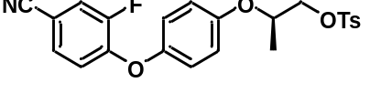General procedure 6 with (R)-3-fluoro-4-(4-(1-hydroxypropan-2-yloxy)phenoxy)benzonitrile on a 4.0 mmol scale followed by flash chromatography (ethyl acetate/n-hexane, 1: 3) gave the title product as a colorless oil (1.53 g, 86% yield). Mp: 80–82 ºC; ¹H NMR (400 MHz, CDCl₃) δ (ppm): 7.78 (d, J = 8.3 Hz, 2H), 7.45 (dd, J = 10.2, 1.9 Hz, 1H), 7.34 (dd, J = 8.5, 3.4 Hz, 3H), 7.03–6.91 (m, 2H), 6.91–6.77 (m, 3H), 4.65–4.43 (m, 1H), 4.12 (ddd, J = 14.9, 10.6, 5.2 Hz, 2H), 2.44 (s, 3H), 1.31 (d, J = 6.3 Hz, 3H); ¹⁹F NMR (376 MHz, CDCl₃) δ (ppm): –130.06 (t, J = 9.0 Hz, 1F); ¹³C NMR (101 MHz, CDCl₃) δ (ppm): 154.87 (s), 152.54 (d, J = 251.7 Hz), 150.69 (d, J = 10.6 Hz), 148.65, 145.21, 132.97, 130.07, 129.55 (d, J = 3.8 Hz), 128.13, 121.23, 120.74 (d, J = 21.2 Hz), 118.72 (d, J = 1.6 Hz), 117.85 (d, J = 2.4 Hz), 117.80, 106.20 (d, J = 8.1 Hz), 72.50, 71.89, 21.83, 16.68. MS (ESI): 459.1 [M+NH₄]⁺. HRMS (ESI) for C₂₃H₂₄N₂O₅FS [M+NH₄]⁺: calc’d: 459.1390; found: 459.1398.
(R)-3-fluoro-4-(4-(1-(2,2,2-trifluoroethoxy)propan-2-yloxy)phenoxy)benzonitrile (56).
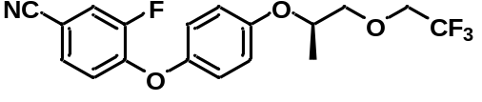General procedure 7 with (R)-2-(4-(4-cyano-2-fluorophenoxy)phenoxy)propyl 4-methylbenzenesulfonate on a 0.5 mmol scale followed by flash chromatography (ethyl acetate/n-hexane, 1: 10) gave 56 as a colorless oil (78 mg, 42% yield). ¹H NMR (400 MHz, CDCl₃) δ (ppm): 7.44 (dd, J = 10.2, 1.9 Hz, 1H), 7.39–7.30 (m, 1H), 7.08–6.92 (m, 4H), 6.87 (t, J = 8.3 Hz, 1H), 4.64–4.35 (m, 1H), 4.09–3.86 (m, 2H), 3.84–3.69 (m, 2H), 1.33 (d, J = 6.3 Hz, 3H); ¹⁹F NMR (376 MHz, CDCl₃) δ (ppm): –74.30 (t, J = 9.1 Hz, 3F); –130.21 (d, J = 9.7 Hz, 1F); ¹³C NMR (101 MHz, CDCl₃) δ (ppm): 155.37, 152.27 (d, J = 302.7 Hz), 151.07 (d, J = 40.1 Hz), 148.41, 129.53 (d, J = 4.0 Hz), 124.11 (q, J = 279.8 Hz), 121.30, 120.70 (d, J = 21.2 Hz), 118.61 (d, J = 1.6 Hz), 117.88 (d, J = 2.4 Hz), 117.82, 106.09 (d, J = 8.1 Hz), 75.82, 74.29, 69.18 (q, J = 34.2 Hz), 16.67 .
2.4. Synthesis of PS13 analogue 57 and precursor for radiolabeling.
2-(1,5-Bis(4-methoxyphenyl)-1H-1,2,4-triazol-3-yloxy)ethanol.
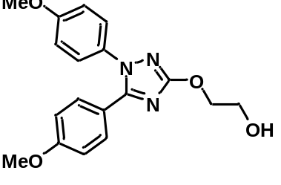1,5-Bis(4-methoxyphenyl)-1H-1,2,4-triazol-3-ol (1.49 g, 5.0 mmol, 1 equiv.), 2-bromoethanol (1.25 g, 10 mmol, 2 equiv.) and Cs₂CO₃ (3.26 g, 10 mmol, 2 equiv.) were added to a round-bottomed flask equipped with a magnetic stirrer bar. The flask was thrice evacuated and backfilled with pure argon. DMF (20 mL) was added from a syringe and the mixture was stirred for 12 h at 80 ºC under argon. Water (30 mL) was added. The mixture was extracted with DCM (2 × 15 mL), washed with brine, dried (Mg₂SO₄), and concentrated under reduced pressure. The residue was purified by flash chromatography (ethyl acetate/n-hexane, 3: 1) to give the title compound (1.23 g, 72% yield) as a white solid. Mp: 104–106 ºC. ¹H NMR (400 MHz, CDCl₃) δ (ppm): 7.38–7.26 (m, 2H), 7.25–7.12 (m, 2H), 6.95–6.80 (m, 2H), 6.80–6.67 (m, 2H), 4.50–4.28 (m, 2H), 3.90 (d, J = 3.3 Hz, 2H), 3.77 (s, 3H), 3.73 (s, 3H), 3.11 (s, 1H); ¹³C NMR (101 MHz, CDCl₃) δ (ppm): 167.66, 161.08, 159.91, 153.22, 131.40, 130.43, 127.26, 120.03, 114.76, 114.11, 71.74, 62.03, 55.74, 55.49. MS (ESI): 274.0 [M+H]⁺. HRMS (ESI) for C₁₈H₂₀N₃O₄ [M+H]⁺: calc’d: 342.1454; found: 342.1457.
2-(1,5-Bis(4-methoxyphenyl)-1H-1,2,4-triazol-3-yloxy)ethyl 4-methylbenzenesulfonate.
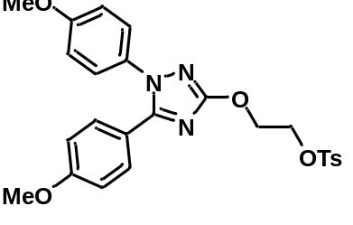General procedure 6 with 2-(1,5-bis(4-methoxyphenyl)-1H-1,2,4-triazol-3-yloxy)ethanol on a 3.0 mmol scale followed by flash chromatography (ethyl acetate/n-hexane, 1: 1) gave the title compound as a colorless oil (1.39 g, 93% yield). ¹H NMR (400 MHz, CDCl₃) δ (ppm): 7.82 (d, J = 8.3 Hz, 2H), 7.43–7.35 (m, 2H), 7.32 (d, J = 8.0 Hz, 2H), 7.25–7.17 (m, 2H), 6.96–6.86 (m, 2H), 6.86–6.76 (m, 2H), 4.52 (dd, J = 5.6, 3.8 Hz, 2H), 4.41 (dd, J = 5.5, 3.8 Hz, 2H), 3.84 (s, 3H), 3.80 (s, 3H), 2.40 (s, 3H); ¹³C NMR (101 MHz, CDCl₃) δ (ppm): 167.10, 161.14, 159.98, 153.35, 145.12, 133.07, 131.50, 130.48, 130.11, 128.32, 127.28, 120.18, 114.83, 114.16, 68.00, 66.85, 55.83, 55.57, 21.91. MS (ESI): 496.1 [M+H]⁺. HRMS (ESI) for C₂₅H₂₆N₃O₆S [M+H]⁺: calc’d: 496.1542; found: 496.1537.
General procedure 8.
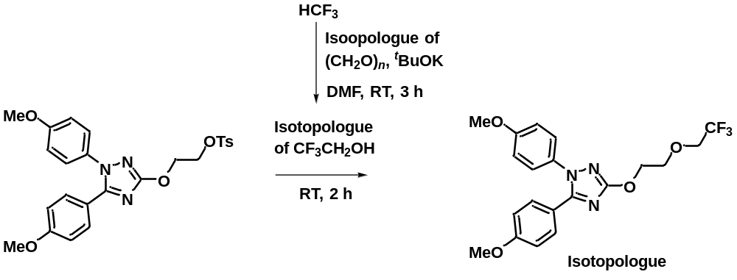
Figure S10. General procedure 8 for the synthesis of PS13 analogues.
1,5-Bis(4-methoxyphenyl)-3-(2-(2,2,2-trifluoroethoxy)ethoxy)-1H-1,2,4-triazole.
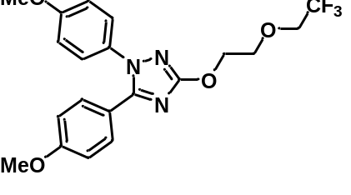The synthesis of this compound exemplifies general procedure 8, as follows. To a round-bottomed flask equipped with a magnetic stirrer bar was added paraformaldehyde (15 mg, 0.5 mmol, 3.0 equiv.) and t-BuOK (56 mg, 0.5 mmol, 3.0 equiv.), and then DMF (3 mL) under argon. A DMF solution of fluoroform (0.3 M, 0.17 mmol, 0.6 mL) was added and the reaction was stirred at RT for 3 h. 2-(1,5-Bis(4-methoxyphenyl)-1H-1,2,4-triazol-3-yloxy)ethyl 4-methylbenzenesulfonate (248 mg, 0.5 mmol, 3 equiv.) was added and the reaction stirred for another 2 h. Water (2 mL) was added and the mixture was extracted with DCM (2 × 5 mL), washed with brine, dried (Mg₂SO₄), and concentrated under reduced pressure. The residue was purified by flash chromatography (ethyl acetate/n-hexane, 1: 2) to give the product (52 mg, 72% yield) as a colorless oil. ¹H NMR (400 MHz, CDCl₃) δ (ppm): 7.50–7.35 (m, 2H), 7.35–7.17 (m, 2H), 6.99–6.87 (m, 2H), 6.87–6.69 (m, 2H), 4.64–4.46 (m, 2H), 4.12–3.91 (m, 4H), 3.85 (s, 3H), 3.81 (s, 3H); ¹⁹F NMR (376 MHz, CDCl₃) δ (ppm): –74.34 (t, J = 8.6 Hz, 3F); ¹³C NMR (101 MHz, CDCl₃) δ (ppm): 167.49, 161.05, 159.90, 153.35, 131.53, 130.45, 127.28, 124.18 (q, J = 279.5 Hz), 120.23, 114.76, 114.09, 71.04, 69.18 (q, J = 33.9 Hz), 69.08, 55.74, 55.48. MS (ESI): 424.2 [M+H]⁺. HRMS (ESI) for C₂₀H₂₁N₃O₄F₃ [M+H]⁺: calc’d: 424.1484; found: 424.1478.
1,5-bis(4-methoxyphenyl)-3-(2-(2,2,2-trifluoroethoxy-1,1-d₂)ethoxy)-1H-1,2,4-triazole.
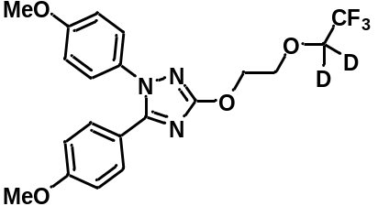General procedure 8 with paraformaldehyde-d₂ ((CD₂O)_{n}) instead of paraformaldehyde followed by flash chromatography (ethyl acetate/n-hexane, 1: 2) gave the title compound as a colorless oil (35 mg, 48% yield). ¹H NMR (400 MHz, CDCl₃) δ (ppm): 7.51–7.37 (m, 2H), 7.37–7.14 (m, 2H), 7.01–6.86 (m, 2H), 6.86–6.74 (m, 2H), 4.59–4.43 (m, 2H), 4.10–3.94 (m, 2H), 3.84 (s, 3H), 3.80 (s, 3H); ¹⁹F NMR (376 MHz, CDCl₃) δ (ppm): –74.49 (s, 3F); ¹³C NMR (101 MHz, CDCl₃) δ (ppm): 167.47, 161.06, 159.91, 153.36, 131.53, 130.46, 127.29, 124.17 (q, J = 279.6 Hz), 120.21, 114.77, 114.10, 70.97, 69.12, 55.76, 55.50. MS (ESI): 426.2 [M+H]⁺. HRMS (ESI) for C₂₀¹H₁₉²H₂N₃O₄F₃ [M+H]^{+:} calc’d: 426.1610; found: 426.1604.
1,5-Bis(4-methoxyphenyl)-3-(2-(2,2,2-trifluoroethoxy-1-¹³C)ethoxy)-1H-1,2,4-triazole.
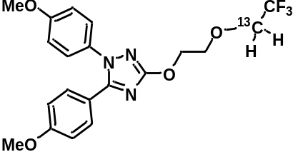General procedure 8 with [¹³C]paraformaldehyde ((¹³CH₂O)_{n}) instead of paraformaldehyde followed by flash chromatography (ethyl acetate/n-hexane, 1: 2) to give the title compound as a colorless oil (40 mg, 56% yield). ¹H NMR (400 MHz, CDCl₃) δ (ppm): 7.50–7.36 (m, 2H), 7.35–7.16 (m, 2H), 7.00–6.87 (m, 2H), 6.87–6.67 (m, 2H), 4.65–4.45 (m, 2H), 4.17 (q, J = 8.7 Hz, 1H), 4.08–3.96 (m, 2H), 3.84–3.78 (m, 7H); ¹⁹F NMR (376 MHz, CDCl₃) δ (ppm): –68.59 to –81.62 (m, 3F); ¹³C NMR (101 MHz, CDCl₃) δ (ppm): 167.48, 161.05, 159.90, 153.36, 131.53, 130.46, 127.29, 120.22, 114.77, 114.09, 71.04, 69.20 (q, J = 34.2 Hz), 55.76, 55.50. MS (ESI): 425.2 [M+H]⁺. HRMS (ESI) for ¹²C₁₉¹³C₁H₂₁N₃O₄F₃ [M+H]⁺: calc’d: 425.1518; found: 425.1515.

Radiochemistry Procedures

3. General HPLC methods
Column: Luna C18(2) (10 µm, 250 × 4.6 mm; i.d. Phenomenex).
The detection wavelength used for HPLC measurements was 254 nm.
Radioactivity was measured using an in-line Flow-Count PMT radioactivity detector (Eckert & Ziegler)).
3.1. HPLC condition A
Solvent A: H₂O, Solvent B: MeCN
Flow rate: 2 mL/min
0–1 min: 40% B
1–3 min: 40% to 60% B
3–6 min: 60% to 95% B
6–12 min: 95% B
3.2. HPLC condition B
Solvent A: H₂O, Solvent B: MeCN
Flow rate = 2 mL/min
0–1 min: 30% B
1–5 min: 30% to 50% B
5–10 min: 50% to 90% B
10–12 min: 90% B
3.3. HPLC condition C
Solvent A: H₂O, Solvent B: MeCN
Flow rate = 2 mL/min
0–1 min: 30% B
1–15 min: 30% to 80% B
3.4. HPLC condition D
Solvent A: H₂O, Solvent B: MeCN
Flow rate = 2 mL/min
0–1 min: 30% B
1–5 min: 30% to 50% B
5–10 min: 90% B
10–15 min: 90% B
3.5. HPLC condition E
Solvent A: H₂O, Solvent B: MeCN
Flow rate = 2 mL/min
0–5 min: 30% B
5–10 min: 30% to 50% B
10–12 min: 50% to 90% B

4. Syntheses of [¹¹C]fluoroform and [¹⁸F]fluoroform
4.1. General procedure for the preparation of [¹¹C]fluoroform ¹³
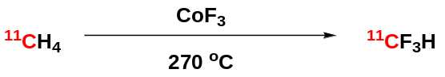
Figure S11. The preparation of [¹¹C]fluoroform from [¹¹C]methane.
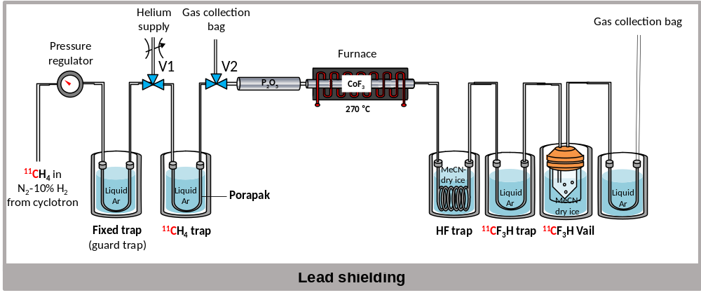
Figure S12. Apparatus for [¹¹C]fluoroform synthesis.
4.1.1. The preparation of [¹¹C]methane.
[¹¹C]Methane was produced by the ¹⁴N(p,α)¹¹C nuclear reaction by irradiation of nitrogen gas (164 psi) containing hydrogen (10%) with a proton beam (16.5 MeV; 5–45 μA) generated with a PETtrace 200 cyclotron (GE Healthcare) for 3 to 10 min.
4.1.2. The preparation of [¹¹C]fluoroform.
The apparatus for [¹¹C]fluoroform synthesis is shown in Figure S12. [¹¹C]Methane (3.7–5.5 GBq) was trapped by passing gas from the irradiated cyclotron target through both cooled U-traps and out into a bag for the safe collection of the nitrogen-hydrogen gas mixture and any untrapped radioactivity. When radioactivity in the cooled Porapak [¹¹C]methane trap had maximized, as indicated by a nearby radiation detector, the liquid argon coolant was removed. The trap was then allowed to warm to RT under a controlled helium flow (20 mL/min) to direct and pass [¹¹C]methane through a heated CoF₃ column, through the cooled HF trap, and into the cooled [¹¹C]fluoroform collection trap. This transfer generally took about 15 min. Then [¹¹C]fluoroform trap was put in warm water (60 ºC) for another 35-45 s to release [¹¹C]fluoroform into a vial containing DMF (0.8 mL) at –40 ºC. The yield of [¹¹C]fluoroform from [¹¹C]methane was usually 35–55% accompanied by 10–50% [¹¹C]fluoromethane. This solution was used for further reactions. The yields of the reaction products are based on the [¹¹C]fluoroform and calculated by decay-correction to the beginning of HPLC analysis. We confirmed that all the radioactivity injected onto the HPLC column was fully recovered.
4.1.3. HPLC analysis of [¹¹C]fluoroform.
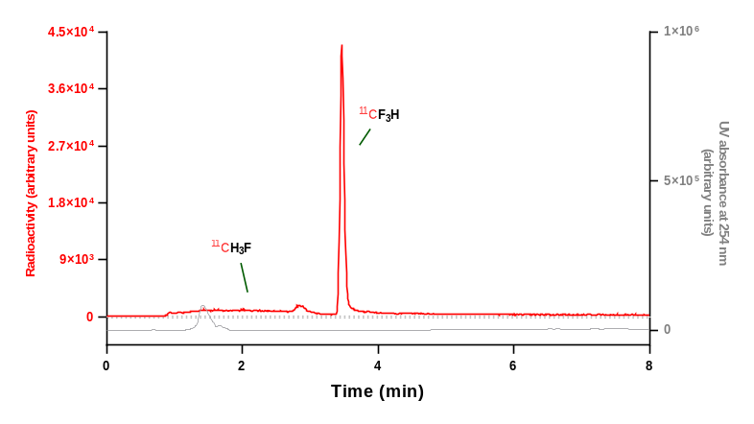
Figure S13. Analytical HPLC chromatogram for [¹¹C]fluoroform in collection solvent. [¹¹C]Fluoroform solution in DMF (0.8 mL) was analyzed with HPLC condition A. HPLC yields of [¹¹C]fluoroform were around 50–85% and the byproduct of this production was [¹¹C]fluoromethane.
4.2. General procedure for the preparation of [¹⁸F]fluoroform.¹⁴
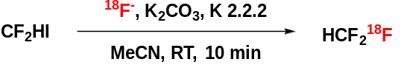
Figure S14. The preparation of [¹⁸F]fluoroform from difluoroiodomethane.
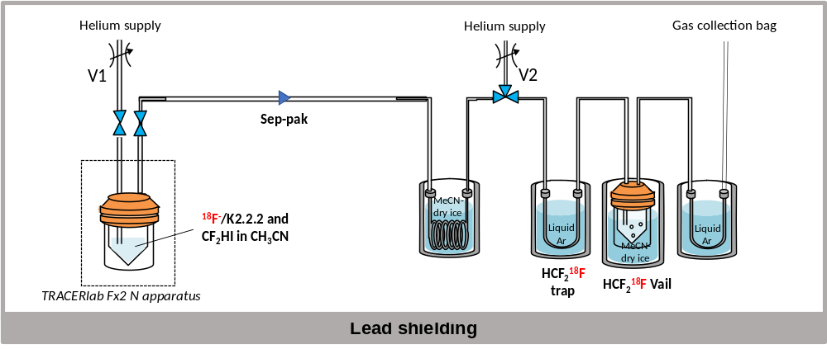
Figure S15. Apparatus for [¹⁸F]fluoroform synthesis from difluoroiodomethane.
4.2.1. Preparation of [¹⁸F]fluoroform.
The apparatus for [¹⁸F]fluoroform synthesis is depicted in Figure S15. [¹⁸F]Fluoride ion was produced on a cyclotron (PETtrace; GE Healthcare) according to the ¹⁸O(p,n)¹⁸F reaction by irradiating ¹⁸O-enriched water (3 mL, 98 atom%) with a beam of protons (35 MeV; 35-45 µA) for at least 45 min. [¹⁸F]Fluoroforrm was synthesized within a fully automated apparatus (TRACERlabTM FX2 NFX2N; GE Healthcare). Thus, [¹⁸F]fluoride ion (3.72–11.1 GBq) in [¹⁸O]water (200–400 µL) and a solution (100 µL) containing K₂CO₃ (3.4 µmol) plus K 2.2.2 (13.6 µmol) were loaded into a glass vial. MeCN (2 mL) was added, and the solvent was azeotropically removed at 80‒100 ºC under a stream of nitrogen gas that was vented to vacuum. This step was repeated after a second addition of MeCN (2 mL). A solution of difluoroiodomethane (8.0 mg, 45 µmol) in anhydrous acetonitrile (1.0 mL) was then added to the dried [¹⁸F]fluoride-K₂CO₃/K 2.2.2 complex, sealed, and heated at 35 °C for 10 min. [¹⁸F]Fluoroform was flushed out of the vial with helium (20 mL/min) and into the [¹⁸F]fluoroform trap. The transfer generally required 5 min. Then the [¹⁸F]fluoroform trap was put in warm water (60 ºC) for another 35 s to release [¹⁸F]fluoroform into a vial containing DMF (0.8 mL) and finally [¹⁸F]fluoroform solvent (35–65% yield from dried [¹⁸F]fluoride). The solution in the vial was used for further reactions.

4.2.2. HPLC analysis of [¹⁸F]fluoroform.
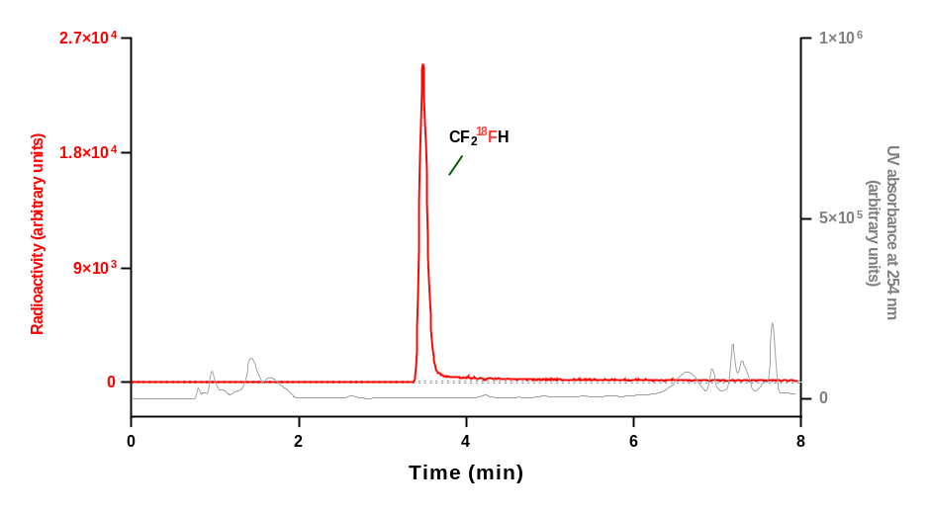
Figure S16. Analytical HPLC chromatogram for [¹⁸F]fluoroform in collection solvent. [¹⁸F]Fluoroform in DMF (0.8 mL) was analyzed using HPLC condition A. HPLC yields of [¹⁸F]fluoroform were quantitative (>99% yield).

5. General procedure for producing [¹¹C/¹⁸F]2,2,2-trifluoroethanol.
5.1. Optimization of the preparation of [¹¹C]2,2,2-trifluoroethanol.
Procedure
To a 10-mL vial contained within a glovebox was added t-BuOK and paraformaldehyde, followed by DMF (6 mL). The t-BuOK-paraformaldehyde mixture in DMF was kept in the glovebox until further use i.e., just before adding to [¹¹C]fluoroform (~ 30 min). A V-vial (1 mL) containing the DMF reagent mixture (200 µL) was closed with a septum-sealed cap and removed from the glovebox. [¹¹C]Fluoroform (37–296 MBq) in DMF (50–300 μL) was added to the vial, mixed by shaking, and left at RT for t min. The reaction was quenched by addition of water (100 μL). Then the reaction mixture was analyzed with radio-HPLC using HPLC condition A. Results are shown in Table S2.

Table S2. Optimization of the preparation of [¹¹C]2,2,2-trifluoroethanol from [¹¹C]fluoroform.
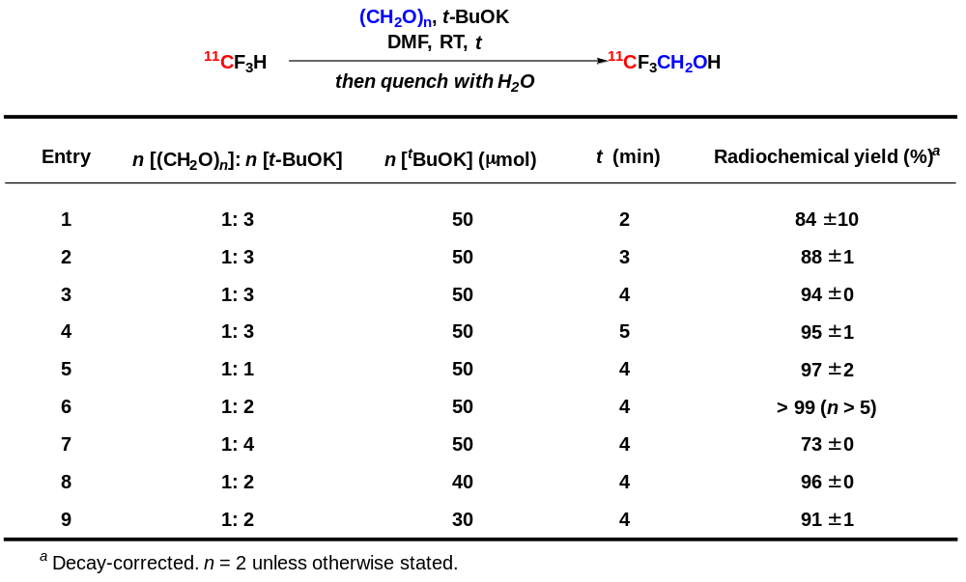
5.2. General procedure for the preparation of [¹¹C]2,2,2-trifluoroethanol and [¹⁸F]2,2,2-trifluoroethanol.
5.2.1. General procedure A.
To a 10-mL vial within a glovebox was added t-BuOK (112.2 mg, 1.0 mmol) and paraformaldehyde ((CH₂O)_{n}; 15.0 mg, 0.5 mmol), followed by DMF (6 mL). The DMF mixture of t-BuOK-(CH₂O)_{n} was stored in the glovebox for about 30 min. A V-vial (1 mL) containing of DMF reagent mixture (200 µL) was closed with a septum-sealed cap and removed from the glovebox. [¹¹C]Fluoroform or [¹⁸F]fluoroform (37–296 MBq) in DMF (50–300 μL) was added to the vial, mixed by shaking, and left at RT for 4 min. The reaction was quenched with water (100 μL) and then the mixture analyzed by HPLC. The corresponding products, ¹¹CF₃CH₂OH or CF₂¹⁸FCH₂OH, were formed in high yields (more than 95% in most cases).

5.2.2. HPLC analysis for [¹¹C]2,2,2-trifluoroethanol.
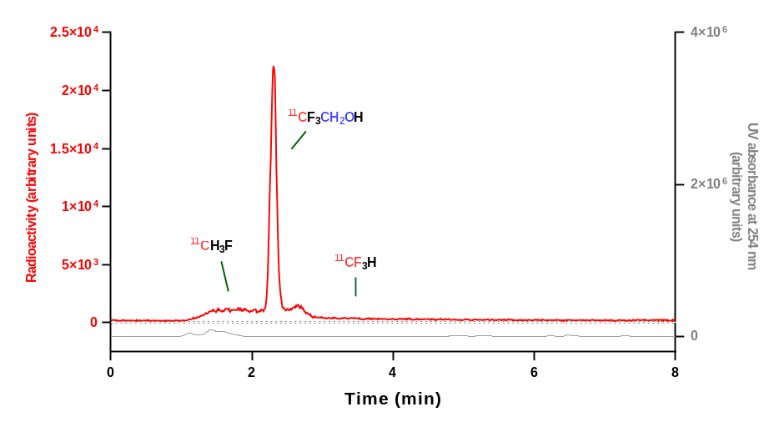
Figure S17. Analytical HPLC chromatogram for crude [¹¹C]2,2,2-trifluoroethanol reaction mixture. [¹¹C]2,2,2-trifluoroethanol was synthesized according to general procedure 1 and analyzed with HPLC condition A. HPLC yields of 2,2,2-trifluoroethanol were high (>99%) based on consuming [¹¹C]fluoroform (in most cases within 4 min).
5.2.3. HPLC analysis for [¹¹C]2,2,2-trifluoroethanol.
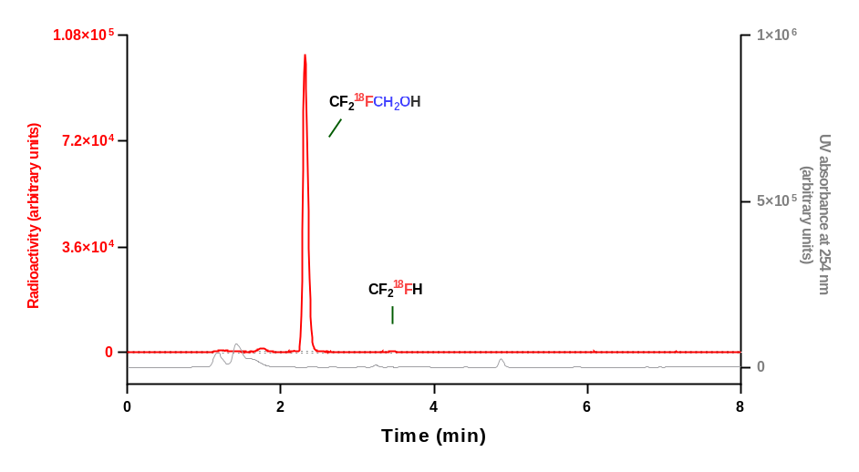
Figure S18. Analytical HPLC chromatogram for crude [¹¹C]2,2,2-trifluoroethanol. Reaction mixture. [¹¹C]2,2,2-trifluoroethanol was synthesized according to general procedure 1 and analyzed with HPLC condition A. HPLC yields of [¹¹C]2,2,2-trifluoroethanol. were high (> 95%) (in most cases within 4 min).

5.3. General procedure for the preparation of [¹¹C/¹⁸F]2,2,2-trifluoroethanol isotopologues.
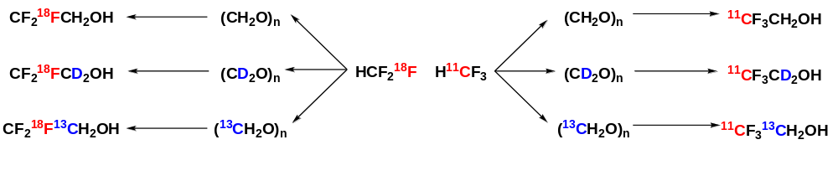
Figure S19. The preparation of [¹¹C/¹⁸F]2,2,2-trifluoroethanol isotopologues from radiolabeled fluoroform and isotopically labeled paraformaldehyde.
General procedure 1 was used for preparing ¹¹CF₃CD₂OH, CF₂¹⁸FCD₂OH, ¹¹CF₃¹³CH₂OH and CF₂¹⁸F¹³CH₂OH from the appropriately isotopically labeled paraformaldehyde. Deuterated paraformaldehyde (CD₂O)_{n} was used for the preparations of ¹¹CF₃CD₂OH and CF₂¹⁸FCD₂OH. [¹³C]Paraformaldehyde ((¹³CH₂O))_{n} was used for the preparations of ¹¹CF₃¹³CH₂OH and CF₂¹⁸F¹³CH₂OH. The different [¹¹C/¹⁸F]2,2,2-trifluoroethanol isotopologues were obtained in high yields (> 95% within 4 min).

6. General procedure for radio-2,2,2-trifluoroethoxylation.
6.1 The preparation of ¹¹C- or ¹⁸F- labeled 2,2,2-trifluoroethyl heterocyclic ethers.
General procedure B.
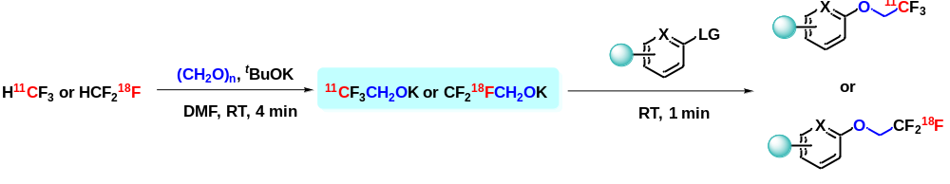
Figure S20. The preparation of radiolabeled 2,2,2-trifluoroethyl heterocyclic ethers.
To a 10-mL vial within a glovebox, was added t-BuOK (112.2 mg, 1.0 mmol) and (CH₂O)_{n} (15.0 mg, 0.5 mmol), followed by DMF (6 mL). The t-BuOK-(CH₂O)_{n} mixture in DMF was kept in the glovebox until further use (~ 30 min). A V-vial (1 mL) containing this reagent mixture in DMF (200 µL) was closed with a septum-sealed cap, removed from the glovebox, and taken to the hot-cell for further reaction. [¹¹C]Fluoroform or [¹⁸F]fluoroform (37–296 MBq) in DMF (50–300 μL) was added to the vial, mixed by shaking, and left at RT for 4 min. A DMF solution of heterocyclic precursor (50 μmol, 200 μL) was added to the reaction vial and the reaction mixture was allowed to react at RT for another 1 min. The reaction was quenched with water (100 μL) and the reaction mixture was analyzed with radio-HPLC.
6.2. Optimization of the preparation of ¹¹C- or ¹⁸F- labeled 2,2,2-trifluoroethyl aryl ethers.
6.2.1. Optimization.
Table S3. Optimization of the preparation of [¹¹C]1–(2,2,2-trifluoroethoxy)naphthalene.
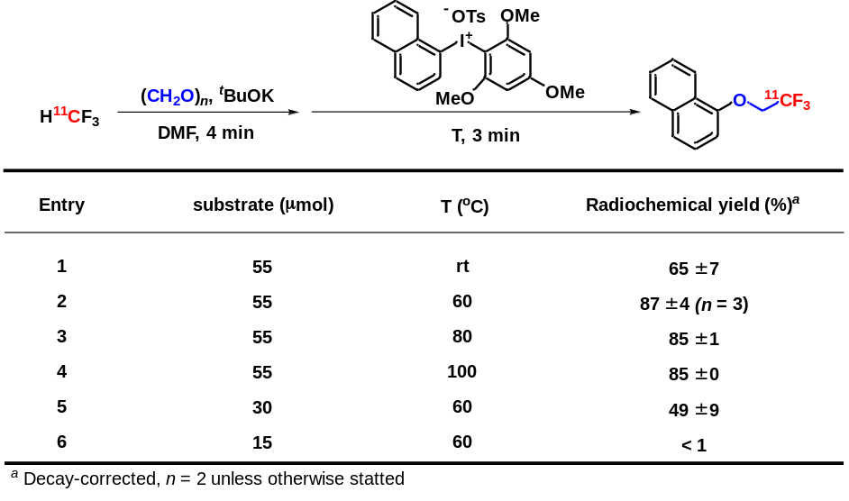
6.2.2. General procedure C.
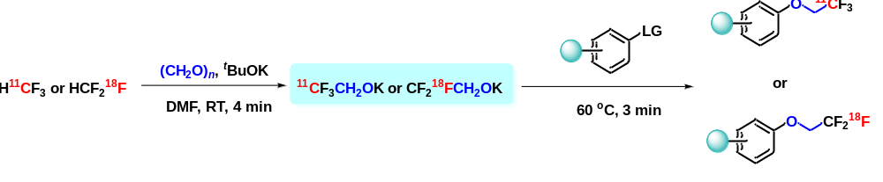
Figure S21. The preparation of radiolabeled 2,2,2-trifluoroethyl aryl ethers.
Within a glovebox, to a 10 mL vial was added t-BuOK (112.2 mg, 1.0 mmol) and (CH₂O)_{n} (15.0 mg, 0.5 mmol), followed by DMF (6 mL). The t-BuOK-(CH₂O)_{n} mixture in DMF was kept in the glovebox until further use (~ 30 min). A V-vial (1 mL) containing this reagent mixture in DMF (200 µL) was closed with a septum-sealed cap, removed from the glovebox, and taken to hot cell for further reaction. [¹¹C]Fluoroform or [¹⁸F]fluoroform (37–296 MBq) in DMF (50–300 μL) was added to the vial, mixed by shaking, and left at RT for 4 min. A DMF solution of benzenoid precursor, TMP iodonium salt or iodonium ylide (55 μmol, in 200 μL) was,added to the vial and the reaction mixture was heated at 60 ºC for 3 min. The reaction was then quenched with water (100 μL) and the reaction mixture was analyzed with radio-HPLC.
6.3. Optimization of the preparation of ¹¹C- or ¹⁸F- labeled 2,2,2-trifluoroethyl alkyl ethers.
6.3.1. Optimization.
Table S4. Optimization of the preparation of a ¹¹C-labeled 2,2,2-trifluoroethyl alkyl ether.
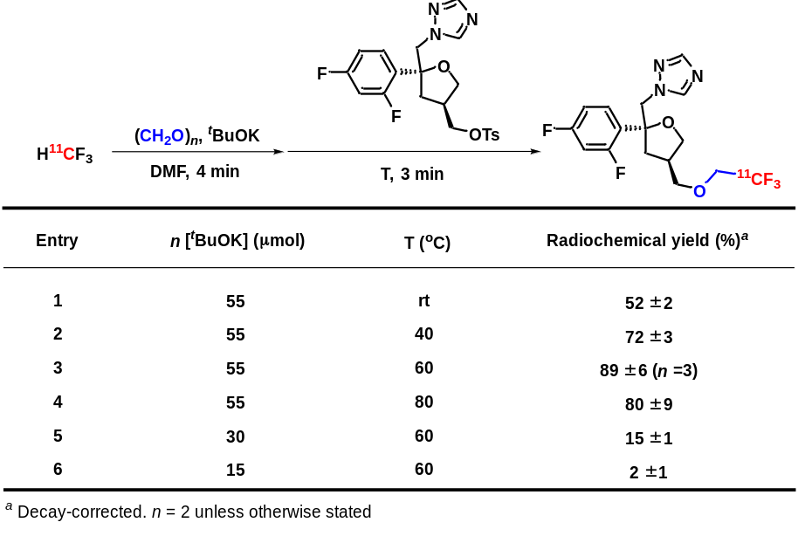
6.3.2. General procedure D.
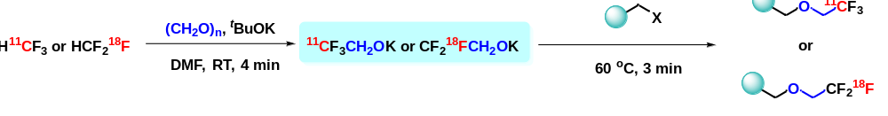
Figure S22. The preparation of radiolabeled 2,2,2-trifluoroethyl alkyl ethers.
To a 10-mL vial within a glovebox, was added t-BuOK (112.2 mg, 1.0 mmol) and (CH₂O)_{n} (15.0 mg, 0.5 mmol), followed by DMF (6 mL). The t-BuOK-(CH₂O)_{n} mixture in DMF was kept in the glovebox until further use (~ 30 min). A V-vial (1 mL) containing this reagent mixture in DMF (200 µL) was closed with a septum-sealed cap, removed from the glovebox, and taken to a hot-cell for further reaction. [¹¹C]Fluoroform or [¹⁸F]fluoroform (37–296 MBq) in DMF (50–300 μL) was added to the vial, mixed by shaking, and left at RT for 4 min. A DMF solution (200 μL) of alkyl precursor (55 μmol) was added and the reaction mixture heated at 60 ºC for another 3 min. The reaction was quenched with water (100 μL) and the reaction mixture analyzed with radio-HPLC.
6.4. The preparation of radiolabeled PS13 analogues.
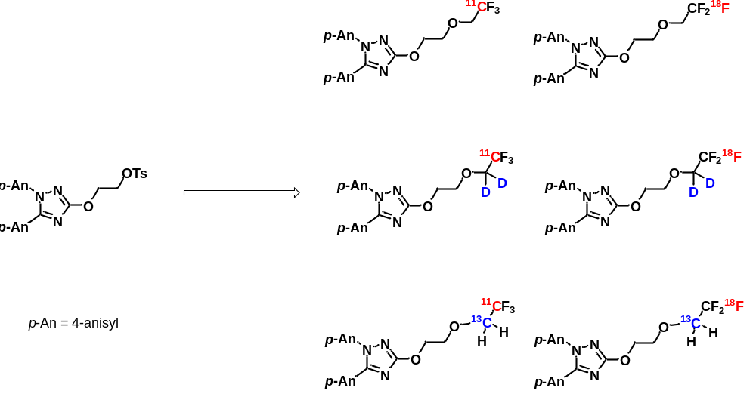
Figure S23. The preparation of radiolabeled PS13 analogues. These followed general procedure D using different isotopic paraformaldehydes. For the preparation of d₂-labled products, (CD₂O)_{n} was used instead of (CH₂O)_{n}. For the preparation of ¹³C-labeled products, (¹³CH₂O)_{n} was used instead of (CH₂O)_{n}. All the radioactive product identities were confirmed by LC-MS analysis of non–radioactive carrier after complete decay.
6.5. Determination of the molar activity for [¹¹C]1.
The molar activity of [¹¹C]1 was measured by HPLC determination of mass of carrier in a sample of analyte of known radioactivity amount from a calibrated UV absorbance response curve for reference 1. The standard mass calibration curve for 1 [Y axis = UV area, X axis = mass (ng)] was created from the UV-absorbance at 254 nm from HPLC analyses of solutions of 1 with known dilutions. For a molar activity determination, [¹¹C]1 from the labeling reaction was purified by HPLC and collected. A known activity of [¹¹C]1 was then analyzed with HPLC using the same conditions used for creating the calibration curve. The standard curve was used to calculate mass and moles of carrier in [¹¹C]1. Starting with about 10 GBq of cyclotron-produced [¹¹C]methane, produced from a 10 µA × 10 min cyclotron irradiation, [¹¹C]1 was obtained with a molar activity of 60 GBq/µmol, corrected to the end of radionuclide production.
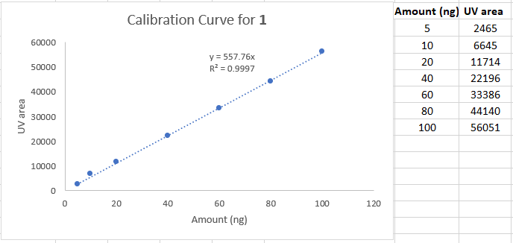
Figure S24. Calibration curve for 2-(2,2,2-trifluoroethoxy)pyrimidine 1 to determine molar activity.
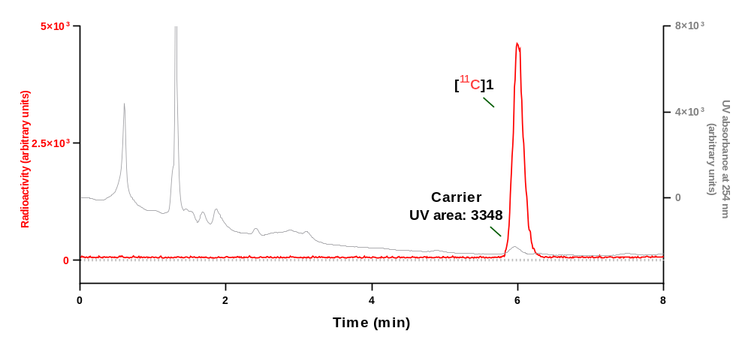
Figure S25. Analytical HPLC chromatogram for QC injection of [¹¹C]1.

7. HPLC analysis of ¹¹C- and ¹⁸F- labeled products.

7.1. HPLC analysis of ¹¹C-labeled compounds.

HPLC analysis of [¹¹C]1
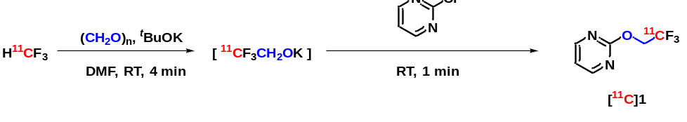
Prepared following general procedure B and analyzed using HPLC condition C.
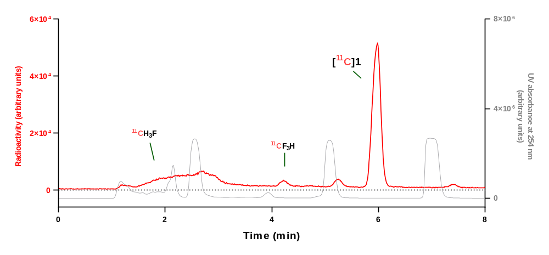
Analytical HPLC chromatogram for reaction mixture.
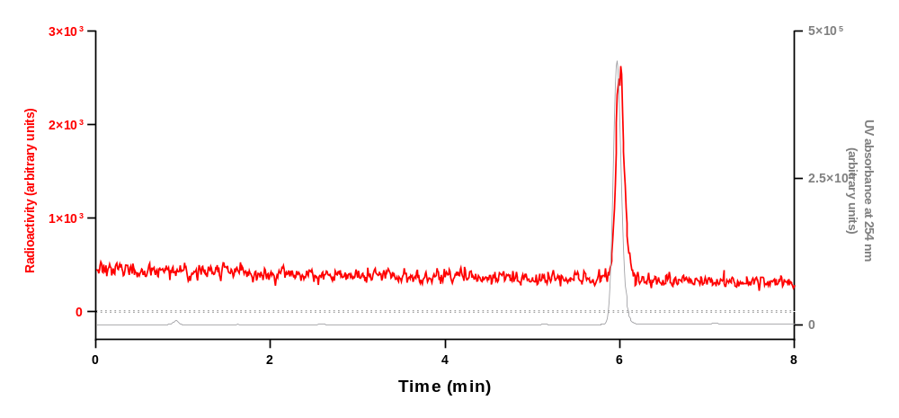
Analytical HPLC chromatogram for [¹¹C]1 collected from the above HPLC analysis when co–injected with 1.
Run | Retention time (min) | Yield (decay-corrected)  (%) | Mean yield ± SD (%)
1 | 5.607 | 88 | 90 ± 2
2 | 5.606 | 89 | 90 ± 2
3 | 5.701 | 92 | 90 ± 2

HPLC analysis of [¹¹C]2
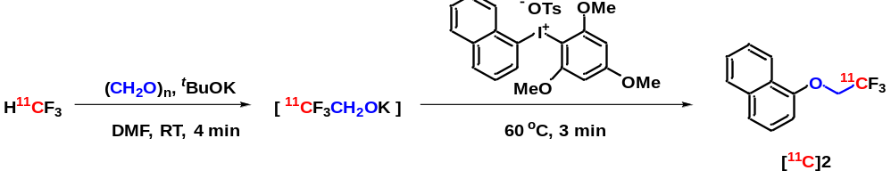
Prepared following general procedure B and analyzed using HPLC condition A.
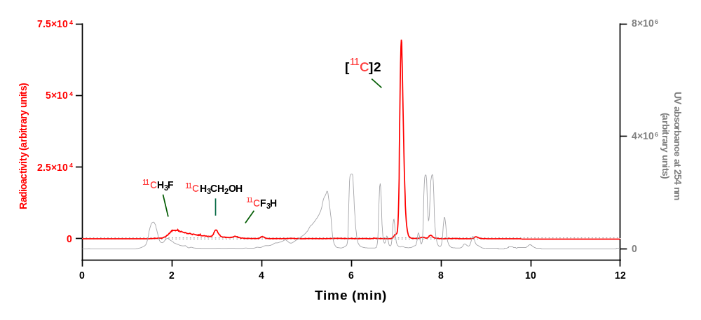
Analytical HPLC chromatogram for reaction mixture.
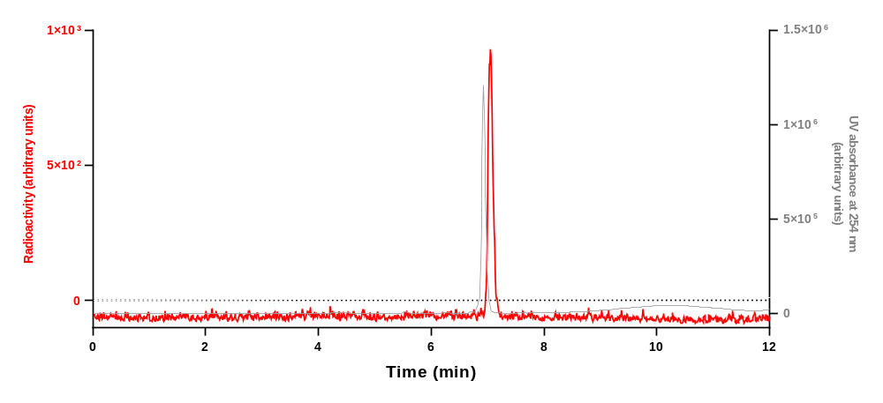
Analytical HPLC chromatogram for [¹¹C]2 collected from the above HPLC analysis when co–injected with 2.
Run | Retention time (min) | Yield (decay-corrected)  (%) | Mean yield ± SD  (%)
1 | 7.088 | 89 | 87 ± 4
2 | 7.118 | 89 | 87 ± 4
3 | 7.023 | 83 | 87 ± 4

HPLC analysis of [¹¹C]3
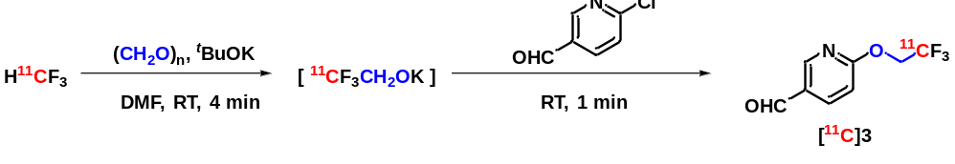
Prepared following general procedure B and analyzed using HPLC condition B.
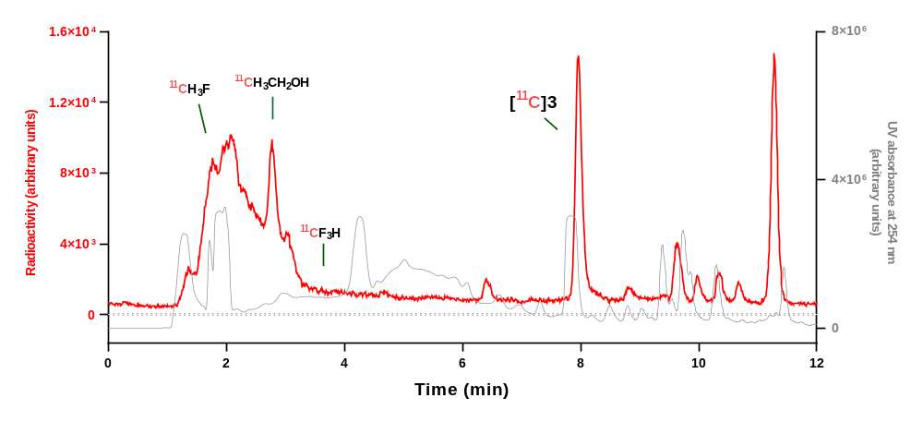
Analytical HPLC chromatogram for reaction mixture.
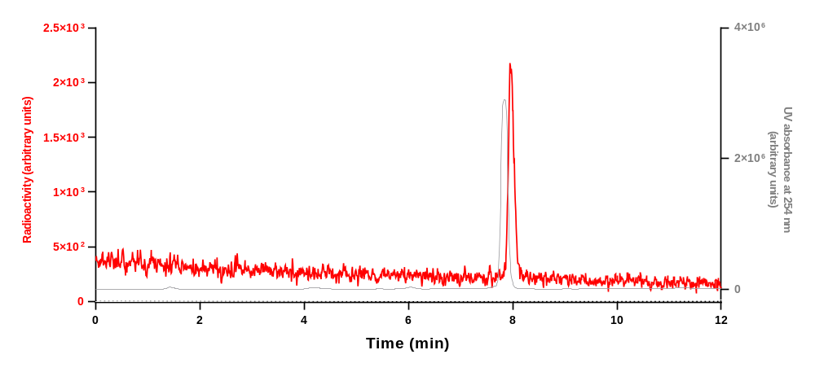
Analytical HPLC chromatogram for [¹¹C]3 collected from the above HPLC analysis when co–injected with 3.
Run | Retention time (min) | Yield (decay-corrected) (%) | Mean yield ± SD  (%)
1 | 7.966 | 20 | 28 ± 9
2 | 7.967 | 37 | 28 ± 9
3 | 7.964 | 26 | 28 ± 9

HPLC analysis of [¹¹C]4
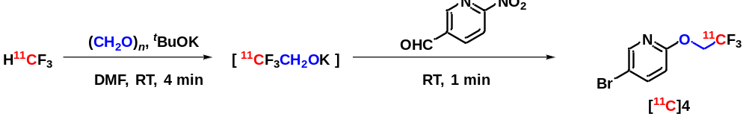
Prepared following general procedure B and analyzed using HPLC condition A.
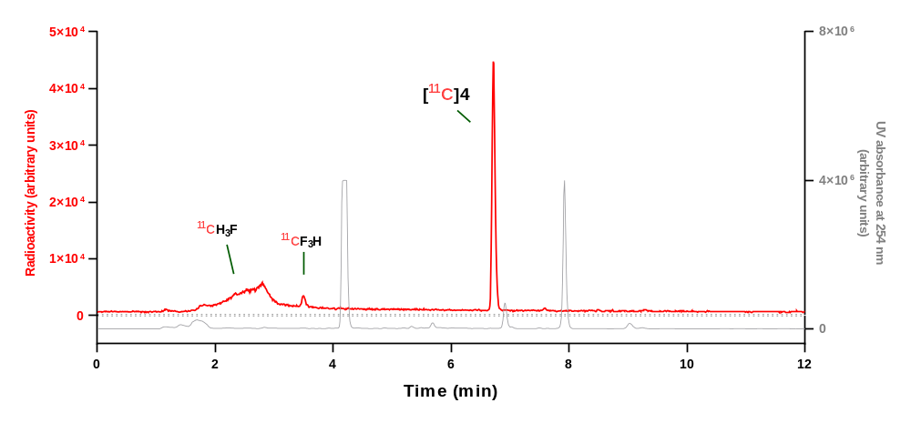
Analytical HPLC chromatogram for reaction mixture.
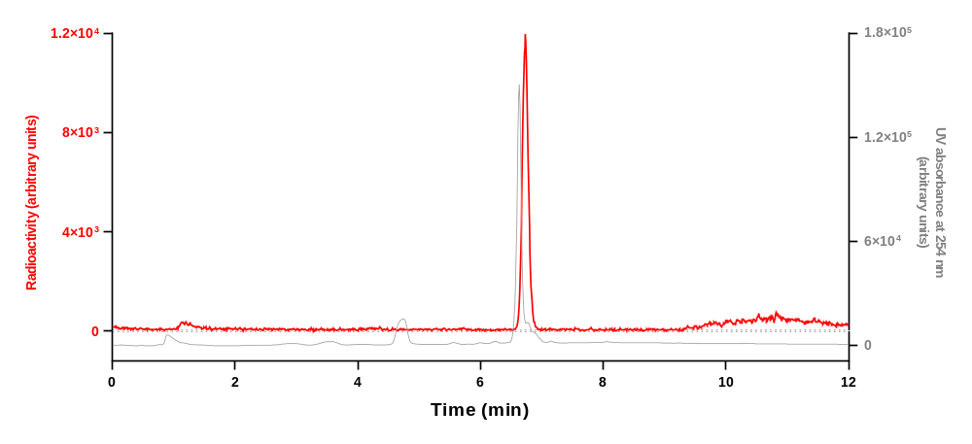
Analytical HPLC chromatogram for [¹¹C]4 collected from the above HPLC analysis when co–injected with 4.
Run | Retention time (min) | Yield (decay corrected) (%) | Mean yield ± SD  (%)
1 | 6.727 | 92 | 94 ± 2
2 | 6.716 | 95 | 94 ± 2
3 | 6.720 | 95 | 94 ± 2

HPLC analysis of [¹¹C]5
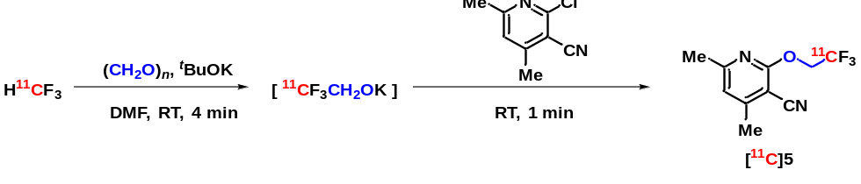
Prepared following general procedure B and analyzed using HPLC condition B.
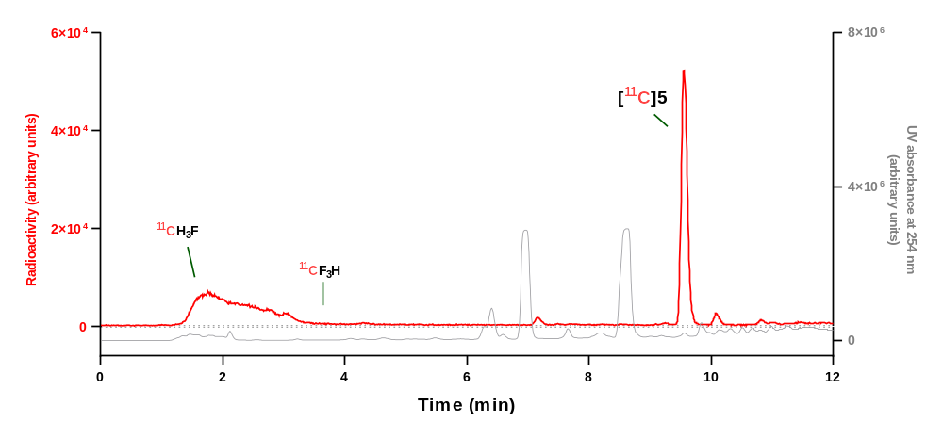
Analytical HPLC chromatogram for reaction mixture.
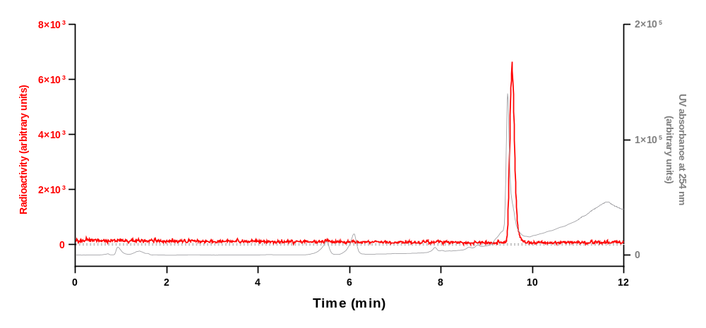
Analytical HPLC chromatogram for [¹¹C]5 collected from the above HPLC analysis when co–injected with 5.
Run | Retention time (min) | Yield (decay corrected) (%) | Mean yield ± SD  (%)
1 | 9.564 | 81 | 86 ± 5
2 | 9.577 | 88 | 86 ± 5
3 | 9.555 | 90 | 86 ± 5

HPLC analysis of [¹¹C]6
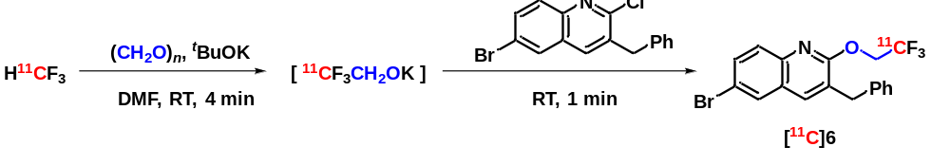
Prepared following general procedure B and analyzed using HPLC condition A.
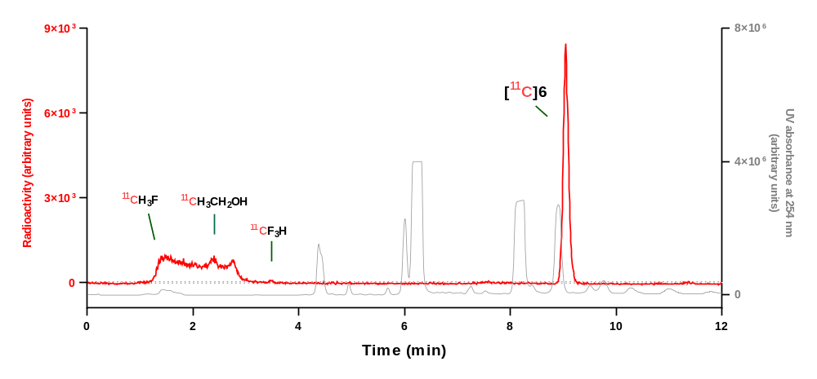
Analytical HPLC chromatogram for reaction mixture.
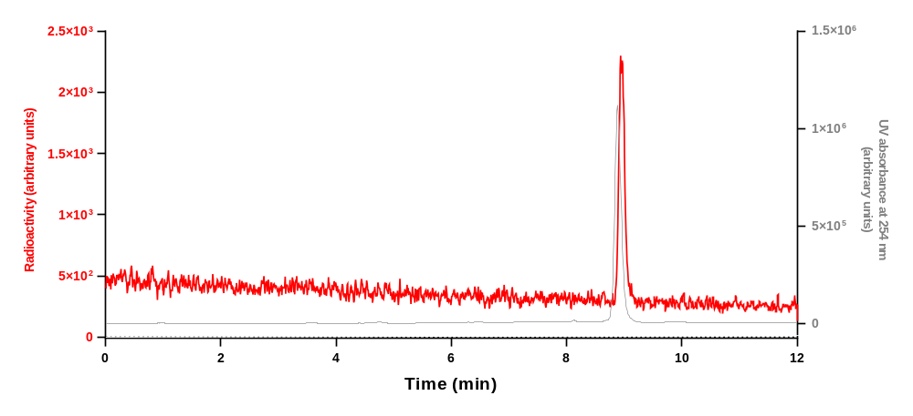
Analytical HPLC chromatogram for [¹¹C]6 collected from the above HPLC analysis when co–injected with 6.
Run | Retention time (min) | Yield (decay-corrected)  (%) | Mean yield ± SD (%)
1 | 8.966 | 88 | 87 ± 1
2 | 9.057 | 87 | 87 ± 1
3 | 9.049 | 87 | 87 ± 1

HPLC analysis of [¹¹C]7
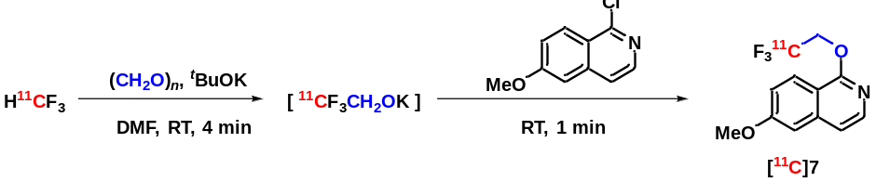
Prepared following general procedure B and analyzed using HPLC condition A.
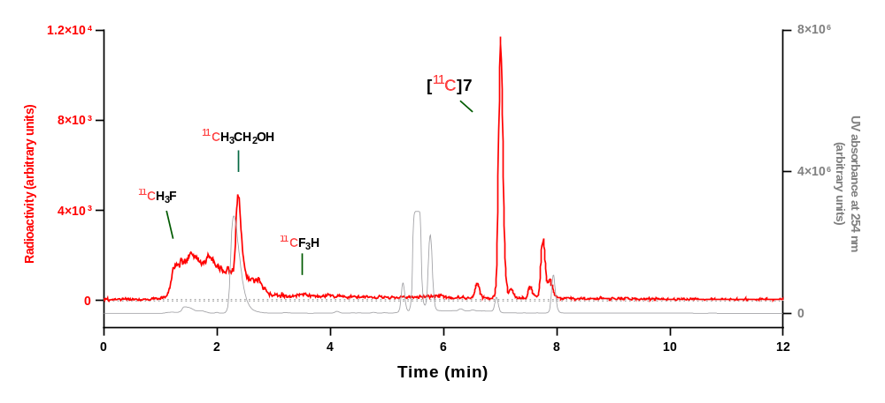
Analytical HPLC chromatogram for reaction mixture.
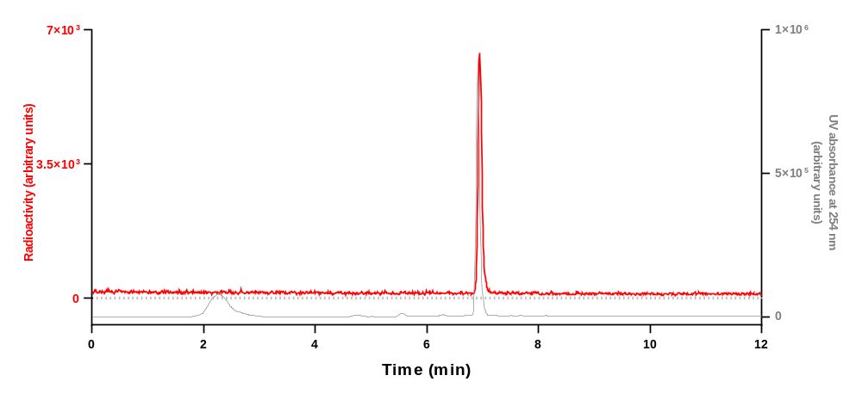
Analytical HPLC chromatogram for [¹¹C]7 collected from the above HPLC analysis when co–injected with 7.
Run | Retention time (min) | Yield (decay-corrected)  (%) | Mean yield ± SD (%)
1 | 7.011 | 41 | 45 ± 5
2 | 7.013 | 44 | 45 ± 5
3 | 7.009 | 50 | 45 ± 5

HPLC analysis of [¹¹C]8
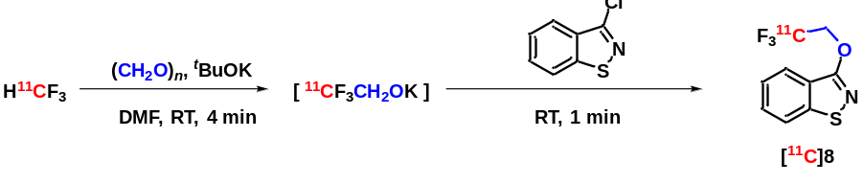
Prepared following general procedure B and analyzed using HPLC condition A.
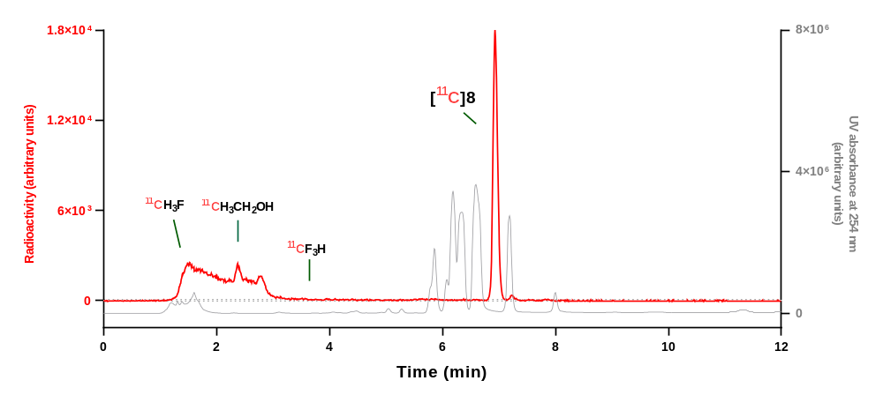
Analytical HPLC chromatogram for reaction mixture.
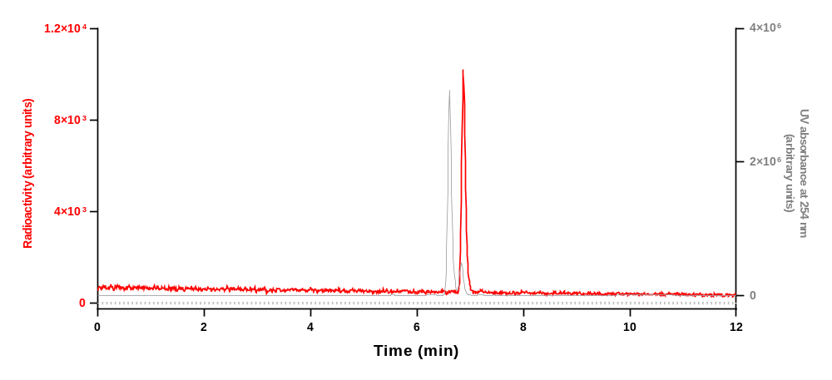
Analytical HPLC chromatogram for [¹¹C]8 collected from the above HPLC analysis when co–injected with 8.
Run | Retention time (min) | Yield (decay-corrected)  (%) | Mean yield ± SD (%)
1 | 6.891 | 78 | 80 ± 5
2 | 6.932 | 85 | 80 ± 5
3 | 6.940 | 76 | 80 ± 5

HPLC analysis of [¹¹C]9
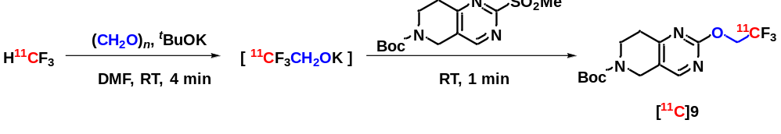
Prepared following general procedure B and analyzed using HPLC condition A.
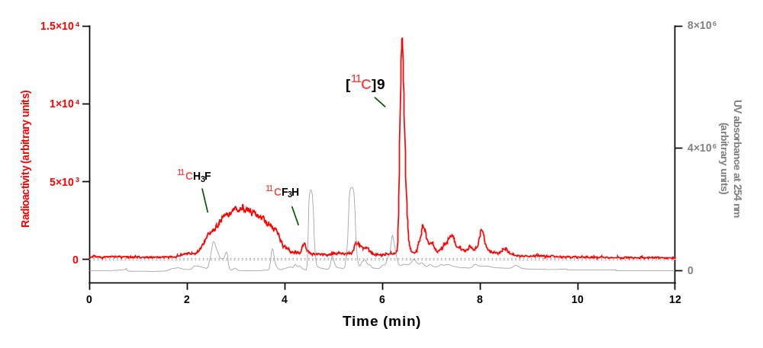
Analytical HPLC chromatogram for reaction mixture.
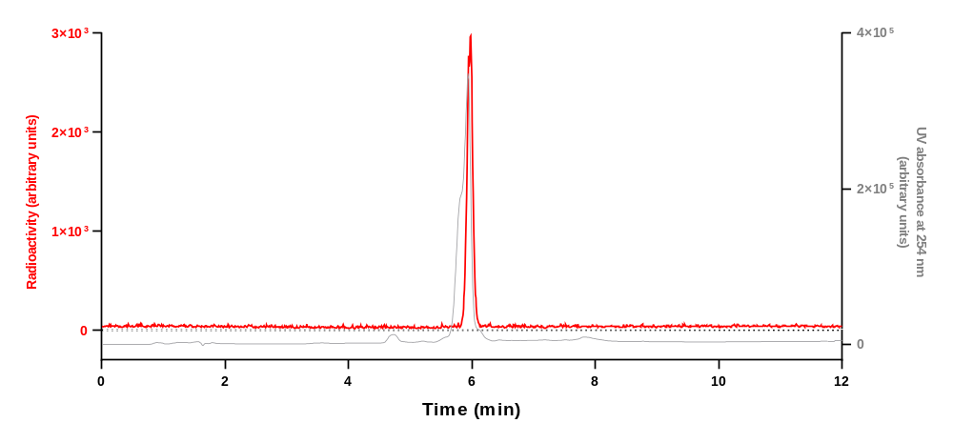
Analytical HPLC chromatogram for [¹¹C]9 collected from the above HPLC analysis when co–injected with 9.
Run | Retention time (min) | Yield (decay-corrected)  (%) | Mean yield ± SD (%)
1 | 6.442 | 45 | 46 ± 2
2 | 6.405 | 48 | 46 ± 2
3 | 6.068 | 44 | 46 ± 2

HPLC analysis of [¹¹C]10
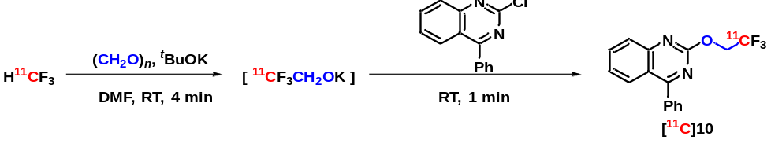
Prepared following general procedure B and analyzed using HPLC condition A.
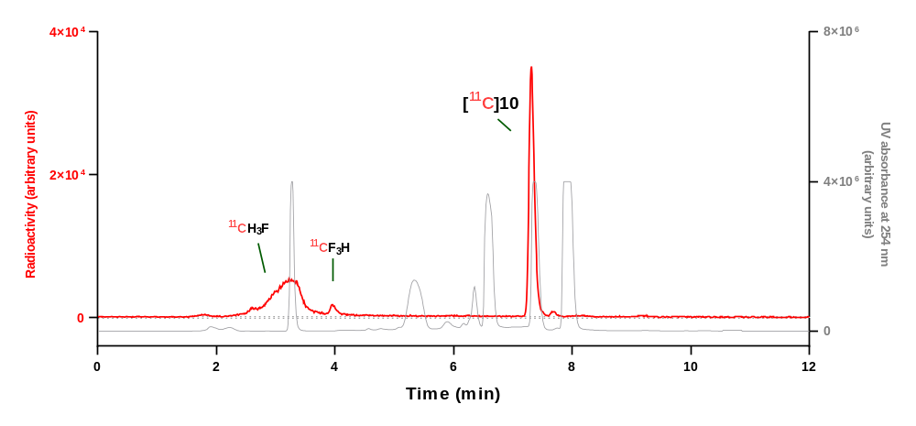
Analytical HPLC chromatogram for reaction mixture.
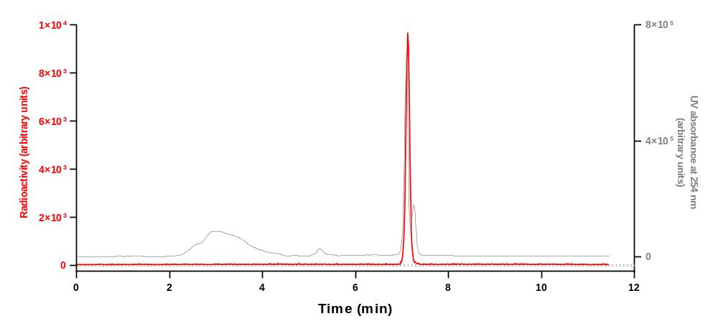
Analytical HPLC chromatogram for [¹¹C]10 collected from the above HPLC analysis when co–injected with 10.
Run | Retention time (min) | Yield (decay-corrected)  (%) | Mean yield ± SD (%)
1 | 7.309 | 88 | 92 ± 4
2 | 7.314 | 95 | 92 ± 4
3 | 7.381 | 93 | 92 ± 4

HPLC analysis of [¹¹C]11
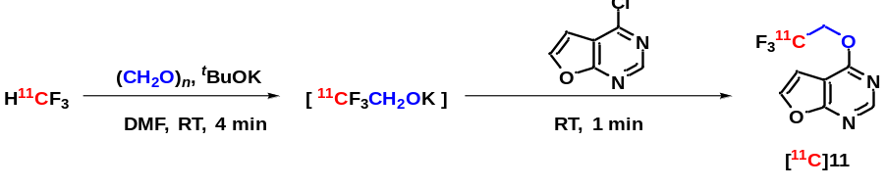
Prepared following general procedure B and analyzed using HPLC condition A.
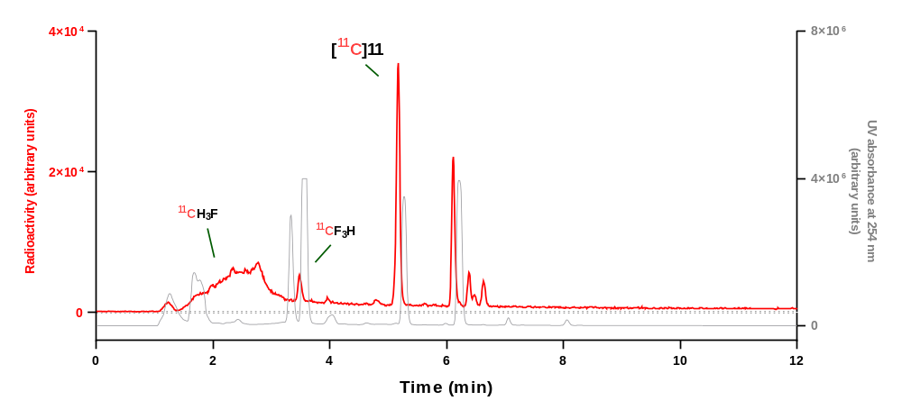
Analytical HPLC chromatogram for reaction mixture.
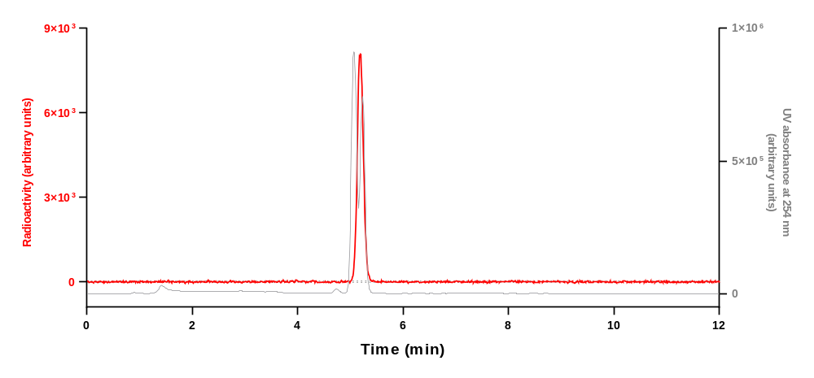
Analytical HPLC chromatogram for [¹¹C]11 collected from the above HPLC analysis when co–injected with 11.
Run | Retention time (min) | Yield (decay-corrected)  (%) | Mean yield ± SD (%)
1 | 5.185 | 28 | 41 ± 12
2 | 5.172 | 49 | 41 ± 12
3 | 5.173 | 47 | 41 ± 12

HPLC analysis of [¹¹C]12
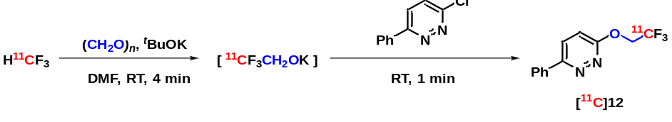
Prepared following general procedure B and analyzed using HPLC condition A.
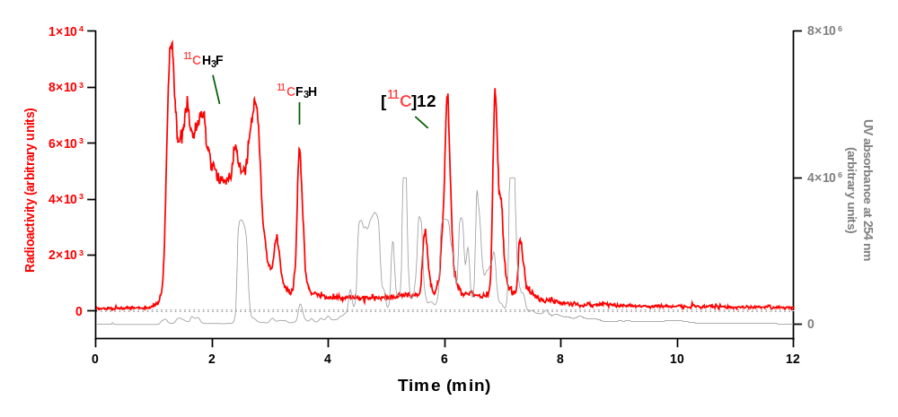
Analytical HPLC chromatogram for reaction mixture.
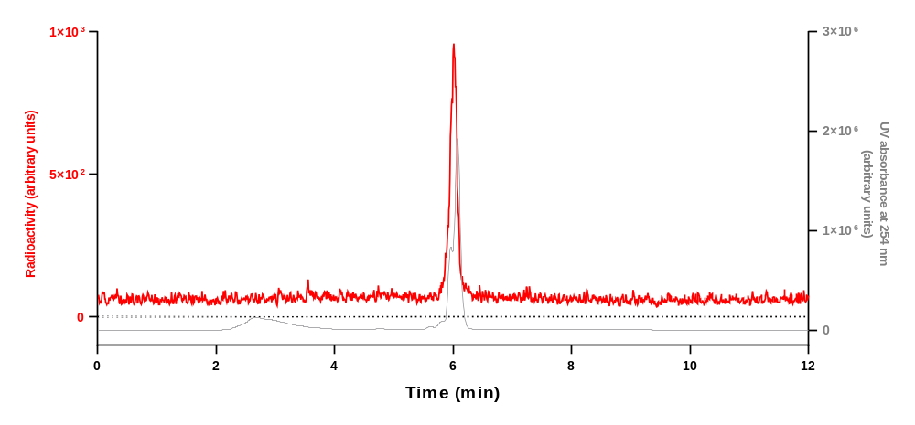
Analytical HPLC chromatogram for [¹¹C]12 collected from the above HPLC analysis when co–injected with 12.
Run | Retention time (min) | Yield (decay-corrected)  (%) | Mean yield ± SD (%)
1 | 6.062 | 21 | 21 ± 4
2 | 6.056 | 25 | 21 ± 4
3 | 6.057 | 17 | 21 ± 4

HPLC analysis of [¹¹C]13
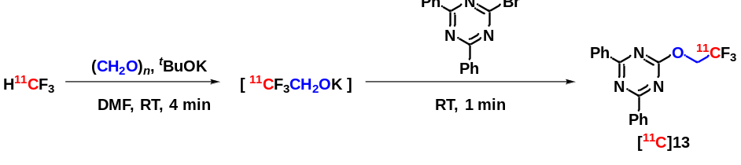
Prepared following general procedure B and analyzed using HPLC condition A.
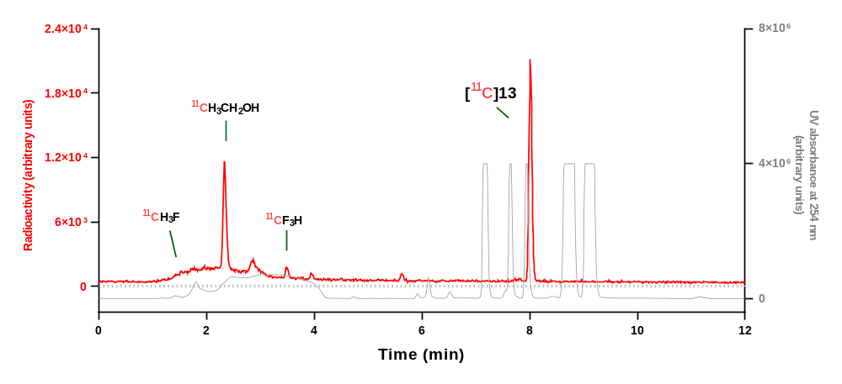
Analytical HPLC chromatogram for reaction mixture.
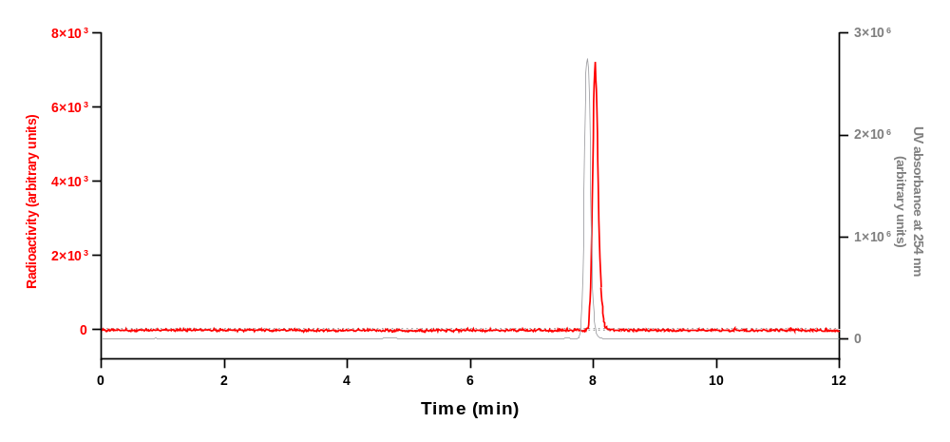
Analytical HPLC chromatogram for [¹¹C]13 collected from the above the HPLC analysis when co–injected with 13.
Run | Retention time (min) | Yield (decay-corrected)  (%) | Mean yield ± SD (%)
1 | 8.014 | 54 | 53 ± 1
2 | 8.011 | 54 | 53 ± 1
3 | 8.015 | 52 | 53 ± 1

HPLC analysis of [¹¹C]14
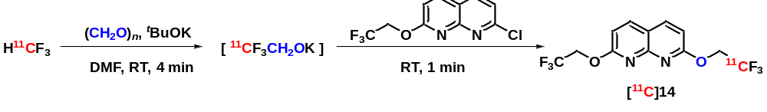
Prepared following general procedure B and analyzed using HPLC condition A.
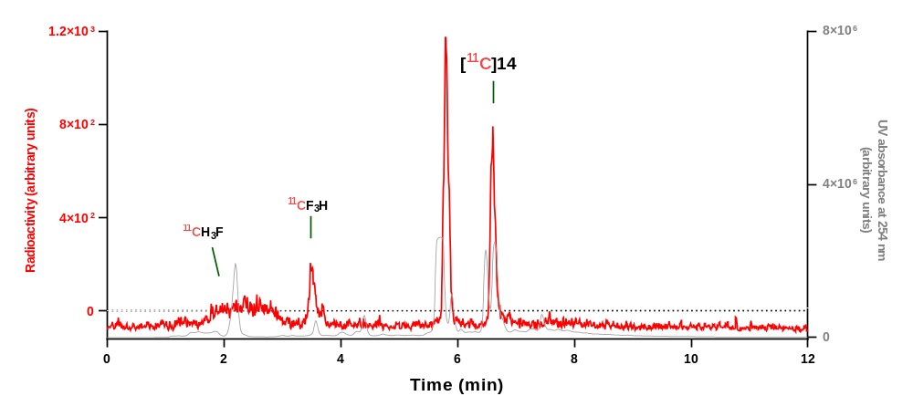
Analytical HPLC chromatogram for reaction mixture.
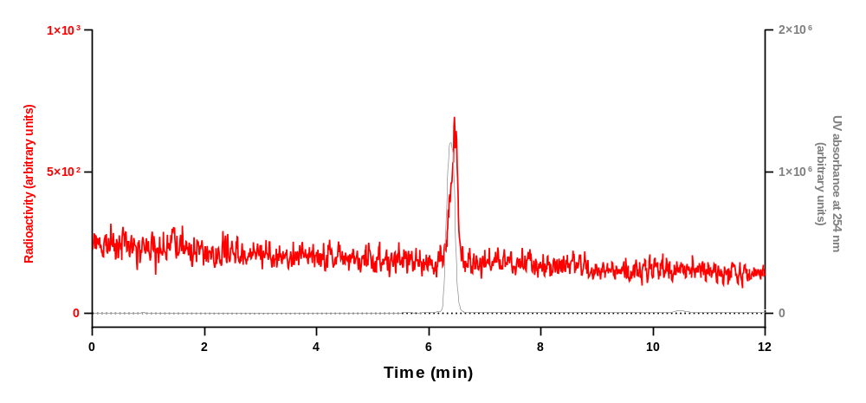
Analytical HPLC chromatogram for [¹¹C]14 collected from the above HPLC analysis when co–injected with 14.
Run | Retention time (min) | Yield (decay-corrected)  (%) | Mean yield ± SD (%)
1 | 6.607 | 37 | 35 ± 2
2 | 6.608 | 34 | 35 ± 2
3 | 6.499 | 35 | 35 ± 2

HPLC analysis of [¹¹C]15
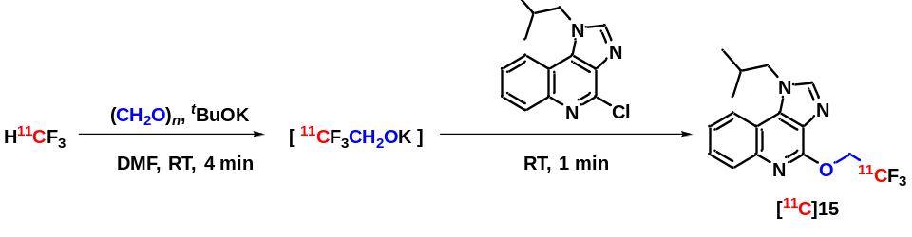
Prepared following general procedure B and analyzed using HPLC condition A.
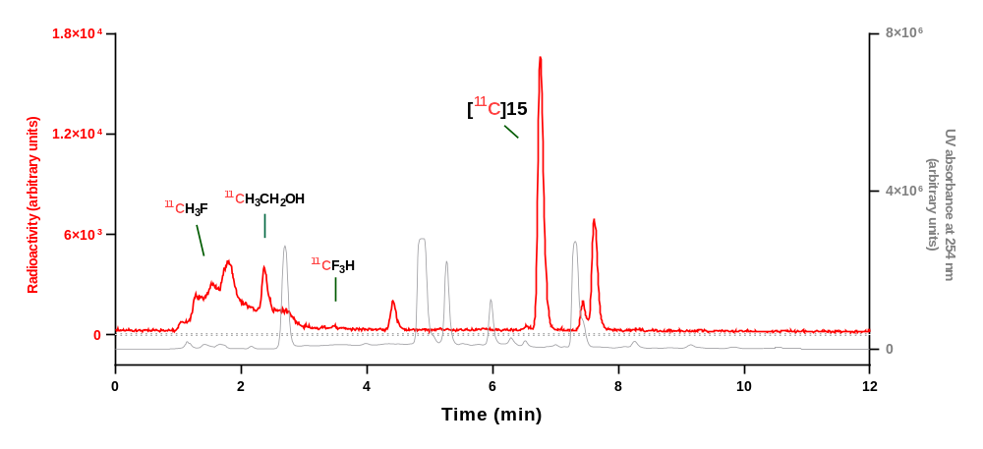
Analytical HPLC chromatogram for reaction mixture.
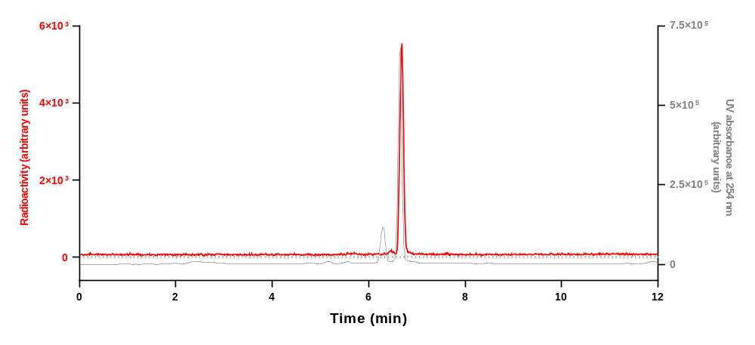
Analytical HPLC chromatogram for [¹¹C]15 collected from the above HPLC analysis when co–injected with 15.
Run | Retention time (min) | Yield (decay-corrected)  (%) | Mean yield ± SD (%)
1 | 6.759 | 37 | 43 ± 8
2 | 6.763 | 40 | 43 ± 8
3 | 6.761 | 52 | 43 ± 8

HPLC analysis of [¹¹C]16
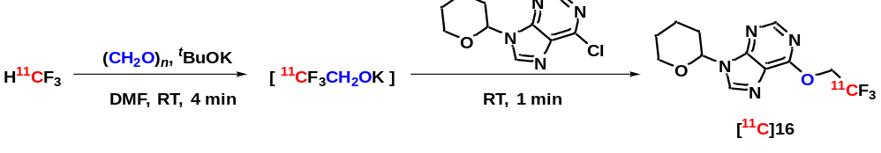
Prepared following general procedure B and analyzed using HPLC condition B.
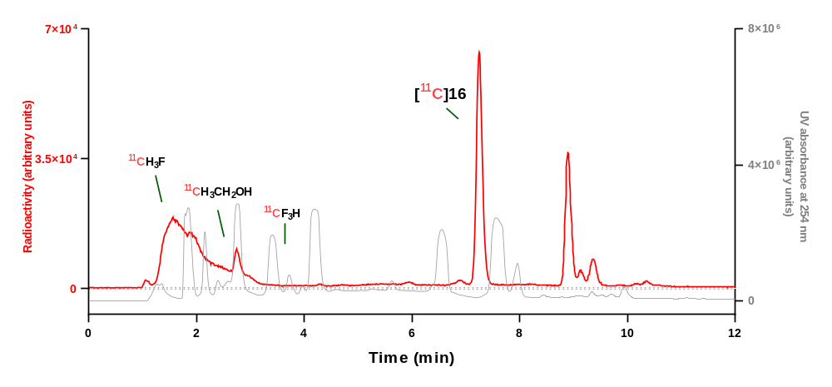
Analytical HPLC chromatogram for reaction mixture.
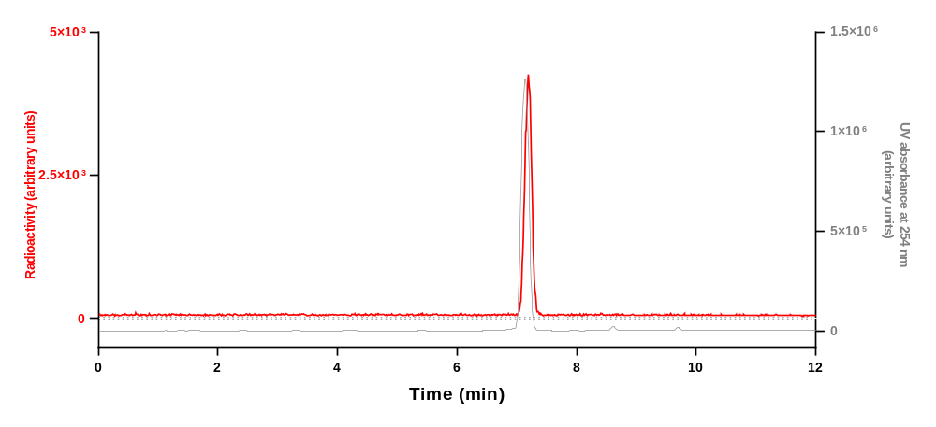
Analytical HPLC chromatogram for [¹¹C]16 collected from the above HPLC analysis when co–injected with 16.
Run | Retention time (min) | Yield (decay-corrected)  (%) | Mean yield ± SD (%)
1 | 7.252 | 47 | 51 ± 4
2 | 7.227 | 55 | 51 ± 4
3 | 7.221 | 50 | 51 ± 4

HPLC analysis of [¹¹C]17
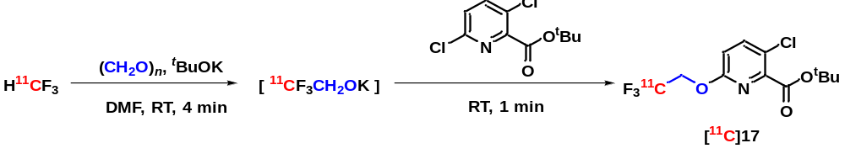
Prepared following general procedure B and analyzed using HPLC condition A.
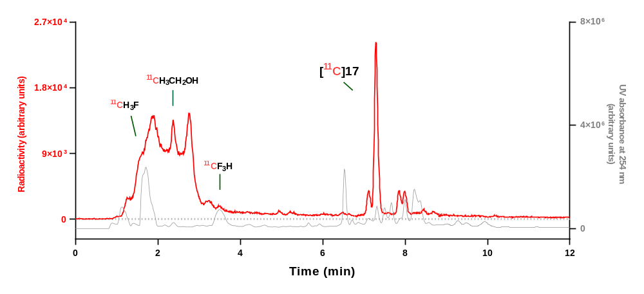
Analytical HPLC chromatogram for reaction mixture.
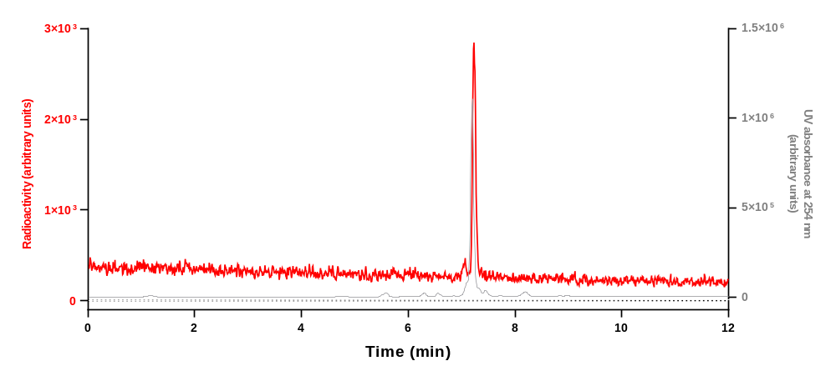
Analytical HPLC chromatogram for [¹¹C]17 collected from the above HPLC analysis when co–injected with 17.
Run | Retention time (min) | Yield (decay-corrected)  (%) | Mean yield ± SD (%)
1 | 7.291 | 37 | 34 ± 6
2 | 7.252 | 37 | 34 ± 6
3 | 7.246 | 27 | 34 ± 6
HPLC analysis of [¹¹C]18
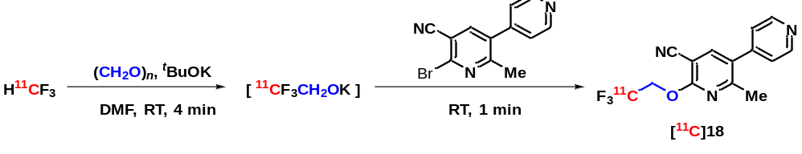
Prepared following general procedure B and analyzed using HPLC condition A.
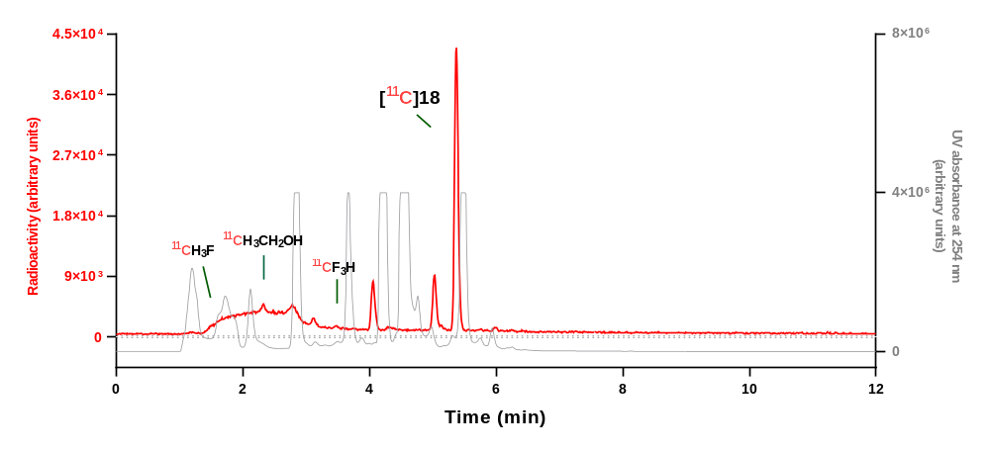
Analytical HPLC chromatogram for reaction mixture.
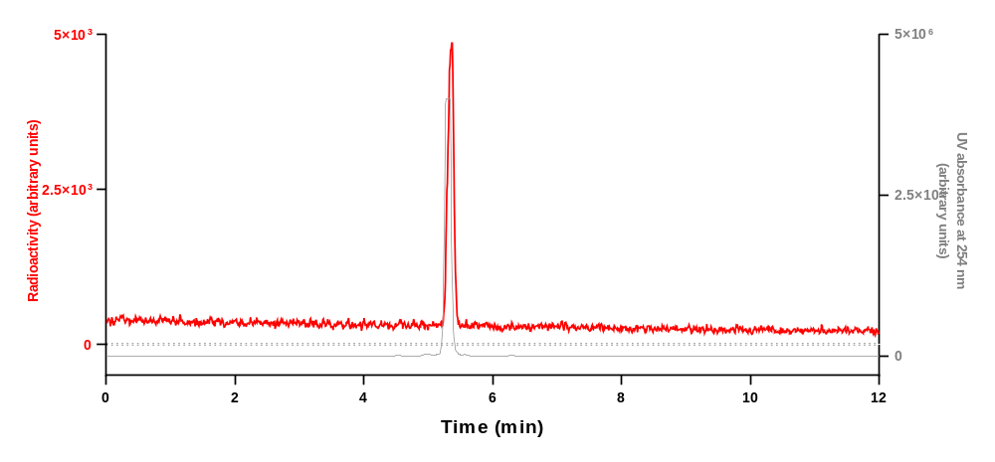
Analytical HPLC chromatogram for [¹¹C]18 collected from the above HPLC analysis when co–injected with 18.
Run | Retention time (min) | Yield (decay-corrected)  (%) | Mean yield ± SD (%)
1 | 5.372 | 61 | 57 ± 5
2 | 5.470 | 58 | 57 ± 5
3 | 5.470 | 52 | 57 ± 5

HPLC analysis of [¹¹C]19
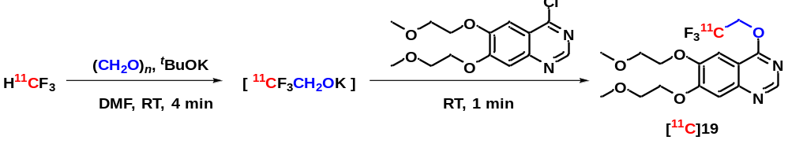
Prepared following general procedure B and analyzed using HPLC condition A.
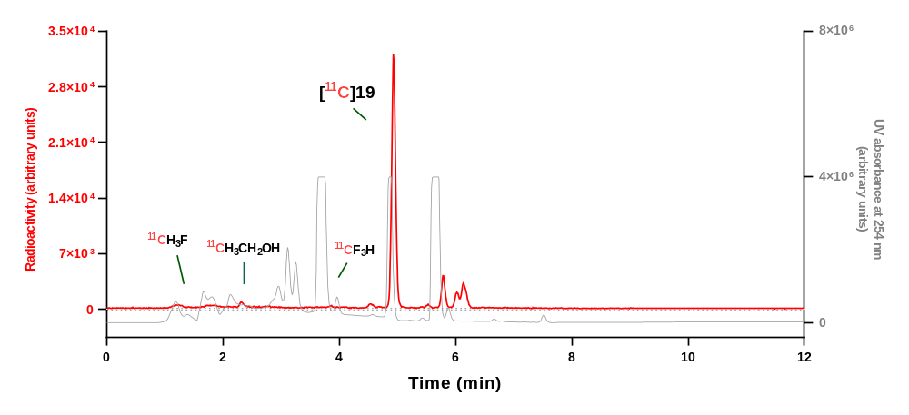
Analytical HPLC chromatogram for reaction mixture.
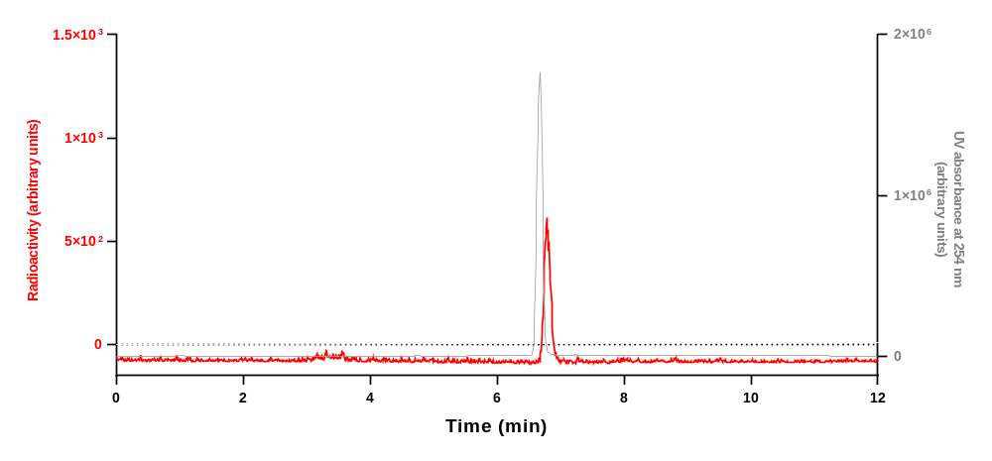
Analytical HPLC chromatogram for [¹¹C]19 collected from the above HPLC analysis when co–injected with 19.
Run | Retention time (min) | Yield (decay-corrected)  (%) | Mean yield ± SD (%)
1 | 4.932 | 70 | 68 ± 4
2 | 4.935 | 71 | 68 ± 4
3 | 4.518 | 63 | 68 ± 4

HPLC analysis of [¹¹C]20
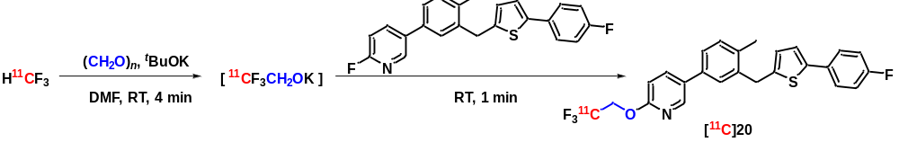
Prepared following general procedure B and analyzed using HPLC condition A.
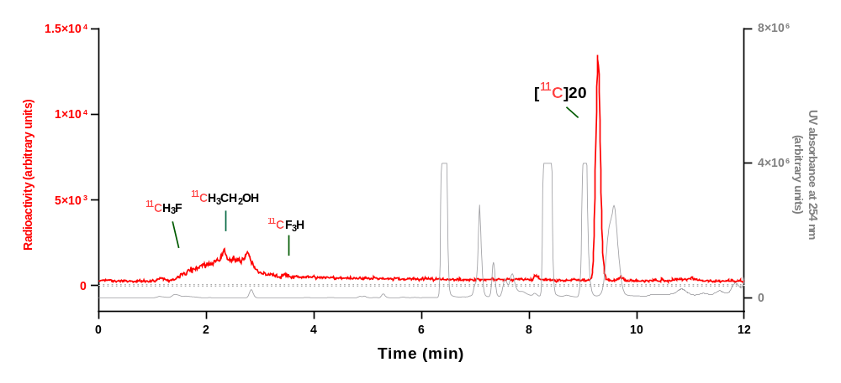
Analytical HPLC chromatogram for reaction mixture.
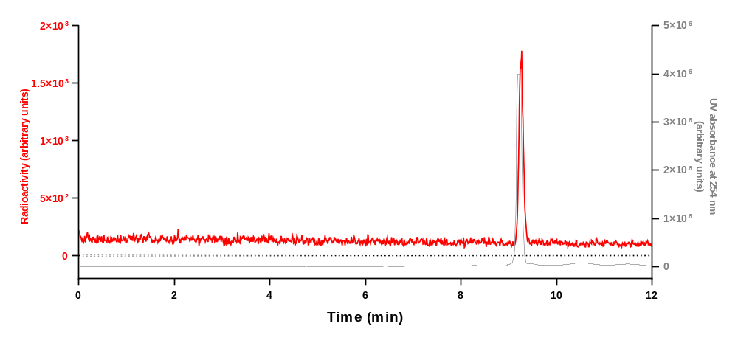
Analytical HPLC chromatogram for [¹¹C]20 collected from the above HPLC analysis when co–injected with 20.
Run | Retention time (min) | Yield (decay-corrected)  (%) | Mean yield ± SD (%)
1 | 9.278 | 79 | 74 ± 4
2 | 9.277 | 72 | 74 ± 4
3 | 9.273 | 72 | 74 ± 4

HPLC analysis of [¹¹C]21
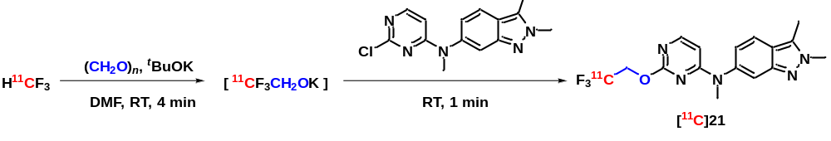
Prepared following general procedure B and analyzed using HPLC condition A.
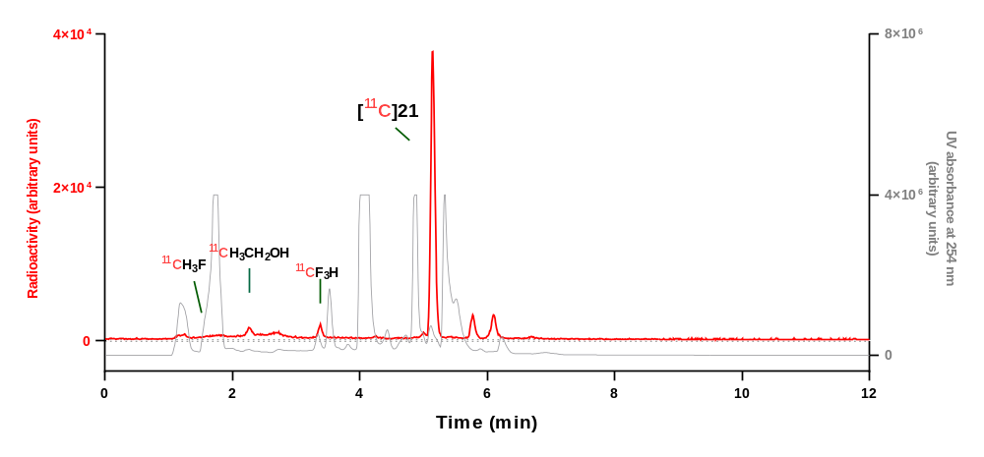
Analytical HPLC chromatogram for reaction mixture.
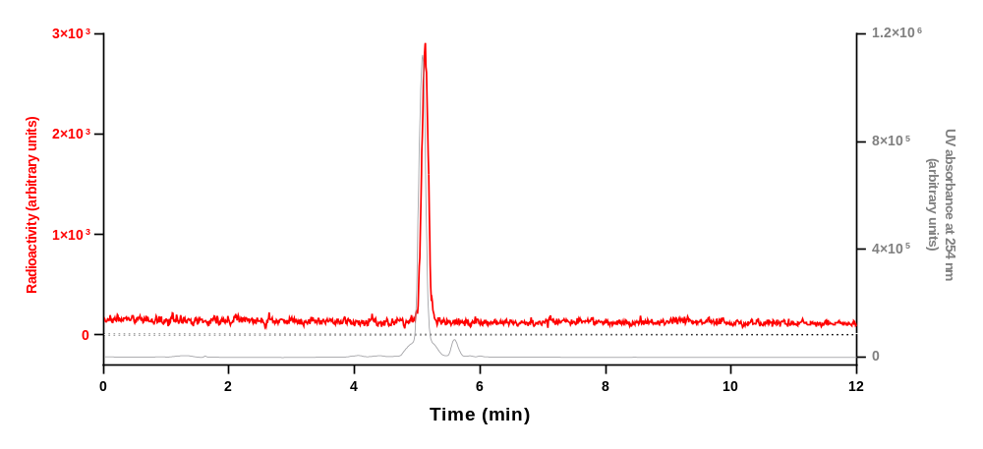
Analytical HPLC chromatogram for [¹¹C]21 collected from the above HPLC analysis when co–injected with 21.
Run | Retention time (min) | Yield (decay-corrected)  (%) | Mean yield ± SD (%)
1 | 5.146 | 75 | 73 ± 2
2 | 5.149 | 72 | 73 ± 2
3 | 5.146 | 71 | 73 ± 2

HPLC analysis of [¹¹C]22
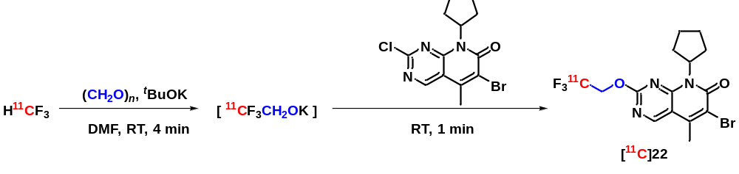
Prepared following general procedure B and analyzed using HPLC condition A.
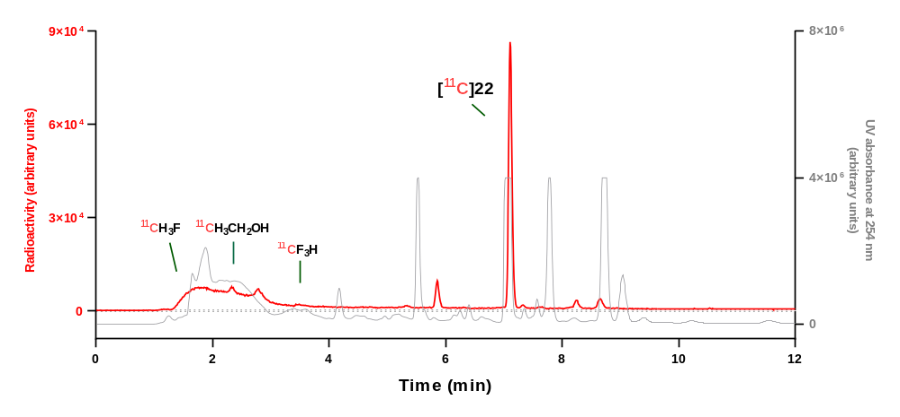
Analytical HPLC chromatogram for reaction mixture.
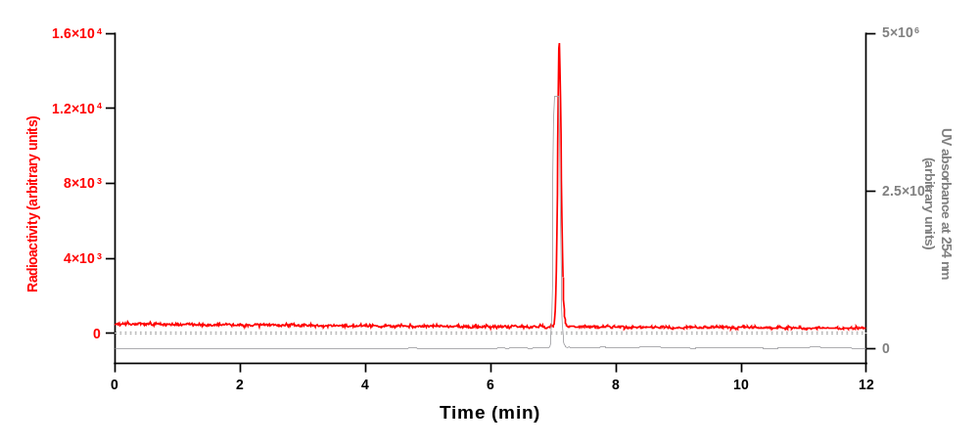
Analytical HPLC chromatogram for [¹¹C]22 collected from the above HPLC analysis when co–injected with 22.
Run | Retention time (min) | Yield (decay-corrected)  (%) | Mean yield ± SD (%)
1 | 7.104 | 65 | 67 ± 7
2 | 7.111 | 75 | 67 ± 7
3 | 7.104 | 62 | 67 ± 7

HPLC analysis of [¹¹C]23
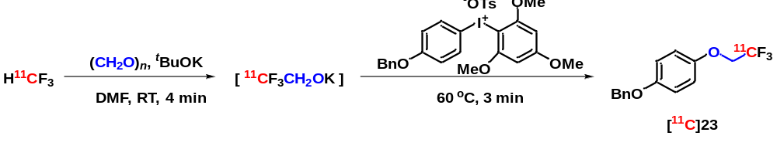
Prepared following general procedure B and analyzed using HPLC condition A.
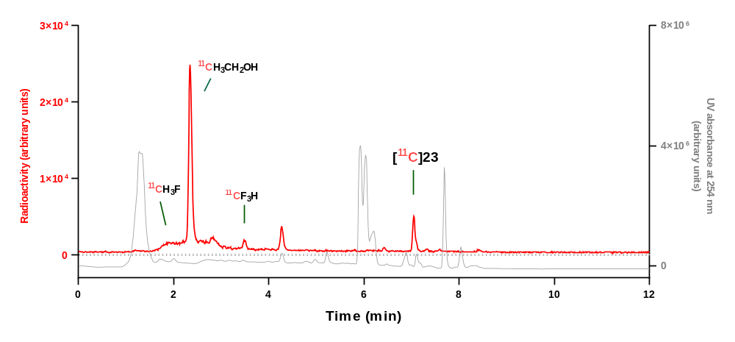
Analytical HPLC chromatogram for reaction mixture.
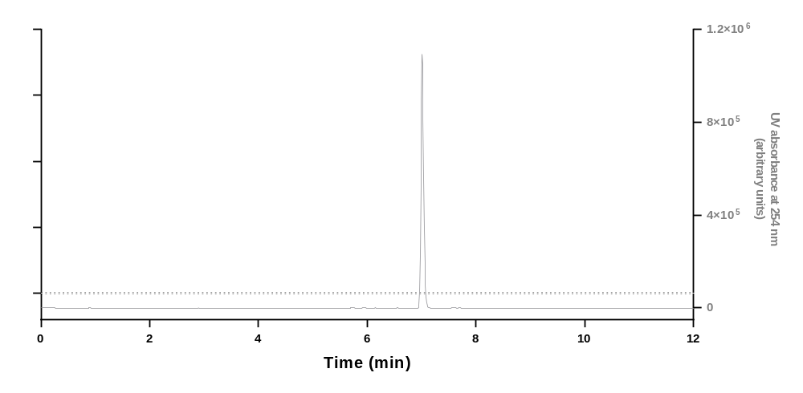
Analytical HPLC chromatogram for 23.
Run | Retention time (min) | Yield (decay-corrected)  (%) | Mean yield ± SD (%)
1 | 7.044 | 14 | 12 ± 2
2 | 7.052 | 13 | 12 ± 2
3 | 7.052 | 10 | 12 ± 2

HPLC analysis of [¹¹C]24
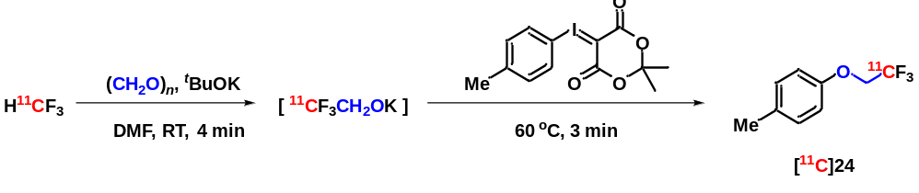
Prepared following general procedure B and analyzed using HPLC condition A.
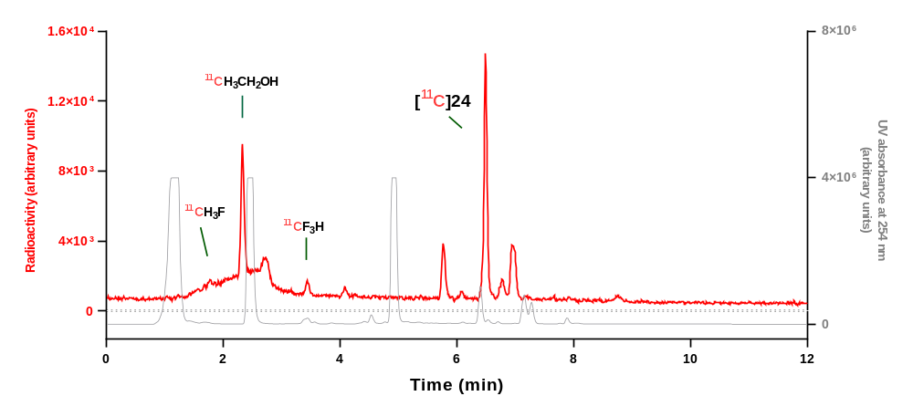
Analytical HPLC chromatogram for reaction mixture.
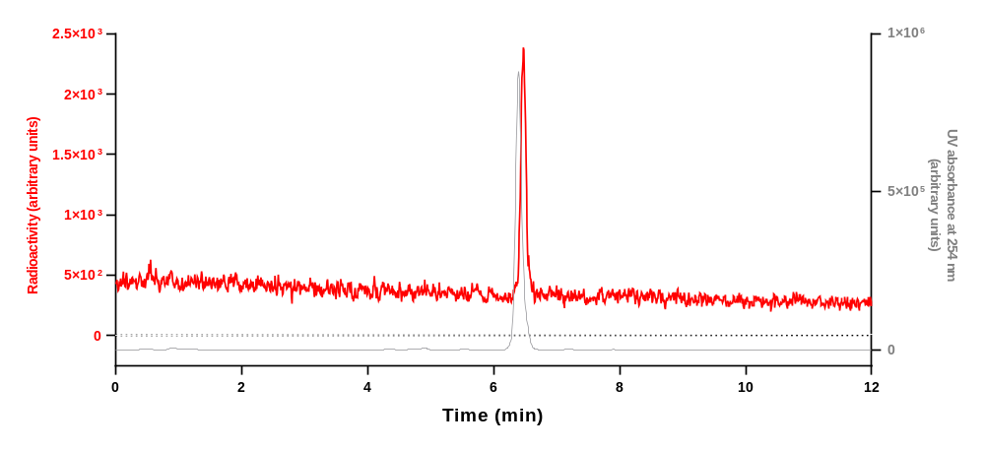
Analytical HPLC chromatogram for [¹¹C]24 collected from the above HPLC analysis when co–injected with 24.
Run | Retention time (min) | Yield (decay-corrected)  (%) | Mean yield ± SD (%)
1 | 6.560 | 44 | 36 ± 9
2 | 6.560 | 36 | 36 ± 9
3 | 6.495 | 27 | 36 ± 9

HPLC analysis of [¹¹C]25
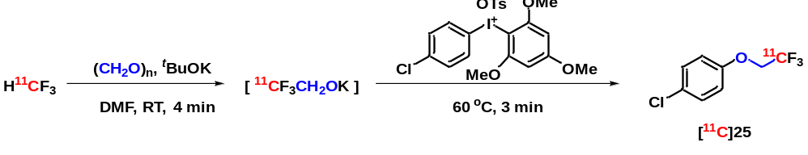
Prepared following general procedure B and analyzed using HPLC condition A.
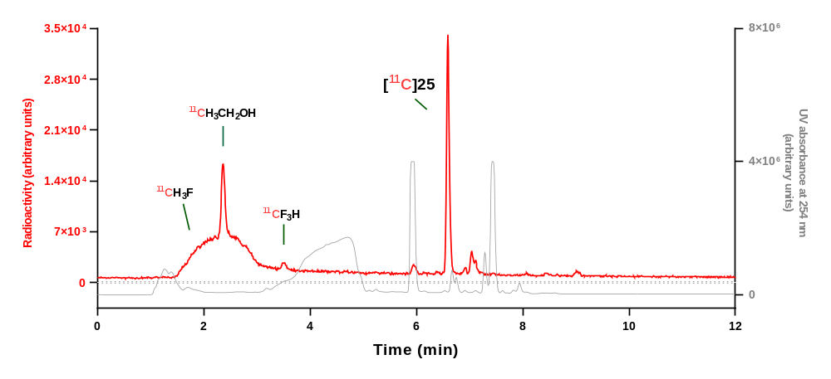
Analytical HPLC chromatogram for reaction mixture.
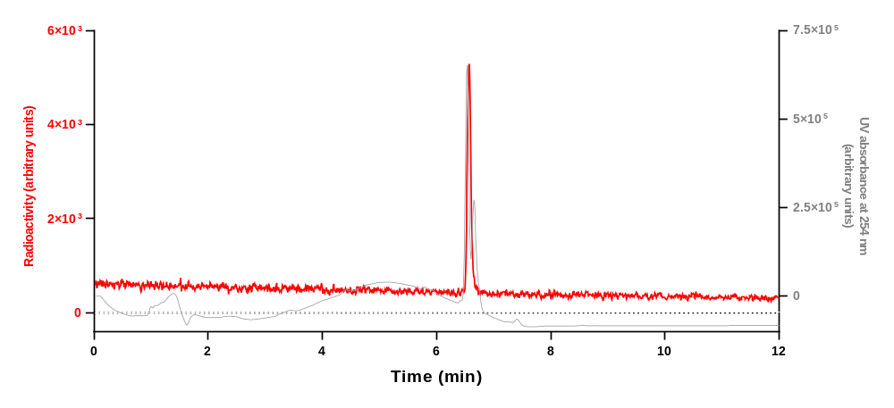
Analytical HPLC chromatogram for [¹¹C]25 collected from the above HPLC analysis when co–injected with 25.
Run | Retention time (min) | Yield (decay-corrected)  (%) | Mean yield ± SD (%)
1 | 6.591 | 49 | 49 ± 1
2 | 6.591 | 50 | 49 ± 1
3 | 6.594 | 48 | 49 ± 1

HPLC analysis of [¹¹C]26
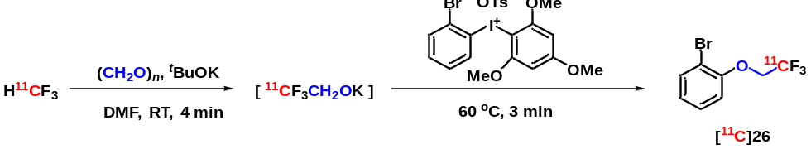
Prepared following general procedure B and analyzed using HPLC condition A.
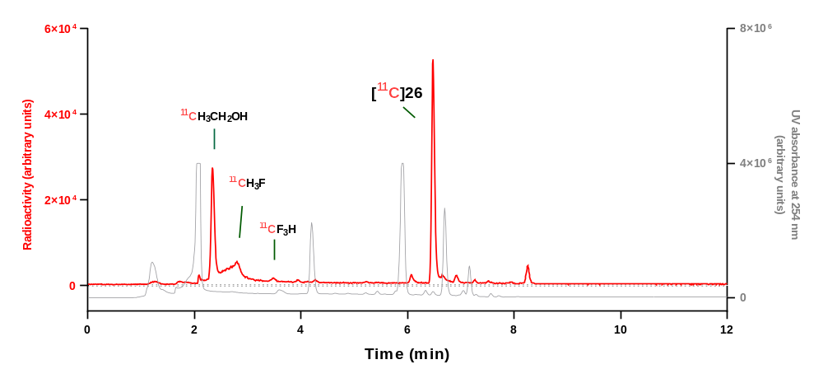
Analytical HPLC chromatogram for reaction mixture.
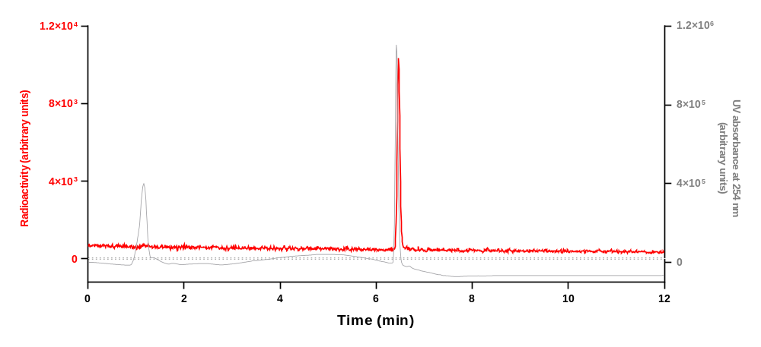
Analytical HPLC chromatogram for [¹¹C]26 collected from the above HPLC analysis when co–injected with 26.
Run | Retention time (min) | Yield (decay-corrected)  (%) | Mean yield ± SD (%)
1 | 6.481 | 56 | 50 ± 5
2 | 6.488 | 46 | 50 ± 5
3 | 6.485 | 49 | 50 ± 5

HPLC analysis of [¹¹C]27
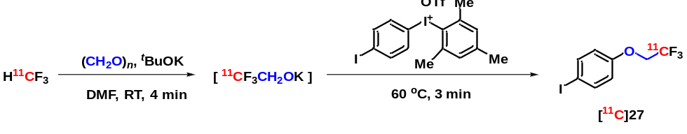
Prepared following general procedure B and analyzed using HPLC condition A.
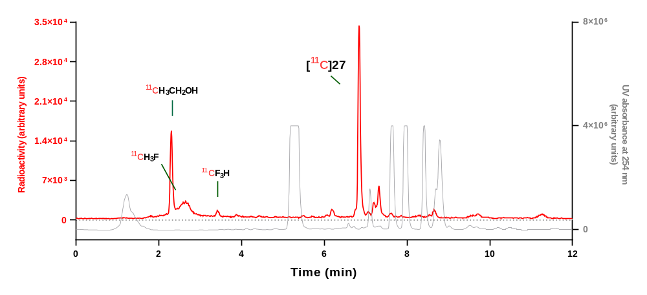
Analytical HPLC chromatogram for reaction mixture.
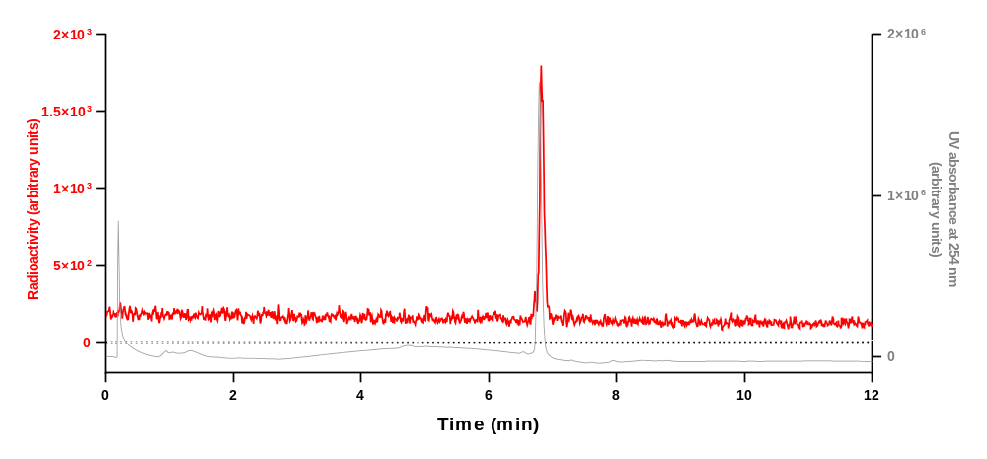
Analytical HPLC chromatogram for [¹¹C]27 collected from the above HPLC analysis when co–injected with 27.
Run | Retention time (min) | Yield (decay-corrected)  (%) | Mean yield ± SD (%)
1 | 6.837 | 48 | 47 ± 3
2 | 6.845 | 49 | 47 ± 3
3 | 6.842 | 44 | 47 ± 3

HPLC analysis of [¹¹C]28
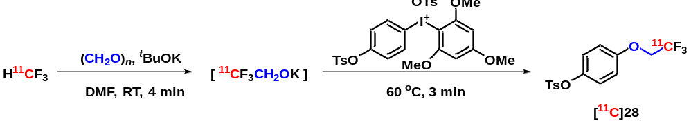
Prepared following general procedure B and analyzed using HPLC condition A.
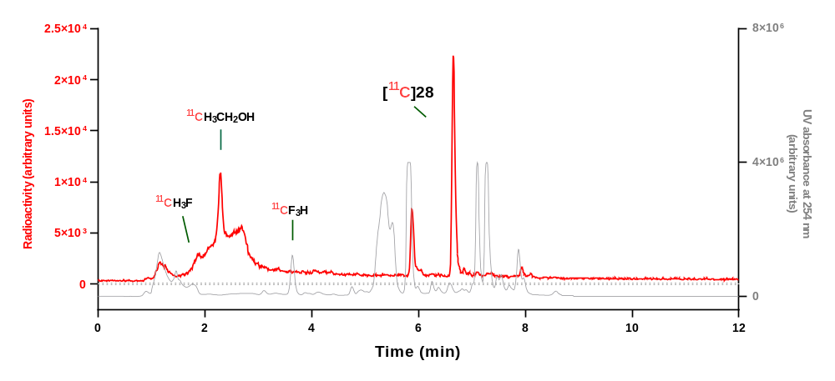
Analytical HPLC chromatogram for reaction mixture.
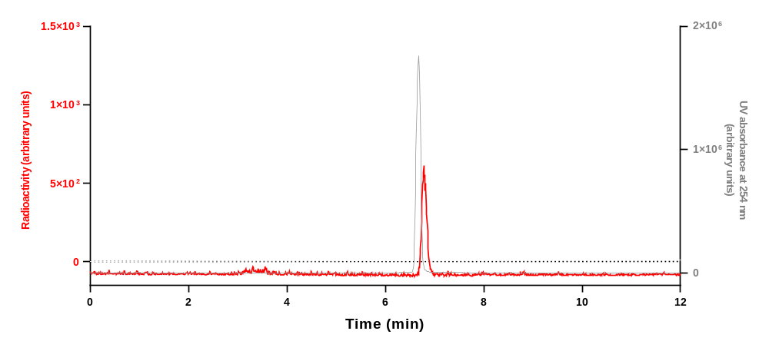
Analytical HPLC chromatogram for [¹¹C]28 collected from the above HPLC analysis when co–injected with 28.
Run | Retention time (min) | Yield (decay-corrected)  (%) | Mean yield ± SD (%)
1 | 6.730 | 34 | 33 ± 1
2 | 6.654 | 32 | 33 ± 1
3 | 6.622 | 33 | 33 ± 1

HPLC analysis of [¹¹C]29
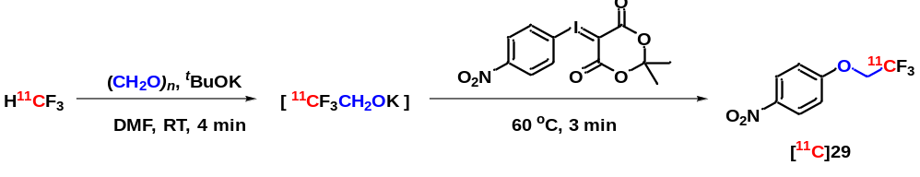
Prepared following general procedure B and analyzed using HPLC condition A.
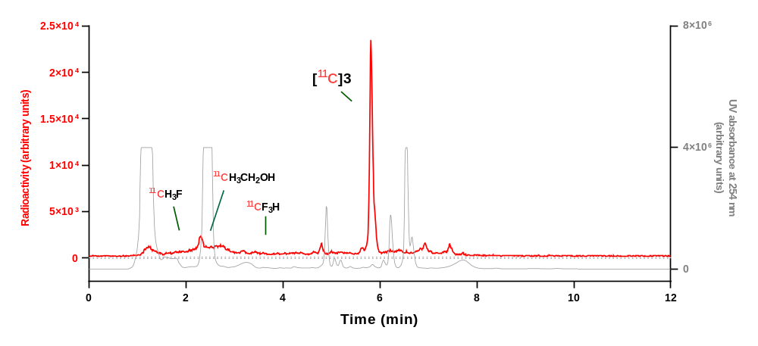
Analytical HPLC chromatogram for reaction mixture.
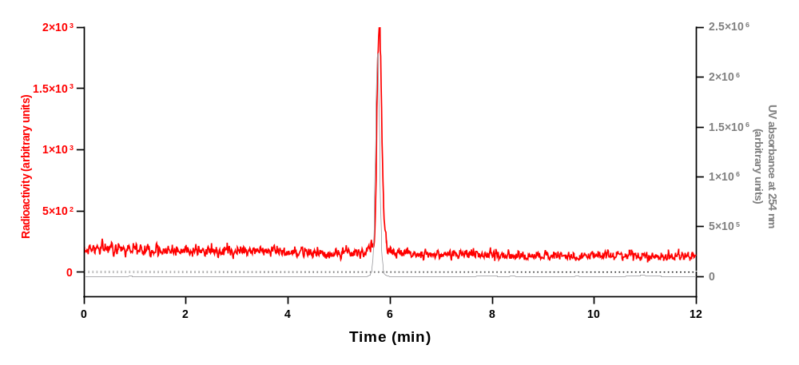
Analytical HPLC chromatogram for [¹¹C]29 collected from the above HPLC analysis when co–injected with 29.
Run | Retention time (min) | Yield (decay-corrected)  (%) | Mean yield ± SD (%)
1 | 5.807 | 71 | 71 ± 1
2 | 5.817 | 72 | 71 ± 1
3 | 5.820 | 71 | 71 ± 1

HPLC analysis of [¹¹C]30
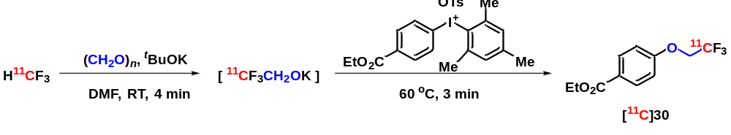
Prepared following general procedure B and analyzed using HPLC condition A.
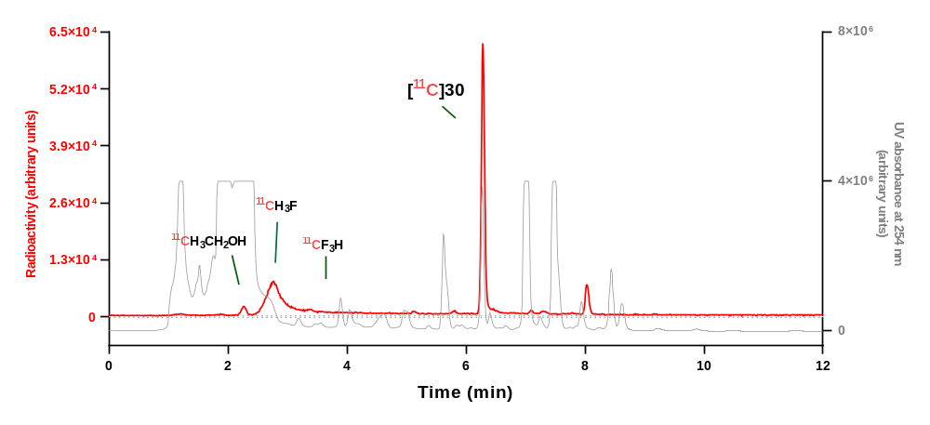
Analytical HPLC chromatogram for reaction mixture.
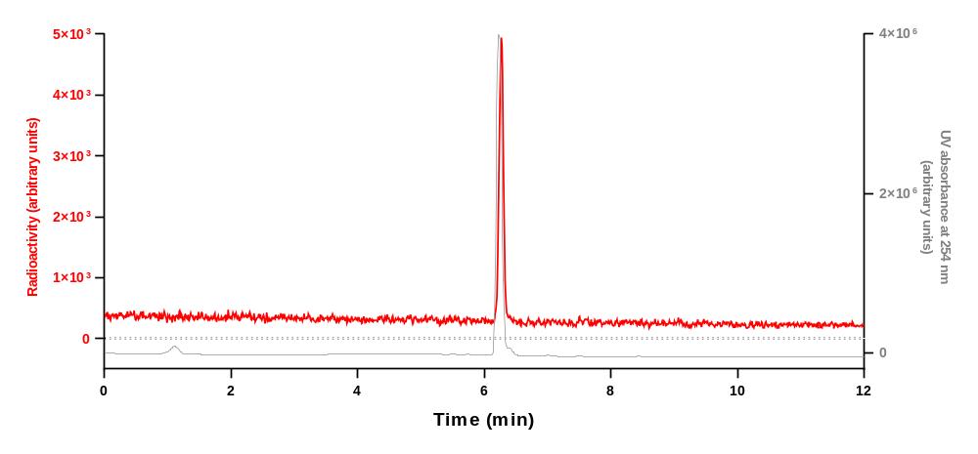
Analytical HPLC chromatogram for [¹¹C]30 collected from the above HPLC analysis when co–injected with 30.
Run | Retention time (min) | Yield (decay-corrected)  (%) | Mean yield ± SD (%)
1 | 6.285 | 86 | 86 ± 1
2 | 6.281 | 86 | 86 ± 1
3 | 6.450 | 85 | 86 ± 1

HPLC analysis of [¹¹C]31
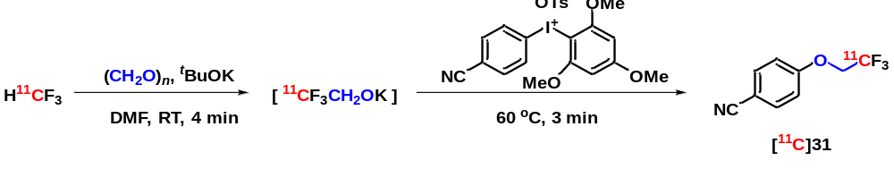
Prepared following general procedure B and analyzed using HPLC condition A.
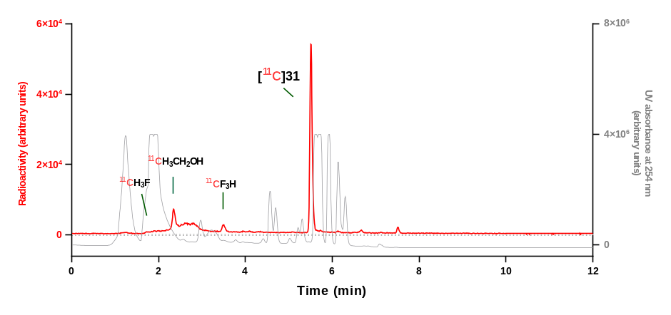
Analytical HPLC chromatogram for reaction mixture.
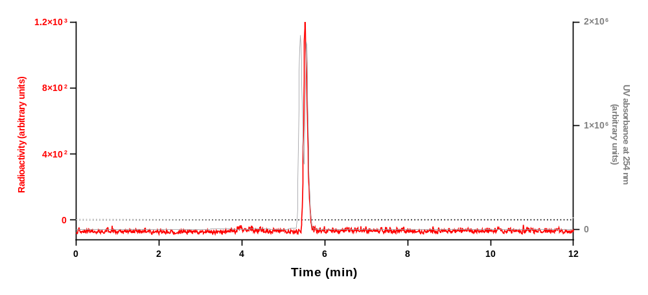
Analytical HPLC chromatogram for [¹¹C]31 collected from the above HPLC analysis when co-injected with 31.
Run | Retention time (min) | Yield (decay-corrected)  (%) | Mean yield ± SD (%)
1 | 5.518 | 77 | 80 ± 3
2 | 5.512 | 81 | 80 ± 3
3 | 5.550 | 82 | 80 ± 3

HPLC analysis of [¹¹C]32
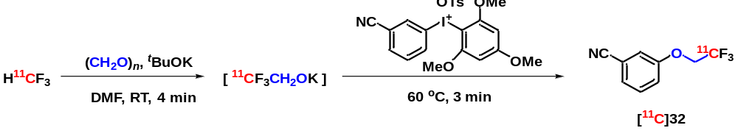
Prepared following general procedure B and analyzed using HPLC condition A.
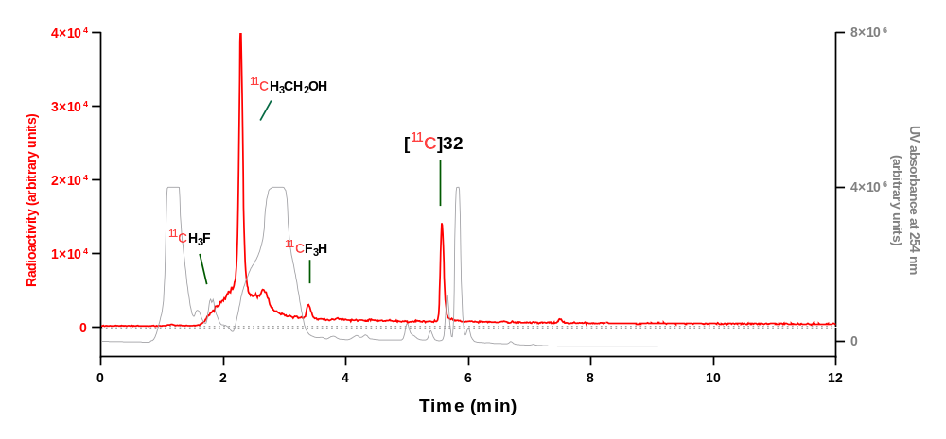
Analytical HPLC chromatogram for reaction mixture.
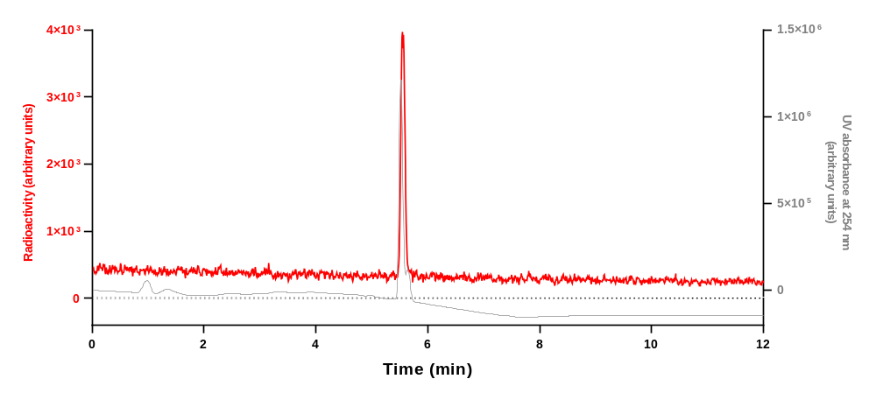
Analytical HPLC chromatogram for [¹¹C]32 collected from the above HPLC analysis when co–injected with 32.
Run | Retention time (min) | Yield (decay-corrected)  (%) | Mean yield ± SD (%)
1 | 5.579 | 22 | 22 ± 1
2 | 5.576 | 21 | 22 ± 1
3 | 5.570 | 22 | 22 ± 1

HPLC analysis of [¹¹C]33
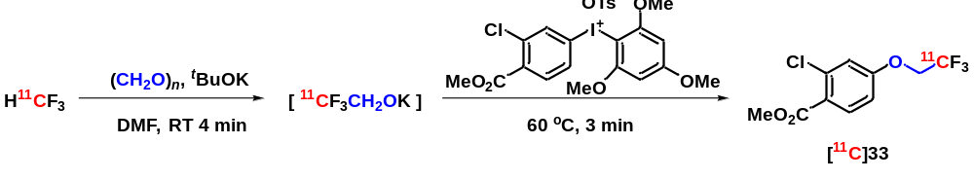
Prepared following general procedure B and analyzed using HPLC condition A.
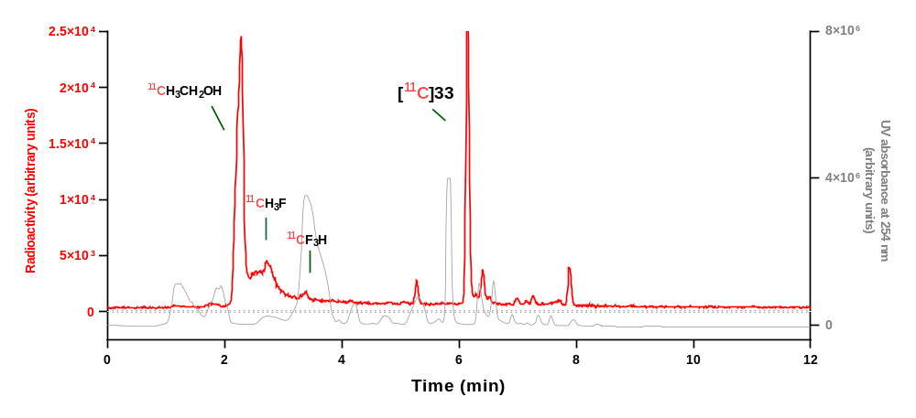
Analytical HPLC chromatogram for reaction mixture.
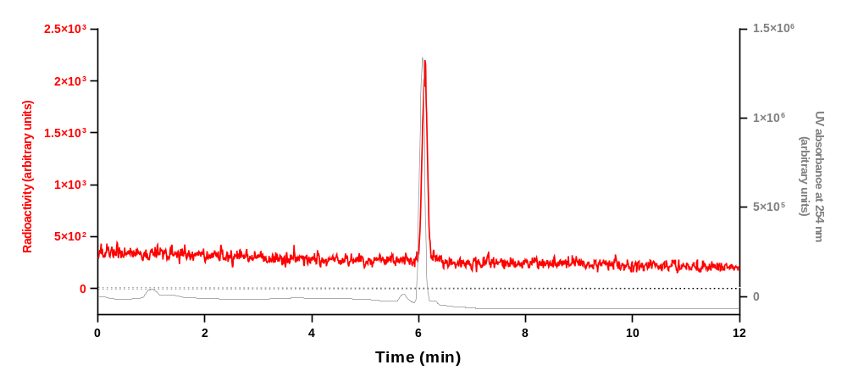
Analytical HPLC chromatogram for [¹¹C]33 collected from the above HPLC analysis when co–injected with 33.
Run | Retention time (min) | Yield (decay-corrected)  (%) | Mean yield ± SD (%)
1 | 6.144 | 33 | 32 ± 2
2 | 6.147 | 32 | 32 ± 2
3 | 6.148 | 30 | 32 ± 2

HPLC analysis of [¹¹C]34
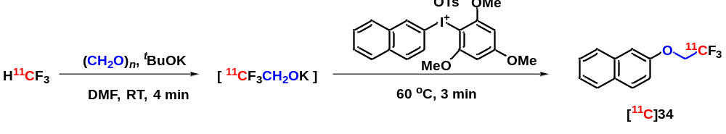
Prepared following general procedure B and analyzed using HPLC condition A.
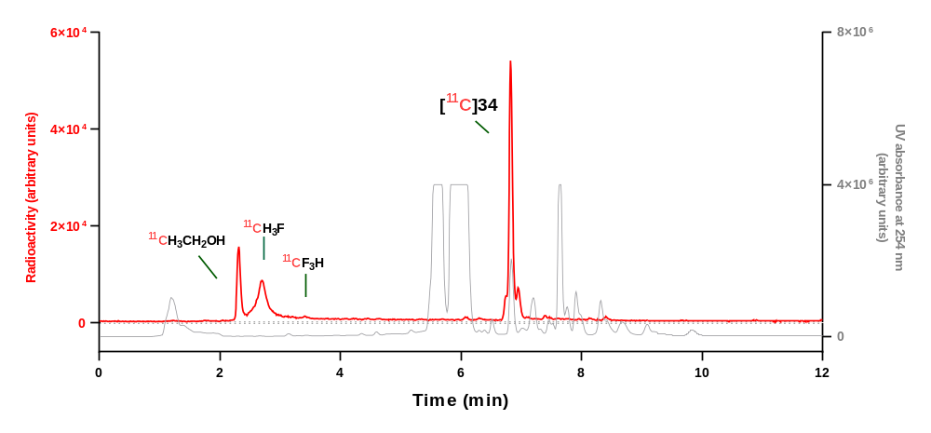
Analytical HPLC chromatogram for reaction mixture.
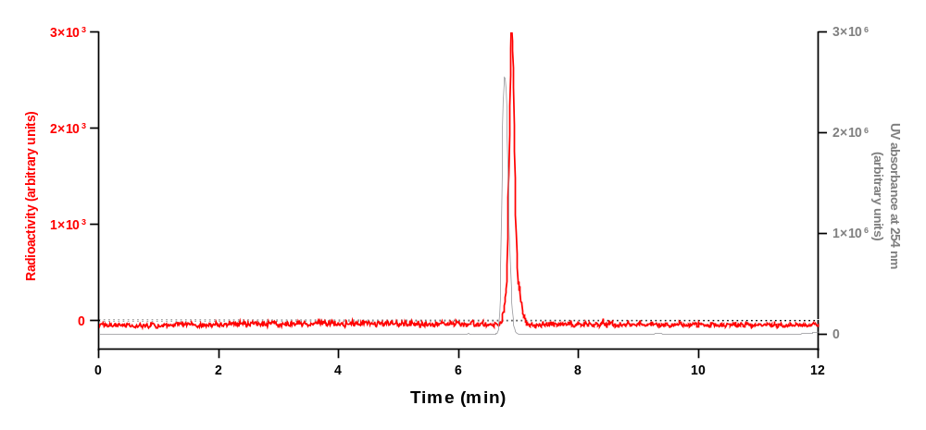
Analytical HPLC chromatogram for [¹¹C]34 collected from the above HPLC analysis when co–injected with 34.
Run | Retention time (min) | Yield (decay-corrected)  (%) | Mean yield ± SD (%)
1 | 6.827 | 69 | 68 ± 4
2 | 6.809 | 64 | 68 ± 4
3 | 6.899 | 71 | 68 ± 4

HPLC analysis of [¹¹C]35
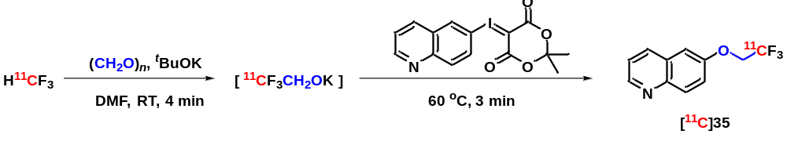
Prepared following general procedure B and analyzed using HPLC condition A.
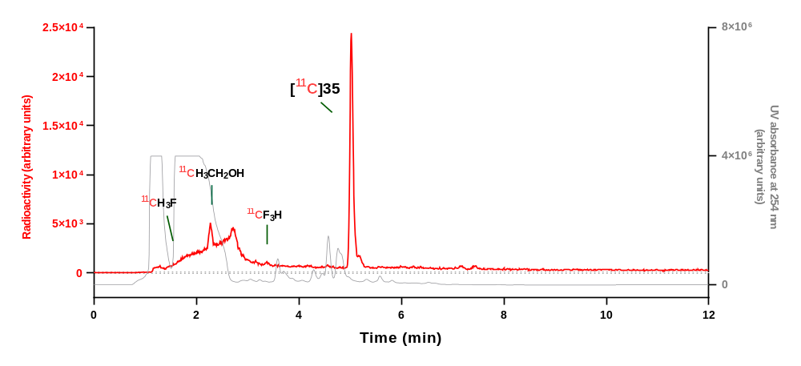
Analytical HPLC chromatogram for reaction mixture.
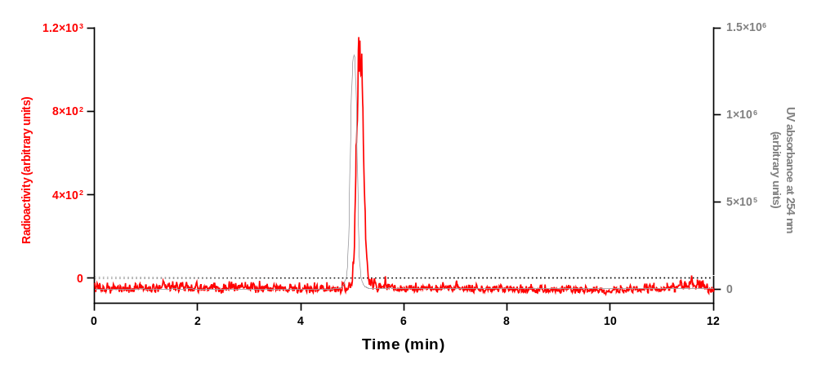
Analytical HPLC chromatogram for [¹¹C]35 collected from the above HPLC analysis when co–injected with 35.
Run | Retention time (min) | Yield (decay-corrected)  (%) | Mean yield ± SD (%)
1 | 5.024 | 75 | 73 ± 2
2 | 5.027 | 73 | 73 ± 2
3 | 5.027 | 71 | 73 ± 2

HPLC analysis of [¹¹C]36
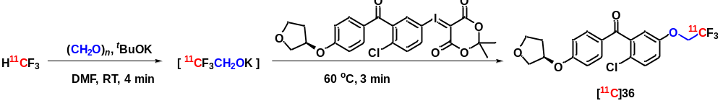
Prepared following general procedure B and analyzed using HPLC condition A.
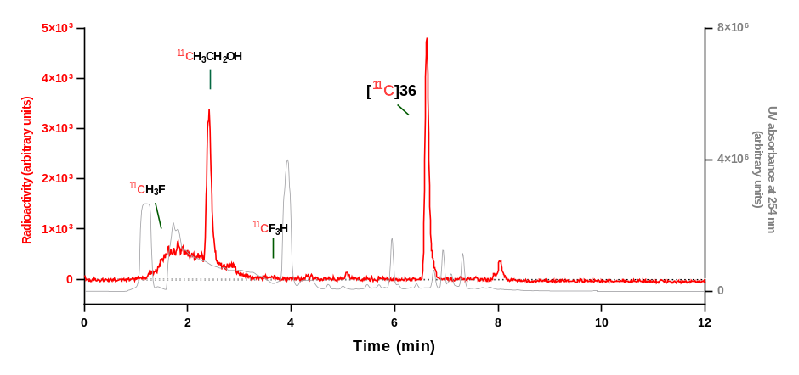
Analytical HPLC chromatogram for reaction mixture.
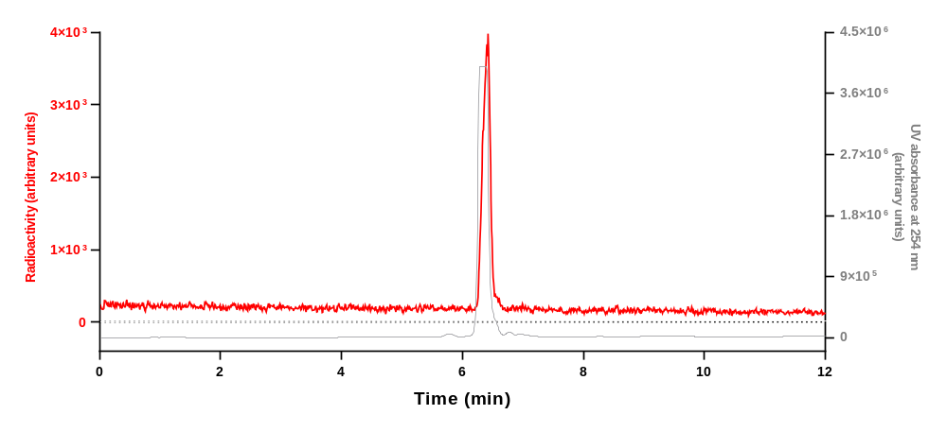
Analytical HPLC chromatogram for [¹¹C]36 collected from the above HPLC analysis when co–injected with 36.
Run | Retention time (min) | Yield (decay-corrected)  (%) | Mean yield ± SD (%)
1 | 6.621 | 46 | 47 ± 2
2 | 6.617 | 46 | 47 ± 2
3 | 6.623 | 49 | 47 ± 2

HPLC analysis of [¹¹C]37
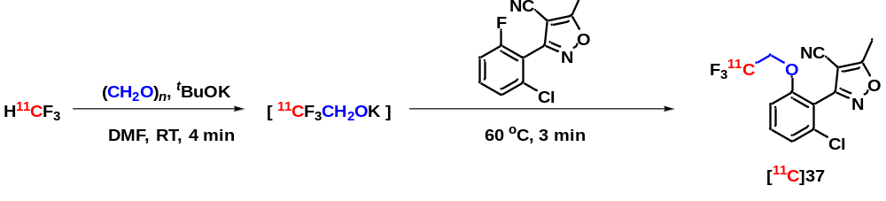
Prepared following general procedure B and analyzed using HPLC condition A.
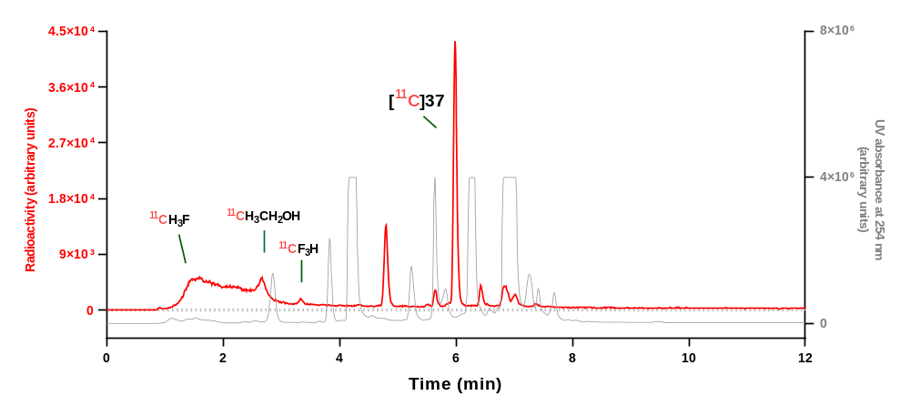
Analytical HPLC chromatogram for reaction mixture.
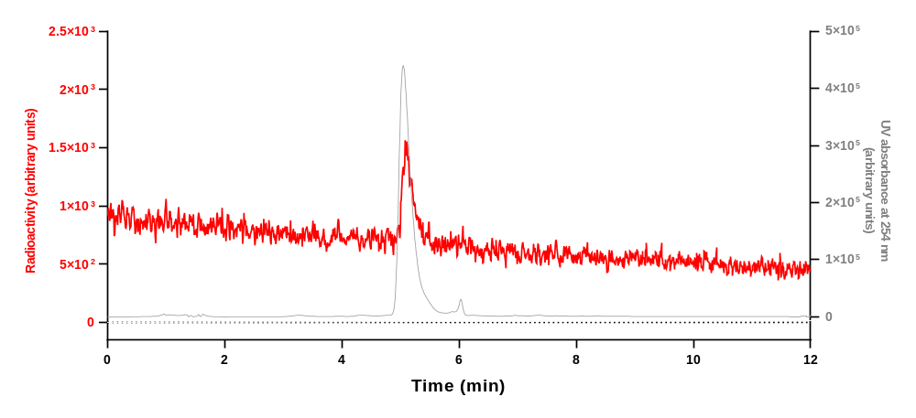
Analytical HPLC chromatogram for [¹¹C]37 collected from the above HPLC analysis when co–injected with 37.
Run | Retention time (min) | Yield (decay-corrected)  (%) | Mean yield ± SD (%)
1 | 5.985 | 49 | 44 ± 10
2 | 6.082 | 33 | 44 ± 10
3 | 6.076 | 51 | 44 ± 10
HPLC analysis of [¹¹C]38
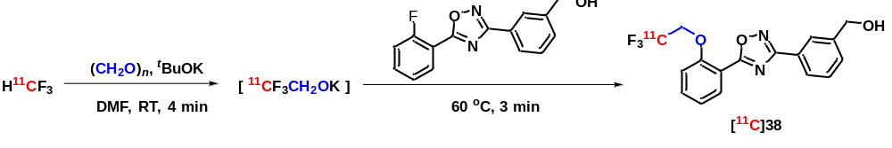
Prepared following general procedure B and analyzed using HPLC condition A.
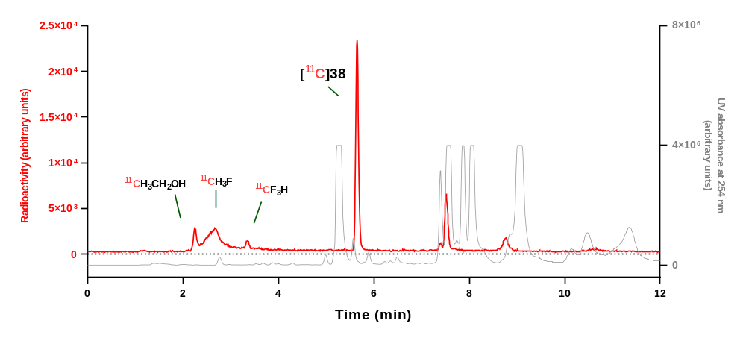
Analytical HPLC chromatogram for reaction mixture.
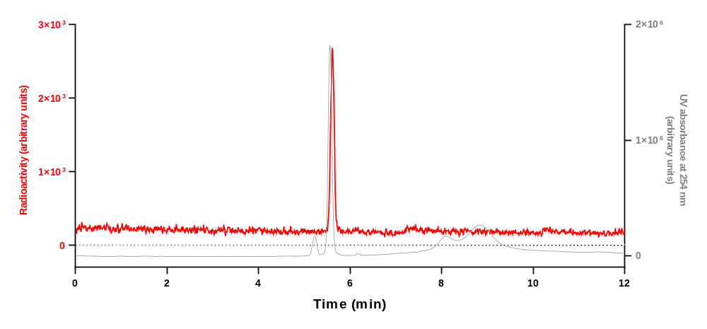
Analytical HPLC chromatogram for [¹¹C]38 collected from the above HPLC analysis when co–injected with 38.
Run | Retention time (min) | Yield (decay-corrected)  (%) | Mean yield ± SD (%)
1 | 5.649 | 60 | 60 ± 1
2 | 5.737 | 61 | 60 ± 1
3 | 5.756 | 60 | 60 ± 1

HPLC analysis of [¹¹C]39
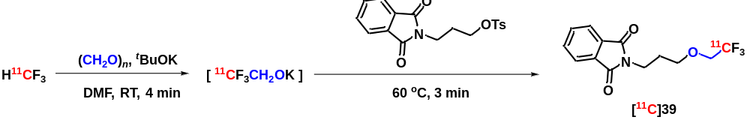
Prepared following general procedure B and analyzed using HPLC condition A.
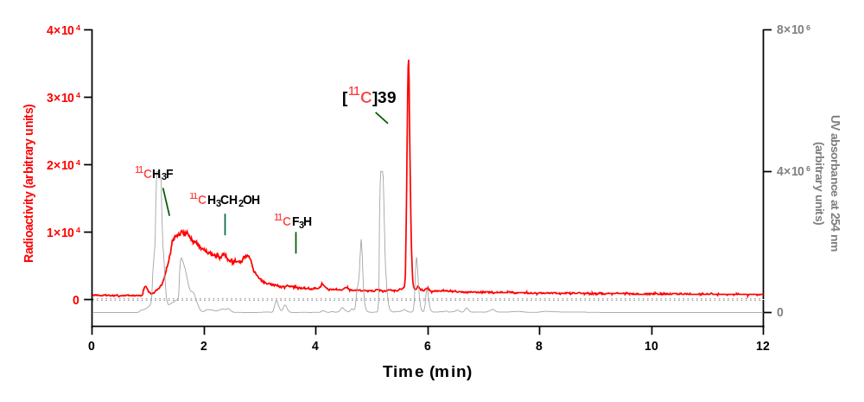
Analytical HPLC chromatogram for reaction mixture.
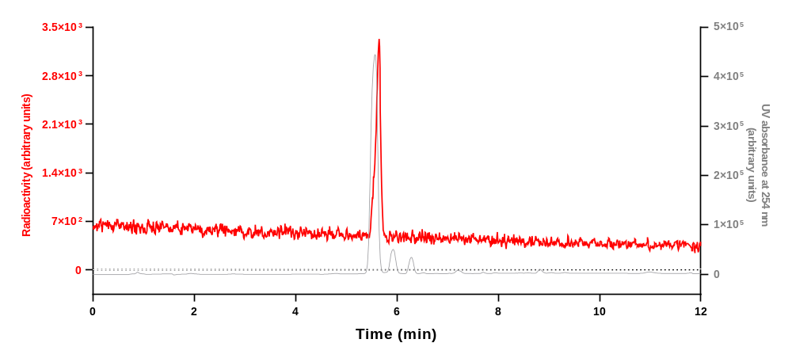
Analytical HPLC chromatogram for [¹¹C]39 collected from the above HPLC analysis when co–injected with 39.
Run | Retention time (min) | Yield (decay-corrected)  (%) | Mean yield ± SD (%)
1 | 5.656 | 34 | 31 ± 3
2 | 5.655 | 31 | 31 ± 3
3 | 5.646 | 29 | 31 ± 3

HPLC analysis of [¹¹C]40
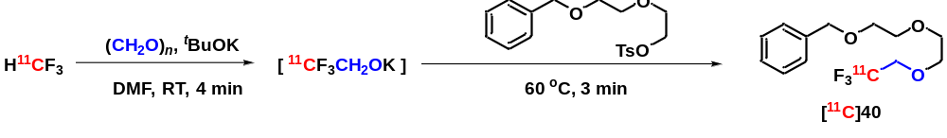
Prepared following general procedure B and analyzed using HPLC condition A.
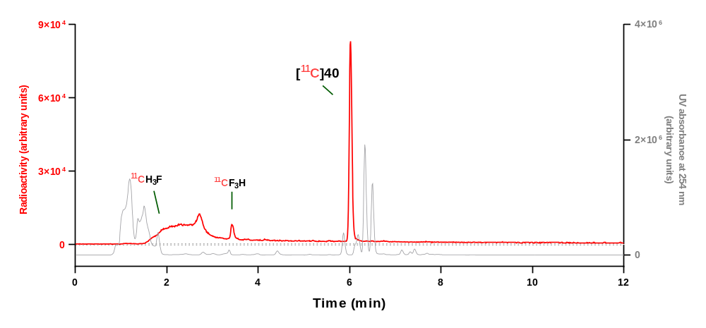
Analytical HPLC chromatogram for reaction mixture.
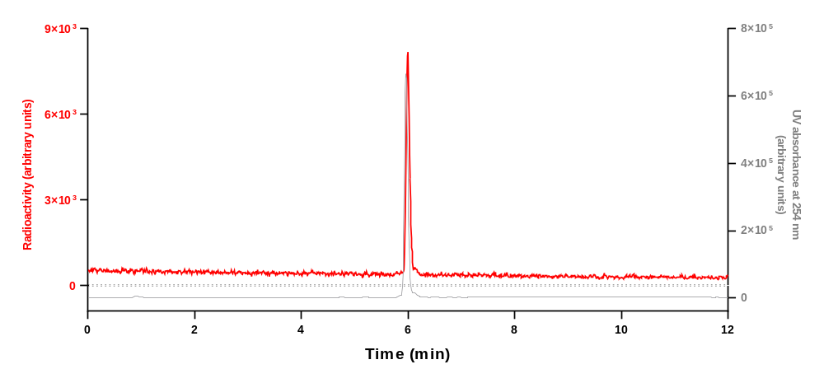
Analytical HPLC chromatogram for [¹¹C]40 collected from the above HPLC analysis when co–injected with 40.
Run | Retention time (min) | Yield (decay-corrected)  (%) | Mean yield ± SD (%)
1 | 6.023 | 90 | 89 ± 4
2 | 6.028 | 92 | 89 ± 4
3 | 6.046 | 85 | 89 ± 4

HPLC analysis of [¹¹C]41
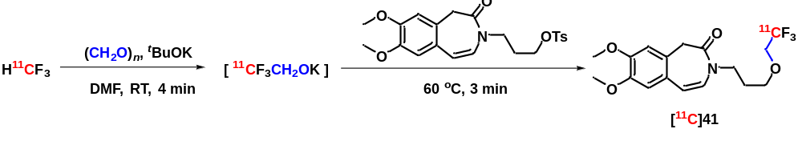
Prepared following general procedure B and analyzed using HPLC condition A.
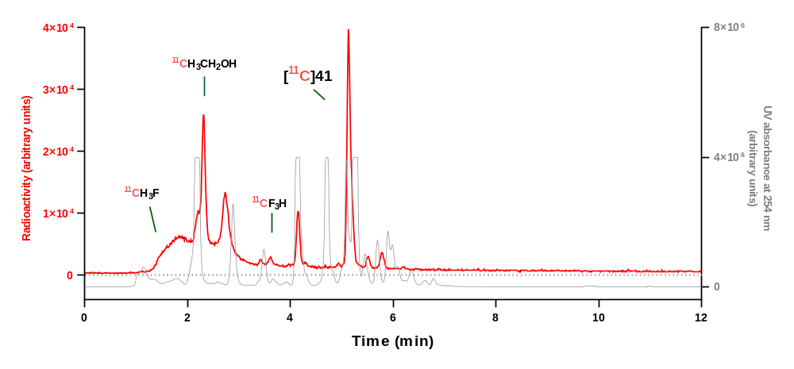
Analytical HPLC chromatogram for reaction mixture.
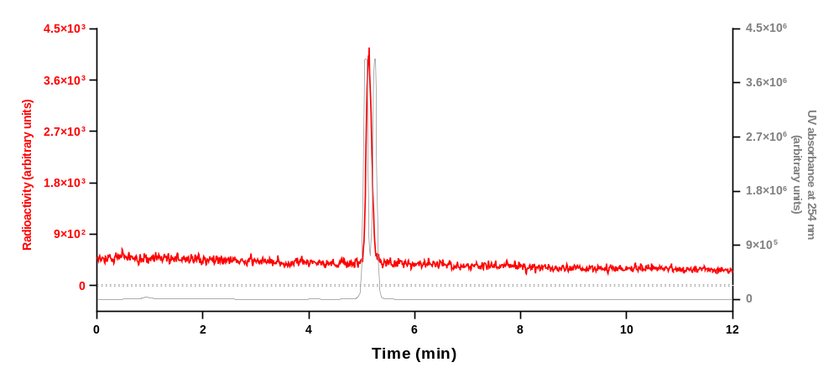
Analytical HPLC chromatogram for [¹¹C]41 collected from the above HPLC analysis when co–injected with 41.
Run | Retention time (min) | Yield (decay-corrected)  (%) | Mean yield ± SD (%)
1 | 5.136 | 46 | 45 ± 1
2 | 5.134 | 44 | 45 ± 1
3 | 5.133 | 44 | 45 ± 1

HPLC analysis of [¹¹C]42
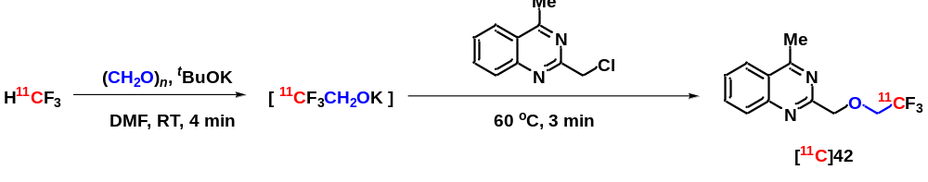
Prepared following general procedure B and analyzed using HPLC condition A.
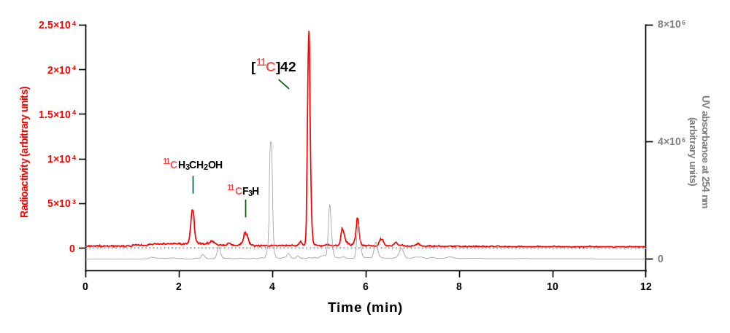
Analytical HPLC chromatogram for reaction mixture.
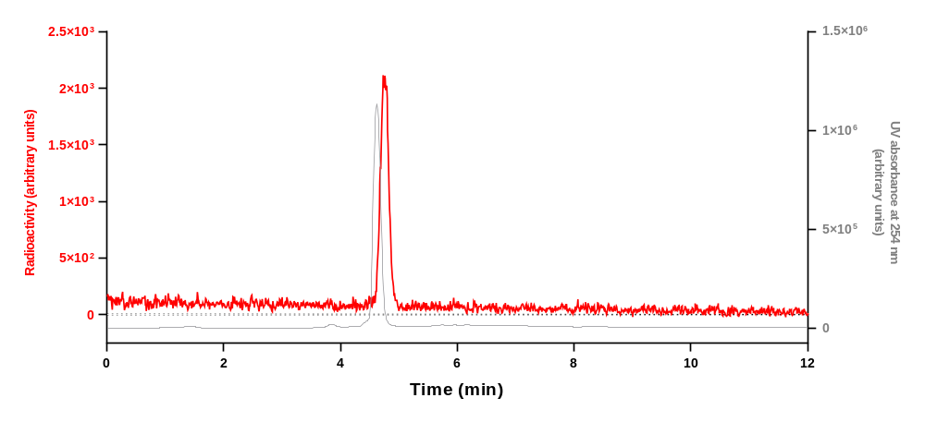
Analytical HPLC chromatogram for [¹¹C]42 collected from the above HPLC analysis when co–injected with 42.
Run | Retention time (min) | Yield (decay-corrected)  (%) | Mean yield ± SD (%)
1 | 4.782 | 57 | 53 ± 4
2 | 4.782 | 54 | 53 ± 4
3 | 4.786 | 49 | 53 ± 4

HPLC analysis of [¹¹C]43
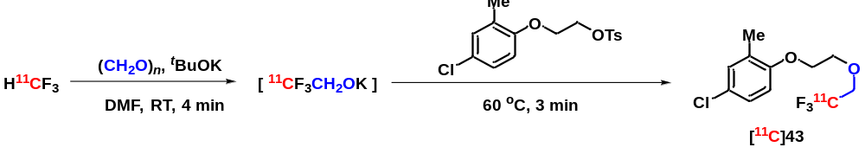
Prepared following general procedure B and analyzed using HPLC condition A.
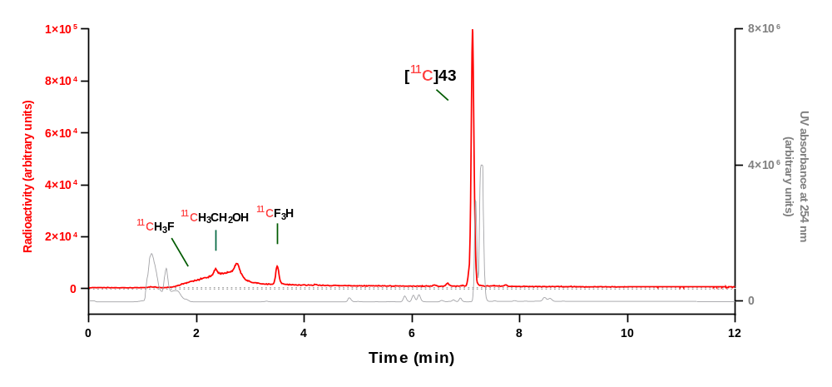
Analytical HPLC chromatogram for reaction mixture.
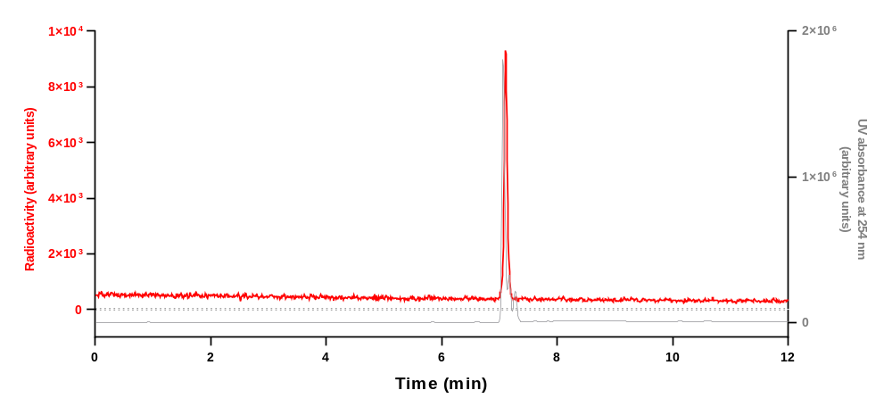
Analytical HPLC chromatogram for [¹¹C]43 collected from the above HPLC analysis when co–injected with 43.
Run | Retention time (min) | Yield (decay-corrected)  (%) | Mean yield ± SD (%)
1 | 7.127 | 86 | 85 ± 1
2 | 7.128 | 85 | 85 ± 1
3 | 7.132 | 85 | 85 ± 1

HPLC analysis of [¹¹C]44
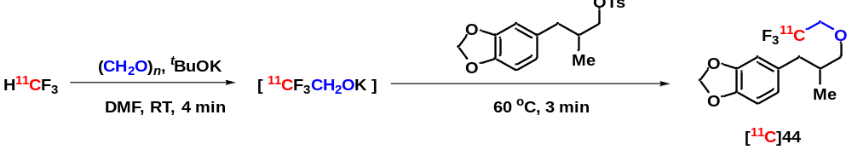
Prepared following general procedure B and analyzed using HPLC condition A.
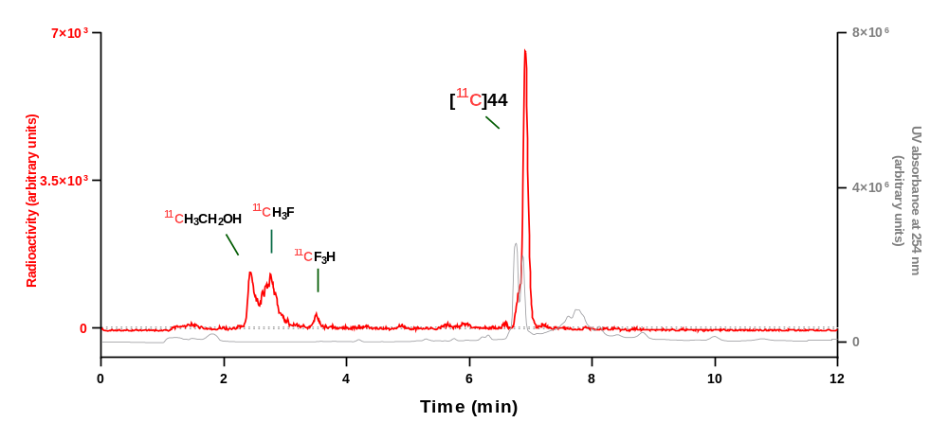
Analytical HPLC chromatogram for reaction mixture.
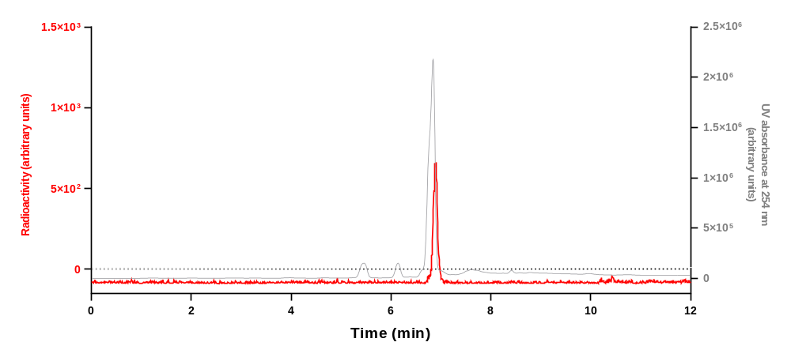
Analytical HPLC chromatogram for [¹¹C]44 collected from the above HPLC analysis when co–injected with 44.
Run | Retention time (min) | Yield (decay-corrected)  (%) | Mean yield ± SD (%)
1 | 6.912 | 60 | 53 ± 7
2 | 6.866 | 51 | 53 ± 7
3 | 6.854 | 47 | 53 ± 7

HPLC analysis of [¹¹C]45
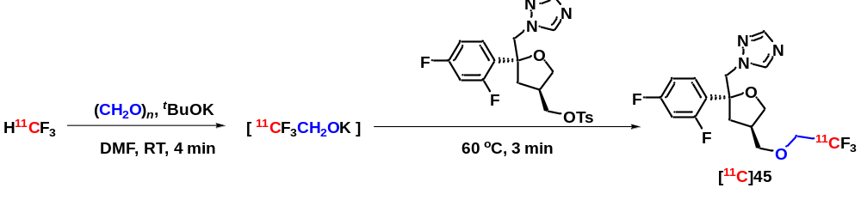
Prepared following general procedure B and analyzed using HPLC condition A.
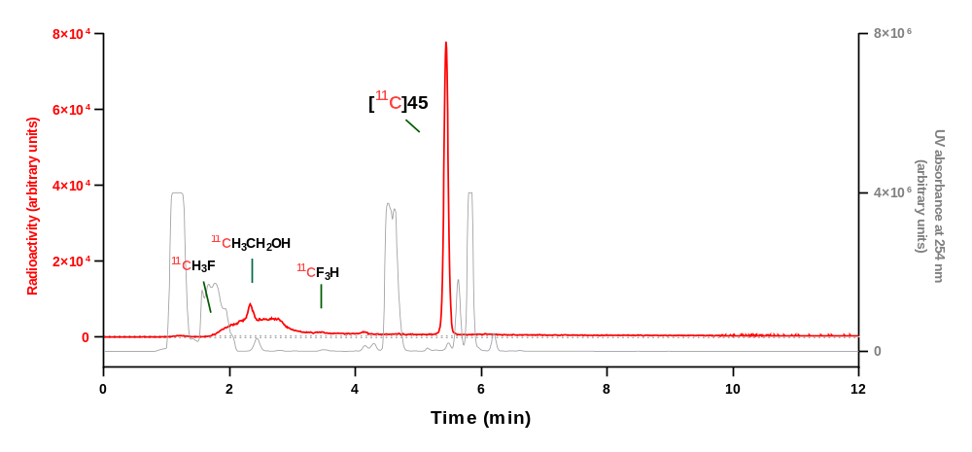
Analytical HPLC chromatogram for reaction mixture.
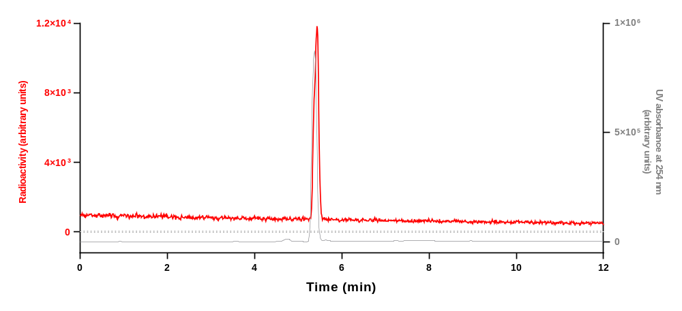
Analytical HPLC chromatogram for [¹¹C]45 collected from the above HPLC analysis when co–injected with 45.
Run | Retention time (min) | Yield (decay-corrected)  (%) | Mean yield ± SD (%)
1 | 5.443 | 91 | 89 ± 6
2 | 5.528 | 93 | 89 ± 6
3 | 5.459 | 82 | 89 ± 6

HPLC analysis of [¹¹C]46
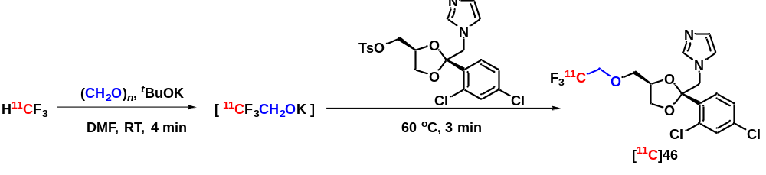
Prepared following general procedure B and analyzed using HPLC condition A.
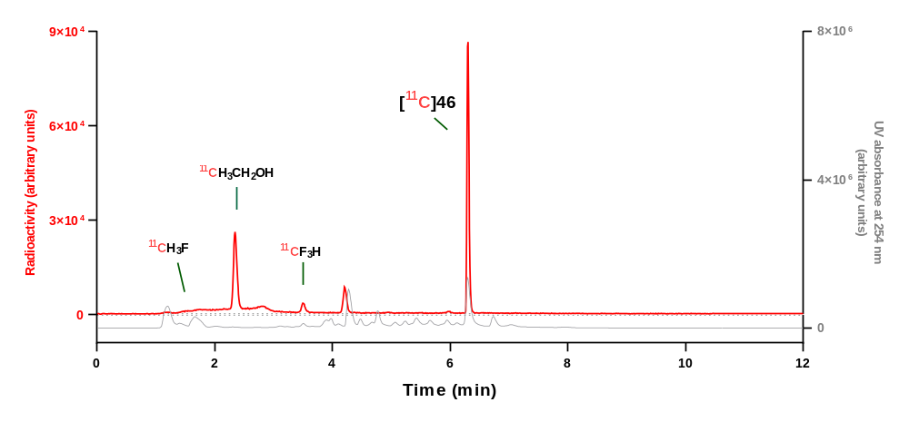
Analytical HPLC chromatogram for reaction mixture.
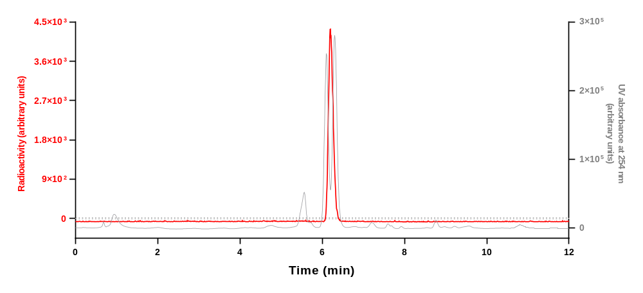
Analytical HPLC chromatogram for [¹¹C]46 collected from the above HPLC analysis when co–injected with 46.
Run | Retention time (min) | Yield (decay-corrected)  (%) | Mean yield ± SD (%)
1 | 6.252 | 50 | 56 ± 5
2 | 6.305 | 58 | 56 ± 5
3 | 6.286 | 59 | 56 ± 5

HPLC analysis of [¹¹C]47
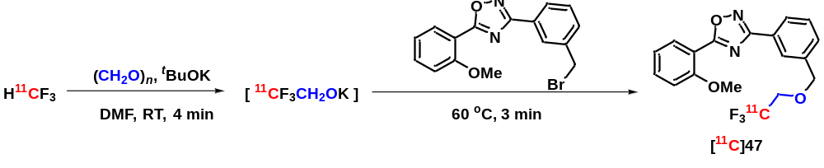
Prepared following general procedure B and analyzed using HPLC condition A.
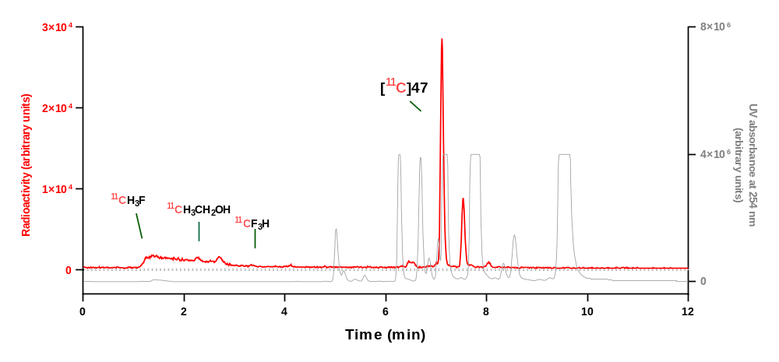
Analytical HPLC chromatogram for reaction mixture.
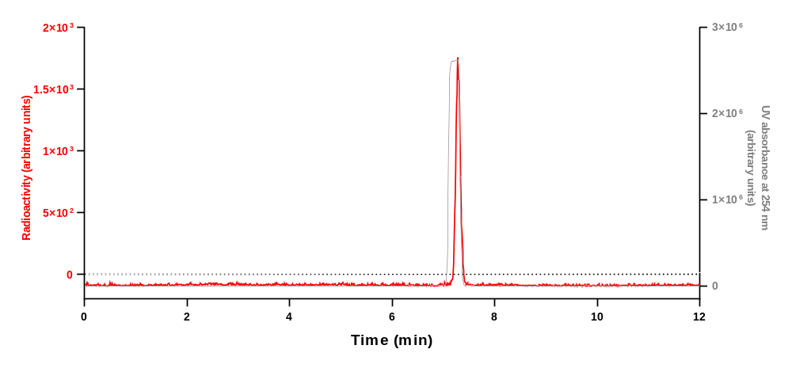
Analytical HPLC chromatogram for [¹¹C]47 collected from the above HPLC analysis when co–injected with 47.
Run | Retention time (min) | Yield (decay-corrected)  (%) | Mean yield ± SD (%)
1 | 7.117 | 71 | 71 ± 1
2 | 7.117 | 72 | 71 ± 1
3 | 7.110 | 70 | 71 ± 1

HPLC analysis of [¹¹C]48
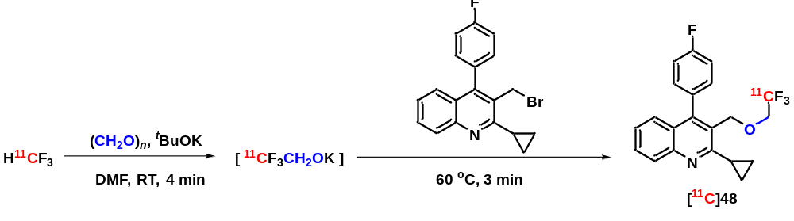
Prepared following general procedure B and analyzed using HPLC condition A.
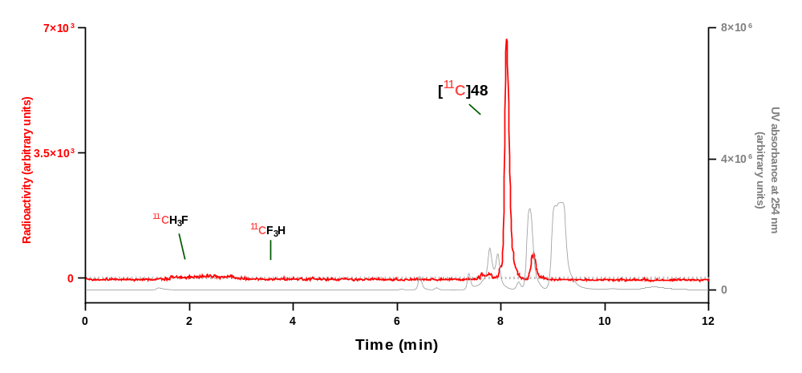
Analytical HPLC chromatogram for reaction mixture.
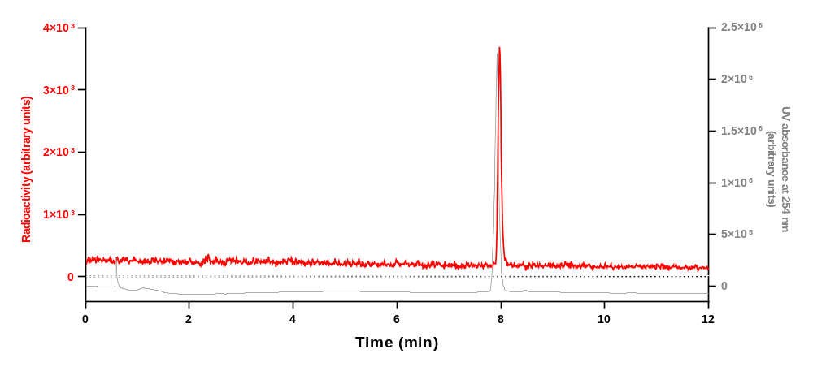
Analytical HPLC chromatogram for [¹¹C]48 collected from the above HPLC analysis when co–injected with 48.
Run | Retention time (min) | Yield (decay-corrected)  (%) | Mean yield ± SD (%)
1 | 7.988 | 84 | 85 ± 2
2 | 8.118 | 85 | 85 ± 2
3 | 8.111 | 87 | 85 ± 2

HPLC analysis of [¹¹C]49
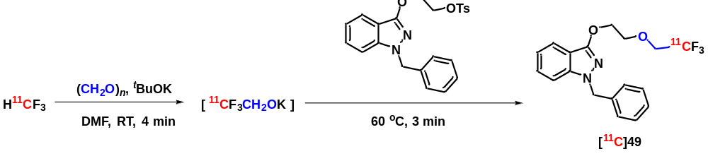
Prepared following general procedure B and analyzed using HPLC condition A.
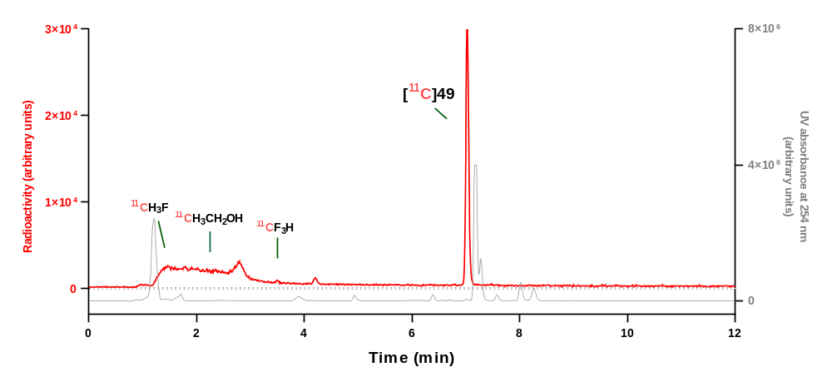
Analytical HPLC chromatogram for reaction mixture.
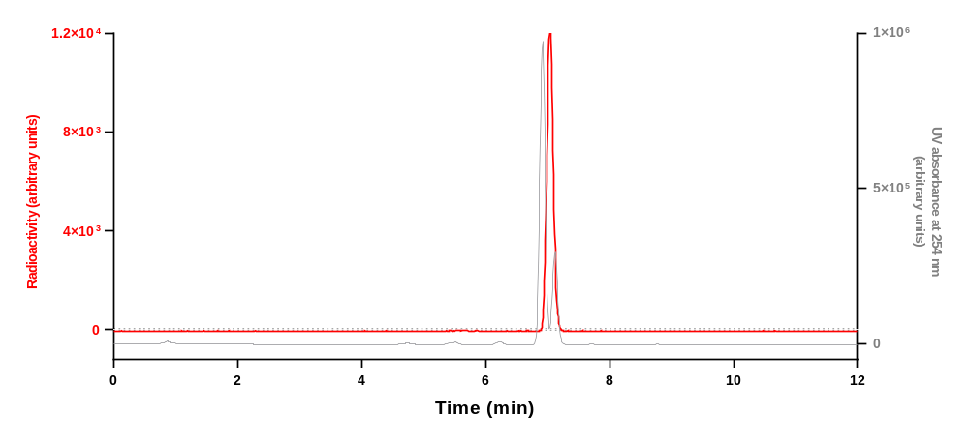
Analytical HPLC chromatogram for [¹¹C]49 collected from the HPLC analysis when co–injected with 49.
Run | Retention time (min) | Yield (decay-corrected)  (%) | Mean yield ± SD (%)
1 | 7.025 | 87 | 86 ± 1
2 | 7.028 | 87 | 86 ± 1
3 | 7.028 | 85 | 86 ± 1

HPLC analysis of [¹¹C]50
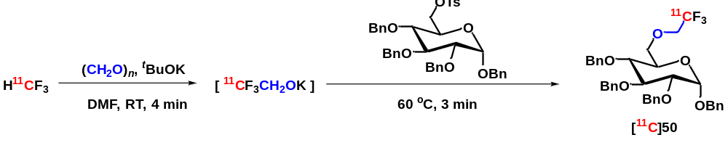
Prepared following general procedure B and analyzed using HPLC condition A.
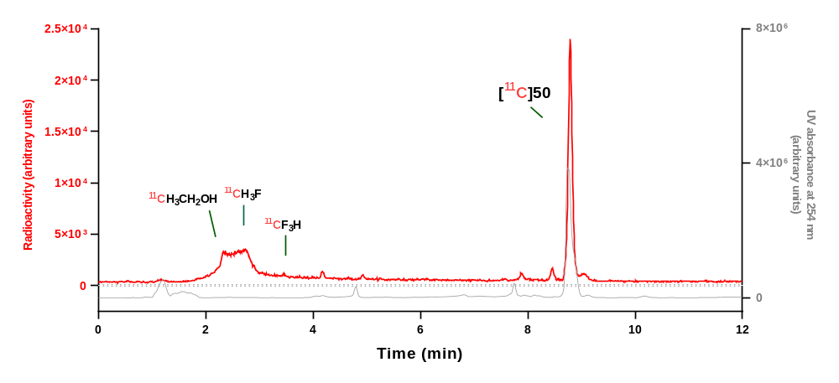
Analytical HPLC chromatogram for reaction mixture.
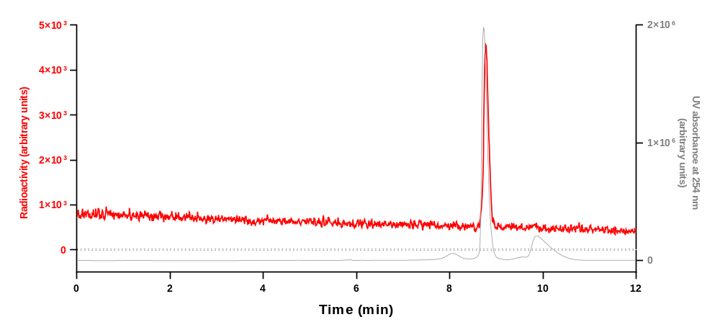
Analytical HPLC chromatogram for [¹¹C]50 collected from the above HPLC analysis when co–injected with 50.
Run | Retention time (min) | Yield (decay-corrected)  (%) | Mean yield ± SD (%)
1 | 8.800 | 82 | 82 ± 1
2 | 8.787 | 81 | 82 ± 1
3 | 8.790 | 82 | 82 ± 1

HPLC analysis of [¹¹C]51
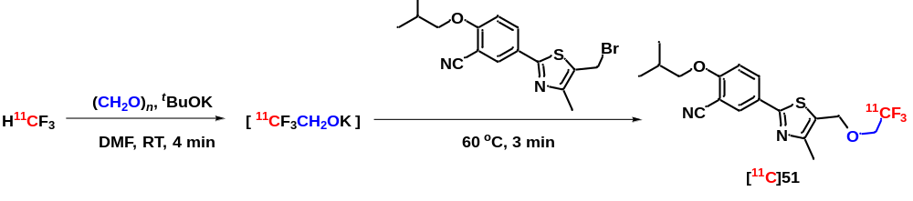
Prepared following general procedure B and analyzed using HPLC condition A.
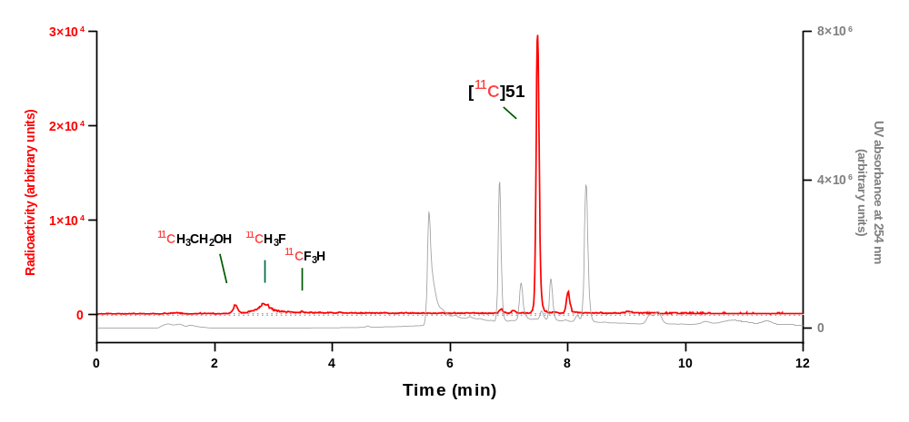
Analytical HPLC chromatogram for reaction mixture.
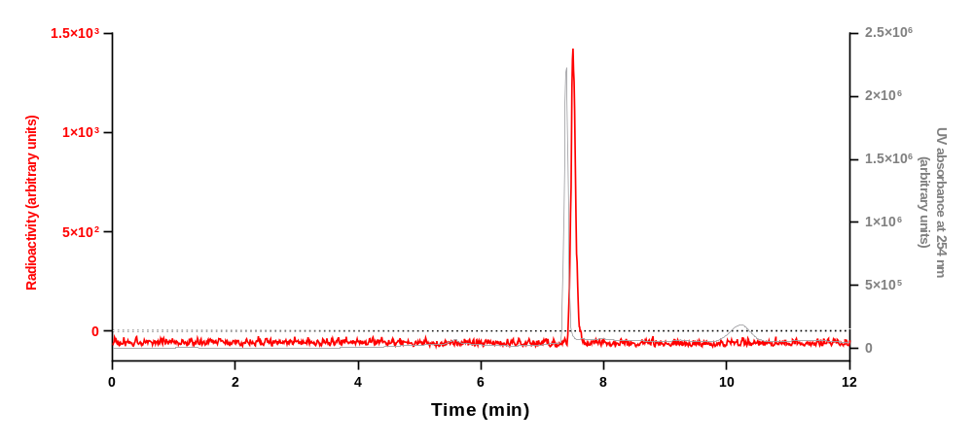
Analytical HPLC chromatogram for [¹¹C]51 collected from the above HPLC analysis when co–injected with 51.
Run | Retention time (min) | Yield (decay-corrected)  (%) | Mean yield ± SD (%)
1 | 7.370 | 86 | 85 ± 2
2 | 7.482 | 83 | 85 ± 2
3 | 7.489 | 85 | 85 ± 2
HPLC analysis of [¹¹C]52
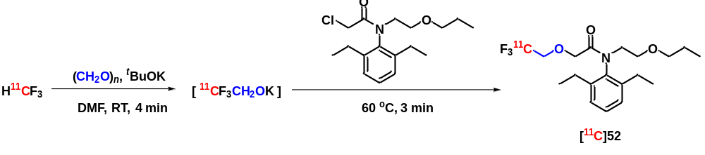
Prepared following general procedure B and analyzed using HPLC condition A.
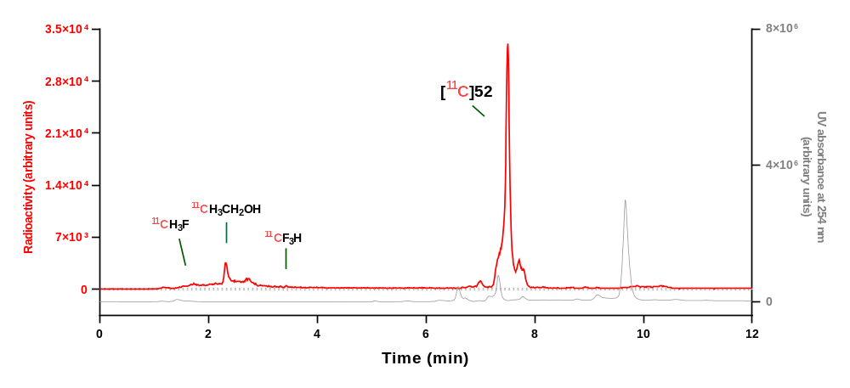
Analytical HPLC chromatogram for reaction mixture.
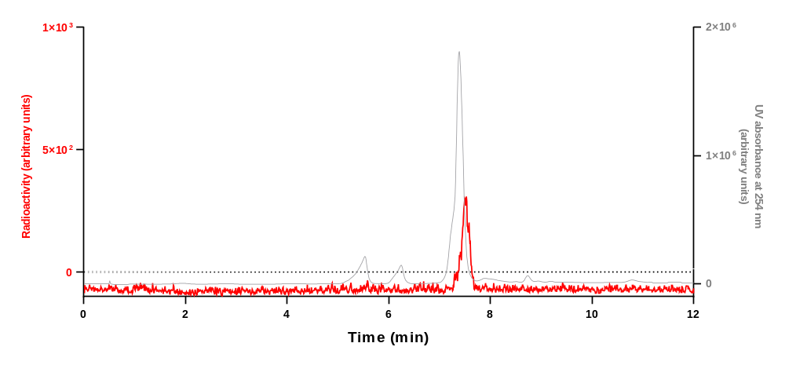
Analytical HPLC chromatogram for [¹¹C]52 collected from the above HPLC analysis when co–injected with 52.
Run | Retention time (min) | Yield (decay-corrected)  (%) | Mean yield ± SD (%)
1 | 7.506 | 70 | 73 ± 3
2 | 7.608 | 76 | 73 ± 3
3 | 7.585 | 73 | 73 ± 3

HPLC analysis of [¹¹C]53
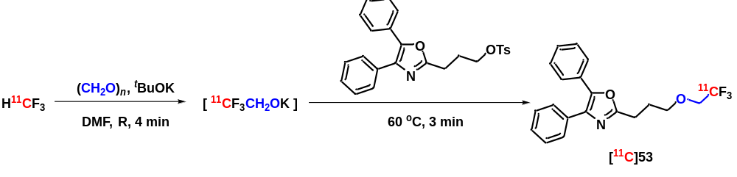
Prepared following general procedure B and analyzed using HPLC condition A.
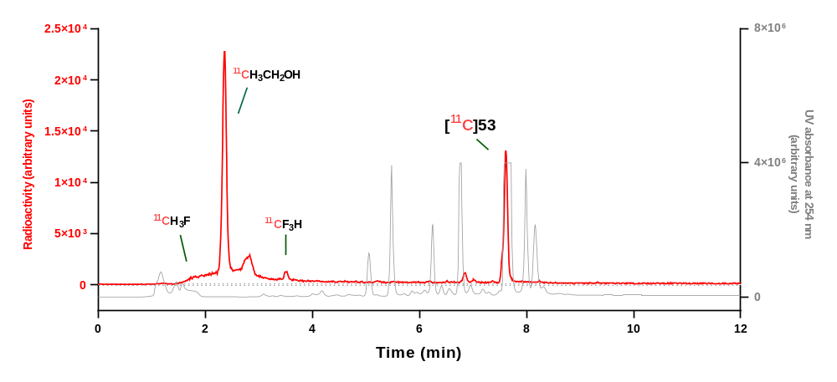
Analytical HPLC chromatogram for reaction mixture.
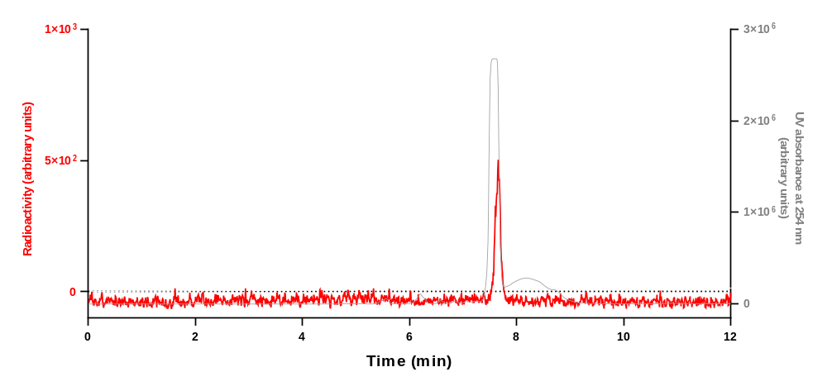
Analytical HPLC chromatogram for [¹¹C]53 collected from the above HPLC analysis when co–injected with 53.
Run | Retention time (min) | Yield (decay-corrected)  (%) | Mean yield ± SD (%)
1 | 7.615 | 35 | 34 ± 2
2 | 7.621 | 35 | 34 ± 2
3 | 7.615 | 32 | 34 ± 2

HPLC analysis of [¹¹C]54
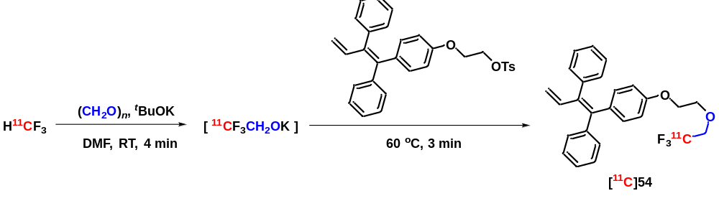
Prepared following general procedure B and analyzed using HPLC condition A.
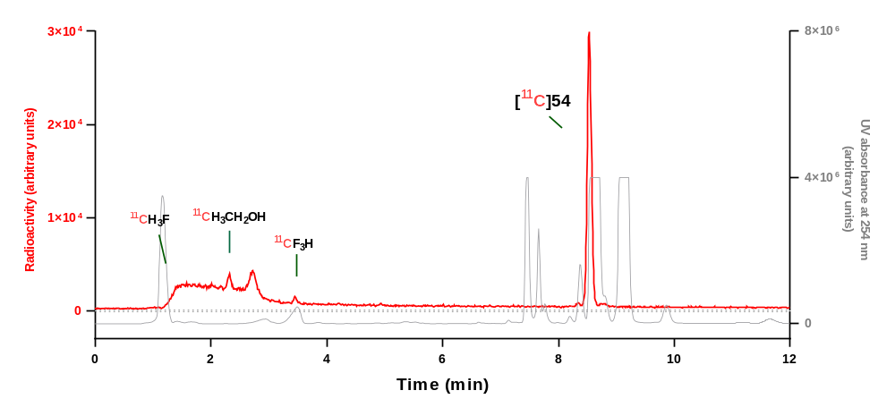
Analytical HPLC chromatogram for reaction mixture.
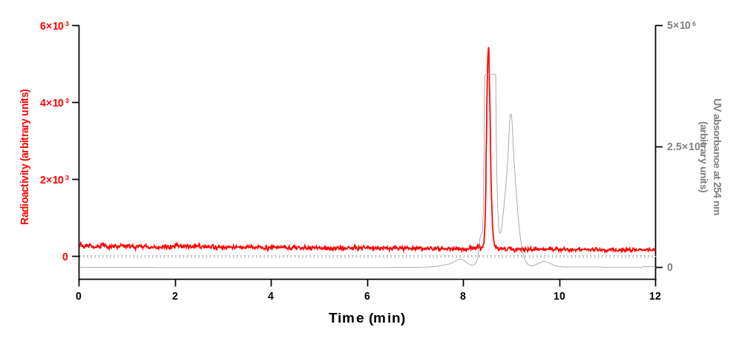
Analytical HPLC chromatogram for [¹¹C]54 collected from the above HPLC analysis when co–injected with 54.
Run | Retention time (min) | Yield (decay-corrected)  (%) | Mean yield ± SD (%)
1 | 8.533 | 91 | 93 ± 2
2 | 8.537 | 93 | 93 ± 2
3 | 8.544 | 95 | 93 ± 2

HPLC analysis of [¹¹C]55
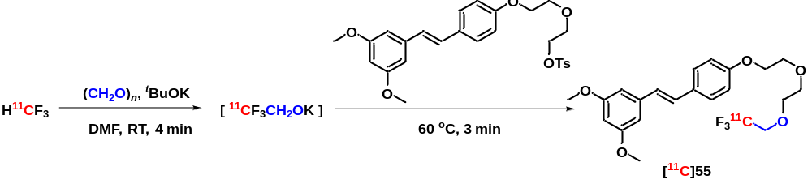
Prepared following general procedure B and analyzed using HPLC condition A.
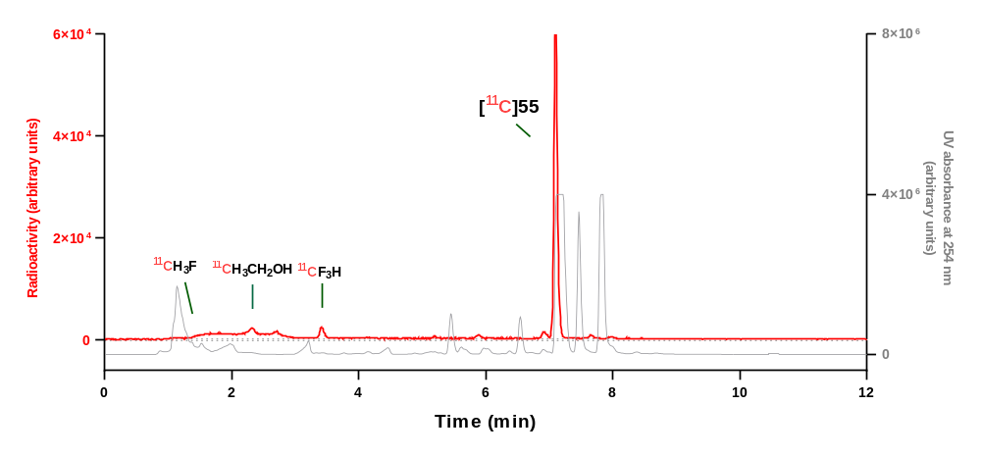
Analytical HPLC chromatogram for reaction mixture.
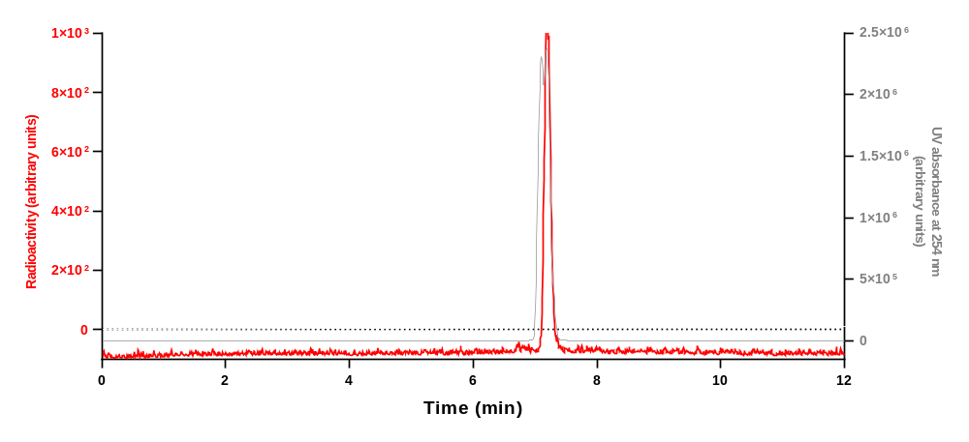
Analytical HPLC chromatogram for [¹¹C]55 collected from the above HPLC analysis when co–injected with 55.
Run | Retention time (min) | Yield (decay-corrected)  (%) | Mean yield ± SD (%)
1 | 7.102 | 84 | 87 ± 3
2 | 7.041 | 89 | 87 ± 3
3 | 7.147 | 89 | 87 ± 3
HPLC analysis of [¹¹C]56
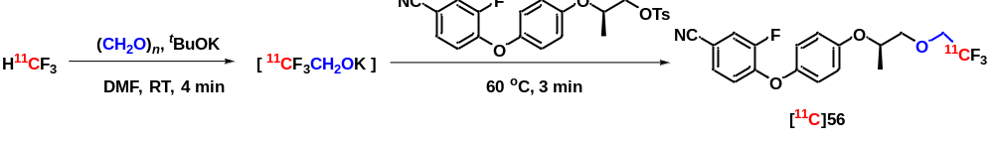
Prepared following general procedure B and analyzed using HPLC condition A.
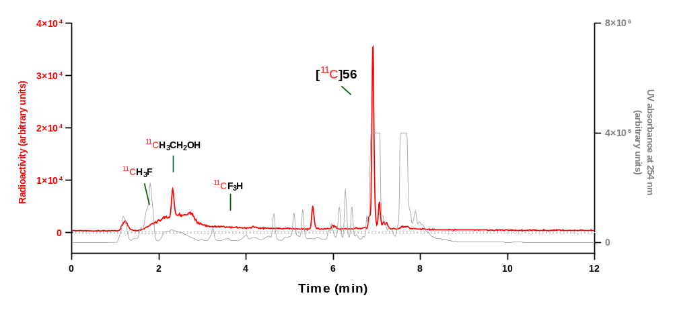
Analytical HPLC chromatogram for reaction mixture.
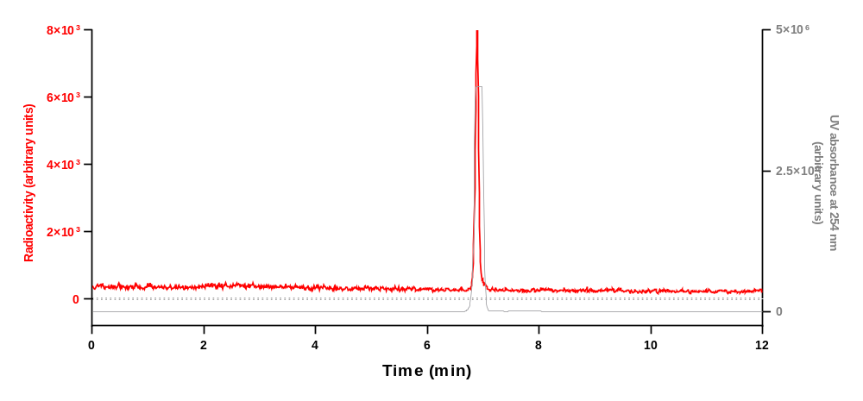
Analytical HPLC chromatogram for [¹¹C]56 collected from the above HPLC analysis when co–injected with 56.
Run | Retention time (min) | Yield (decay-corrected)  (%) | Mean yield ± SD (%)
1 | 6.913 | 50 | 51 ± 1
2 | 6.913 | 51 | 51 ± 1
3 | 6.914 | 52 | 51 ± 1

7.2. HPLC analysis of ¹⁸F-labeled compounds.
HPLC analysis of [¹⁸F]1
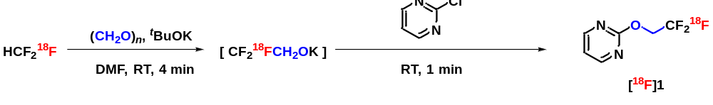
Prepared following general procedure B and analyzed using HPLC condition E.
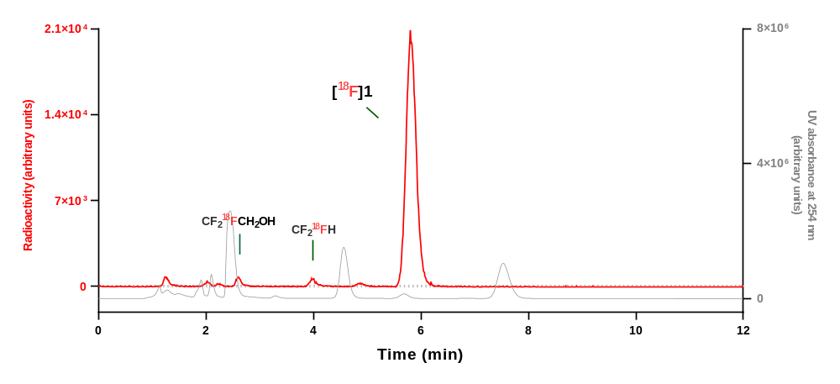
Analytical HPLC chromatogram for reaction mixture.
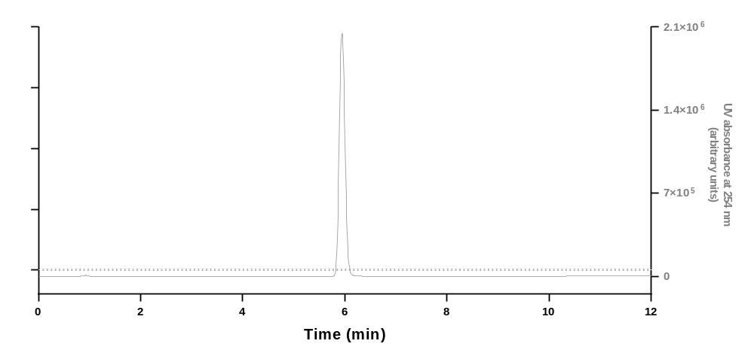
Analytical HPLC chromatogram for 1.
Run | Retention time (min) | Yield (decay-corrected)  (%) | Mean yield ± SD (%)
1 | 5.818 | 82 | 88 ± 5
2 | 5.824 | 91 | 88 ± 5
3 | 5.804 | 91 | 88 ± 5

HPLC analysis of [¹⁸F]4
Prepared following general procedure B and analyzed using HPLC condition A.
Analytical HPLC chromatogram for reaction mixture.
Analytical HPLC chromatogram for [¹⁸F]4 collected from the above HPLC analysis when co–injected with 4.
Run | Retention time (min) | Yield (decay-corrected)  (%) | Mean yield ± SD (%)
1 | 6.767 | 94 | 96 ± 2
2 | 6.775 | 98 | 96 ± 2
3 | 6.773 | 95 | 96 ± 2
HPLC analysis of [¹⁸F]6
Prepared following general procedure B and analyzed using HPLC condition A.
Analytical HPLC chromatogram for reaction mixture.
Analytical HPLC chromatogram for [¹⁸F]6 collected from the above HPLC analysis when co–injected with 6.
Run | Retention time (min) | Yield (decay-corrected)  (%) | Mean yield ± SD (%)
1 | 8.912 | 88 | 91 ± 2
2 | 9.033 | 92 | 91 ± 2
3 | 9.047 | 92 | 91 ± 2

HPLC analysis of [¹⁸F]8
Prepared following general procedure B and analyzed using HPLC condition A.
Analytical HPLC chromatogram for reaction mixture.
Analytical HPLC chromatogram for [¹⁸F]8 collected from the above HPLC analysis when co–injected with 8.
Run | Retention time (min) | Yield (decay-corrected)  (%) | Mean yield ± SD (%)
1 | 6.964 | 92 | 94 ± 2
2 | 6.956 | 96 | 94 ± 2
3 | 6.953 | 94 | 94 ± 2

HPLC analysis of [¹⁸F]13
Prepared following general procedure B and analyzed using HPLC condition A.
Analytical HPLC chromatogram for reaction mixture.
Analytical HPLC chromatogram for [¹⁸F]13 collected from the above HPLC analysis when co–injected with 13.
Run | Retention time (min) | Yield (decay-corrected)  (%) | Mean yield ± SD (%)
1 | 7.826 | 83 | 82 ± 2
2 | 7.833 | 83 | 82 ± 2
3 | 7.836 | 80 | 82 ± 2
HPLC analysis of [¹⁸F]15
Prepared following general procedure B and analyzed using HPLC condition A.
Analytical HPLC chromatogram for reaction mixture.
Analytical HPLC chromatogram for [¹⁸F]15 collected from the above HPLC analysis when co–injected with 15.
Run | Retention time (min) | Yield (decay-corrected)  (%) | Mean yield ± SD (%)
1 | 6.683 | 54 | 56 ± 4
2 | 6.662 | 54 | 56 ± 4
3 | 6.652 | 60 | 56 ± 4
HPLC analysis of [¹⁸F]17
Prepared following general procedure B and analyzed using HPLC condition A.
Analytical HPLC chromatogram for reaction mixture.
Analytical HPLC chromatogram for [¹⁸F]17 collected from the above HPLC analysis when co–injected with 17.
Run | Retention time (min) | Yield (decay-corrected)  (%) | Mean yield ± SD (%)
1 | 7.214 | 58 | 56 ± 2
2 | 7.229 | 54 | 56 ± 2
3 | 7.220 | 57 | 56 ± 2
HPLC analysis of [¹⁸F]18
Prepared following general procedure B and analyzed using HPLC condition A.
Analytical HPLC chromatogram for reaction mixture.
Analytical HPLC chromatogram for [¹⁸F]18 collected from the above HPLC analysis when co–injected with 18.
Run | Retention time (min) | Yield (decay-corrected)  (%) | Mean yield ± SD (%)
1 | 5.437 | 63 | 64 ± 1
2 | 5.436 | 64 | 64 ± 1
3 | 5.413 | 64 | 64 ± 1
HPLC analysis of [¹⁸F]19
Prepared following general procedure B and analyzed using HPLC condition A.
Analytical HPLC chromatogram for reaction mixture.
Analytical HPLC chromatogram for [¹⁸F]19 collected from the above HPLC analysis when co–injected with 19.
Run | Retention time (min) | Yield (decay-corrected)  (%) | Mean yield ± SD (%)
1 | 4.946 | 72 | 77 ± 5
2 | 4.948 | 79 | 77 ± 5
3 | 4.946 | 81 | 77 ± 5
HPLC analysis of [¹⁸F]20
Prepared following general procedure B and analyzed using HPLC condition A.
Analytical HPLC chromatogram for reaction mixture
Analytical HPLC chromatogram for [¹⁸F]20 collected from the above HPLC analysis when co–injected with 20.
Run | Retention time (min) | Yield (decay-corrected)  (%) | Mean yield ± SD (%)
1 | 9.248 | 61 | 66 ± 4
2 | 9.201 | 67 | 66 ± 4
3 | 9.252 | 69 | 66 ± 4
HPLC analysis of [¹⁸F]21
Prepared following general procedure B and analyzed using HPLC condition A.
Analytical HPLC chromatogram for reaction mixture.
Analytical HPLC chromatogram for [¹⁸F]21 collected from the above HPLC analysis when co–injected with 21.
Run | Retention time (min) | Yield (decay-corrected)  (%) | Mean yield ± SD (%)
1 | 5.240 | 75 | 69 ± 6
2 | 5.228 | 63 | 69 ± 6
3 | 5.233 | 69 | 69 ± 6

HPLC analysis of [¹⁸F]22
Prepared following general procedure B and analyzed using HPLC condition A.
Analytical HPLC chromatogram for reaction mixture.
Analytical HPLC chromatogram for [¹⁸F]22 collected from the above HPLC analysis when co–injected with 22.
Run | Retention time (min) | Yield (decay-corrected)  (%) | Mean yield ± SD (%)
1 | 6.986 | 54 | 61 ± 6
2 | 6.774 | 63 | 61 ± 6
3 | 7.056 | 66 | 61 ± 6
HPLC analysis of [¹⁸F]27
Prepared following general procedure B and analyzed using HPLC condition A.
Analytical HPLC chromatogram for reaction mixture.
Analytical HPLC chromatogram for [¹⁸F]27 collected from the above HPLC analysis when co–injected with 27.
Run | Retention time (min) | Yield (decay-corrected)  (%) | Mean yield ± SD (%)
1 | 6.908 | 52 | 49 ± 3
2 | 6.939 | 48 | 49 ± 3
3 | 6.908 | 47 | 49 ± 3

HPLC analysis of [¹⁸F]31
Prepared following general procedure B and analyzed using HPLC condition A.
Analytical HPLC chromatogram for reaction mixture.
Analytical HPLC chromatogram for [¹⁸F]33 collected from the above HPLC analysis when co–injected with 33.
Run | Retention time (min) | Yield (decay-corrected)  (%) | Mean yield ± SD (%)
1 | 5.480 | 76 | 69 ± 6
2 | 5.532 | 65 | 69 ± 6
3 | 5.475 | 67 | 69 ± 6

HPLC analysis of [¹⁸F]35
Prepared following general procedure B and analyzed using HPLC condition A.
Analytical HPLC chromatogram for reaction mixture.
Analytical HPLC chromatogram for [¹⁸F]35 collected from the above HPLC analysis when co–injected with 35.
Run | Retention time (min) | Yield (decay-corrected)  (%) | Mean yield ± SD (%)
1 | 5.075 | 73 | 68 ± 4
2 | 5.131 | 66 | 68 ± 4
3 | 5.078 | 66 | 68 ± 4

HPLC analysis of [¹⁸F]36
Prepared following general procedure B and analyzed using HPLC condition A.
Analytical HPLC chromatogram for reaction mixture.
Analytical HPLC chromatogram for [¹⁸F]36 collected from the above HPLC analysis when co–injected with 36.
Run | Retention time (min) | Yield (decay-corrected)  (%) | Mean yield ± SD (%)
1 | 6.586 | 25 | 27 ± 2
2 | 6.554 | 27 | 27 ± 2
3 | 6.527 | 29 | 27 ± 2

HPLC analysis of [¹⁸F]37
Prepared following general procedure B and analyzed using HPLC condition A.
Analytical HPLC chromatogram for reaction mixture.
Analytical HPLC chromatogram for [¹⁸F]37 collected from the above HPLC analysis when co–injected with 37.
Run | Retention time (min) | Yield (decay-corrected)  (%) | Mean yield ± SD (%)
1 | 6.075 | 51 | 52 ± 2
2 | 6.144 | 51 | 52 ± 2
3 | 6.064 | 54 | 52 ± 2
HPLC analysis of [¹⁸F]38
Prepared following general procedure B and analyzed using HPLC condition A.
Analytical HPLC chromatogram for reaction mixture.
Analytical HPLC chromatogram for [¹⁸F]38 collected from the above HPLC analysis when co-injected with 38.
Run | Retention time (min) | Yield (decay-corrected)  (%) | Mean yield ± SD (%)
1 | 5.773 | 55 | 53 ± 2
2 | 6.865 | 52 | 53 ± 2
3 | 5.772 | 53 | 53 ± 2
HPLC analysis of [¹⁸F]44
Prepared following general procedure B and analyzed using HPLC condition A.
Analytical HPLC chromatogram for reaction mixture.
Analytical HPLC chromatogram for [¹⁸F]44 collected from the above HPLC analysis when co–injected with 44.
Run | Retention time (min) | Yield (decay-corrected)  (%) | Mean yield ± SD (%)
1 | 6.990 | 84 | 83 ± 1
2 | 6.984 | 82 | 83 ± 1
3 | 6.904 | 84 | 83 ± 1

HPLC analysis of [¹⁸F]45
Prepared following general procedure B and analyzed using HPLC condition A.
Analytical HPLC chromatogram for reaction mixture.
Analytical HPLC chromatogram for [¹⁸F]45 collected from the above HPLC analysis when co–injected with 45.
Run | Retention time (min) | Yield (decay-corrected)  (%) | Mean yield ± SD (%)
1 | 5.498 | 87 | 87 ± 1
2 | 5.503 | 88 | 87 ± 1
3 | 5.455 | 86 | 87 ± 1
HPLC analysis of [¹⁸F]46
Prepared following general procedure B and analyzed using HPLC condition A.
Analytical HPLC chromatogram for reaction mixture.
Analytical HPLC chromatogram for [¹⁸F]46 collected from the above HPLC analysis when co–injected with 46.
Run | Retention time (min) | Yield (decay-corrected)  (%) | Mean yield ± SD (%)
1 | 6.345 | 35 | 36 ± 1
2 | 6.337 | 36 | 36 ± 1
3 | 6.236 | 37 | 36 ± 1
HPLC analysis of [¹⁸F]49
Prepared following general procedure B and analyzed using HPLC condition A.
Analytical HPLC chromatogram for reaction mixture.
Analytical HPLC chromatogram for [¹⁸F]49 collected from the above HPLC analysis when co–injected with 49.
Run | Retention time (min) | Yield (decay-corrected)  (%) | Mean yield ± SD (%)
1 | 6.099 | 86 | 90 ± 4
2 | 7.051 | 94 | 90 ± 4
3 | 6.979 | 91 | 90 ± 4
HPLC analysis of [¹⁸F]50
Prepared following general procedure B and analyzed using HPLC condition A.
Analytical HPLC chromatogram for reaction mixture.
Analytical HPLC chromatogram for [¹⁸F]50 collected from the above HPLC analysis when co–injected with 50
Run | Retention time (min) | Yield (decay-corrected)  (%) | Mean yield ± SD (%)
1 | 8.857 | 82 | 84 ± 3
2 | 8.837 | 82 | 84 ± 3
3 | 8.844 | 87 | 84 ± 3
HPLC analysis of [¹⁸F]51
Prepared following general procedure B and analyzed using HPLC condition A.
Analytical HPLC chromatogram for reaction mixture.
Analytical HPLC chromatogram for [¹⁸F]51 collected from the above HPLC analysis when co–injected with 51.
Run | Retention time (min) | Yield (decay-corrected)  (%) | Mean yield ± SD (%)
1 | 7.472 | 64 | 83 ± 16
2 | 7.472 | 91 | 83 ± 16
3 | 7.467 | 93 | 83 ± 16

HPLC analysis of [¹⁸F]52
Prepared following general procedure B and analyzed using HPLC condition A.
Analytical HPLC chromatogram for reaction mixture.
Analytical HPLC chromatogram for [¹⁸F]52 collected from the above HPLC analysis when co–injected with 52.
Run | Retention time (min) | Yield (decay-corrected)  (%) | Mean yield ± SD (%)
1 | 7.558 | 80 | 75 ± 5
2 | 7.530 | 73 | 75 ± 5
3 | 7.516 | 71 | 75 ± 5

HPLC analysis of [¹⁸F]53
Prepared following general procedure B and analyzed using HPLC condition A.
Analytical HPLC chromatogram for reaction mixture.
Analytical HPLC chromatogram for [¹⁸F]53 collected from the above HPLC analysis when co–injected with 53.
Run | Retention time (min) | Yield (decay-corrected)  (%) | Mean yield ± SD (%)
1 | 7.621 | 15 | 15 ± 1
2 | 7.620 | 15 | 15 ± 1
3 | 7.622 | 14 | 15 ± 1
HPLC analysis of [¹⁸F]54
Prepared following general procedure B and analyzed using HPLC condition A.
Analytical HPLC chromatogram for reaction mixture.
Analytical HPLC chromatogram for [¹⁸F]54 collected from the above HPLC analysis when co–injected with 54.
Run | Retention time (min) | Yield (decay-corrected)  (%) | Mean yield ± SD (%)
1 | 8.452 | 95 | 95 ± 1
2 | 8.456 | 95 | 95 ± 1
3 | 8.449 | 94 | 95 ± 1

HPLC analysis of [¹⁸F]55
Prepared following general procedure B and analyzed using HPLC condition A.
Analytical HPLC chromatogram for reaction mixture.
Analytical HPLC chromatogram for [¹⁸F]55 collected from the above HPLC analysis when co–injected with 55.
Run | Retention time (min) | Yield (decay-corrected)  (%) | Mean yield ± SD (%)
1 | 7.102 | 91 | 94 ± 3
2 | 7.096 | 96 | 94 ± 3
3 | 7.100 | 96 | 94 ± 3

HPLC analysis of [¹⁸F]56
Prepared following general procedure B and analyzed using HPLC condition A.
Analytical HPLC chromatogram for reaction mixture.
Analytical HPLC chromatogram for [¹⁸F]56 collected from the above HPLC analysis when co–injected with 56.
Run | Retention time (min) | Yield (decay-corrected)  (%) | Mean yield ± SD (%)
1 | 6.883 | 56 | 56 ± 1
2 | 6.882 | 57 | 56 ± 1
3 | 6.886 | 56 | 56 ± 1

7.3. HPLC and LCMS analysis of PS13 analogues.
HPLC analysis of [¹¹C]57
Prepared following general procedure B and analyzed using HPLC condition D.
Analytical HPLC chromatogram for reaction mixture.
Analytical HPLC chromatogram for [¹¹C]57 collected from above HPLC analysis when co–injected with 57.
Run | Retention time (min) | Yield (decay-corrected)  (%) | Mean yield ± SD (%)
1 | 9.676 | 87 | 88 ± 2
2 | 9.628 | 87 | 88 ± 2
3 | 9.742 | 90 | 88 ± 2
HPLC analysis of [¹⁸F]57
Prepared following general procedure B and analyzed using HPLC condition D.
Analytical HPLC chromatogram for reaction mixture.
Analytical HPLC chromatogram for [¹⁸F]57 collected from HPLC analysis when co–injected with 57.
Run | Retention time (min) | Yield (decay-corrected)  (%) | Mean yield ± SD (%)
1 | 9.722 | 86 | 84 ± 2
2 | 9.709 | 85 | 84 ± 2
3 | 9.696 | 82 | 84 ± 2

HPLC analysis of [²H/¹¹C]57
Prepared following general procedure B and analyzed using HPLC condition D.
Analytical HPLC chromatogram for reaction mixture.
Analytical HPLC chromatogram for [²H/¹¹C]57 collected from the above HPLC analysis when co-injected with 57.
Run | Retention time (min) | Yield (decay-corrected)  (%) | Mean yield ± SD (%)
1 | 9.680 | 83 | 82 ± 2
2 | 9.687 | 82 | 82 ± 2
3 | 9.698 | 80 | 82 ± 2
HPLC analysis of [²H/¹⁸F]57
Prepared following general procedure B and analyzed using HPLC condition D.
Analytical HPLC chromatogram for reaction mixture.
Analytical HPLC chromatogram for [²H/¹⁸F]57 collected from the above HPLC analysis when co-injected with 57.
Run | Retention time (min) | Yield (decay-corrected)  (%) | Mean yield ± SD (%)
1 | 9.642 | 80 | 86 ± 5
2 | 9.645 | 90 | 86 ± 5
3 | 9.649 | 87 | 86 ± 5
HPLC analysis of [¹³C/¹¹C]57
Prepared following general procedure B and analyzed using HPLC condition D.
Analytical HPLC chromatogram for reaction mixture.
Analytical HPLC chromatogram for [¹³C/¹¹C]57 collected from the HPLC analysis when co-injected with 57.
Run | Retention time (min) | Yield (decay-corrected)  (%) | Mean yield ± SD (%)
1 | 9.653 | 93 | 92 ± 1
2 | 9.652 | 92 | 92 ± 1
3 | 9.667 | 92 | 92 ± 1

HPLC analysis of [¹³C/¹⁸F]57
Prepared following general procedure B and analyzed using HPLC condition D.
Analytical HPLC chromatogram for reaction mixture.
Analytical HPLC chromatogram for [¹³C/¹⁸F]57 collected from the above HPLC analysis when co–injected with 57.
Run | Retention time (min) | Yield (decay-corrected)  (%) | Mean yield ± SD (%)
1 | 9.645 | 85 | 84 ± 1
2 | 9.654 | 83 | 84 ± 1
3 | 9.655 | 83 | 84 ± 1

8. Abbreviations
DCC, N,N’-dicyclohexylcarbodiimide
DCM, dichloromethane
DMAP, 4-dimethylaminopyridine
DMF, dimethylformamide
DMSO, dimethyl sulfoxide
ESI, electrospray ionization
HPLC, high performance liquid chromatography
K 2.2.2, 2.2.2. cryptand (4,7,13,16,21,24-hexaoxa-1,10-diazabicyclo[8.8.8]hexacosane)
mCPBA, meta chloroperbenzoic acid
Meldrum’s acid, 2,2-dimethyl-1,3-dioxane-4,6-dione
Mesyl, mesityl (2,4,6-trimethylphenyl)
NIDDK, National Institute of Diabetes, Digestive and Kidney Diseases
NIMH, National Institute of Mental Health
RT, room temperature
THF, tetrahydrofuran

9. References
[1]. Andrew, G.; Brian, M.; Gabriel, M. B.; Kiran, R.; Marion, W. U.S. Patent 62677903, 2018.
[2]. Nilova, A.; Metze, B.; Stuart, D. R. Org. Lett. 2021, 23, 4813.
[3]. Rotstein, B. H.; Wang, Lu.; Liu, R. Y.; Patteson, J.; Kwan, E. E.; Vasdev, N.; Liang, S. H. Chem. Sci. 2016, 7, 4407.
[4]. Chen, Z. X.; Jiang, Y. W.; Zhang, L.; Guo, Y. L.; Ma, D. W. J. Am. Chem. Soc. 2019, 141, 3541.
[5]. Yang, Q. L.; Njardarson, J. T Tetrahedron Lett. 2013, 54, 7080.
[6]. Kamal, A.; Pratap, T. B.; Ramana, K. V.; Ramana, A. V.; Babu, A. H. Tetrahedron Lett. 2002, 43, 7353.
[7]. Tan, X. Q.; Liu, Z. L.; Shen, H. G.; Zhang, P.; Zhang, Z. Z.; Li, C. Z. J. Am. Chem. Soc. 2017, 139, 12430.
[8]. Chiu, G.; Li, S. J.; Connolly, P. J.; Pulito, V.; Liu, J. C.; Middleton, S. A. Bioorg. Med. Chem. Lett. 2007, 17, 3930.
[9]. Zhang, K.; Xu, X. H.; Qing, F. L. J. Fluorine Chem. 2017, 196, 24.
[10]. Huang, R. L.; Huang, Y. J.; Lin, X. X.; Rong, M. G.; Weng, Z. Q. Angew. Chem. Int. Ed. 2015, 54, 5736.
[11]. Idoux, J. P.; Madenwald, M. L.; Garcia, B. S.; Chu, D. L.; Gupton, J. T. J. Org. Chem. 1985, 50, 1876.
[12]. Scott D. L.; Richard, N.; Kim, H.; Dylan, K.; Erika Mathes, L. U.S. Patent 16376349, 2019.
[13]. Haskali, M. B.; Pike, V. W. Chem. Eur. J. 2017, 23, 8156.
[14]. van der Born, D.; Sewing, C.; Herscheid, J. D. M.; Windhorst, A. D.; Orru, R. V.; Vugts, D. J. Angew. Chem. Int. Ed. 2014, 53, 11046.

10. NMR spectra of precursors and standards
¹H NMR, ¹⁹F NMR and ¹³C NMR spectra of compound 1

¹H NMR, ¹⁹F NMR and ¹³C NMR spectra of compound 2 and precursor

¹H NMR, ¹⁹F NMR and ¹³C NMR spectra of compound 3

¹H NMR, ¹⁹F NMR and ¹³C NMR spectra of compound 4

¹H NMR, ¹⁹F NMR and ¹³C NMR spectra of compound 5

¹H NMR, ¹⁹F NMR and ¹³C NMR spectra of compound 6

¹H NMR, ¹⁹F NMR and ¹³C NMR spectra of compound 7

¹H NMR, ¹⁹F NMR and ¹³C NMR spectra of compound 8

¹H NMR, ¹⁹F NMR and ¹³C NMR spectra of compound 9

¹H NMR, ¹⁹F NMR and ¹³C NMR spectra of compound 10

¹H NMR, ¹⁹F NMR and ¹³C NMR spectra of compound 11

¹H NMR, ¹⁹F NMR and ¹³C NMR spectra of compound 12

¹H NMR, ¹⁹F NMR and ¹³C NMR spectra of compound 13

¹H NMR, ¹⁹F NMR and ¹³C NMR spectra of compound 14

¹H NMR, ¹⁹F NMR and ¹³C NMR spectra of compound 15 and precursor

¹H NMR, ¹⁹F NMR and ¹³C NMR spectra of compound 16

¹H NMR, ¹⁹F NMR and ¹³C NMR spectra of compound 17 and precursor

¹H NMR, ¹⁹F NMR and ¹³C NMR spectra of compound 18 and precursor

¹H NMR, ¹⁹F NMR and ¹³C NMR spectra of compound 19

¹H NMR, ¹⁹F NMR and ¹³C NMR spectra of compound 20 and precursor

¹H NMR, ¹⁹F NMR and ¹³C NMR spectra of compound 21

¹H NMR, ¹⁹F NMR and ¹³C NMR spectra of compound 22

¹H NMR, ¹⁹F NMR and ¹³C NMR spectra of compound 23 and precursor

¹H NMR, ¹⁹F NMR and ¹³C NMR spectra of compound 24 and precursor

¹H NMR, ¹⁹F NMR and ¹³C NMR spectra of compound 25 and precursor

¹H NMR, ¹⁹F NMR and ¹³C NMR spectra of compound 26 and precursor

¹H NMR, ¹⁹F NMR and ¹³C NMR spectra of compound 27

¹H NMR, ¹⁹F NMR and ¹³C NMR spectra of compound 28 and precursor

¹H NMR, ¹⁹F NMR and ¹³C NMR spectra of compound 29 and precursor

¹H NMR, ¹⁹F NMR and ¹³C NMR spectra of compound 30 and precursor

¹H NMR, ¹⁹F NMR and ¹³C NMR spectra of compound 31 and precursor

¹H NMR, ¹⁹F NMR and ¹³C NMR spectra of compound 32 and precursor

¹H NMR, ¹⁹F NMR and ¹³C NMR spectra of compound 33 and precursor

¹H NMR, ¹⁹F NMR and ¹³C NMR spectra of compound 34 and precursor

¹H NMR, ¹⁹F NMR and ¹³C NMR spectra of compound 35 and precursor

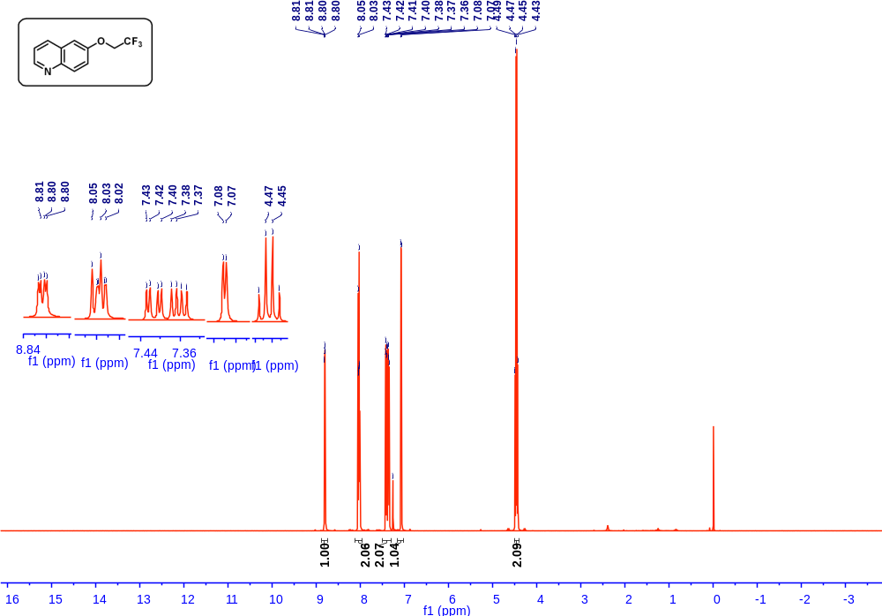

¹H NMR, ¹⁹F NMR and ¹³C NMR spectra of compound 36 and precursor

¹H NMR, ¹⁹F NMR and ¹³C NMR spectra of compound 37

¹H NMR, ¹⁹F NMR and ¹³C NMR spectra of compound 38 and precursor

¹H NMR, ¹⁹F NMR and ¹³C NMR spectra of compound 39 and precursor

¹H NMR, ¹⁹F NMR and ¹³C NMR spectra of compound 40 and precursor

¹H NMR, ¹⁹F NMR and ¹³C NMR spectra of compound 41

¹H NMR, ¹⁹F NMR and ¹³C NMR spectra of compound 42

¹H NMR, ¹⁹F NMR and ¹³C NMR spectra of compound 43 and precursor

¹H NMR, ¹⁹F NMR and ¹³C NMR spectra of compound 44 and precursor

¹H NMR, ¹⁹F NMR and ¹³C NMR spectra of compound 45

¹H NMR, ¹⁹F NMR and ¹³C NMR spectra of compound 46

¹H NMR, ¹⁹F NMR and ¹³C NMR spectra of compound 47 and precursor

¹H NMR, ¹⁹F NMR and ¹³C NMR spectra of compound 48

¹H NMR, ¹⁹F NMR and ¹³C NMR spectra of compound 49 and precursor

¹H NMR, ¹⁹F NMR and ¹³C NMR spectra of compound 50 and precursor

¹H NMR, ¹⁹F NMR and ¹³C NMR spectra of compound 51 and precursor

¹H NMR, ¹⁹F NMR and ¹³C NMR spectra of compound 52

¹H NMR, ¹⁹F NMR and ¹³C NMR spectra of compound 53 and precursor

¹H NMR, ¹⁹F NMR and ¹³C NMR spectra of compound 54 and precursor

¹H NMR, ¹⁹F NMR and ¹³C NMR spectra of compound 55 and precursor

¹H NMR, ¹⁹F NMR and ¹³C NMR spectra of compound 56 and precursor

¹H NMR, ¹⁹F NMR and ¹³C NMR spectra of compound 57 and precursor

