Supplementary Materials

Table S1

Compound number | Chemical Structure | Name |  | ¹H NMR | LCMS m/z [M+H]⁺ | LCMS purity (%)
1 | 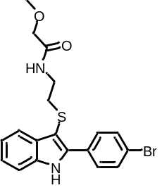 | N-(2-((2-(4-bromophenyl)-1H-indol-3-yl)thio)ethyl)-2-methoxyacetamide | ¹H NMR (300 MHz, CDCl₃ δ 8.48 (s, 1H), 7.80 (ddd, J = 7.1, 2.1, 0.8 Hz, 1H), 7.75 - 7.70 (m, 2H), 7.64 - 7.59 (m, 2H), 7.44 - 7.39 (m, 1H), 7.32 - 7.22 (m, 2H), 6.53 (s, 1H), 3.72 (s, 2H), 3.36 (s, 3H), 3.13 (q, J = 6.0 Hz, 2H), 2.75 (dd, J = 6.8, 5.4 Hz, 2H). |  | 419.1 | 99
2 | 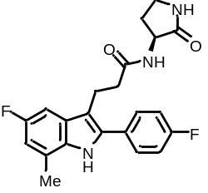 | (S)-3-(5-fluoro-2-(4-fluorophenyl)-7-methyl-1H-indol-3-yl)-N-(2-oxopyrrolidin-3-yl)propanamide | ¹H NMR (300 MHz, CD₃OD) δ 10.45 (s, 1H), 8.23 (d, J = 8.1 Hz, 1H), 7.70 – 7.57 (m, 2H), 7.27 – 7.16 (m, 2H), 7.13 (dd, J = 9.8, 2.4 Hz, 1H), 6.70 (ddd, J = 10.1, 2.5, 0.9 Hz, 1H), 4.45 (ddt, J = 10.3, 8.5, 4.0 Hz, 1H), 3.17 – 3.06 (m, 2H), 2.60 – 2.51 (m, 2H), 2.49 (t, J = 0.7 Hz, 3H), 2.44 – 2.31 (m, 1H), 1.94 – 1.74 (m, 1H). |  | 398.2 | 99.5
3 | 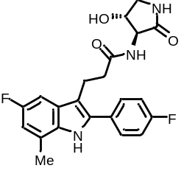 | 3-(5-fluoro-2-(4-fluorophenyl)-7-methyl-1H-indol-3-yl)-N-((3S,4R)-4-hydroxy-2-oxopyrrolidin-3-yl)propanamide | ¹H NMR (300 MHz, CD₃OD) δ 7.69 - 7.59 (m, 2H), 7.27 - 7.17 (m, 2H), 7.18 - 7.11 (m, 1H), 6.70 (ddd, J = 10.1, 2.5, 1.0 Hz, 1H), 4.34 (td, J = 7.6, 6.8 Hz, 1H), 4.22 (d, J = 7.7 Hz, 1H), 3.56 (dd, J = 9.9, 7.5 Hz, 1H), 3.18 - 3.05 (m, 3H), 2.65 - 2.54 (m, 2H), 2.50 (d, J = 0.7 Hz, 3H) |  | 414.3 | 96
4 | 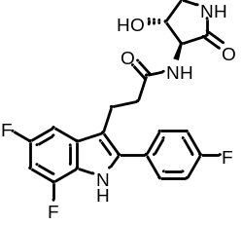 | 3-(5,7-difluoro-2-(4-fluorophenyl)-1H-indol-3-yl)-N-((3S,4R)-4-hydroxy-2-oxopyrrolidin-3-yl)propanamide | ¹H NMR (300 MHz, CD₃OD) δ 7.70 - 7.58 (m, 2H), 7.29 - 7.13 (m, 3H), 6.73 (ddd, J = 11.1, 9.6, 2.2 Hz, 1H), 4.34 (td, J = 7.6, 6.8 Hz, 1H), 4.21 (d, J = 7.8 Hz, 1H), 3.56 (dd, J = 9.9, 7.6 Hz, 1H), 3.20 - 3.04 (m, 3H), 2.65 - 2.53 (m, 2H) |  | 418.2 | 99

Table S1. Characterization of chemical compounds

Fig. S1.
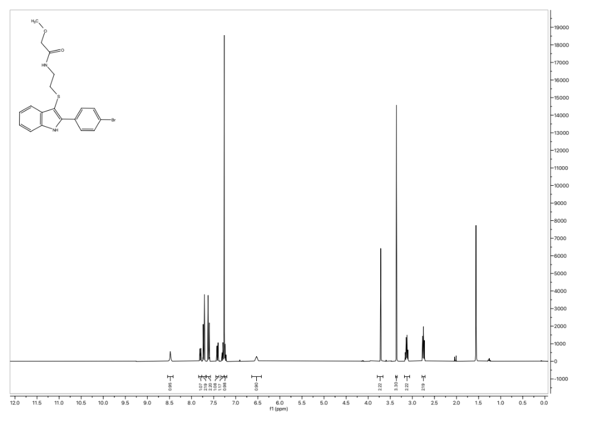
Fig. S1. NMR spectra of compound 1
Fig. S2.
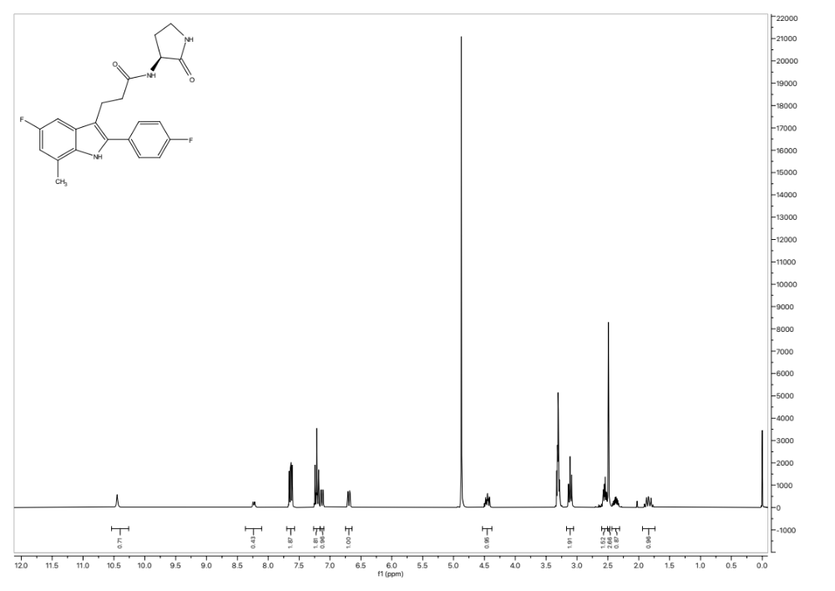
Fig. S2. NMR spectra of compound 2

Fig. S3.
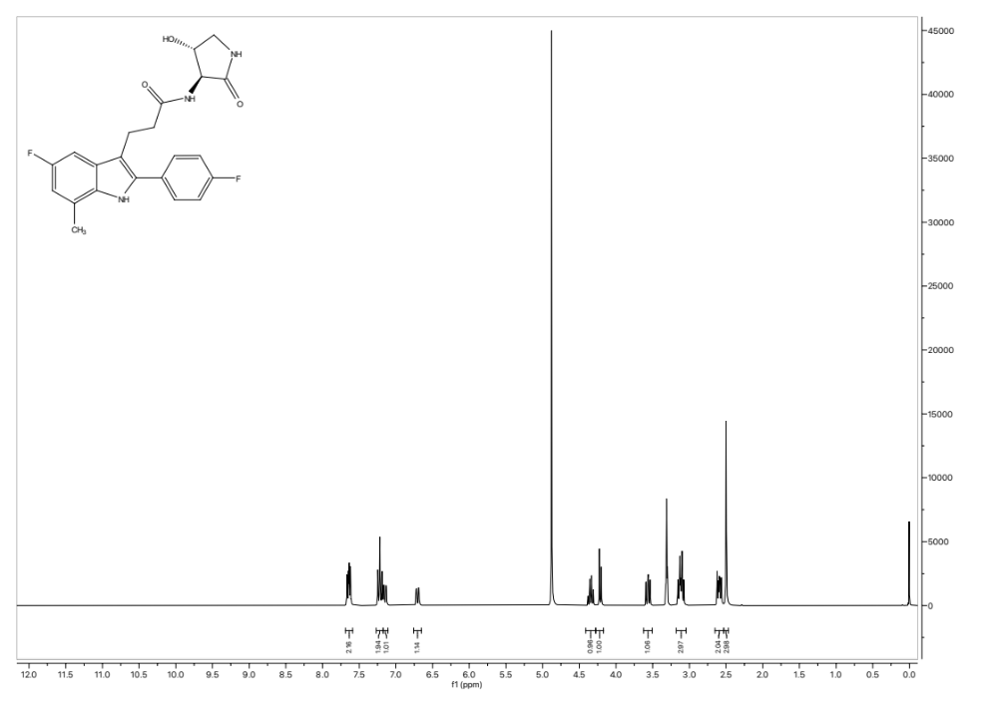
Fig. S3. NMR spectra of compound 3

Fig. S4.
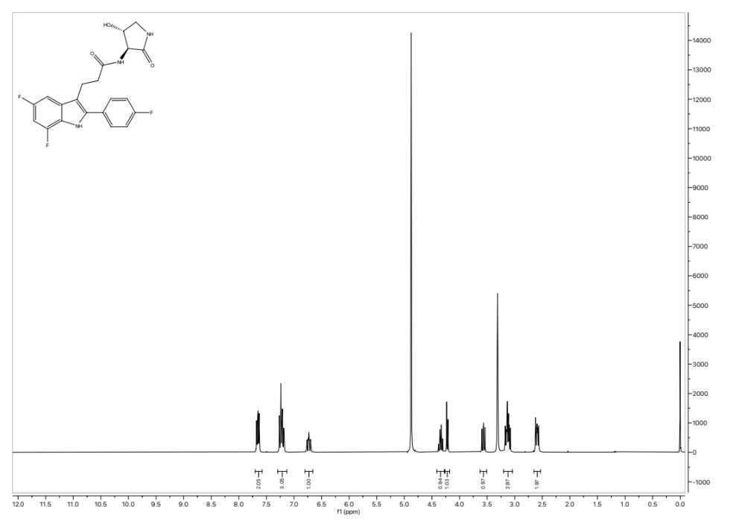
Fig. S4. NMR spectra of inaxaplin

Fig. S5
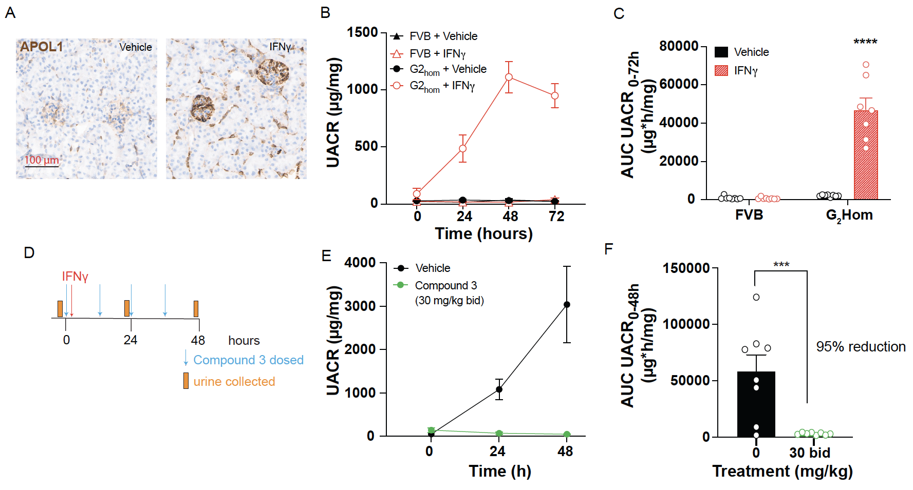
Fig. S5: Interferon-induced APOL1-mediated proteinuria in APOL1 G2 multicopy mice is prevented by an analog of VX-147, Compound 3.
(A) Assessment of APOL1 induction in APOL1 G2 multicopy transgenic mice in response to IFNγ injection compared to saline. Brown chromogen is DAB (3,3'Diaminobenzidine) staining with hematoxylin counterstain. (B) Assessment of urinary albumin-to-creatinine ratio (UACR) in response to IFNγ in FVB mice or APOL1 G2 multicopy transgenic mice was measured across 72 hours. n=7-8/group. (C) UACR area under the curve (AUC) was calculated from panel (B). (D) Experimental dosing paradigm for prophylactic assessment of compound 3 efficacy highlighting times of compound 3 administration, IFNγ injection, and urine collection. n=8/group. (E) Compound 3 administration 2 times a day at a dose of 30 mg/kg reduces IFNγ-induced proteinuria. UACR was measured across 48 hours. (F) AUC was calculated from panel (E) to assess the magnitude of the effect of compound 3 reduction of proteinuria. Percent reduction in UACR AUC with compound 3 treatment was calculated. Log-transformed AUC data in panel (C) and (F) were analyzed with a two tailed t-test. Statistical significance was set at p≤0.05. ***p<0.001; ****p<0.0001. Results are presented as arithmetic mean ± SEM.

