Table 1. Examples of stigma experiences reported by participants alongside their proposed solutions to guide the design of multi-level stigma intervention components.

Socio-ecological model level | Experiences of stigma | Proposed stigma intervention components
Individual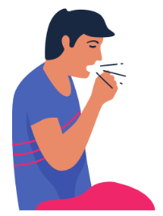  Internal stigma Anticipated stigma | “You have negative thoughts because you don’t have enough information.”  “They say if you have TB, HIV is following.” Intersectional stigma | Education: optimise existing counselling provided to people with TB by health workers  “What I want to hear here at the clinic when I am counselled is that if you have TB, it is not your fault, TB can be found anywhere.”  “Knowledge is power, the moment you know what you are doing you can stand anything.”
 | “If you have TB, you don’t know who you are and you lose hope.” | Empowerment: create platforms for TB survivor peer support with guided messaging  “Get someone who is going to come and talk to us and hold us through the journey.”  “Counselling is needed and it mustn’t just end when you are diagnosed.”
Interpersonal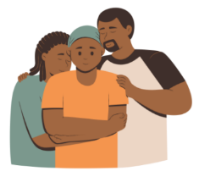  Anticipated stigma  Enacted stigma | “We don't understand TB until we have it.” | Empowerment: TB support groups to share experiences  “Another thing that has helped it was groups, clubs and support groups. You see even the one who didn’t understand the nurse or the counsellor they understand better when it’s being explained by someone next to them who are having the same experience.”
 | “Some of us don’t get support from our families… they are scared to get infected because they don’t know about TB.” | Education: family-centred counselling to improve knowledge, dispel misconceptions and generate support  “I wish they can go even in the households so that everyone can be counselled so they can understand what is happening.”
Institutional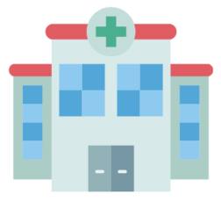  Anticipated stigma  Enacted stigma | “[The nurses] were saying that I was the problem… I ended up seeing myself as a problem.” | Education: health worker TB stigma training by TB survivors  “I want […] a relationship where there is humanity and support.”
 | “He didn’t want to be seen taking TB medication, which made him change clinic, and that made him become lost to follow up.” | Innovation: restructure service delivery models to decrease stigma and improve patient-centred TB care  “If they could see in that first week that you are having difficulties, perhaps you can you get your medication at home.”
Community  Anticipated stigma  Enacted stigma | “In the community most people fear that, if you are infected with TB, the moment you pass by, you are going to infect them.”  “There are children who judged him at school, saying that he is going to infect us with TB.” | Engagement: increase community awareness and knowledge through community educational forums, school curricula  “People can’t just be open and talk, but when they hear [someone else] talking they start coming out and disclosing that they are TB survivors.”  “TB is an airborne disease and everyone breathes the same air, if these children can be well educated […] to understand exactly what TB is and how does it infect you and to know that it is curable and how it is cured.”
Policy  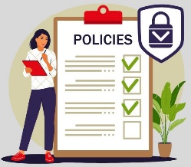  Anticipated stigma  Enacted stigma | “I am scared to be seen putting my card in that box, people already know that I have TB.”  “I said to the doctor there is this name that you use called ‘default’. You do not understand why most TB patients fall under that name; it’s because taking this medication that you give us is not easy.” | Innovation: restructure service delivery models to decrease stigma and improve patient-centred TB care  “We need enough staff, enough resources, so that we can work very careful with infection control.”  “The system has to hire more staff so that there is not only one nurse, the system must hire more counsellors or navigators, as people who will be mediators between the staff and the patient, so we understand where the biggest challenge is.”

DISCUSSION

