Supplemental Appendix

Table S1. List of questionnaires and ePROs
Outcome measure | Description
ePROs
The Medical Outcomes Study 36-item Short-form Health Survey [1] | The SF-36 is a health survey with 36 questions in eight domains that measure health concepts including physical function, role-physical, role-emotional, energy/fatigue, emotional well-being, social function, pain, and general health measured with 3-, 5-, 6- point VRS and dichotomous “Yes”/“No” scales. The SF-36 scores range from 0–100. Higher scores indicate better HRQoL.
Patient-Reported Outcomes Measurement Information System Short-form Fatigue [2] | The PROMIS-SF version 1.0 consists of 13 items adopted from the Functional Assessment of Chronic Illness Therapy-Fatigue module. Participants are asked to evaluate their fatigue over the past seven days, using a 5-point Likert Scale. Raw scores for the PROMIS-SF are converted to a T-score using the scoring manual, with higher scores indicating increased fatigue according to developer guidelines.
Single-Item Numerical Rating Scale and Visual Analog Scale | Nine single-item NRS and VAS were developed to evaluate preferences for presentation format. The VAS single items evaluated alertness, energy, sleep, appetite, and pain severity. The NRS single items evaluated tenseness, enjoyment of social activities, general happiness, and overall health. Single item VAS had numeric score ranges from 0–100 while the single item NRS had numeric ranges of 0–5.
Patient Preference Questionnaires
Visit 1 | A participant paper-based preference questionnaire was developed to assess participants preferences for presentation of items, the overall burden for completing the ePROs.  The NRS ranged from 0–5 (0 = very difficult/disliked very much/very bothersome; 5 = very easy/liked very much/not at all bothersome).
Visit 2 | The visit 2 preference questionnaire (also paper-based) included the same items as the visit 1 questionnaire, along with additional questions specific to participants’ preferences (if any) for the presentation format, perceived differences regarding the time to complete the task, and perception of the format (single-item-per-screen vs. multiple-items-per-screen).
Patient Global Impression of Change | The paper-based PGIC (“Since your last visit, has your overall health changed?”) was a single item with a 5-point VRS included in the visit 2 preference questionnaire to establish stability/no change in the health of the participants. Response options included “much better,” “a little better,” “about the same/no change,” “a little worse,” and “much worse.”
Sociodemographic Form | This paper-based form included the questions regarding the participants’ age, sex assigned at birth, ethnic background, race/ethnicity, employment status, highest level of education completed, experience with technology devices, and any current health conditions.
ePRO electronic patient-reported outcome, HRQoL health-related quality of life, NRS Single-Item Numerical Rating Scale, PGIC, Patients Global Impression of Change, PROMIS-SF Patient-Reported Outcomes Measurement Information System Short-Form, SF-36 Medical Outcomes Study 36-item Short-form Health Survey Version 1.0, VAS Visual Analog Scale, VRS Verbal Response Scales

Table S2. Summary of assessments
Endpoint | Definition | Timing
Participant preference: readability | Q: “How easy was it to read the text on each screen?” | Visits 1 and 2
Participant preference: burden | Q: “How bothersome was it to repeatedly select the next button on each page?” | Visits 1 and 2
Completion time | The difference in time it takes to complete each ePRO between the two visits (i.e., multiple-items per screen vs. single-item per screen) | Visits 1 and 2
Response differences among ePROs | Evaluation of all item responses and ePRO scores (when applicable) to compare for differences in responses between administrations | Visits 1 and 2
Participant preference: presentation of items | Q: “You have now been presented with the same survey twice, where the only difference was questions were either presented in groups on one screen (i.e., multiple questions on a screen) or presented as a single question per screen. Which of these approaches did you prefer?” | Visit 2
ePRO electronic patient-reported outcome, Q question

Table S3. Participant responses on single- versus multiple-item formats at visit 2
Questions | Quotes
Which approach (single- vs. multiple-item) did you prefer?
Single-item-per-screen | It is clearer, less intimidating, and for some strange psychosomatic reason, feels more comforting and less stressful.
 | It made me concentrate on the question without being distracted, like looking at other questions.
 | I selected that response because with only one single question per screen, I felt like I wasn't rushed or felt any pressure to answer them all at once, compared to multiple questions on a screen. More time to focus on one thing, rather than thinking about many.
 | I think I put more effort and thought to a single question.
 | Easier read/ not cluttered.
 | Ease to ready and select answer, not messy looking.
Multiple-item-per-screen | Putting all the questions in one screen put them in perspective.
 | Wasn't paying attention to questions per page but prefer multiple. Goes faster.
 | Multiple questions seemed to go faster. Could determine better answer by comparing without having to go back.
No preference | Both ways were easy to understand & answer.
 | Multiple questions seemed to go faster. Could determine better answer by comparing without having to go back.
 | Either way is fine for me.
 | Both ways were easy to understand & answer.
 | It didn’t make a difference.
Did not notice a difference | I was able to easily answer all questions without any issues or difficulty.
Which format (single- vs. multiple-item) would most people prefer to answer during a clinical trial?
Single-item-per-screen | Especially for potentially serious or health/pharma related protocols, the ease of use, "comforting", and clarity aspects of a questionnaire would yield better, more honest results. It feels like you have more time for reflection where multiple choice feels a bit more rushed.
 | People may be overwhelmed by more than one question or prefer to focus on one at a time depending on the nature of the content/questions.
 | Because if you were receiving an experimental treatment you would want to go a bit slower and read the questions fully.
 | We're talking about one's health here.
 | Grid format can get overwhelming, single questions is easier to read and select.
 | It makes it easier to focus and not jump to the next question.
Multiple-item-per-screen | I really can't say for them. However, a lot of people feel like they can finish faster with multiple questions per screen.
 | Easier and faster, less next page clicking.
 | It depends on age. The multiple questions could be too much info for older folks.
 | Having multiple questions on one screen minimizes the number of pages to get through.
 | Most people don't enjoy surveys and want to complete fast.
No Preference | It might depend if the questions were "heavy" ones maybe more makes them not so heavy. Simple is easier, but if questions were invasive or hard, in this one case maybe more is better.

Table S4. Participant preferences on the perceived usability and accessibility of single- versus multiple-item formats at visits 1 and 2
Questions | Quotes
Visit 1: How easy was it to read the text on each screen? How did you like the presentation of the questions on each screen?
Single-item-per-screen | It was very clear with only one question and list of answers on the screen.
 | Everything was clear and easy to understand.
 | Questions were clear, gave enough white space to read, use of bold help read, large print.
 | Bold letters with straightforward language, easy to read.
 | Very user friendly.
Multiple-item-per-screen | I selected that response because there was no confusion, it was straightforward and easy to understand.
 | The layout was simple, easy to read and made sense.
 | The questions were easy to read and respond to.
Visit 2: How easy was it to read the text on each screen? How did you like the presentation of the questions on each screen?
Single-item-per-screen | I think the matrixª is certainly quicker, but it feels more formal. It's also more difficult to complete and aesthetically looks overwhelming.
 | Very easy to understand and respond.
 | This information was easier to parse through quickly. The size/scale of the tablet & size of font combo worked well.
 | Questions were written in great format.
Multiple-item-per-screen | The overall experience felt much faster.
 | Grouped nicely, easy to read and respond.
 | I selected this response because everything that was asked of me was clear. I wasn't confused and I was able to answer every question promptly.
 | Clear & understandable.
ª Matrix refers to the grid format in a multiple-item-per-screen presentation.

Table S5. Comparison of SF-36 by format
SF-36 V1 Scores | N ª | Mean | SD | Difference in administrationMean (SD) ^{b} | p-value ^{c} | ICC (95% CI) ^{d}
Physical Functioning |  |  |  | -0.9 (3.9) | 0.254 | 0.93 (0.87–0.97)
Single-item | 29 | 49.0 | 10.2
Multiple-item | 29 | 48.1 | 11.5
Role Physical |  |  |  | 0.7 (8.5) | 0.648 | 0.71 (0.48–0.85)
Single-item | 29 | 48.7 | 11.8
Multiple-item | 29 | 49.4 | 10.6
Bodily Pain |  |  |  | 0.2 (2.7) | 0.664 | 0.97 (0.94–0.99)
Single-item | 29 | 50.3 | 11.3
Multiple-item | 29 | 50.5 | 10.8
General Health |  |  |  | 0.3 (4.8) | 0.718 | 0.86 (0.74–0.93)
Single-item | 29 | 51.1 | 9.1
Multiple-item | 29 | 51.5 | 9.1
Vitality |  |  |  | -0.8 (5.7) | 0.447 | 0.85 (0.70–0.92)
Single-item | 29 | 50.8 | 10.1
Multiple-item | 29 | 50.0 | 10.4
Social Functioning |  |  |  | 0.9 (5.6) | 0.378 | 0.86 (0.73–0.93)
Single-item | 29 | 47.0 | 10.6
Multiple-item | 29 | 48.0 | 10.8
Role Emotional |  |  |  | 1.5 (6.1) | 0.212 | 0.86 (0.73–0.93)
Single-item | 29 | 45.2 | 11.8
Multiple-item | 29 | 46.6 | 11.3
Mental Health |  |  |  | -0.9 (7.7) | 0.554 | 0.77 (0.57–0.88)
Single-item | 29 | 49.5 | 10.5
Multiple-item | 29 | 48.6 | 12.0
PCS-36 |  |  |  | -0.1 (4.2) | 0.927 | 0.94 (0.88–0.97)
Single-item | 29 | 50.6 | 12.0
Multiple-item | 29 | 50.5 | 12.0
MCS-36 |  |  |  | 0.4 (6.0) | 0.754 | 0.88 (0.76–0.94)
Single-item | 29 | 47.4 | 11.5
Multiple-item | 29 | 47.8 | 12.3
CI confidence interval, ICC intraclass correlation coefficient, MCS Mental Component Summary, PCS Physical Component Summary, PGIC Patients’ Global Impression of Change SD standard deviation, SF-36 36-Item Short Form Survey
ª Number of participants who responded “about the same/no change” for the PGIC at visit 2.
^{b} Difference = Multiple-item format value - Single-item format value.
^{c} p-value from a paired t-test.
^{d} Limits of agreement are 95% CI around the ICC.

Table S6. Comparison of FACIT Fatigue overall by single-item vs. multiple-item format
FACIT Fatigue Score | N ª | Mean | SD | Difference in Administration  Mean (SD) ^{b} | p-value ^{c} | ICC (95% CI) ^{d}
Total Score |  |  |  | -0.7 (3.7) | 0.306 | 0.92 (0.84–0.96)
Single-item | 29 | 48.4 | 8.9
Multiple-item | 29 | 47.7 | 9.5
CI confidence interval, FACIT Functional Assessment of Chronic Illness Therapy, ICC intraclass correlation coefficient, PGIC Patients’ Global Impression of Change, SD standard deviation
ª Number of participants who responded “about the same/no change” for PGIC item at visit 2.
^{b} Difference = Multiple-item format value - Single-item format value.
^{c} p-value from a paired t-test.
^{d} Limits of agreement are 95% CI around the ICC.

Table S7. Comparison of NRS by single-item vs. multiple-item formats
NRS Scores | N ª | Mean | SD | Difference in Administration  Mean (SD) ^{b} | p-value ^{c} | ICC (95% CI) ^{d}
How tense this week |  |  |  | -0.2 (1.2) | 0.445 | 0.69 (0.45–0.84)
Single-item | 29 | 2.2 | 1.7
Multiple-item | 29 | 2.1 | 1.4
Enjoyment of social activities this week |  |  |  | -0.1 (1.2) | 0.648 | 0.39 (0.05–0.65)
Single-item | 29 | 4.3 | 0.9
Multiple-item | 29 | 4.2 | 1.2
General happiness |  |  |  | -0.1 (0.8) | 0.380 | 0.53 (0.22–0.75)
Single-item | 29 | 4.1 | 0.8
Multiple-item | 29 | 3.9 | 0.9
Overall health |  |  |  | -0.1 (0.8) | 0.380 | 0.53 (0.22–0.75)
Single-item | 29 | 4.1 | 0.8
Multiple-item | 29 | 3.9 | 0.9
CI confidence interval, ICC intraclass correlation coefficient, NRS Numerical Rating Scale, PGIC Patients’ Global Impression of Change, SD standard deviation
ª Number of participants who responded “about the same/no change” for PGIC item at visit 2.
^{b} Difference = Multiple-item format value - Single-item format value.
^{c} p-value from a paired t-test.
^{d} Limits of agreement are 95% CI around the ICC.

Table S8. Comparison of VAS overall by single-item versus multiple-item format
VAS Scores | N ª | Mean | SD | Difference in AdministrationMean (SD) ^{b} | p-value ^{c} | ICC (95% CI) ^{d}
How alert you felt |  |  |  | -4.5 (15.5) | 0.129 | 0.61 (0.34–0.79)
Single-item | 29 | 85.6 | 16.4
Multiple-item | 29 | 81.1 | 18.9
How energized you felt |  |  |  | -3.7 (9.2) | 0.042 | 0.93 (0.85–0.96)
Single-item | 28 | 72.6 | 24.1
Multiple-item | 28 | 68.9 | 24.0
Sleep rating |  |  |  | -5.0 (11.8) | 0.031 | 0.90 (0.81–0.95)
Single-item | 29 | 60.8 | 26.6
Multiple-item | 29 | 55.8 | 27.0
Appetite rating |  |  |  | -1.7 (9.6) | 0.352 | 0.89 (0.79–0.95)
Single-item | 29 | 78.7 | 21.0
Multiple-item | 29 | 77.0 | 20.2
Severity of pain |  |  |  | 0.5 (9.6) | 0.774 | 0.94 (0.88–0.97)
Single-item | 29 | 26.6 | 28.2
Multiple-item | 29 | 27.1 | 28.3
CI confidence interval, ICC intraclass correlation coefficient, PGIC Patient Global Impression of Change, SD standard deviation, VAS Visual Analog Scale
ª Number of participants who responded “about the same/no change” for PGIC item at visit 2.
^{b} Difference = Multiple-item format value - Single-item format value.
^{c} p-value from a paired t-test.
^{d} Limits of agreement are 95% CI around the ICC.

Fig. S1 Sample ePRO questions in single- and multiple-item formats
A. Single-item-per-screen format | B. Multiple-item-per-screen format | A. Multiple-item-per-screen format (grid)
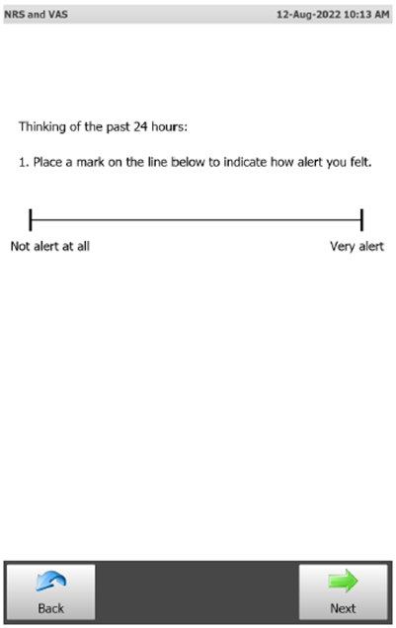 | 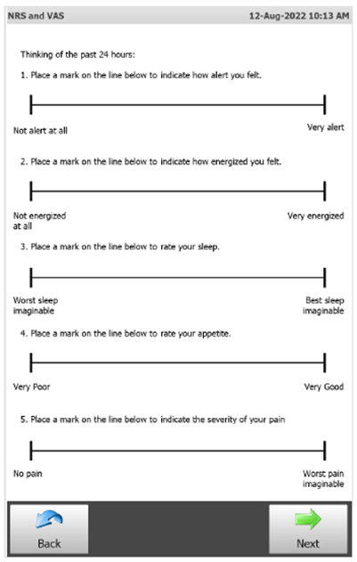 | 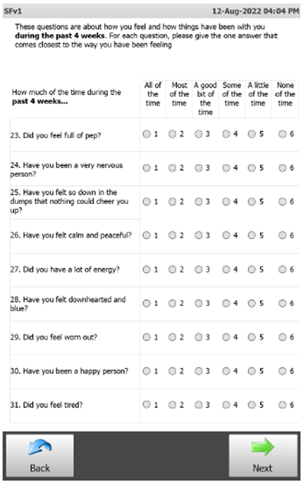
ePRO electronic patient-reported outcome, NRS numerical rating scale, VAS Visual Analog Scale
The displayed images are representative of the tablet’s screen (26.2 cm/10.3").

Fig S2 ePRO completion time by group ¹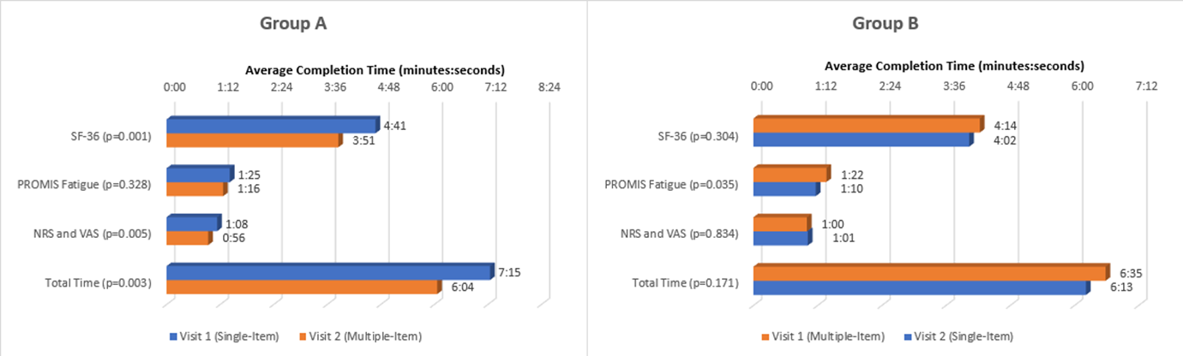
ePRO electronic patient-reported outcome, NRS numerical rating scale, PROMIS-SF Patient-Reported Outcome Measurement Information System Short-Form, SD standard deviation, SF-36 36-item Short Form health survey, VAS Visual Analog Scale
¹ p-value is from a paired t-test.
Mean and median in minutes: seconds.
Group A was presented ePROs in the single-item format at visit 1 and multiple-item format at visit 2. Group B was presented ePROs in the multiple-item format at visit 1 and single-item format at visit 2.

References

1. Ware JE, Sherbourne CD. (1992) The MOS 36-ltem Short-Form Health Survey (SF-36). Medical Care 30(6):473-83.
2. Yellen SB, Cella DF, Webster K, et al. (1997) Measuring fatigue and other anemia-related symptoms with the Functional Assessment of Cancer Therapy (FACT) measurement system. Journal of Pain and Symptom Management 13(2):63-74.

