Supplementary Information
Photoelectrochemical CO₂ Reduction Devices Employing a Boundary Layer Flow for Direct Ocean Carbon Capture and Conversion

Bin Liu^{1, 2}, Zheng Qian^{1, 2, 3}, Xiang Shi^{1, 2, 4}, Haoqing Su^{1, 2}, Yuze Zheng^{1, 2, 5}, Chengxing He^{1, 2}, Rito Yanagi^{1, 2}, Wentao Zhang^{1, 2}, Atsu Kludze^{1, 2}, and Shu Hu*^{1, 2}
¹ Department of Chemical and Environmental Engineering, School of Engineering and Applied Sciences, Yale University, New Haven, CT 06520, USA.
² Energy Sciences Institute, Yale West Campus, West Haven, CT 06516, USA.
³ Department of Energy and Power Engineering, Tsinghua University, Beijing 100084, China
⁴ School of Chemistry and Materials Science, University of Science and Technology of ChinaHefei, Anhui 230026, China
⁵ College of Chemistry and Molecular Engineering, Peking University, Beijing 100871, China

* Corresponding author: shu.hu@yale.edu

Supplementary Figures
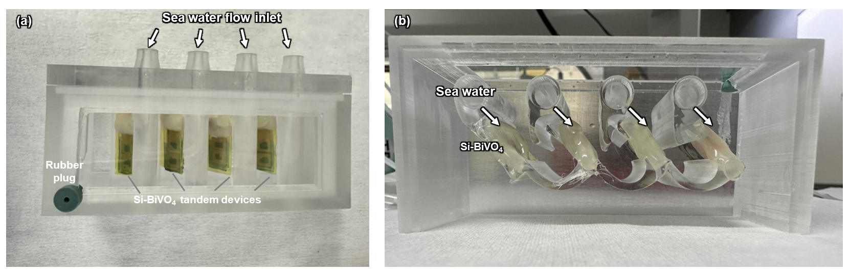
Fig. S1 Photographs of the (a) top and (b) cross sectional view of flowing seawater reactor utilized in this study.

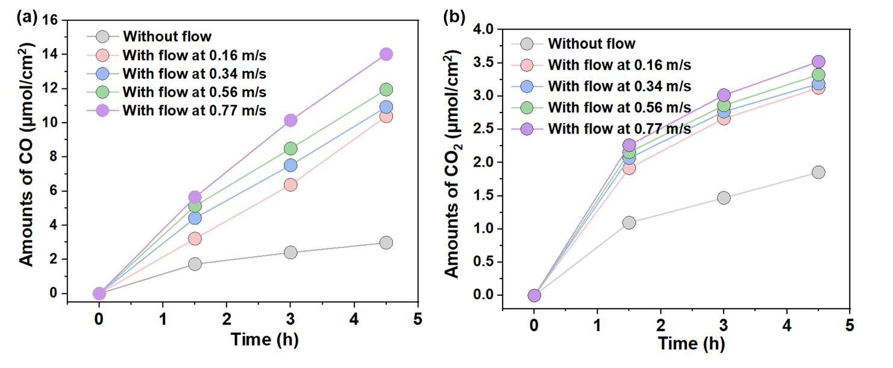
Fig. S2 (a) CO gas production and CO₂ extraction over time at varying flow velocities under AM 1.5G 1-sun illumination (100 mW/cm²).

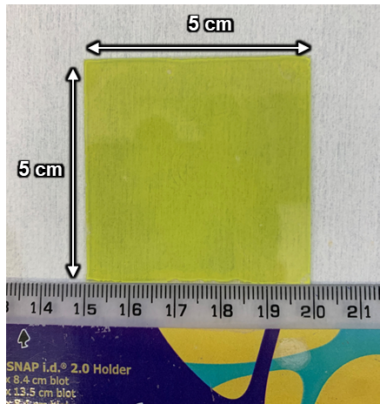
Fig. S3 Photograph of BiVO₄ photoanode.

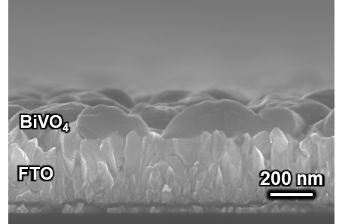
Fig. S4 SEM image of BiVO₄ photoanode cross section.

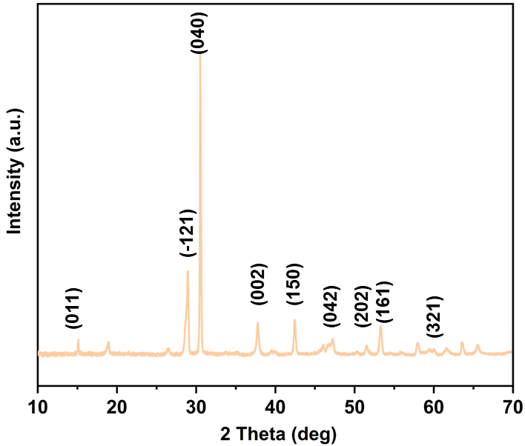
Fig. S5 XRD pattern of BiVO₄ photoanode.

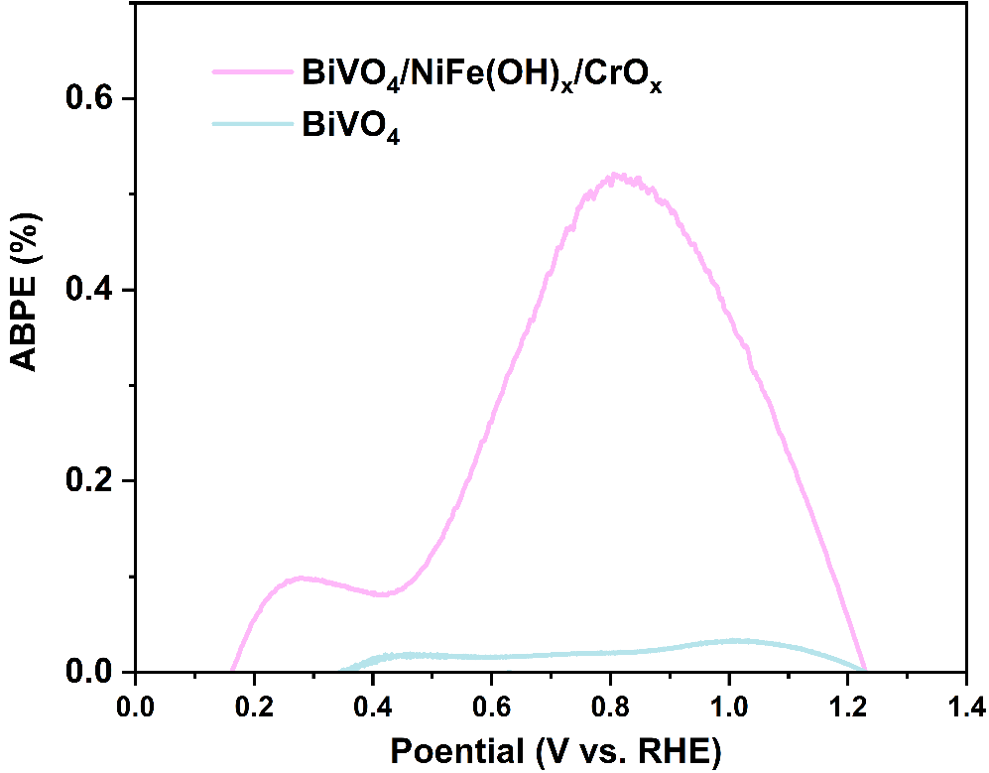
Fig. S6 ABPEs of BiVO₄ photoanode with and without catalyst at varying applied potentials.

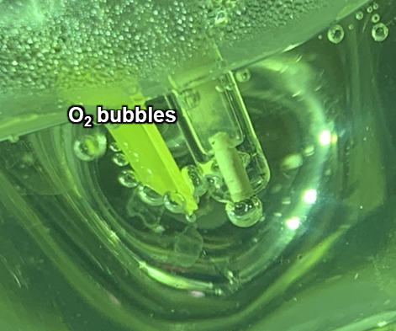
Fig. S7 Photograph of BiVO₄ photoanode during seawater oxidation.

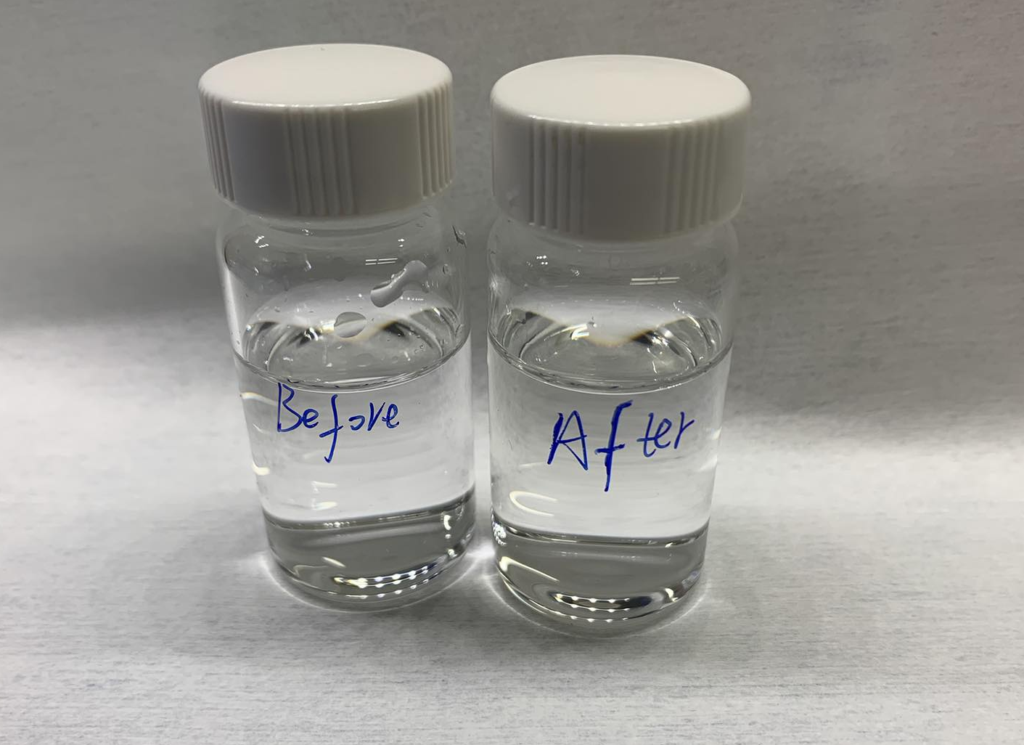
Fig. S8 Photograph of seawater solution with excessive iodide ions added, taken before and after 10 hours of seawater oxidation.

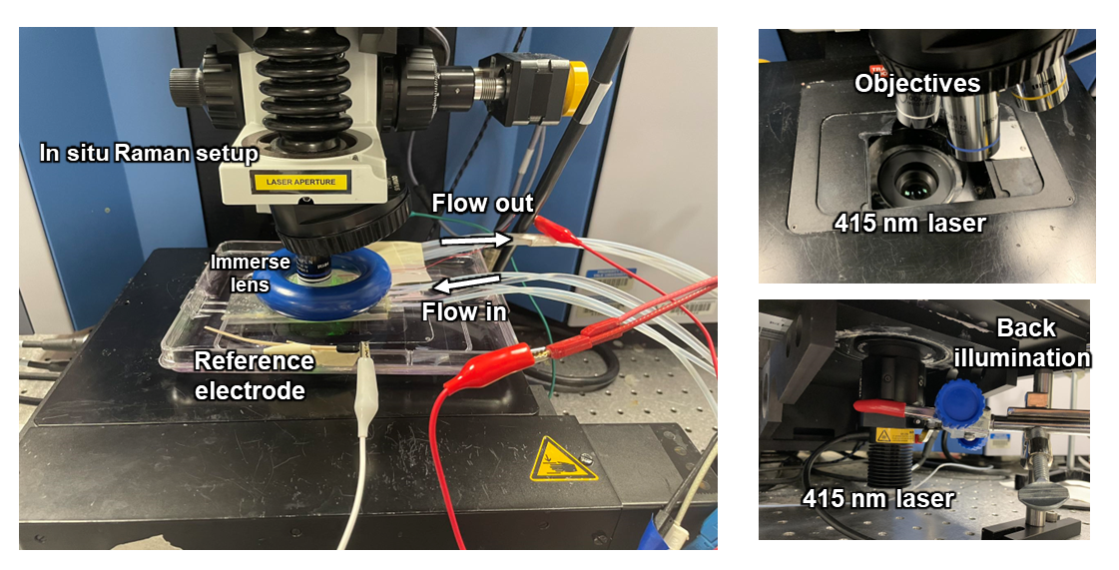
Fig. S9 Photograph of apparatus used in the in-situ fluorescence measurement.

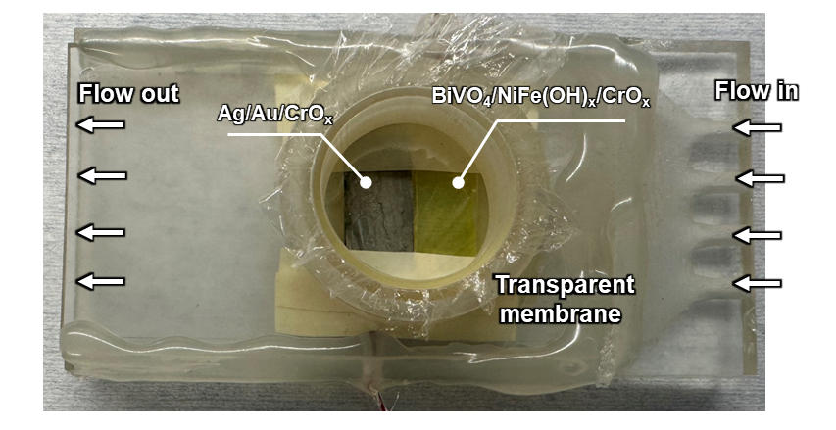
Fig. S10 Photograph of photoreactor used during in-situ photo-fluorescence via confocal Raman spectroscopy.

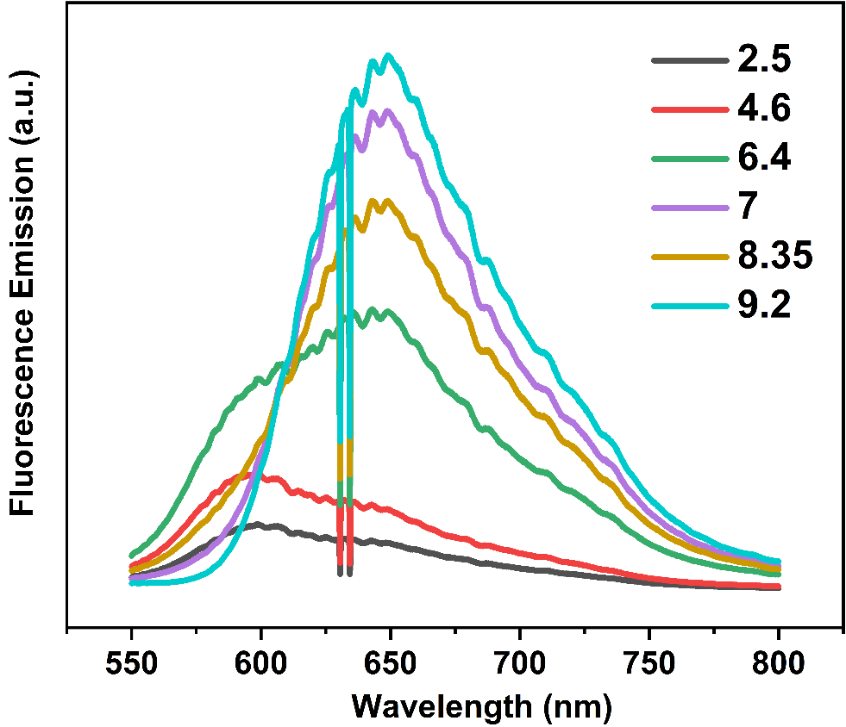
Fig. S11 Raman spectrums of Carboxy SNARF-1 in electrolyte at varying pH.

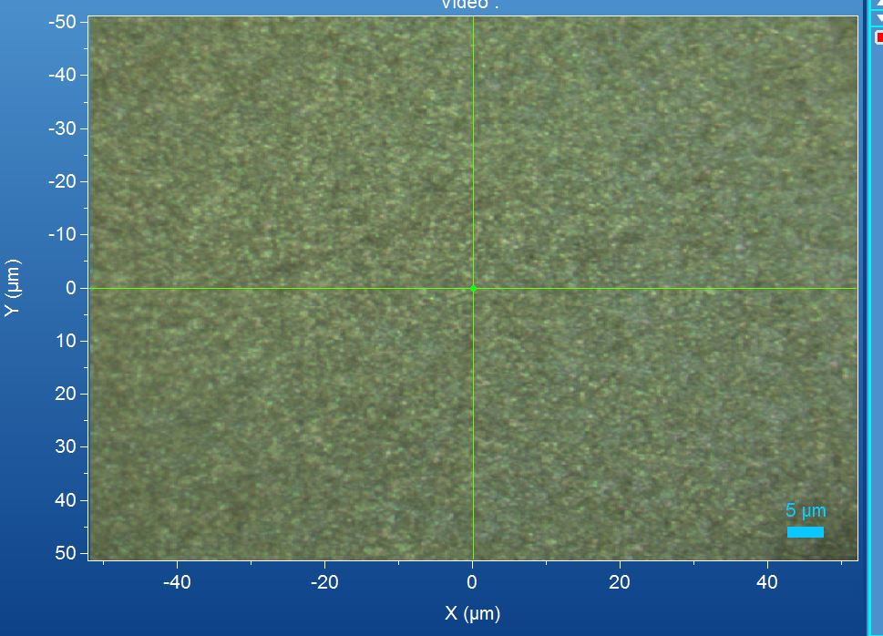
Fig. S12 Image of BiVO₄ photoanode captured using Raman 60× immersion lens.

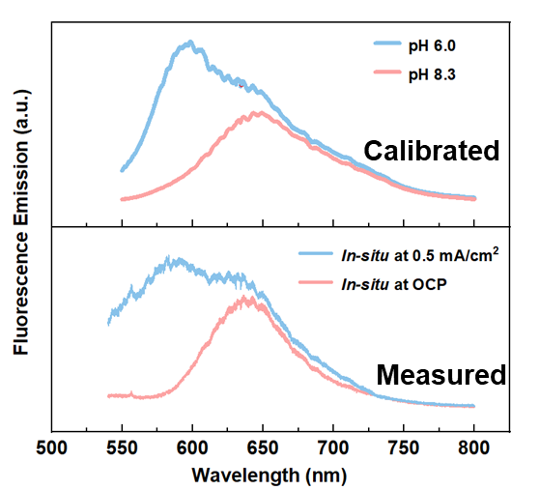
Fig. S13 The fluorescence emission spectra curves of calibrated (upper) and measured (lower) pH.

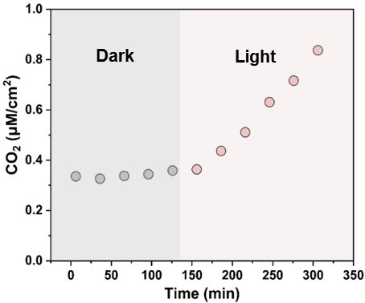
Fig. S14 CO₂ gas extraction over time.

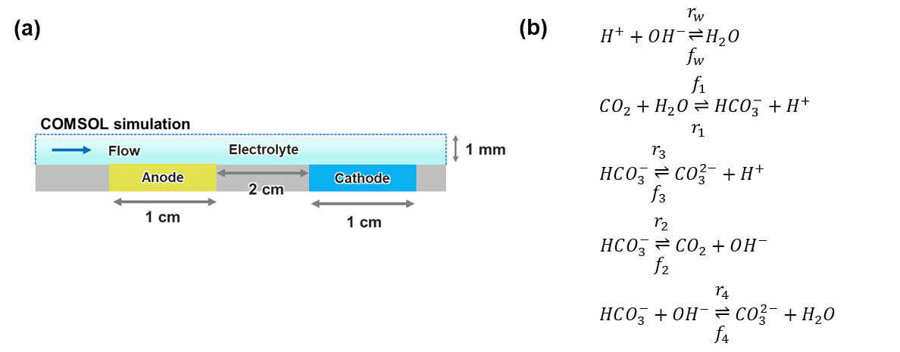
The equation for $CO_{2}$:
$$\frac{∂C_{CO_{2}}}{∂t}=∇⋅\left(D_{CO_{2}}∇C_{CO_{2}}\right)-∇⋅\left(vC_{CO_{2}}\right)+∇⋅\left(\frac{Z_{CO_{2}}F}{RT}D_{CO_{2}}C_{CO_{2}}∇ϕ\right)-k_{f1}C_{CO_{2}}+k_{r1}C_{HCO_{3}^{-}}C_{H^{+}}+k_{r2}C_{HCO_{3}^{-}}-k_{f2}C_{CO_{2}}C_{OH^{-}}$$

Fig. S15 (a) Schematic of the COMSOL numerical simulation (figure not to scale for clarity) and (b) kinetic rate laws for carbonate speciation.

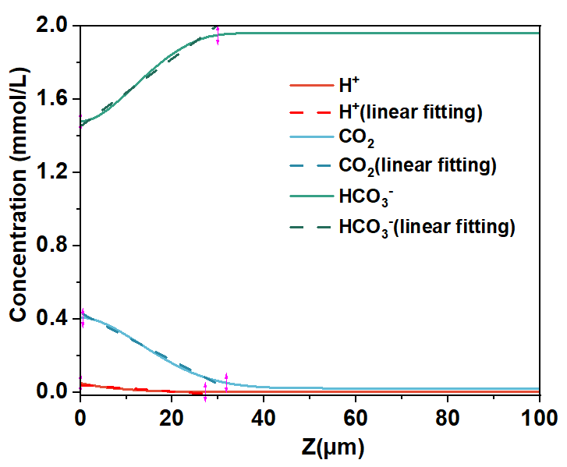
Fig. S16 The spatial profile of H⁺, CO₂, HCO₃⁻ in the z direction obtained using COMSOL Multiphysics simulation software.

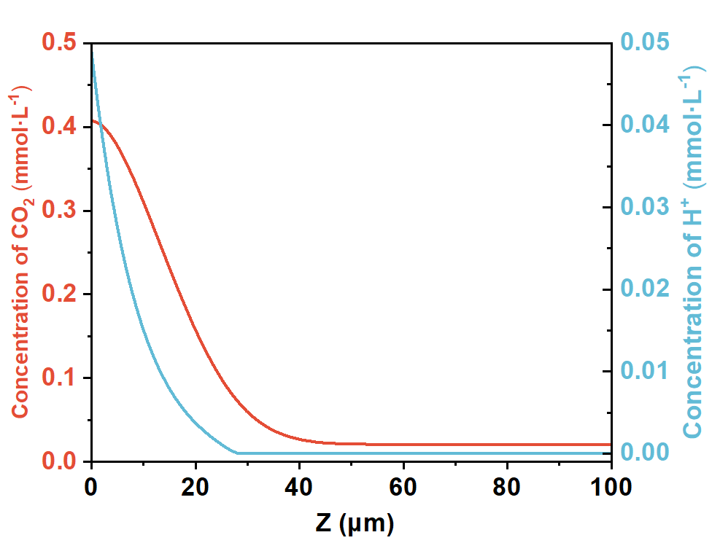
Fig. S17 Concentration of CO₂ and H⁺ at x = 0.8 cm at a flow rate of 0.77m/s

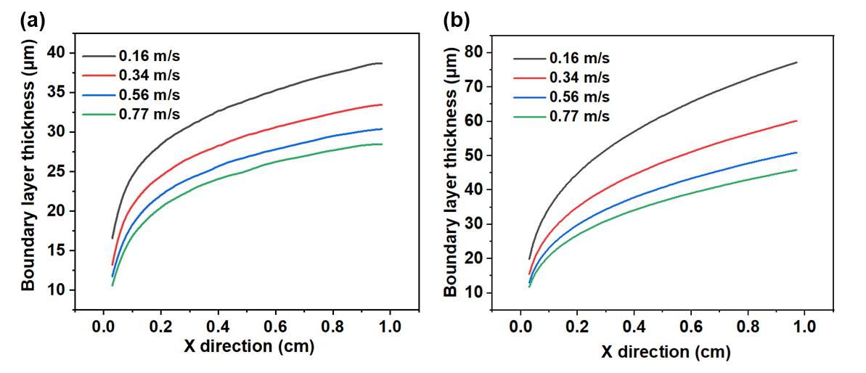
Fig. S18 Boundary layer thickness of (a) H⁺ and (b) CO₂ calculated using Equation (8).

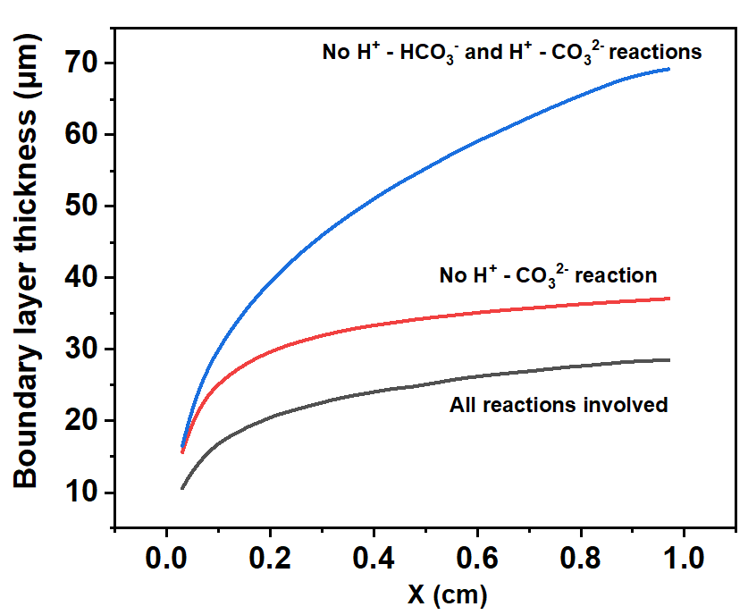
Fig. S19 Boundary layer thickness of H⁺ under different reactions conditions.

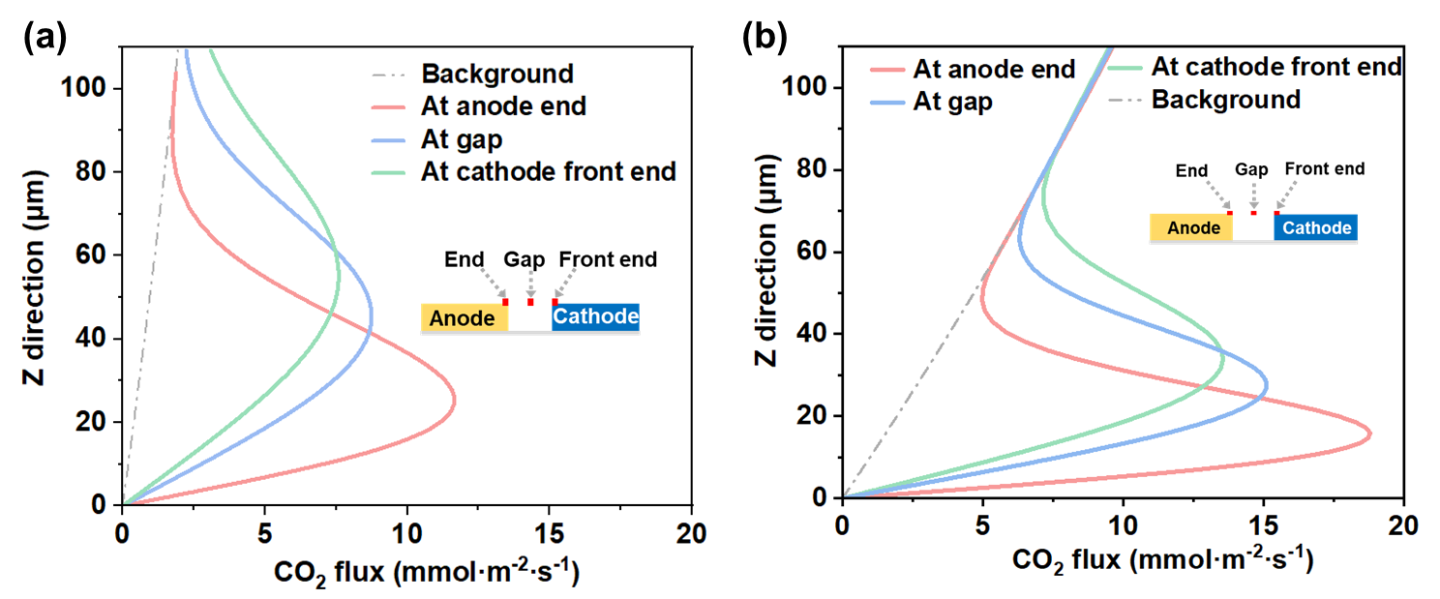 Fig. S20 COMSOL simulated convective flux of CO₂(aq) at 0.16 m/s (a) and 0.77 m/s (b) at the end of the anode (x₀ = 1 cm), at the gap between cathode and anode, and at the front end of the cathode.

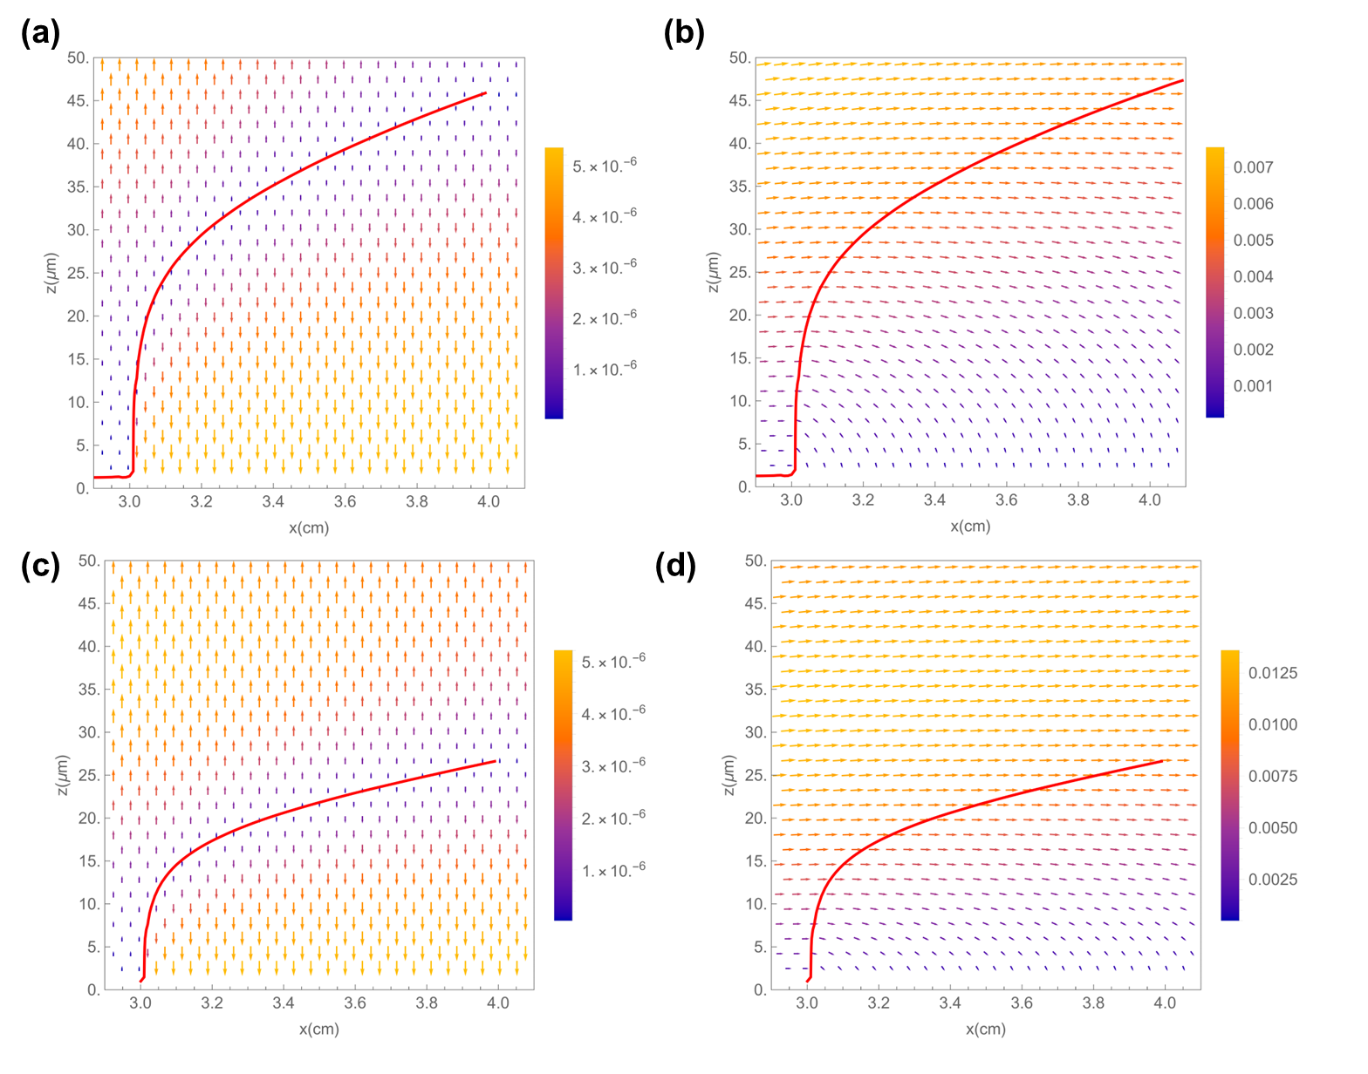
Fig. S21 The convection flux of (a) CO₂(aq) and (b) H⁺ at 0.16 m/s. The convection flux of (c) CO₂(aq) and (d) H⁺ at 0.77 m/s.

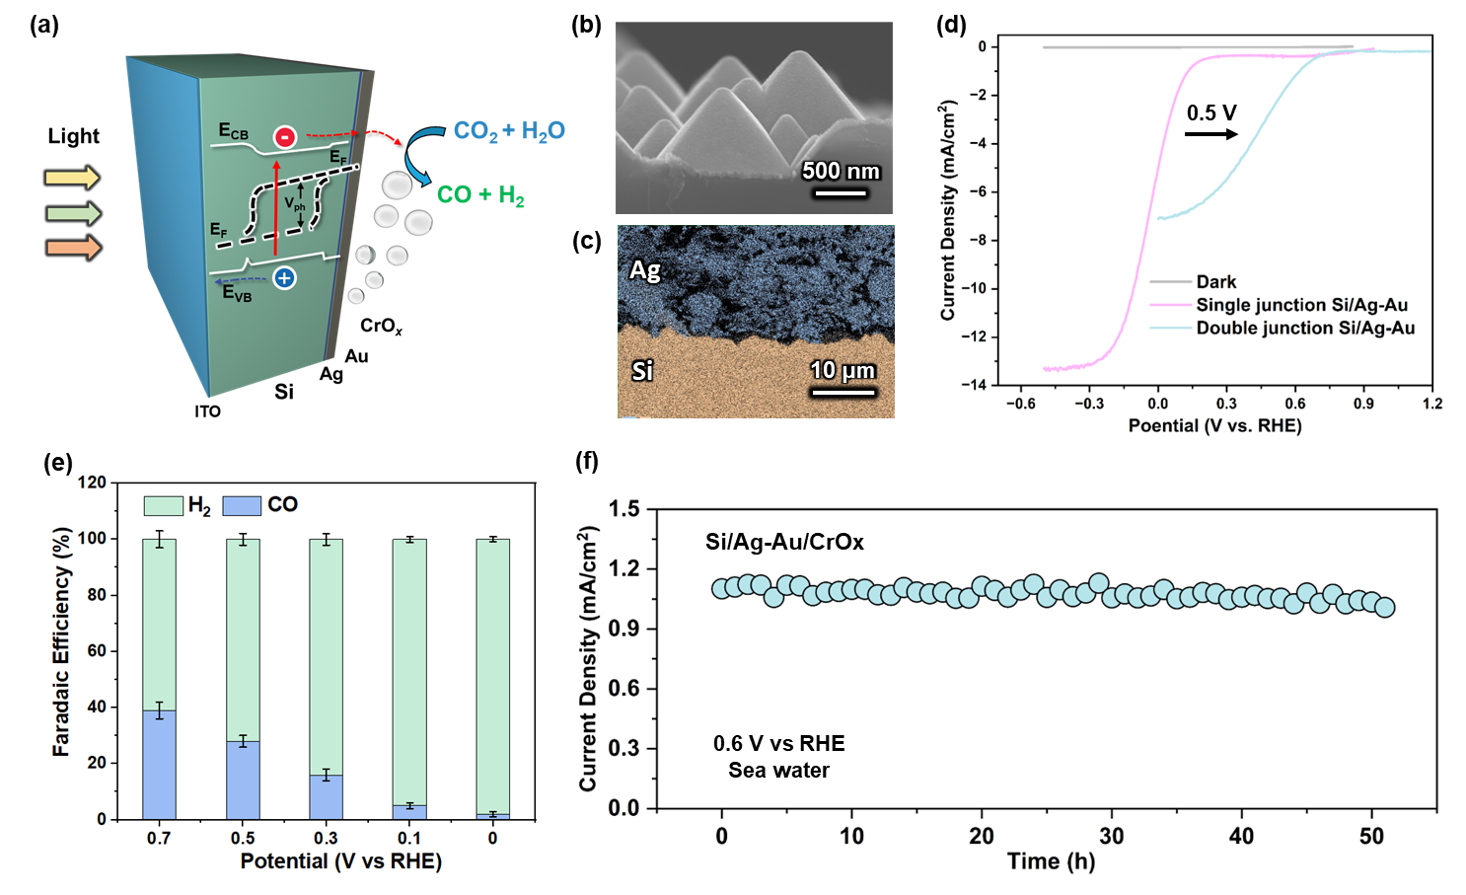
Fig. S22 Si photocathodes CO₂ conversion performance in seawater. a, The schematic energy band diagram of Si photocathodes under back illumination configuration. The cross-section SEM image (b) and corresponding element mapping (c) of Si photocathodes. d, J-E curves of Si photocathodes with single and double junctions, e, Potential dependent Faradaic efficiencies toward CO and H₂ production. f, stability of double Si photocathode at 0.6 V vs RHE.

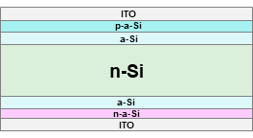
a

b
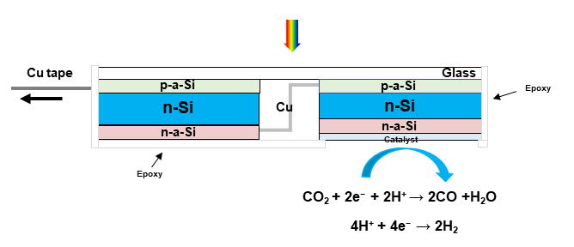
Fig. S23 a, Schematic of Si photocathode with a-Si passivation layer (a-Si). b, schematic of double junction Si photocathode for seawater CO₂RR.

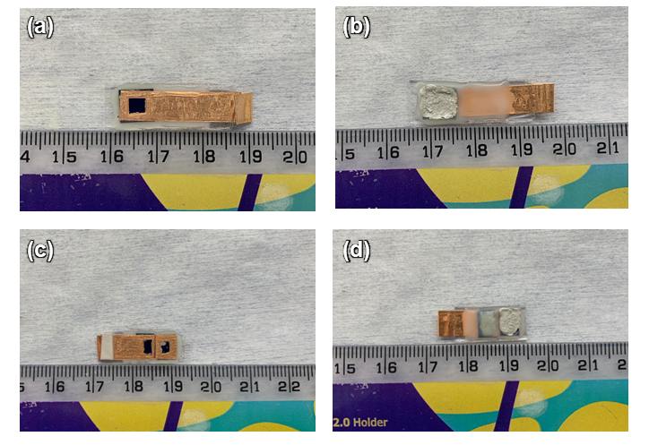
Fig. S24 Photograph of back-illuminated Si photocathodes: (a) light-facing side and (b) surface reaction side of single junction Si. (c) light-facing side and (d) surface reaction side of double junction Si photocathodes.

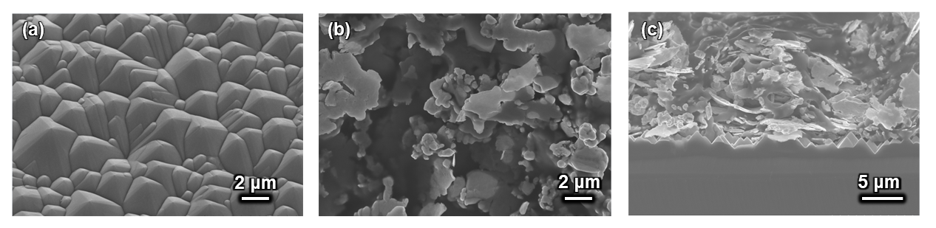
Fig. S25 (a) Top view SEM images of Si photocathode after texture with (b) Ag and Au layer. (c) cross sectional SEM image of Si photocathode with Ag and Au layer.

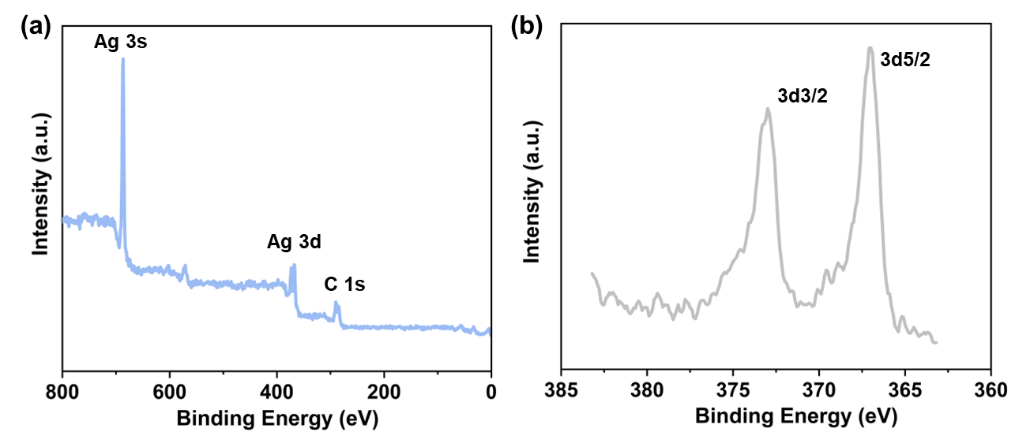
Fig. S26 XPS of Si photocathode. (a) XPS survey spectrum. (b, c) High-resolution XPS spectra
of the Ag3d.

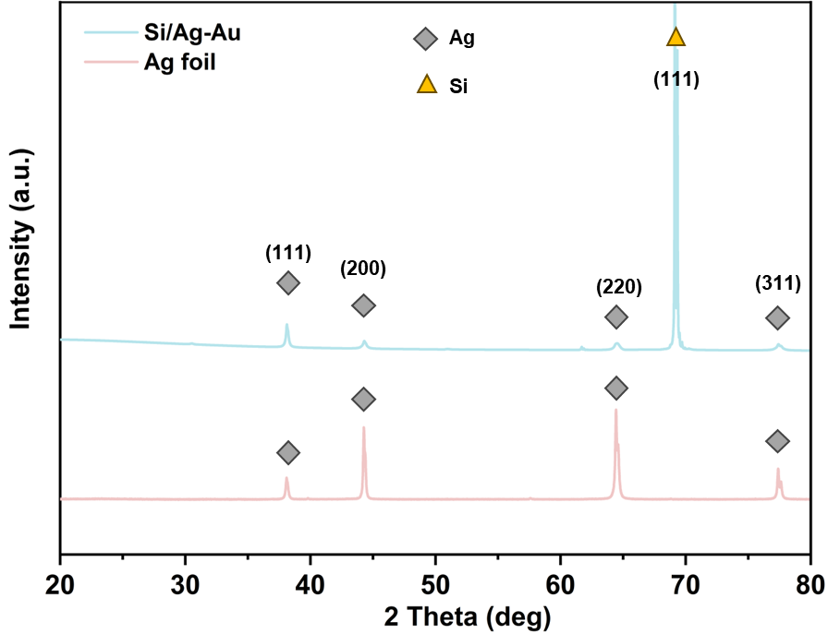
Fig. S27 XRD patterns of Si photocathode and Ag foil.

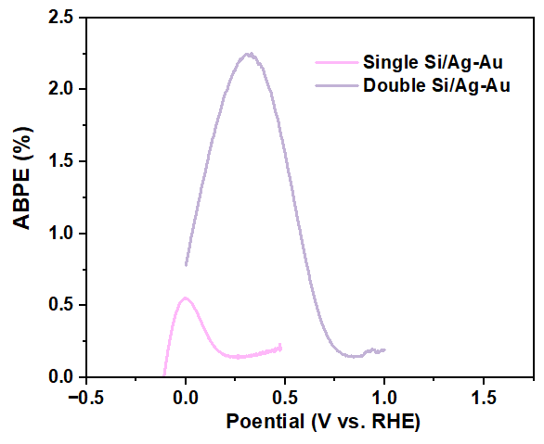
Fig. S28 ABPEs of single and double Si photocathodes at varying applied potentials.

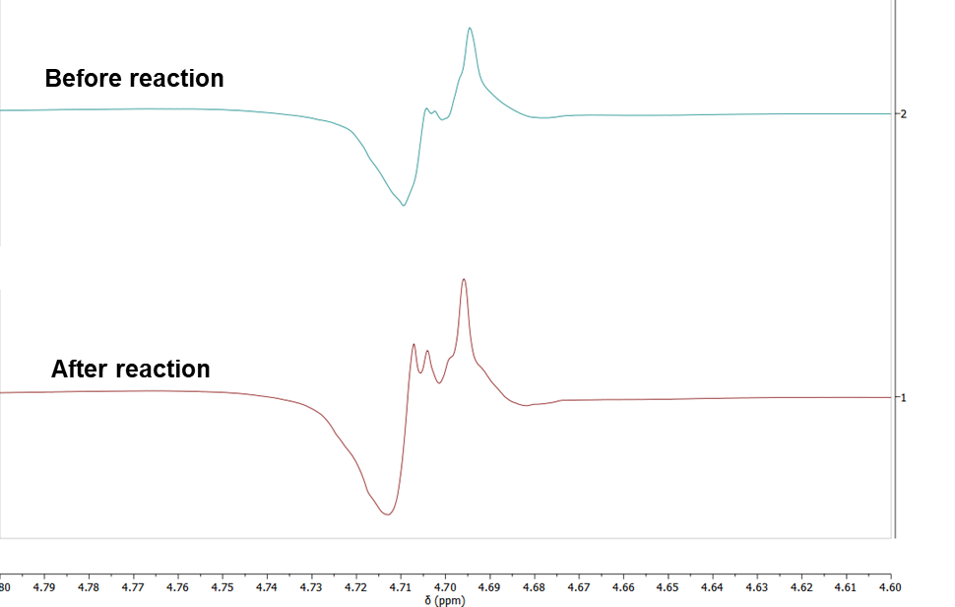
Fig. S29 NMRs spectra of seawater before and after CO₂RR.

Supplementary Materials

Quantitative boundary layer for protons and CO₂:
Our COMSOL Multiphysics simulations indicated that the concentrations of various species gradually change from electrode surface to the seawater bulk (Fig. S16). To calculate the thickness of the boundary layer of each relevant chemical species obtained from COMSOL Multiphysics simulation results, the following equation was used:
$\frac{{[i]}_{z}-{[i]}_{bulk}}{{[i]}_{surface}-{[i]}_{bulk}}×100\%=1\%$ (S1)
Taking H⁺ for example, the [H⁺]_{bulk} is the H⁺ concentration of bulk solution (5.2 × 10⁻⁹ mol/L), [H⁺]_{surface} is the H⁺ concentration of electrode surface, and [H⁺]_{z} is the H⁺ concentration within the boundary layer. When the value calculated by Equation S1 is 1%, the proton concentration at that position is much smaller than the proton concentration at the electrode surface. Within the boundary layer, HCO₃⁻ is acidified by H⁺ to produce CO₂(aq). Outside the H⁺ boundary layer, [H⁺] is too low for us to consider the effective acidification of HCO₃- to generate CO₂. Hence, this position is defined as boundary layer.
Based on the Equation (8), the boundary layer distributions of H⁺ (Fig. S18a) and CO₂(aq) (Fig. S18b) were calculated. The boundary layer thickness in relation to flow velocity and position were closely described by our analytical boundary layer calculations (Equation (7)). Compared to the cases where chemical reactions are not considered, the thickness of the H⁺ boundary layer was significantly thinner due to the formation of CO₂(aq) from H⁺ and HCO₃⁻ (Fig. S19) according to the rate laws. In contrast, the thickness of the CO₂ boundary layer maintains a similar thickness what is presented in Fig. 5a, even when chemical reactions are considered, suggesting that the CO₂(aq) produced by acidification is confined within this thin layer.

Reactive transport equation for CO₂(aq):
$$\frac{∂C_{CO_{2}}}{∂t}=∇⋅\left(D_{CO_{2}}∇C_{CO_{2}}\right)-∇⋅\left(vC_{CO_{2}}\right)+∇⋅\left(\frac{Z_{CO_{2}}F}{RT}D_{CO_{2}}C_{CO_{2}}∇ϕ\right)-k_{f1}C_{CO_{2}}+k_{r1}C_{HCO_{3}^{-}}C_{H^{+}}+k_{r2}C_{HCO_{3}^{-}}-k_{f2}C_{CO_{2}}C_{OH^{-}}$$

Analysis of COMSOL numerical simulations for CO₂(aq) flux:
The diffusion length (L), influenced by the transport time (L$= \sqrt{Dt}$), decreases with the increasing flow velocity, leads to a reduction in the z-direction diffusion of CO₂(aq). Compared to the CO₂(aq) flux of 7.5 mmol·m⁻²·s⁻¹ (Fig. S20) at 0.16 m/s at the front end of cathode, a CO₂(aq) flux of 13.53 mmol·m⁻²·s⁻¹ was achieved at 0.77m/s, indicating that an elevated flow rate corresponds to higher CO₂(aq) flux near the cathode surface. This can explain why the CO selectivity and STF efficiency increases at higher flow velocities (Fig. 2a), with an optimized flow velocity allows for more CO₂(aq) to be transported to the cathode surface, leading to higher CO₂ coverage and CO Faradaic efficiencies.

Performance, selectivity, and stability of Si photocathode under 1-atm CO₂ gas purge:
Although CO₂ extraction from seawater using a BiVO₄ photoanode is feasible, the conversion of CO₂ into value-added products remains challenging due to the inherent issues of low stability and selectivity associated with Si photocathodes. To protect Si from corrosion in the electrolyte, a commonly used strategy is to apply a TiO₂ protection layer on the surface of Si to isolate the Si and electrolyte. However, the TiO₂/Si interface tends to generate H₂, resulting in low CO₂ conversion selectivity¹. Moreover, if a metal layer were selected as the protective layer, it would impede the transmission of light and result in a reduction in the current density of the Si photocathode².
To overcome these obstacles, a low-cost method was developed to fabricate Si photocathodes (Fig. S22). We can scale up this manufacturing approach to make photoelectrodes covering a large area of ocean surface. To enhance the driving force for PEC CO₂R, an amorphous-Si (a-Si) passivated monocrystalline Si photocathode with a back-illuminated configuration was constructed (schematic in Fig. S23, photograph in Fig. S24). The Si surface was textured with micro-pyramids to decrease surface reflection (Fig. S22b). The dangling bonds on Si surface were fixed by a-Si, achieving ultra-low surface defects density and long minority carrier diffusion length (longer than ~2000 μm). Therefore, the light absorption and surface reaction can be separated on different side of Si substrate (thickness in 150 μm), the photogenerated minority carriers can transfer from the bulk to the surface to participate in the CO₂ conversion reaction before recombination. In a back-illuminated configuration, the catalytic layers will not compete with Si for light absorption. To suppress the H₂ production, a 20-μm thick layer of Ag paste was uniformly scribbled to the surface of Si substrate in direct contact with the indium tin oxide (ITO) layer (Fig. S22 and S25), which serves as the catalytic and protective layer for Si photocathodes. It is worth noting that the preparation method is easily scalable and possesses low costs as it does not require the use of a vacuum for the fabrication of the protective and catalytic layer. To further accelerate the kinetics of CO₂R, a 5-nm Au layer was deposited onto the Ag layer surface, which is confirmed by XPS (Fig. S26) and XRD (Fig. S27). The CrO_{x} layer was then deposited by electrochemical on the Au layer to prevent the oxygen reduction reaction and other side reactions in seawater. For PEC measurements, the Si substrate was encapsulated as electrodes without further treatment. Light-driven CO₂ reduction on the photocathode was performed under AM 1.5G illumination (100 mW/cm²) in seawater with CO₂ purge (pH 7) under ambient conditions. The Si photocathode with single junction exhibits an onset potential of 0.3 V vs RHE (defined as the potential required to achieve a photocurrent of 0.1 mA/cm²) (Fig. 6d). Although the Si photocathodes have shown promising onset potential and ABPE (Fig. S28), the interaction point between the Si photocathode and BiVO₄ photoanode remains relatively low, leading to suboptimal unbiased overall performance. Therefore, to further enhance the driving force for CO₂ reduction, double-junction Si photocathodes, which are connected with a Si solar cell in series, were fabricated (Fig. S23b and Fig. S24). The onset potential was positively shifted to 0.75 V vs RHE, contributing to an ABPE of 0.52% (Fig. S28), which is to our knowledge the record value among monocrystalline Si-based photocathodes (Table S5).
The potential-dependent faradaic efficiencies (FEs) toward CO and H₂ were evaluated at various potentials. The considerable CO was produced at 0.7 V vs RHE, leading to a FE of 40% for CO. The production of CO was achieved in a wide potential range from 0.7 to 0.1 V vs RHE (Fig. S22e), demonstrating the excellent selectivity of Ag-Au catalyst layers and CrO_{x} to eliminate the side reactions. The onset potential is attributed to the large photovoltage provided by the double Si junction obtained from a-Si as well as the fast surface reaction kinetics on Ag-Au catalysts. It should be noted that as the potential negatively increases the reductive current density increases, whereas the FE of CO is decreased. This can be attributed to low bicarbonate concentration present in seawater, which limits the ability to sustain higher CO₂ reduction current densities at more negative potentials. Hence, H₂ production becomes the domain reaction at a higher potential. Meanwhile, no liquid products were detected (Fig. S29). Furthermore, the Si photocathode was tested at 0.5 V vs RHE for a long-term period of up to 50 h (Fig. S22f). The current density remained nearly unchanged throughout the stability tests. The surfaces of the Si photocathodes maintained the initial morphology, which can be attributed to the dense Ag paste layer. As a result, the Si photocathodes reveal excellent CO₂R activity and stability in seawater, which is crucial for practical CO₂ conversion.

Table S1 Elemental composition of instant ocean water
Major elemental | Concentration (mmol/Kg)
Na⁺ | 470
K⁺ | 10.2
Ca²⁺ | 10.3
Mg²⁺ | 53
Sr⁺ | 0.09
Cl⁻ | 521
SO₄²⁻ | 23
Trace elemental | Concentration (μmol/Kg)
Li | 54
Si | 16
Mo | 1.8
Ba | 0.85
V | 2.9
Ni | 1.7
Cr | 7.5
Al | 240
Cu | 1.8
Zn | 0.5
Mn | 1.2
Fe | 0.24
Cd | 0.24
Pb | 2.1
Co | 1.3
Ag | 2.3
Ti | 0.67

Table S2 Kinetic rate laws used in COMSOL
Rate Constant | Value | Unit | Ref.
$$k_{f1}$$ | $$3.71×{10}^{-2}$$ | $$s^{-1}$$ | ³
$$k_{f2}$$ | $$2.23×{10}^{3}$$ | $$M^{-1}s^{-1}$$ | ³
$$k_{f3}$$ | $$5×{10}^{10}$$ | $$M^{-1}s^{-1}$$ | ⁴
$$k_{f4}$$ | $$9×{10}^{4}$$ | $$s^{-1}$$ | $$k_{r2}×k_{f1}×k_{f3}$$
$$k_{r1}$$ | $$7.83×{10}^{4}$$ | $$M^{-1}s^{-1}$$ | ³
$$k_{r2}$$ | $$4.85×{10}^{-5}$$ | $$s^{-1}$$ | ³
$$k_{r3}$$ | $$2.5$$ | $$s^{-1}$$ | ³
$$k_{r4}$$ | $$4.37×{10}^{5}$$ | $$s^{-1}$$ | $$k_{f2}×k_{r1}×k_{r3}$$
$$k_{fw}$$ | $$1.4×{10}^{-3}$$ | $$M s^{-1}$$ | ⁴
$$k_{rw}$$ | $$1.6×{10}^{11}$$ | $$M^{-1}s^{-1}$$ | $$k_{fw}/K_{w}$$

Table S3 Diffusion coefficient used in COMSOL
Diffusion Coefficient | Value | Unit
$$D_{H^{+}}$$ | $$9.31×{10}^{-9}$$ | $$m^{2}s^{-1}$$
$$D_{OH^{-}}$$ | $$5.27×{10}^{-9}$$ | $$m^{2}s^{-1}$$
$$D_{CO_{2}}$$ | $$1.9×{10}^{-9}$$ | $$m^{2}s^{-1}$$
$$D_{HCO_{3}^{-}}$$ | $$1.18×{10}^{-9}$$ | $$m^{2}s^{-1}$$
$$D_{CO_{3}^{2-}}$$ | $$0.955×{10}^{-9}$$ | $$m^{2}s^{-1}$$

Table S4 Electric charge of species used in COMSOL
Charge of Species | Value
$$Z_{H^{+}}$$ | 1
$$Z_{OH^{-}}$$ | -1
$$Z_{CO_{2}}$$ | 1
$$Z_{HCO_{3}^{-}}$$ | -1
$$Z_{CO_{3}^{2-}}$$ | -2
$$Z_{H_{2}O}$$ | 0

Table S5 PEC performance of recently reported silicon photocathodes for CO₂RR
Photocathode | Onset potential (V vs RHE) | Electrolyte / pH | FE (%) | Irradiation Intensity | Ref
p⁺-a-Si/Si/ n⁺-a-Si/Ag/Au | 0.75 | Sea water | 73 for CO | 1 Sun | This work
Si/TiO₂/  APTES* | 0 | CO₂ saturated 0.1 M  KHCO₃ | 76 for CO | 1.5 Suns | ⁵
Si/Au | 0.22 | CO₂ saturated 0.1 M  KHCO₃ | 82.2 for CO | 1 Sun | ⁶
n⁺p-Si/Au/TiO₂ | 0.24 | CO₂ saturated 0.1 M  KHCO₃ | 86 for CO | 1 Sun | ⁷
Si/Cu | 0 | CO₂ saturated 0.1 M  KHCO₃ | 25 for C₂H₄ | 1 Sun | ⁸
Si/TiO₂/CNT/@Co^{II}-(BrqPy)* | 0.2 | CO₂ saturated 0.1 M  KHCO₃ | 100 for CO | 1 Sun | ⁹
p-Si/n-ZnO_{v}/p-Cu_{x}O | 0.2 | CO₂ saturated 0.1 M  KHCO₃ | 60 for C₂H₅OH | 1 Sun | ¹⁰
p-Si/ZnO/Bi-Bi₂O₃ | -0.3 | CO₂ saturated 0.1 M  KHCO₃ | 84.3 for formate | 2 Suns | ¹¹
p-Si/Ni@In | -0.5 | CO₂ saturated 0.1 M  KHCO₃ | 87 for formate | 1 Sun | ¹²
p-Si/SiO₂-Cu-Ag | -0.8 | CO₂ saturated 0.1 M  KHCO₃ | 65.9 for CO | 1 Sun | ¹³
n⁺p-Si/Cu | 0.2 | CO₂ saturated 0.1 M  KHCO₃ | Not reported | 1 Sun | ¹⁴
b-Si/Ag/2ABT* | 0 | CO₂ saturated 0.2 M  KHCO₃ | 75 for CO | 0.66 Sun | ¹⁵
p-Si/Bi | 0.1 | CO₂ saturated 0.5 M  KHCO₃ | 72 for formate | 1 Sun | ¹⁶
p-Si/TiO₂/Ag | -0.16 | CO₂ saturated 0.1 M  KHCO₃ | 47 for CO | 1 Sun | ¹⁷
p-Si/Bi | -0.2 | CO₂ saturated 0.5 M  KHCO₃ | 90 for formate | 0.5 Sun | ¹⁸
n⁺pp⁺-Si/Ag-Cu | 0.1 | CO₂ saturated 0.1 M CsHCO3 | 60 for hydrocarbon | 1 Sun | ¹⁹
p-Si/Bi | 0 | CO₂ saturated 0.5 M  KHCO₃ | 90 for formate | 0.5 Sun | ²⁰
p-Si/Ag | -0.6 | CO₂ saturated 0.1 M  KHCO₃ | 53 for CO | 1 Sun | ²¹
n⁺p-Si/Sn-pNWs* | 0.32 | CO₂ saturated 0.1 M  KHCO₃ | 59.2 for HCOOH | 1 Sun | ²²
p-Si/Ag | 0 | CO₂ saturated 0.5 M  KHCO₃ | 90 for CO | 0.5 Sun | ²³
p-Si/N-GQSs | -1.53 vs Ag/Ag⁺ | CO₂ saturated 0.1 M TBAH | 95 for CO | 1 Sun | ²⁴

*APTES: (3-aminopropyl)triethoxysilane
*(BrqPy): 4’,4’’-bis(4-bromophenyl)-2,2’ :6’,2’’ :6’’,2’’’-quaterpyridine)
*DCP: 2,6-dicarboxypyridin-4-yl
*ABT: 2-aminobenzenethiol
*Sn-pNWs: porous SnO₂ nanowires
*N-GQSs: nitrogen-doped graphene quantum sheets

Table S6 Performance of recently reported unbiased cells (BiVO₄) for CO₂RR
Photoanodes | Photocathodes | Catalysts | Solution | pH | STF (%) | Ref.
BiVO₄ | Perovskite | CoMTPP* | CO₂ saturated 0.5 M KHCO₃ | 7.4 | 0.63 | ²⁵
BiVO₄ | Perovskite | CotpyP* | CO₂ saturated 0.1 M KHCO₃ | 6.7 | 0.08 | ²⁶
BiVO₄ | Perovskite | S.ovata | S. ovatamedium | 7 | 0.7 | ²⁷
BiVO₄ | a-Si | Au | CO₂ saturated 0.1 M KHCO₃ | 6.8 | 0.43 | ²⁸
BiVO₄ | CuO | ClFDH* | CO₂ saturated 0.1 M phosphate buffer | 6.5 | 0.008 | ²⁹
BiVO₄ | Si | Au | Sea water without CO₂ saturated | 8.3 | 0.71 | This work
*CoMTPP: cobalt(II) meso-tetrakis(4-methoxyphenyl)-porphyrin
*CotpyP: phosphonated cobalt(II) bis(terpyridine)
*ClFDH: Clostridium ljungdahlii

References:
1 Wu, B. et al. Stable solar water splitting with wettable organic-layer-protected silicon photocathodes. Nature Communications 13 (2022). https://doi.org:ARTN 4460
10.1038/s41467-022-32099-1
2 Bae, D., Seger, B., Vesborg, P. C., Hansen, O. & Chorkendorff, I. Strategies for stable water splitting via protected photoelectrodes. Chem Soc Rev 46, 1933-1954 (2017). https://doi.org:10.1039/c6cs00918b
3 Chen, Y., Lewis, N. S. & Xiang, C. Modeling and Simulation of the Spatial and Light-Intensity Dependence of Product Distributions in an Integrated Photoelectrochemical CO2 Reduction System. ACS Energy Letters 1, 273-280 (2016). https://doi.org:10.1021/acsenergylett.6b00134
4 Schulz, K. G., Riebesell, U., Rost, B., Thoms, S. & Zeebe, R. E. Determination of the rate constants for the carbon dioxide to bicarbonate inter-conversion in pH-buffered seawater systems. Marine Chemistry 100, 53-65 (2006). https://doi.org:10.1016/j.marchem.2005.11.001
5 Shang, B. et al. Aqueous Photoelectrochemical CO(2) Reduction to CO and Methanol over a Silicon Photocathode Functionalized with a Cobalt Phthalocyanine Molecular Catalyst. Angew Chem Int Ed Engl 62, e202215213 (2023). https://doi.org:10.1002/anie.202215213
6 Hu, J. et al. Facet engineering in Au nanoparticles buried in p-Si photocathodes for enhanced photoelectrochemical CO2 reduction. Applied Catalysis B: Environmental 327 (2023). https://doi.org:10.1016/j.apcatb.2023.122438
7 Wang, K. et al. Steering the Pathway of Plasmon-Enhanced Photoelectrochemical CO(2) Reduction by Bridging Si and Au Nanoparticles through a TiO(2) Interlayer. Small 18, e2201882 (2022). https://doi.org:10.1002/smll.202201882
8 Roh, I. et al. Photoelectrochemical CO(2) Reduction toward Multicarbon Products with Silicon Nanowire Photocathodes Interfaced with Copper Nanoparticles. J Am Chem Soc 144, 8002-8006 (2022). https://doi.org:10.1021/jacs.2c03702
9 Wen, Z. et al. Aqueous CO(2) Reduction on Si Photocathodes Functionalized by Cobalt Molecular Catalysts/Carbon Nanotubes. Angew Chem Int Ed Engl 61, e202201086 (2022). https://doi.org:10.1002/anie.202201086
10 Kan, M. et al. Defect‐Assisted Electron Tunneling for Photoelectrochemical CO2 Reduction to Ethanol at Low Overpotentials. Advanced Energy Materials 12 (2022). https://doi.org:10.1002/aenm.202201134
11 Zhang, Q. et al. A Bismuth Species-Decorated ZnO/p-Si Photocathode for High Selectivity of Formate in CO2 Photoelectrochemical Reduction. ACS Sustainable Chemistry & Engineering 10, 2380-2387 (2022). https://doi.org:10.1021/acssuschemeng.1c06712
12 Ma, W. et al. Nickel and indium core-shell co-catalysts loaded silicon nanowire arrays for efficient photoelectrocatalytic reduction of CO2 to formate. Journal of Energy Chemistry 54, 422-428 (2021). https://doi.org:10.1016/j.jechem.2020.06.023
13 Dong, W. J. et al. Grain Boundary Engineering of Cu-Ag Thin-Film Catalysts for Selective (Photo)Electrochemical CO(2) Reduction to CO and CH(4). ACS Appl Mater Interfaces 13, 18905-18913 (2021). https://doi.org:10.1021/acsami.1c03735
14 Kempler, P. A., Richter, M. H., Cheng, W.-H., Brunschwig, B. S. & Lewis, N. S. Si Microwire-Array Photocathodes Decorated with Cu Allow CO2 Reduction with Minimal Parasitic Absorption of Sunlight. ACS Energy Letters 5, 2528-2534 (2020). https://doi.org:10.1021/acsenergylett.0c01334
15 Kan, M. et al. 2-Aminobenzenethiol-Functionalized Silver-Decorated Nanoporous Silicon Photoelectrodes for Selective CO(2) Reduction. Angew Chem Int Ed Engl 59, 11462-11469 (2020). https://doi.org:10.1002/anie.202001953
16 Fu, D. et al. Bismuth‐Decorated Silicon Photocathodes for CO2‐to‐Formate Solar‐Driven Conversion. ChemCatChem 12, 5819-5825 (2020). https://doi.org:10.1002/cctc.202000889
17 Kim, C. et al. Photoelectrochemical Reduction of CO2 to Syngas by Reduced Ag Catalysts on Si Photocathodes. Applied Sciences 10 (2020). https://doi.org:10.3390/app10103487
18 Ding, P. et al. Controlled chemical etching leads to efficient silicon–bismuth interface for photoelectrochemical CO2 reduction to formate. Materials Today Chemistry 11, 80-85 (2019). https://doi.org:10.1016/j.mtchem.2018.10.009
19 Gurudayal, G. et al. Si photocathode with Ag-supported dendritic Cu catalyst for CO2reduction. Energy & Environmental Science 12, 1068-1077 (2019). https://doi.org:10.1039/c8ee03547d
20 Gong, Q. et al. Structural defects on converted bismuth oxide nanotubes enable highly active electrocatalysis of carbon dioxide reduction. Nat Commun 10, 2807 (2019). https://doi.org:10.1038/s41467-019-10819-4
21 Wei, L. et al. Photoelectrocatalytic reduction of CO2 to syngas over Ag nanoparticle modified p-Si nanowire arrays. Nanoscale 11, 12530-12536 (2019). https://doi.org:10.1039/c9nr02786f
22 Rao, K. R. et al. Photoelectrochemical reduction of CO2to HCOOH on silicon photocathodes with reduced SnO2porous nanowire catalysts. Journal of Materials Chemistry A 6, 1736-1742 (2018). https://doi.org:10.1039/c7ta09672k
23 Hu, Y. et al. Designing effective Si/Ag interface via controlled chemical etching for photoelectrochemical CO2 reduction. Journal of Materials Chemistry A 6, 21906-21912 (2018). https://doi.org:10.1039/c8ta05420g
24 Yang, K. D. et al. Graphene Quantum Sheet Catalyzed Silicon Photocathode for Selective CO2 Conversion to CO. Advanced Functional Materials 26, 233-242 (2015). https://doi.org:10.1002/adfm.201502751
25 Andrei, V. et al. Floating perovskite-BiVO(4) devices for scalable solar fuel production. Nature 608, 518-522 (2022). https://doi.org:10.1038/s41586-022-04978-6
26 Wang, Q. et al. Molecularly engineered photocatalyst sheet for scalable solar formate production from carbon dioxide and water. Nature Energy 5, 703-710 (2020). https://doi.org:10.1038/s41560-020-0678-6
27 Wang, Q., Kalathil, S., Pornrungroj, C., Sahm, C. D. & Reisner, E. Bacteria-photocatalyst sheet for sustainable carbon dioxide utilization. Nature Catalysis 5, 633-+ (2022). https://doi.org:10.1038/s41929-022-00817-z
28 Li, C. et al. Photoelectrochemical CO2 reduction to adjustable syngas on grain-boundary-mediated a-Si/TiO2/Au photocathodes with low onset potentials. Energy & Environmental Science 12, 923-928 (2019). https://doi.org:10.1039/c8ee02768d
29 Kuk, S. K. et al. CO(2) -Reductive, Copper Oxide-Based Photobiocathode for Z-Scheme Semi-Artificial Leaf Structure. ChemSusChem 13, 2940-2944 (2020). https://doi.org:10.1002/cssc.202000459

