Supplementary Information

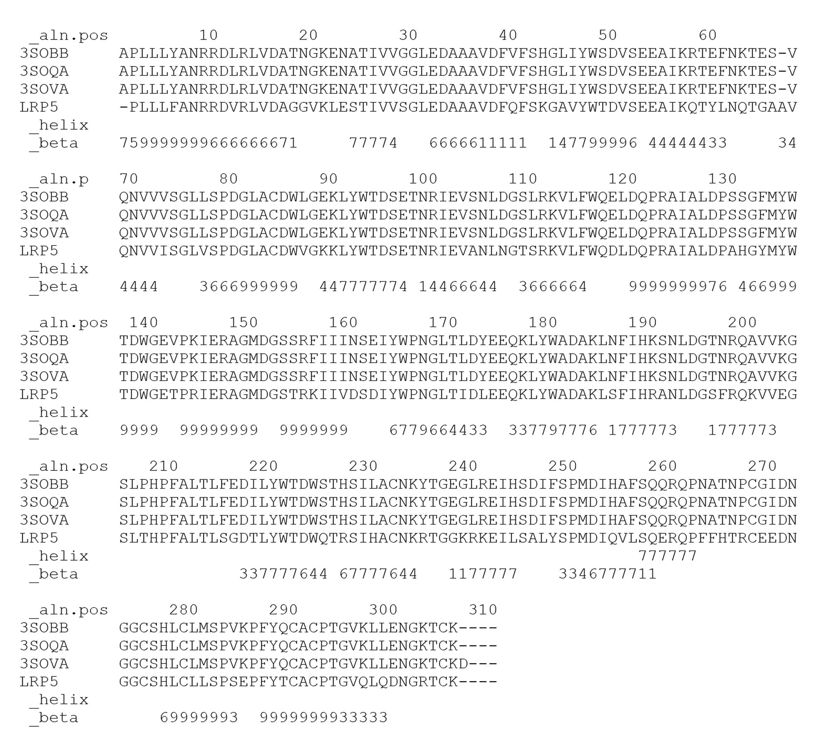
Supplementary Fig. S1. Alignment of sequence template and LRP5 sequence to generate de MHM

A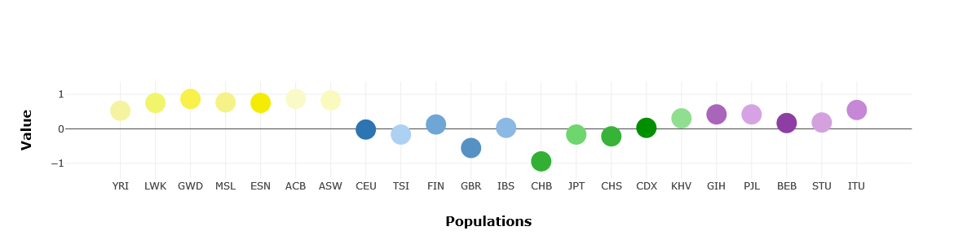
B
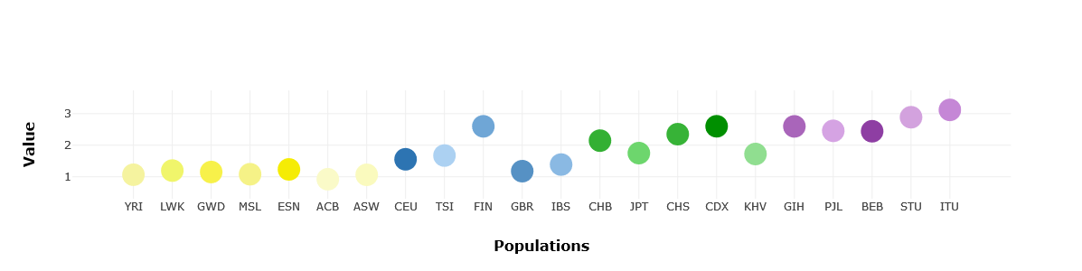
Supplementary Fig. S2. Alpha (A) and iHS (B) statistics in the LRP5 gene for the 1000G populations computed by popHumanScan. Sub-Saharan African populations (yellow) show large values for the alpha statistic. South Asian populations (purple) show large iHS values. In both cases, these values are compatible with the fingerprint of positive selection.

Supplementary Fig. S3. Stability ΔΔG±SD (kcal/mol) of variants in Archaic humans and High Bone Mass (HBM) variants in the LRP5 protein. The dot line indicate the threshold established at 1.6 kcal/mol. Dash lines indicate median and quartiles.

Supplementary Table S1. X-Ray crystallography structures evaluated from PDB
 | 3S94 | 3SOB | 3SOQ | 3SOV | 4DG6 | 5GJE
Method | X-ray  crystallography | X-ray  crystallography | X-ray  crystallography | X-ray  crystallography | X-ray  crystallography | Electron Microscopy
Resolution [Å] | 2.8 Å | 1.9 Å | 1.9 Å | 1.27 Å | 2.9 Å | 21.0 Å
R-Value  (Free // Work) | 0.296 // 0.237 | 0.212 // 0.174 | 0.221 // 0.177 | 0.180 // 0.153 | 0.313 // 0.257 | -
Chains | A, B | B | A | A | A | A
Length | 305 | 305 | 305 | 305 | 305 | 305
E-value | 5.84961E-132 | 1.68734E-132 | 1.59161E-132 | 1.59161E-132 | 3.91915E-132 | 5.84961E-132
% Identity of B-propeller 1 & EGF-L1 | 221/305 (72%) | 221/305 (72%) | 221/305 (72%) | 221/305 (72%) | 221/305 (72%) | 221/305 (72%)
Score | 468.774bits (1205) | 470.7bits (1210) | 470.7bits (1210) | 470.7bits (1210) | 469.159bits (1206) | 468.774bits (1205)
Positives | 259/305 (85%) | 259/305 (85%) | 259/305 (85%) | 259/305 (85%) | 259/305 (85%) | 259/305 (85%)
Gaps | 1/305 (0%) | 1/305 (0%) | 1/305 (0%) | 1/305 (0%) | 1/305 (0%) | 1/305 (0%)
Structure  region | B-Propeller 1 y 2  EGF-like 1 y 2 | B-Propeller 1  EGF-like 1 | B-Propeller 1  EGF-like 1 | B-Propeller 1  EGF-like 1 | B-Propeller 1 y 2  EGF-like 1 y 2 | B-Propeller 1,2,3 y 4  EGF-like 1,2,3 y 4
Protein | LRP6 | LRP6 | LRP6 | LRP6 | LRP6 | LRP6
PMID | 21984209 | 21944579 | 21944579 | 21944579 | 22696217 | 28052259
Supplementary Table S2. Effect of LRP5 archaic and HBM variants
Variants | Repeat* | Effect | ΔΔG Stability ± SD LRP5 (kcal/mol)¹ | ΔΔG Interaction LRP5-DKK1 (kcal/mol)
Archaic Human Variants
p.A67T |  | Stability? | 0.91 ± 0.02 | -0.05
p.A67V |  | Stability | 5.77 ± 0.10 | -0,09
p.R186Q | LDL-receptor class B 3 | Electrostatic | 0.80 ± 0.1 | NA²
p.M282R | LDL-receptor class B 5 | Stability/Interaction/  Electrostatic | 6.16 ± 2.5 | 2.7
p.R291Q |  | Electrostatic | 0.36 ± 0.47 | NA
HBM Variants
p.D111Y | LDL-receptor class B 1 | Stability | -1.76 ± 0.60 | NA
p.G112V | LDL-receptor class B 1 | Stability | 7.59 ± 0.01 | NA
p.R154M | LDL-receptor class B 2 | Interaction | 0.93 ± 0.18 | ?
p.G171R | LDL-receptor class B 3 | Stability | 13.92 ± 2.60 | NA
p.G171V# | LDL-receptor class B 3 | Stability | 12.14 ± 0.43 | NA
p.N198Y | LDL-receptor class B 4 | Stability | 16.35 ± 1.67 | NA
p.N198S | LDL-receptor class B 4 | Stability | 1.34 ± 0.43 | NA
p.A214T | LDL-receptor class B 4 | Stability | 4.86 ± 0.21 | NA
p.A214V | LDL-receptor class B 4 | Stability | 5.50 ± 0.17 | NA
p.A242T | LDL-receptor class B 5 | Stability | 2.37 ± 0.49 | NA
p.T253I | YWTD4 | Stability | 3.48 ± 0.85 | NA
p.R266C | LDL-receptor class B 5 | Electrostatic | 0.68 ± 0.18 | NA
p.M282V | LDL-receptor class B 5 | Stability | 2.40 ± 0.52 | NA
*All variants are found in the first β-propeller region.
#Variant used as positive control for the luciferase assay.
¹Threshold: ±1.6 kcal/mol (corresponding to twice the standard deviation calculated with FoldX). Values above threshold are indicated in bold).
²The residue is not located at the DKK1 interaction domain of LRP5 in our model.

