SUPPORTING INFORMATION

Equations:
- Encapsulation efficiency (EE)
$$EE (\%)= \left[\frac{A_{PLGA}}{A_{PLGA}+A_{Supernatant}+A_{Tube}}\right]×100$$
A_{PLGA}, A_{Supernatant}, and A_{Tube} correspond to the ²²⁵Ac activity within the PLGA nanoparticle suspension, supernatant, and Eppendorf tube, respectively.

- Radionuclide retention

$${Ac}_{released} (\%)= \left[\frac{A_{dialysate}}{A_{0}e^{-λt}}\right]×100$$
A_{dialysate}, A₀, and t correspond to the ²²⁵Ac activity in the dialysate, initial ²²⁵Ac activity in the cassette, and time in dialysis, respectively.

$${Fr}_{released} (\%)= \left[\frac{A_{dialysate}- A_{Ac}}{A_{0}e^{-λt}}\right]×100$$

$$A_{dialysate} (nCi)= \left[\frac{A_{measured}× t ×λ}{1-e^{-λt}}\right]×100$$
A_{dialysate}, A_{Ac,} A₀, and t correspond to the ²²¹Fr activity in the dialysate, ²²⁵Ac activity in the dialysate, initial ²²⁵Ac activity in the cassette, and time in dialysis, respectively. Owing to the short half-life of ²²¹Fr, the activity measured in the dialysate (A_{measured}) must be corrected by decay.

$${Bi}_{released} (\%)= \left[\frac{A_{dialysate}- A_{Ac}}{A_{0}e^{-λt}}\right]×100$$
A_{dialysate}, A_{Ac,} A₀, and t correspond to the ²¹³Bi activity in the dialysate, ²²⁵Ac activity in the dialysate, initial ²²⁵Ac activity in the cassette, and time in dialysis, respectively.
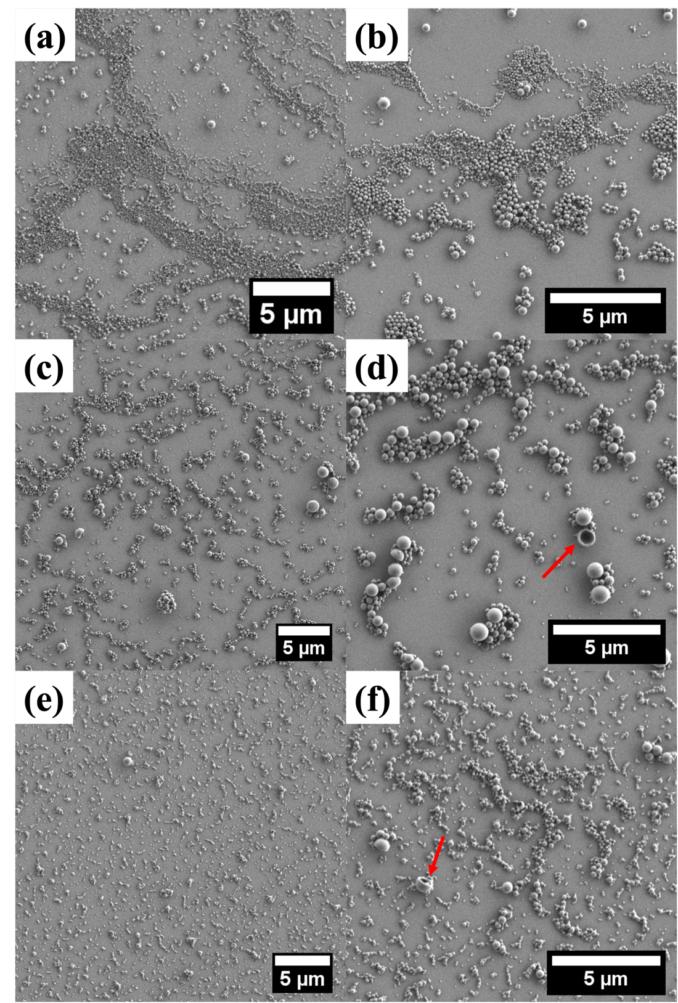
Figure S. 1. Spherical PLGA nanoparticles can be obtained with various size distributions by altering synthesis parameters. Representative SEM images of PLGA nanoparticles synthesized with standard conditions while the concentration of vitamin E-TPGS and the number of sonication cycles are varied. PLGA nanoparticles synthesized with (a, b) 1 wt % of vitamin E-TPGS and two sonication cycles, (c, d) 0.1 wt % of vitamin E-TPGS and two sonication cycles, and (e, f) 0.5 wt % of vitamin E-TPGS and one sonication cycle. Arrows (red) indicate larger PLGA nanoparticles were not completely formed or that have burst/collapsed during synthesis.
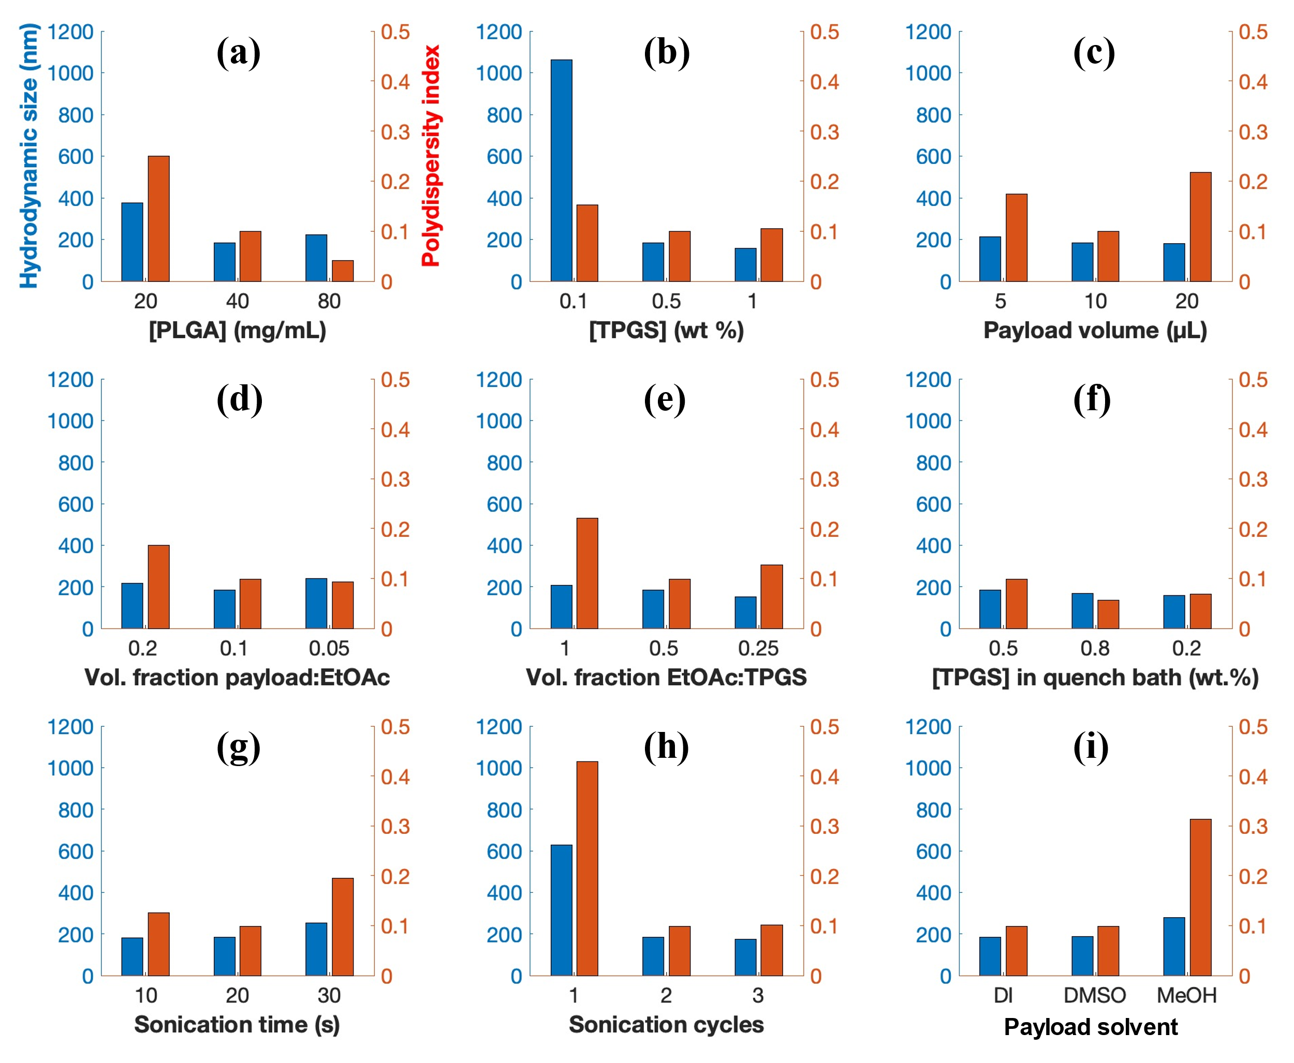
Figure S. 2. The size distribution of PLGA nanoparticles can be tailored by adjusting synthesis parameters. Influence of (a) PLGA concentration, (b) TPGS concentration, (c) payload volume, (d) volume fraction between payload and EtOAc, (e) volume fraction between EtOAc and TPGS, (f) TPGS concentration in quench bath, (g) sonication time, (h) sonication cycles, and (i) payload solvent on the mean hydrodynamic size and polydispersity of PLGA nanoparticles. PLGA nanoparticles were synthesized using a double-emulsion solvent evaporation method. One parameter was varied at a time while the others were kept constant based on the standard conditions.
Figure S. 3. PLGA nanoparticles maintained a similar hydrodynamic size in different media. Stability of PLGA nanoparticles in (a) dionized water, (b) phosphate buffered saline, and (c) DMEM/F12 complete media. Intensity size distribution over time after maintaining the PLGA nanoparticles at 4ºC between measurements. Inset in (c) shows the presence of small intensity peak from DMEM/F12 complete media.
Table S. 1 PLGA nanoparticles suspended in complete culture media maintain similar size and size distribution over time. Mean hydrodynamic size (Z_{ave}) and polydispersity (PDI) of PLGA nanoparticles in different media over time. PLGA nanoparticles remained stable in DI H₂O, whereas a slight aggregation was observed after 14 days in PBS.
 | Z_{ave} (nm) [PDI]
Time (d) | 0 | 1 | 3 | 7 | 14
DI H₂O | 167.7 [0.127] | 170.4 [0.113] | 170.2 [0.096] | 166.1 [0.107] | 158.5 [0.078]
PBS | 168.4 [0.129] | 167.6 [0.107] | 168.3 [0.110] | 166.2 [0.082] | 250.4 [0.253]
DMEM/F12 | 125.9 [0.451] | 128.4 [0.373] | 130.8 [0.340] | 124.7 [0.434] | 125.5 [0.382]

Figure S. 4. The internalization of fluorescent PLGA nanoparticles by E0771 cells is influenced by exposure time and particle concentration. Confocal images of E0771 cells exposed to low (33 µg) and high (133 µg) concentrations of PLGA-Cy5 fluorescent nanoparticles after 2 h and 24 h of incubation with the nanoparticles.
Figure S. 5. The internalization of fluorescent PLGA nanoparticles by MM231 cells is influenced by exposure time and particle concentration. Confocal images of MM231 cells exposed to low (33 µg) and high (133 µg) concentrations of PLGA-Cy5 fluorescent nanoparticles after 2 h and 24 h of incubation with the nanoparticles.
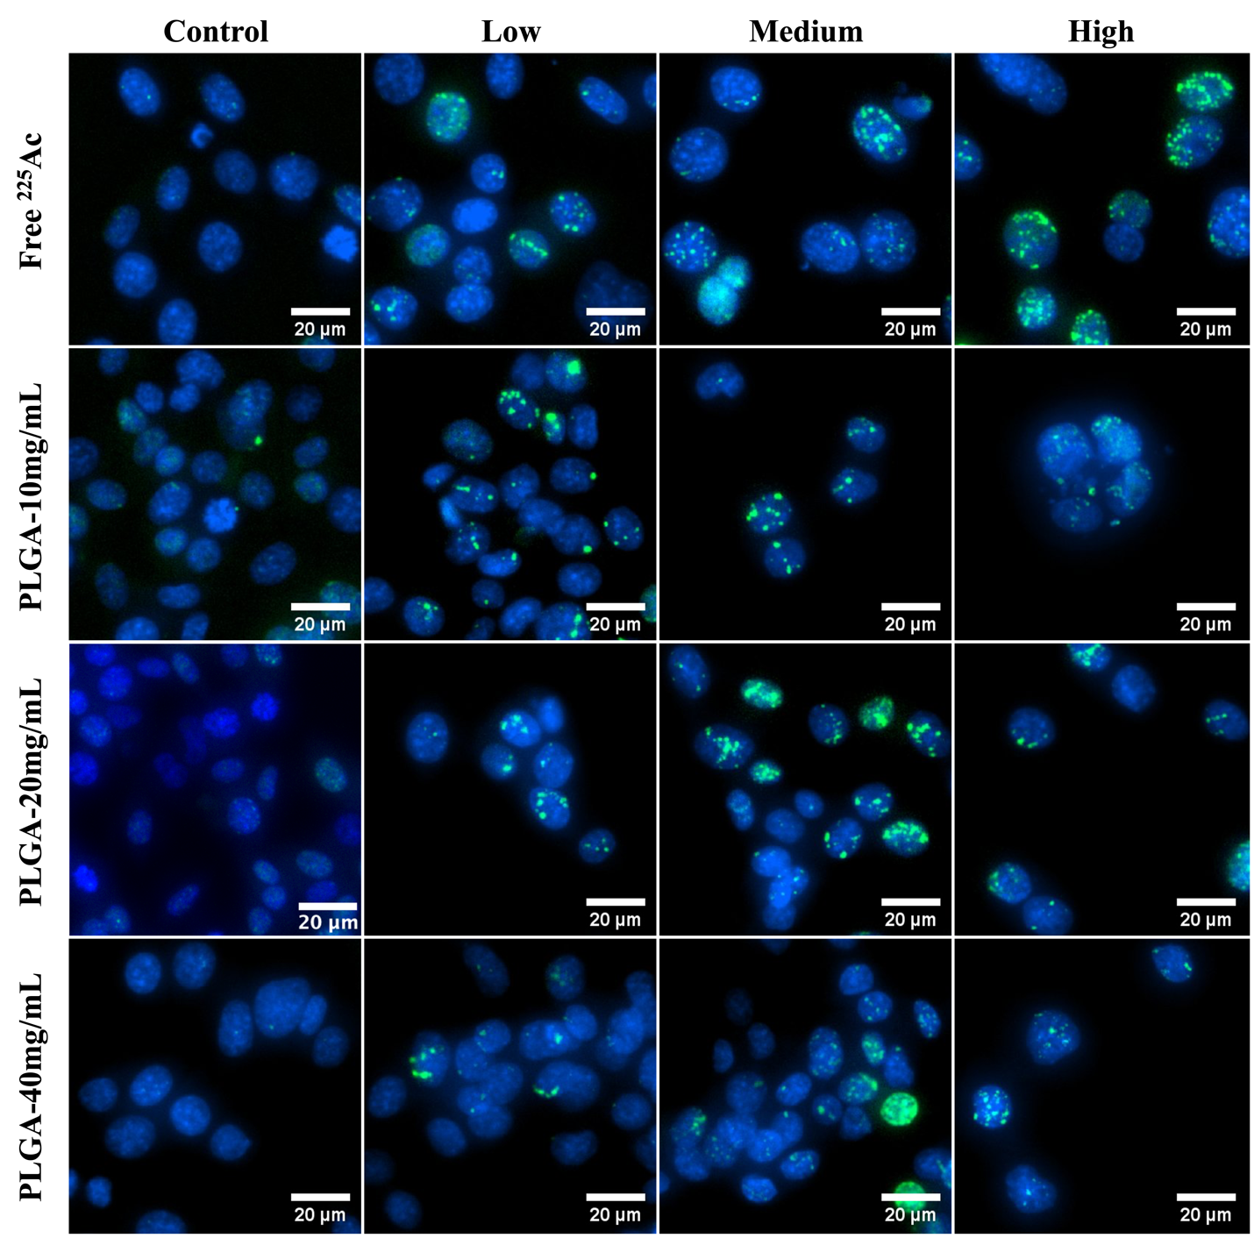
Figure S. 6 Alpha particles from ²²⁵Ac and its decay daughters induced the expression of γ-H2AX foci, indicative of DNA double strand breaks that can lead to cell death. Representative images of γ-H2AX foci in E0771 cells exposed to free ²²⁵Ac (Low – 3.0 nCi/well, Medium – 6.1 nCi/well, High – 12.2 nCi/well), PLGA(²²⁵Ac-BLPhen) [10 mg/mL] (Low – 2.2 nCi/well, Medium – 4.4 nCi/well, High – 8.9 nCi/well), PLGA(²²⁵Ac-BLPhen) [20 mg/mL] (Low – 2.2 nCi/well, Medium – 4.4 nCi/well, High – 8.9 nCi/well), and PLGA(²²⁵Ac-BLPhen) [40 mg/mL] (Low – 2.4 nCi/well, Medium – 4.9 nCi/well, High – 9.7 nCi/well) for 24 h. γ-H2AX (green) and nuclear DNA stained with hoechst (blue). Scale bar is 20 µm and images were acquired using Cytation 1 Imager and Plate reader.
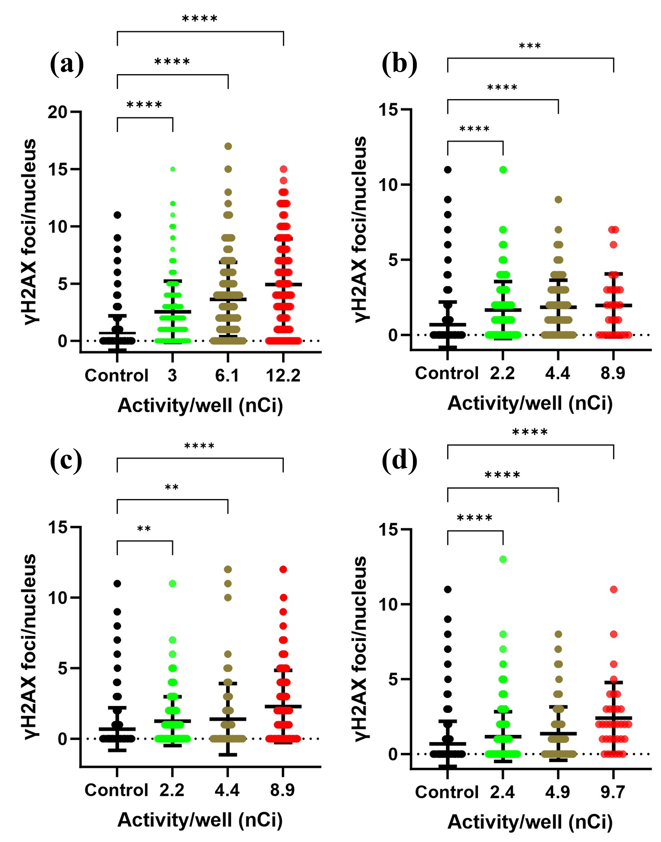
Figure S. 7. Increase of γ-H2AX foci indicating DNA double-strand breaks with higher ²²⁵Ac activities. γ-H2AX foci of DNA double-strand breaks quantified by an automated spot counting algorithm. Data summarizing analysis and quantification of individual γ-H2AX foci per E0771 nucleus after 24 h exposure to (A) free ²²⁵Ac and PLGA nanoparticles encapsulating ²²⁵Ac-BLPhen at (B) 10 mg/mL, (C) 20 mg/mL, and (D) 40 mg/mL. Reported values correspond to the mean of 4 technical replicates and n = 1 experiment. *P<0.05, **P<0.01, ***P<0.001, ****P<0.0001, one-way ANOVA followed by Tukey multiple comparisons post-test.
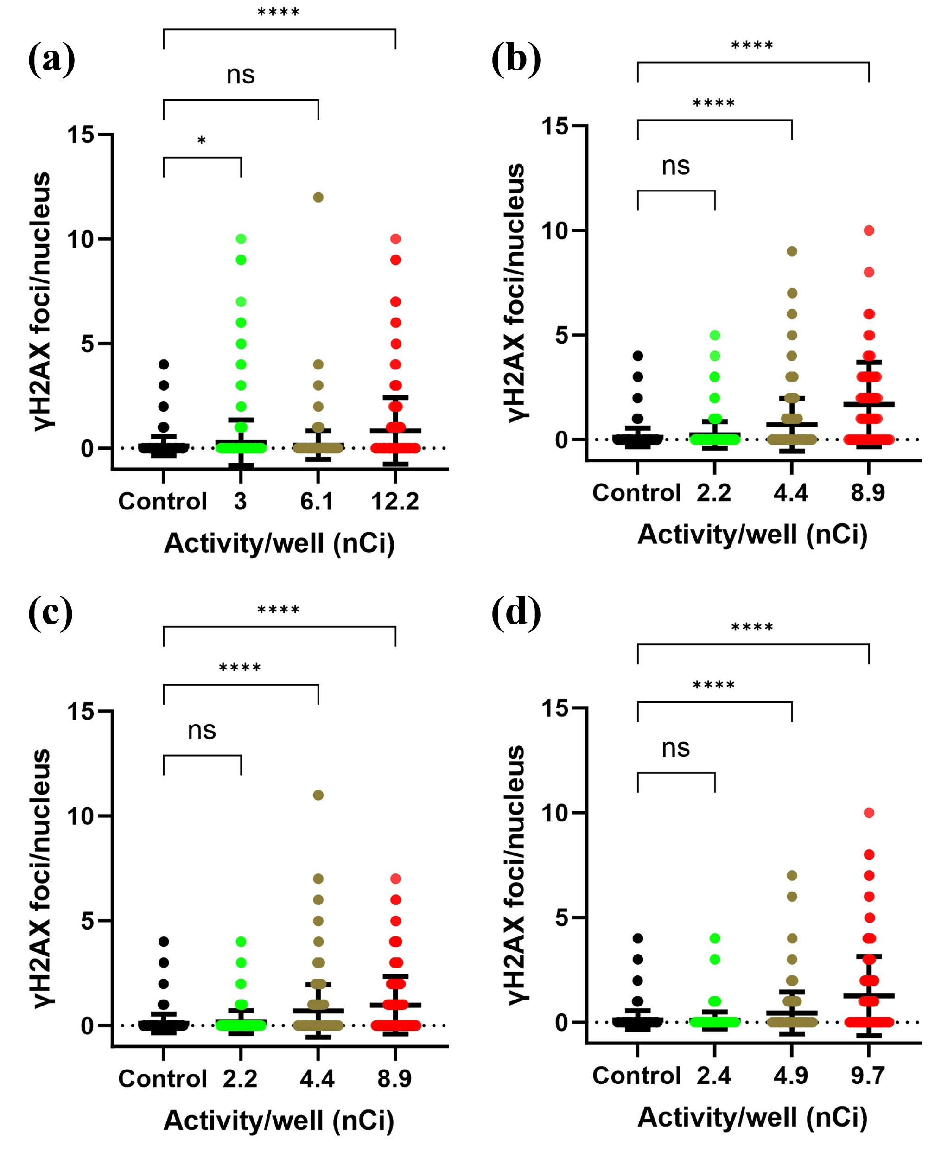
Figure S. 8. Increase of γ-H2AX foci indicating DNA double-strand breaks with higher ²²⁵Ac activities. γ-H2AX foci of DNA double-strand breaks quantified by automated spot counting algorithm. Data summarizing analysis and quantification of individual γ-H2AX foci per MCF7 nucleus after 24 h exposure to (A) free ²²⁵Ac and PLGA nanoparticles encapsulating ²²⁵Ac-BLPhen at (B) 10 mg/mL, (C) 20 mg/mL, and (D) 40 mg/mL. Reported values correspond to the mean of 4 technical replicates and n = 1 experiment. *P<0.05, **P<0.01, ***P<0.001, ****P<0.0001, one-way ANOVA followed by Tukey multiple comparisons post-test.

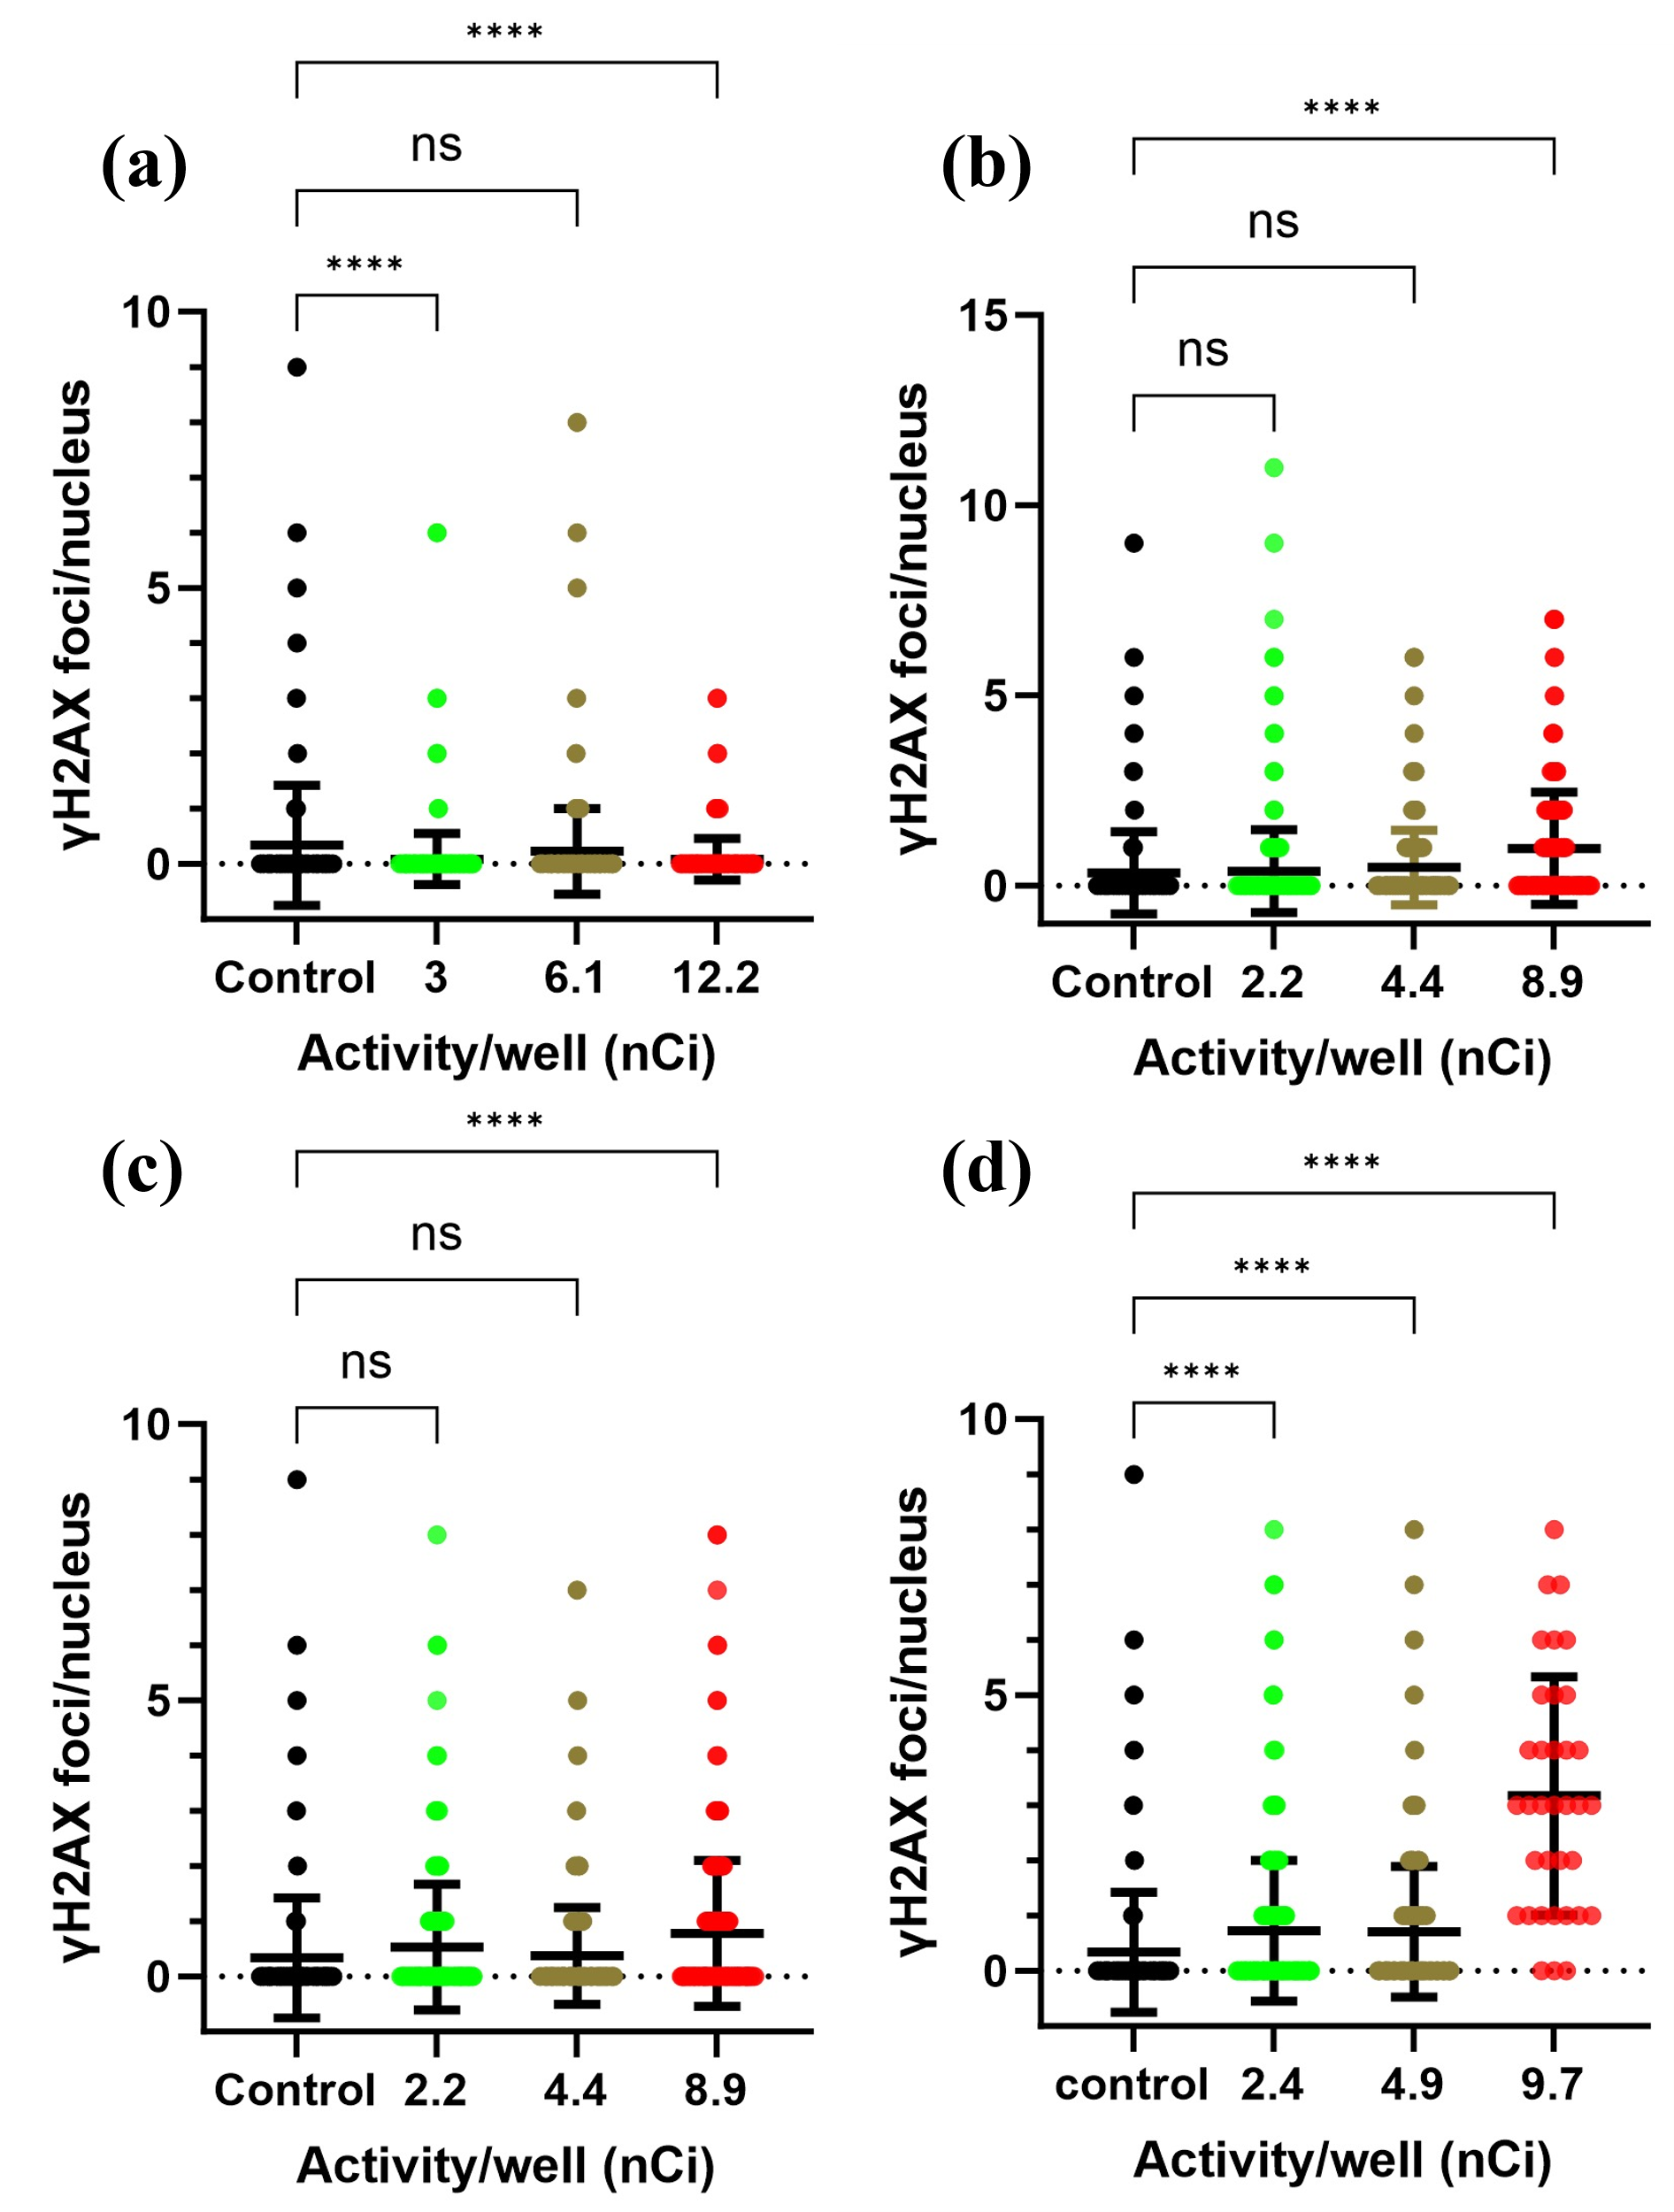
Figure S. 9. Increase of γ-H2AX foci indicating DNA double-strand breaks with higher ²²⁵Ac activities. γ-H2AX foci of DNA double-strand breaks quantified by automated spot counting algorithm. Data summarizing analysis and quantification of individual γ-H2AX foci per MM231 nucleus after 24 h exposure to (A) free ²²⁵Ac and PLGA nanoparticles encapsulating ²²⁵Ac-BLPhen at (B) 10 mg/mL, (C) 20 mg/mL, and (D) 40 mg/mL. Reported values correspond to the mean of 4 technical replicates and n = 1 experiment. *P<0.05, **P<0.01, ***P<0.001, ****P<0.0001, one-way ANOVA followed by Tukey multiple comparisons post-test.

Figure S. 10. Exposure time influences the cytotoxic effect of ²²⁵Ac delivered as free radionuclide and encapsulated within PLGA nanoparticles. Increasing ²²⁵Ac exposure time decreases E0771 cell viability for both free ²²⁵Ac and ²²⁵Ac-BLPhen encapsulated within PLGA nanoparticles. Viability relative to untreated cells was evaluated (a) 24 h and (b) 48 h post-exposure to free ²²⁵Ac for different times. Similarly, viability relative to untreated cells was assessed (c) 24 h and (d) 48 h post-exposure to ²²⁵Ac-BLPhen encapsulated within PLGA nanoparticles for different times. An alamarBlue assay was used to evaluate cell viability; the reported values correspond to the mean of five technical replicates and n = 1 experiment. Error bars show the standard error of the mean.
Figure S. 11. Exposure time influences the cytotoxic effect of ²²⁵Ac delivered as free radionuclide and encapsulated within PLGA nanoparticles. Increasing ²²⁵Ac exposure time decreases MCF7 cell viability for both free ²²⁵Ac and ²²⁵Ac-BLPhen encapsulated within PLGA nanoparticles. Viability relative to untreated cells was evaluated (a) 24 h and (b) 48 h post-exposure to free ²²⁵Ac for different times. Similarly, viability relative to untreated cells was assessed (c) 24 h and (d) 48 h post-exposure to ²²⁵Ac-BLPhen encapsulated within PLGA nanoparticles for different times. An alamarBlue assay was used to evaluate cell viability; the reported values correspond to the mean of five technical replicates and n = 1 experiment. Error bars show the standard error of the mean.

