Table AS Hydrogen-bond geometry (Å, º) for2-HDETDHP.
D—H···A | D—H | H···A | D···A | D—H···A
O3—H3O···O5^{i} | 0.80 (4) | 1.79 (4) | 2.586 (3) | 178 (3)
O4—H4O···O2^{i} | 0.93 (4) | 1.60 (4) | 2.526 (2) | 173 (3)
O5—H5O···O1^{ii} | 0.93 (4) | 1.63 (4) | 2.556 (3) | 176 (4)
C3—H3B···O1 | 0.98 | 2.48 | 3.439 (3) | 166
C4—H4B···O3^{iii} | 0.98 | 2.54 | 3.504 (3) | 170
C4—H4C···O1^{iv} | 0.98 | 2.49 | 3.457 (3) | 168
C5—H5A···O3^{iv} | 0.98 | 2.46 | 3.430 (3) | 172
C5—H5B···O1^{iii} | 0.98 | 2.42 | 3.382 (3) | 169
C5—H5C···O2 | 0.98 | 2.60 | 3.549 (3) | 164

Symmetry codes : (i) -x+2, -y+1, -z ; (ii) -x+1, -y+1, -z ; (iii) -x+1, -y+1, -z+1 ; (iv) x, y-1, z.

Table 1S The crystal data and structure refinement for 2-HDETDHP.
Crystal data
Chemical formula | C₅H₁₄NO⁺·H₂PO₄⁻
M_{r} | 201.16
Crystal system, space group | Triclinic, P$\overline{1}$
Temperature (K) | 193
a, b, c (Å) | 6.9232 (3), 8.2807 (4), 9.2333 (3)
a, b, g (°) | 84.458 (3), 71.414 (3), 70.758 (3)
V (Å³) | 473.68 (4)
Z | 2
Radiation type | Cu Ka
m (mm⁻¹) | 2.55
Crystal size (mm) | 0.60 × 0.10 × 0.02

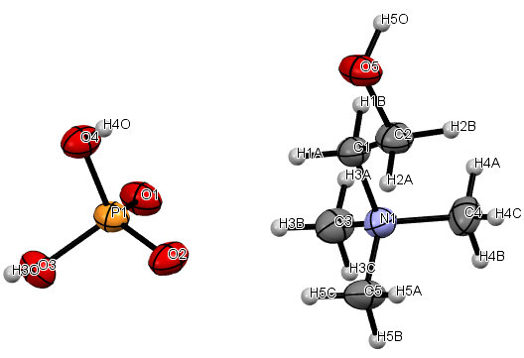
Figure 1S Molecular structure plot displaying atom labeling. At 50% likelihood, displacement ellipsoids are drawn.

Optimized Geometry
The electronic and geometric properties were calculated DFT at B3LYP and HF methods by 6-311G bases set. The compound has C₁ point group symmetry and exists asreal minima on the potential energy surface and the energy of RMS 0.00000766 a.u.
Table 2S Selected structural characteristics of the 2-HDETDHP compound determined both empirically and theoretically through free molecule optimization.
Parameters | Experimental | DFT/B3LYP/6-311G | HF/6-311G
P1-O2  P1-O3  P1-O4  P1-O5  O2-H11  O2-H18  O3-H11  O3-H27  O4-H6  O5-H7  O8-C13 O8-H28 N9-C10  N9-C16 N9-C20 N9-C24 C10-H11 C10-H12 C10-C13 C13-H14 C13-H15 C16-H17 C16-H18 C16-H19 C20-H21 C20-H22 C20-H23 C24-H25 C24-H26 C24-H27 | 1.5028  1.5167  1.6724  1.6668  3.1446  1.7328  1.8256  1.8578  0.9812  0.9824  1.4334  0.9782  1.5236  1.5065  1.5165  1.5091  1.1577  1.1096  1.5264  1.1143  1.1030  1.0966  1.1592  1.0964  1.1053  1.1030  1.1043  1.0955  1.0988  1.1451 | 1.4967 1.5080 1.5772 1.5630 3.1675 2.4796  2.9189 2.5973 0.7885 0.9292 1.4271 0.9355 1.5127 1.4993 1.4984 1.4927  0.9900  0.9900 1.5131 0.9899 0.9906 0.9807 0.9799 0.9793  0.9800 0.9794 0.9804 0.9802  0.9800  0.9801 | 1.5596  1.5647  1.6510  1.6700  2.1769  1.9940  3.0521  2.0238  0.9442  0.9439  1.4295  0.9466  1.5237  1.5128  1.4917  1.5120  1.0743  1.0802  1.5255  1.0731  1.0836  1.0776  1.0788  1.0773  1.0765  1.0768  1.0757  1.0766  1.0767  1.0772
O2-P1-O3 O2-P1-O4 O2-P1-O5 O3-P1-O4 O3-P1-O5 O4-P1-O5 P1-O2-H11 P1-O2-H18 H11-O2-H18  P1-O3-H11 P1-O3-H27  H11-O3-H27 P1-O4-H6  P1-O5-H7 C13-O8-H28 C10-N9-C16 C10-N9-C20 C10-N9-C24 C16-N9-C20 C16-N9-C24 C20-N9-C24 N9-C10-H11 N9-C10-H12 N9-C10-C13 H11-C10-H12  H11-C10-C13 H12-C10-C13 O2-H11-O3 O2-H11-C10 O3-H11-C10 O8-C13-C10 O8-C13-H14  O8-C13-H15 C10-C13-H14 C10-C13-H15 H14-C13-H15 N9-C16-H17 N9-C16-H18 N9-C16-H19 H17-C16-H18 H17-C16-H19 H18-C16-H19 O2-H18-C16) N9-C20-H21 N9-C20-H22 N9-C20-H23 H21-C20-H22 H21-C20-H23 H22-C20-H23 N9-C24-H25 N9-C24-H26 N9-C24-H27 H25-C24-H26 H25-C24-H27 H26-C24-H27 O3-H27-C24 | 118.0941  110.1926  110.2356  107.6588  109.5320  99.49300  63.74270  112.1032  53.56100  114.9068  113.0111  76.97170  115.7665  115.7193  111.1013  108.9753  110.4279  110.1260  108.0793  109.7697  109.4304  106.9119  109.7768  115.9435  107.1314  106.4675  110.1568  55.42470  124.5887  142.4157  111.6229  102.6649  110.7388  109.1925  113.6050  108.3895  112.7768  111.8669  112.7130  104.9154  109.3990  104.5807  178.5276  110.9159  111.2376  111.5295  107.7938  107.1500  108.0303  112.8372  112.3725  109.4138  109.3152  106.4662  106.0463  146.7567 | 115.2025 104.8051 110.6392 109.7790 110.2419 105.6110 83.88710 117.5342 47.85040 93.05890 125.2276  51.60660 112.8081 116.6101 114.4546 107.4590 110.5218 110.6509 108.6678 108.7668 110.6793 108.5491 108.5395 114.8995 107.5430 108.5168 108.5591 49.06090 140.0236 147.1515 107.1071 110.3274 110.2834 110.3258 110.2818 108.5179 109.4362 109.4795 109.5027 109.4601 109.4340 109.5147 166.1196 109.4708 109.5114 109.4717 109.4455 109.4325 109.4953 109.4694 109.4779 109.4626 109.4455 109.4584 109.5135 163.7030 | 114.4758  109.3743  112.7916  112.9171  109.0730  96.92980  106.4843  132.1126  63.64720  73.79680  104.6566  57.67080  119.8925  121.2556  114.0569  107.2030  110.7378  111.5392  109.1362  108.9778  109.1874  106.3741  105.9612  115.1457  109.2989  109.6140  110.2359  57.44080  149.4005  108.5808  107.7412  106.0737  110.3288  110.3651  112.5589  109.5586  108.1546  108.2463  108.3156  109.9121  109.9978  112.1043  152.3302  109.3064  109.0363  109.8613  109.5431  109.7702  109.3076  108.6933  107.9333  110.1946  109.5095  109.1620  111.3023  164.1466

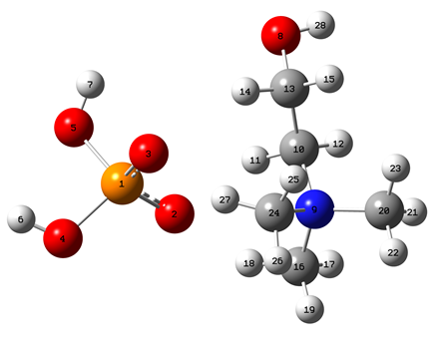
Figure 2S The optimized molecular structure of 2-HDETDHP.

Table 3S FT-IR vibrational wavenumbers (cm⁻¹) and assignments.
FT-IR | Assignements
3416  3329  3070  2821  2682  2342  2328  1725  1611  1333  1264  1030  997  540 | O–H stretching of water  N–H stretching  N–H···O, N–H···N stretching  P–O–H asymmetric stretching of hydroxide group  P–O–H symmetric stretching of hydroxide group  O–H···O asymmetric stretching, with water molecules  Vibrations of hydrogen bonds formed  Quadrant stretching; CNC bending  Side-chain asymmetric C–N stretching  P=O stretching  P–O asymmetric stretching  P–O symmetric stretching  P–O–H deformation  C–N bending vibration

Table 4S Adjust elements of the full transition hyperpolarizability tensor of [2-HDETDHP].
XXX | 1.00 | YXX | 2.757
XXY | 0.00 | YXY | 0.00
XXZ | 2.55 | YXZ | 5.491
XYX | 0.00 | YYX | 0.00
XYY | 0.386 | YYY | 0.830
XYZ | 0.00 | YYZ | 0.00
XZX | 2.55 | YZX | 5.491
XZY | 0.00 | YZY | 0.00
XZZ | -1.375 | YZZ | -4.644

Table 5S Adjust elements of the transition polarizability tensor Alpha of 2-HDETDHP.
XX | 2.850 | YX | -2.015 | ZX | -0.00
XY | -2.015 | YY | 1.480 | ZY | -0.00
XZ | -0.00 | YZ | -0.00 | ZZ | -0.202

Milliken population analysis
The Milliken charge distribution of every atom in 2-HDETDHP is displayed in Table 5S. The atoms of the asymmetric unit are listed. The atoms in the molecule have the following numbers: The atomic charge distribution shows that the eight anions have negative charges ranging from -0.72 to -0.50, whereas the H15 and P1 atoms of phosphate have positive charges ranging from 0.152376 to 1.5110.The negative charges of C20, C10, and N9 for the aliphatic group are -0.365832, -0.235895, and -0.516157, in that order. The outcomes of the molecular electrostatic potential study are consistent with this result. Hydrogen atoms have a positive charge that varies from 0.21 to 0.41 according on the atom they are attached to. In conclusion, an approximate value of 0.2 electrons is assigned to the electrical transition from anion to cation.
Table 5S Milliken population analysis in 2-HDETDHP

Atoms | DFT | HF
P1  O2  O3  O4  O5  H 6  H7  O8  N 9  C10  H11  H12  C13  H 14  H 15  C16  H 17  H18  H 19  C20  H21  H 22  H 23  C 24  H 25  H 26  H 27  H28 | 1.511969  -0.794571  -0.793442  -0.754216  -0.773005  0.411430  0.400796  -0.573683  -0.516157  -0.235895  0.322516  0.173959  -0.120157  0.265867  0.152376  -0.392850  0.200504  0.336750  0.192870  -0.365832  0.217411  0.220440  0.218950  -0.398528  0.196736  0.198659  0.342520  0.354584 | 2.069530  -0.997768  -0.988038  -0.928522  -0.950915  0.459417  0.453837  -0.704295  -0.655671  -0.174478  0.338229  0.176861  -0.031365  0.277436  0.145771  -0.354377  0.195804  0.365296  0.188029  -0.319400  0.213598  0.216533  0.215107  -0.361083  0.190883  0.195840  0.375641  0.388100

FMO Theory
Named as frontier molecular orbital (FMOs), both the highest occupied molecular orbital (HOMO) is an electron donor and the lowest unoccupied molecular orbital (LUMO) is an electron acceptor one. In the present study, the (HOMO – 0.17719 a.u.) and (LUMO -0.01585a.u.) energies were predicted atB3LYPmethod with the 6-311Gbasis set. According to the obtained results, the energy gap between the HOMOs and LUMOs represents the critical parameter in determining the molecular electrical transport properties which help the electron conductivity measurement. The frontier molecular orbitals’ energies (EHOMO, ELUMO) were used to calculate the global chemical reactivity descriptors of the molecule such as the ionization potential electron affinity, the electronegativity, the global hardness, the global softness, the chemical potential and the electrophilicity index. These important descriptors are calculated as follows:
Ionization potential: IP = - E_{HOMO}
Electron affinity: EA = - E_{LUMO}
Electronegativity: χ= - 1/2(E_{LUMO}+ E_{HOMO})
Chemica lpotential: μ= 1/2(E_{LUMO} + E_{HOMO})
Global hardness: η= 1/2(E_{LUMO}- E_{HOMO})
Global softness: S = 1/2η
Electrophilicity index: ω= μ²/2η
Where A is the ionization potential and I is the electron affinity of the molecule. Both parameters can be expressed through HOMO and LUMO orbital energies as I = –E_{HOMO} and EA = –E_{LUMO}. The electro affinity and the Ionization potential of 2-HDETDHP are given in Table 7. The calculated values of the softness, the hardness, the chemical potential, the electronegativity and the electrophilicity index of the molecule are found to be respectively 6.08 eV by B3LYP/6-311G. The soft molecule represents a small HOMO-LUMO gap, while that of the hard molecule is supposed to be large.

Table 6S Difference of energies between the possible combinations, chemical potential,
Electronegativity, Global hardness, Softness and Electrophilicity. All values are in eV
except for S which is given in eV⁻¹.
DFT/B3LYP/6e311G | Values
E_{HOMO} (eV)  E_{LUMO} (eV)  ΔE_{HOMO-LUMO} gap (eV)  Chemical Potential μ (eV)  Electronegativity χ (eV)  Global hardness η (eV)  Softness S (eV⁻¹)  Electrophilicity (eV) | -4.8188  -0.4313  4.3900  -2.6250  +2.6250  2.1937  0.2279  1.1966

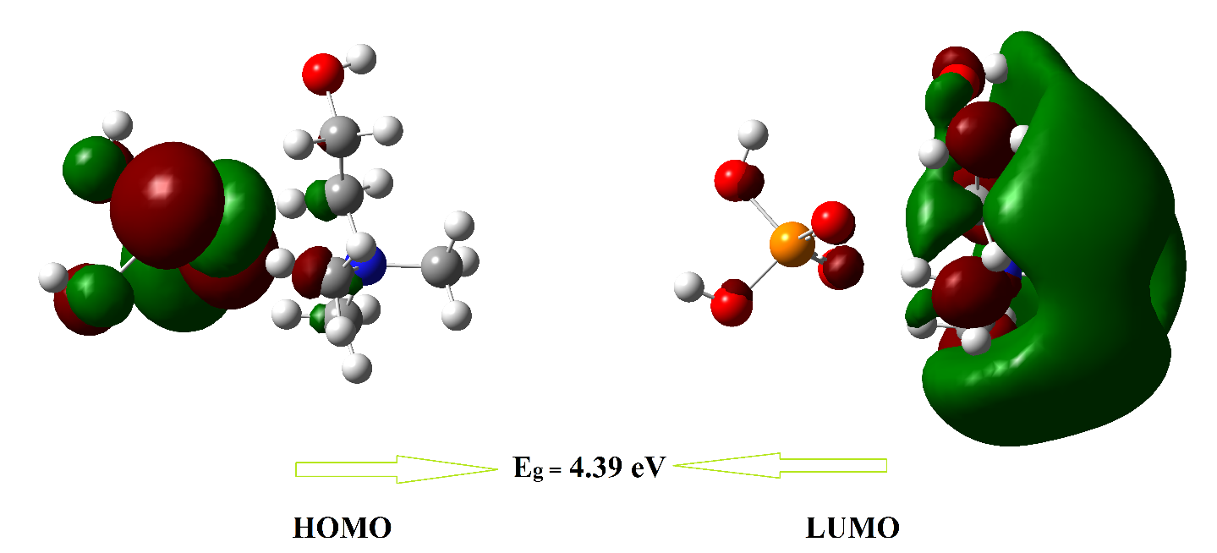

Figure 2S Frontier molecular orbitals analysis of 2-HDETDHP

