Characteristics of Mesoscale Stratospheric Gravity Waves Induced by Tropical Cyclones Resolved by ERA5 Reanalysis

Supplementary Information
This supplement contains six additional figures and one additional table that bolster the analysis presented in the main paper.

Supplementary Table 1. TC intensity category
TC intensity category | Range of 2-min mean maximum sustained wind (m s⁻¹) near the TC center (Vmax)
Smaller than Tropical Depression | Vmax<10.8 m s⁻¹
Tropical Depression (TD) | 10.8 m s⁻¹≤ Vmax ≤ 17.1 m s⁻¹
Tropical Storm (TS) | 17.2 m s⁻¹≤ Vmax ≤24.4 m s⁻¹
Severe Tropical Storm (STS) | 24.5 m s⁻¹≤ Vmax ≤32.6 m s⁻¹
Typhoon (TY) | 32.7 m s⁻¹≤ Vmax ≤41.4 m s⁻¹
Severe Typhoon (STY) | 41.5 m s⁻¹≤ Vmax ≤50.9 m s⁻¹
Super Typhoon (SuperTY) | Vmax ≥51 m s⁻¹
Degeneration

Supplementary Fig. 1| Composite analysis of the MF (10⁻⁴ Pa). TC-SGWI for TC intensity category a TD, b TS, c STS, d TY, e STY, and f SuperTY. Dotted areas have passed the 99% significance test.
Supplementary Fig. 2| As Supplementary Fig. 1, but for MFu

Supplementary Fig. 3| As Supplementary Fig. 1, but for MFv

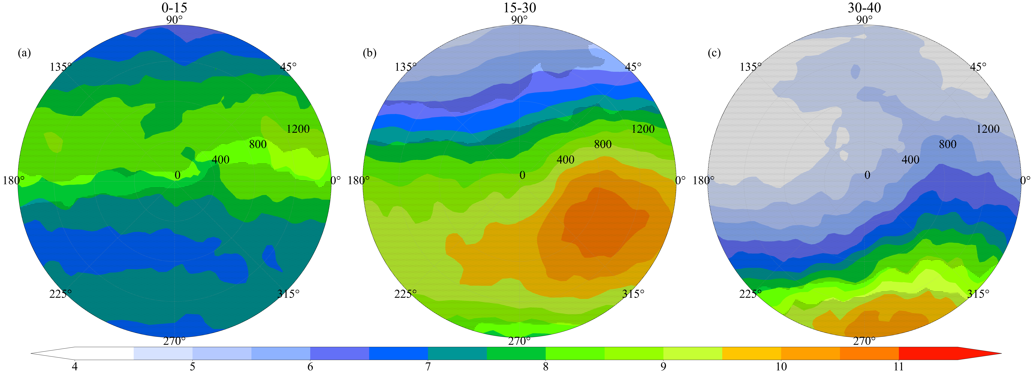
Supplementary Fig. 4| Composite analysis of the MF (10⁻⁴ Pa) for different latitudes of the TC center. The latitude of the TC center is at a 0°N–15°N, b 15°N– 30°N, and c 30°N– 40°N. Dotted areas have passed the 99% significance test.
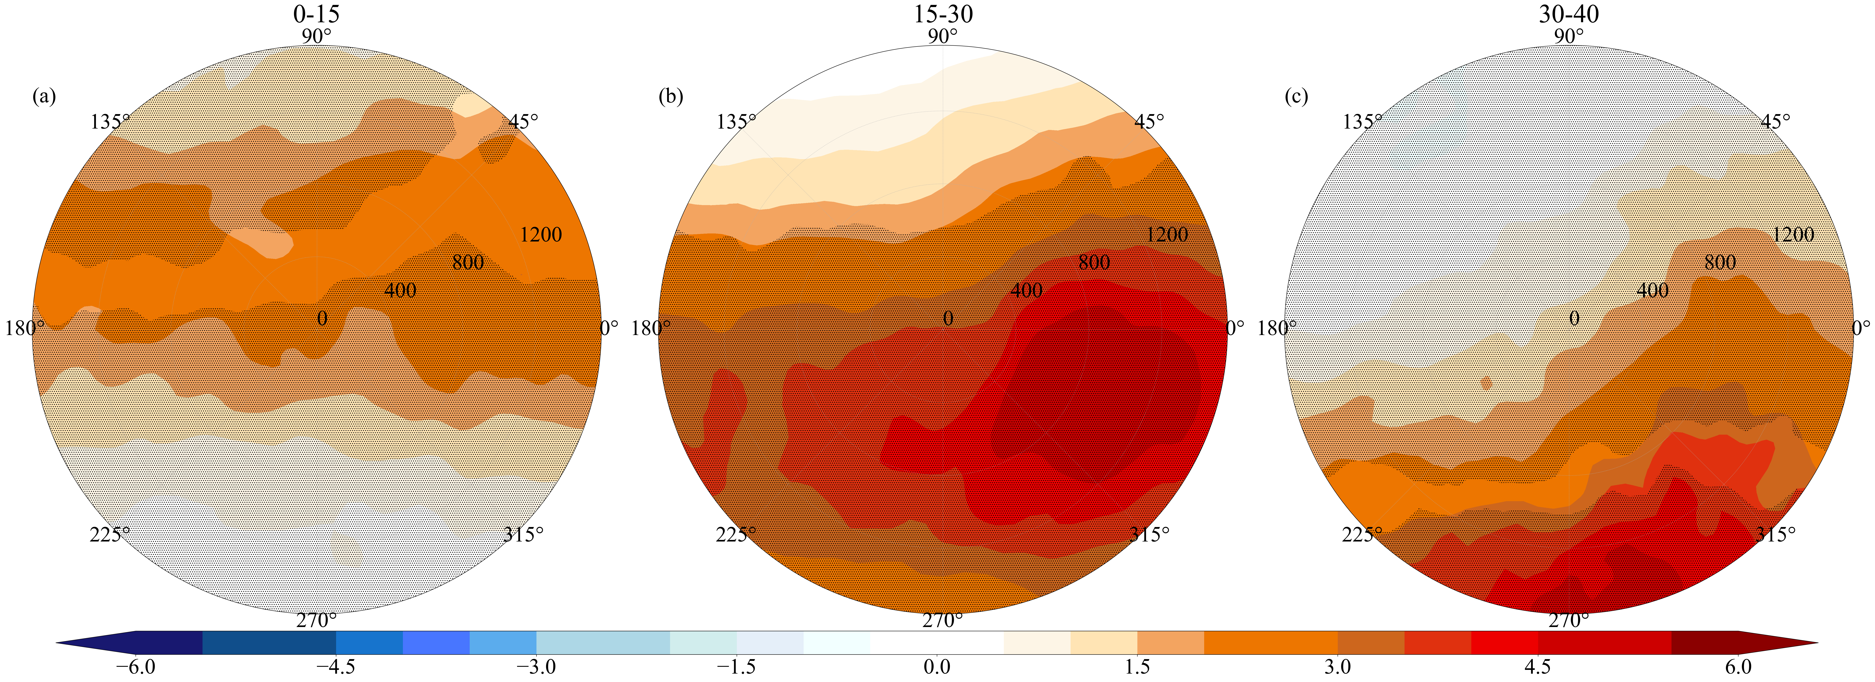
Supplementary Fig. 5| As Supplementary Fig. 4, but for MFu
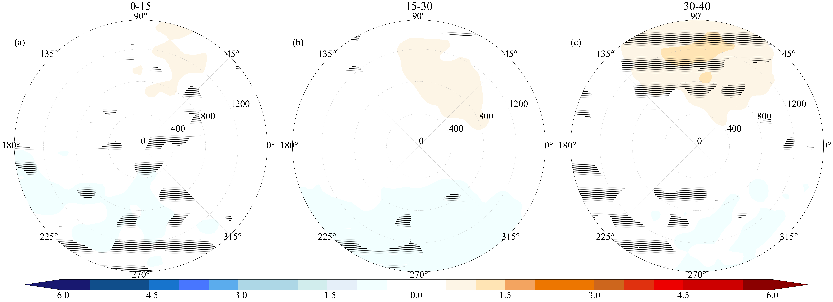
Supplementary Fig. 6| As Supplementary Fig. 4, but for MFv

