Preferential Graphitic-Nitrogen Formation in Pyridine-Extended Graphene Nanoribbons

SUPPORTING INFORMATION

Nicolò Bassi¹†, Xiushang Xu²†, Feifei Xiang¹, Nils Krane¹, Carlo A. Pignedoli¹, Akimitsu Narita²*, Roman Fasel^{1,3}, Pascal Ruffieux¹*
¹ nanotech@surfaces Laboratory, Empa, Swiss Federal Laboratories for Materials Science and Technology, 8600 Dübendorf, Switzerland.
² Organic and Carbon Nanomaterials Unit, Okinawa Institute of Science and Technology Graduate University, Okinawa, Japan.
³ Department of Chemistry, Biochemistry and Pharmaceutical Sciences, University of Bern, 3012 Bern, Switzerland.

* Corresponding author(s). E-mail(s): akimitsu.narita@oist.jp; pascal.ruffieux@empa.ch;
† These authors contributed equally to this work.

Keywords: Graphene nanoribbons, Graphitic-N, Nitrogen substitution, On-surface synthesis, scanning tunneling microscopy

Synthetic procedures
All reactions working with air- or moisture-sensitive compounds were carried out under argon atmosphere using standard Schlenk line techniques. Unless otherwise noted, all starting materials and other chemicals were purchased from commercial sources and used without further purification. 9,9'-Bianthracene-2,2'-diyl bis(trifluoromethanesulfonate) (2) was prepared according to our previously reported procedure⁴⁴.Thin-layer chromatography (TLC) was done on silica gel coated aluminum sheets with F254 indicator and column chromatography separation was performed with silica gel (particle size 0.063-0.200 mm). Nuclear Magnetic Resonance (NMR) spectra were recorded in CD₂Cl₂ using Bruker AVANCE NEO 500 MHz NMR spectrometer. Chemical shifts (δ) were expressed in ppm relative to the residual solvents (CD₂Cl₂, ¹H: 5.32 ppm, ¹³C: 54.00 ppm; CDCl₃, ¹H: 7.26 ppm, ¹³C: 76.00 ppm ). Coupling constants (J) were recorded in Hertz. Abbreviations: s = singlet, d = doublet, t = triplet, q = quartet, m = multiplet. High-resolution mass spectra (HRMS) were recorded on Thermo Scientific LTQ-Orbitrap Mass Spectrometer by electrospray ionization (ESI).

2,2'-bis(4,4,5,5-tetramethyl-1,3,2-dioxaborolan-2-yl)-9,9'-bianthracene （3）
A 50-mL Schlenk tube was charged with 9,9'-bianthracene-2,2'-diyl bis(trifluoromethanesulfonate) (2) (400 mg, 0.615 mmol), bis(pinacolato)diboron (467 mg, 1.84 mmol), potassium acetate (KOAc) (270 mg, 3.00 mmol), [1,1’-bis(diphenylphosphino)ferrcene]dichloropalladium(II) (Pd(dppf)Cl₂) (52.0 mg, 61.5 μmol), and anhydrous dimethylformamide (DMF) (6.0 mL). After degassing by argon bubbling for 15 min, the reaction mixture was heated at 85 °C under argon atmosphere for 16 h. After cooling to a room temperature, the resulting mixture was poured into water (50 mL) and extracted with diethyl ether (10 mL) for three times. The organic phases were combined, washed with brine, dried over MgSO₄, and evaporated. The residue was purified by silica gel column chromatography to give the title compound as light yellow solid (281 mg, 75% yield. ¹H NMR (500 MHz, CDCl₃) δ 8.66 (s, 2H), 8.15 – 8.13 (m, 4H), 7.81 (d, J = 8.5 Hz, 2H), 7.67 (d, J = 1.3 Hz, 2H), 7.44 – 7.35 (m, 2H), 7.08 – 7.02 (m, 2H), 6.97 – 6.81 (m, 2H), 1.16 (d, J = 2.4 Hz, 24H). ¹³C NMR (126 MHz, CDCl₃) δ 134.43, 133.26, 131.62, 131.16, 130.93, 130.37, 128.42, 127.34, 126.54, 126.26, 126.19, 124.55, 82.63, 23.67.HRMS (ESI, Positive): m/z Calcd. For C₄₀H₄₁B₂O₄⁺: 607.3185 [M+H]⁺, found:607.3161.
2,2'-di(pyridin-2-yl)-9,9'-bianthracene (4)
A 30-mL Schlenk tube was charged with compound 3 (30 mg, 49 μmol), 2-bromopyridine (39 mg, 0.25 mmol), Pd(PPh₃)₄ (5.7 mg, 4.9 μmol), K₂CO₃ (2.0 M aqueous solution, 0.5 mL), and tetrahydrofuran (THF) (2.0 mL). After degassing by argon bubbling for 10 min, the reaction mixture was heated at 80 °C under argon atmosphere for 20 h. The resulting mixture was cooled to a room temperature, and then poured into water (20 mL), followed by extraction with CH₂Cl₂ (10 mL) for three times. The organic phases were combined, washed with brine, dried over MgSO₄, and evaporated. The residue was purified by silica gel column chromatography to give the title compound as light yellow solid (16 mg, 66% yield). ¹H NMR (500 MHz, CD₂Cl₂) δ 8.70 (s, 2H), 8.38 – 8.36 (m, 2H), 8.24 (d, J = 9.0 Hz, 2H), 8.16 – 8.08 (m, 4H), 7.64 (dd, J = 1.7, 0.9 Hz, 2H), 7.42 – 7.39 (m, 4H), 7.24 – 7.19 (m, 2H), 7.12 – 7.03 (m, 2H), 7.00 – 6.91 (m, 4H). ¹³C NMR (126 MHz, CD₂Cl₂) δ 156.79, 149.46, 136.90, 136.48, 133.82, 132.08, 131.67, 131.56, 129.30, 128.71, 127.37, 126.62, 126.13, 125.68, 124.54, 122.03, 120.72. HRMS (ESI, Positive): m/z Calcd. For C₃₈H₂₅N₂⁺: 509.2012 [M+H]⁺, found: 509.1996.
10,10'-dibromo-2,2'-di(pyridin-2-yl)-9,9'-bianthracene (1)
A 50-mL Schlenk tube was charged with compound 4 (120 mg, 0.236 mmol), N-bromosuccinimide (NBS) (168 mg, 0.945 mmol), and CH₂Cl₂ (10 mL). The resulting mixture was stirred at room temperature overnight. After quenching with acetone (10 mL), the solvents were evaporated and the residue was purified by silica gel column chromatography to the tittle compound 1 as light yellow solid (141 mg, 90% yield). ¹H NMR (500 MHz, CD₂Cl₂) δ 8.76 (d, J = 9.3 Hz, 2H), 8.67 – 8.64 (m, 2H), 8.42 – 8.39 (m, 2H), 8.26 (dd, J = 9.3, 1.8 Hz, 2H), 7.66 (d, J = 1.7 Hz, 2H), 7.55 – 7.53 (m, 2H), 7.44 – 7.42 (m, 2H), 7.23 – 7.19 (m, 2H), 7.14 – 7.10 (m, 2H), 7.02-6.98 (m, 2H), 6.98 – 6.95 (m, 2H). ¹³C NMR (126 MHz, CD₂Cl₂) δ 173.25, 155.98, 149.57, 137.36, 136.61, 133.94, 132.67, 132.34, 130.90, 130.44, 128.80, 128.15, 127.59, 127.07, 126.64, 126.45, 124.70, 124.03, 122.39, 120.91. HRMS (ESI, Positive): m/z Calcd. For C₃₈H₂₃Br₂N₂⁺: 665.0223 [M+H]⁺, found:665.0209.

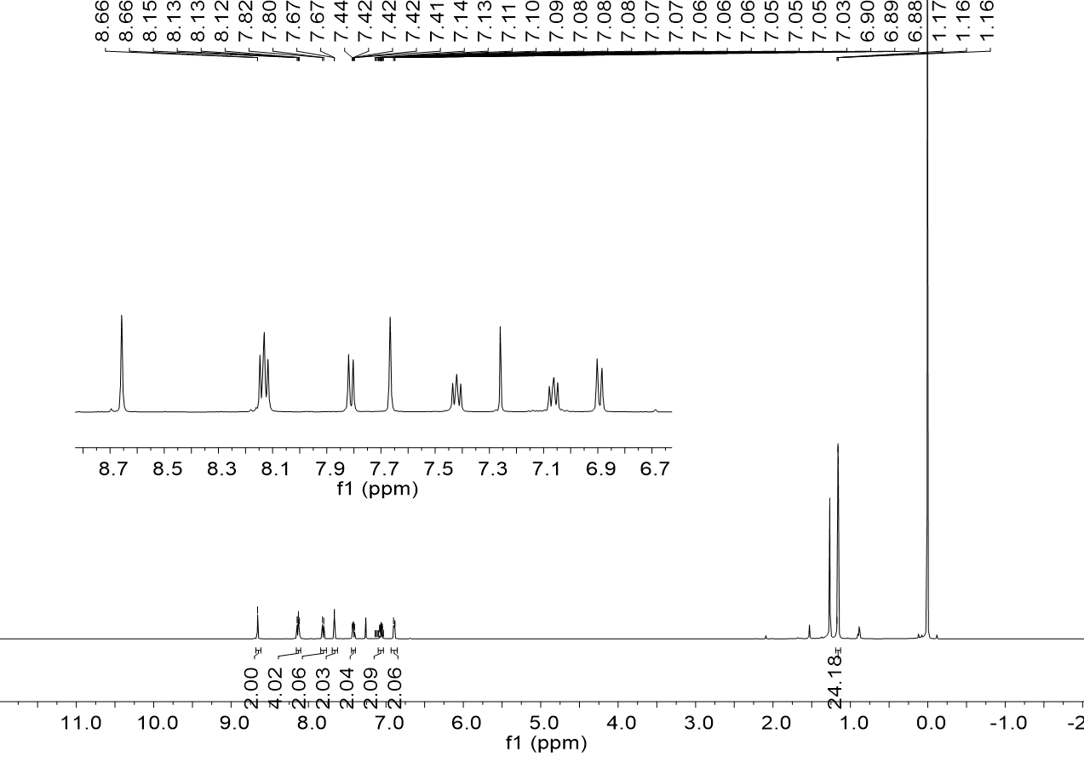
Figure SI 1. ¹H NMR spectrum of compound 3 in CDCl₃ (500 MHz, 298 K).

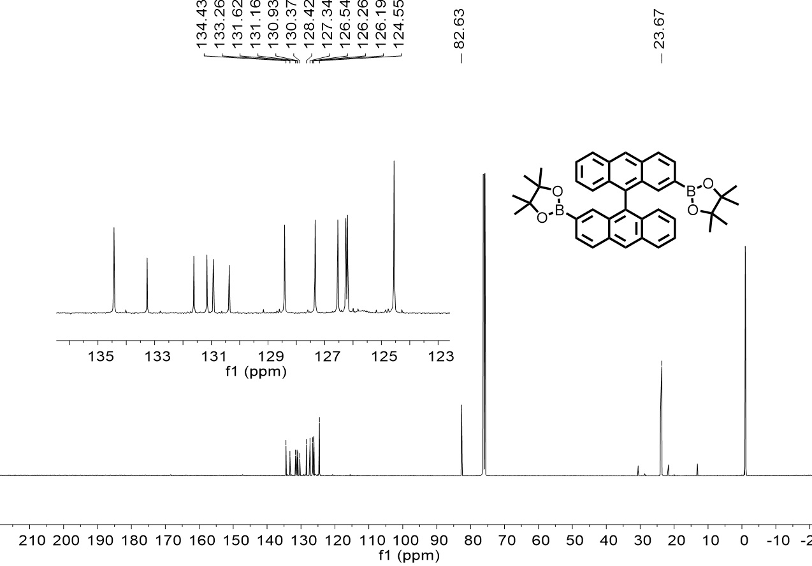
Figure SI 2. ¹³C NMR spectrum of compound 3 in CDCl₃ (126 MHz, 298 K).

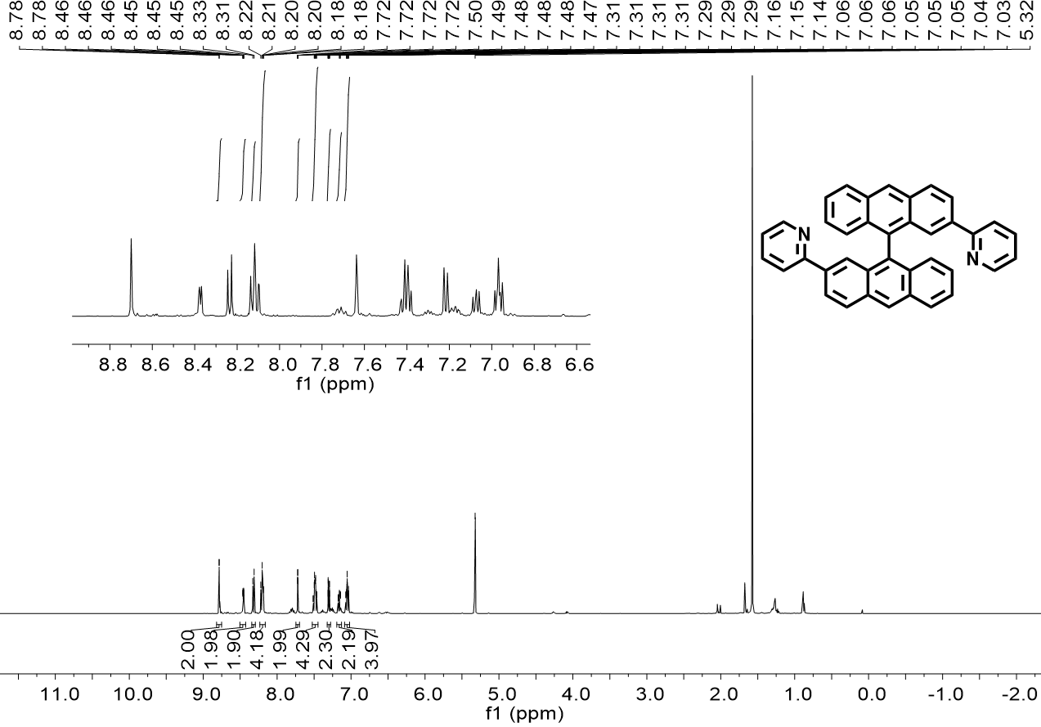
Figure SI 3. ¹H NMR spectrum of compound 4 in CD₂Cl₂ (500 MHz, 298 K).

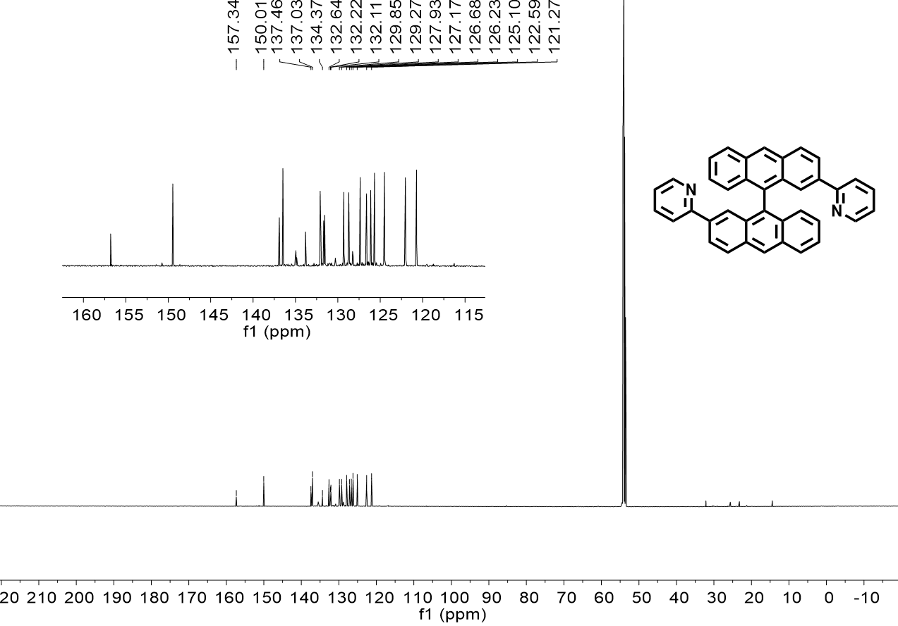
Figure SI 4. ¹³C NMR spectrum of compound 4 in CD₂Cl₂ (126 MHz, 298 K).

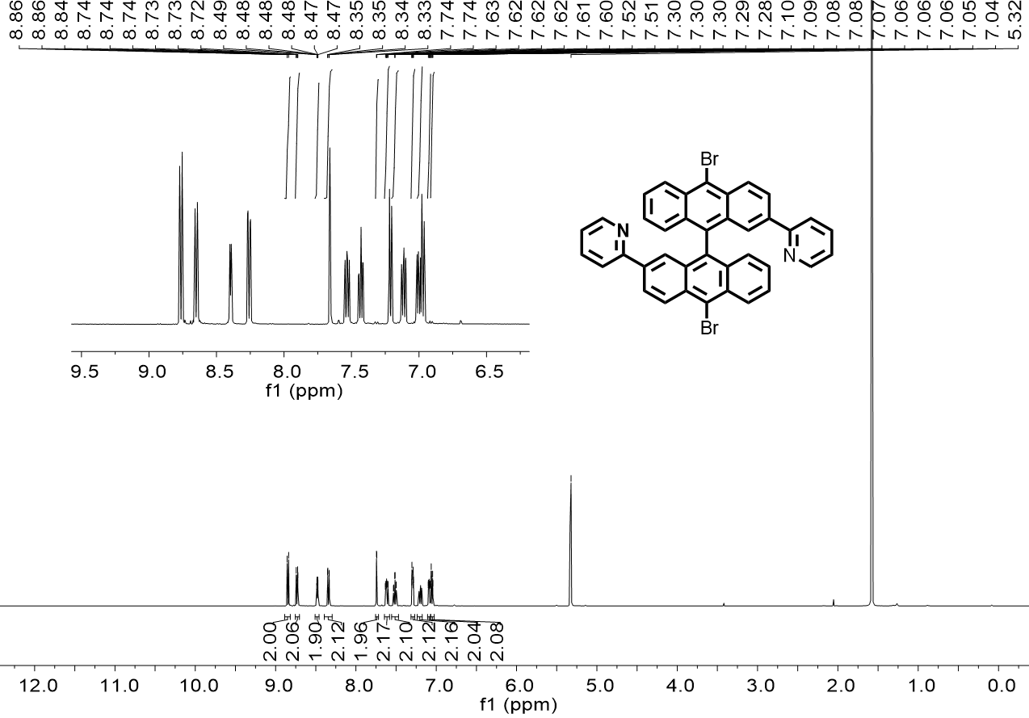
Figure SI 5. ¹H NMR spectrum of compound 1 in CD₂Cl₂ (500 MHz, 298 K).
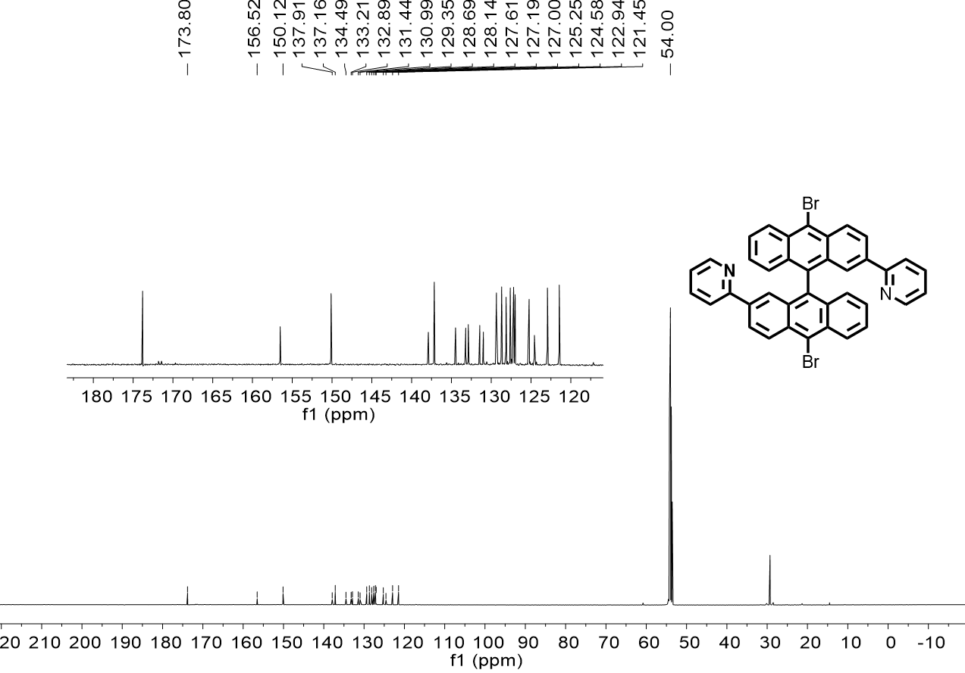
Figure SI 6. ¹³C NMR spectrum of compound 1 in CD₂Cl₂ (126 MHz, 298 K).

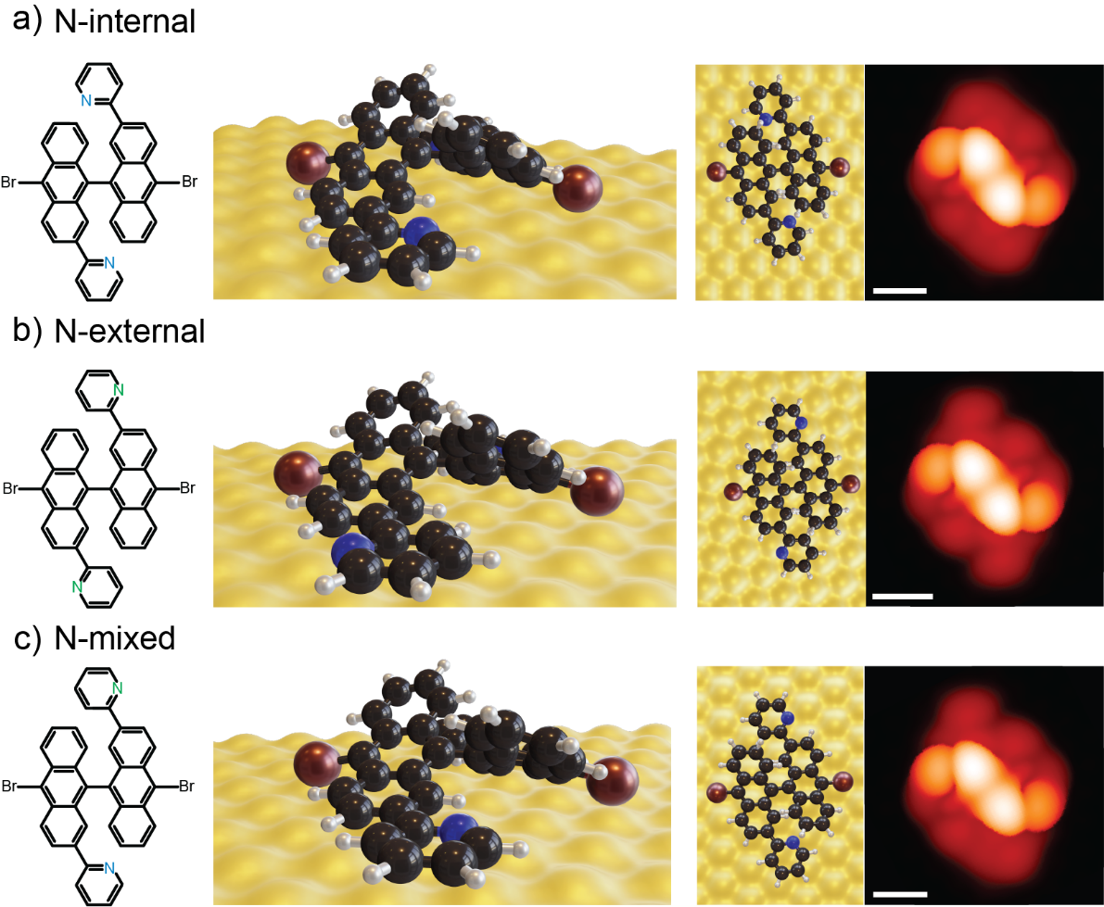
Figure SI 7: DFT-relaxed geometries of DB-DPBA with different pyridyl orientations. a) N atoms pointing towards the bianthracene unit (from left: chemical structure of the pyridyl orientation, DFT-relaxed structure (perspective view), DFT-relaxed structure (top view) and corresponding STM simulation). b) N atoms pointing away from the bianthracene unit (from left: chemical structure of the pyridyl orientation, DFT-relaxed structure (perspective view), DFT-relaxed structure (top view) and corresponding STM simulation). c) N atoms pointing in both directions with respect to the bianthracene unit (from left: chemical structure of the pyridyl orientation, DFT-relaxed structure (perspective view), DFT-relaxed structure (top view) and corresponding STM simulation). The three different configurations are quite similar and difficult to distinguish from STM. Scale bars: 1 nm

Table 1: Structural properties of the three different pyridyl orientations
 | N-internal | N-external | N-mixed
Maximum height (nm) | 0.663 | 0.651 | 0.665
Distance bright dots (nm) | 0.793 | 0.795 | 0.795
Energy (eV)  ΔE | -44312.192  0.113 | -44312.305  0 | -44312.265  0.04
Table summarizing structural parameters of the three different geometries after optimization. DFT relaxed structure are reported in Figure SI 7

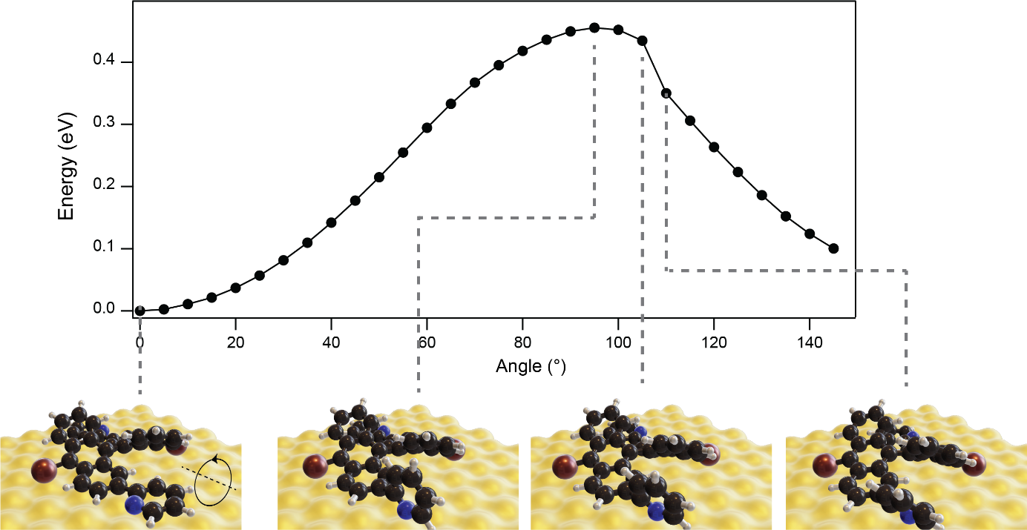
Figure SI 8: Energy barrier for rotation. Energy barrier to flip the pyridyl ring of 180°. The x- axis refers to the dihedral angle of the pyridyl unit (rotation direction reported in the left panel). The energy barrier needed to overcome is 0.45 eV at an angle of 95°. Bottom row: DFT-optimized geometry (perspective view) at significant points.

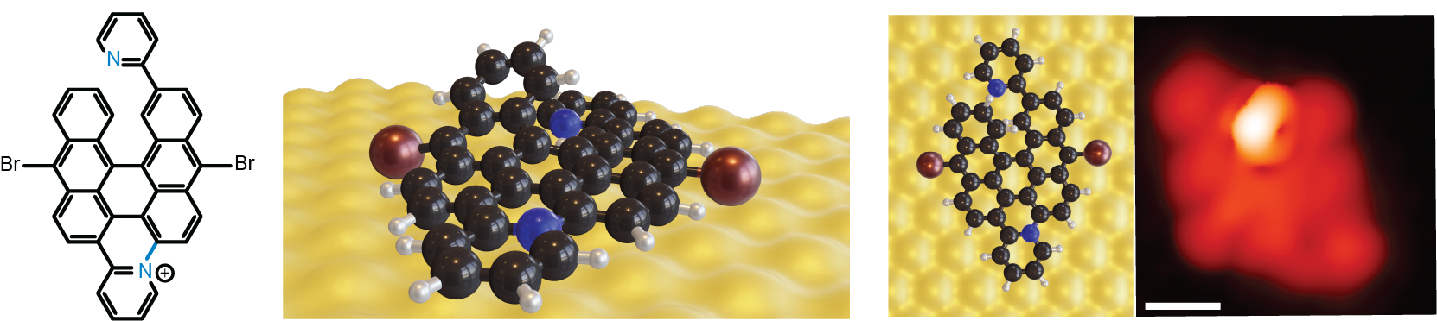
Figure SI 9: Partially planar structure. Partially planar structure after annealing at 250 °C. These agree with our experimental evidences of the sample. From left: chemical structure of the pyridyl orientation, equilibrium geometry obtained by DFT (perspective view), DFT-relaxed structure (top view) and corresponding STM simulation.

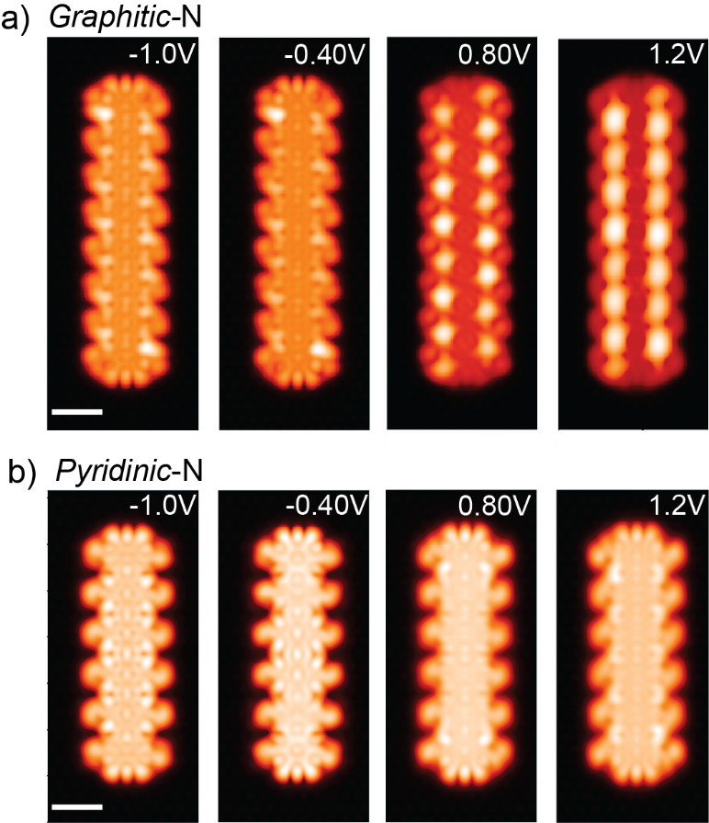
Figure SI 10: STM simulations at selected voltages. STM simulations based on DFT relaxed structures of Py-7-AGNR containing only a) graphitic-N and b) pyridinic-N. The graphitic-N edges appear bent at negative bias (upward on the left edge while downward on the right) and at positive values, there are high intensity states localized at the N positions. The pyridinic-N edges appear, instead, more rounded and symmetric without any signal at positive bias. These simulations match well with our experimental images. Scale bar: 1 nm. The simulated voltages are reported in the inset of each panel.
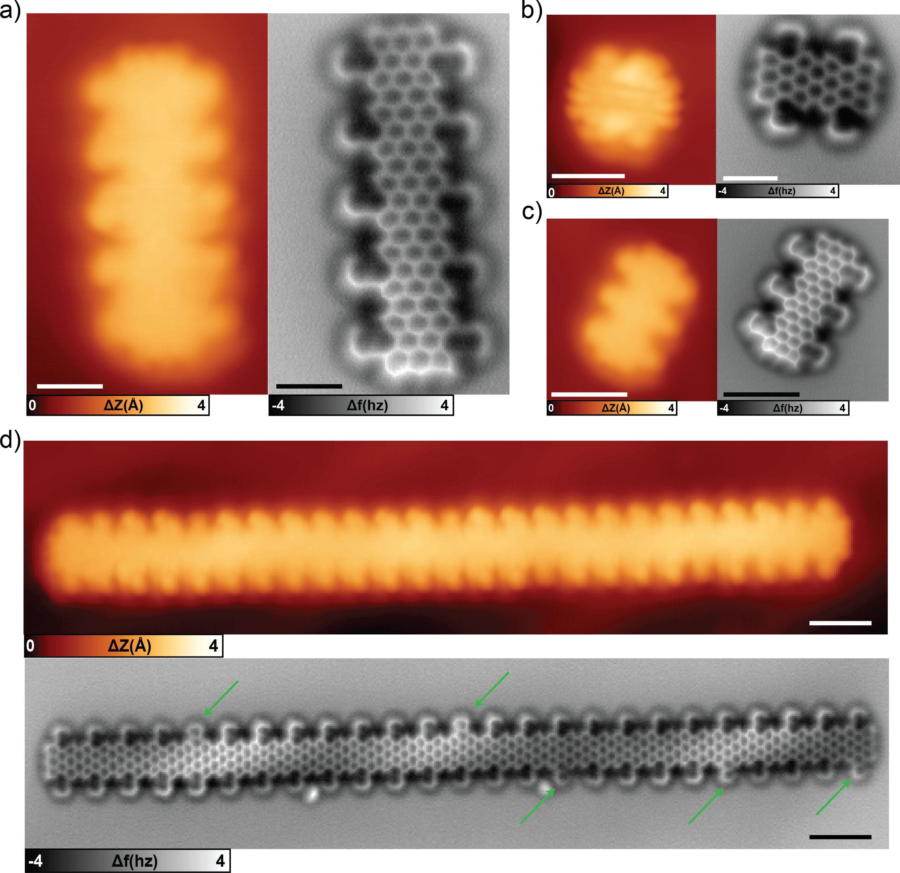
Figure SI 11: STM and nc-AFM images of different nanoribbons. a) pentamer (scale bar 1 nm, scanning parameter:-0.1 V, 100 pA. b) dimer (scale bar 1 nm, scanning parameter:- 0.1 V, 100 pA c) trimer (scale bar 2 nm, scanning parameter:-0.1 V, 100 pA). d) long ribbon (scale bar 2 nm, scanning parameter:-0.7 V, 70 pA). It can be noticed that most of the edge extensions exhibit graphitic-N, except the ones highlighted by green arrows in panel d.
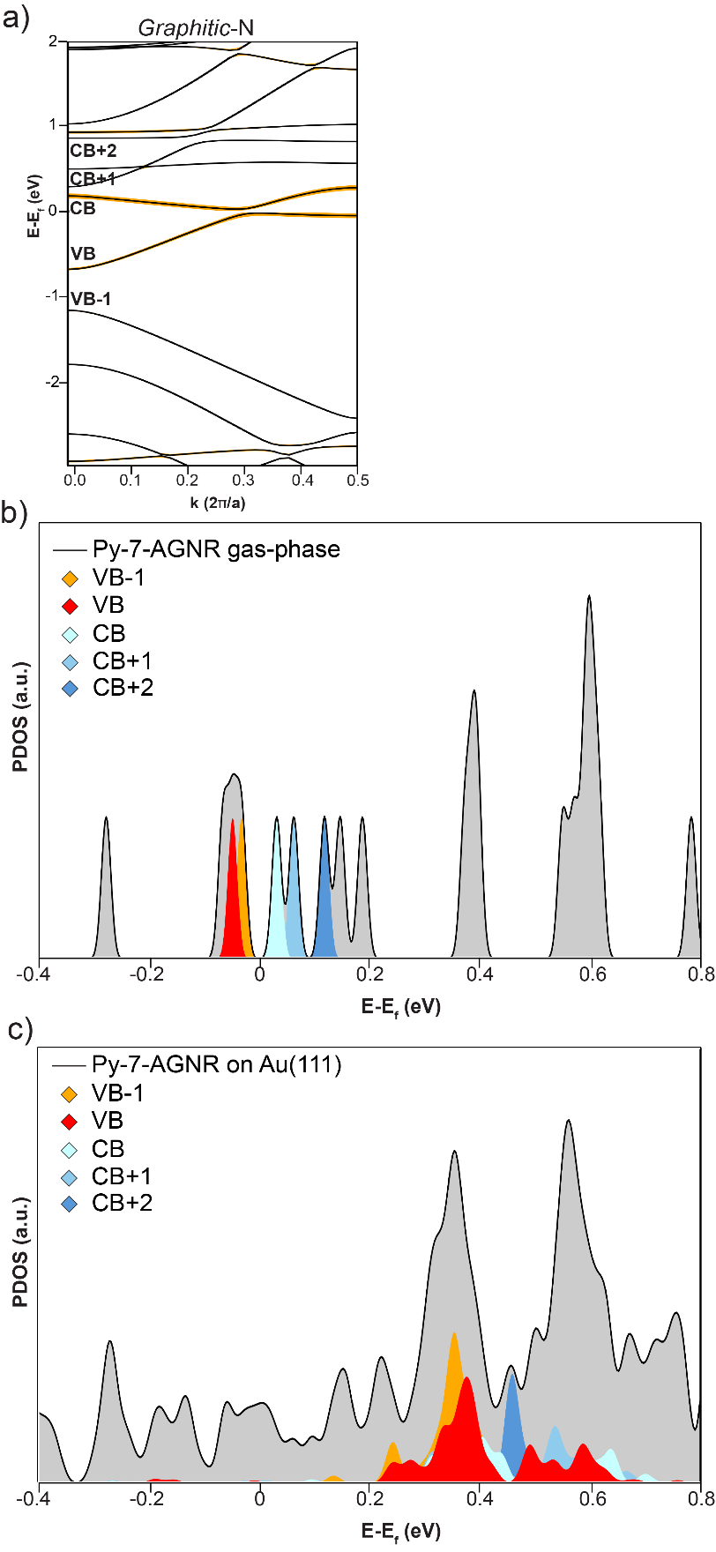
Figure SI 12: PDOS of Py-7-AGNR with graphitic-N on Au(111). a) Band structure of charged-neutral Py-7-AGNR with graphitic-N. Corresponding bands are label in the figure. b) DFT-based simulation of a short segment of Py-7-AGNR with graphitic-N in gas-phase. c) DFT-based simulation of a 8-units segment of Py-7-AGNR with graphitic-N on Au(111). The different levels are reported with different colors. The simulation shows that, upon adsorption on the substrate, VB and VB-1 are shifted to positive energies (unoccupied states), indicating charging.

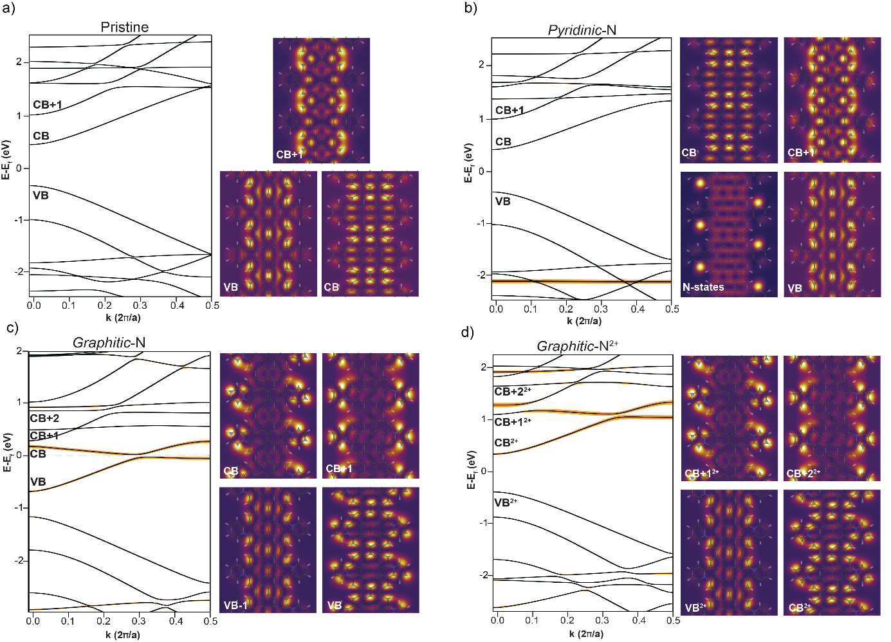
Figure SI 13: Band structure and corresponding PDOS maps of selected bands. Band structures and DOS maps of the frontier energy levels evaluated at the Γ-point of different Py-7-AGNR structures: a) pristine b) pyridinic-N c) graphitic-N and d) graphitic-N²⁺. The corresponding bands are reported in each panel. Pristine and pyridinic-N geometries have very similar properties, with almost the same bandgap. The main effect of the N is a localized state below -2eV. Contrary, the charge-neutral graphitic-N case is different. Thanks to the additional electrons from the N atoms contributed to the π-electron system, the band forming the (empty) CB of the pristine Py-7-AGNR structure is now occupied. This shifts the Fermi level E_{f} and the system has a small gap. Graphitic-N²⁺ was modelled by removing two electrons per unit cell for comparison to the experimental results. This empties the newly occupied level and the band order returns to be very similar to the one of the pristine case, albeit with a slightly smaller band gap

