[Additional Figures]
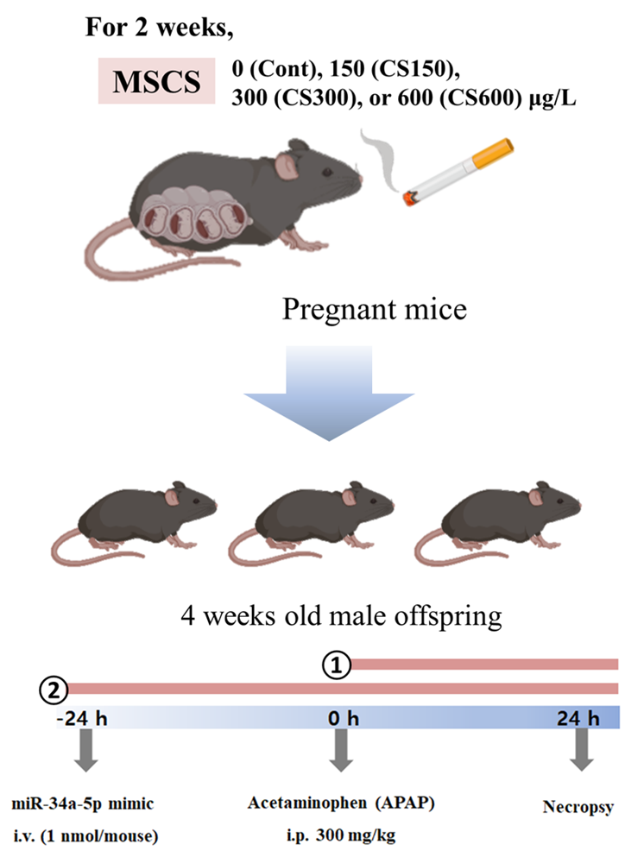
Fig. S1. Overall procedure of experiment.
In the first experiment, pregnant mice were exposed to an indicated concentration of MSCS from day 6 to day 17 of gestation using a nose-only exposure system. Male offspring mice were injected with APAP to induce ALI. In the second study, pregnant mice were exposed to MSCS at 0 or 600 μg/L using the same method. These male offspring mice received either the miR-mock or miR-34a-5p mimic at 24 hours before APAP treatment. Samples were then collected at 24 hours after APAP injection.
A | 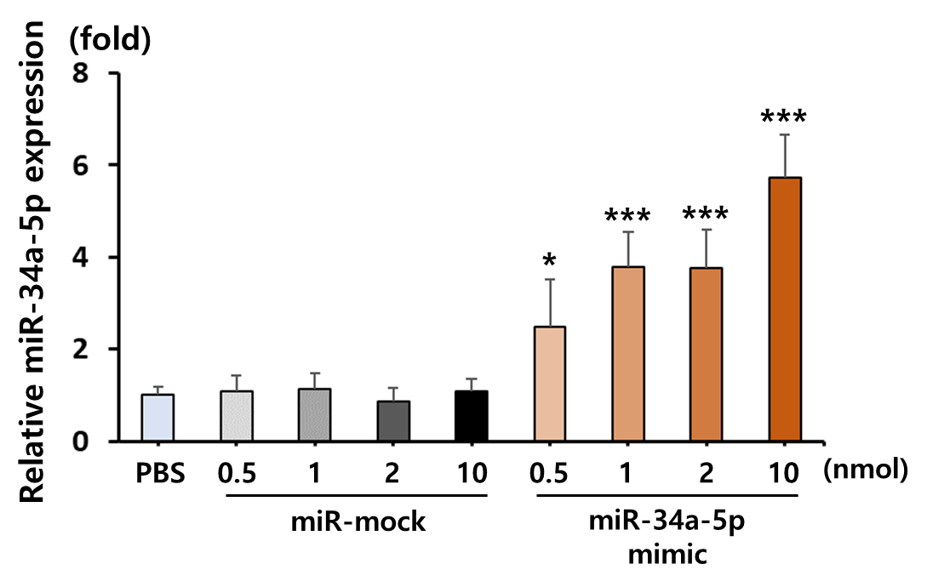
B | 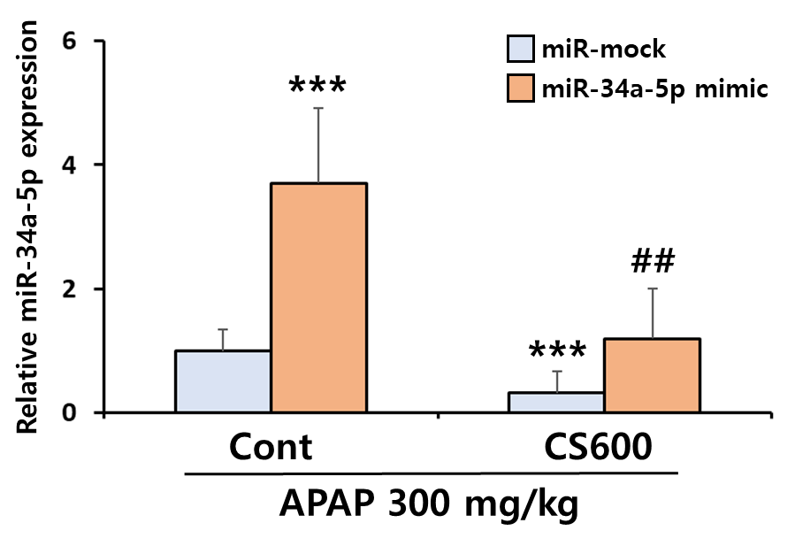
Fig. S2. Relative mRNA expression of miR-34a-5p.
(A) Mice were injected with PBS, miR-mock, or different doses of miR-34a-5p mimic to assess hepatic expression levels of miR-34a-5p. Data are presented as mean ± SD. * p < 0.05, *** p < 0.001 versus the PBS group. (B) After injection of APAP (300 mg/kg) and miR-34a-5p mimic (1 nmol) into offspring mice exposed to prenatal MSCS, levels of miR-34a-5p were determined. Data are presented as mean ± SD. *** p < 0.001 versus the miR-mock group of the Cont group. ## p < 0.01 versus the miR-mock group of the CS600 group.
A | 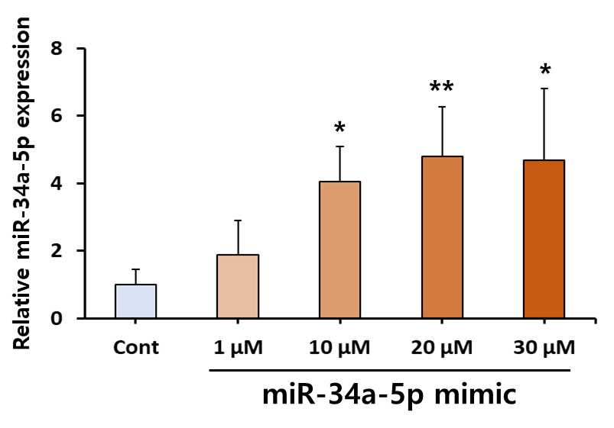
B | 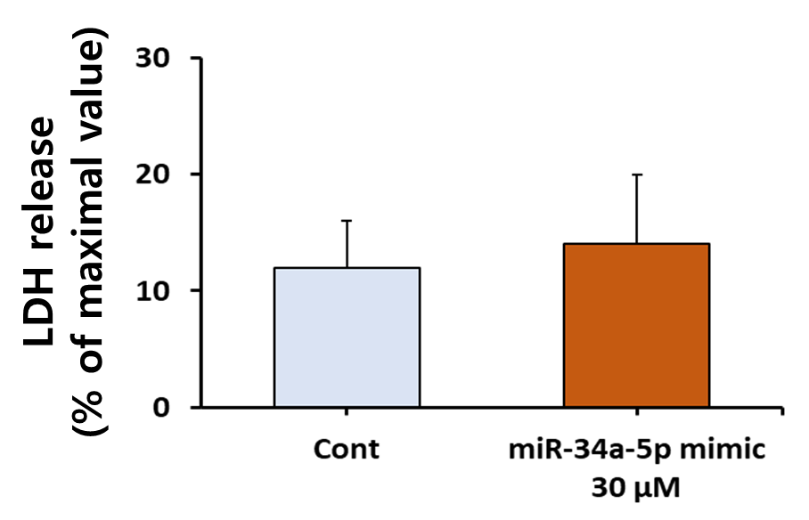
Fig. S3. Expression levels of miR-34a-5p in primary hepatocytes following treatment with miR-34a-5p mimic.
(A) Primary hepatocytes isolated from mice were treated with various concentrations of miR-34a-5p mimics to overexpress miR-34a-5p. Relative miR-34a-5p expression was significantly increased at doses above 10 μM. (B) The maximum dose of 30 μM mimic did not show cytotoxicity in the LDH assay. Data are presented as mean ± SD. * p < 0.05, ** p < 0.01 versus the Cont group.

