Supplementary Material
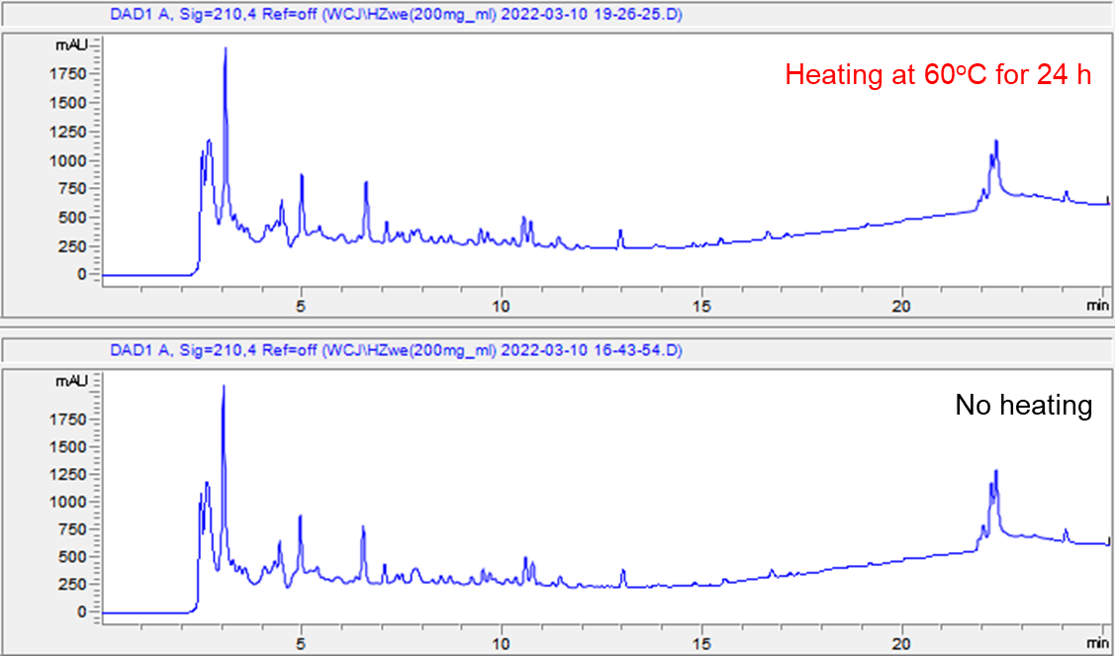
Figure S1. The chemical stability test for JE aqueous solution by HPLC-PDAD-UV analysis

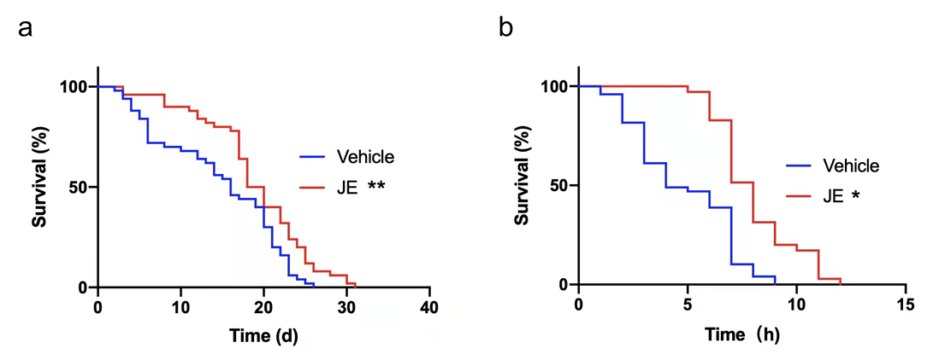
Figure S2. Effect of JE on C. elegans feeding dead OP50. Lifespan of C. elegans treated with 100 μg/mL JE or vehicle, (a) at normal condition (20℃), (b) exposed to 37°C thermal shock. (n = 50). Values are mean ± SE. *P ≤ 0.05, **P ≤ 0.01.
Table S1. Effect of JE on the lifespan of N₂ C. elegans
Group | Number | Mean lifespan (days) | % of control | P value VS Control | Maximum lifespan (days)
Vehicle | 146 | 15.76±3.59 | 100 | —— | 21
JE (20μg/ml) | 149 | 16.18±3.67 | 102.6 | 0.3602 | 21
JE (50μg/ml) | 148 | 17.25±4.77 | 109.4 | 0.0029 | 24
JE (100μg/ml) | 150 | 19.12±5.42 | 121.3 | <0.001 | 27
JE (200μg/ml) | 150 | 17.60±5.30 | 111.6 | <0.001 | 27

Table S2. JE extend the lifespan of N₂ under heat stress
Group | Number | Mean lifespan (hours) | % of control | P value VS Control | Maximum lifespan (hours)
Vehicle | 121 | 7.58±2.90 | 100 | —— | 13
JE (100μg/ml) | 120 | 8.81±5.30 | 116.13 | 0.0014 | 17

Table S3. JE extend the lifespan of N₂ under oxidative stress
Group | Number | Mean lifespan (hours) | % of control | P value VS Control | Maximum lifespan (hours)
Vehicle | 160 | 12.48±2.94 | 100 | —— | 22
JE (100μg/ml) | 139 | 8.81±5.30 | 107.00 | 0.021 | 22

Table S4. JE extend the lifespan of eat-2 mutant C. elegans
Group | Number | Mean lifespan (days) | % of control | P value VS Control | Maximum lifespan (days)
Vehicle | 119 | 15.99±4.82 | 100 | —— | 26
JE (100μg/ml) | 120 | 17.82±5.72 | 111.41 | 0.0080 | 30

Table S5. JE extend the lifespan of hsf-1 mutant C. elegans
Group | Number | Mean lifespan (days) | % of control | P value VS Control | Maximum lifespan (days)
Vehicle | 120 | 11.70±3.56 | 100 | —— | 18
JE (100μg/ml) | 120 | 12.96±4.24 | 110.75 | 0.0145 | 21

Table S6. JE extend the lifespan of hsp16.2 mutant C. elegans
Group | Number | Mean lifespan (days) | % of control | P value VS Control | Maximum lifespan (days)
Vehicle | 120 | 13.55±4.15 | 100 | —— | 21
JE (100μg/ml) | 120 | 14.71±4.73 | 108.55 | 0.0452 | 23

Table S7. JE extend the lifespan of skn-1 mutant C. elegans
Group | Number | Mean lifespan (days) | % of control | P value VS Control | Maximum lifespan (days)
Vehicle | 120 | 12.48±3.97 | 100 | —— | 21
JE (100μg/ml) | 120 | 14.15±4.34 | 113.35 | 0.0018 | 33

Table S8. JE extend the lifespan of daf-2 mutant C. elegans
Group | Number | Mean lifespan (days) | % of control | P value VS Control | Maximum lifespan (days)
Vehicle | 119 | 20.92±6.90 | 100 | —— | 31
JE (100μg/ml) | 120 | 22.83±6.75 | 109.13 | 0.0313 | 33

Table S9. JE extend the lifespan of daf-16 mutant C. elegans
Group | Number | Mean lifespan (days) | % of control | P value VS Control | Maximum lifespan (days)
Vehicle | 120 | 10.98±3.28 | 100 | —— | 19
JE (100μg/ml) | 120 | 10.8±2.62 | 98.41 | 0.6613 | 18

