Additional details for understanding the craftsmanship of Tianche

1 Construction procedures
The construction procedures of the Tianches can be analyzed from macro, meso and micro perspectives respectively.
From the macroscopic perspective, the sequence for constructing the overall structure involves distinct phases. Focusing on the most common quadruple-legged Tianche as an example, the process commences with erecting two main columns (正身, zhengshen). Tianche columns are hollow cylindrical structures composed of circles of logs. This is followed by the installation of the top pulley device, comprising the crown beam (天箍头, tiangutou, a sturdy short beam at the top of the structure) and sky-pulley (天滚子, tiangunzi, a wooden or iron pulley). Subsequently, the remaining two columns, namely supporting column (支杆, zhigan) and assisting column (倒挂, daogua), are constructed. The final step involves adjusting the tension cables (风篾, fengmie).
From the mesoscopic perspective, the column construction represents the most challenging stage. The process is more complicated than simply erecting a circle of foot members (脚子料, jiaoziliao, slender members located at the base of the column) followed by several circles of doll members (娃娃料, spindle-shaped elongated rods).
After placing the initial foot member, known as the "Qingtianzhu" (擎天柱) in the dialect, the first doll member is immediately installed, quickly followed by the second foot member and second and third doll member. Although lacking a fixed formula, the primary goal is to ascend to the column's apex swiftly, placing two doll members at the top and installing one inverted dragon member (倒龙料, daolongliao). This strategic approach facilitates early determination of the overall shape. The members were then methodically assembled from the bottom to the top, creating a cylindrical and hollow column. The assembly process hinges on the expertise and on-site judgment of the Tianche member selection expert (选料师, xuanlaioshi), who determines the sequence and placement of members, which are then hoisted and assembled by the binding craftsmen.
From the microscopic perspective, shaping a column's form is arguably the most technically intricate part of construction. This involves the following five processes:
- Initial draft: We used white palm ropes for X- and O-type binding to secure the relative positions of adjacent members.
- Adjustment: With the integration of more members forming a circle, we applied twisting (绞, jiao) and hammering (捶, chui) techniques to shape the column into a hollow cylinder.
- Refined draft: We bundled a hollow cylinder with white palm ropes and inserted temporary wedges as a preliminary structure.
- Further adjustment: We used techniques such as twisting (绞, jiao), prying (挑, tiao), leveraging (撬, qiao), hammering (捶, chui), chopping (砍, kan), whittling (削, xue), scraping (刮, gua), and sawing (锯, ju) for fine-tuning the members' positions and the column's shape, gradually achieving a hollow cylinder that narrows towards the top and widens at the base.
- Final version: The process culminates in binding with bamboo or steel cables, driving in wooden wedges, and removing white palm ropes, thus solidifying the final structure.
The creation of a doll member (娃娃料) facilitates slanted contacts among all members, allowing for flexible adjustments in positioning and greater tolerance. Coupled with the high tolerance of the binding joints, this enables the construction of relatively precise structures from imprecise logs, resulting in straight and hollow columns gradually tapering towards the top.
Tianche construction requires expertise in binding for assembling logs into a substantial structure.

2 Craftsmanship of mortise and tenon
The mortise and tenon (榫卯, sunmao) techniques used in Tianche construction are relatively straightforward, primarily functioning as auxiliary joints. They primarily consist of half-tenons (半榫, bansun, akin to half lap joint) and straight tenons (直榫, zhisun) (Fig. S3). Half-tenons connect doll members, while straight tenons are used for placing the inverted dragon member (倒龙料, daolongliao). A straight tenon was cut at the top to fit the mortise of the crown beam. For the inverted dragon member of the supporting or assisting columns, the straight tenon fits into the mortise of the assisting beam (扒扒, papa). Smaller Tianche structures also employ half-tenons for the inverted dragon member, overlaid on the assisting beam and bound. This simplified method was adopted for the construction experiments in this study.
Mortise and tenon techniques can also unite timbers into a cohesive entity, particularly in Chinese large woodwork (大木作, damuzuo). The log is processed into diverse standard timbers with tenons and mortises prior to assembly. However, this resource- and labor-intensive construction mode is ill-suited for industrial buildings such as Tianche. Although the mortise and tenon joints offer precision, binding improves error tolerance. Therefore, in situations involving non-standard logs, binding is more adaptable.

3 Durability of Tianche structures
Tianches are distinguished by their considerable durability, with some structures functioning for over a century given proper upkeep. Maintenance, typically conducted annually in spring and summer, includes routine repairs (花捆) annually and comprehensive overhauls (全捆) every two years. Comparing the Dongyuan (东源) Well Tianche's photograph from the "History of Chinese well salt technology" (1987) with its current state (Fig. S4) shows only minor structural alterations, notably some curvature in the columns. This consistency suggests the Tianche might have been erected prior to 1987, affirming its notable considerable durability.
In the field, the author discovered a soft, decayed layer approximately 1 centimeter thick just beneath the column's outer skin. Local craftsmen explain this phenomenon as characteristic of Chinese fir, often described as having a "rotten exterior but a solid core." This observation is supported by several factors: the high salinity environment is inhospitable to insects and microorganisms; the emission of toxic hydrogen sulfide gas from the salt wells acts as an insect repellent; and, crucially, Chinese fir itself possesses inherent properties of decay resistance, termite resistance, and moisture tolerance, as exemplified by its use in structural elements like rafters and roof sheathings in the Forbidden City. Thus, the notion that Tianches can last for over a century is well-grounded in both the material qualities and environmental conditions.

4 Materials sources
Up until the mid-20th century, Tianches were primarily built using Cunninghamia lanceolata logs (commonly known as Chinese fir), bamboo, and some denser hardwoods for wedges.
Fundamentally, the construction of Tianche necessitated only two materials: Chinese fir logs and bamboo cables. A notable example is the Tianche at Dade Well (113.32 m), constructed exclusively from corrosion-resistant Chinese fir. This timber was preferred for its properties of decay and termite resistance, along with being lightweight, making it ideal for main structural components. Bamboo cables, valued for their flexibility and strength, were utilized for binding the columns of the Tianche and for crafting tension cables (风篾). In the 1950s, bamboo cables were gradually replaced by steel cables, with much higher strength.

Chinese Fir
The building of Tianches was heavily reliant on Chinese fir. A typical Tianche of over 20 m in height required more than a hundred logs, and those above 30 m needed three to four hundred logs.[] For large Tianches exceeding 80 m, thousands of Chinese fir logs and tens of thousands of wooden wedges were necessary. Intriguingly, Zigong, the hub of Tianche concentration, did not produce Chinese fir. As recounted by Congyou Liu (刘从友), a famous craftsman in this field, "The Chinese fir used for Tianches was sourced from distant mountains, mainly from Ebian (峨边) and Rongxian (荣县). These logs were transported via water routes through Leshan (乐山), employing specialized timber rafting (Fig. S5). Zigong's salt industry experienced several boom periods – the 1940s' Anti-Japanese war, the 1950s' Great Leap Forward (大跃进), the 1960s' Great Competition (大比武), and the 1970s' salt production surge – leading to the formation of dedicated teams for procuring Tianche materials. When water transport proved insufficient, special trains were deployed for material transportation."
Before the 20th century, Chinese fir for Tianche construction was likely sourced primarily from the mountainous regions of Rongxian (荣县) and Weiyuan County (威远县), located about 40 kilometers west of Zigong. Timbers were then transported via Rongxian River (荣县河) and Weiyuan River (威远河) to the downstream Zigong (Fig. S5). However, in the 20th century, as the scale of Tianche construction expanded, new timber sources were developed in the Emei (峨眉) Mountain area. According to field surveys conducted around Yibin (宜宾) and Leshan, the densely forested mountainous region of Ebian (峨边) County south of Emei Mount is traversed by the Dadu River (大渡河), which later joins the Minjiang River (岷江) in the Leshan. Subsequently, the confluence of the Minjiang and Jinsha rivers (金沙江) occurs in Yibin, forming the Yangtze River, facilitating downstream timber transport. However, Zigong is not situated directly along this waterway, necessitating additional transport of timber upon its arrival at the Yibin. The opening of the Neiyi Railway (内宜铁路) in 1960 enabled the transportation of timber from Yibin to Zigong via rail (Fig. S5).

Bamboo cables
In Zigong's well salt production, the demand for bamboo cables has always been significant, leading to the development of a specialized handicraft industry. This industry includes the harvesting of bamboo, processing of bamboo strips (板篾), and manufacturing of bamboo cables (篾索), encompassing the processes of "Hua (花)－Fang (纺)－Guo (过)." The main production area for bamboo strips is located in the mountainous regions around Machang (马场), Longxingchang (隆兴场), Xianmachang (仙马场), and Xuchang (徐场) in Yibin, contributing about 75% of total output. Additional production is based in Rongxian County, particularly in Lianhuachang (莲花场), Niuweihe (牛尾河), and Wubao Town (五宝镇), accounting for the remaining 25%. The production centers for bamboo cables are Qishudong (漆树凼) and Gaoshengchang (高升场) in Yibin (宜宾), situated 30-45 kilometers from Zigong. Delivery is predominantly done by porters, with the closer routes being completed within a day and the farther ones requiring overnight travel (Fig. S5).
Bamboo cables were essential for brine extraction in salt wells. The used cables, termed "Wei cables (尾索)," were repurposed for binding Tianches due to their denser structure from brine exposure, commanding a market price close to new cables. The Anti-Japanese War period saw increased salt production alongside a decline in steel cables supply, leading to a spike in bamboo cables demand, with monthly outputs reaching around 1 million kilograms.
The Republic of China period marked the beginning of steel cables replacing bamboo cables. However, the complete transition didn't occur until the late 20th century, primarily due to the nascent stage of China's steel industry at that time. During the eight years between 1926 and 1933, the total annual steel production of Chinese steel enterprises barely exceeded 20,000 tons. Additionally, bamboo cables have certain advantages; if they break in the wells, they are easier to crush and retrieve, whereas steel cables are much more difficult to crush and retrieve.

5 Small members vs. large structure
This study aims to bridge this gap by translating traditional terms into contemporary engineering languages (Table 1). It also provides a detailed diagram of a typical quadruple-legged Tianche structure and its members (Fig. 9). Despite only focusing on a medium-sized Tianche, this diagram vividly illustrates the contrast between the small individual members and the large overall structure.

Small members
The construction of a Tianche requires approximately ten types of timber members, as outlined in Table 1. Among these, doll member (娃娃料), foot member (脚子料, and inverted dragon member (倒龙料) are particularly crucial. The foot members form the base, and the inverted dragon member is positioned at the apex of the column; both typically exceed 10m in length. All structural elements between several foot members and one inverted dragon member are doll members. Additionally, a few infill members (填箱料), made from offcuts, are employed to fill gaps or voids within the structure rather than provide structural support.
Doll members constitute innovative and crucial components in constructing Tianche and play an instrumental role in transmitting frictional forces. These spindle-shaped rods, characterized by their elongated form with a thick middle tapering towards the ends, vary in length (from approximately 10 to over 20 m) and diameter (from approximately 10 to more than 20 cm). The manufacturing process involved shaping half-tenons at the broader ends of two Chinese fir. Subsequently, these logs are conjoined, the joint secured with ropes, and the structural integrity enhanced by hammering in two to three wooden dowels (木销钉). This sequence of operations effectively harnesses the natural shape of Cunninghamia lanceolata to assemble larger and structurally pivotal members.
All structural members are made from debarked Cunninghamia lanceolata, with lengths ranging from several meters to over 10 m and diameters extending from slightly over 10 to more than 20 cm. Although these dimensions are substantial compared to a worker's stature, they appear relatively small when juxtaposed with columns, which can reach heights exceeding 100 m and diameters of approximately 2 m. The construction of a large Tianche requires approximately 2400 logs and 32,000 wooden wedges[]. Interestingly, each log constitutes a mere 0.04% of the total structural volume, underscoring individual members' relative smallness in contrast to the overall structure.

Large structure
The three main members were assembled into multiple columns interconnected by horizontal bracing members to form a tower structure. The horizontal bracing members, varying based on their positions, predominantly consist of transverse X-bracing (横穿), longitudinal X-bracing (顺穿), V-bracing (剪) set at specific angles, and secondary beams (扒扒) of supporting and assisting columns (Fig. 9). Additionally, the Tianche is stabilized by several taut bamboo or steel cables; one end is attached to the crown beam (天箍头), and the other is anchored to ground-based rocks. The cables maintained their tension while the columns were compressed. Notably, the Tianche exhibits characteristics of tower and mast structures, as recognized in contemporary structures.
The dimensions of the Tianche structures were notably impressive. For instance, the Dade Well Tianche reached a height of 113.32 m, comparable to that of a 30-story building. According to technical data from the Jiuda Salt Factory (久大盐厂), the main columns (正身) of Tianche, standing 100 m high, have a base width of 14 m; the distance from the bottom of the supporting column to the assisting column spans 25.5 m. The ground area the structure covers is approximately 300 m², reflecting its large scale.
Utilizing numerous small logs to erect large structures, this construction approach exemplifies the technical strategy of "strive for large with small." Because tower and mast structures have been prevalent since ancient times, assembling a tower-mast structure with columns as the fundamental units is straightforward. The primary challenge is assembling columns exceeding 100 m in height using logs.
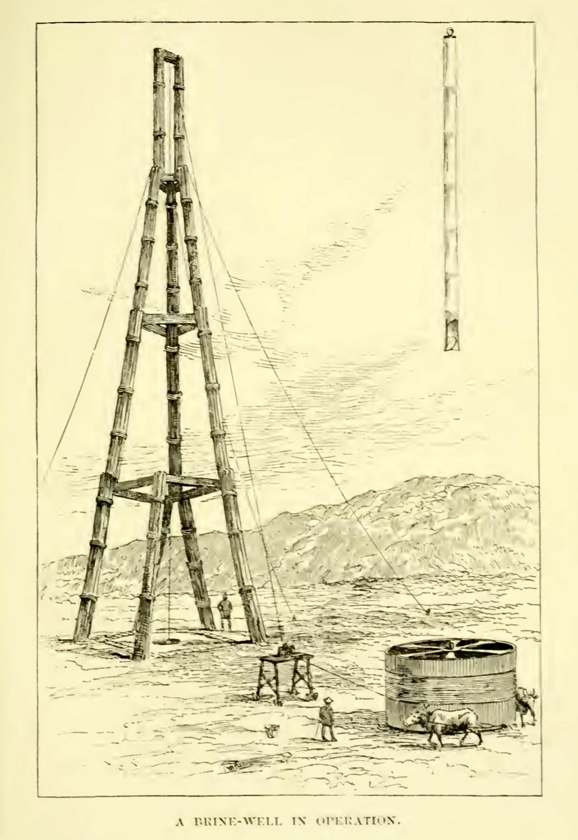
Figure S1 In 1888, American missionary Virgil Chittenden Hart sketched a Tianche structure. Sources: Western China: a Journey to the great Buddhist centre of Mount Omei.

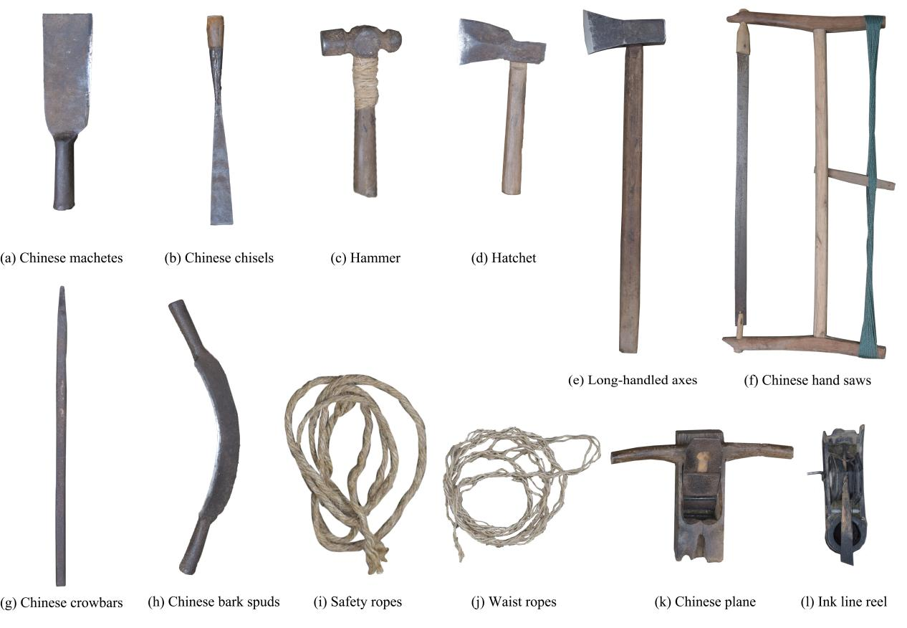
Figure S2 Traditional tools for Tianche craftsmanship. Sources: the authors.

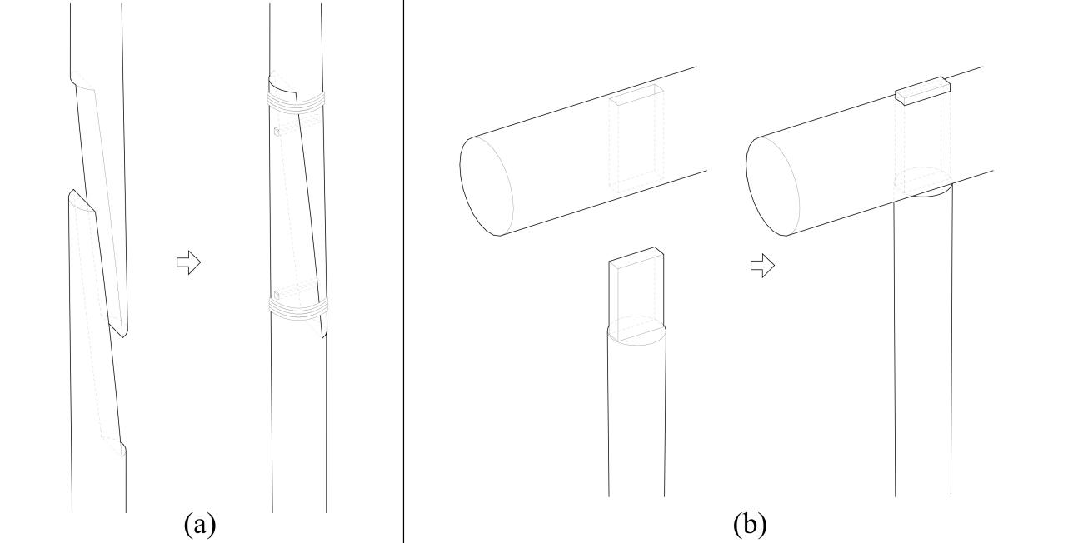
Figure S3 Craftsmanship of mortise and tenon of Tianche, (a) Half tenons; (b) Straight tenons. Sources: the authors.
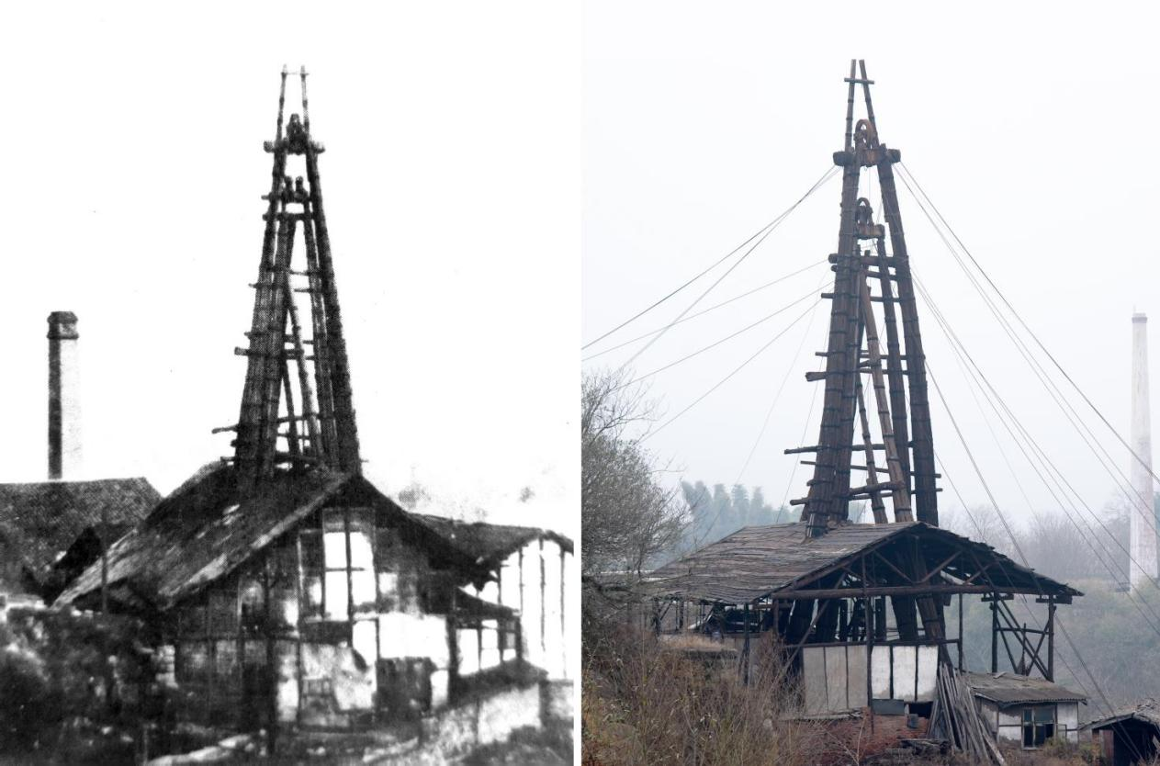
Figure S4 Comparison of historical photos of the Dongyuan Well Tianche before 1987 with its current state. Sources: the authors.

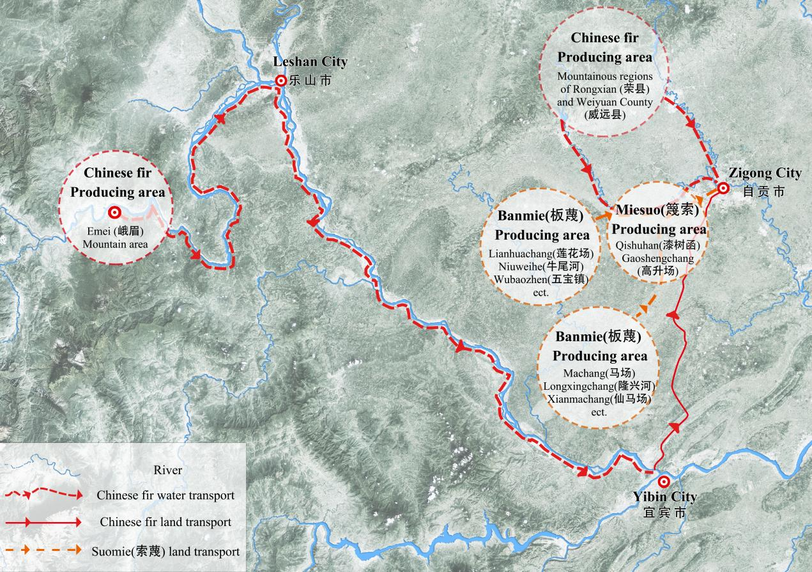
Figure S5 Sources of main building materials for Tianche. Sources: the authors.

[] Lin YX, Song LX, Zhong CY, Ma ZY, Chen R, Nie CX. History of Chinese well salt technology. Chengdu: Sichuan Science and Technology Press;1987. p. 316.
[] Lin YX, et al. History of Chinese well salt technology. Chengdu: Sichuan Science and Technology Press;1987.

