Supporting Information
Intrinsic single-layer multiferroics in transition-metal-decorated chromium trihalides
Meng Liu,¹ Shuyi He,¹ Hongyan Ji,¹ Jingda Guo,¹ Zhaotan Jiang,² and Jia-Tao Sun^{1,*}, Hong-Jun Gao²
¹ School of Integrated Circuits and Electronics, MIIT Key Laboratory for Low-Dimensional Quantum Structure and Devices, Beijing Institute of Technology, Beijing 100081, China.
² School of Physics, Beijing Institute of Technology, Beijing 100081, China.
³ Beijing National Center for Condensed Matter Physics and Institute of Physics, Chinese Academy of Sciences, Beijing 100190, China.

- Calculation methods
Spin-polarized density-functional theory (DFT) first-principles calculations were carried out with the Vienna ab initio simulation package (VASP).^{1, 2} The projector augmented wave method was employer to describe the interaction between the core and valence electrons.³ The Perdew, Burke, and Emzerhof parameterized gradient approximation is chosen to describe the exchange-correction functional.⁴ The climbing image nudged elastic band (CI-NEB) method is used to calculate the energy barriers of transition states.⁵ In addition, for all the calculations, the cutoff energy for the basis set is chosen to be 500 eV. All geometric structures are fully relaxed until the force on each atom is less than 0.001 eV/Å, and the convergence criterion is 10⁻⁶ eV for energy. A vacuum space of 20 Å along the z direction was adopted to avoid spurious interactions between adjacent layers. The k-points sampling was performed with Monkhorst-Pack grids of 12 × 12 × 1. The on-site effective Hubbard interaction U was taken to be 0.5 eV in considering the electron correlation of 3d electrons of Cr atoms. Phonon dispersion relations are then acquired employing the PHONOPY code⁶ with the finite displacement approach and the adapted 3 × 3 × 1 supercell is large enough to evaluate the dynamical stability. Then, we chose the Heisenberg model to simulate the Curie temperature of our systems based on the Monte Carlo simulation. The software package developed by Zhang et al.,⁷ and the 70 × 70 × 1 lattice is used in the Monte Carlo simulation.
The calculation of the electron transport properties is implemented by Quantum Atomistix ToolKit (ATK) package,⁸ which is based on the DFT and the non-equilibrium Green's function. The spin-polarized generalized gradient approximation (SGGA) with the parametrization of Perdew-Burke-Ernzerhof (PBE), the cut-off energy of 310 Ry and a basis set of double-zeta polarized (DZP) are used. A vacuum slab of 15 Å is added between the nearest neighboring layers to eliminate their coupling. The Monkhorst-Pack k-mesh is chosen to be 1 × 5 × 150. Using the non-equilibrium Green's function formalism, the transmission coefficient T(E) is calculated as⁹
$$\text{T}\left(\text{E}\right)\text{= }{\text{T}}_{\text{r}}\left[{}_{\text{L}}{\text{G}}^{}{}_{\text{R}}{\text{G}}^{\text{a}}\right]\text{,}$$
where ${\text{G}}^{\text{r(a)}}$ is the retarded (advanced) Green's function, and ${\text{Γ}}_{\text{L}}\left({\text{Γ}}_{\text{R}}\right)$ is the coupling of the central region to the left (right) lead. And the current is calculated by the Landauer-Büttiker formula, which is written as¹⁰
$$\text{I}\left(\text{V}\right)\text{= }\frac{\text{2e}}{\text{h}}\int_{\text{-}\text{∞}}^{\text{∞}}{\text{T}\left(\text{E}\right)\left[\text{f}\left(\text{E - }{\text{μ}}_{\text{L}}\right)\text{-f}\left(\text{E - }{\text{μ}}_{\text{R}}\right)\right]\text{dE}\text{,}}$$
where $\text{f}\left(\text{E-}{\text{μ}}_{\text{L(R)}}\right)$ is the Fermi-Dirac distribution function of the left (right) electrode, where $μ_{L(R)}$ is the electrochemical potential of left (right) electrode.

- How to generate the 2D M(CrX₃)₂ family
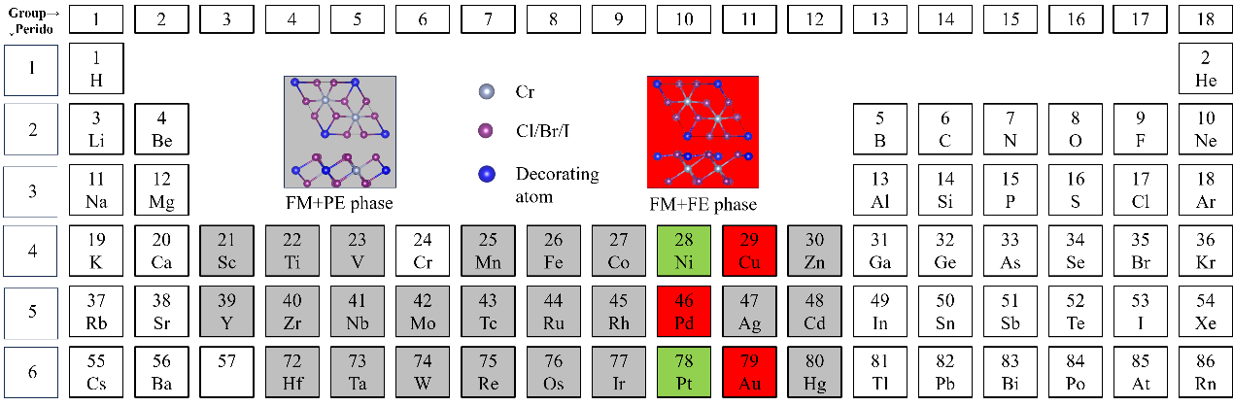
Figure S1. Diagram of periodic table of elements. 28 transition metal elements were used to decorate CrX₃. The elements highlighted in gray indicate that their trihalides will form a paraelectric phase, the elements highlighted in green indicate that some of their trihalides will form a ferroelectric phase, while the elements highlighted in red indicate that both of their trihalides will form a ferroelectric phase.
Based on first-principles calculations, we decorated 28 transition metal elements into trihalides and obtained 12 single-layer multiferroics materials with out of plane ferroelectric polarization as shown in the Figure S1 and TABLE S1.
TABLE S1. The adopted elements for M(CrX₃)₂ (M is transition metal elements, X = (Cl/Br/I)).
Trihalides | Singler-layer Multiferroics
CrCl₃ | Cu(CrCl₃)₂, Pd(CrCl₃)₂, Pt(CrCl₃)₂, Au(CrCl₃)₂
CrBr₃ | Cu(CrBr₃)₂, Pd(CrBr₃)₂, Pt(CrBr₃)₂, Au(CrBr₃)₂, Ni(CrBr₃)₂
CrI₃ | Cu(CrI₃)₂, Pd(CrI₃)₂, Au(CrI₃)₂

- The geometric structure of Cu(CrX₃)₂
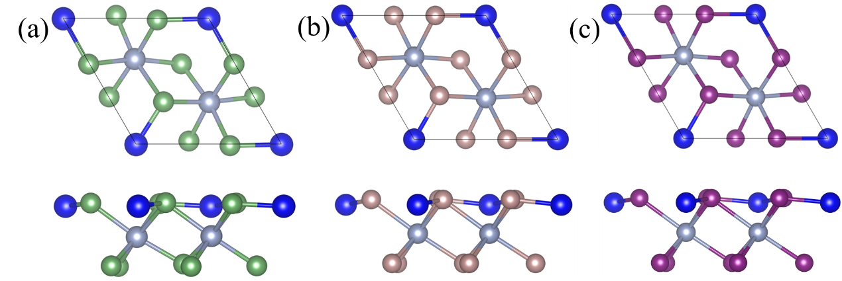
Figure S2. Atomic structure of monolayer Cu(CrCl₃)₂ (a), Cu(CrBr₃)₂ (b) and Cu(CrI₃)₂(c).

- The phonon spectrum of Cu(CrX₃)₂
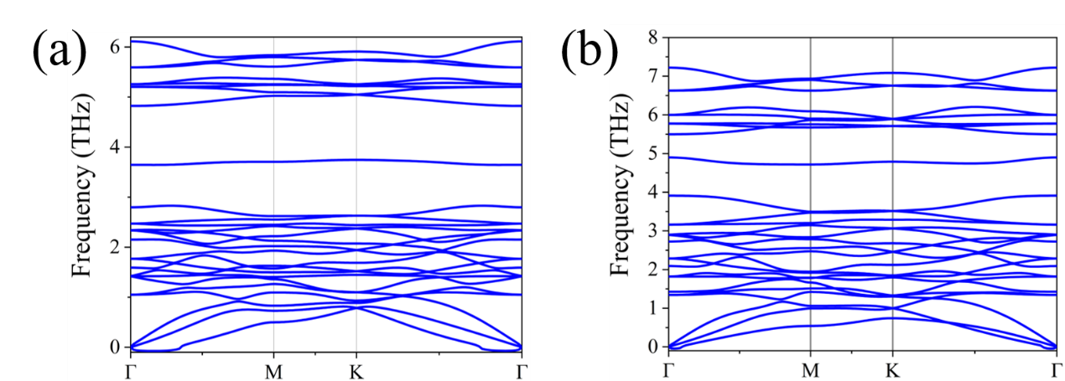
Figure S3. The phonon spectrum of monolayer Cu(CrBr₃)₂ (a) and Cu(CrI₃)₂ (b).
- The formation energies of Cu(CrX₃)₂
The thermodynamic stability is examined by the formation energy (E_{f}), which represents the energy released during the formation of a compound from the corresponding simple substances. Here, E_{f} can be calculated by the expression
$${\text{E}}_{\text{f}}\text{=}\frac{{\text{E}}_{\text{Cu(Cr}{\text{X}}_{\text{3}}{\text{)}}_{\text{2}}\text{-}}{\text{E}}_{\text{Cu}}\text{-}{\text{E}}_{\text{(}{\text{CrX}}_{\text{3}}{\text{)}}_{\text{2}}}}{\text{9}}$$
Where $E_{Cu(CrX)_{2}}$, $E_{M}$ and $E_{(CrX_{3})_{2}}$ represent the total energies of Cu(CrX₃)₂ per unit cell, simple substance Cu per atom and monolayer CrX₃, respectively. According to the above definition, E_{f} < 0 implies that the process of forming the compound Cu(CrX₃)₂ from simple substance Cu and monolayer CrX₃ is exothermic, whereas a more negative E_{f} indicates greater thermodynamic stability. As listed in Table S2, the formation energies of Cu(CrCl₃)₂, Cu(CrBr₃)₂ and Cu(CrI₃)₂ are negative, indicating that they are very likely to be synthesized. These three materials are therefore highly expected to be synthesized experimentally in the future since they not only have strong dynamic stability but also show good thermodynamic stability.

- The tetrahedral crystal field in ferroelectric phase and the octahedral crystal field in paraelectric phase.
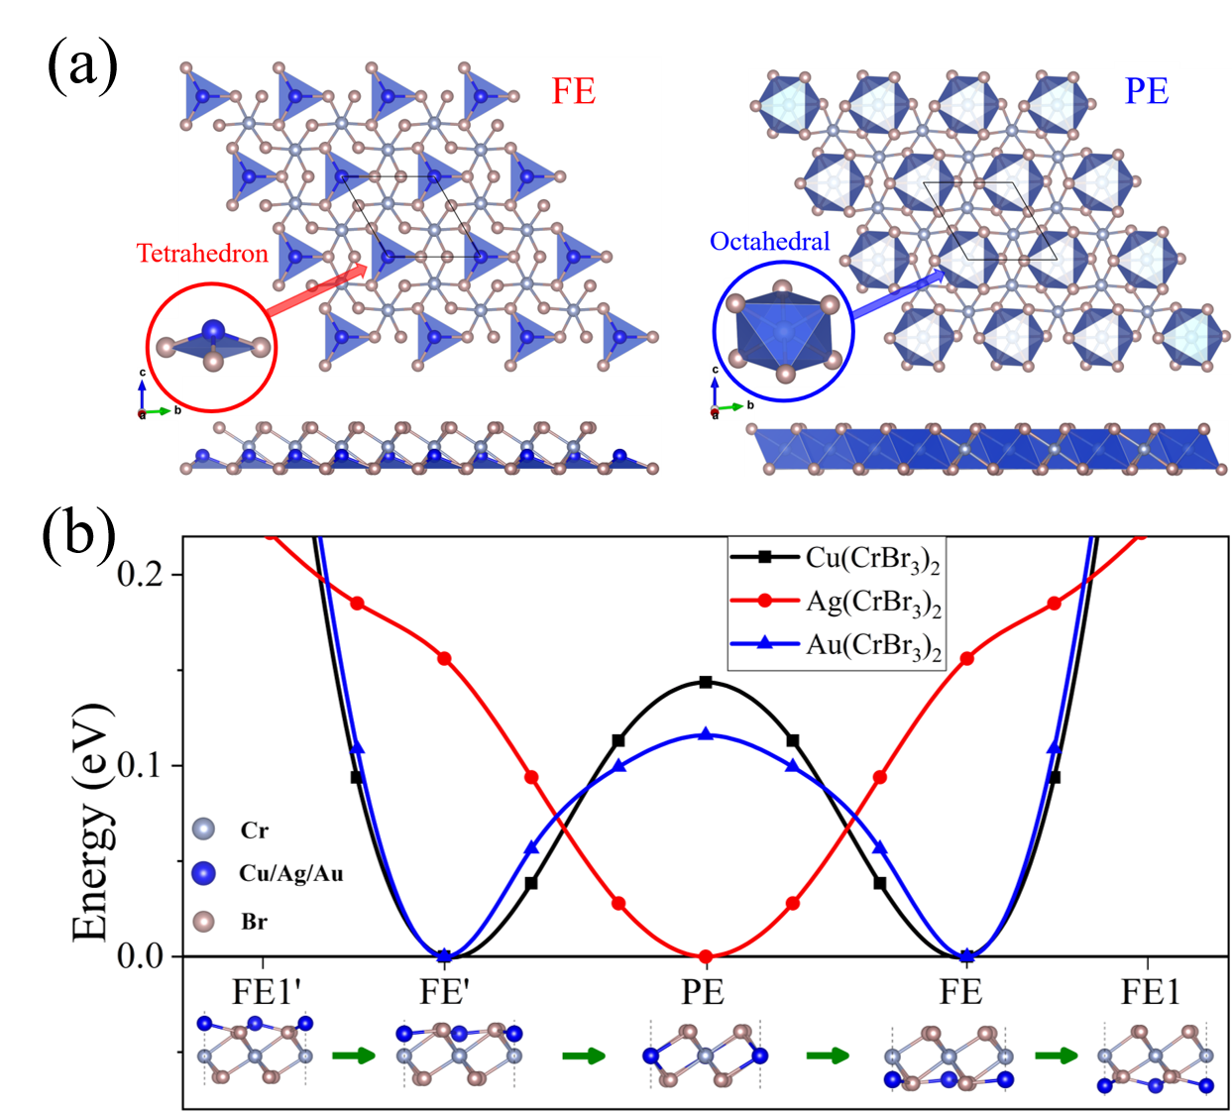
Figure S4. (a) In the ferroelectric phase (FE), the doping atoms form a tetrahedral structure with three Br atoms. In the paraelectric phase (PE), the doping atoms form an octahedral structure with six Br atoms. (b) Ferroelectric switching energy curves of single-layer CrBr₃ doped with Cu, Ag and Au respectively.
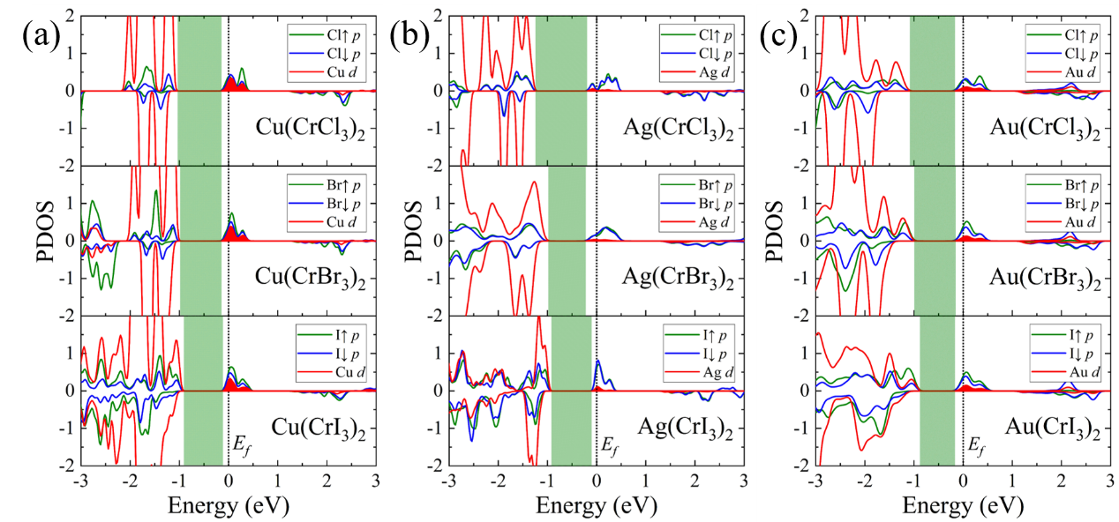
Figure S5. The projected density of states (PDOS) for (c) M(CrX₃)₂ (M = Cu/Ag/Au, X = Cl/Br/I) monolayer calculated by DFT+U method. The X↑ and X↓ represent the upper and lower surfaces X atoms, respectively. For the FE phase, the X↓ atoms are close to M atoms. Compared with Cu and Au, the contribution of Ag d orbital at the Fermi level (E_{f}) is almost zero (We mark the contribution of the M d orbital at the Fermi level in red.).
TABLE S2. The crystal field energy splitting (E_{c}) of CrX₃ and Cu(CrX₃)₂. In CrX₃ and Cu(CrX₃)₂ E_{ex} = E_{c}.
Compounds | E_{c} (eV) | Compounds | E_{c} (eV)
CrCl₃ | 1.787 | Cu(CrCl₃)₂ | 1.055
CrBr₃ | 1.547 | Cu(CrBr₃)₂ | 1.013
CrI₃ | 1.245 | Cu(CrI₃)₂ | 0.928
- The calculation of out-of-plane electric polarization
The total out-of-plane electric polarization per unit-cell $P_{total}$ is the sum of ion $P_{ion}$ and electron $P_{el}$ polarizations. The $P_{ion}$ is calculated based on the point charge model, and the out-of-plane $P_{el}$ is calculated using ${\text{P}}_{\text{el}}\text{=}\iint{\text{zρ}\left(\vec{\text{r}}\right)\text{d}\vec{\text{r}}}$, where $ρ(\vec{r})$ is the electron density and 𝑧 is the spatial position along the 𝑧 direction. As a benchmark, we calculate the polarization for bilayer AB-stacking BN, which was reported to have a polarization of -2.08 × 10⁻¹² C/m.¹¹ Our calculated polarization for AB-stacking BN is -2.32 × 10⁻¹² C/m, which is very close to its previous calculation value, demonstrating the accuracy of our calculation method.
Table S3. Lattice constant (Å), formation energy (eV/atom), out-of-plane electric polarization (pC/m), the vertical distance between Cu and the nearest surface (h), the distance from the Cu atom to the nearest surface (d₀), the transition energy barrier from ferroelectric phase to antiferroelectric phase (dE₁), the transitiono energy barrier from antiferroelectric phase to ferroelectric phase (dE₂), and ferroelectric flipping energy barrier (dE₃), for monolayer Cu(CrX₃)₂.
Compounds | Cu(CrCl₃)₂ | Cu(CrBr₃)₂ | Cu(CrI₃)₂
Lattice constant (Å) | 6.326 | 6.670 | 7.166
Formation energy (eV/atom) | -2.902 | -0.322 | -0.353
Polarization (pC/m) | 14.98 | 7.56 | 5.72
h (Å) | 0.154 | 0.208 | 0.224
d₀ (Å) | 2.244 | 2.379 | 2.535
dE₁ (eV) | 0.009 | 0.032 | 0.125
dE₂ (eV) | 0.181 | 0.232 | 0.274
dE₃ (eV) | 0.125 | 0.114 | 0.199

- The Kinetic pathway of the polarization reversal process for Cu(CrCl₃)₂ and Cu(CrI₃)₂
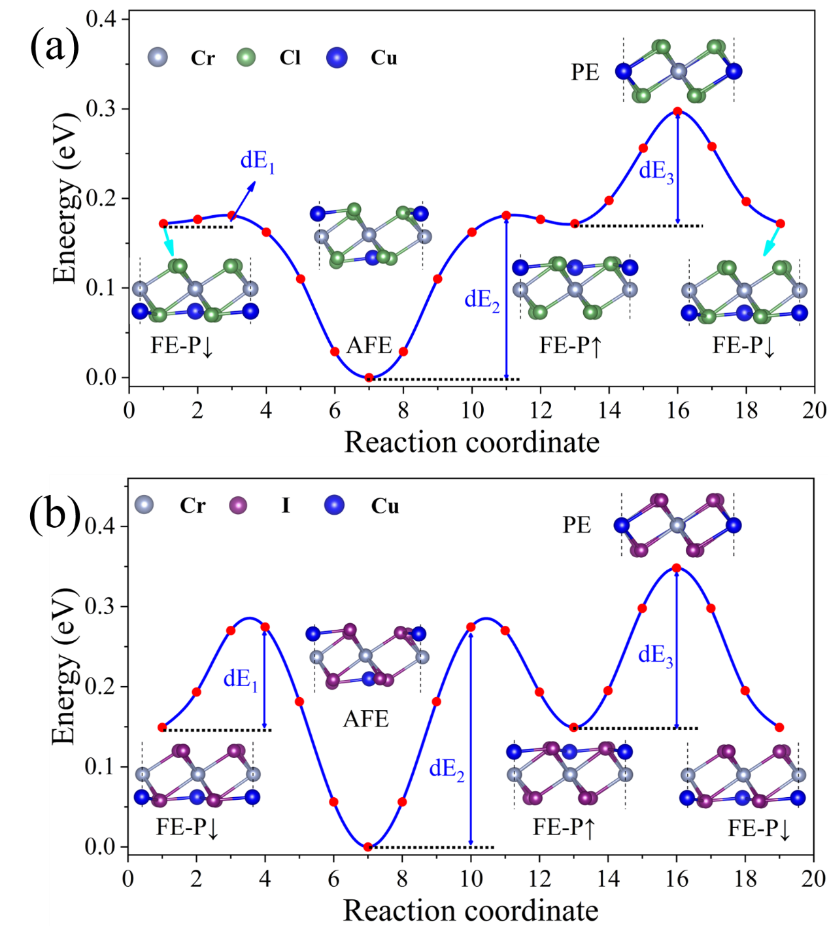
Figure S6. Kinetic pathway of the polarization reversal process for Cu(CrCl₃)₂ (a) and Cu(CrI₃)₂ (b).

- Electronic band structures of monolayer CrX₃ and Cu(CrX₃)₂
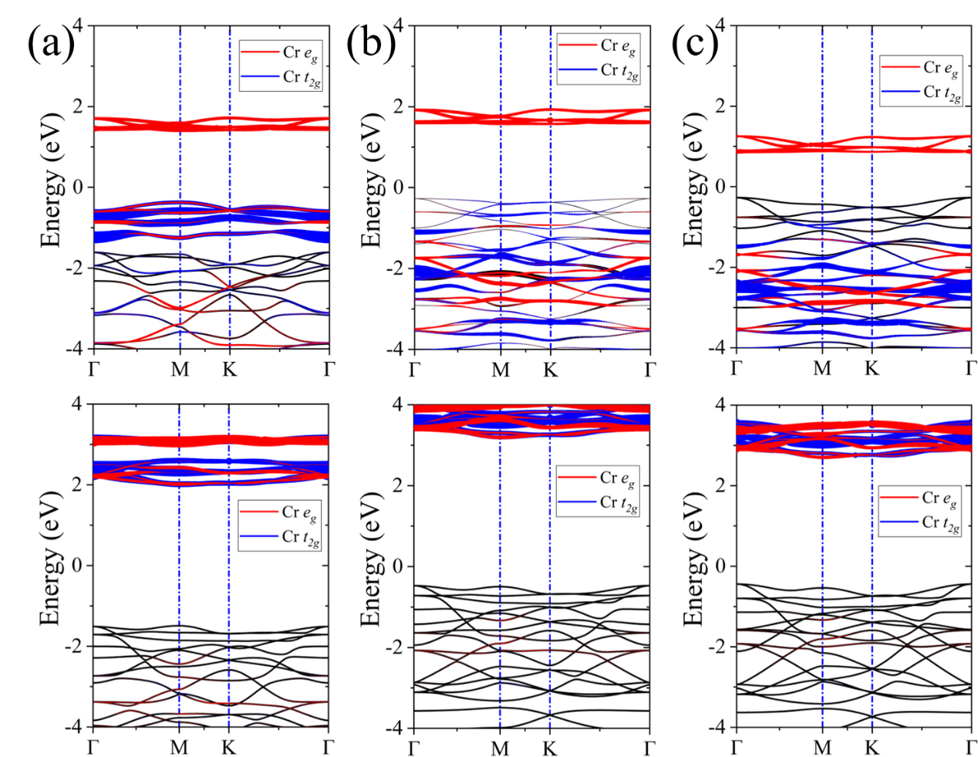
Figure S7. Spin-polarized band structures of pristine (a) CrCl₃, (b) CrBr₃, and (c) CrI₃ monolayer calculated by DFT+U method. The upper and lower panels represent the spin-up and spin-down bands respectively. The red line and blue line represent the e_{g} and t_{2g} orbital of Cr respectively.
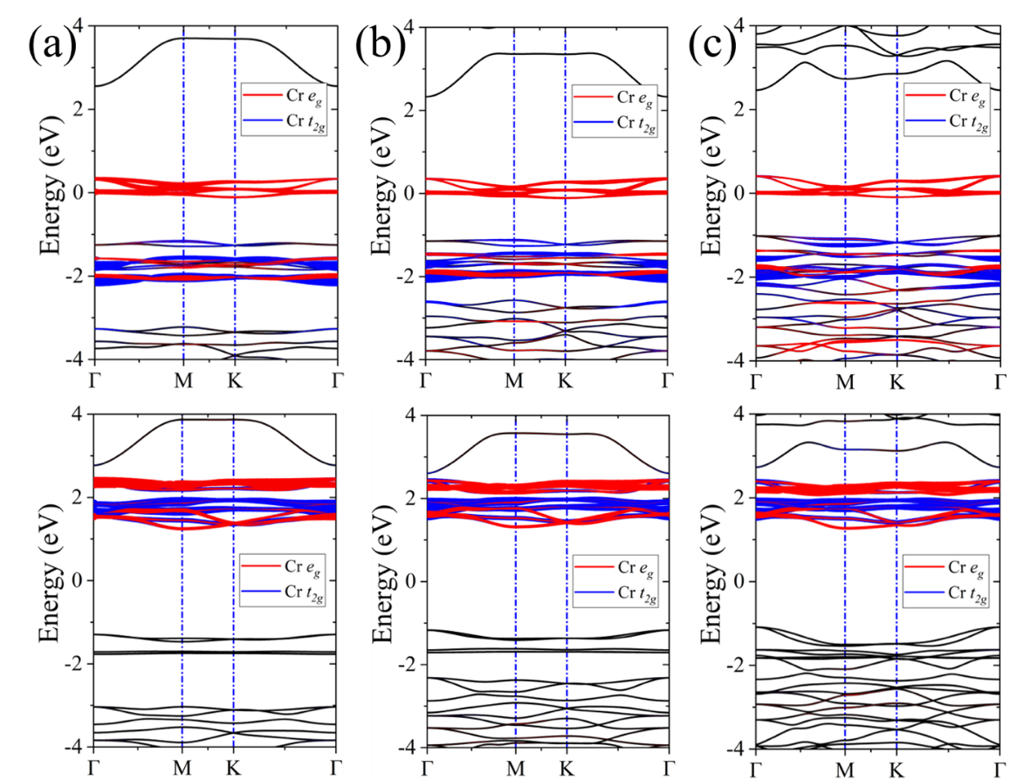
Figure S8. Spin-polarized band structures of (a) ferroelectric Cu(CrCl₃)₂, (b) Cu(CrBr₃)₂, and (c) Cu(CrI₃)₂ monolayer calculated by DFT+U method. The upper and lower panels represent the spin-up and spin-down bands respectively. The red line and blue line represent the e_{g} and t_{2g} orbital of Cr respectively.

- Ferroelectric configuration and ferroelectric properties
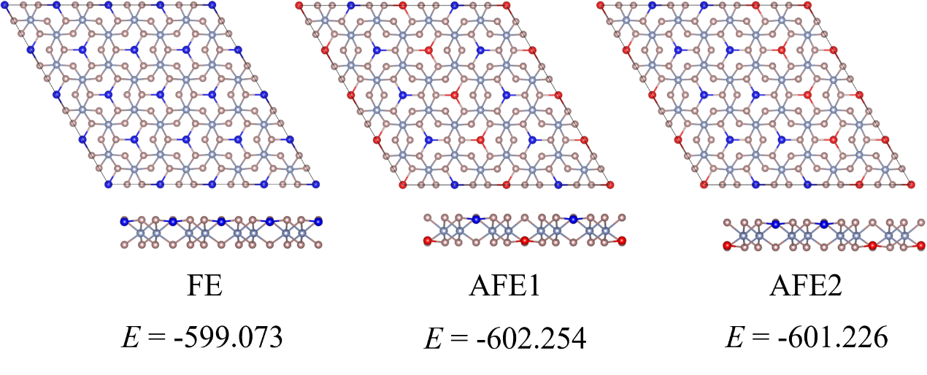
Figure S9. The polarization order of for Cu(CrBr₃)₂ monolayer in FE, AFE1 and AFE2 configurations, respectively. E (eV) is the total energy of each compound.

- Magnetic configurations
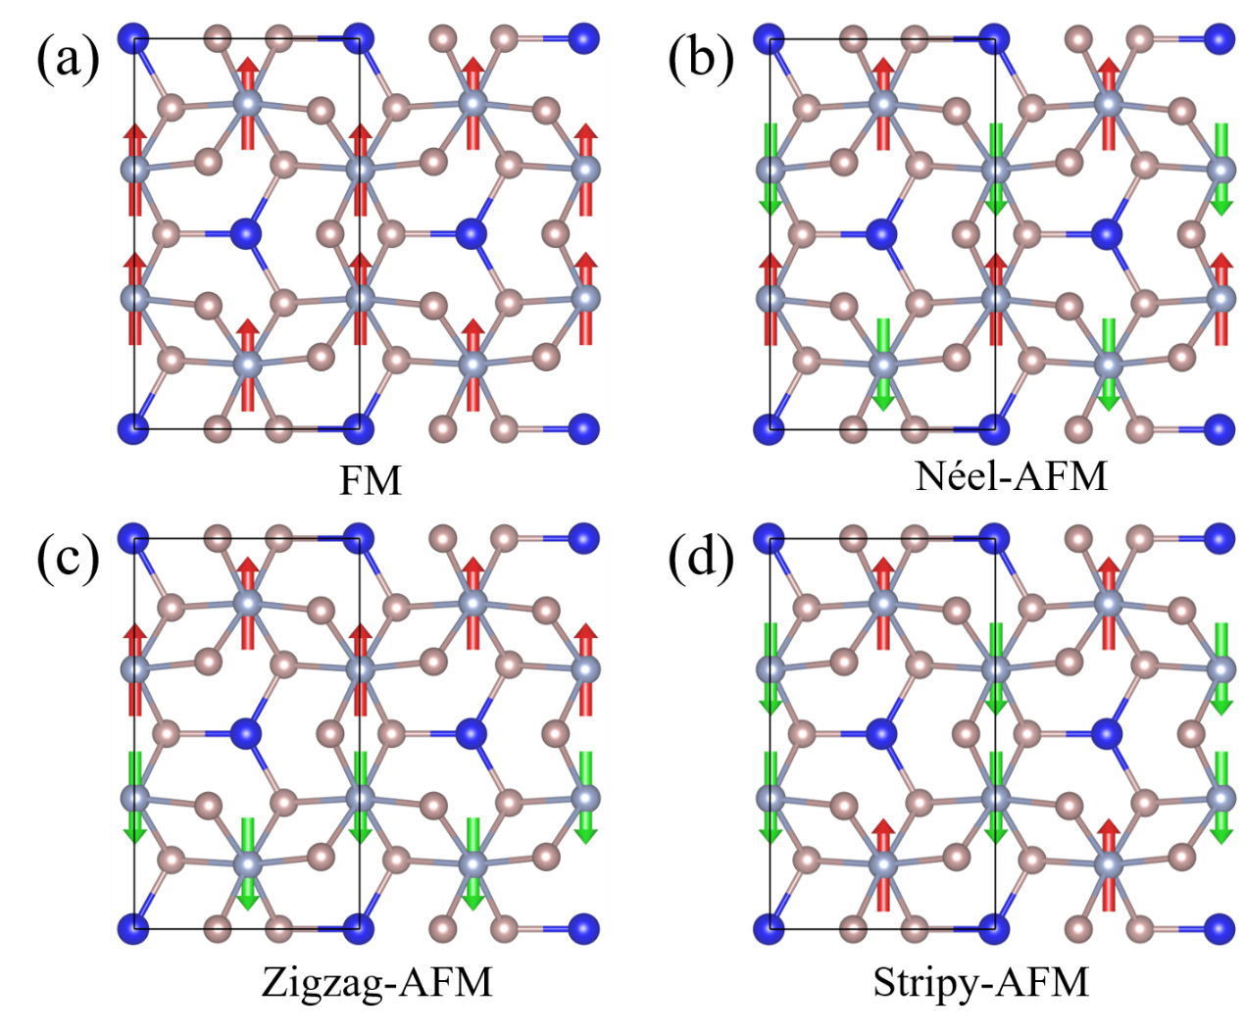
Figure S10. Top view of the different spin configurations: the FM ordered (a), Néel-AFM ordered (b), Zigzag-AFM ordered (c), and Stripy-AFM ordered (d). Up (down) spins are represented by red (green) arrow.

TABLE S4. The exchange coupling (J), Curie temperature (T_{C}), magnetic moment (M), and MAE of single-layer chromium trihalides and Cu-decorated chromium trihalides.
Compounds | J (meV) | Calculated T_{C} (K) | Experimental T_{C} (K) | M  (μ_{B}/Cr) | MAE (meV/Cr)
CrCl₃ | 2.15 | 21 | 27 (bulk)¹² | 2.93 | 0.03
Cu(CrCl₃)₂ | 5.65 | 72 | - | 3.25 | -0.07
CrBr₃ | 2.74 | 34 | 34¹³ | 2.98 | 0.21
Cu(CrBr₃)₂ | 4.32 | 62 | - | 3.40 | 0.16
CrI₃ | 2.95 | 43 | 45¹⁴ | 3.08 | 0.77
Cu(CrI₃)₂ | 3.91 | 58 | - | 3.47 | -0.11

- Magnetoelectric coupling
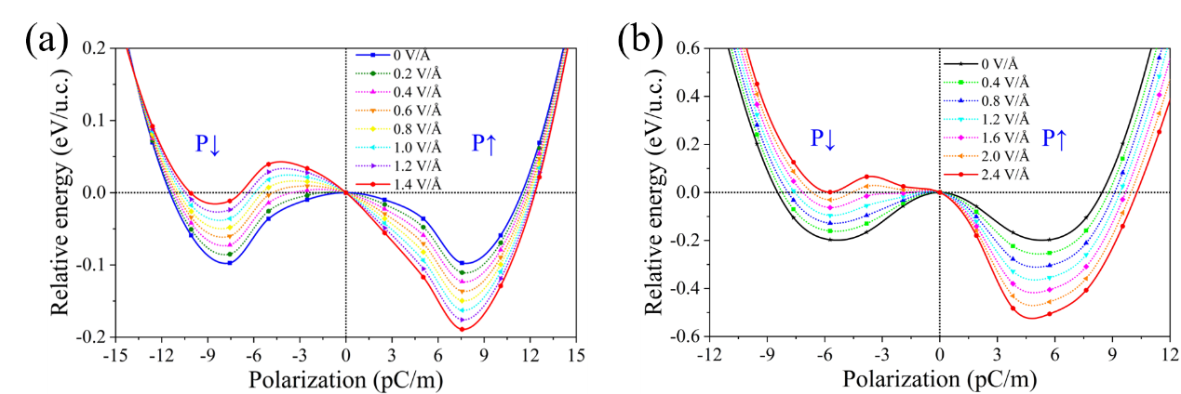
Figure S11. The relative energy versus polarization under a vertical external electric field in Cu(CrBr₃)₂ (a) and Cu(CrI₃)₂ (b). The reference energy is set to that of paraelectricity.

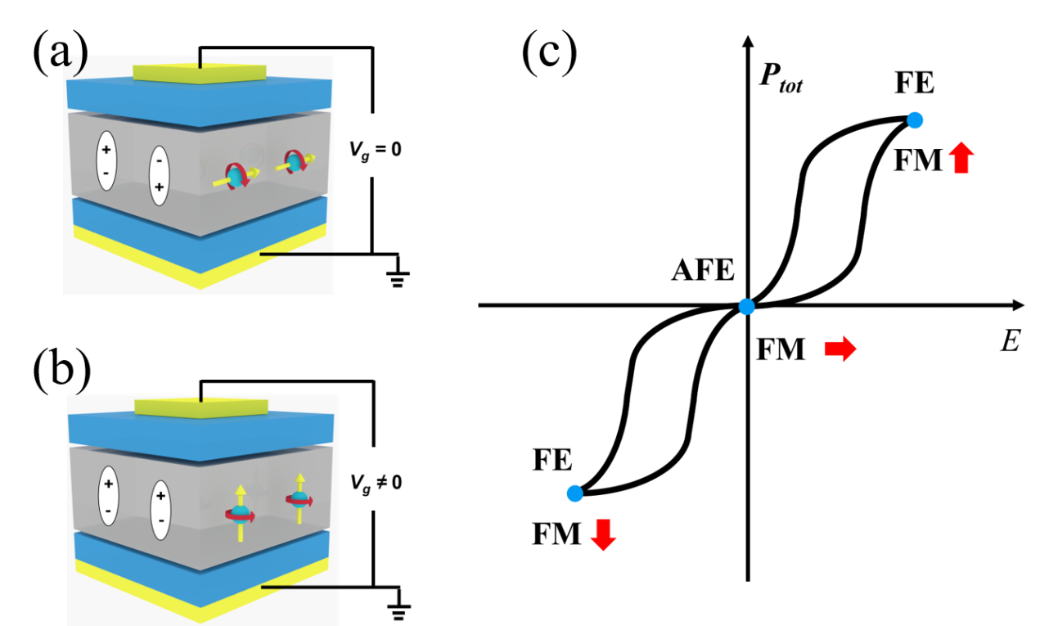
Figure S12. (a) and (b) Schematic diagrams of the magnetic ordering versus electric gate field. Different electric orderings correspond to different magnetic exchange paths and thus result in the different magnetic orderings. (c) The 𝑃–𝐸 hysteretic loop with the corresponding electric and magnetic ordering.

- References
1. Kresse, G. & Hafner, J. Ab initio molecular dynamics for liquid metals. Phys. Rev. B 47, 558-561 (1993).
2. Kresse, G. & Furthmüller, J. Efficient iterative schemes for ab initio total-energy calculations using a plane-wave basis set. Phys. Rev. B 54, 11169-11186 (1996).
3. Blöchl, P. E. Projector augmented-wave method. Phys. Rev. B 50, 17953-17979 (1994).
4. Perdew, J. P., Burke, K. & Ernzerhof, M. Perdew, Burke, and Ernzerhof Reply. Phys. Rev. Lett. 80, 891-891 (1998).
5. Henkelman, G., Uberuaga, B. P. & Jónsson, H. A climbing image nudged elastic band method for finding saddle points and minimum energy paths. J. Chem. Phys. 113, 9901-9904 (2000).
6. Togo, A. & Tanaka, I. First principles phonon calculations in materials science. Scripta Mater. 108, 1-5 (2015).
7. Zhang, Y., Wang, B., Guo, Y., Li, Q. & Wang, J. A universal framework for metropolis Monte Carlo simulation of magnetic Curie temperature. Comput. Mater. Sci. 197, 110638 (2021).
8. Smidstrup, S., et al. QuantumATK: an integrated platform of electronic and atomic-scale modelling tools. J. Phys.: Condens. Matter 32, 015901 (2020).
9. Fisher, D. S. & Lee, P. A. Relation between conductivity and transmission matrix. Phys. Rev. B 23, 6851-6854 (1981).
10. Büttiker, M., Imry, Y., Landauer, R. & Pinhas, S. Generalized many-channel conductance formula with application to small rings. Phys. Rev. B 31, 6207-6215 (1985).
11. Li, L. & Wu, M. Binary Compound Bilayer and Multilayer with Vertical Polarizations: Two-Dimensional Ferroelectrics, Multiferroics, and Nanogenerators. ACS Nano 11, 6382-6388 (2017).
12. McGuire, M. A., Dixit, H., Cooper, V. R. & Sales, B. C. Coupling of Crystal Structure and Magnetism in the Layered, Ferromagnetic Insulator CrI₃. Chem. Mater. 27, 612-620 (2015).
13. Zhang, Z., et al. Direct Photoluminescence Probing of Ferromagnetism in Monolayer Two-Dimensional CrBr₃. Nano Lett. 19, 3138-3142 (2019).
14. Huang, B., et al. Layer-dependent ferromagnetism in a van der Waals crystal down to the monolayer limit. Nature 546, 270-273 (2017).

