Supplementary Information

Phototransformation and toxicity enhancement of AgCl NPs by polystyrene microplastics under irradiation
Yonghao Sun¹, Jiaolong Huang², Zhen Wang¹, Peng Duan², Weicheng Zhang^{1, 2*}
¹ Center for Environment and Health in Water Source Area of South-to-North Water Diversion, School of Public Health, Hubei University of Medicine, Shiyan, China
² Key Laboratory of Zebrafish Modeling and Drug Screening for Human Diseases of Xiangyang City, Department of Obstetrics and Gynaecology, Xiangyang No.1 People's Hospital, Hubei University of Medicine, China
------------------------------------------------------------------------------------
* Corresponding author: weichengzhang@hbmu.edu.cn

Text S1: Materials
Spherical polystyrene microplastics (PS MPs) of diameters (0.1 μm), no functional groups (-NF) ere sourced from Tianjin Baseline Chromtech Research Centre, China. Various necessary chemicals for the experiments were procured from different sources. Polyvinylpyrrolidone (PVP) was purchased from Solarbio (Beijing Solarbio Science & Technology Co.，Ltd.). AgNO₃, NaCl, Na₂CO₃, and Na₂HPO₄ were obtained from the Tianjin Guangfu Fine Chemical Research Institute located in Tianjin, China. Humic acid (HA), urfuryl alcohol (FFA), para-chlorobenzoic acid (pCBA), 2,4,6-trimethylphenol (TMP) and p-benzoquinone (BQ) were supplied by Sigma−Aldrich. And the compounds exhibited purities exceeding 98%, with the exception of HA (purity ≥ 90%).
Text S2: Characterization and synthesis of AgCl, PS MPs and Ag NPs
Characterization of AgCl: Transmission electron microscopy (TEM, JEM-100CXII, JEOL, Ltd., Japan) and scanning electron microscopy (SEM, GeminiSEM 500, Zeiss) were utilized to ascertain the dimensions and shapes of AgCl. X-ray diffraction (XRD, Bruker D8 Advance) was employed to elucidate the crystal phases present in AgCl (with a scanning range of 20° to 80° at a scanning speeding of 2°/min in 2θ). Subsequently, a comparison was made between the acquired XRD data and the repository provided by the International Centre for Diffraction Data.

Characterization of PS MPs and Ag NPs: The morphology of Ag NPs and PS MPs was observed using Transmission electron microscopy (TEM, JEM-100CXII, JEOL, Ltd., Japan), The lattice fringe spacing was determined on high-resolution transmission electron microscope (HR-TEM), and the elemental mapping of imaged objects was characterized using an energy-dispersive X-ray (EDX) detector JEM2100F, JEOL, Ltd., Japan). UV-visible spectroscopy (Evolution 300, Thermo Scientific, USA) was utilized to measure the UV-vis spectra of the Ag NPs in the presence and absence of PS MPs.
Text S3: O₂^{•−}, ¹O₂, •OH and ³PS* detection
Electron paramagnetic resonance (EPR, EMX Micro-6/1/P/L, Bruker) analysis was conducted to assess the generation of reactive oxygen species (ROS), including superoxide radical (O₂^{•−}), singlet oxygen (¹O₂), and hydroxyl radical (•OH) on surfaces of AgCl / PS MPs and AgCl. For the detection of O₂^{•−}, 5,5-Dimethyl-1-pyrroline N-oxide (DMPO) was employed as a scavenger. To capture ¹O₂ and •OH, 2,2,6,6-Tetramethylpiperidine (TEMP) and dimethyl sulfoxide (DMSO) were utilized, respectively. Additionally, to quench specific ROS, namely O₂^{•−}, ¹O₂, •OH, and the excited triplet state of PS (³PS*), the following compounds were applied: BQ (50 μM), FFA (100 μM), pCBA (50 μM), and TMP (50 μM), respectively. These quenching agents were chosen based on previous studies. The experimental procedures for quenching were conducted following the same methodology using ion chromatography.
Text S4: Dissolution and transformation of AgCl NPs with and without PS MPs under sunlight
The dissolution and transformation of AgCl NPs, both in the presence and absence of PS MPs, were assessed within 50 mL quartz glass containers sealed with quartz lids, all while exposed to simulated sunlight. (λ = 200 to 800 nm; xenon lamp, WXE-80T, Wewon Test Equipment Co., Ltd., 550 W/m²) at 30°C. Concurrently, under dark conditions, the dissolution and/or transformation of the particles occurred by enveloping the quartz glass containers with aluminum foil. The pH in the experiment was adjusted from 8.5 to 5.5 with H₃BO₃ (0.2 M) and Na₂B₄O₇·4H₂O (0.05 M), and the pH values were recorded at different time points (table S1). Collect a volume of 10 ml of liquid and filter it using a 0.22 μm membrane filter. Utilize ion chromatography (IC, Metrohm 930, Switzerland) to identify chloride ions within the collected sample.
Text S5: Influence of PS MPs on the AgCl dissolution in realistic water conditions
In order to gain a more comprehensive understanding of whether PS MPs exert an influence on the dissolution and transformation of AgCl within realistic water conditions, a realistic water samples were collected from the Hanjiang river (HJR, on 21th February 2023, Shiyan city, China 110°41'40''E, 32°47'17''N). At designated location, a water sampler was employed to procure five liters of water into glass vials. Subsequently, the collected water samples underwent centrifugation (12,000g, 10 minutes) at ambient temperature (~ 28°C), followed by filtration through 0.22 μm glass fiber filters. This filtration step was taken to mitigate the potential influence of PS MPs contamination (Di, Liu, Wang, & Wang, 2019). The filtered water samples were placed into a refrigeration unit for preservation and future use.
Text S6: Evaluating the impact of AgCl NPs on the photodegradation of polystyrene microplastics
The aim of this study was to investigate the degradation of PS MPs in the presence or absence of AgCl. PS MPs samples, with or without AgCl, were exposed to visible light, and samples were collected at predetermined irradiation time intervals. Various analytical techniques were employed in this research, including Transmission Electron Microscopy (TEM), Total Organic Carbon (Shimadzu, TOC-L) analysis and energy-dispersive X-ray (EDX). A detailed examination of the morphology of PS MPs with and without AgCl was conducted using TEM. Furthermore, preliminary evaluations of the mineralization process under light exposure were performed using TOC analyzer for PS MPs with and without AgCl.
Text S7: Zebrafish toxicity test
As a common laboratory model organism, zebrafish are extensively utilized in toxicity experiments (Stine, Harper, Conner, Velev, & Harper, 2021). Zebrafish toxicity testing was one of the methods employed to assess the degree of toxicity of chemical substances on living organisms. The preliminary experiments provided crucial guidance for the formal experiments. The concentration levels of AgCl NPs were established at 10 μg/L, along with a concentration of 1 mg/L for PS MPs (Lasee et al., 2017). The formal experiments aimed to investigate the individual and combined toxicity of AgCl in the presence or absence of PS MPs, as well as their toxic effects following 60 hours of sunlight exposure, and the measurement of Ag⁺ content within zebrafish.
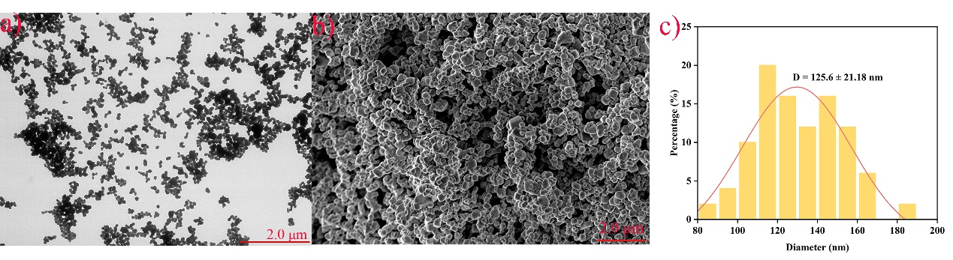
Fig. S1. (a) The TEM of synthesized AgCl. (b) The SEM of synthesized AgCl. (c) Size of synthesized AgCl particle.

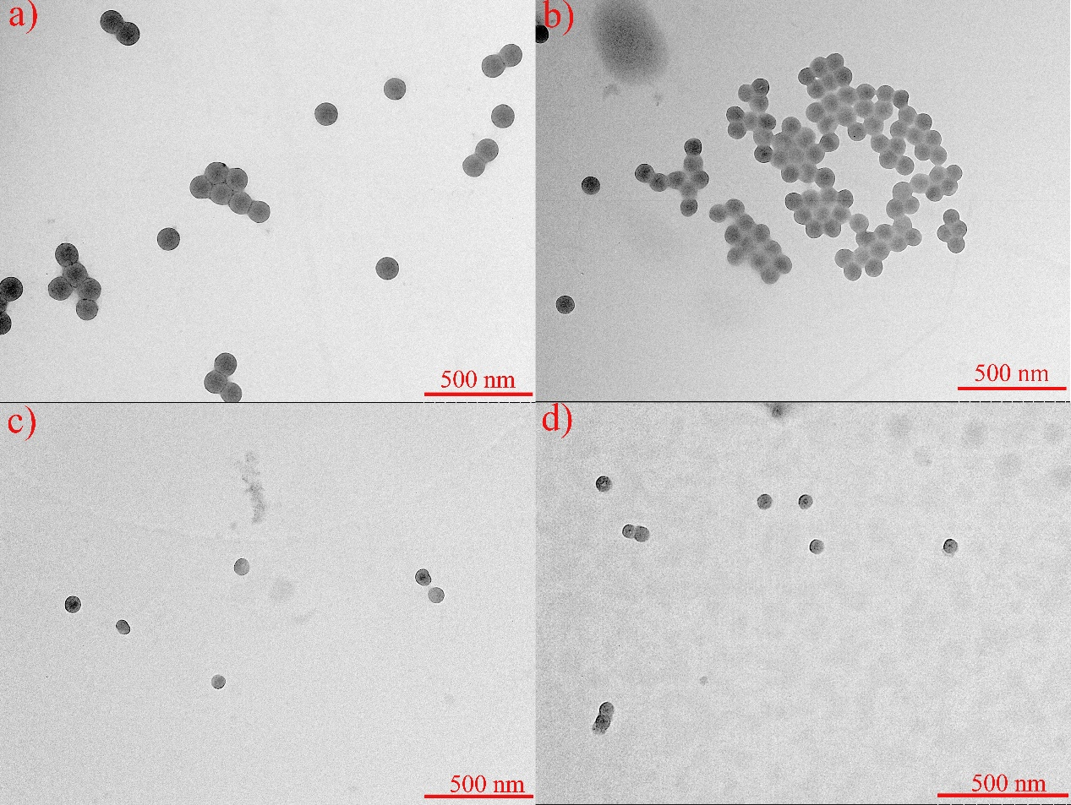
Fig. S2. Pictures of PS MPs under sunlight at different time points: (a) 0 h, (b) 48 h, (c) 72 h, (d) 96 h.

Fig. S3. (a) The concentration of Cl⁻ under various radical quenchers. (b) Characteristic absorbance spectra of newly formed Ag NPs under various radical quenchers.

Fig. S4. (a) The concentration of Cl⁻ under different temperature. (b) Characteristic absorbance spectra of newly formed Ag NPs under different temperature. (c) The concentration of Cl⁻ under different pH. (d) Characteristic absorbance spectra of newly formed Ag NPs under different pH. (e) The concentration of Cl⁻ under different concentration of CO₃²⁻ (1, 5 and 10 mg/L). (f) Characteristic absorbance spectra of newly formed Ag NPs under different concentration of CO₃²⁻ (1, 5 and 10 mg/L).

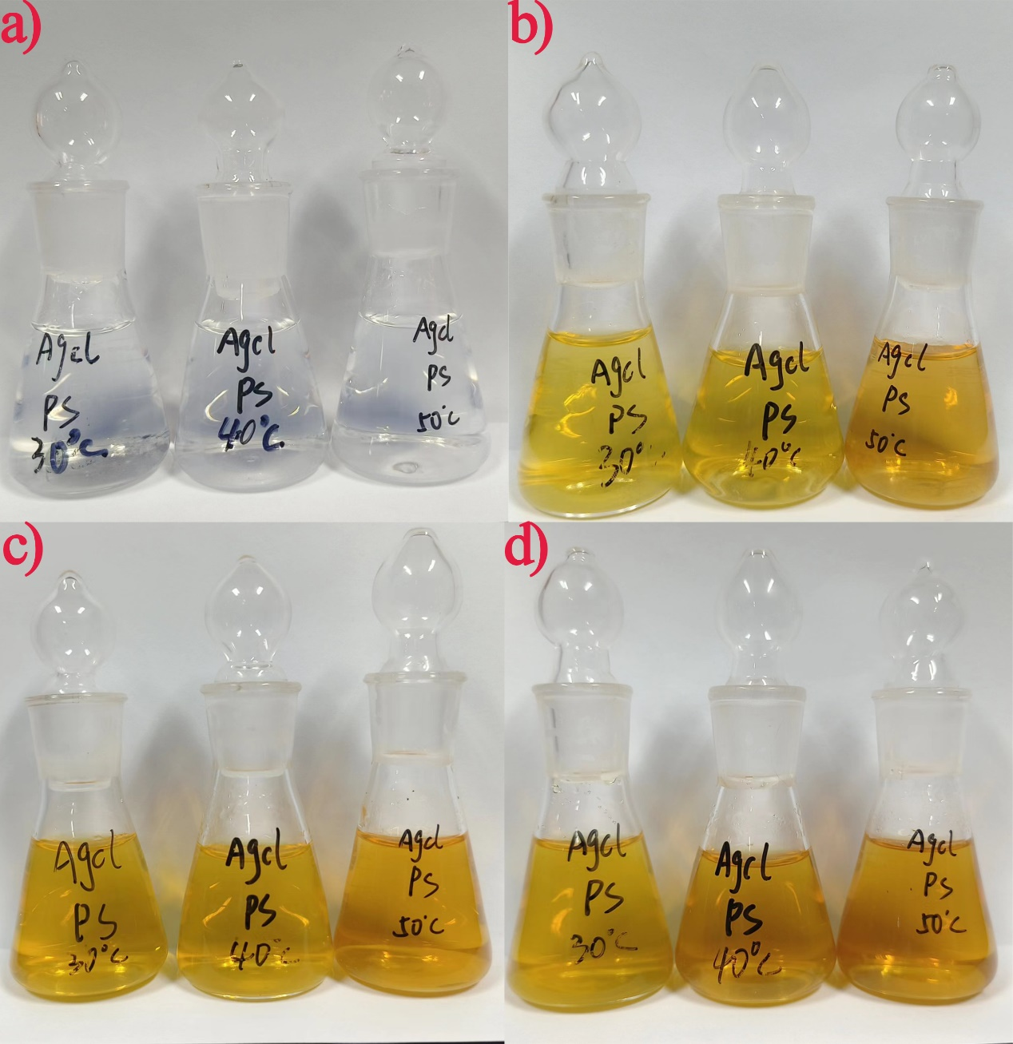

Fig. S5. Pictures of AgCl and PS MPs with different temperature (30℃, 40℃, 50℃) under sunlight at different time points: (a) 0 h, (b) 9 h, (c) 24 h, (d) 60 h.
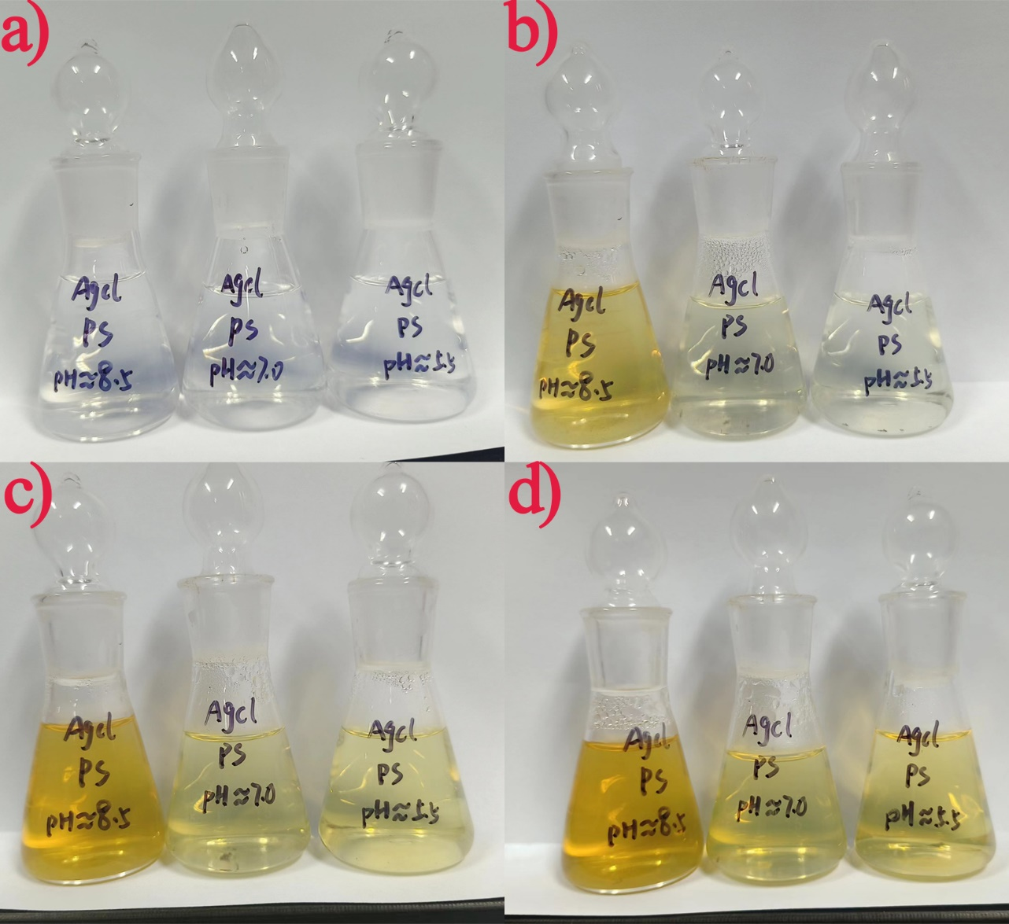

Fig. S6. Pictures of AgCl and PS MPs with different pH (8.5, 7.0, 5.5) under sunlight at different time points: (a) 0 h, (b) 9 h, (c) 24 h, (d) 60 h.

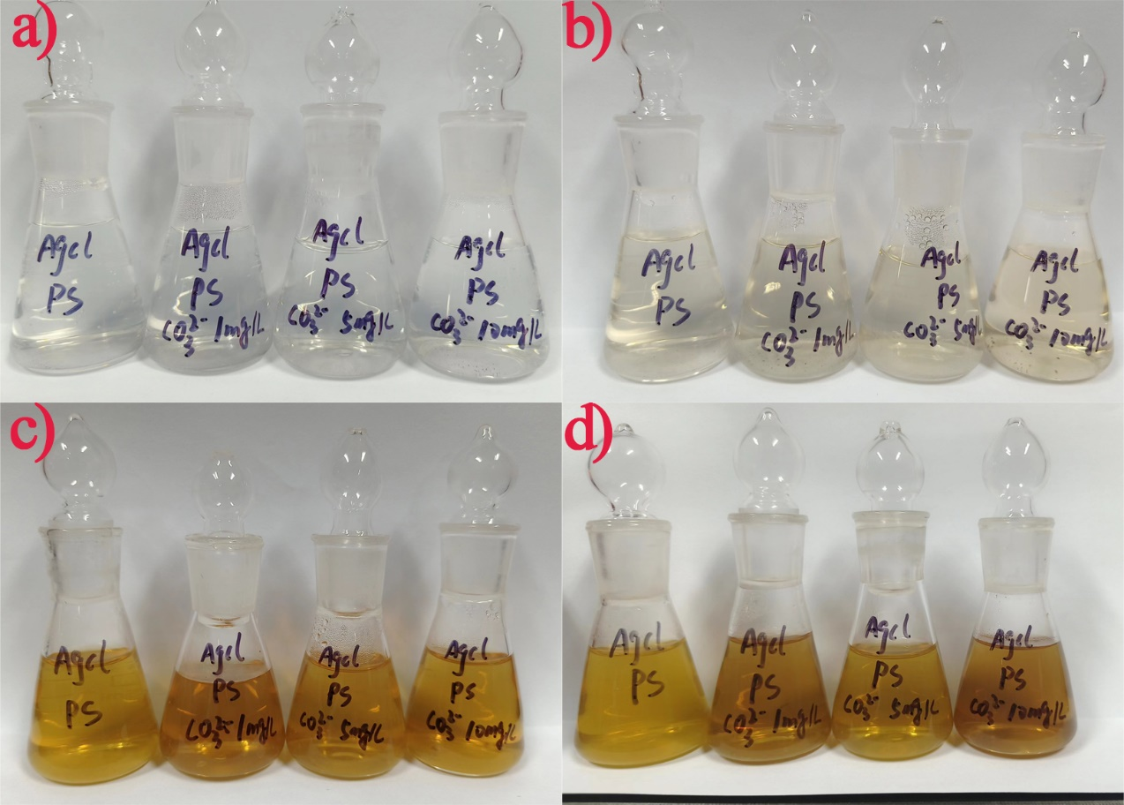

Fig. S7. Pictures of AgCl and PS MPs with different concentration of CO₃²⁻ (1, 5 and 10 mg/L) under sunlight at different time points: (a) 0 h, (b) 6 h, (c) 24 h, (d) 60 h.

Fig. S8. (a) XRD analysis of precipitates from AgCl NPs and PS MPs with CO₃²⁻/PO₄³⁻ under simulated sunlight irradiation.

Fig. S9. (a) The concentration of Cl⁻ under different concentration of HA (1, 5 and 10 mg/L). (b) Characteristic absorbance spectra of newly formed Ag NPs under different concentration of HA (1, 5 and 10 mg/L). (c) The concentration of Cl⁻ under different concentration of PO₄³⁻ (1, 5 and 10 mg/L). (d) Characteristic absorbance spectra of newly formed Ag NPs under different concentration of PO₄³⁻ (1, 5 and 10 mg/L).

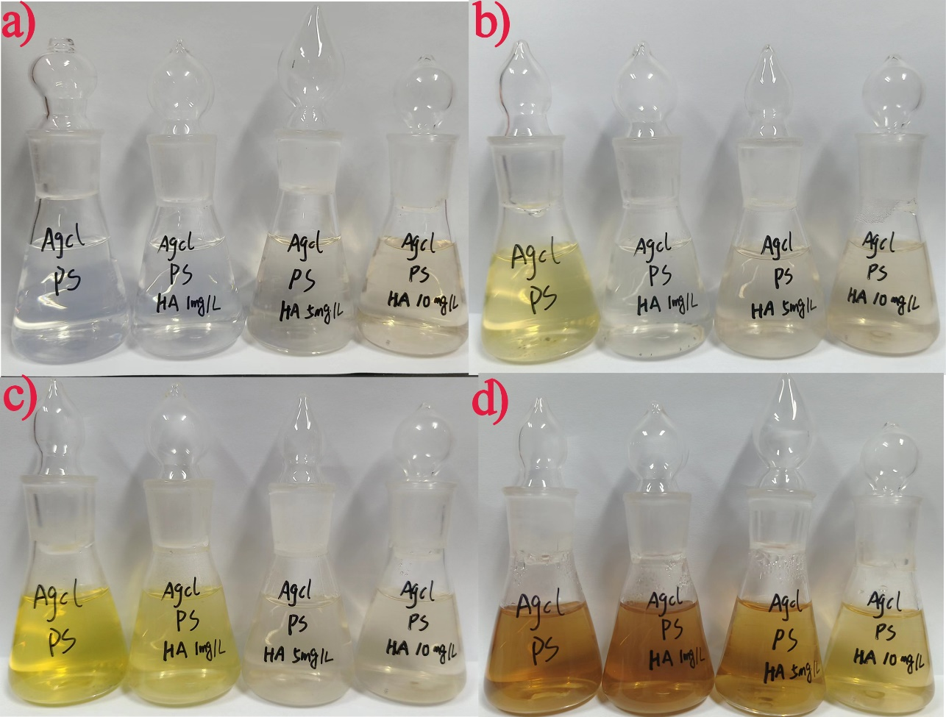

Fig. S10. Pictures of AgCl and PS MPs with different concentration of HA (1, 5 and 10 mg/L) under sunlight at different time points: (a) 0 h, (b) 12 h, (c) 24 h, (d) 60 h.

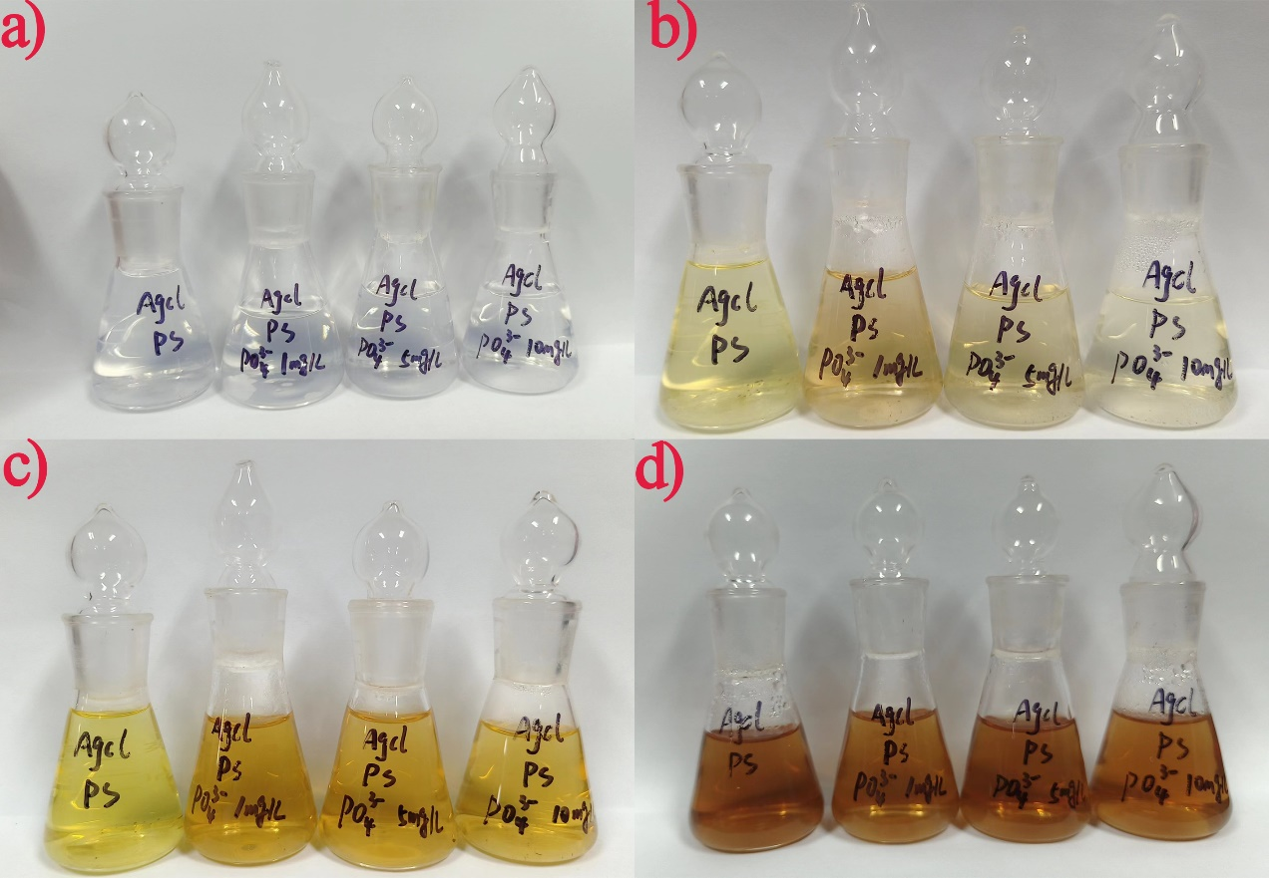

Fig. S11. Pictures of AgCl and PS MPs with different concentration of PO₄³⁻ (1, 5 and 10 mg/L) under sunlight at different time points: (a) 0 h, (b) 9 h, (c) 24 h, (d) 60 h.

Fig. S12. Pictures of UV–Vis absorption spectra of AgCl and PS MPs with different concentration of HA (1, 5 and 10 mg/L).

Fig. S13. (a) The concentration of Cl⁻ (20 mg/L; pH = 8.5) with PS (0.1 µm, 20 mg/L and -NF) in DD – water and HJR. (b) Characteristic absorbance spectra of Ag NPs with PS (0.1 µm, 20 mg/L and -NF) in DD – water and HJR.

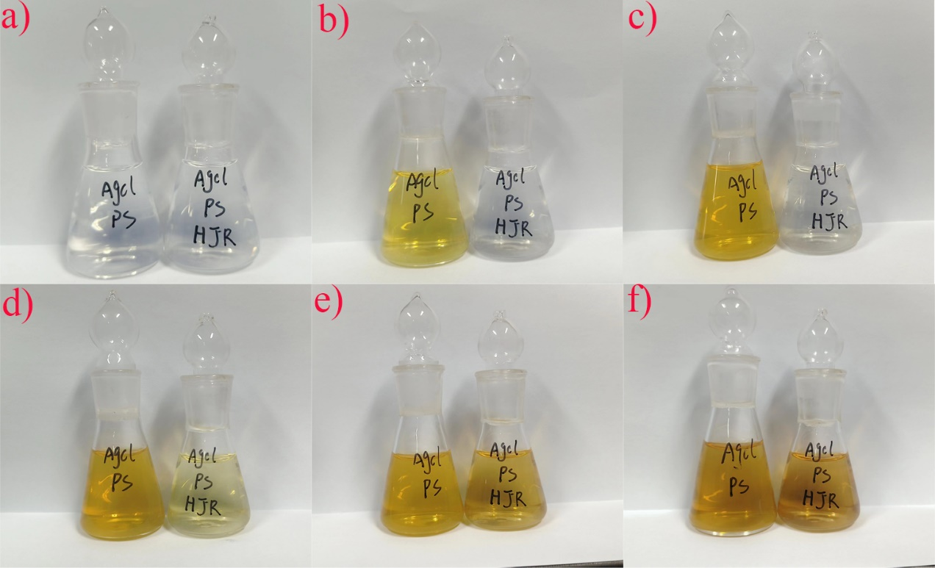

Fig. S14. Pictures of AgCl NPs and PS MPs in DD-Water and Hanjiang River water under sunlight at different time points: (a) 0 h, (b) 9 h, (c) 24 h, (d) 36 h, (e) 48 h, (f) 60 h.

Table S1. The pH values of AgCl NPs with or without PS MPs under different conditions were determined during 60 h sunlight irradiation.
Conditions |  | pH
Conditions | 0 h |  | 24 h | 48 h | 60 h
AgCl (20 mg/L) + PS (0.1 µm; 20 mg/L) (light) | 8.50 ± (0.02) |  | 8.18 ± (0.10) | 8.05± (0.07) | 7.99 ± (0.06)
AgCl (20 mg/L) (light) | 8.50 ± (0.01) |  | 8.30 ± (0.09) | 8.19± (0.10) | 8.08 ± (0.11)
AgCl (20 mg/L) + PS (0.1 µm; 20 mg/L) (dark) | 8.50 ± (0.01) |  | 8.31 ± (0.01) | 8.27± (0.02) | 8.23 ± (0.04)
AgCl (20 mg/L) (dark) | 8.50 ± (0.02) |  | 8.30 ± (0.04) | 8.26± (0.01) | 8.19 ± (0.03)
AgCl (20 mg/L) + PS (0.1 µm; 20 mg/L) + CO₃²⁻ (1 mg/L) | 8.50 ± (0.03) |  | 8.15 ± (0.04) | 8.02± (0.03) | 8.01 ± (0.05)
AgCl (20 mg/L) + PS (0.1 µm; 20 mg/L) + CO₃²⁻ (5 mg/L) | 8.50 ± (0.01) |  | 8.16 ± (0.09) | 8.05± (0.05) | 8.01 ± (0.11)
AgCl (20 mg/L) + PS (0.1 µm; 20 mg/L) + CO₃²⁻ (10 mg/L) | 8.50 ± (0.03) |  | 8.19 ± (0.09) | 8.09± (0.07) | 8.05 ± (0.06)
AgCl (20 mg/L) + PS (0.1 µm; 20 mg/L) + PO₄³⁻ (1 mg/L) | 8.50 ± (0.02) |  | 8.07 ± (0.07) | 8.00± (0.11) | 7.92 ± (0.08)
AgCl (20 mg/L) + PS (0.1 µm; 20 mg/L) + PO₄³⁻ (5 mg/L) | 8.50 ± (0.03) |  | 8.03 ± (0.10) | 7.98± (0.08) | 7.87 ± (0.12)
AgCl (20 mg/L) + PS (0.1 µm; 20 mg/L) + PO₄³⁻ (10 mg/L) | 8.50 ± (0.02) |  | 8.09 ± (0.10) | 7.96± (0.01) | 7.81 ± (0.12)
AgCl (20 mg/L) + PS (0.1 µm; 20 mg/L) + HA (1 mg/L) | 8.50 ± (0.03) |  | 8.16 ± (0.05) | 8.09± (0.05) | 7.99 ± (0.11)
AgCl (20 mg/L) + PS (0.1 µm; 20 mg/L) + HA (5 mg/L) | 8.50 ± (0.03) |  | 8.08 ± (0.09) | 8.00± (0.05) | 7.91 ± (0.08)
AgCl (20 mg/L) + PS (0.1 µm; 20 mg/L) + HA (10 mg/L) | 8.50 ± (0.02) |  | 8.01 ± (0.05) | 7.93± (0.02) | 7.84 ± (0.06)
AgCl (20 mg/L) + PS (0.1 µm; 20 mg/L) + FFA | 8.50 ± (0.01) |  | 8.33 ± (0.01) | — | —
AgCl (20 mg/L) + PS (0.1 µm; 20 mg/L) + pCBA | 8.50 ± (0.02) |  | 8.36 ± (0.11) | — | —
AgCl (20 mg/L) + PS (0.1 µm; 20 mg/L) + TMP | 8.50 ± (0.02) |  | 8.32 ± (0.09) | — | —
AgCl (20 mg/L) + PS (0.1 µm; 20 mg/L) + BQ | 850 ± (0.04) |  | 8.37 ± (0.07) | — | —
AgCl (20 mg/L) + PS (0.1 µm; 20 mg/L) (pH = 7.0) | 7.00 ± (0.02) |  | 6.80 ± (0.08) | 5.93± (0.04) | 5.68 ± (0.09)
AgCl (20 mg/L) + PS (0.1 µm; 20 mg/L) (pH = 5.5) | 5.50 ± (0.02) |  | 5.01 ± (0.06) | 4.09± (0.06) | 4.03 ± (0.11)
AgCl (20 mg/L) + PS (0.1 µm; 20 mg/L) (HJR) | 7.30 ± (0.11) |  | 6.60± (0.07) | 6.58± (0.03) | 6.52 ± (0.08)
AgCl (20 mg/L) + PS (0.1 µm; 20 mg/L) (40 ℃) | 8.50 ± (0.02) |  | 8.30 ± (0.09) | 8.22± (0.01) | 8.24 ± (0.17)
AgCl (20 mg/L) + PS (0.1 µm; 20 mg/L) (50 ℃) | 8.50 ± (0.01) |  | 8.35 ± (0.07) | 8.20± (0.05) | 8.21 ± (0.10)

Table S2. The physicochemical data of Hanjiang River water (n = 3).
pH | DO (mg/L) | CO₃²⁻ (mg/L) | PO₄³⁻ (mg/L) | TOC (mg/L)
7.30 (± 0.11) | 4.02 (± 0.08) | 5.24 (± 0.20) | 0.12 (± 0.04) | 6.07 (± 0.13)

References
Di, M., Liu, X., Wang, W., & Wang, J. (2019). Manuscript prepared for submission to environmental toxicology and pharmacology pollution in drinking water source areas: Microplastics in the Danjiangkou Reservoir, China. Environ Toxicol Pharmacol, 65, 82-89. doi:10.1016/j.etap.2018.12.009
Lasee, S., Mauricio, J., Thompson, W. A., Karnjanapiboonwong, A., Kasumba, J., Subbiah, S., . . . Anderson, T. A. (2017). Microplastics in a freshwater environment receiving treated wastewater effluent. Integr Environ Assess Manag, 13(3), 528-532. doi:10.1002/ieam.1915
Stine, J. S., Harper, B. J., Conner, C. G., Velev, O. D., & Harper, S. L. (2021). In Vivo Toxicity Assessment of Chitosan-Coated Lignin Nanoparticles in Embryonic Zebrafish (Danio rerio). Nanomaterials (Basel), 11(1). doi:10.3390/nano11010111

