Supplementary Material

The Brønsted-Lewis acid sites in Metal-organic framework nanozymes for cooperatively enhancing the hydrolysis of lactose
Chenshu Yi ^{a#}, Keyu Xing ^{a#}, Keyu Xu ª, Li Yao ª, Pei Jia ª, Hao Wu ª, Li Wen ª, Yunhui Cheng ^{a,b}, Zhou Xu ^{a,c}*
ª Hunan Provincial Key Laboratory of Cytochemistry, School of Food Science and Bioengineering, Changsha University of Science & Technology, Changsha, 410114, Hunan, China
^{b} School of Food Science and Engineering, Qilu University of Technology, Jinan 250353, China
^{c} State Key Laboratory of Utilization of Woody Oil Resource, Hunan Academy of Forestry, Changsha, 410004, Hunan, China
#These authors contributed equally to the work.
*Corresponding authors at: Hunan Provincial Key Laboratory of Cytochemistry, School of Food Science and Bioengineering, Changsha University of Science & Technology, Changsha 410114, Hunan, China.
E-mail address: xz_jnu@126.com (Zhou Xu)

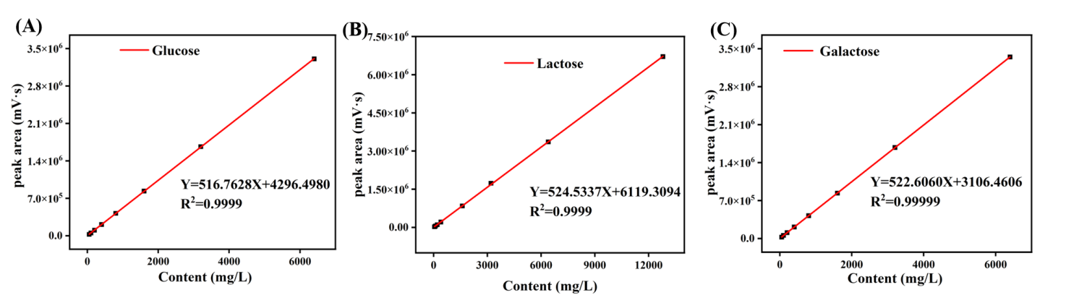
Figure S1. Calibration plots of (A) Glucose, (B) Lactose, and (C) Galactose standards by HPLC method. (D) Liquid chromatogram of mixed standard.

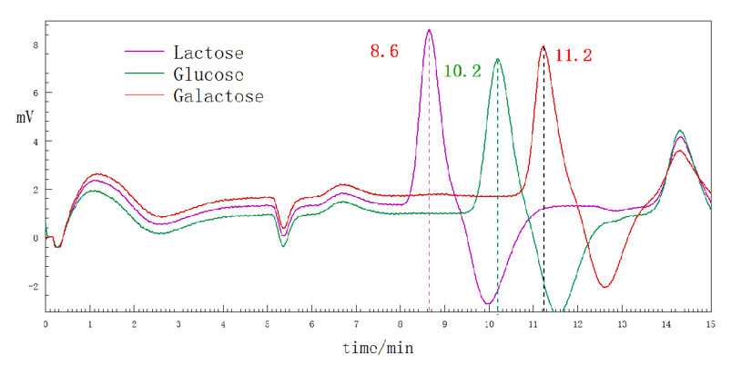
Figure S2. Liquid chromatogram of mixed standard.

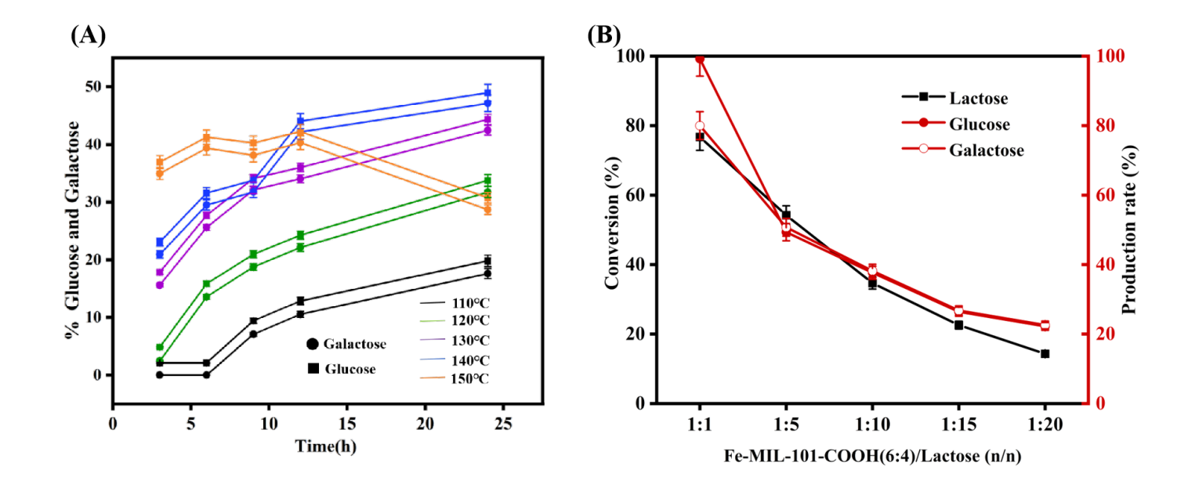
Figure S3. Condition optimization of lactose hydrolysis. Effect of the reaction temperature (A). Effect of the the substrate concentration (B).

