Supplementary Material

Supplementary figures

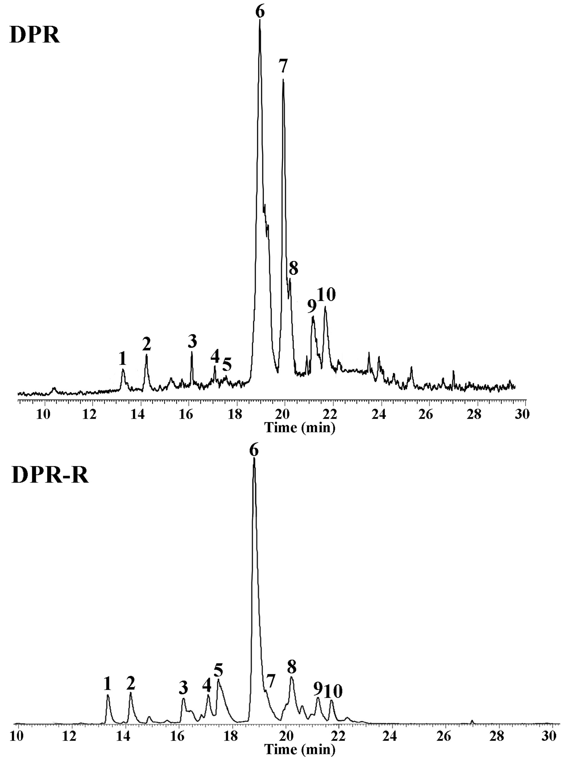
Fig. S1 Total ion flow diagram of GC–MS analysis for DPR and DPR-R.

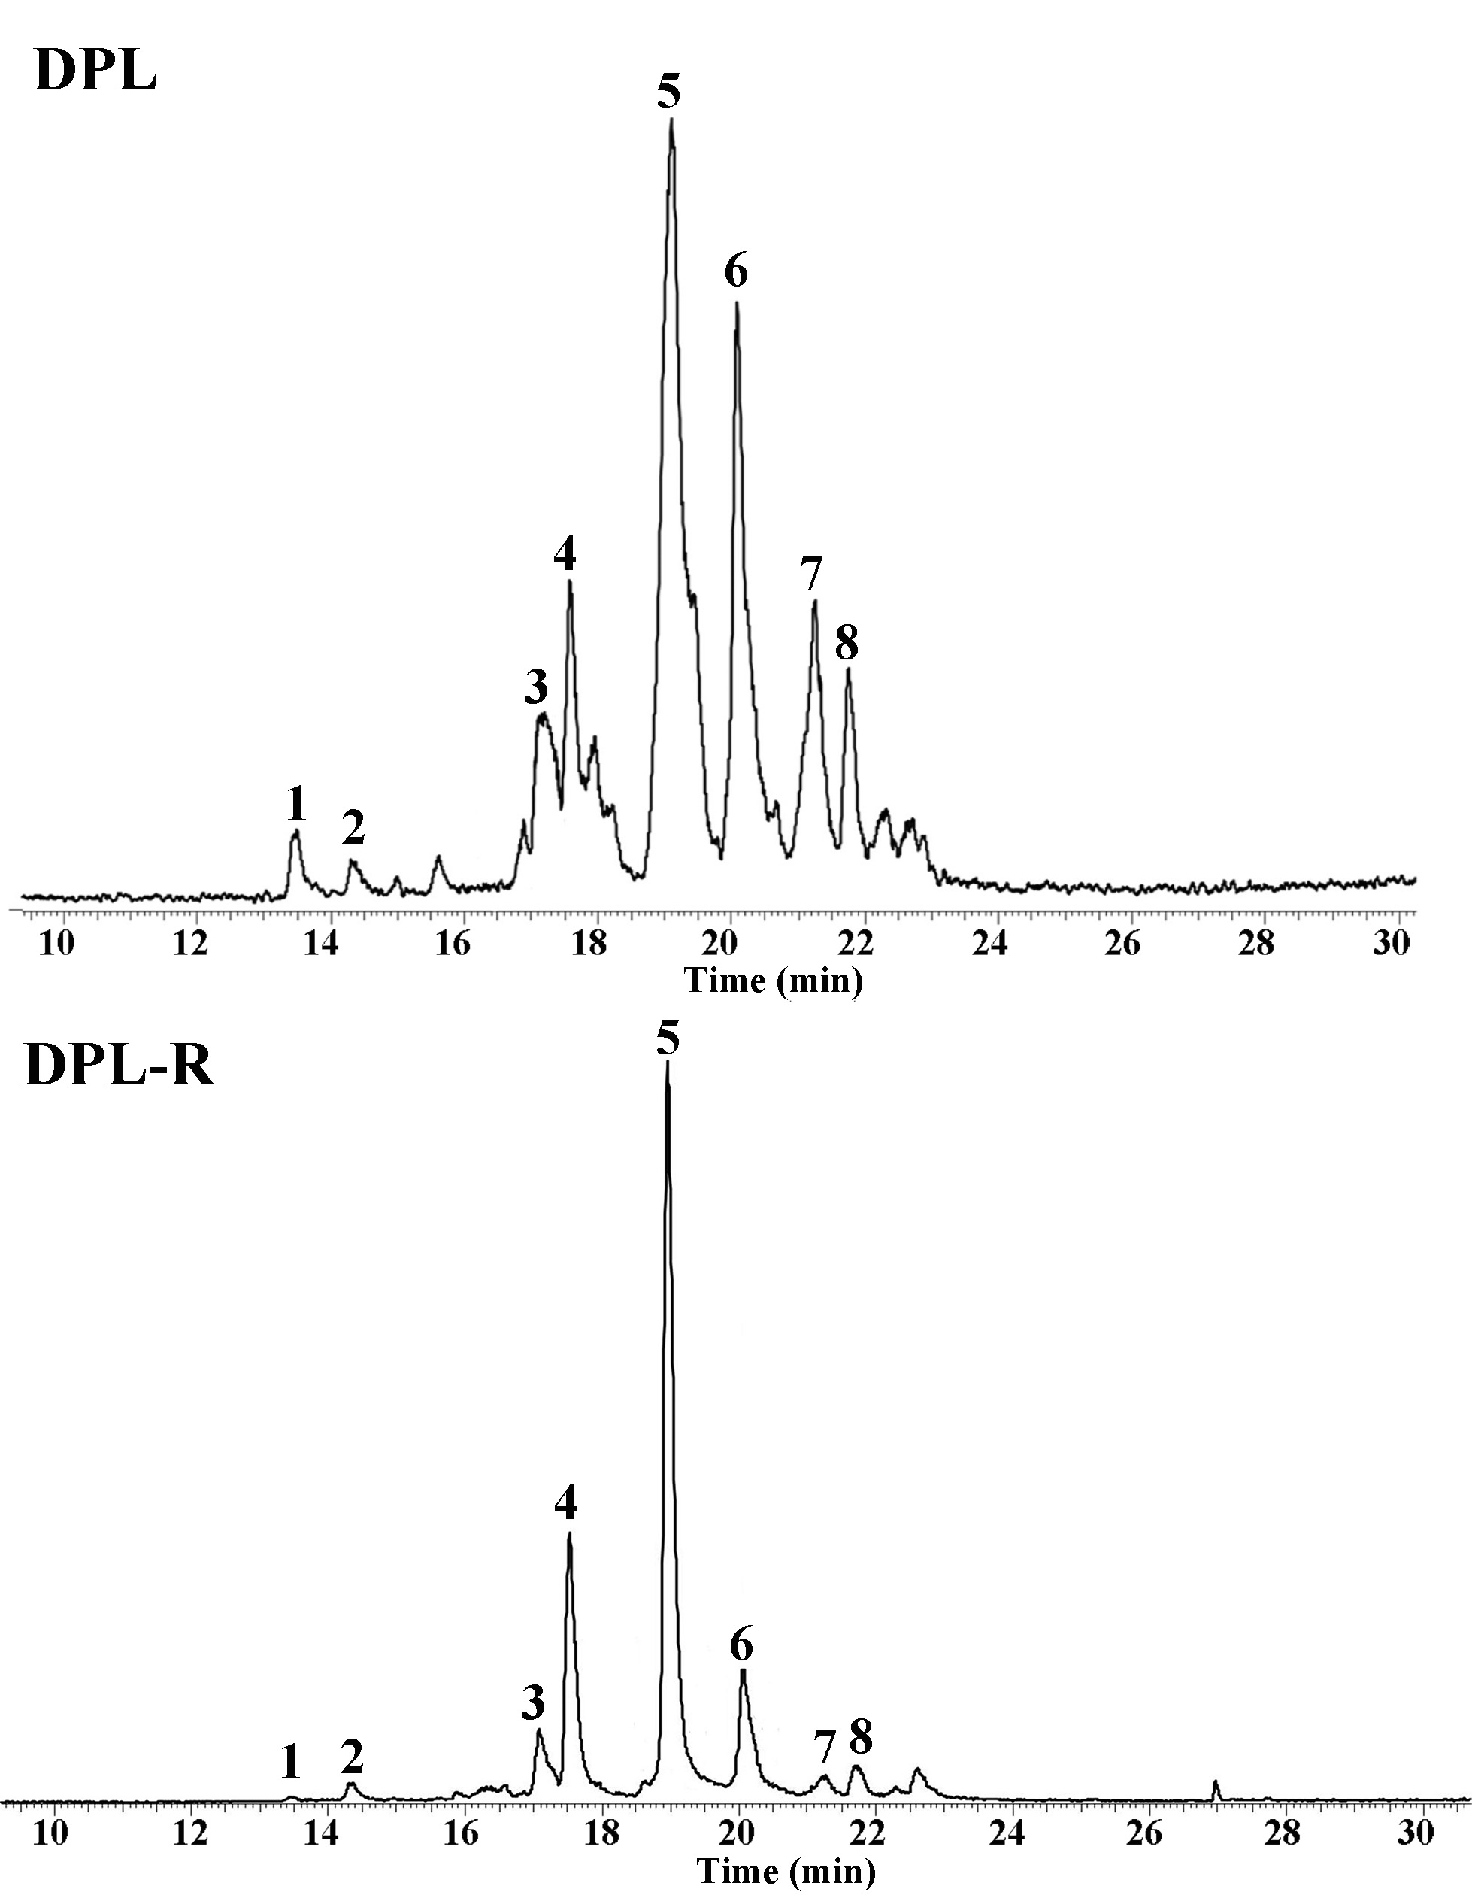
Fig. S2 Total ion flow diagram of GC–MS analysis for DPL and DPL-R.

