Supplementary information
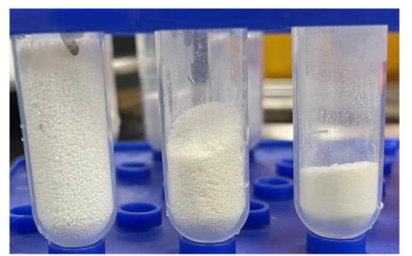
Figure S1. Stacking volume of chitosan microspheres of the same quality (from left to right, it is 1.0 group, 3.0 group, and 5.0 group)

Table S1 BET average specific surface area, BJH average pore size and volume；
Sample | BET average specific surface area (m²/g) | BJH average pore size (nm) | Volum(cm³/g)
1.0 group | 97.62 | 10.94 | 0.25
3.0 group  5.0 group | 91.83  11.34 | 15.30  17.38 | 0.59  0.03
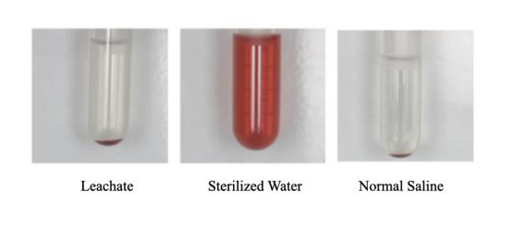

Figure S2. Color of liquid in centrifuge tubes for hemolysis experiments.

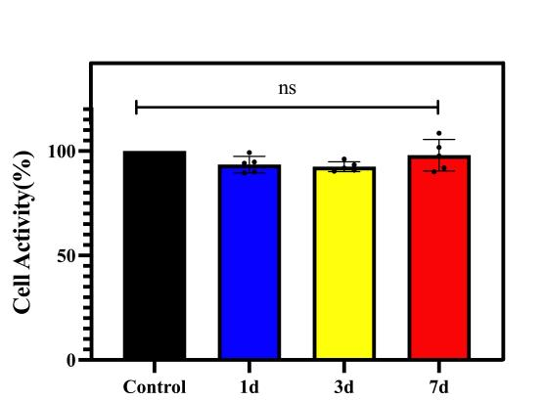

Figure S3. The results of in vitro cytotoxicity (CCK8 assay).

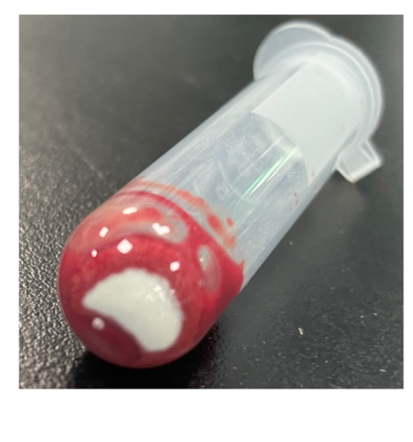

Figure S4. After coagulation, the material at the bottom of the centrifuge tube did not infiltrate.

