Supplement for
"Post-Sunset Humid-Heat Maxima near the Southern Persian/Arabian Gulf"

Colin Raymond¹*, Tom Matthews², and Cascade Tuholske^{3,4}

1 Joint Institute for Regional Earth System Science and Engineering, University of California, Los Angeles, Los Angeles, CA, USA; csraymond@ucla.edu
2 Department of Geography, King's College London, London, UK
3 Department of Earth Sciences, Montana State University, Bozeman, MT, USA
4 Geospatial Core Facility, Montana State University, Bozeman, MT, USA

* Corresponding author: Colin Raymond, csraymond@ucla.edu

Contents:

Figures S1-S2

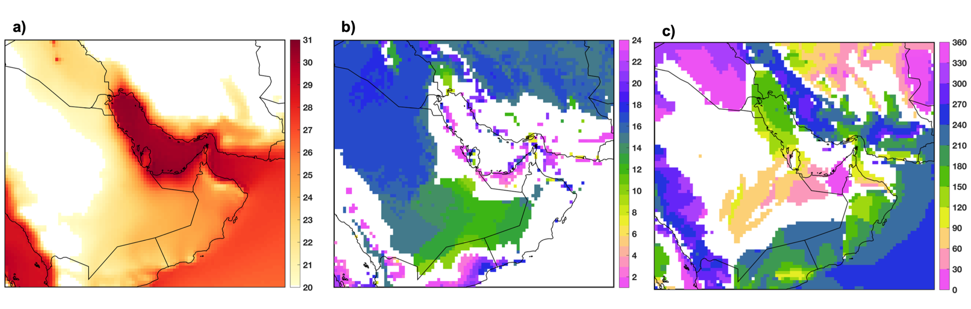
Figure S1: As in Figure 1 but with a larger geographic domain.

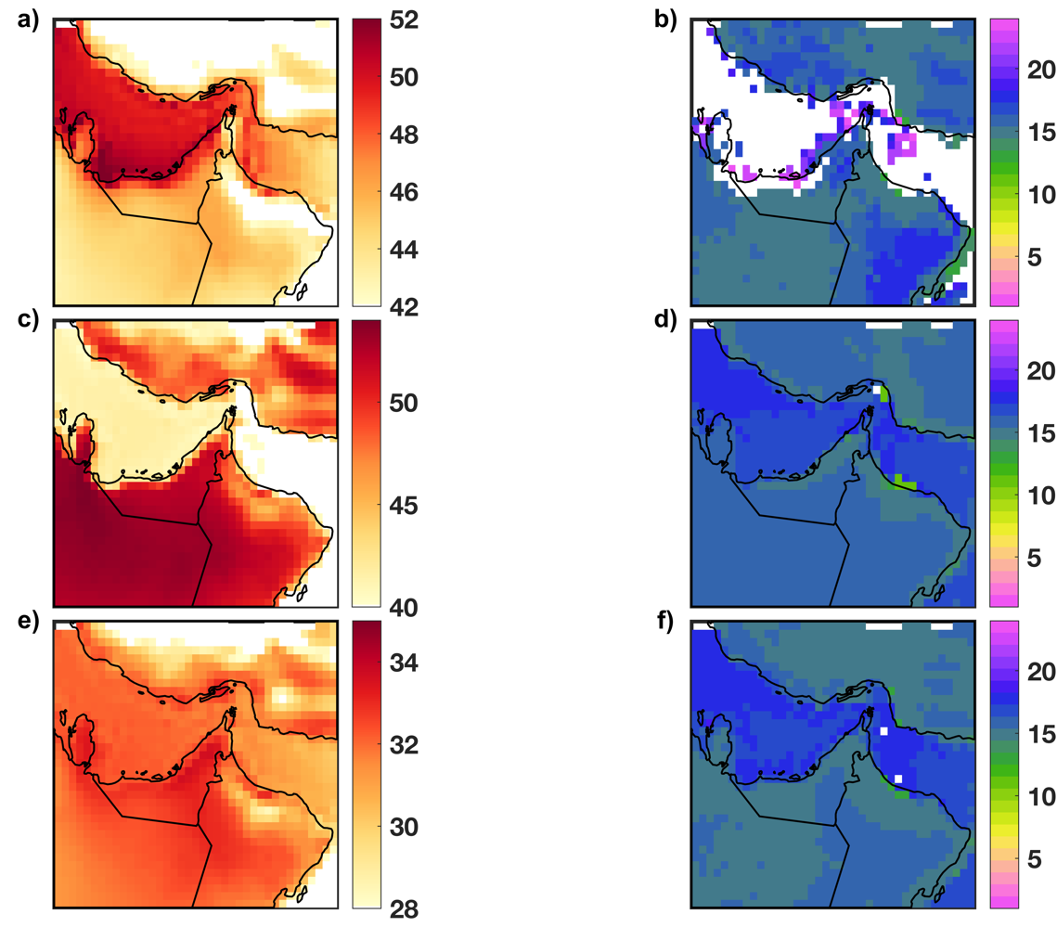
Figure S2: Key characteristics of humid heat as measured by heat index, Universal Thermal Climate Index (UTCI), and wet-bulb globe temperature (WBGT). (a) 95th percentile of heat index (°C) across all June-July-August days, 2000-2020, at each ERA5 gridcell (shading). (b) Hours (LST) for which a 6-hour surrounding window encompasses the largest number of >=95th-percentile daily-maximum heat-index values, with a minimum of 50%. Blank areas are those where no hour meets this criterion. (c,d) As in (a,b) but for the UTCI. (e,f) As in (a,b) but for WBGT.

