Supplementary Information
Alloy-Tunable Single-Layer 2D Heterophase Photocatalysts for Efficient Solar Fuel Production
Jiayi Chen^{†1}, Md Nasir Uddin^{†2}, Xiaozhi Liu^{†3}, Rundong Mao¹, Kaili Liu², Hsien-Yi Hsu⁴, Dong Su*³, Yunguo Li*⁵, Ido Hadar⁶, Mark A. Buntine¹, Xuyong Yang⁷, Zongyou Yin*², and Guohua Jia*¹
¹ School of Molecular and Life Sciences, Curtin University, Bentley, WA 6102, Australia
² Research School of Chemistry, Australian National University, Canberra, ACT 2600, Australia
³ Beijing National Laboratory for Condensed Matter Physics, Institute of Physics, Chinese Academy of Sciences, Beijing 100190, China
⁴ School of Energy and Environment & Department of Materials Science and Engineering, City University of Hong Kong, Kowloon Tong, Hong Kong, China, and Shenzhen Research Institute of City University of Hong Kong, Shenzhen, 518057, China
⁵ CAS Key Laboratory of Crust−Mantle Materials and Environments, School of Earth and Space Sciences, University of Science and Technology of China, Hefei, Anhui 230026, China
⁶ Institute of Chemistry, and the Center for Nanoscience and Nanotechnology, The Hebrew University of Jerusalem, Jerusalem 91904, Israel
⁷ Key Laboratory of Advanced Display and System Applications of Ministry of Education, Shanghai University, Shanghai 200072, P. R. China
† These authors contribute equally to this work.
Corresponding authors E-mail: guohua.jia@curtin.edu.au; zongyou.yin@anu.edu.au; dongsu@iphy.ac.cn; liyunguo@ustc.edu.cn

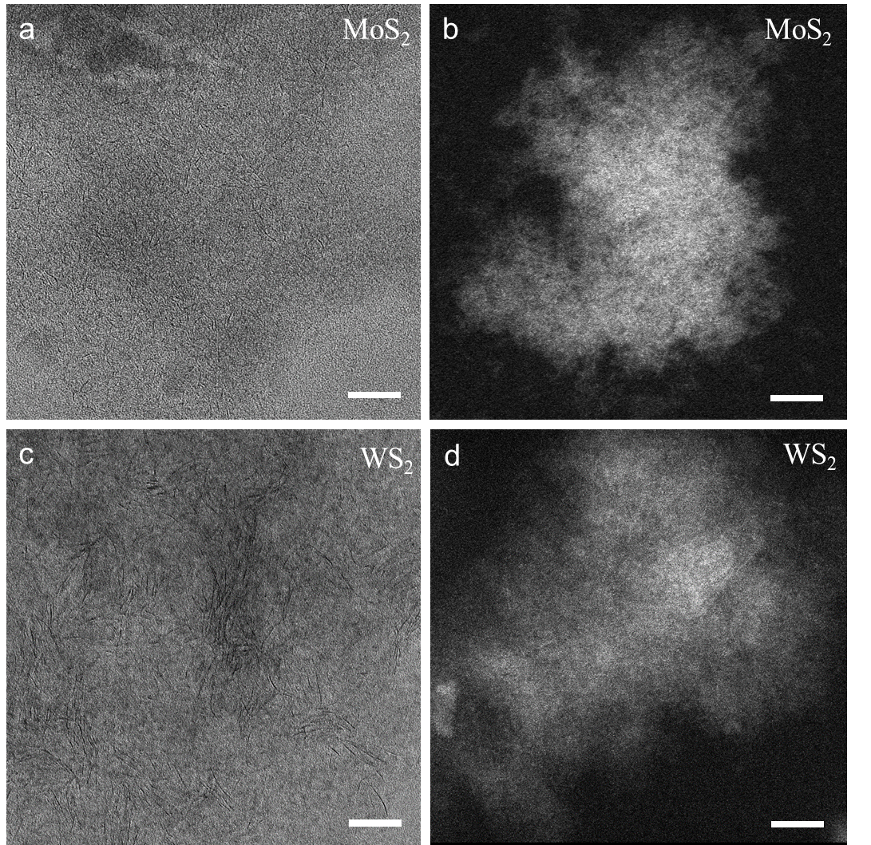
Supplementary Fig. 1 BF-TEM and STEM-HAADF images of (a-b) MoS₂ and (c-d) WS₂, respectively. All scale bars are 20 nm.

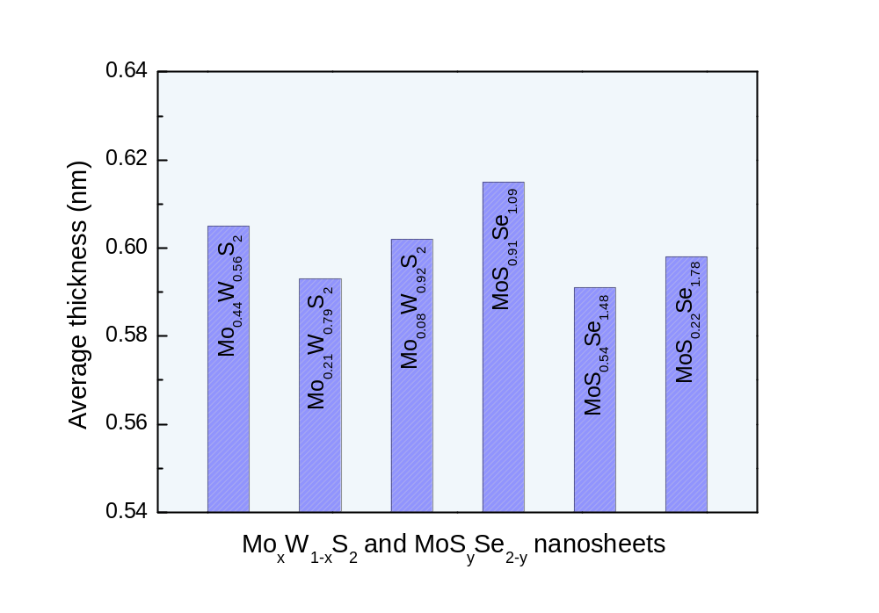
Supplementary Fig. 2 Thickness histogram of alloyed singly-layer Mo_{x}W_{1-x}S₂ and MoS_{y}Se_{2-y} nanosheets.

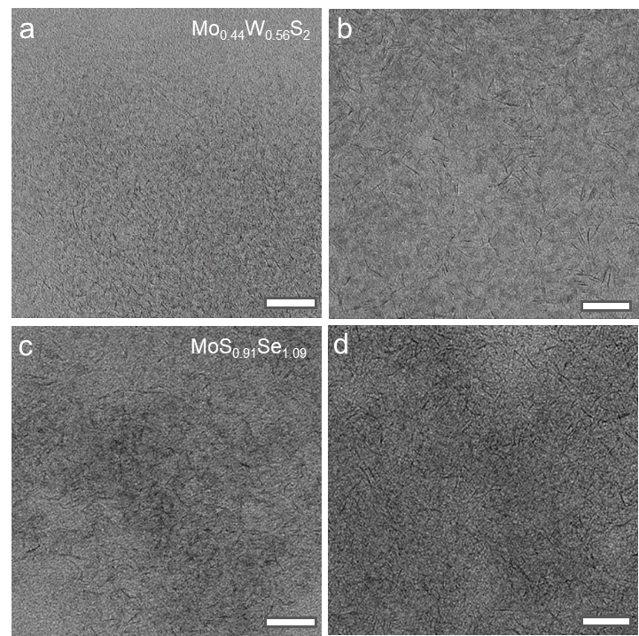
Supplementary Fig. 3 TEM images of single-layer Mo_{x}W_{1-x}S₂ and MoS_{y}Se_{2-y} nanosheets. The scale bars are 20 nm.

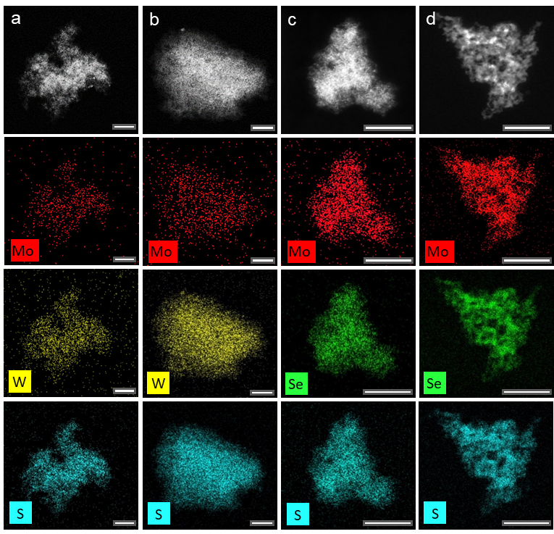
Supplementary Fig. 4 (a-d) HAADF-STEM images of Mo_{0.44}W_{0.56}S₂, Mo_{0.08}W_{0.92}S₂, MoS_{0.91}Se_{1.09} and MoS_{0.22}Se_{1.78} nanosheets and the corresponding STEM-EDS elemental mappings of Mo, W, S and Se. All scale bars are100 nm.

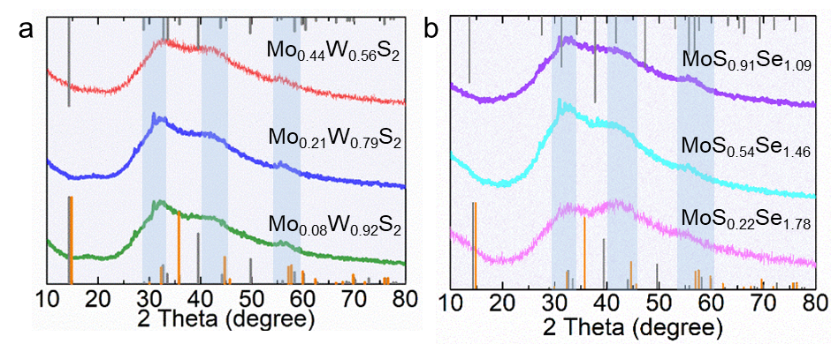
Supplementary Fig. 5 (a) XRD patterns of synthesised single-layer Mo_{x}W_{1-x}S₂ nanosheets, the orange lines on the bottom are patterns of 1T phase MoS₂ (ICSD: 254956), the grey lines on the bottom and the top are patterns of 2H phase MoS₂ (PDF#37-1492) and 2H phase WS₂ (PDF#08-0237), respectively. (b) XRD patterns of synthesised single-layer MoS_{x}Se_{2-x} nanosheets, the orange lines on the bottom are patterns of 1T phase MoS₂ (ICSD: 254956), the grey lines are patterns of 2H phase MoS₂ (PDF#37-1492) and 2H phase MoSe₂ (PDF#29-0914), respectively.

Supplementary Table 1
Calculated molecular formula of Mo_{x}W_{1-x}S₂ with different molar ratio of added reactant.
Molar ratio of added reactant | Molybdenum | Tungsten | Sulfur | Calculated formula
Mo:W = 1:1 | 17.98% | 18.52% | 63.50% | Mo_{0.44}W_{0.56}S₂
Mo:W = 1:3 | 8.29% | 26.37% | 65.34% | Mo_{0.21}W_{0.79}S₂
Mo:W = 1:5 | 23.93% | 30.54% | 45.53% | Mo_{0.08}W_{0.92}S₂

Calculation of element ratio in Mo_{x}W_{1-x}S₂ nanosheets:
2(Mo% + W%) = S%
Mo% + W% + S% = 1,
Therefore,
S% = 66.67%
Mo% = 33.33% - W%.

Supplementary Table 2
Calculated molecular formula of MoS_{x}Se_{2-x} with different molar ratio of added reactant.
Molar ratio of added reactant | Molybdenum | Tungsten | Sulfur | Calculated formula
S:Se = 1:3 | 42.42% | 21.37% | 36.21% | MoS_{0.91}Se_{1.09}
S:Se = 1:4 | 27.61% | 23.71% | 48.68% | MoS_{0.54}Se_{1.46}
S:Se = 1:5 | 31.28% | 9.37% | 59.35% | MoS_{0.22}Se_{1.78}

Calculation of element ratio in MoS_{y}Se_{2-y} nanosheets:
2Mo% = S% + Se%
Mo% + S% + Se% = 1,
Therefore,
Mo% = 33.33%,
S% = 66.67% - Se%.

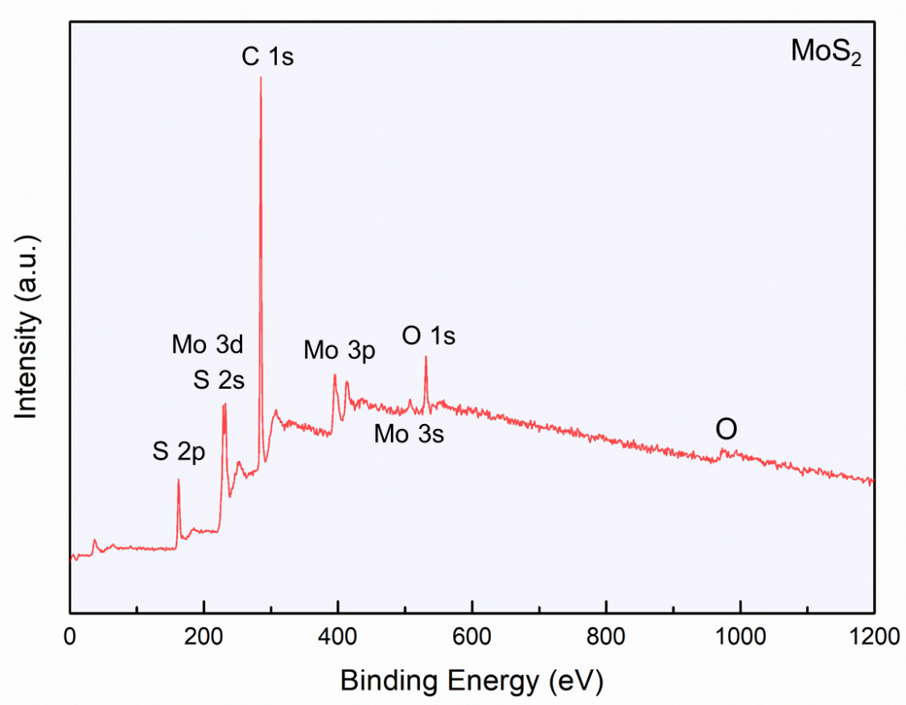
Supplementary Fig. 6 The XPS survey spectrum of single-layer MoS₂ nanosheets.

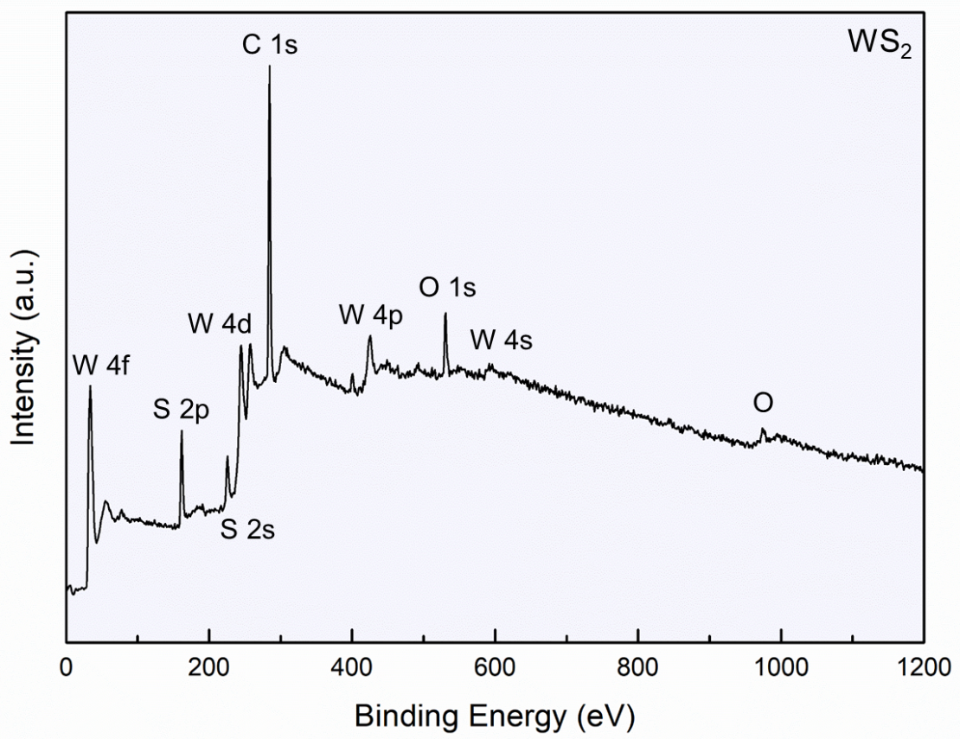
Supplementary Fig. 7 The XPS survey spectrum of single-layer WS₂ nanosheets.
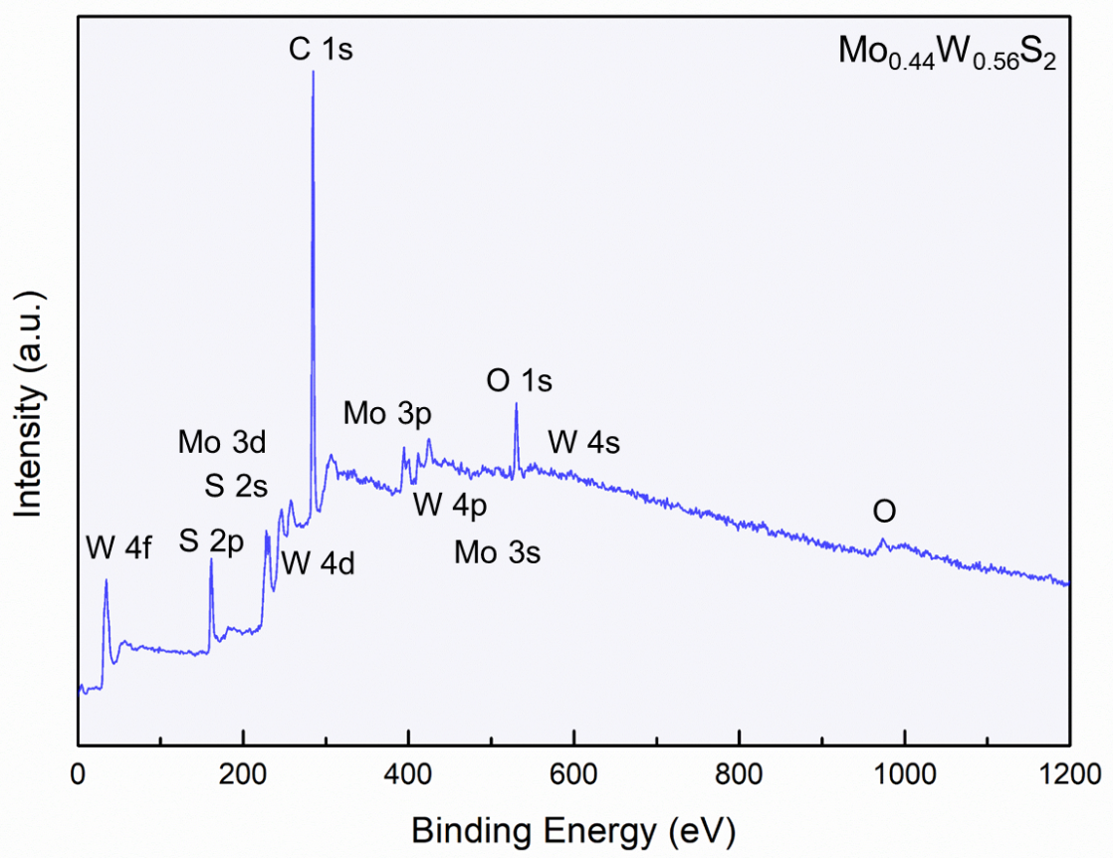
Supplementary Fig. 8 The XPS survey spectrum of single-layer Mo_{0.44}W_{0.56}S₂ nanosheets.

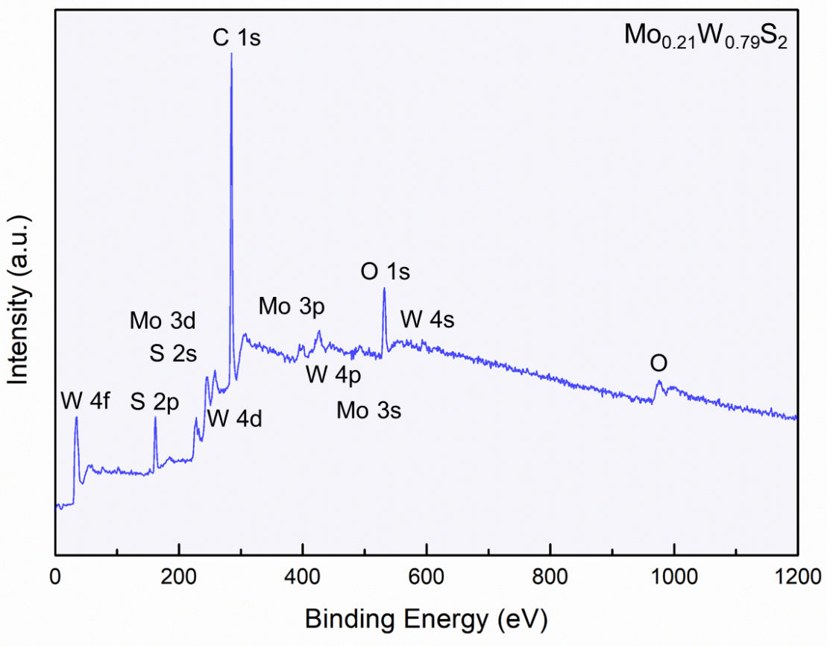
Supplementary Fig. 9 The XPS survey spectrum of single-layer Mo_{0.21}W_{0.79}S₂ nanosheets.
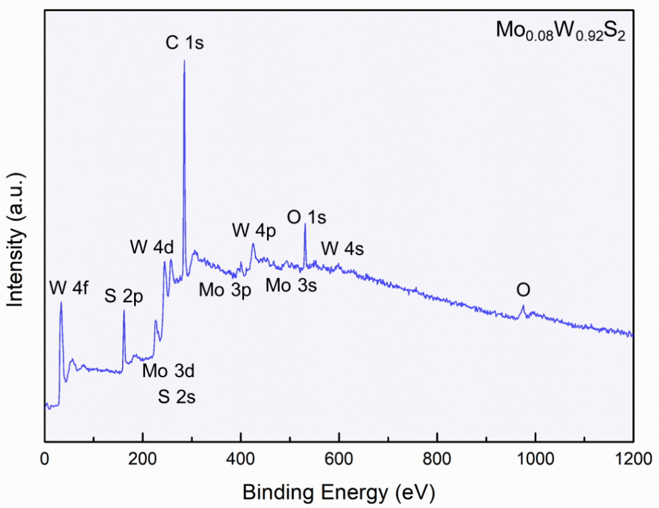
Supplementary Fig. 10 The XPS survey spectrum of single-layer Mo_{0.08}W_{0.92}S₂ nanosheets.

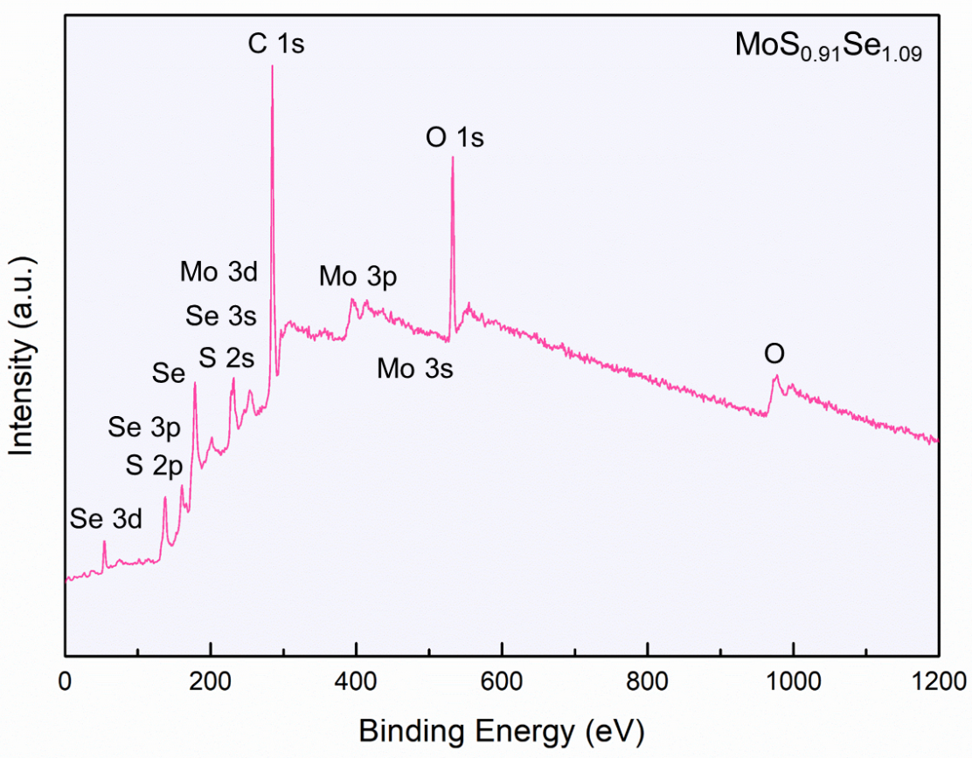
Supplementary Fig. 11 The XPS survey spectrum of single-layer MoS_{0.91}Se_{1.09} nanosheets.
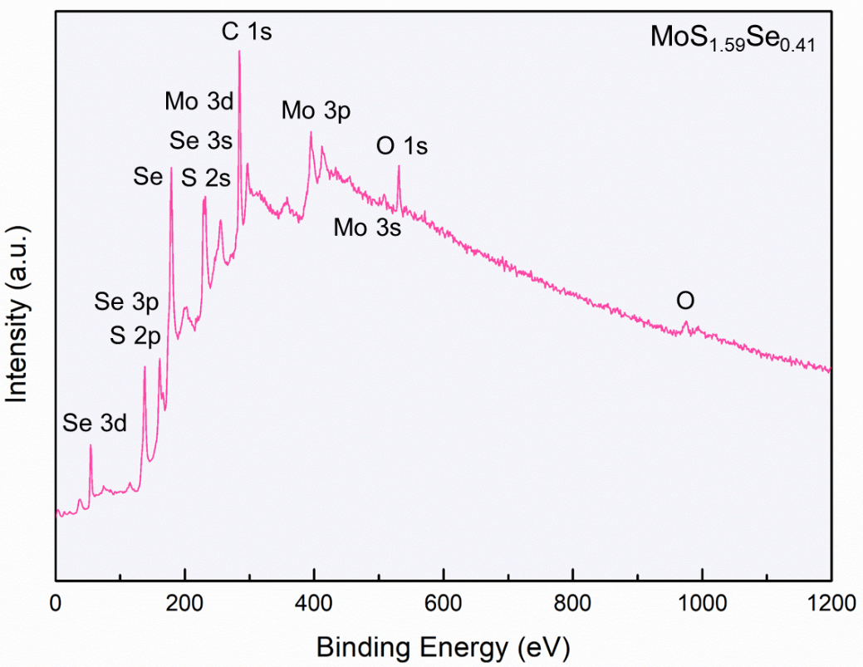
Supplementary Fig. 12 The XPS survey spectrum of single-layer MoS_{1.59}Se_{0.41} nanosheets.

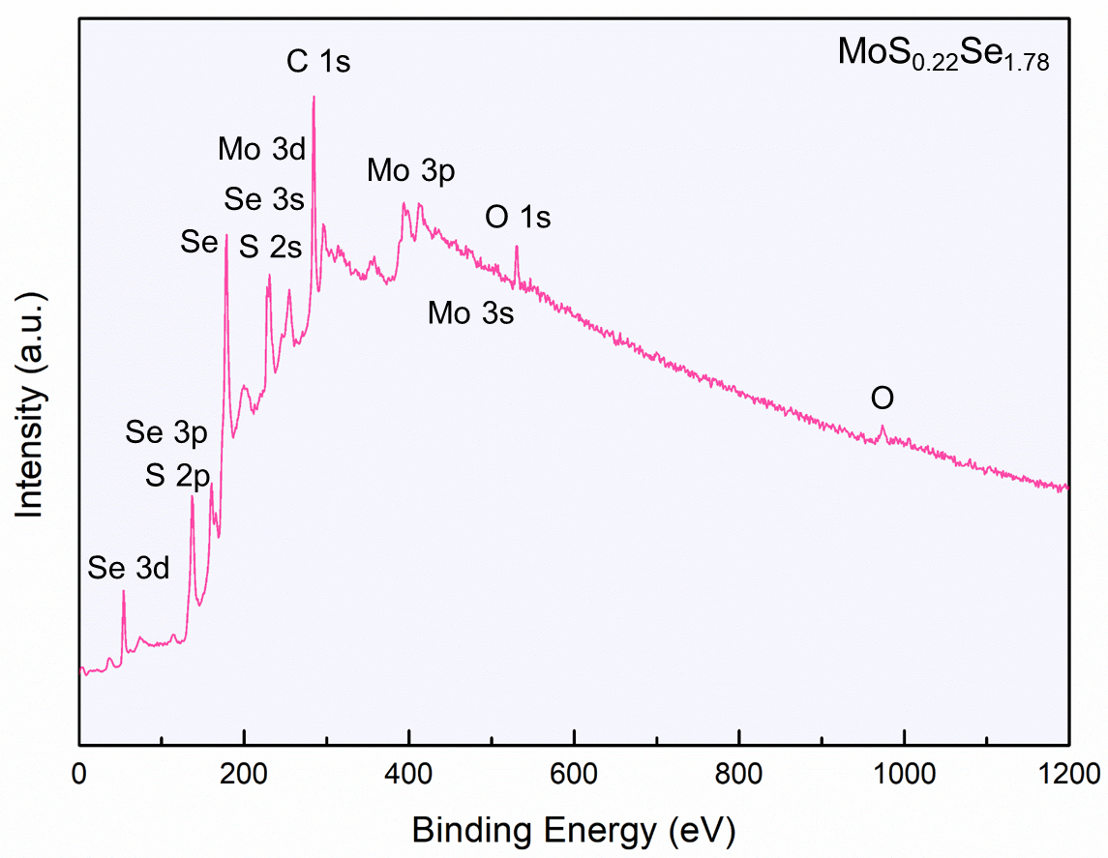
Supplementary Fig. 13 The XPS survey spectrum of single-layer MoS_{0.22}Se_{1.78} nanosheets.
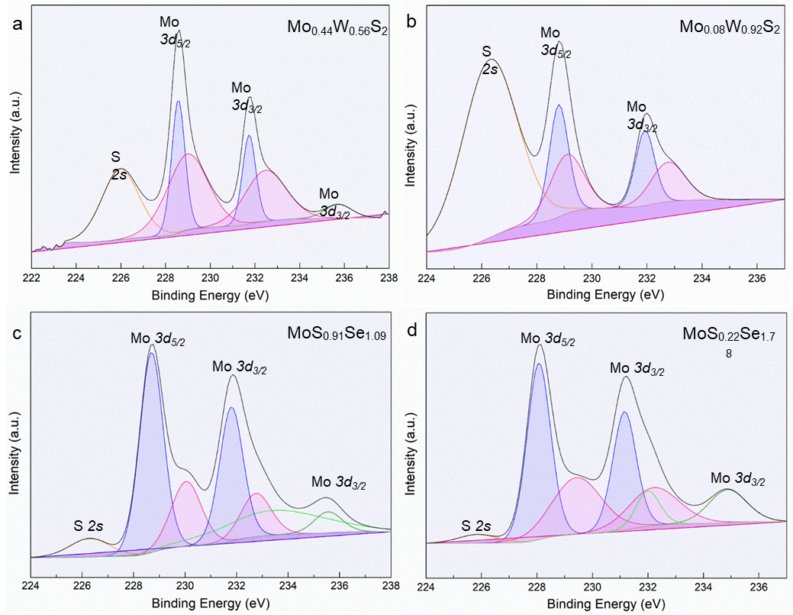
Supplementary Fig. 14 XPS spectra of Mo 3d of (a) Mo_{0.44}W_{0.56}S₂, (b) Mo_{0.08}W_{0.92}S₂, (c) MoS_{0.91}Se_{1.09} and (d) MoS_{0.22}Se_{1.78} nanosheets, the blue and pink areas indicate 1T’ and 2H phase, respectively.

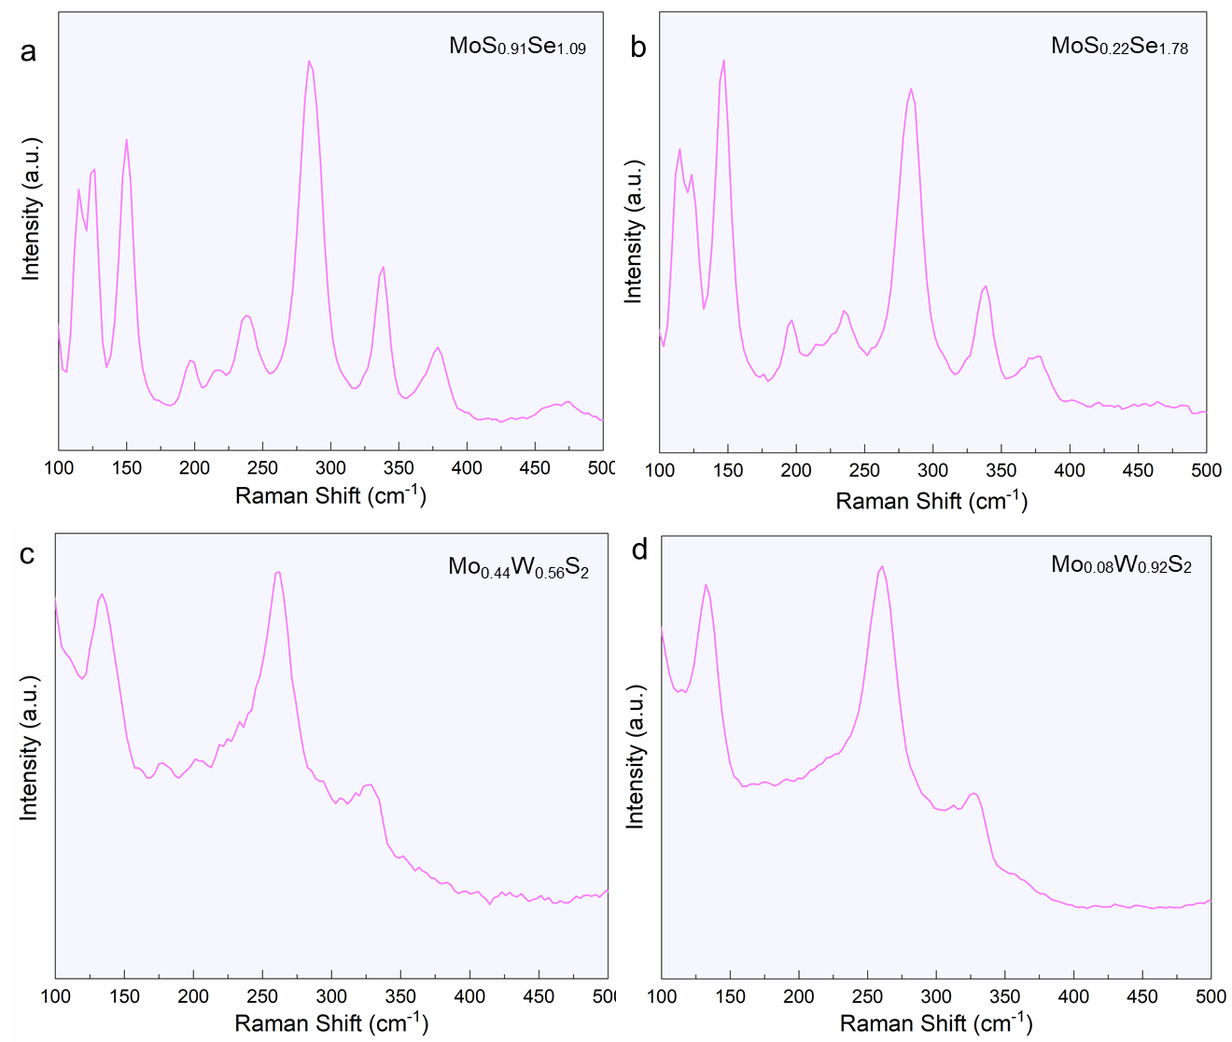
Supplementary Fig. 15 Raman spectra of (a) MoS_{0.91}Se_{1.09}, (b) MoS_{0.22}Se_{1.78}, (c) Mo_{0.44}W_{0.56}S₂ and (d) Mo_{0.08}W_{0.92}S₂ nanosheets, respectively.

Supplementary Table 3
Stability calculation of 1T and 1T’ phase in Mo_{x}W_{1-x}S₂ or MoS_{x}Se_{2-x} nanosheets with different content of W or Se element.
 | X_{W/Se} (%) | 0 | 25 | 5 | 75 | 100
W | E_{1T} (eV) | -20.954 | -21.434 | -21.905 | -22.369 | -22.822
W | E_{1T’} (eV) | -21.248 | -21.736 | -22.225 | -22.707 | -23.183
W | E_{1T} - E_{1T’} (eV) | -0.294 | -0.303 | -0.321 | -0.338 | -0.362
Se | E_{1T} (eV) | -20.954 | -20.540 | -20.121 | -19.695 | -19.264
Se | E_{1T’} (eV) | -21.248 | -20.836 | -20.531 | -20.056 | -19.641
Se | E_{1T} - E_{1T’} (eV) | -0.294 | -0.295 | -0.409 | -0.360 | -0.377

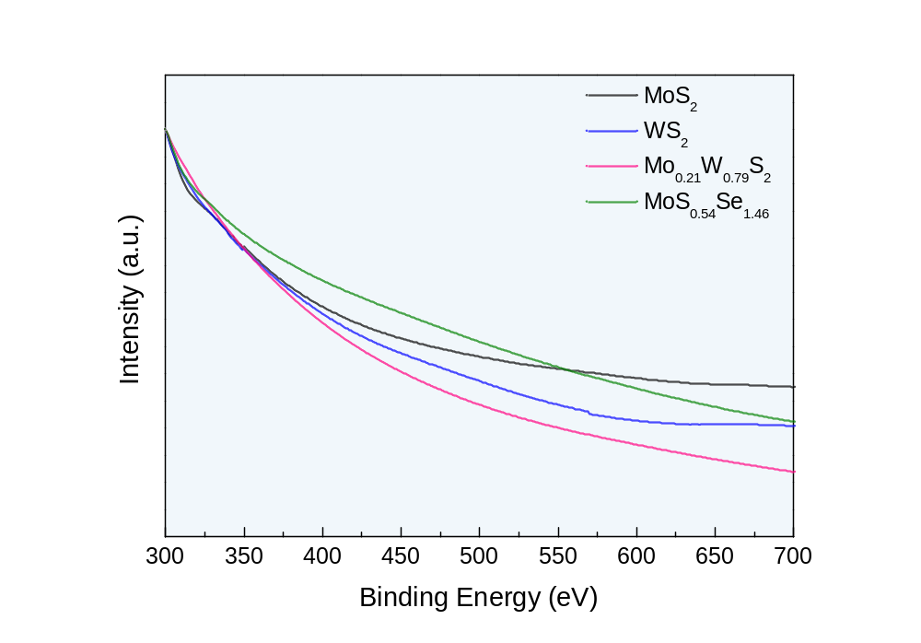
Supplementary Fig. 16 UV-vis spectra of singly-layer MoS₂, WS₂, Mo_{0.21}W_{0.79}S₂ and Mo_{0.08}S_{0.91}Se_{1.09} nanosheets.

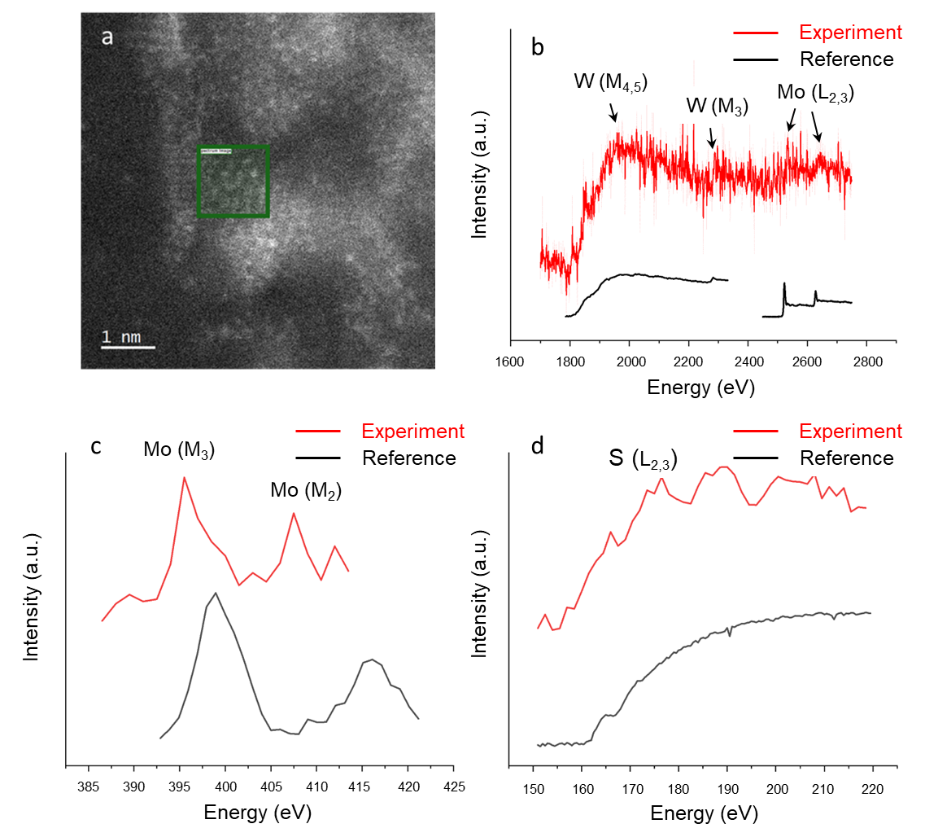
Supplementary Fig. 17 (a) A STEM image of Mo_{0.21}W_{0.79}S₂ nanosheet, (b-d) EELS spectra of Mo-L edges, Mo-M edges, W-M edges and S-L edges. The spectra were acquired in the green area in (a).

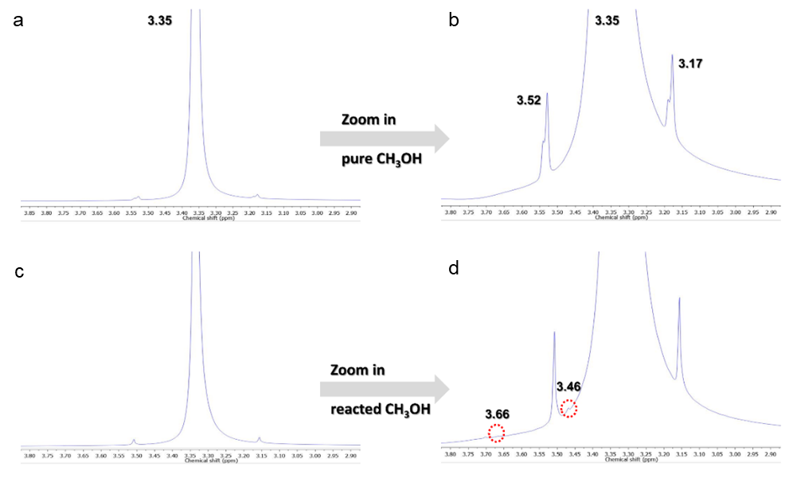
Supplementary Fig. 18 Proton-NMR measurement for hydrogen production from methanol. (a) Pure methanol as the control before light illumination, (b) Zoom in section of pure methanol, (c) Reacted pure methanol after light illumination and (d) Zoom in section of the reacted methanol. Experimental conditions: 3 mL pure and reacted methanol diluted with 4 mL CD₃OD during the measurement with Bruker 400 MHz instrument.

Supplementary Table 4
Bandgap calculation of 2H and 1T’ phase in Mo_{0.21}W_{0.79}S₂ nanosheets.
 | E_{fermi} | E_{vaccum} | E_{VBM} | E_{CBM} | Bandgap
2H - Mo_{0.21}W_{0.79}S₂ | -1.127 | 4.526 | -5.653 | -3.806 | 1.847
1T’ - Mo_{0.21}W_{0.79}S₂ | -2.307 | 3.347 | -5.655 | -5.625 | 0.030

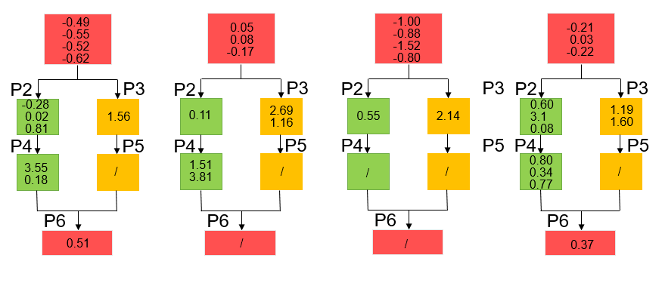
Supplementary Fig. 19 Free energies ΔG (in eV) for elementary reaction processes of hydrogen evolution from methanol catalyzed on Mo-edge-b, Mo-edge-m, Mo-edge-m+d, S-edge-m+d, and S-edge-m edges, respectively. Numbers inside box are ΔG and the number in bold text indicates the lowest one. We stopped exploring further reactions if the lowest ΔG is bigger than 0.5 eV.

