Lateral lamina V projection neuron axon collaterals connect sensory processing across the dorsal horn of the mouse spinal cord

Tyler J Browne^{1*}, Kelly M Smith², Mark A Gradwell³, Christopher V Dayas¹, Robert J Callister¹, David I Hughes⁴, & Brett A Graham¹

¹ School of Biomedical Sciences & Pharmacy, Faculty of Health, University of Newcastle, Callaghan; and Hunter Medical Research Institute (HMRI), New Lambton Heights, NSW, Australia.
² Department of Neurobiology and the Pittsburgh Center for Pain Research, University of Pittsburgh, Pittsburgh, PA 15213, USA.
³ Department of Cell Biology and Neuroscience, Rutgers, The State University of New Jersey, Piscataway, NJ, USA; and W.M. Keck Center for Collaborative Neuroscience, Rutgers, The State University of New Jersey, Piscataway, NJ, USA.
⁴ Institute of Neuroscience Psychology, College of Medical, Veterinary & Life Sciences, University of Glasgow, Glasgow, UK.

Text pages:
Figures:
Tables:

Corresponding author:
T. J. Browne: School of Biomedical Sciences and Pharmacy, Faculty of Health, University of Newcastle, Callaghan, NSW 2308, Australia. Email: Tyler.Browne@newcastle.edu.au

Acknowledgements:
This work was funded by the National Health and Medical Research Council (NHMRC) of Australia (grants 631000, 1043933, 1144638, and 1184974 to B.A.G and R.J.C), the Hunter Medical Research Institute (grant to B.A.G. and R.J.C.), and the BBSRC (grant BB/J000620/1 to D.I.H.). All authors have no conflict of interest to declare.

Virus Class | Construct | Titre (GC/mL) | Source | Cat# | Acknowledgement
Opsin Probe (ChR2) | pAAV-hSyn-hChR2(H134R)-EYFP  (rAAV2-ChR2) | 1.98x10¹² | Addgene | 26973-AAVrg | Gifted by Karl Deisseroth
Fluorescent Reporter | pENN.AAV.CB7.CI.mCherry.WPRE.RBG  (AAV9-RFP) | 2.5x10¹³ | Addgene | 105544-AAV9 | Gift by James M. Wilson
Fluorescent Reporter | pAAV-hSyn-EGFP  (rAAV2-GFP) | 2.3x10¹³ | Addgene | 50465-AAVrg | Gift by Bryan Roth
Cre recombinase | pENN-AAV-hSyn-HI-eGFP-Cre.WPRE.SV40 | 1.9 x 10¹³ | Addgene | 105540-AAVrg | Gift by James M Wilson
Brainbow | AAV-EF1a-BbTagBY | 5.3 x 10¹¹ | Addgene | 45185-AAV9 | Gift from Dawen Cai & Joshua Sanes
Brainbow | AAV-EF1a-BbChT | 1.7 x 10¹² | Addgene | 45186-AAV9 | Gift from Dawen Cai & Joshua Sanes
Antibody | Details | Conc. | Source | Cat#
Primary | Chicken antiGFP | 1:1000 | Abcam | Ab13790
Primary | Goat antiRFP | 1:1000 | Jomar Life research | 200-101-379
Primary | Rabbit Anti-phosphoERK | 1:1000 | Cell Signalling Technologies | #9101
Primary | Chicken anti-mCherry | 1:5000 | Abcam | ab205402
Primary | Rat anti-mTFP | 1:1000 | Kerafast Inc., Boston, MA USA | EMU103
Primary | Guinea Pig anti-TagRFP | 1:500 | Kerafast Inc., Boston, MA, USA | EMU107
Primary | Rabbit anti-NeuN | 1:500 | Abcam | 104225
Supplemental Table 1 : Resources and reagents

Supplemental Figure 4:
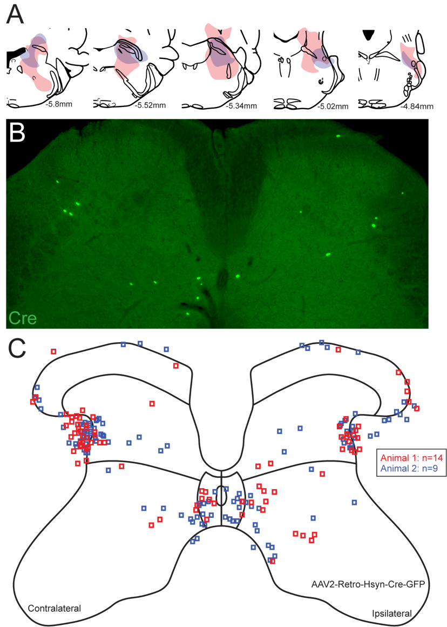

Supplementary Figure 4: Spinal distribution of Cre-recombinase expression following parabrachial nucleus injection of rAAV2-CreGFP. A, maps show brain injection site reconstructions from two animals (red and blue) that received rAAV2-CreGFP injections in PBN to confirm this constructs can transduce LV^{Lat} SPBNs for subsequent Cre-dependent brainbow labelling experiments. Note, both injections spanned the PBNs rostrocaudal extent. B, image shows a transverse spinal cord section (50mm thick) with representative rAAV2-mediated Cre-GFP expression. Note bilateral Cre-GFP expression including profiles located in the LV^{Lat} region. C, summary map showing distribution of Cre-GFP labelled profiles counted across two animals (14 and 9 sections, respectively - red and blue). Labelled profiles were concentrated bilaterally in the LV^{Lat} region, as well as more sparse labelling in the superficial DH, deep DH, LX and intermediate zone.

