Table 1. Acute biodistribution of the small molecule radiotracer for the renal tumor and other organs
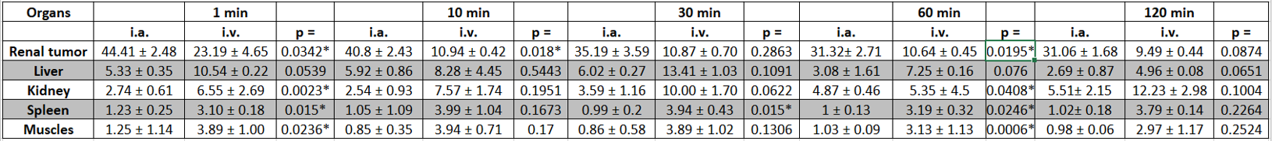

Table 2. Acute biodistribution of the small molecule radiotracer for blood pool and urine excretion
