SUPPLEMENTARY INFORMATION
Supplementary figure 1
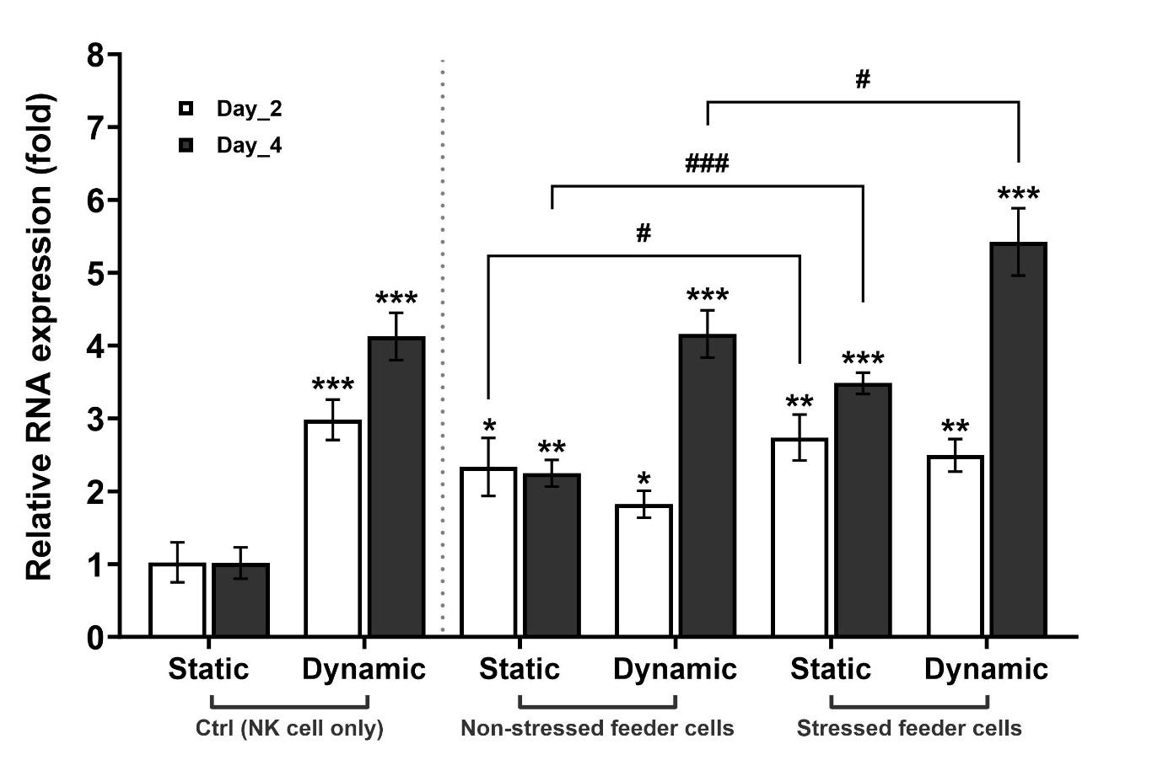
After co-culturing feeder cells and NK cells, the elevation in 4-1BB expression on NK cells was verified through RT-qPCR utilizing the TNFRSF9 gene (4-1BB). Co-culture procedures were consistent with those detailed in the main text. RT-qPCR analysis was performed on samples obtained on days 2 and 4 during the culture period. The results revealed a statistically significant upregulation of expression in all groups, irrespective of the culture method, compared to that in the control.
Furthermore, the disparity in TNFRSF9 expression in response to feeder cells exposed to stress factors was confirmed to be significantly increased in NK cells with stressed feeder cells under static conditions on day 2 and in NK cells with stressed feeder cells under both static and dynamic conditions on day 4.

Supplementary figure 2
(A)
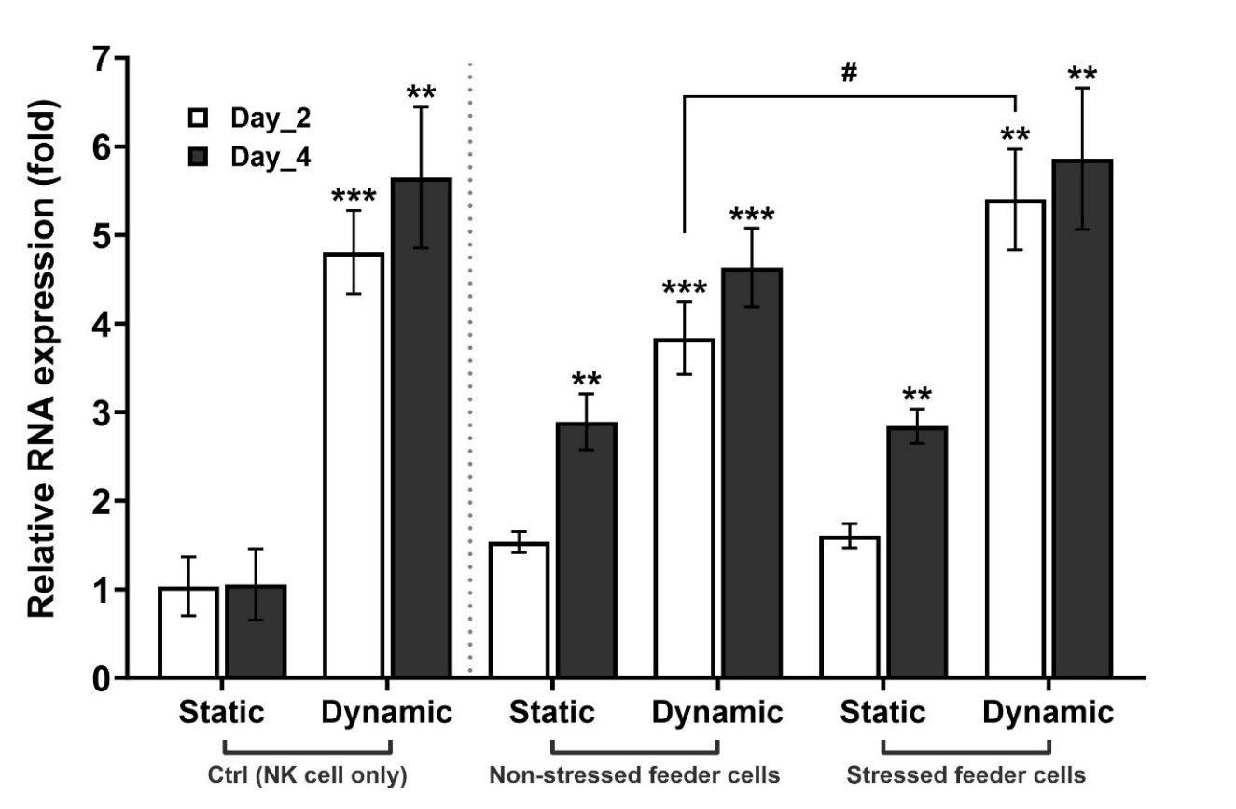
(B)
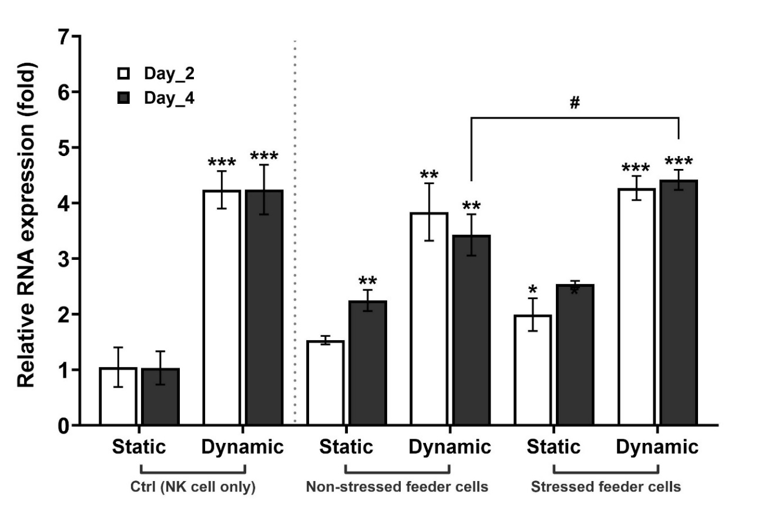
Supplementary figure 2 (Continued)
(C)
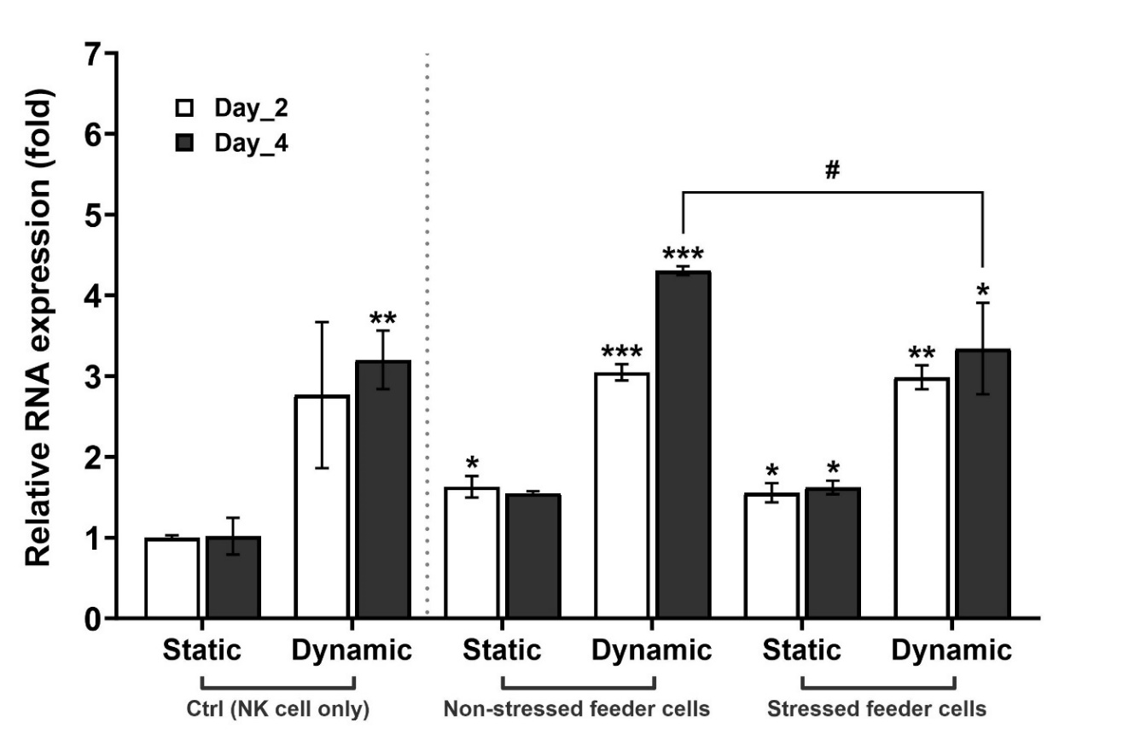
The heightened cytokine release from NK cells following co-culture with feeder cells was confirmed through RT-qPCR utilizing (A) IFN-γ, (B) TNF-α, and (C) IL-10 as marker genes. The analysis revealed an upregulation in the expression of cytokine-related genes.
Initially, the expression of IFN-γ was observed to be significantly upregulated in all groups, except for the two groups involving NK cells with stressed and non-stressed feeder cells under static conditions. The disparity in IFN-γ expression in response to feeder cells exposed to stress factors was determined to be significantly increased in NK cells with stressed feeder cells in dynamic conditions on day 2.
Subsequently, the expression of TNF-α exhibited a statistically significant upregulation in all groups, except for NK cells with non-stressed feeder cells in static conditions. The response of TNF-α expression to feeder cells exposed to stress factors was confirmed to be significantly upregulated in NK cells with stressed feeder cells in dynamic conditions on day 4.
Lastly, the expression of IL-10 was found to be significantly upregulated in all groups, except for the control group, under dynamic conditions. The variation in IL-10 expression in response to stress factor exposure was significantly downregulated in NK cells with stressed feeder cells under dynamic conditions on day 4.

