Supporting Information for
Fault Instability in a Geothermal Reservoir Facilitated by Low-grade Metamorphism
Mengke An^{1, 2}, Fengshou Zhang^{1, 2}, Ki-Bok Min³, Derek Elsworth^{4, 5}, and Chris Marone⁵
¹Department of Geotechnical Engineering, College of Civil Engineering, Tongji University, Shanghai 200092, China
²Key Laboratory of Geotechnical & Underground Engineering of Ministry of Education, Tongji University, Shanghai 200092, China
³Department of Energy Resources Engineering, College of Engineering, Seoul National University, Gwanak-ro 1, Seoul 08826, Republic of Korea
⁴Department of Energy and Mineral Engineering, EMS Energy Institute and G3 Center, The Pennsylvania State University, University Park, PA 16802, USA
⁵Department of Geosciences, The Pennsylvania State University, University Park, PA 16802, USA

Contents of this file
Figures S1 to S12, Tables S1 to S2
Introduction
The supporting information includes 12 figures (Figures S1-S12) and two tables (Tables S1-S2). Figure S1 shows the location of Pohang and the granodiorite fractures with metamorphism. Figure S2 exhibits the XRD results of one natural fracture. The particle size distribution and XRD results of epidote and chlorite gouge are shown in Figures S3 and S4, respectively. Figure S5 shows the schematic plot of the triaxial shearing apparatus. Examples of methods for determining the values of Δμ are shown in Figure S6. Friction-displacement curves for all experiments are listed in Figures S7 and S8. The microstructures for all experiments are compared in Figures S9 and S10. Figure S11 compares the coefficient of friction and values of (a – b) for epidote/chlorite mixed gouge with different structures. Figure S12 shows the distribution of epidote and chlorite minerals in deformed gouge samples after the shear experiments. Table S1 summarizes the experiment details and Tables S2 shows the calculated friction constitutive data for all experiments.
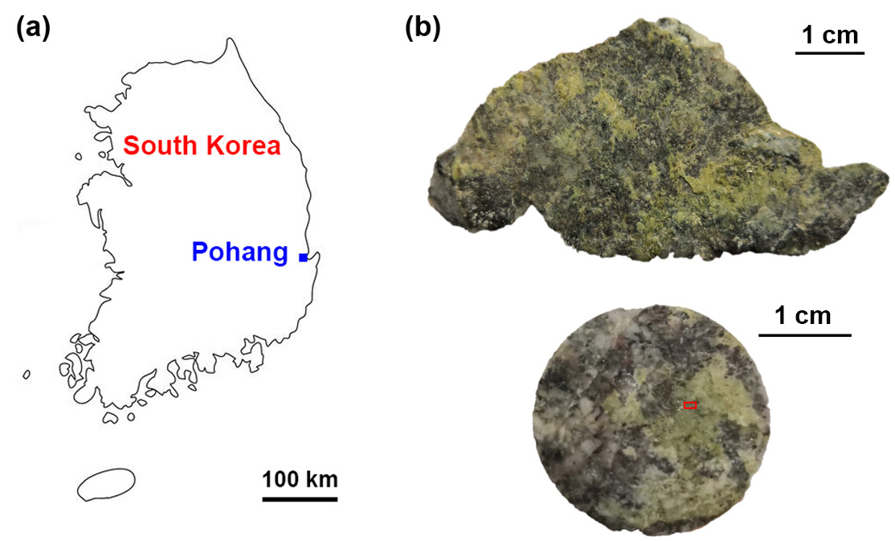

Figure S1. (a) The location of Pohang in South Korea. (b) Granodiorite fractures recovered from cores at the depth of 4.2 km of the Pohang geothermal reservoir with evident metamorphism (green surfaces). The SEM images in Figure 1 were taken from the areas in the red rectangle of (b).

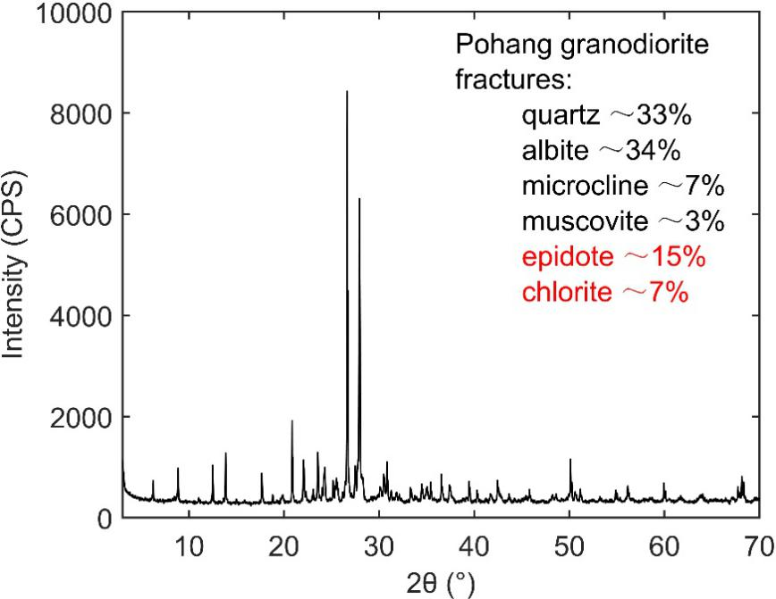

Figure S2. X-ray diffraction (XRD) results of one Pohang granodiorite natural fracture.

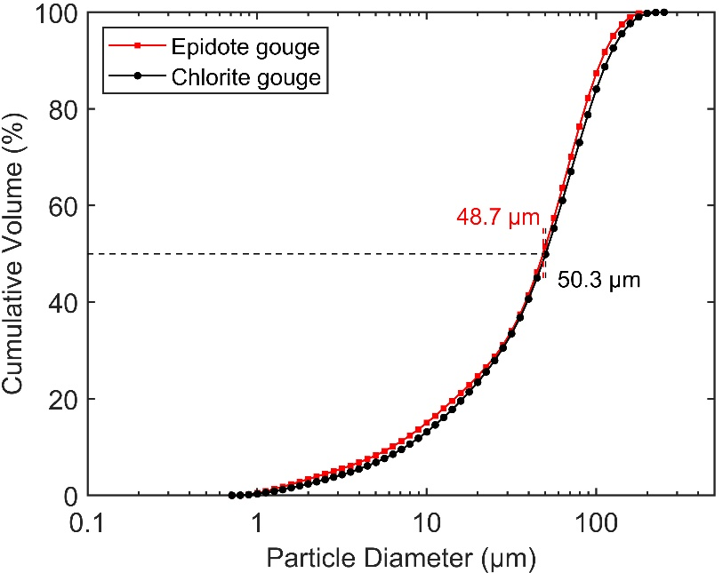

Figure S3. Particle size distribution of the epidote and chlorite gouge for shear experiments. The median particle sizes of epidote and chlorite gouge are 48.7 and 50.3 μm, respectively.

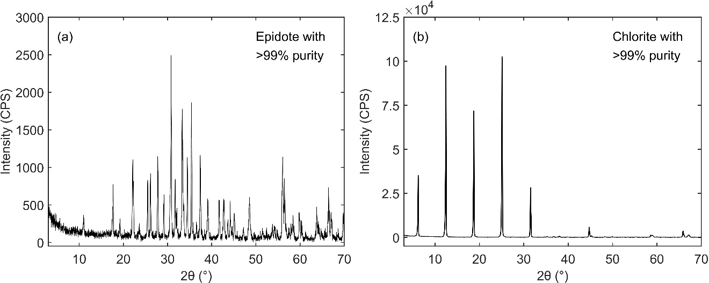

Figure S4. XRD results of the epidote and chlorite gouge for shear experiments. Both epidote and chlorite have >99% purity.

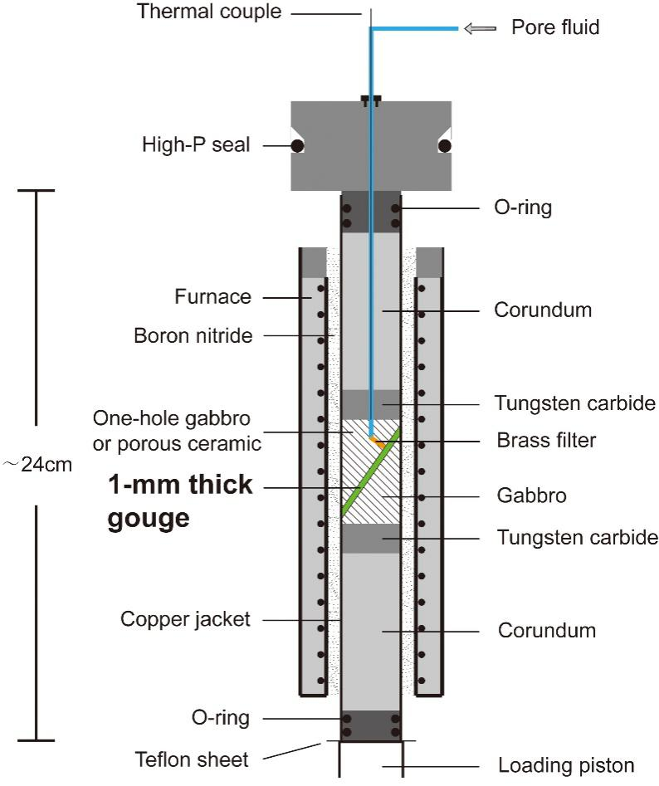

Figure S5. Schematic plot of the triaxial shearing apparatus. O-rings on both sides of the copper jacket were adopted to prevent the argon gas medium into the gouge space. The high-P seal in the upper piston was used to prevent the leakage of argon gas and keep the sealing of the whole assembly. A thermal couple was inserted in the pore fluid inlet to monitor the gouge temperature during the experiments. The space between the copper jacket and furnace was filled with good thermal boron nitride to prevent the convection of argon gas.

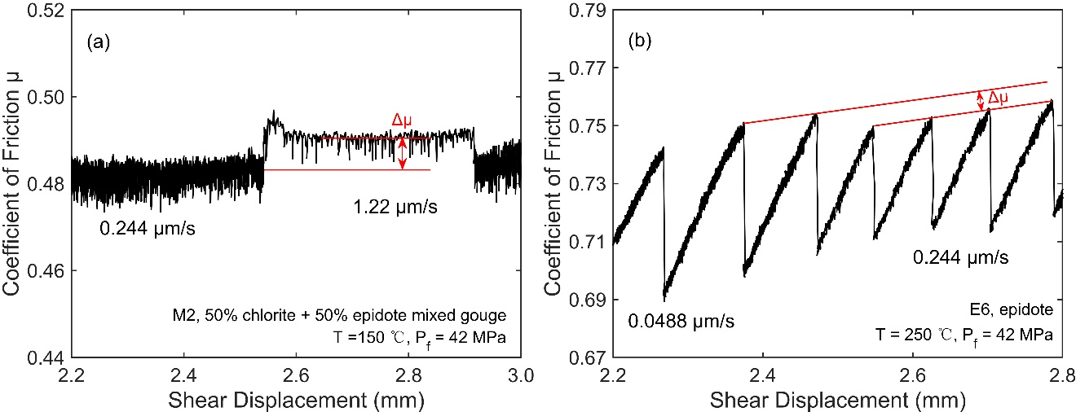

Figure S6. Examples for determining the values of Δμ at conditions of (a) velocity strengthening (testing ID, M2) and (b) stick-slip (testing ID, E6). For velocity strengthening/weakening sequence, values of Δμ are calculated by the difference of the steady state coefficients of friction before and after a velocity step. For stick-slip sequence, values of Δμ are roughly estimated by the difference of the peak coefficients of friction before and after a velocity step.

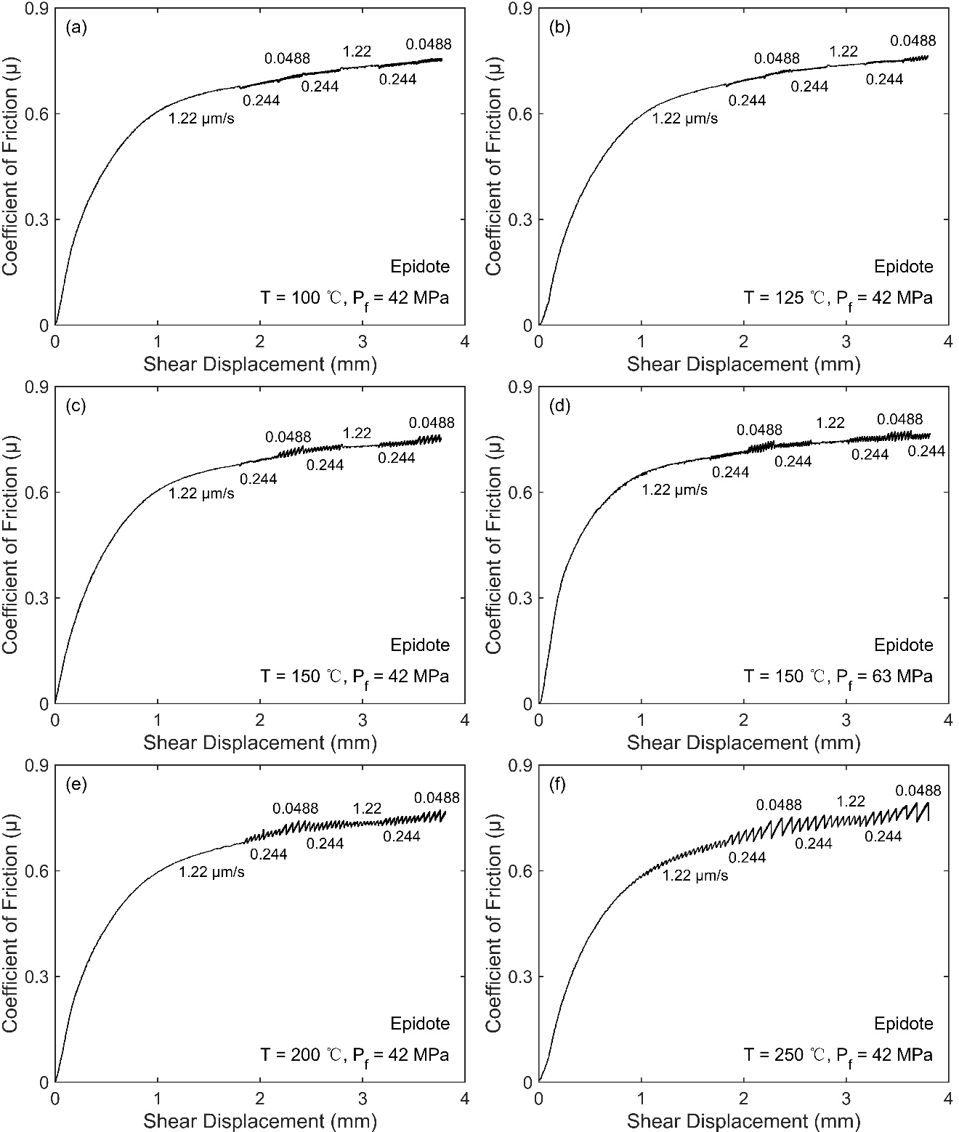

Figure S7. Coefficient of friction-shear displacement curves for epidote gouge at σ_{c} = 110 MPa and varied temperatures and pore fluid pressures. Experiment conditions: (a) T = 100 ℃, P_{f} = 42 MPa, (b) T = 125 ℃, P_{f} = 42 MPa, (c) T = 150 ℃, P_{f} = 42 MPa, (d) T = 150 ℃, P_{f} = 63 MPa, (e) T = 200 ℃, P_{f} = 42 MPa, and (f) T = 250 ℃, P_{f} = 42 MPa.

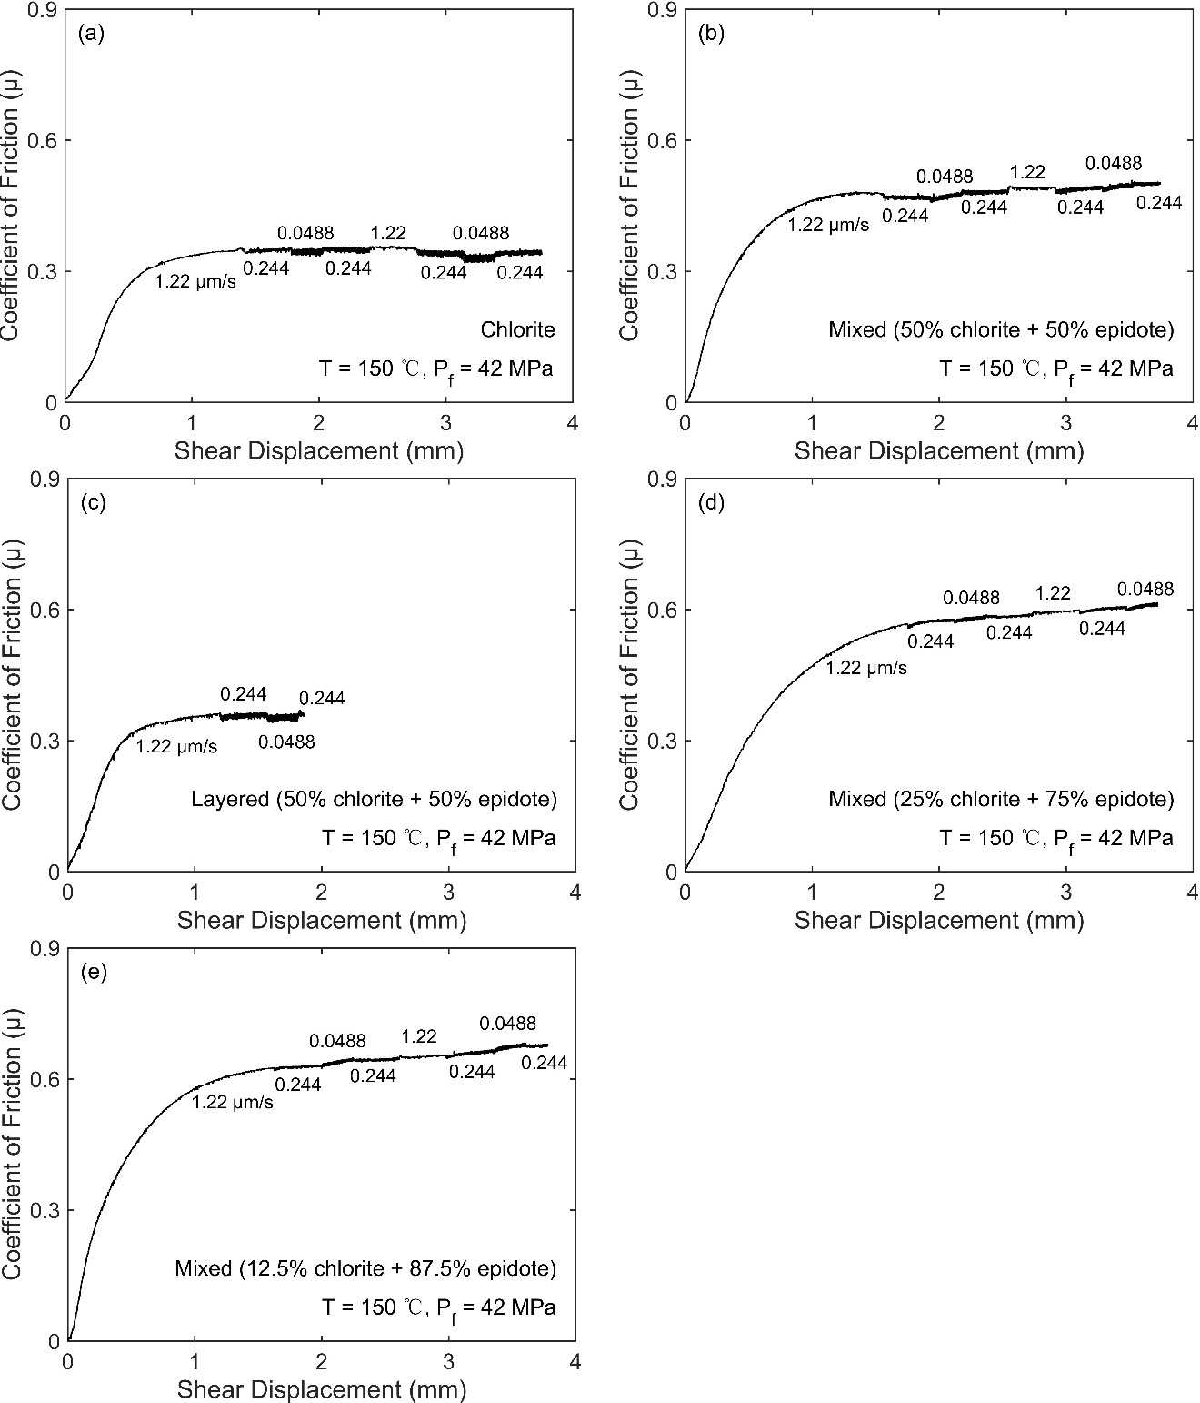

Figure S8. Coefficient of friction-shear displacement curves for epidote/chlorite mixed gouge at σ_{c} = 110 MPa, T = 150 ℃ and P_{f} = 42 MPa. Experiment conditions: (a) 100% chlorite gouge, (b) 50% chlorite + 50% epidote mixed gouge, (c) 50% chlorite + 50% epidote layered gouge, (d) 25% chlorite + 75% epidote mixed gouge, and (e) 12.5% chlorite + 87.5% epidote mixed gouge. The gouge samples in (c) underwent early copper jacket failure and only three velocity steps were conducted.

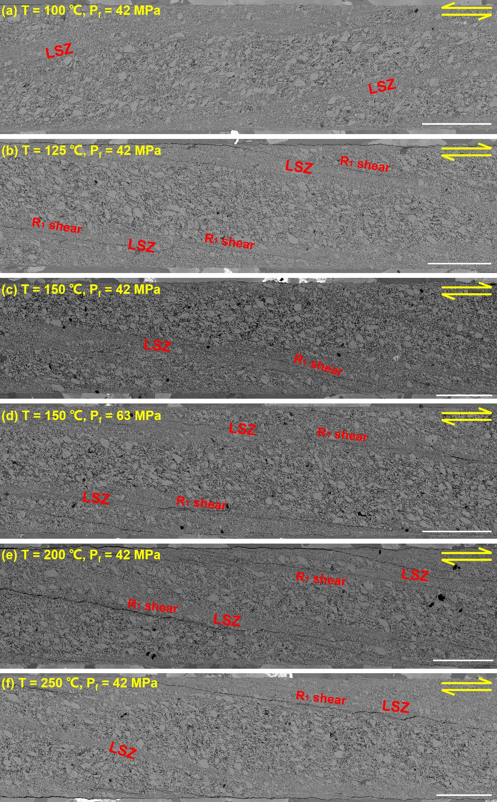

Figure S9. Microstructures (backscattered images) of the deformed epidote gouge after shear experiments. The terminology in Logan et al. (1992) is adopted to describe the main features. Experiment conditions: (a) T = 100 ℃, P_{f} = 42 MPa, (b) T = 125 ℃, P_{f} = 42 MPa, (c) T = 150 ℃, P_{f} = 42 MPa, (d) T = 150 ℃, P_{f} = 63 MPa, (e) T = 200 ℃, P_{f} = 42 MPa, and (f) T = 250 ℃, P_{f} = 42 MPa. Scale bars, 500 μm. At T = 100 ℃, we observe that the deformed epidote gouge shows minor localized shear zone (LSZ) characterized by particle size reduction. With the temperature elevation, the deformed epidote gouges exhibit evident R₁ shear within the localized shear zone. Only gouge sample in (a) exhibit velocity strengthening and gouge samples in (b)-(f) all show velocity weakening.

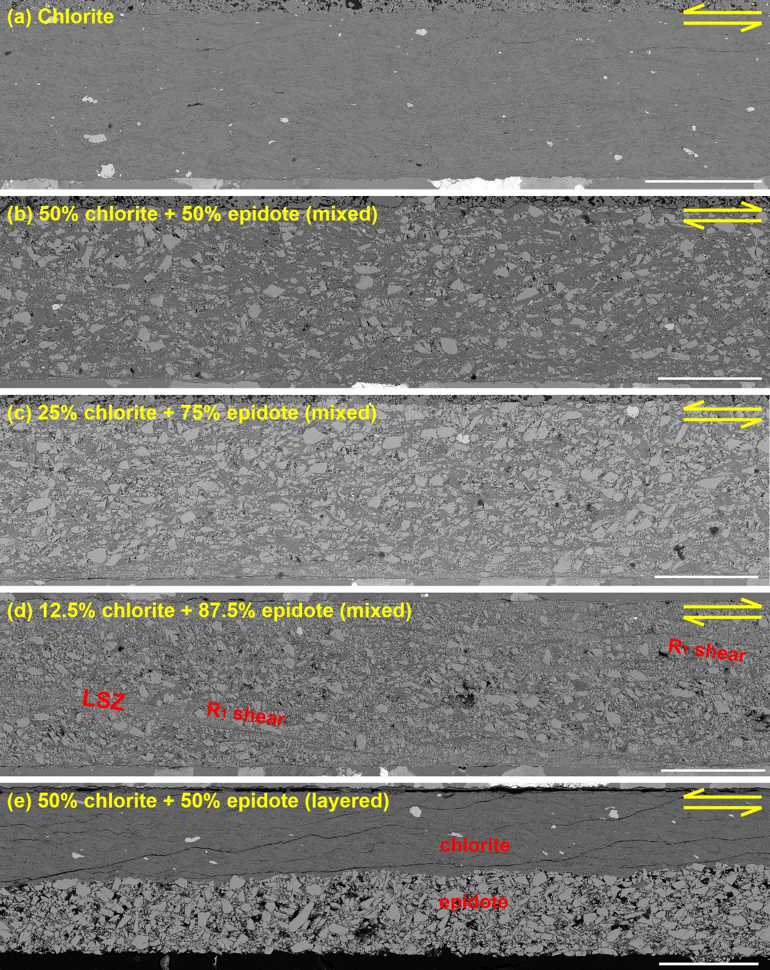

Figure S10. Microstructures (backscattered images) of the deformed epidote/chlorite mixed gouges after shear experiments. Experiment conditions: (a) 100% chlorite gouge, (b) 50% chlorite + 50% epidote mixed gouge, (c) 25% chlorite + 75% epidote mixed gouge, (d) 12.5% chlorite + 87.5% epidote mixed gouge, and (e) 50% chlorite + 50% epidote layered gouge. Scale bars, 500 μm. Gouge samples in (a), (b), (c) and (e) show velocity strengthening, and only gouge sample in (d) exhibit velocity weakening.

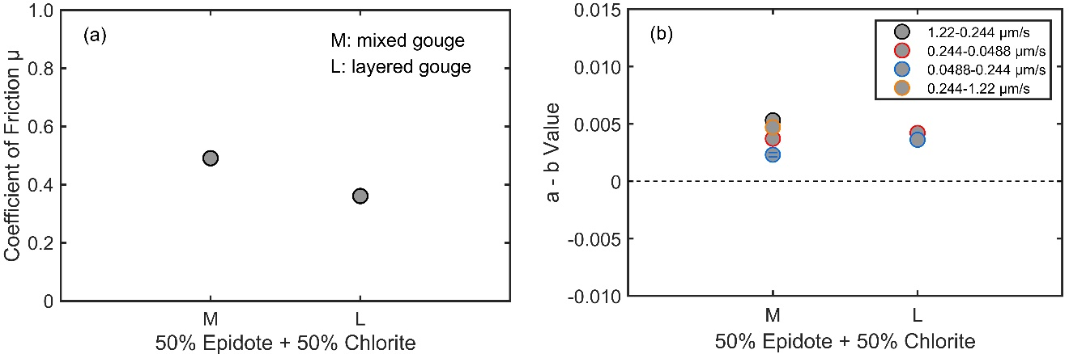

Figure S11. (a) Values of μ and (b) (a – b) versus the gouge structure for 50% epidote + 50% chlorite mixed gouge at σ_{c} = 110 MPa, T = 150 ℃ and P_{f} = 42 MPa.

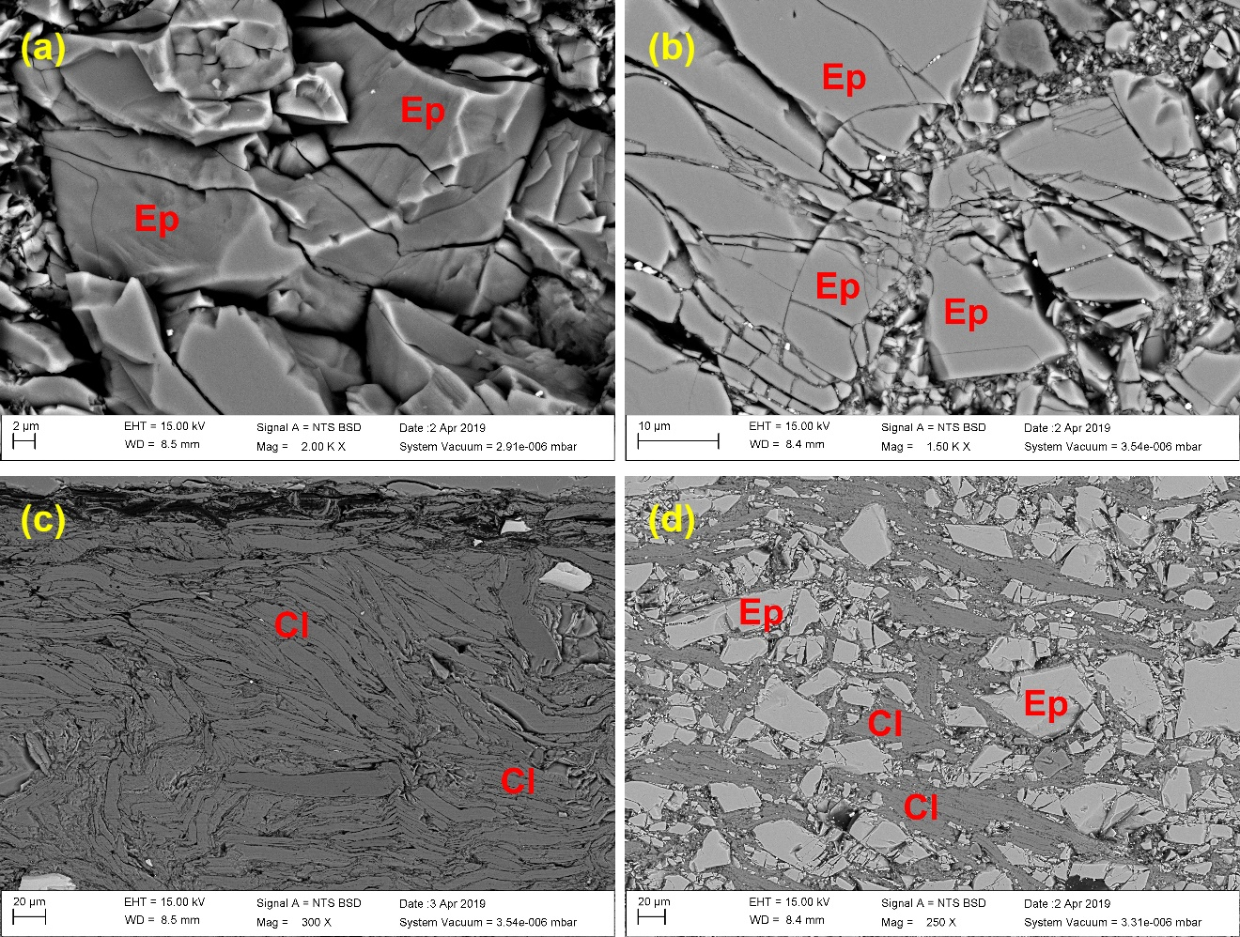

Figure S12. (a) Microcracks forming in the epidote (Ep) particle after the shear experiments. (b) Extrusion of two epidote particles after the shear experiments. (c) Layered structures of chlorite (Cl). (d) Distribution of epidote and chlorite particles in the 50% epidote + 50% chlorite mixed gouge.

Testing ID | Gouge | T (℃) | σ_{c} (MPa) | P_{f} (MPa) | Type of motion | l_{final} (mm)
E1 | Epidote | 100 | 110 | 42 | vs, vw | 3.78
E2 | Epidote | 125 | 110 | 42 | vs, vw | 3.80
E3 | Epidote | 150 | 110 | 42 | vw, ss | 3.77
E4 | Epidote | 150 | 110 | 63 | vw, ss | 3.82
E5 | Epidote | 200 | 110 | 42 | ss | 3.81
E6 | Epidote | 250 | 110 | 42 | ss | 3.80
M1 | Chlorite | 150 | 110 | 42 | vs | 3.76
M2 | Mixed (50% chlorite + 50% epidote) | 150 | 110 | 42 | vs | 3.74
M3 | Layered (50% chlorite + 50% epidote) | 150 | 110 | 42 | vs | 1.86
M4 | Mixed (25% chlorite + 75% epidote) | 150 | 110 | 42 | vs | 3.73
M5 | Mixed (12.5 % chlorite + 87.5% epidote) | 150 | 110 | 42 | vs, vw | 3.78

Table S1. Experiment details. T = temperature, P_{c} = confining pressure, P_{f} = pore fluid pressure, l_{final} = final shear displacement, vs = velocity strengthening, vw = velocity weakening, ss = stick slip. Mixed gouge: the epidote and chlorite are homogeneously mixed in the fault gouge. Layered gouge: the epidote and chlorite are distributed in layers in the fault gouge.

Testing ID | μ_{ss} | Velocity steps (μm/s) | Average values  of (a – b) | Standard deviations of (a – b)
E1 | 0.733 | 1.22-0.244 | 0.0017 | -
E1 | 0.733 | 0.244-0.0488 | 0 | 0.0007
E1 | 0.733 | 0.0488-0.244 | 0.0009 | -
E1 | 0.733 | 0.244-1.22 | 0.0022 | -
E2 | 0.738 | 1.22-0.244 | -0.0021 | -
E2 | 0.738 | 0.244-0.0488 | -0.0015 | 0.0002
E2 | 0.738 | 0.0488-0.244 | -0.0009 | -
E2 | 0.738 | 0.244-1.22 | 0.0001 | -
E3 | 0.730 | 1.22-0.244 | -0.0039 | -
E3 | 0.730 | 0.244-0.0488 | -0.0062 | 0.0003
E3 | 0.730 | 0.0488-0.244 | -0.0053 | -
E3 | 0.730 | 0.244-1.22 | -0.0057 | -
E4 | 0.745 | 1.22-0.244 | -0.0056 | -
E4 | 0.745 | 0.244-0.0488 | -0.0073 | 0.0021
E4 | 0.745 | 0.0488-0.244 | -0.0063 | 0.0009
E4 | 0.745 | 0.244-1.22 | -0.0062 | -
E5 | 0.734 | 1.22-0.244 | -0.0039 | -
E5 | 0.734 | 0.244-0.0488 | -0.0048 | 0.0003
E5 | 0.734 | 0.0488-0.244 | -0.0057 | -
E5 | 0.734 | 0.244-1.22 | -0.0044 | -
E6 | 0.743 | 1.22-0.244 | -0.0051 | -
E6 | 0.743 | 0.244-0.0488 | -0.0060 | 0.0010
E6 | 0.743 | 0.0488-0.244 | -0.0048 | -
E6 | 0.743 | 0.244-1.22 | -0.0034 | -
M1 | 0.353 | 1.22-0.244 | 0.0053 | -
M1 | 0.353 | 0.244-0.0488 | 0.0054 | 0.0019
M1 | 0.353 | 0.0488-0.244 | 0.0057 | 0.0020
M1 | 0.353 | 0.244-1.22 | 0.0039 | -
M2 | 0.491 | 1.22-0.244 | 0.0053 | -
M2 | 0.491 | 0.244-0.0488 | 0.0037 | 0.0009
M2 | 0.491 | 0.0488-0.244 | 0.0023 | 0.0002
M2 | 0.491 | 0.244-1.22 | 0.0047 | -
M3 | 0.361 | 0.244-0.0488 | 0.0042 | -
M3 | 0.361 | 0.0488-0.244 | 0.0036 | -
M4 | 0597 | 1.22-0.244 | 0.0028 | -
M4 | 0597 | 0.244-0.0488 | 0.0011 | 0.0009
M4 | 0597 | 0.0488-0.244 | 0.0010 | -
M4 | 0597 | 0.244-1.22 | 0.0020 | -
M5 | 0.655 | 1.22-0.244 | 0.0007 | -
M5 | 0.655 | 0.244-0.0488 | -0.0019 | 0.0001
M5 | 0.655 | 0.0488-0.244 | -0.0008 | 0.0003
M5 | 0.655 | 0.244-1.22 | 0.0006 | -

Table S2. Results of coefficient of friction μ and frictional stability parameter (a – b). μ_{ss} = steady state coefficient of friction. Nearly values of μ were evaluated at ~3.0 mm shear displacement and 1.22 μm/s shear velocity. Due to the early failure of copper jacket, the value of μ of M3 was measured at ~1.2 mm shear displacement and 1.22 μm/s shear velocity. Values of (a – b) were calculated from the second velocity step to ensure that the data are qualified in their steady states. The raw data were recorded with the sampling frequency of 1 Hz. To compensate for the effects of the variation of gouge contact area and the shear resistance of the copper jacket, the recorded stress and displacement data were corrected by the method described in He et al. (2006).

