OTHER BINNING APPROACHES
We expanded our primary analysis by using a median-split analysis to divide the trials in two-bins. The pattern of results did not change with this new bin configuration as indicated by the significant differences in accuracy (accuracy _{above-median bin} = 0.75 ± 0.01, accuracy _{below-median bin} = 0.72 ± 0.01, t₁₁₅ = -3.71, p < 0.01) and d' (d’ _{above-median bin} = 1.65 ± 0.07, d’ _{below-median bin} = 1.46 ± 0.07, t₁₁₅ = -3.10, p < 0.01) between above-median and below-median IAF bins.
The results were further corroborated when we used a quartile approach to bin the data. One way ANOVA showed a significant effect of the quartile on accuracy (F _{3,354} = 8.84, p < 0.001) and on d’ (F _{3,354} = 6.72, p < 0.01). Post hoc analysis using one-tail paired ttest showed that accuracy in the first quartile (accuracy _{first quartile} = 0.72 ± 0.01) and in the second quartile (accuracy _{second quartile} = 0.73 ± 0.01) were statistically different from the accuracy computed when considering the third (accuracy _{third quartile} = 0.75 ± 0.01) and the fourth quartile (accuracy fourth _{quartile} = 0.75 ± 0.01, all t₁₁₅ > 3.14, all p < 0.01). Other comparisons did not reach the significance level (all t₁₁₅ < 1.2, all p > 0.23). Similarly, d’ in the first quartile (d _{first quartile} = 1.39 ± 0.07) and in the second quartile (d _{second quartile} = 1.37 ± 0.07) were statistically different from the d’ computed when considering the third (d third _{quartile} = 1.61 ± 0.07) and the fourth quartile (d fourth _{quartile} = 1.51 ± 0.07, all t₁₁₅ > 2.39, all p < 0.019). Other comparisons did not reach significance (all t₁₁₅ < 1.45, all p > 0.15).
We conducted an ANOVA comparing accuracy, d' and criterion across the second phase bin along with the first and third bins. Significant values were obtained when considering accuracy (F _{2,230} = 7.22, p < 0.001) and d’ (F _{2,230} = 5.17, p < 0.01), but not criterion (F _{2,230} = 2.13, p = 0.13). These results testify that a significant difference exists between the three terciles. Post hoc analyses using one-tail paired ttest revealed significant differences in accuracy and d' between the first and third bins (as reported in the main text). Regarding accuracy, there was also a difference between the first and the second bin (t ₁₁₅ = -1.87, p = 0.03) and between the second and the third bin (t ₁₁₅ = -1.92, p = 0.03) Moreover, a significant difference emerged between the second and the third bins when considering d’ (t ₁₁₅ = -1.92, p = 0.02) but no differences when comparing the first and the second bin (t ₁₁₅ = -1.32, p = 0.09).
Additionally, we provide regression analyses that demonstrate a significant positive slope for accuracy (mean slope = 0.016 ± 0.001, t ₁₁₅ ₌ 3.71, p < 0.01) and d' (mean slope = 0.09 ± 0.03, t ₁₁₅ ₌ 3.09, p < 0.01) but not for criterion (mean slope = -0.02 ± 0.001, t ₁₁₅ ₌ 1.67, p = 0.10) across the three bins, reinforcing the notion of a gradual and monotonic increase in performance with higher IAF.

IAF AND REACTION TIMES
When examining the relationship between IAF bins and reaction times (RTs), no significant differences were observed between the first and third terciles, whether considered overall (RT _{first tercile} = 0.88 ± 0.03, RT _{third tercile} = 0.88 ± 0.03, t₁₁₅ = -0.19, p = 0.85) or when weighted by response accuracy (RT _{first tercile correct} = 0.85 ± 0.03, RT _{first tercile incorrect} = 1.00 ± 0.04; RT _{third tercile correct} = 0.86 ± 0.03, RT _{third tercile incorrect} = 0.97 ± 0.04, all t₁₁₅ < 1.42, all p > 0.16). We also tested whether IAF fluctuations were associated with RT in the task, demonstrating that variations in IAF did not significantly predict RT on a trial-by-trial basis (mean slope = 0.05, SE = 0.10, t₁₁₅ = 0.52, p = 0.60, BF = 0.12). These results collectively support the notion that IAF has a significant impact on the probability of accurate perceptual responses while leaving reaction time unaffected. This finding is important as it indicates that the impact of IAF on accuracy is not due to a speed/accuracy trade-off. If such a trade-off were present, higher IAF would be expected to correlate with slower reaction times, as individuals might prioritize accuracy over speed. However, since no such effect on reaction time was observed, it suggests that IAF directly enhances response accuracy without affecting response speed.

Confirmation of the Robust IAF–Sensory Precision Relationship Using an Alternative 1/f Removal Method
We conducted supplementary investigations to assess whether the results linking IAF and sensory accuracy are robust to different methods for removing the 1/f component. Specifically, we applied an alternative approach that uses a polynomial fitting procedure to remove 1/f noise. For each trial, we computed the FFT using Welch’s method to obtain both the power spectrum and the phase information over the prestimulus window. The power spectrum was then converted into a logarithmic scale, and a second-degree polynomial was fitted to capture the 1/f component. By subtracting this polynomial from the log-transformed power spectrum and converting the result back to the original scale, we effectively removed the 1/f noise. The corrected power spectrum was then recombined with the original phase information and transformed back into the time domain using an inverse FFT.
We subsequently replicated our original analysis linking IAF to perceptual precision using the IAF estimates derived from this aperiodic-free signal. The results confirm that our findings are robust and consistent regardless of the specific method used for 1/f removal. Specifically, tercile analysis confirmed that trials in the third versus the first tercile are characterized by higher sensitivity and accuracy (all t₁₁₅ > 2.80, all p < 0.01; all BF > 4.16). Moreover, correct responses were associated with higher IAF compared to incorrect responses (t₁₁₅ = 4.29, p < 0.01; BF = 439.41), and trial-by-trial fluctuations in IAF predicted variations in perceptual accuracy (t₁₁₅ = 4.42, p < 0.01; BF = 703.19).
Single-trial IAF estimation via aperiodic-free gaussian fitting
To further validate the reliability of our single-trial IAF estimation, we conducted an additional analysis using an aperiodic-free Gaussian fitting approach. In this procedure, the power spectrum was computed over the prestimulus window using Welch's method per each trial separately, focusing on the alpha band. An initial peak estimate was determined by identifying the frequency with the highest power within this band. Around this peak, we defined a narrow fitting window extending 3 Hz on either side to isolate the region of interest. Within this window, a Gaussian function—characterized by its amplitude, centre frequency, and width—was fitted to the data, and the centre frequency of the fitted Gaussian was taken as the IAF for that trial. An adjusted R² was calculated to assess the goodness-of-fit, and trials were excluded if the adjusted R² was below 0.9 or if the IAF was estimated at the boundaries of the fitting window, suggesting that the fit was constrained rather than reflecting a true spectral peak. First, we also compared the goodness-of-fit between correct and incorrect trials and observed no significant differences (Adjuster r² correct = 0.98± 0.01; Adjuster r² incorrect = 0.98 ± 0.01; t₁₁₅ = -0.33, p = 0.74). Moreover, the IAF estimates obtained with this method successfully predicted participants' performance, replicating the results presented in the main text. Specifically, terciles analysis confirmed that trials included in the third vs. first terciles are characterized by higher sensitivity and accuracy (all t₁₁₅ > 2.96, all p < 0.01; all BF > 6.46). Moreover, correct responses were associated with higher IAF compared to incorrect responses (t₁₁₅ = 2.65, p < 0.01; BF = 2.91) and trial-by-trial fluctuations in IAF predicts variations in perceptual accuracy (t₁₁₅ = 2.69, p < 0.01; BF = 3.24)
FFT-based method for estimating single-trial IAF confirmed the pattern of results observed with the instantaneous frequency approach.
To further validate the reliability of single-trial IAF estimation, we compared the results obtained using the FFT-based method with those derived from the instantaneous frequency approach. Specifically, we applied the Corcoran et al. (2018) algorithm to the single-trial power spectra, allowing us to extract IAF values based on a robust peak detection method rather than phase-based instantaneous frequency calculations. The key advantage of this approach is its reliance on spectral features rather than time-domain fluctuations, reducing the influence of transient noise. Our analyses revealed a strong correspondence between the two methods. Specifically, trials in which the FFT-based IAF estimates were in the third terciles showed higher accuracy (t₁₁₅ = 3.03, p < 0.01, BF = 7.64) and sensitivity (t₁₁₅ = 2.77, p < 0.01, BF = 3.85), while maintaining the same level of criterion (t₁₁₅ = 1.46, p = 0.15, BF = 0.29). Moreover, correct responses were linked to higher IAF compared to incorrect responses (t₁₁₅ = 3.03, p < 0.01, BF = 9.11). Finally, fluctuation in trial-by-trial FFT-bases IAF estimate impacted the probability of making a correct detection of the target (t₁₁₅ = 3.48, p < 0.01, BF = 40.31). Therefore, both methods consistently indicated that higher IAF was associated with better perceptual performance, confirming the robustness of our original findings. These results suggest that different analytical frameworks can reliably capture the same underlying neural dynamics, reinforcing the conclusion that prestimulus IAF fluctuations play a crucial role in shaping perceptual outcomes.

The FFT-based and instantaneous frequency approaches result in comparable single-trial IAF values.
A direct comparison of single-trial IAF values obtained through the FFT-based and instantaneous frequency methods revealed a significant association between the two approaches (r = 0.65, p < 0.01, BF > 1000). This strong correspondence suggests that the two methods capture the same neural signal properties, albeit from different analytical perspectives.

IAF extracted from the pooled correct trials was higher than that extracted from the pooled incorrect trials.
Beyond single-trial analyses, we also examined whether IAF differences between correct and incorrect trials were evident when estimated from pooled data. This approach provides a complementary perspective, as it avoids trial-by-trial variability and instead focuses on broader spectral properties of the prestimulus signal. Specifically, we computed the power spectrum by pooling all trials within each response category (correct vs. incorrect) and identified the alpha peak separately for each condition. Our results revealed a systematic difference: IAF extracted from the pooled correct trials was significantly higher than that extracted from the pooled incorrect trials. This finding was consistent across subjects and was confirmed using both visual inspection of the power spectrum (t₁₀₀ = 3.11, p < 0.01, BF = 9.80) of the spectra and the Corcoran et al. (2018) algorithm for automated peak detection applied to the aperiod-free power spectrum (t₈₁ = 2.77, p < 0.01, BF = 3.73). Importantly, this pattern replicated the results obtained using the single-trial approach, reinforcing the conclusion that prestimulus IAF is a key predictor of perceptual accuracy. The consistency across different estimation methods highlights the robustness of the observed effect, ruling out the possibility that it arises from noise-related fluctuations in single-trial analyses.

GLMM ANALYSIS
GLMM analysis corroborated the IAF-sensitivity finding derived from the non-parametric multiple regression analysis (see main text) as IAF was a significant predictor of trial-by-trial accuracy (slope = 0.13, p < 0.01). This effect remained significant when accounting for trial-by-trial fluctuations in alpha power (slope IAF= 0.07, p < 0.01; slope alpha power = -0.03, p = 0.14).

Sources analysis confirm that posterior IAF is a robust predictor of perceptual sensitivity
We addressed the concern that the observed relationship between IAF and behavior might be an artifact of merging alpha activity originating from distinct sources by performing a source-level analysis, inspired by the approach in Haegens et al. (2014). Specifically, we used the Desikan-Killiany atlas to select occipital (Pericalcarine sulcus and lateral occipital cortex) and parietal regions (Inferior Parietal and Superior Parietal cortex). For each region, we identified the sources with the highest alpha power and extracted the IAF separately for occipital and parietal sources, thereby mirroring the procedure used in our sensor-level analysis.
Then, we investigated the influence of pre-stimulus IAF on perceptual sensitivity and bias by employing a binning analysis using the IAF extracted for each individual and separately for the two sources (i.e., occipital and parietal). This analysis involved dividing the trials into three terciles based on pre-stimulus IAF. Firstly, we time-collapsed the IAF data by computing the average values from -800ms to -100ms for each participant. Subsequently, we computed the signal detection indices from trials within the first and third terciles. The results demonstrated that trials in the first tercile were associated with reduced sensitivity compared to trials within the third tercile both in the right occipital (mean d’_{first tercile} = 1.42, SE = 0.08; mean d’_{third tercile} = 1.61, SE = 0.06; t₁₀₁ = -3.56, p < 0.01; BF = 37.44; Fig. 1A) and in the right parietal sources (mean d’_{first tercile} = 1.46, SE = 0.08; mean d’_{third tercile} = 1.61, SE = 0.06; t₁₀₆ = -2.33, p = 0.02; BF = 1.43).
Similarly, accuracy was higher in the third compared to the first terciles when considering the occipital (mean accuracy _{first tercile} = 0.71, SE = 0.01; mean accuracy _{third tercile} = 0.75, SE = 0.01; t₁₀₁ = -3.95, p < 0.01; BF = 129.50) as well as parietal sources (mean accuracy _{first tercile} = 0.72, SE = 0.01; mean accuracy _{third tercile} = 0.75, SE = 0.01; t₁₀₆ = -2.78, p < 0.01; BF = 4.11). Conversely, the criterion indices estimated in the first vs. third terciles were not statistically different (Occipital source: mean c _{first tercile} = 0.42, SE = 0.05; mean c _{third tercile} = 0.40, SE = 0.05; t₁₀₁ = 0.94, p = 0.35; BF = 0.17; Parietal source: mean c _{first tercile} = 0.44, SE = 0.05, mean c _{third tercile} = 0.43, SE = 0.04, t₁₀₆ = 0.25, p = 0.80, BF = 0.11).
It is important to note that the strength of the relationship between IAF and perceptual performance is significantly more pronounced when considering occipital IAF compared to parietal IAF, suggesting that the alpha activity generated in the occipital lobe has a more critical impact on performance. This aspect becomes even more pronounced when we examined the differentiation of IAF in correct and incorrect responses, as well as the trial-by-trial analyses linking accuracy fluctuations to IAF variations. In this context, only the IAF extracted from the occipital source reached full statistical significance when comparing IAF in correct (IAF_{correct} = 11.27, SE = 0.1) and in incorrect trials (IAF _{incorrect} = 11.24, SE = 0.11, t₁₀₁ = 2.48, p = 0.01, BF = 2.02) as well as in the trial-by-trial analysis (mean slope = 0.31, SE = 0.1, t₁₀₁ = 3.22¸ p < 0.01, BF = 13.25), while the IAF extracted at the parietal level showed only non-significant trends, further weakened by Bayesian factors indicating a higher probability for the null compared to the alternative hypothesis (IAF_{correct} = 11.24, SE = 0.1; IAF _{incorrect} = 11.21, SE = 0.11, t₁₀₆ = 1.86, p = 0.07, BF = 0.56; mean slope = 0.20, SE = 0.1, t₁₀₆ = 1.89¸ p = 0.06, BF = 0.60).

Additional analyses discard the relationship between IAF and perceptual bias
To further demonstrate that the relationship between IAF and response bias is likely spurious (as indicated by the fact that a small IAF-criterion relationship emerged in only one analysis), we conducted three additional analyses that collectively support the absence of a genuine IAF-bias relationship:
- We repeated the analysis included in the main text that showed higher IAF values in correct compared to incorrect trials. In this new analysis, however, trials were grouped by choice rather than accuracy. The rationale was that if higher IAF promoted a tendency to report target presence over absence (i.e., reflecting a perceptual bias), a significant relationship should emerge between choice type and IAF. However, IAF did not vary with choice; it remained stable whether participants reported the target’s presence or absence (IAF report present = 11.35 ± 0.09, IAF report absence = 11.33 ± 0.09, t₁₁₅ = 1.60, p = 0.11, BF = 0.34).
- We also repeated the trial-by-trial analysis using choice (rather than accuracy) as the dependent variable, examining whether IAF fluctuations predicted variations in choice. Again, IAF fluctuations did not predict whether participants reported the target as present or absent (mean slope = 0.12, p = 0.21, BF = 0.22).
- Lastly, we performed a new trial-by-trial analysis including both accuracy and choice as predictors, with IAF as the dependent variable. This analysis showed that only accuracy predicted IAF (mean slope = 0.41, p < 0.001, BF = 262.49), with correct trials associated with higher IAF, while choice—indicating any potential bias towards reporting target presence—did not predict IAF (mean slope = -0.06, p = 0.52, BF = 0.12).

Figure S1. No significant differences observed in behavioural performance between first and third power terciles
We replicated the initial analysis included in the main text by binning trials based on pre-stimulus power in the first and third terciles. The analysis revealed that this binning approach did not dictate behavioural performance (all t₁₁₅ < 1.68, all p > 0.09, all BF < 0.41).

Figure S2. Correct and Incorrect trials are not characterized by difference in oscillatory amplitude.
We conducted a time-frequency analysis to assess whether correct responses exhibited different amplitudes compared to incorrect responses. The cluster-based analysis revealed no significant differences between the two types of trials, indicating that power, unlike IAF, does not differentiate correctness across trials.
Additionally, we employed a more direct approach by computing the power spectrum for pooled correct vs. pooled incorrect trials. This allowed us to assess power spectrum differences between these two conditions within the 4-20 Hz range. In line with previous analysis, we found again no significant differences in power, neither in the alpha band nor in other frequency bands, including theta and beta (all t₁₁₅ < 0.61, all p > 0.54, all BF < 0.12). Please also note the mean frequency difference between pooled corrected and incorrected responses of the order of magnitude similar to the one observed in the trial-by-trial analysis (~0.20 Hz difference between correct and incorrect responses).

Figure S3. Trial-by-trial fluctuations in alpha power do not account for perceptual accuracy.
We conducted an analysis to evaluate whether trial-by-trial fluctuations in power, alongside those of IAF, influenced the accuracy of the responses provided. We extracted the power calculated from the time-frequency analysis by taking the alpha frequency closest to the IAF, normalizing it through a z-score transformation. Subsequently, we created a design matrix that included the intercept, IAF, and normalized alpha power. The regression analysis confirmed the significant predictive ability of IAF fluctuations on perceptual accuracy (mean slope = 0.37 p < 0.001). In contrast, fluctuations in power did not modulate the participant's ability to accurately retain the stimulus (mean slope = -0.15 p = 0.12).

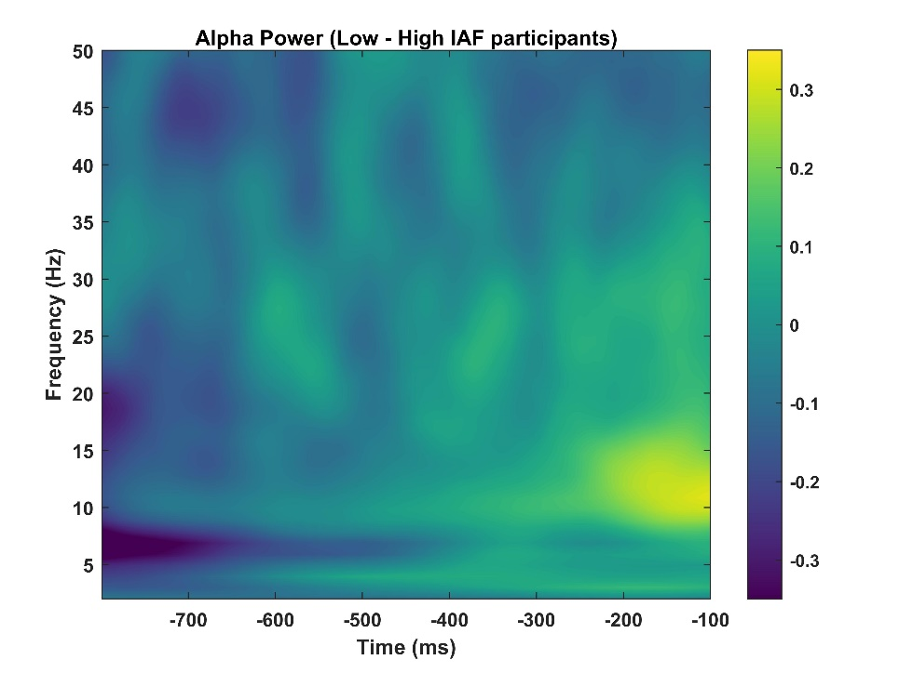
Figure S4. Low and Fast IAF groups do not exhibit significant differences in oscillatory amplitude.
We conducted a time-frequency analysis to assess whether participants in the low IAF frequency group exhibited different amplitude profiles compared to those in the high IAF frequency group. The cluster-based analysis revealed no significant differences between the two populations, indicating that power does not effectively differentiate between the two groups.

