Supplementary information
Movie S1 Markerless labeling with DeepLabCut
Movie S2 Robotic bait performance testing
Movie S3 Trajectory generation for mice and robotic bait
Movie S4 Preying tasks at each difficulty level
Movie S5 Multiple accelerations during the pursuit
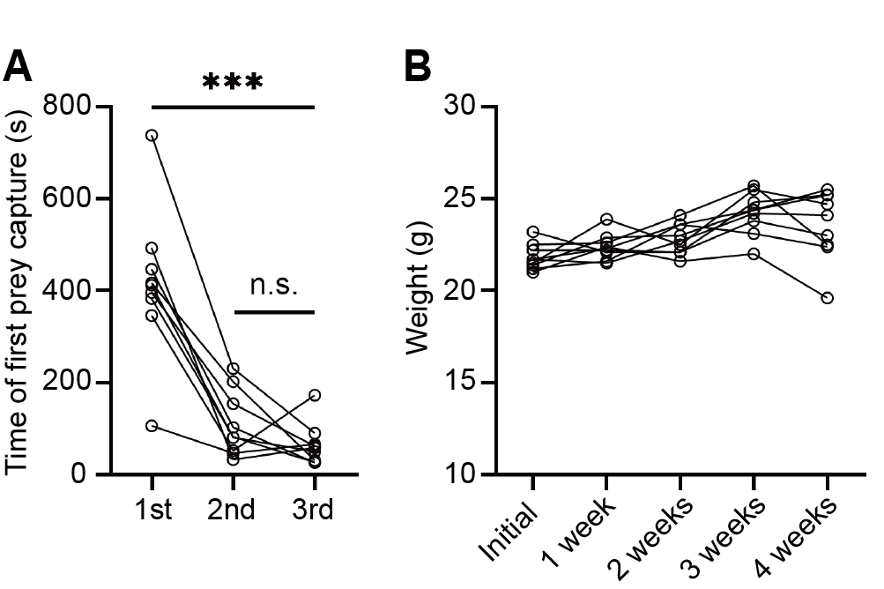
Fig. S1 Habilitation and body weight changes in mice
A The time to first food retrieval in mice during habituation. There was no significant difference in the time to first food retrieval in mice during the second and third habituation ( n = 9. One-way ANOVA).
B Body weight changes in mice throughout the experiment. A weight gain can be found (21.82 ± 0.6960 g to 23.58 ± 1.910 g, n = 9. One-way ANOVA).
n.s., P > 0.05; * P < 0.05; ** P < 0.01; *** P < 0.001; **** P < 0.0001.
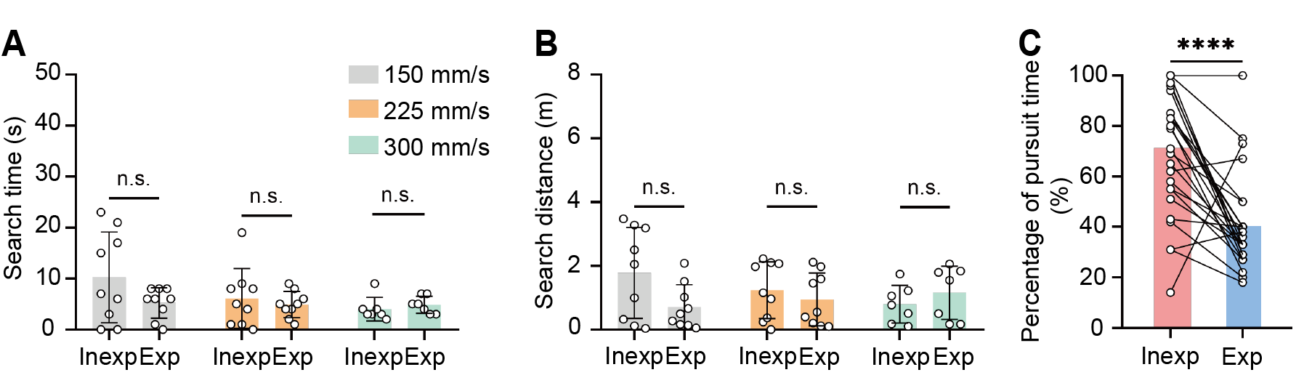
Fig. S2 Efficiency in the search phase
A, B Search time and distance statistics of mice at each difficulty level (low and medium difficulty, n = 9, high difficulty, n = 7. Paired t-test).
C Comparison of pursuit time proportions between inexperienced and experienced mice (n = 25. Paired t-test).
n.s., P > 0.05; * P < 0.05; ** P < 0.01; *** P < 0.001; **** P < 0.0001.

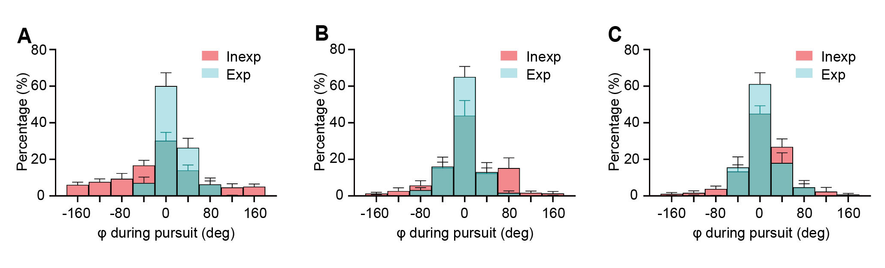
Fig. S3 The distribution of bearing angle φ.
A Histogram of bearing angle φ during pursuit in experienced and inexperienced mice at low difficulty level (bin = 40 degree, histograms are shown as mean values).
B Histogram of bearing angle φ during pursuit in experienced and inexperienced mice at medium difficulty level (bin = 40 degree, histograms are shown as mean values).
C Histogram of bearing angle φ during pursuit in experienced and inexperienced mice at high difficulty level (bin = 40 degree, histograms are shown as mean values).

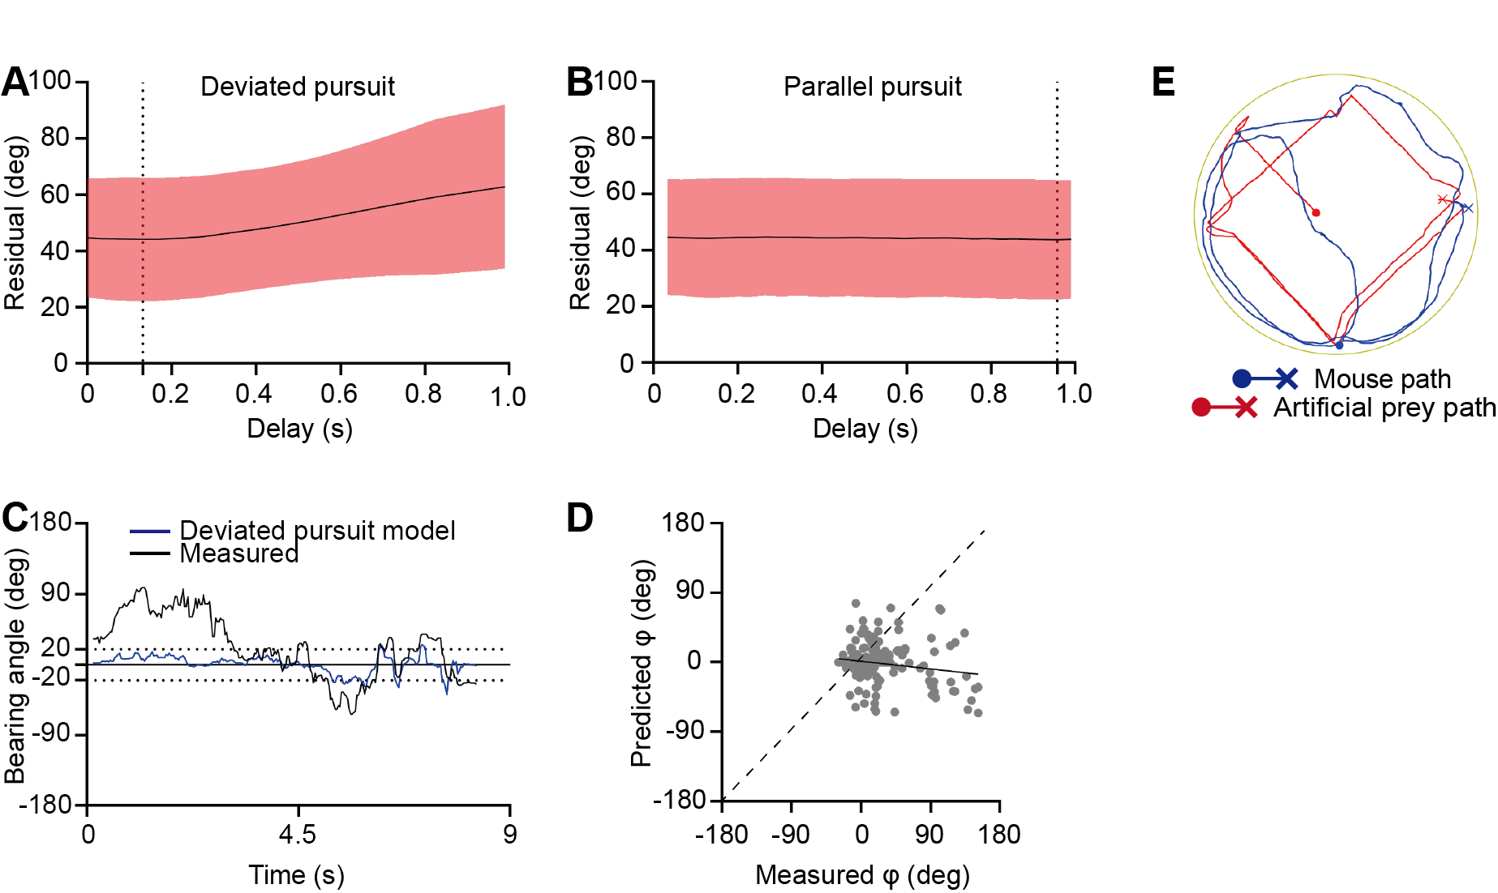
Fig. S4 Comparison of pursuit models in inexperienced mice
A The mean residuals of the deviated pursuit model in inexperienced mice, τ = 0.132 s when mean residual is minimum.
B The mean residuals of the parallel navigation model in inexperienced mice, τ = 0.957 s when mean residual is minimum.
C The time series of the measured bearing angle in inexperienced mice and the predicted bearing angle by the deviated pursuit model.
D Representative linear regression of the measured bearing angle in inexperienced mice against the predicted bearing angle by the parallel navigation model. No regression analysis had a slope close to the unit line ( 0.06591 ± 0.1763. P < 0.05, n = 25. One simple t-test).
E Trajectories of the pursuit in inexperienced mice.
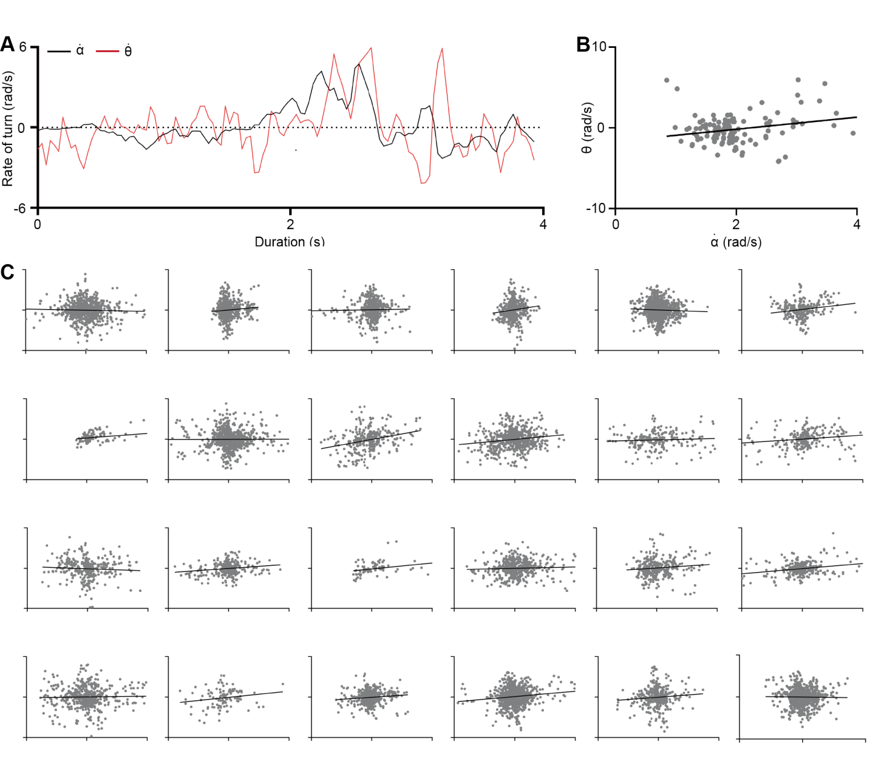
Fig. S5 Experimental measurements of the navigation constant in inexperienced mice
A Representative measurements from a signal experiment in inexperienced mice showed the turning rate of the line of sight (black) and heading (red).
B The scatterplot depicted the relationship between $\dot{α}$ and $\dot{θ}$. The black line is a linear regression fit.
C Scatter plots and linear regression fits of $\dot{α}$ and $\dot{θ}$ for all inexperienced mice. The x and y-axis for all scatter plots are identical to B. The population average of the slopes differed from 1, but was not significantly different from 0.3 (n = 25, P = 0.092. One sample t-test for a hypothesized mean).
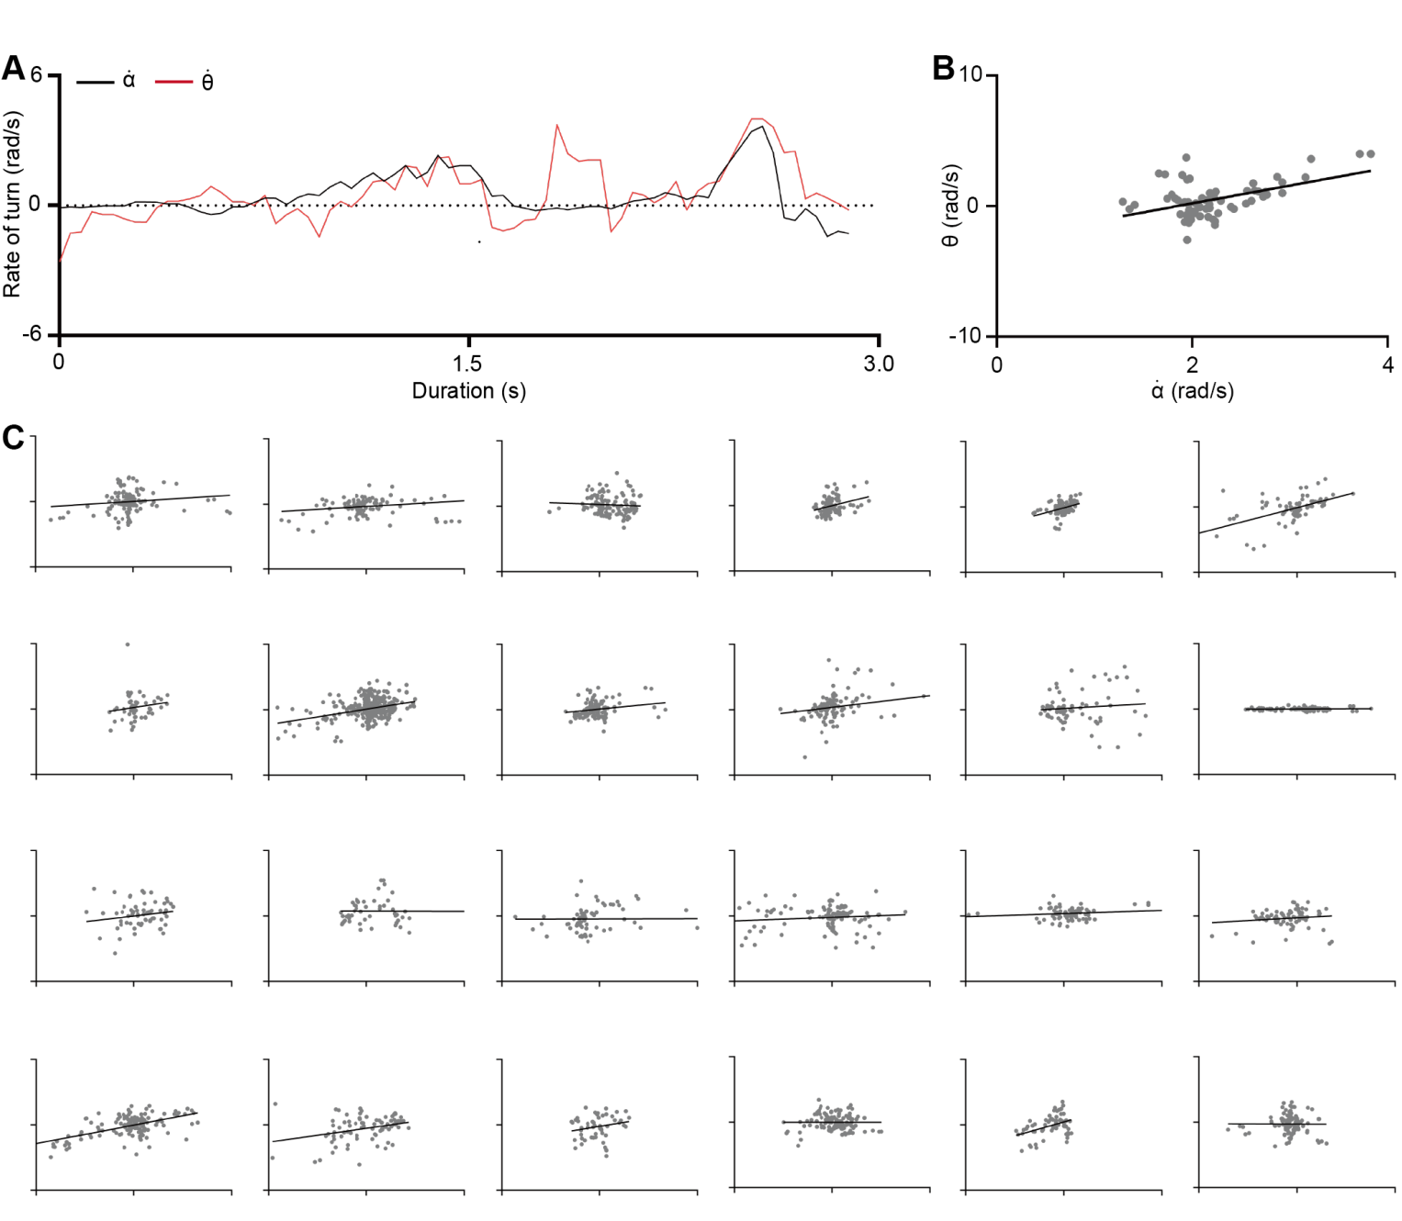
Fig. S6 Experimental measurements of the navigation constant in experienced mice
A Representative measurements from a signal experiment in experienced mice showed the turning rate of the line of sight (black) and heading (red).
B The scatterplot depicted the relationship between $\dot{α}$ and $\dot{θ}$. The black line is a linear regression fit.
C Scatter plots and linear regression fits of $\dot{α}$ and $\dot{θ}$ for all experienced mice. The x and y-axis for all scatter plots are identical to B. The population average of the slopes differed from 1, but was not significantly different from 0.5 (n = 25, P = 0.163. One sample t-test for a hypothesized mean).

Fig. S7 Relative distances between mice and artificial prey during pursuit
A, B, C Relative distances to artificial prey for experienced and inexperienced mice at each difficulty level, with normalized results shown in Fig. All variations of the difference are not smooth (A: low difficulty; B: medium difficulty; C: high difficulty; mean ± SEM, P > 0.05, non-smooth. Augmented Dickey-Fuller test).

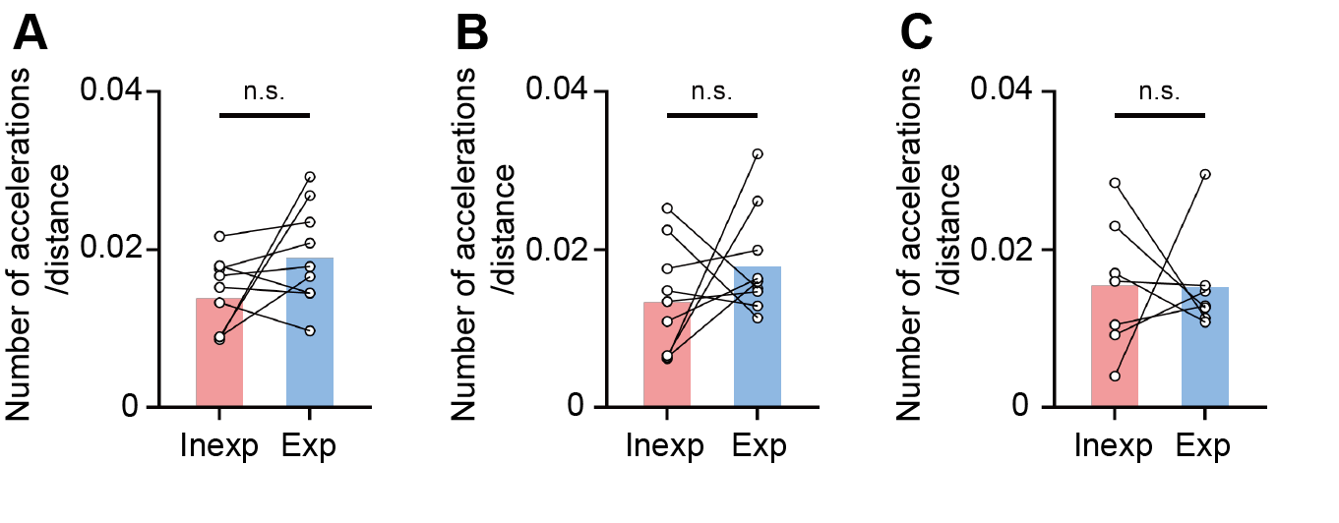
Fig. S8 Number of accelerations normalized to distance
A Number of accelerations per unit distance for experienced and inexperienced mice at low difficulty (n = 9. Paired t-test).
B Number of accelerations per unit distance for experienced and inexperienced mice at medium difficulty (n = 9. Paired t-test).
C Number of accelerations per unit distance for experienced and inexperienced mice at high difficulty (n = 7. Paired t-test).
n.s., P > 0.05; * P < 0.05; ** P < 0.01; *** P < 0.001; **** P < 0.0001.

