Supplementary Figures
The preliminary ratio of stromal: epithelial cells in the de novo reconstructed 3D-ET
Stromal: Epithelial ratio
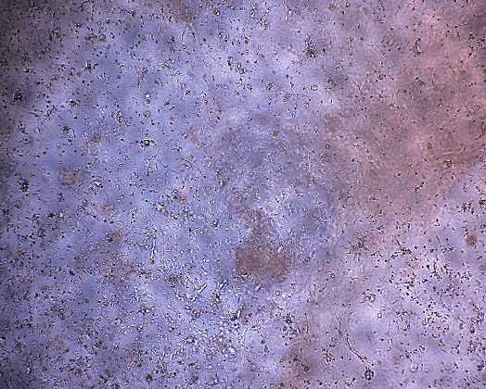
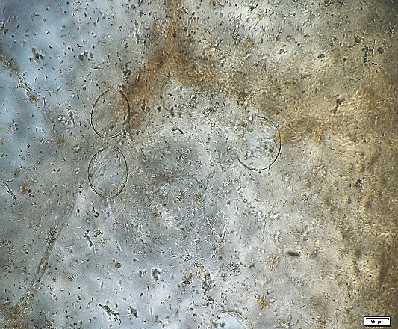
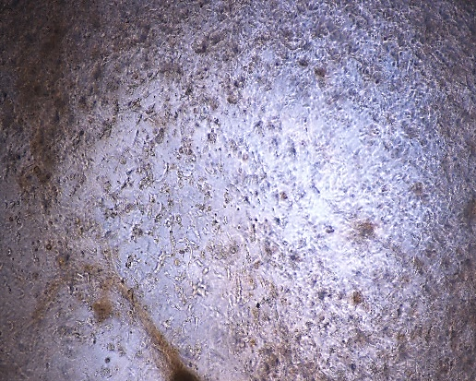
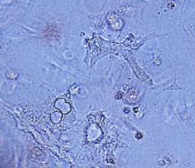
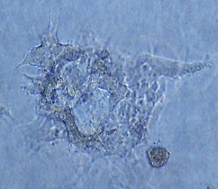
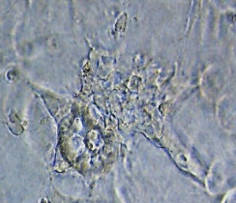
1: 10
1: 5
1: 1
A D3 After 3D-ET reconstruction
Scale bar 200 µm
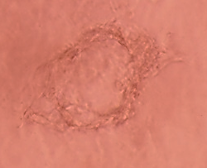
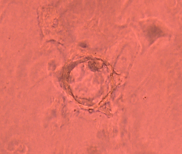
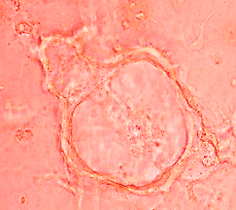
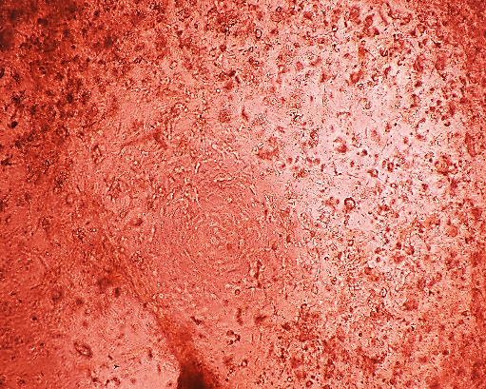
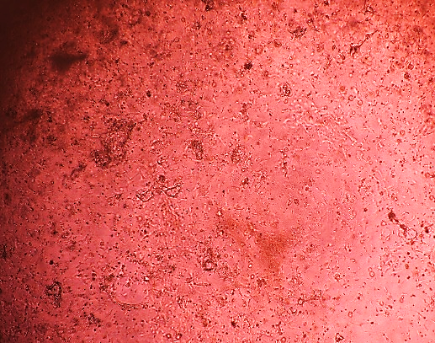
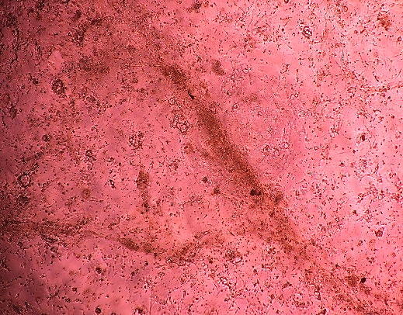
B D5 After 3D-ET reconstruction
Scale bar 200 µm
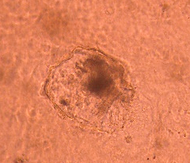
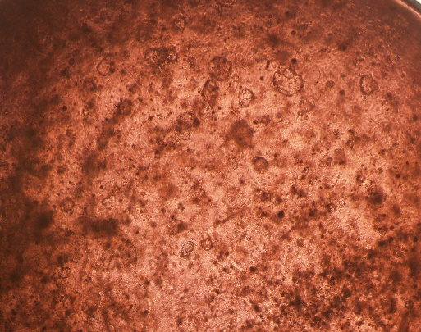
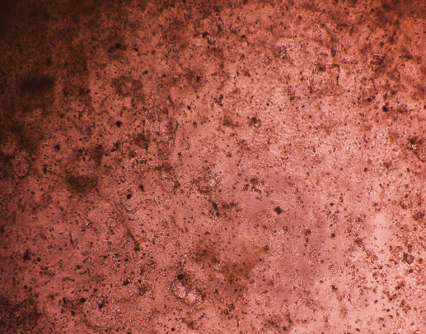
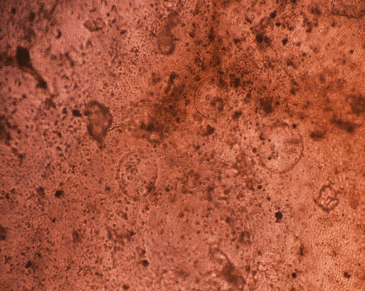
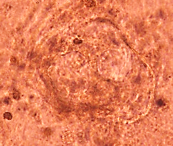
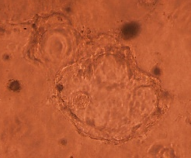
C D10 After 3D-ET reconstruction

Scale bar 200 µm
Supplementary Figure 1: In the preliminary 3D-ET reconstruction A) the ratio between stromal and epithelial cells was observed at D3 after seeding. At this stage, 3d-ETs from all ratios began illustrating gland-like structures. B) The gland-like structures exhibited continued growth, eventually developing into hollow structures. C) At D10 of culture, all 3D-ET initial cell ratios exhibited pigmentation in the glands, indicating glandular apoptosis. However, at seeding ratios of 1:5 and 1:10, the apoptotic effect was more pronounced than at the 1:1 ratio.

