Supplementary materials

Highly efficient pure-blue organic light-emitting diodes based on rationally designed heterocyclic phenophosphazinine-containing emitters
Longjiang Xing^{1,†}, Jianghui Wang^{2,†}, Wen-Cheng Chen^{1,3}*, Bo Liu¹, Guowei Chen¹, Xiaofeng Wang¹, Season Si Chen,⁴ Jia-Xiong Chen^{1,3}, Shaomin Ji^{1,3}, Zujin Zhao^{2,}*, Man-Chung Tang^{4,}* and Yanping Huo^{1,3,5}*

¹School of Chemical Engineering and Light Industry, Guangdong University of Technology, Guangzhou, 510006, P. R. China
²State Key Laboratory of Luminescent Materials and Devices, Key Laboratory of Luminescence from Molecular Aggregates of Guangdong Province, South China University of Technology, Guangzhou, 510640, P. R. China
³Guangdong Provincial Laboratory of Chemistry and Fine Chemical Engineering Jieyang Center, Jieyang, 515200, P. R. China
⁴Institute of Materials Research, Tsinghua Shenzhen International Graduate School, Tsinghua University, Shenzhen, 518055, P. R. China
⁵Analytical & Testing Center, Guangdong University of Technology, Guangzhou, 510006, P. R. China
†These authors contributed equally
*E-mail: wencchen@gdut.edu.cn; mszjzhao@scut.edu.cn; kobetang2021@sz.tsinghua.edu.cn; yphuo@gdut.edu.cn

Quantum chemical calculations
All calculations were performed with Gaussian 16_A03 program package.^{[1]} The ground-state geometries were optimized using the density function theory (DFT) method with B3LYP functional at the basis set level of 6-31G (d), and the ΔE_{ST} values were calculated by time-dependent DFT (TD-DFT) method at the B3LYP/6-31G (d) level. The root-mean squared displacement (RMSD) between S₀ and S₁ molecular geometries was calculated and visualized with the VMD program.^{[2]} NTOs analysis was conducted in Multiwfn 3.7 code.^{[3]} Reorganization energy analysis was carried out using Molecular Materials Property Prediction Package (MOMAP). Based on the optimized S₀ molecular geometries, the spin-orbit coupling matrix elements (SOCEMs) between two first singlet and triplet excited states were calculated in B3LYP/G TZVP level using Orca 4.1.2 package.

Analysis of rate constants
The rate constants of radiative decay (k_{r,S}) and nonradiative decay (k_{nr,S}) from S₁ to S₀ states, the rate constants of intersystem crossing (k_{ISC}) and reverse intersystem crossing (k_{RISC}) were calculated from the following equations^{[4]}:
${\text{k}}_{\text{p}}\text{=}{\text{1}}/{{\text{τ}}_{\text{p}} }$………………………………………………………………………………………(1)
${\text{k}}_{\text{d}}\text{=}{\text{1}}/{{\text{τ}}_{\text{d} }}$………………………………………………………………………………………(2)
${\text{k}}_{\text{r,S}} \text{= }{\text{Φ}}_{\text{p}}{\text{k}}_{\text{p}} \text{+}{ \text{Φ}}_{\text{p}}{\text{k}}_{\text{d}} \text{≈ }{\text{Φ}}_{\text{p}}{\text{k}}_{\text{p}}$……………………………………………………………………(3)
${\text{k}}_{\text{nr,S} }\text{=} \frac{\text{1} \text{-}{ \text{Φ}}_{\text{PL}}}{{\text{Φ}}_{\text{PL}}}{\text{k}}_{\text{r,s}}$………………………………………………………………………………(4)
${\text{k}}_{\text{ISC}} \text{=} {\text{k}}_{\text{p}} \text{-} {\text{k}}_{\text{r,s}} \text{-} {\text{k}}_{\text{nr,s}}$…………………………………………………………………………(5)
${\text{k}}_{\text{RISC}}\text{=} \text{(}{\text{k}}_{\text{p}}{\text{k}}_{\text{d}}{\text{Φ}}_{\text{d}}\text{)/(}{\text{k}}_{\text{ISC}}{\text{Φ}}_{\text{p}}\text{)}$……………………………………………………………………(6)
Where τ_{p} and τ_{d} represent the prompt and decay fluorescence lifetime, which determined from transient PL spectra. The k_{p} and k_{d} represent the decay rate constants for prompt and delayed fluorescence, respectively. Φ_{p} and Φ_{d} indicate prompt and delayed fluorescence components and can be distinguished from the total Φ_{PL} by comparing the integrated intensities of prompt and delayed components in the transient PL spectra.

Synthesis
Commercially available reagents and solvents were used as received unless otherwise noted. BNCz-Br was synthesized according to literature procedures.^{[5]}
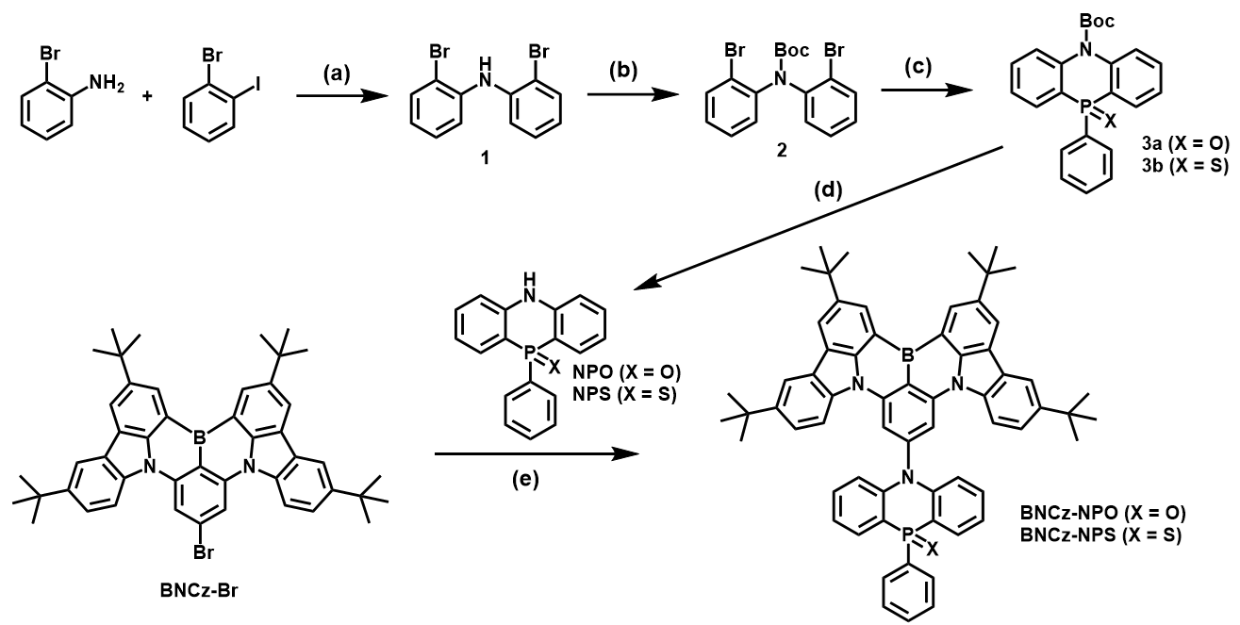
Scheme S1. The synthetic routes of BNCz-NPO and BNCz-NPS. (a) Pd₂(dba)₃, dppf, t-BuONa, toluene, 120 °C, 12 h; (b) DMAP, Boc₂O, THF, 80 °C, 12 h; (c) n-BuLi, THF, -78ºC, 1 h; dichloro(phenyl)phosphane, -78ºC, 1 h；30% H₂O₂ (for 3a) at room temperature, CH₂Cl₂；or S₈ (for 3b) at 110 ºC, 8 h；(d) CF₃COOH, CH₂Cl₂, rt, 12 h; (e) Pd₂(dba)₃, t-BuONa, t-Bu₃PHBF₄, toluene, 120 ºC, 12 h.

Synthesis of bis(2-bromophenyl)amine (1). A mixture of 2-bromoaniline (1.72 g, 10 mmol), 1-bromo-2-iodobenzene (4.24 g, 15mmol), Sodium tert-butoxide (2.88 g, 30 mmol), 1,1'-bis(diphenylphosphino)ferrocene (0.554 g, 1 mmol) 40 mL toluene and Pd₂(dba)₃ (0.45 g, 0.50 mmol) were added and refluxed at 120 °C under nitrogen atmosphere for 12 hours. The mixture was poured into water to quench the reaction and then extracted with dichloromethane. The organic phase was collected and dried over anhydrous Na₂SO₄. After evaporation of the solvent, the residue was purified via column chromatography using petroleum ether/dichloromethane (10:1, v/v) as an eluent to afford a white solid. (2.59 g, yield: 80%).¹H NMR ¹H NMR (400 MHz, DMSO_{d6}) δ (ppm): 7.64 (dd, J = 8.0, 1.2 Hz, 2H), 7.36 – 7.24 (m, 2H), 7.07 (dd, J = 8.0, 1.1 Hz, 2H), 7.01 (s, 1H), 6.93 (td, J = 8.0, 1.3 Hz, 2H).
Synthesis of tert-butyl bis(2-bromophenyl)carbamate (2). A mixture of bis(2-bromophenyl)amine (3.24 g, 10 mmol), N,N-dimethyl-4-aminopyridine (0.244 g, 2 mmol) , di-tert-butyl dicarbonate (4.36 g, 20 mmol) and 60 ml THF were added and refluxed at 80°C under nitrogen atmosphere for 12 hours. The mixture was poured into water to quench the reaction and then extracted with dichloromethane. The organic phase was collected and dried over anhydrous Na₂SO₄. After evaporation of the solvent, the residue was purified via column chromatography using petroleum ether/dichloromethane (3:1, v/v) as eluent to afford white solid. (3.61g, yield: 85%).¹H NMR (400 MHz, CDCl₃,) δ (ppm): 7.64 (d, J = 6.7 Hz, 2H), 7.43 (d, J = 7.7 Hz, 2H), 7.22 (td, J = 7.8, 1.3 Hz, 2H), 7.10 (td, J = 7.9, 1.5 Hz, 2H), 1.46 (s, 9H).
Synthesis of tert-butyl 10-phenyl-5H-phenophosphazinine-5-carboxylate 10-oxide (3a). Step 1: A mixture of 2 (4.24 g, 10 mmol), and 40 ml THF were added three-neck flash. The flash was evacuated, and refilled with nitrogen for 3 times and the mixture was cooled to -78 °C. n-BuLi (hexane solution, 2.5 M, 30 mmol, 12 mL) was added dropwise under N₂, and the resulting mixture was stirred for 1 h at -78 °C. Dichloro(phenyl)phosphane (3.55 g, 20 mmol) was added at -78 ºC and then the reaction mixture was allowed to warm to room temperature overnight. The mixture was poured into water to quench the reaction and then extracted with dichloromethane. The organic phase was collected and dried over anhydrous Na₂SO₄. After evaporation of the solvent, the mixture was filtered, and the solid was washed with water, ethanol, and dichloromethane, respectively, to afford a white solid. The crude intermediates were directly used to the next step. Step 2: A mixture of the above intermediate (3.75 g, 10 mmol), 30% hydrogen peroxide (H₂O₂) (20 ml), 30 ml dichloromethane were added and stirred at room temperature under a nitrogen atmosphere for 12 h. The mixture was poured into water to quench the reaction and then extracted with dichloromethane. The organic phase was collected and dried over anhydrous Na₂SO₄. After evaporation of the solvent, the residue was purified via column chromatography by using petroleum ether/ ethyl acetate (1:1, v/v) as an eluent to afford white solid. (1.76 g, yield: 45%). ¹H NMR (400 MHz, CDCl₃,) δ (ppm): 8.12 (ddd, J = 12.2, 7.5, 1.0 Hz, 2H), 7.67 (dt, J = 13.2, 6.6 Hz, 2H), 7.59 – 7.37 (m, 7H), 7.32 (td, J = 7.5, 3.0 Hz, 2H), 1.28 (s, 9H). ³¹P NMR (162 MHz, CDCl₃) δ (ppm): 16.92 (s).
Synthesis of tert-butyl 10-phenyl-5H-phenophosphazinine-5-carboxylate 10-sulfide (3b). Step 1: the same as synthetic 3a. Step 2: A mixture of the above intermediate (3.75 g, 10 mmol), 3sulfur (0.97 g, 30 mmol), 30 ml toluene were added and stirred at 110 °C under a nitrogen atmosphere for 12 h. The mixture was poured into water to quench the reaction and then extracted with dichloromethane. The organic phase was collected and dried over anhydrous Na₂SO₄. After evaporation of the solvent, the residue was purified via column chromatography using petroleum ether/ ethyl acetate (8:1, v/v) as eluent to afford white solid. (1.62g, yield: 40%). ¹H NMR (400 MHz, DMSO_{d6}) δ (ppm): 8.16 (ddd, J = 14.8, 7.6, 1.4 Hz, 2H), 7.80 – 7.72 (m, 2H), 7.72 – 7.65 (m, 2H), 7.63 – 7.54 (m, 2H), 7.49 – 7.41 (m, 1H), 7.42 – 7.34 (m, 2H), 7.32 – 7.21 (m, 2H), 1.20 (s, 9H). ³¹P NMR (162 MHz, DMSO_{d6}) δ (ppm): 20.73 (s).
Synthesis of 10-phenyl-5H-phenophosphazinine 10-oxide (NPO). A mixture of 3a (1.17 g, 3 mmol), trifluoroacetic acid (6.9 ml, 90 mmol), and 20 ml CH₂Cl₂ were added and refluxed at room temperature under a nitrogen atmosphere for 12 hours. The mixture was poured into water to quench the reaction and then extracted with dichloromethane. The organic phase was collected and dried over anhydrous Na₂SO₄. After evaporation of the solvent, the residue was purified via column chromatography using petroleum ether/ ethyl acetate (1:1, v/v) as an eluent to afford a white solid. (0.59 g, yield: 68%). ¹H NMR (400 MHz, DMSO_{d6}) δ (ppm): 10.40 (s, 1H), 7.69 – 7.36 (m, 9H), 7.26 (dd, J = 8.0, 5.9 Hz, 2H), 7.02 (t, J = 7.3 Hz, 2H). ³¹P NMR (162 MHz, DMSO_{d6}) δ (ppm): 4.45 (s).
Synthesis of 10-phenyl-5H-phenophosphazinine 10-sulfide (NPS). A mixture of 3b (1.22 g, 3 mmol), trifluoroacetic acid (6.9 ml, 90 mmol), and 20 ml CH₂Cl₂ were added and refluxed at room temperature under a nitrogen atmosphere for 12 h. The mixture was poured into water to quench the reaction and then extracted with dichloromethane. The organic phase was collected and dried over anhydrous Na₂SO₄. After evaporation of the solvent, the residue was purified via column chromatography using petroleum ether/ethyl acetate (8:1, v/v) as an eluent to afford a white solid. (0.60 g, yield: 65%).¹H NMR (400 MHz, DMSO_{d6}) δ (ppm):10.30 (s, 1H), 7.72 (dd, J = 14.9, 7.7 Hz, 2H), 7.48 (dd, J = 28.4, 21.8 Hz, 7H), 7.31 – 7.15 (m, 2H), 7.08 (t, J = 7.1 Hz, 2H). ³¹P NMR (162 MHz, DMSO_{d6}) δ (ppm): 16.92 (s).
Synthesis of BNCz-NPO. A mixture of NPO (1.45 g, 5 mmol), (t-Bu)₃P•BF₄(6.9 ml, 0.25 mmol), Sodium tert-butoxide (0.98 g, 10 mmol), BNCz-Br (2.15 g, 3 mmol), 40 mL toluene and Pd₂(dba)₃ (0.23 g, 0.50 mmol) were added and refluxed at 120 °C under nitrogen atmosphere for 12 hours. The mixture was poured into water to quench the reaction and then extracted with dichloromethane. The organic phase was collected and dried over anhydrous Na₂SO₄. After evaporation of the solvent, the residue was purified via column chromatography using petroleum ether/ ethyl acetate (2:1, v/v) as eluent to afford white solid. (1.53 g, yield: 55%).¹H NMR (400 MHz, CDCl₃,) δ (ppm): 8 9.20 (d, J = 1.7 Hz, 2H), 8.52 (d, J = 1.6 Hz, 2H), 8.31 (s, 2H), 8.26 (d, J = 1.9 Hz, 2H), 8.18 (d, J = 8.8 Hz, 2H), 7.89 (dddd, J = 13.5, 9.1, 6.7, 1.6 Hz,4H), 7.66 – 7.51 (m, 5H), 7.31 (s, 2H), 7.10 (s, 2H), 6.88 (dd, J = 8.7, 6.2 Hz, 2H), 1.70 (s, 18H), 1.48 (s, 18H); ¹³C NMR (101 MHz, CDCl₃) δ (ppm): 146.60, 146.19, 145.51, 145.13, 144.92, 144.87, 141.69, 138.07, 135.88, 134.73, 132.85, 132.27, 132.24, 132.22, 132.14, 131.53, 131.51, 130.00, 128.57, 128.44, 127.25, 124.87, 124.04, 121.61, 121.50, 121.25, 117.43, 117.31, 117.24, 114.47, 114.27, 113.44, 109.37, 35.31, 34.85, 32.22, 31.77; ³¹P NMR (162 MHz, CDCl₃) δ (ppm): 5.13 (s). HRMS (ESI) m/z: [M + H]⁺ calcd for C₆₄H₆₁BN₃OP, 930.4718; found, 930.4717.
Synthesis of BNCz-NPS. A mixture of NPS (1.53 g, 5 mmol), (t-Bu)₃P•BF₄(6.9 ml, 0.25 mmol), Sodium tert-butoxide (0.98 g, 10 mmol), BNCz-Br (2.15 g, 3 mmol), 40 mL toluene and Pd₂(dba)₃ (0.23 g, 0.50 mmol) were added and refluxed at 120 °C under nitrogen atmosphere for 12 hours. The mixture was poured into water to quench the reaction and then extracted with dichloromethane. The organic phase was collected and dried over anhydrous Na₂SO₄. After evaporation of the solvent, the residue was purified via column chromatography using petroleum ether/ ethyl acetate (10:1, v/v) as eluent to afford white solid. (1.41 g, yield: 50%).¹H NMR (400 MHz, CDCl₃,) δ (ppm): 9.09 (d, J = 1.4 Hz, 2H), 8.88 (d, J = 1.5 Hz, 2H), 8.57 (d, J = 1.9 Hz, 2H), 8.34 (s, 2H), 8.16 (d, J = 8.9 Hz, 2H), 8.04 (ddd, J = 15.7, 7.7, 1.2 Hz, 2H), 7.71 (ddd, J = 14.0, 6.5, 3.0 Hz, 2H), 7.66 – 7.55 (m, 5H), 7.42 (t, J = 7.8 Hz, 2H), 7.26 (t, J = 7.3 Hz, 2H), 6.94 (dd, J = 8.4, 6.4 Hz, 2H), 1.66 (s, 18H), 1.45 (s, 18H); ¹³C NMR (101 MHz, CDCl₃) δ (ppm): 146.52, 146.21, 145.57, 144.95, 144.21, 144.18, 141.74, 138.32, 138.12, 137.44, 132.74, 132.66, 130.93, 130.89, 130.82, 130.09, 128.76, 128.64, 127.36, 124.85, 124.07, 123.12, 122.50, 122.38, 121.74, 121.32, 117.54, 116.94, 116.88, 114.19, 113.94, 113.09, 109.55, 35.37, 34.90, 32.29, 31.85; ³¹P NMR (162 MHz, CDCl₃). δ (ppm): 16.89 (s). RMS (ESI) m/z: [M + H]⁺ calcd for C₆₄H₆₁BN₃PS, 946.4489; found, 946.4487.
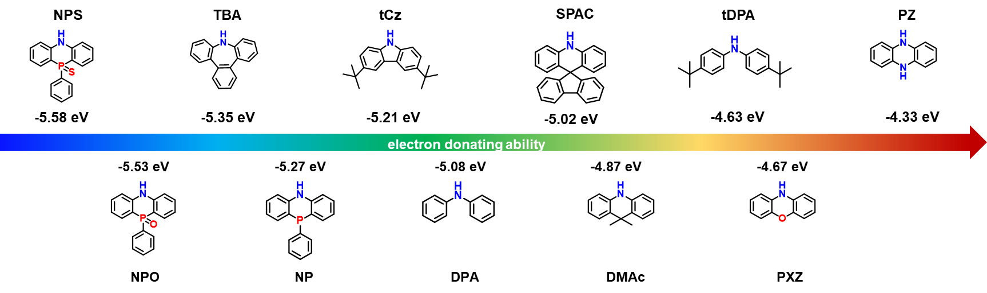
Figure S1. Structure and HOMO energy levels of commonly used electron donors and NPO/NPS computed by DFT at the B3LYP/6-31G (d) level.
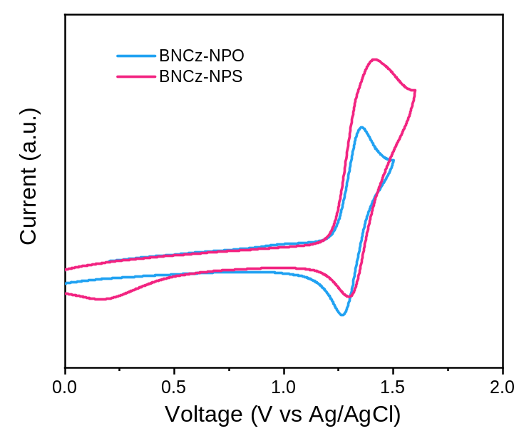
Figure S2. Cyclic voltammogram of BNCz-NPO and BNCz-NPS.

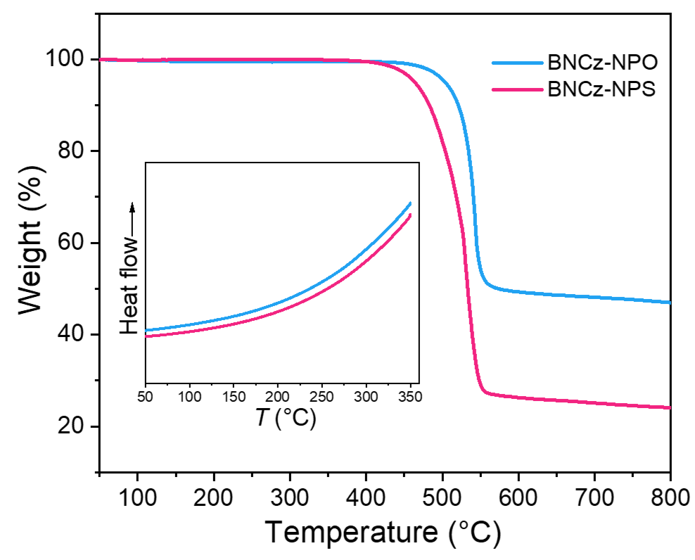
Figure S3. TGA and DSC (inset) curves of BNCz-NPO and BNCz-NPS at a heating rate of 10 °C min⁻¹
Table S1. Crystal data and structure refinement for BNCz-NPO-α and BNCz-NPO-β
Parameter | BNCz-NPO-α | BNCz-NPO-β
CCDC no. | 2253324 | 2282192
Empirical formula | C₆₄H₆₁BN₃OP | C₆₄H₆₁BN₃OP
Formula weight (g mol⁻¹) | 929.93 | 929.93
Temperature (K) | 150.00(10) | 150.00(10)
Crystal system | monoclinic | triclinic
Space group | P21/n | P-1
a (Å) | 14.4394(2) | 12.6376(4)
b (Å) | 13.88700(10) | 15.0173(3)
c (Å) | 26.8466(3) | 16.3976(3)
α (°) | 90 | 79.740(2)
Β (°) | 102.7370(10) | 79.810(2)
γ (°) | 90 | 72.857(2)
Volume (Å³) | 5250.81(10) | 2900.44(13)
Z | 4 | 2
Cal. density (g cm⁻³) | 1.176 | 1.065
Absorption coefficient (mm⁻¹) | 0.803 | 0.727
F(000) | 1976.0 | 988.0
Crystal size/mm³ | 0.13 × 0.12 × 0.08 | 0.15 × 0.12 × 0.1
Radiation | Cu Kα (λ = 1.54184) | Cu Kα (λ = 1.54184)
2Θ range for data collection (°) | 6.438 to 147.732 | 5.526 to 133.186
Index ranges | -12 ≤ h ≤ 17, -15 ≤ k ≤ 17, -31 ≤ l ≤ 33 | -15 ≤ h ≤ 15, -17 ≤ k ≤ 13, -19 ≤ l ≤ 19
Reflections collected | 20311 | 28045
Independent reflections | 10387 [R_{int} = 0.0241, R_{sigma} = 0.0311] | 10132 [R_{int} = 0.0375, R_{sigma} = 0.0453]
Data/restraints/parameters | 10387/17/654 | 10132/57/688
Goodness-of-fit on F² | 1.025 | 1.104
Final R indexes [I>=2σ (I)] | R₁ = 0.0393, wR₂ = 0.0983 | R₁ = 0.1092, wR₂ = 0.3063
Final R indexes [all data] | R₁ = 0.0439, wR₂ = 0.1020 | R₁ = 0.1254, wR₂ = 0.3163
Largest diff. peak/hole (e Å⁻³) | 0.34/-0.32 | 0.86/-0.45

Table S2. Crystal data and structure refinement for BNCz-NPS-α and BNCz-NPS-β
Parameter | BNCz-NPS-α | BNCz-NPS-β
CCDC no. | 2285218 | 2247937
Empirical formula | C₆₄H₆₁BN₃PS | C₆₄H₆₁BN₃PS
Formula weight (g mol⁻¹) | 945.99 | 945.99
Temperature (K) | 99.98(13) | 170.00(10)
Crystal system | monoclinic | monoclinic
Space group | P2₁/n | Cc
a (Å) | 18.88520(10) | 17.4998(9)
b (Å) | 25.2745(2) | 21.3090(11)
c (Å) | 24.1828(2) | 17.6514(10)
α (°) | 90 | 90
Β (°) | 105.4650(10) | 97.258(5)
γ (°) | 90 | 90
Volume (Å³) | 11124.86(15) | 6529.5(6)
Z | 8 | 4
Cal. density (g cm⁻³) | 1.130 | 0.962
Absorption coefficient (mm⁻¹) | 1.093 | 0.931
F(000) | 4016.0 | 2008.0
Crystal size/mm³ | 0.16 × 0.13 × 0.11 | 0.15 × 0.13 × 0.11
Radiation | Cu Kα (λ = 1.54184) | Cu Kα (λ = 1.54184)
2Θ range for data collection (°) | 5.158 to 133.198 | 7.884 to 133.188
Index ranges | -22 ≤ h ≤ 20, -30 ≤ k ≤ 18, -28 ≤ l ≤ 28 | -18 ≤ h ≤ 20, -24 ≤ k ≤ 25, -17 ≤ l ≤ 21
Reflections collected | 60705 | 20416
Independent reflections | 19630 [R_{int} = 0.0329, R_{sigma} = 0.0380] | 7819 [R_{int} = 0.0600, R_{sigma} = 0.0576]
Data/restraints/parameters | 19630/1533/1364 | 7819/761/583
Goodness-of-fit on F² | 1.091 | 1.079
Final R indexes [I>=2σ (I)] | R₁ = 0.1004, wR₂ = 0.2430 | R₁ = 0.1255, wR₂ = 0.3416
Final R indexes [all data] | R₁ = 0.1053, wR₂ = 0.2461 | R₁ = 0.1472, wR₂ = 0.3529
Largest diff. peak/hole (e Å⁻³) | 0.63/-0.68 | 1.07/-1.01

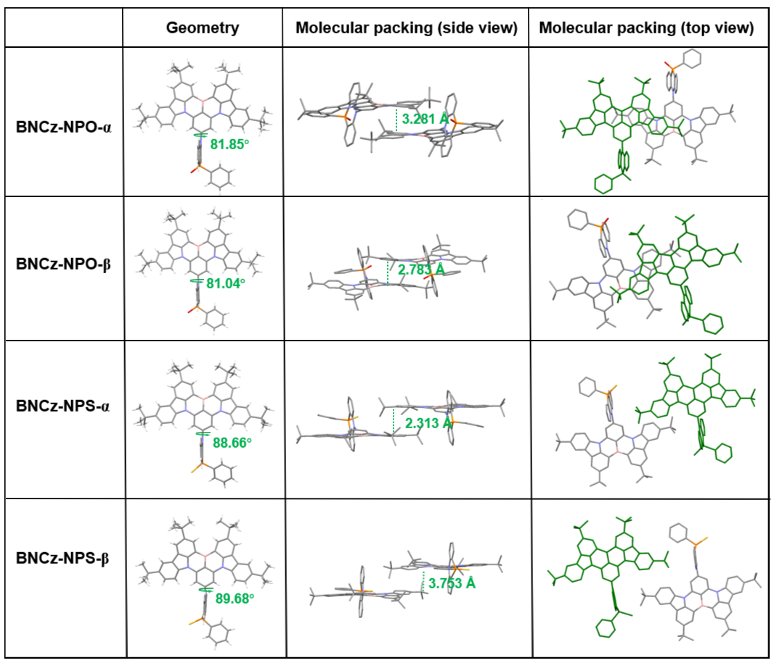
Figure S4. Molecular geometries and packing modes of BNCz-NPO-α, BNCz-NPO-β, BNCz-NPS-α, and BNCz-NPS-β.

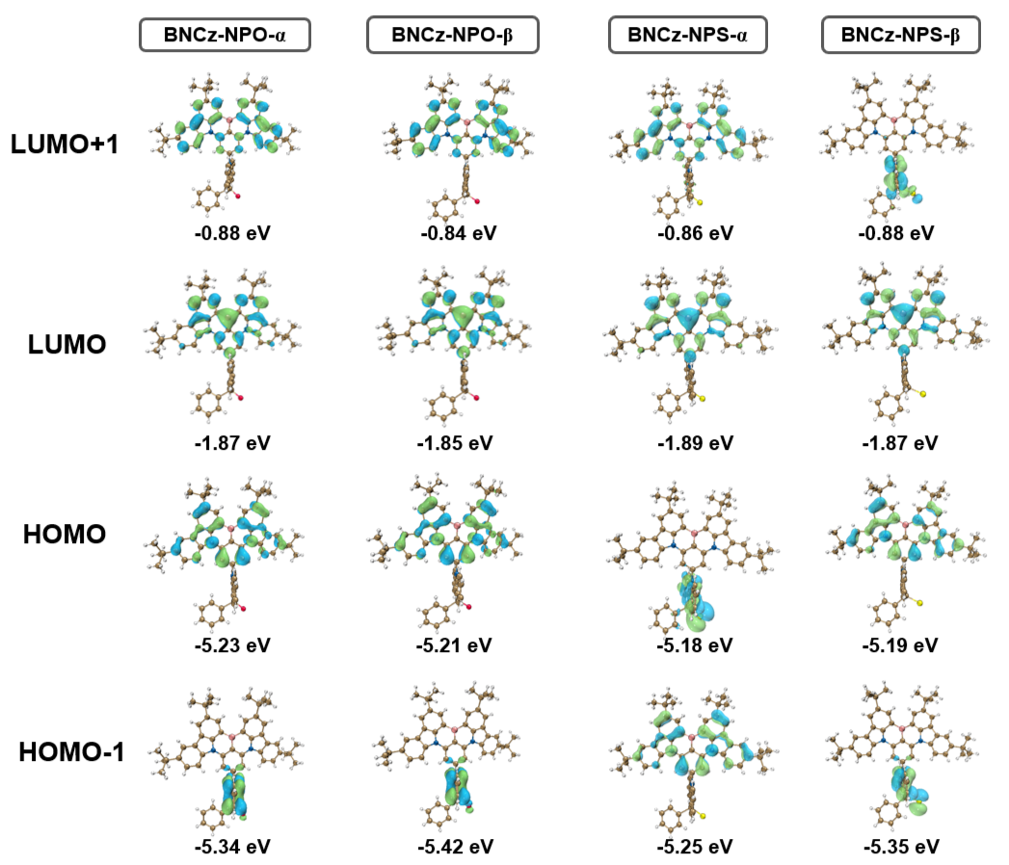
Figure S5. LUMO+1, LUMO, HOMO, HOMO-1 distributions and related energy levels of BNCz-NPO-α, BNCz-NPO-β, BNCz-NPS-α and BNCz-NPS-β.

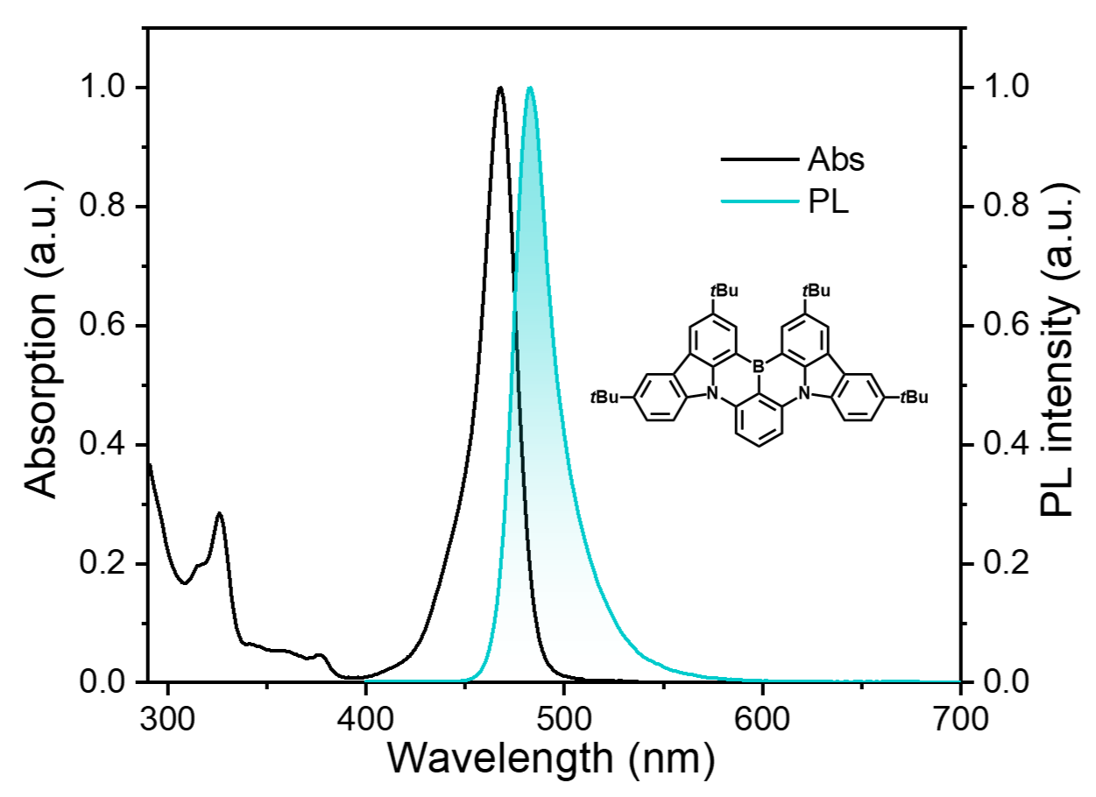
Figure S6. Absorption and PL spectra of BNCz in toluene (1 × 10⁻⁵ M).

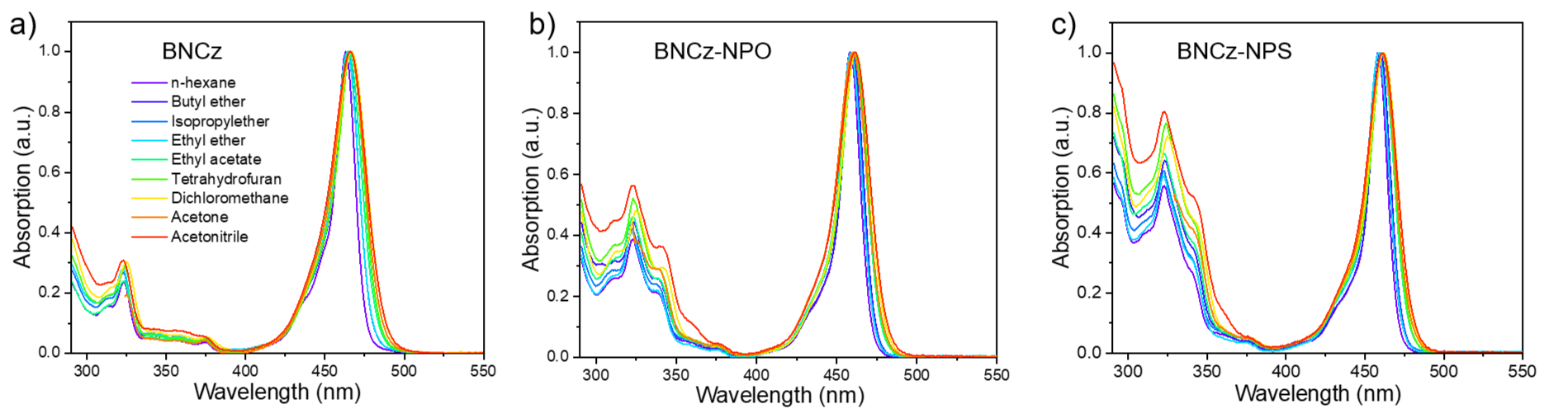
Figure S7. Absorption spectra of a) BNCz, b) BNCz-NPO and c) BNCz-NPS in different solvents (1×10⁻⁵ M).

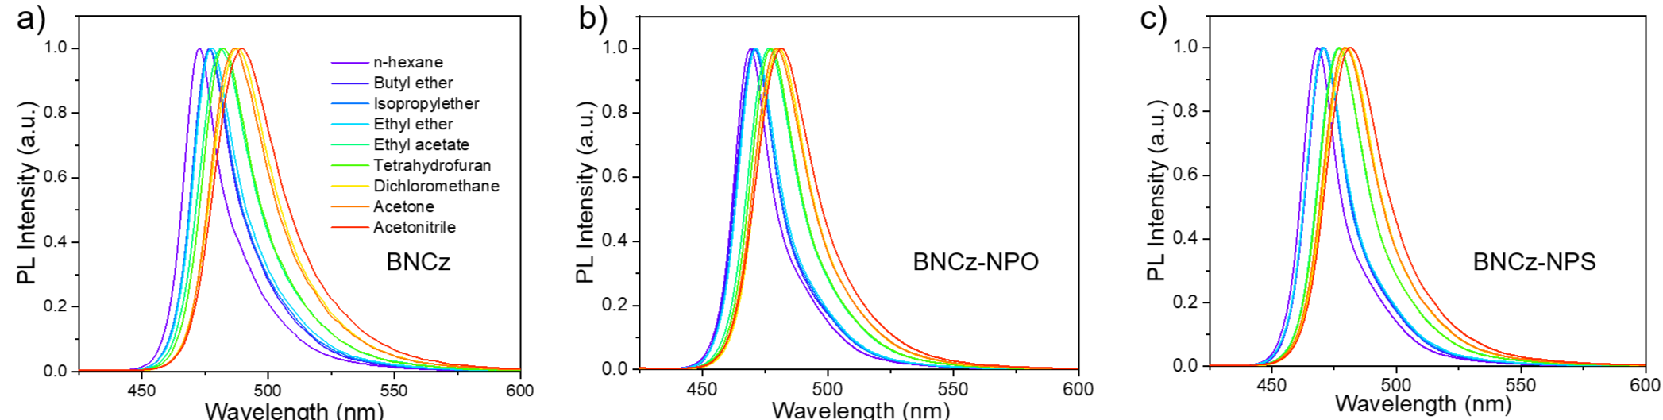
Figure S8. PL spectra of a) BNCz, b) BNCz-NPO and c) BNCz-NPS in different solvents (1×10⁻⁵ M).

Table S3 Absorption and PL peaks of BNCz, BNCz-NPO and BNCz-NPS measured in different solvents.
 | BNCz |  |  | BNCz-NPO |  |  | BNCz-NPS
Solvent | λ_{abs}ª  (nm) | λ_{pl}ª  (nm) | FWHM^{b}  (nm) | λ_{abs}ª  (nm) | λ_{pl}ª  (nm) | FWHM^{b}  (nm) | λ_{abs}ª  (nm) | λ_{pl}ª  (nm) | FWHM^{b}  (nm)
n-hexane | 463 | 473 | 19 | 458 | 469 | 18 | 458 | 468 | 18
Butyl ether | 464 | 477 | 21 | 460 | 471 | 20 | 460 | 471 | 19
Isopropyl ether | 464 | 477 | 21 | 459 | 471 | 19 | 459 | 470 | 19
ethyl ether | 464 | 478 | 22 | 459 | 471 | 20 | 459 | 471 | 20
Ethyl acetate | 465 | 481 | 26 | 460 | 477 | 23 | 461 | 477 | 23
Tetrahydrofuran | 466 | 482 | 25 | 461 | 477 | 23 | 461 | 477 | 23
Dichloromethane | 467 | 488 | 29 | 462 | 481 | 25 | 462 | 480 | 25
Acetone | 466 | 487 | 28 | 460 | 480 | 26 | 461 | 479 | 26
Acetonitrile | 466 | 490 | 31 | 461 | 482 | 27 | 461 | 481 | 27
ª Peak wavelength of absorption and emission in different solvents; ^{b} Full-width at half-maximum.

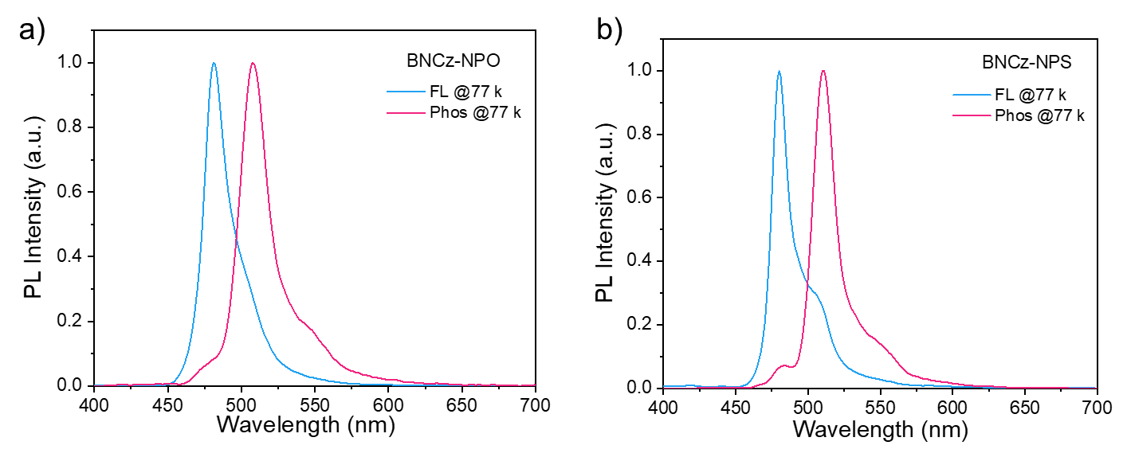
Figure S9. Fluorescence (blue line) and phosphorescence (red line) spectra of a) BNCz-NPO and b) BNCz-NPS in toluene solution (1 × 10⁻⁵ M, 77 K).

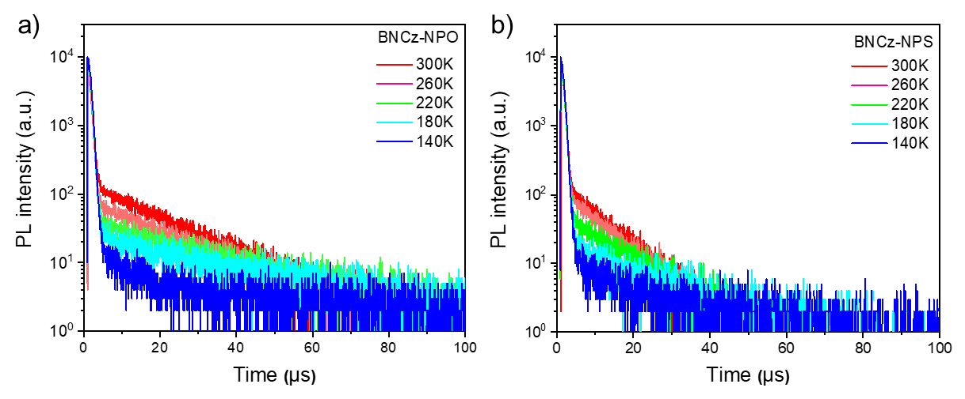
Figure S10. Temperature-dependent transient PL decays of a) BNCz-NPO and b) BNCz-NPS in oxygen-free toluene solution using a variable pulsed laser (Edinburgh VPL-375).

Table S4. Photophysical data and kinetic parameters of BNCz-NPO and BNCz-NPS in doped films (3 wt% in PhCzBCz).
Emitter | λ_{em}ª  [nm] | FWHM^{b} [nm/eV] | ΔE_{ST}^{c}  [eV] | PLQY^{d}  [%] | τ_{PF}^{e}  [ns] | τ_{DF}^{f}  [μs] | k_{r}^{g}  [10⁷ s⁻¹] | k_{nr}^{g}  [10⁶ s⁻¹] | k_{ISC}^{g}  [10⁷ s⁻¹] | k_{RISC}^{g}  [10⁵ s⁻¹]
BNCz-NPO | 478 | 26/0.14 | 0.10 | 95.5 | 2.8 | 28.5 | 7.1 | 3.7 | 28.2 | 1.6
BNCz-NPS | 481 | 26/0.14 | 0.10 | 92.0 | 3.0 | 21.9 | 5.0 | 4.9 | 27.8 | 2.7
^{a)}Peak of fluorescence spectrum. ^{b)}Full width at half-maximum (FWHM) of fluorescence spectrum. ^{c)}S₁−T₁ energy gap determined from fluorescence and phosphorescence spectra at 77 K. ^{d)}Absolute photoluminescence quantum yield. ^{e)}Lifetime of prompt fluorescence. ^{f)}Lifetime of delayed fluorescence. ^{g)}Rate constants of singlet radiative decay (k_{r}), non-radiative decay (k_{nr}), intersystem crossing (k_{ISC}), and reverse intersystem crossing (k_{RISC}).

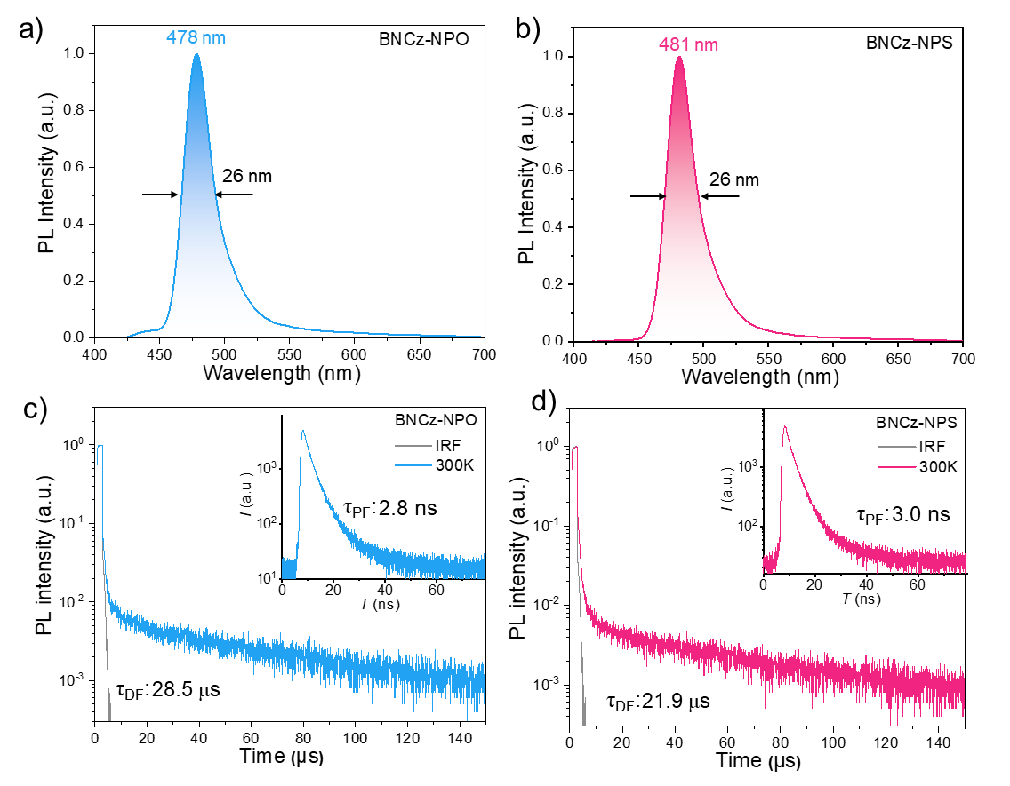
Figure S11. PL spectra of a) BNCz-NPO and b) BNCz-NPS doped films (3 wt% in PhCzBCz) at 300 K. Transient PL decay curves of c) BNCz-NPO and d) BNCz-NPS doped films (3 wt% in PhCzBCz) at 300 K using a variable pulsed laser (Edinburgh VPL-375) and a picosecond pulsed diode laser (Edinburgh EPL-375, inset)

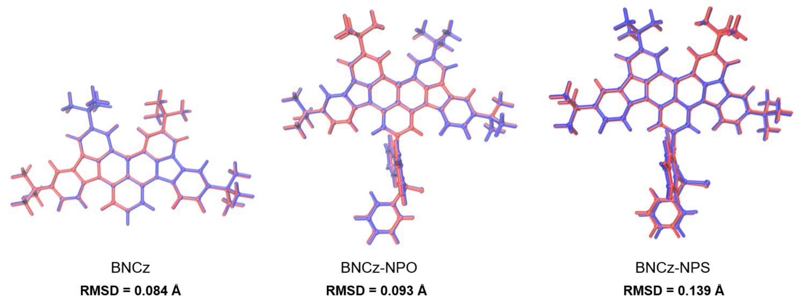
Figure S12. The RMSD values of BNCz, BNCz-NPO, and BNCz-NPS between the optimized S₀ (red) and S₁ (blue) geometries.
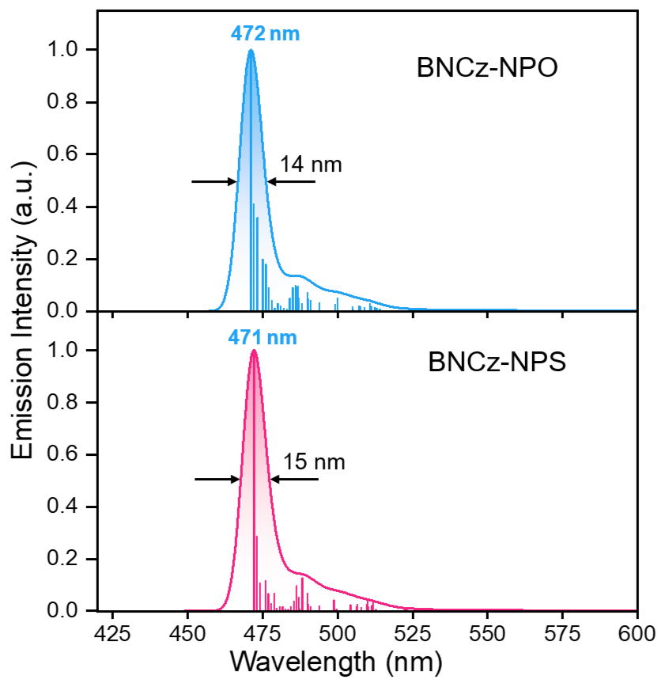
Figure S13. Emission spectra simulated by Franck–Condon analysis of S₁–S₀ transition, the vertical lines are the vibrational transition dipoles with strength > 0.001.

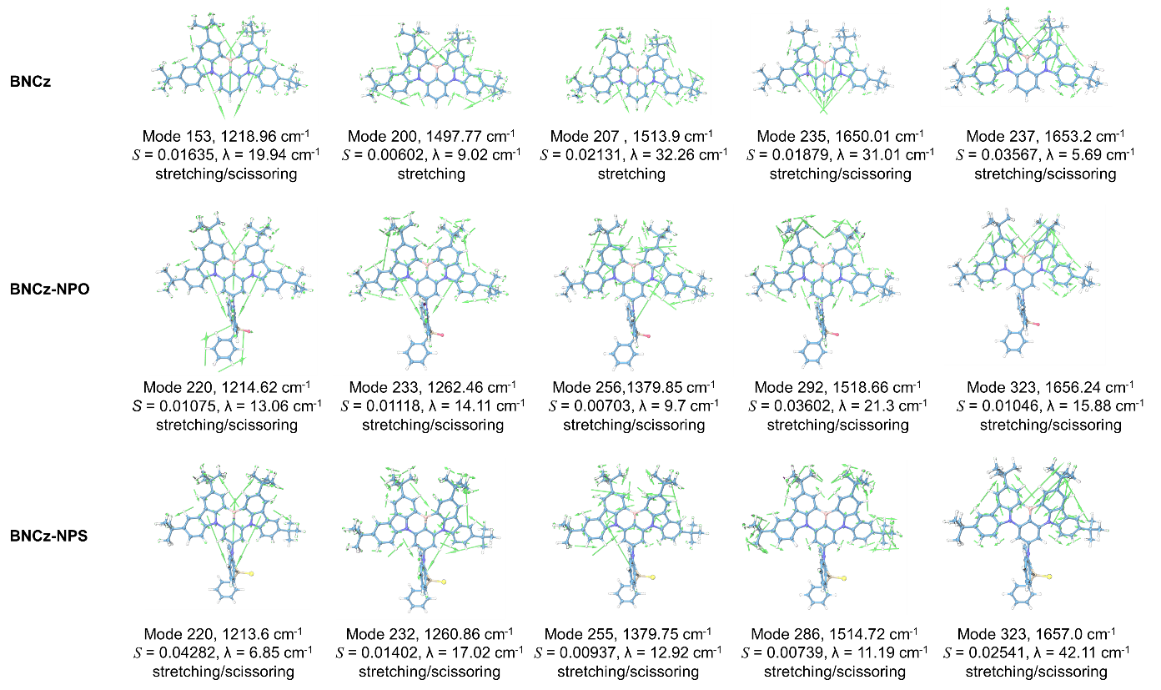
Figure S14. Transition frequencies, S, and reorganization energies of the vibrational modes contribute to the S₁-S₀ transition of the parent molecule BNCz, BNCz-NPO, and BNCz-NPS in the region of frequency > 1000 cm⁻¹.

Table S5. Summary of Franck-Condon analysis on the S₁–S₀ transition of BNCz, BNCz-NPO, and BNCz-NPS at the (TD) B3LYP/6-31G(d) level.
Compd. | Transition  (S₁→S₀) | Frequency  (cm⁻¹) | Relative frequency  (cm⁻¹) | Line density | Dipole strength  (arb. units)
BNCz | 0→0 | 21649.5367 | 0 | 666.1 | 0.5347
 | 0→2¹ | 21632.2176 | -17.3191 | 193.6 | 0.1562
 | 0→3¹ | 21617.3416 | -32.1951 | 114.5 | 0.09271
 | 0→7¹ | 21609.3069 | -40.2298 | 84.81 | 0.06875
 | 0→9¹ | 21591.5786 | -57.9581 | 544.0 | 0.4420
 | 0→9¹,2¹ | 21574.2594 | -75.2773 | 152.5 | 0.1242
 | 0→9¹,3¹ | 21559,3835 | -90.1532 | 93.15 | 0.07614
 | 0→9¹,7¹ | 21551.3487 | -98.1880 | 75.69 | 0.06196
 | 0→9² | 21533.6204 | -115.9163 | 224.4 | 0.1841
BNCz-NPO | 0→0 | 21901.2363 | 0 | 717.2 | 0.5498
 | 0→3¹ | 21889.7477 | -11.4886 | 395.9 | 0.3044
 | 0→3² | 21878.2591 | -22.9772 | 114.2 | 0.08792
 | 0→11¹ | 21862.5103 | -38.7260 | 112.7 | 0.08697
 | 0→14¹ | 21844.5658 | -56.6705 | 126.2 | 0.09795
 | 0→15¹ | 21842.9812 | -58.2551 | 101.9 | 0.07905
BNCz-NPS | 0→0 | 21860.4119 | 0 | 426.5 | 0.3293
 | 0→1¹ | 21857.0276 | -3.3843 | 408.5 | 0.3159
 | 0→1² | 21853.6433 | -6.7686 | 101.3 | 0.07834
 | 0→3¹ | 21849.7412 | -10.6707 | 97.82 | 0.07577
 | 0→3¹,1¹ | 21846.3569 | -14.0550 | 76.24 | 0.05903
 | 0→14¹ | 21804.5658 | -55.8461 | 93.18 | 0.07270
 | 0→15¹ | 21802.4181 | -57.9938 | 76.94 | 0.06013
 | 0→14¹,1¹ | 21801.1815 | -59.2304 | 93.55 | 0.07310
 | 0→15¹,1¹ | 21799.0338 | -61.3781 | 74.94 | 0.05854

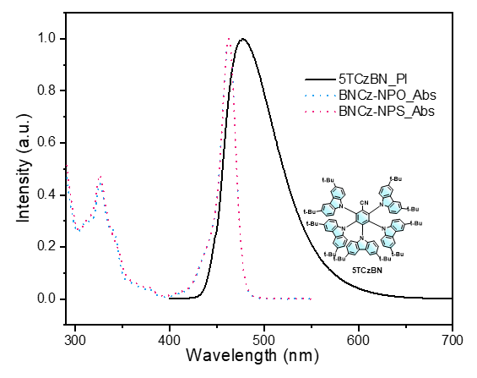
Figure S15. Absorption spectra of BNCz-NPO and BNCz-NPS, and PL spectrum of 5TCzBN in toluene solution (1 × 10⁻⁵ M, 298 K).

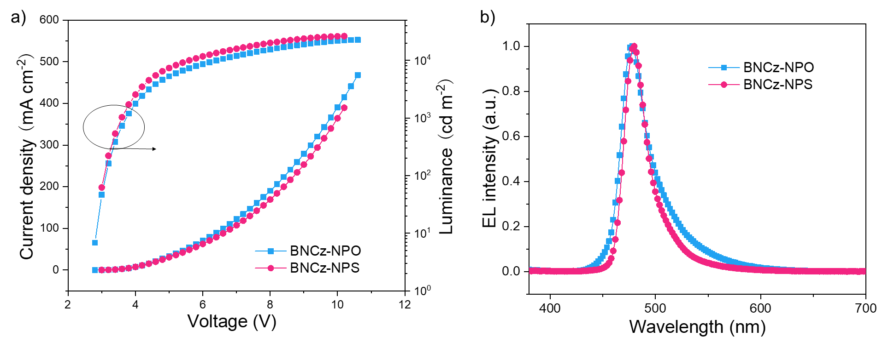
Figure S16. a) Current density-voltage-luminance characteristics, b) EL spectra of HF-I type OLEDs measured at 4 V.

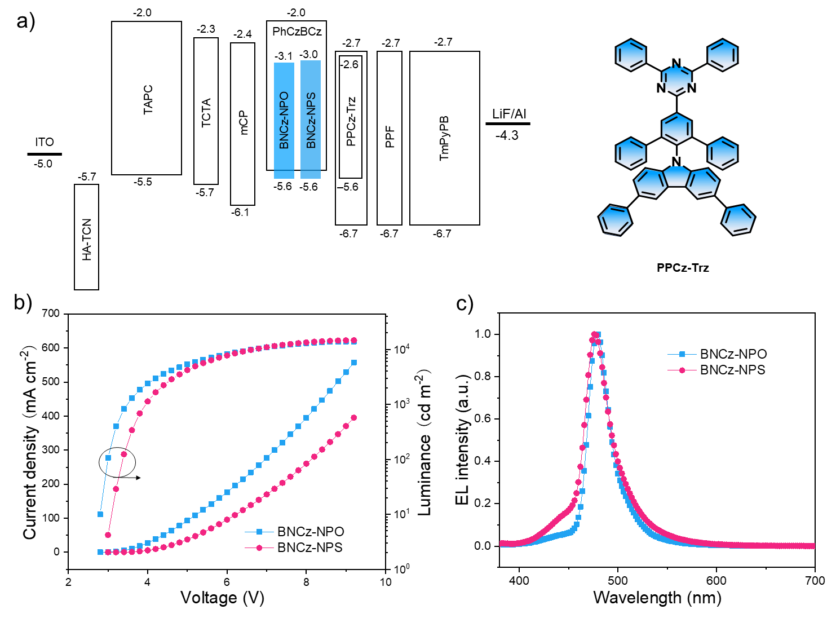
Figure S17. a) Device structure of HF-II type OLEDs and the chemical structure of PPCz-Trz; b) Current density-voltage-luminance characteristics of HF-II type OLEDs; c) EL spectra measured at 4 V.

Table S6. EL performance of the reported high-performance blue MR-TADF emitters. The plotted data for Figure 7 in main text are highlighted with color.
Dopant type | Emitter | λ_{EL}  [nm] | FWHM  [nm] | EQE_{max}  [%] | EQE₁₀₀  [%] | EQE₁₀₀₀  [%] | CIE (x, y) | Ref.
Monoboron | BNCz-NPO | 480 | 26 | 32.1 | 21.7 | 9.7 | (0.11, 0.22) | This work
Monoboron | BNCz -NPS | 476 | 26 | 29.6 | 23.5 | 13.5 | (0.11, 0.16) | This work
Monoboron | BNCz-NPO (HF-I) | 476 | 26 | 30.2 | 28.0 | 20.7 | (0.12, 0.22) | This work
Monoboron | BNCz-NPO (HF-II) | 480 | 26 | 37.6 | 30.2 | 12.0 | (0.11, 0.18) | This work
Monoboron | BNCz-NPS (HF-I) | 480 | 30 | 31.9 | 31.6 | 26.4 | (0.14, 0.24) | This work
Monoboron | BNCz-NPs (HF-II ) | 476 | 30 | 32.2 | 29.2 | 17.3 | (0.13, 0.18) | This work
Monoboron | TBA-BCz-BN (HF) | 470 | 28 | 30.8 | 19.0 | 11.7 | (0.12, 0.15) | 5
Monoboron | DCzBNO (HF) | 469 | 45 | 31.7 | - | - | (0.13, 0.15) | 6
Monoboron | TCzBNO(HF) | 482 | 52 | 36.5 | - | - | (0.13, 0.25) | 6
Monoboron | γ-Cb-B | 461 | 28 | 19.0 | 16.2 | 7.7 | (0.13, 0.13) | 7
Monoboron | Cz-B | 482 | 30 | 22.6 | 16.6 | 6.9 | (0.11, 0.31) | 7
Monoboron | Tip-DtCzB (HF) | 484 | 25 | 29.0 | 23.2 | 11.0 | (0.10, 0.29) | 8
Monoboron | tDPA-DtCzB (HF) | 480 | 27 | 30.2 | 27.5 | 18.0 | (0.11, 0.24) | 8
Monoboron | BNO-DPAC (HF) | 448 | 36 | 27.7 | - | 14.5 | (0.151, 0.083) | 9
Monoboron | BNO-DMAC (HF) | 449 | 36 | 28.7 | - | 18.2 | (0.149, 0.090) | 9
Monoboron | BNO-tBuDMAC | 447 | 59 | 27.7 | - | 18.8 | (0.155, 0.144) | 9
Monoboron | t-DAB-DPA | 459 | 26 | 27.9 | 21.8 | 8.1 | (0.13, 0.08) | 10
Monoboron | t-DABNA | 464 | 26 | 28.4 | 14.8 | 4.4 | (0.13, 0.10) | 10
Monoboron | PAB | 456 | 31 | 14.7 | - | - | (0.145, 0.076) | 11
Monoboron | 2tPAB | 456 | 27 | 16.8 | - | - | (0.145, 0.076) | 11
Monoboron | 3tPAB | 460 | 26 | 19.3 | - | - | (0.141, 0.076) | 11
Monoboron | tDPAC-BN (HF) | 460 | 28 | 21.6 | 15.3 | 5.4 | (0.135, 0.094) | 12
Monoboron | tDMAC-BN (HF) | 472 | 34 | 22.3 | 19.0 | 10.4 | (0.116, 0.186) | 12
Monoboron | DPACzBN1 | 475 | 34 | 23.6 | 19.3 | 9.6 | (0.14, 0.30) | 13
Monoboron | DPACzBN2 | 469 | 28 | 24.0 | 23.5 | 14.3 | (0.13, 0.16) | 13
Monoboron | DPACzBN3 | 472 | 24 | 27.7 | 19.3 | 6.7 | (0.12, 0.18) | 13
Monoboron | B-dpa-Cz | 475 | 27 | 20.1 | 15.3 | 4.7 | (0.11, 0.19) | 14
Monoboron | B-dpa-dmAc | 478 | 32 | 24.3 | 23.3 | 14.9 | (0.11, 0.22) | 14
Monoboron | B-dpa-SpiroAc | 478 | 32 | 24.3 | 23.6 | 15.6 | (0.11, 0.22) | 14
Monoboron | B-O-dpa | 443 | 32 | 16.3 | 6.5 | 2.2 | (0.15, 0.05) | 15
Monoboron | B-O-Cz | 481 | 63 | 13.4 | 9.5 | 5.9 | (0.13, 0.22) | 15
Monoboron | B-O-dmAc | 475 | 44 | 16.2 | 13.5 | 8.4 | (0.12, 0.21) | 15
Monoboron | B-O-dpAc | 473 | 42 | 17.0 | 14.3 | 9.6 | (0.12, 0.20) | 15
Monoboron | mono-mx-CzDABNA (HF) | 481 | 48 | 21.4 | 14.0 | 7.8 | (0.13, 0.24) | 16
Monoboron | tri-mx-CzDABNA (HF) | 472 | 34 | 26.9 | 26.1 | 24.8 | (0.13, 0.19) | 16
Monoboron | DABNA-2 | 467 | 28 | 20.2 | - | - | (0.12, 0.13) | 17
Monoboron | DABNA-1 | 459 | 28 | 13.5 | - | - | (0.13, 0.09) | 17
Monoboron | DABNA-NP-TB | 457 | 33 | 19.5 | 17.5 | 12 | (0.14, 0.11) | 18
Monoboron | Cz2DABNA-NP-M/TB | 477 | 27 | 21.8 | 20.4 | 14.9 | (0.11, 0.23) | 18
Monoboron | mBP -DABNA-Me | 468 | 28 | 24.3 | 19.5 | 16.0 | (0.12, 0.14) | 19
Monoboron | tCBN-DADPO | 472 | 28 | 30.8 | 23.3 | 16.2 | (0.14, 0.22) | 20
Monoboron | CzBO | 448 | 30 | 16.3 | 10.7 | 4.7 | (0.15, 0.05) | 21
Monoboron | CzBS | 474 | 31 | 29.1 | 27.4 | 20.0 | (0.11, 0.16) | 21
Monoboron | CzBSe | 481 | 33 | 30.1 | 29.7 | 26.1 | (0.10, 0.24) | 21
Monoboron | DCz-BSN | 473 | 29 | 22.0 | 18.6 | 10.0 | (0.11, 0.17) | 22
Monoboron | Cz-BSN | 482 | 32 | 18.9 | 13.4 | 6.8 | (0.11, 0.28) | 22
Monoboron | PTZBN3 (HF) | 468 | 46 | 32.0 | 30.3 | 25.0 | (0.15, 0.24) | 23
Monoboron | PTZBN2 (HF) | 478 | 48 | 34.8 | 28.8 | 19.5 | (0.15, 0.29 | 23
Monoboron | PTZBN1 (HF) | 489 | 47 | 32.7 | 25.9 | 16.5 | (0.14, 0.41 | 23
Monoboron | TBN-TPA | 474 | 27 | 32.1 | 27.4 | 13.9 | (0.12, 0.19) | 24
Monoboron | TCz-BN | 474 | 34 | 18.88 | 15.19 | 10.52 | (0.13, 0.20) | 25
Monoboron | ADBNA -Me-Mes | 481 | 32 | 16.2 | 11.1 |  | (0.10, 0.27) | 26
Monoboron | ADBNA -Me-Tip | 480 | 33 | 21.4 | 15.4 |  | (0.11, 0.29) | 26
Monoboron | BN-TC | 474 | 37 | 21.2 | 8.7 | 4.2 | (0.13, 0.20) | 27
Monoboron | BN-AC | 484 | 27 | 23.4 | 15.9 | 5.5 | (0.10, 0.31) | 27
Monoboron | Tp-DABNA (HF) | 462 | 29 | 27.5 | 18.6 |  | (0.14, 0.13) | 28
Monoboron | t-DABNA (HF) | 464 | 34 | 23.3 | 14.7 |  | (0.13, 0.14) | 28
Monoboron | p-TBNCz | 488 | 26 | 27.0 | 11.7 | 5.8 | (0.09, 0.35) | 29
Monoboron | OBN | 437 | 44 | 15.7 |  |  | 0.15, 0.09) | 30
Monoboron | NBN | 452 | 40 | 23.02 |  |  | (0.14, 0.09) | 30
Monoboron | BIC-pCz (HF) | 466 | 48 | 39.8 |  |  | (0.14, 0.16) | 31
Monoboron | BN1 (HF) | 457 | 28 | 31.2 | 18.3 | 9.3 | (0.14, 0.06) | 32
Monoboron | BN2 (HF) | 467 | 23 | 33.2 | 25.5 | 15.5 | (0.13, 0.11) | 32
Polyboron | ODBN | 446 | 54 | 24.15 |  |  | (0.15, 0.10) | 30
Polyboron | BIC-mCz (HF) | 432 | 42 | 19.4 |  |  | (0.16, 0.05) | 31
Polyboron | mDBIC (HF) | 431 | 42 | 13.5 |  |  | (0.16, 0.05) | 31
Polyboron | BN3 (HF) | 458 | 23 | 37.6 | 34.0 | 26.2 | (0.14, 0.08) | 32
Polyboron | V-DABNA -Mes | 480 | 27 | 22.9 | 20.3 | 10.9 | (0.09, 0.21) | 33
Polyboron | m[B-N]N1 (HF) | 479 | 27 | 36.0 |  | 32.3 | (0.12, 0.27) | 34
Polyboron | m[B-N]N2 (HF) | 485 | 33 | 33.4 |  | 29.7 | (0.14, 0.46) | 34
Polyboron | α-3BNMes (HF) | 443 | 49 | 14.6 | 10.2 |  | (0.15, 0.10) | 35
Polyboron | B2 | 460 | 37 | 18.3 | 12.6 |  | (0.13, 0.11) | 36
Polyboron | v-DABNA | 469 | 18 | 34.4 | 32.8 | 26.0 | (0.14, 0.11) | 37
Polyboron | v-DABNA-OMe | 465 | 23 | 29.5 | 28.8 | 26.9 | (0.13, 0.10) | 38
Polyboron | m-ν-DABNA | 471 | 18 | 36.2 |  |  | (0.12, 0.12) | 39
Polyboron | 4F-ν-DABNA | 464 | 18 | 35.8 |  |  | (0.13, 0.08) | 39
Polyboron | 4F-mν-DABNA | 461 | 18 | 33.7 |  |  | (0.13, 0.06) | 39
Polyboron | BOBO-Z | 445 | 18 | 16.6 | 12.4 | 5.3 | (0.15, 0.04) | 40
Polyboron | BOBS-Z | 455 | 23 | 33.1 | 30.2 | 20.2 | (0.14, 0.06) | 40
Polyboron | BSBS-Z | 463 | 23 | 32.2 | 30.2 | 20.2 | (0.13, 0.08) | 40
Polyboron | m-DiNBO | 466 | 21 | 24.2 | 17.3 |  | (0.13, 0.10) | 41
Polyboron | BSBS-N1 | 478 | 21 | 25 |  |  | (0.11, 0.22) | 42
Polyboron | NO-DBMR | 469 | 26 | 33.7 |  |  | (0.12,0.12) | 43
Polyboron | Cz-DBMR | 491 | 22 | 29.8 |  |  | (0.09,0.34) | 43
Polyboron | BBCz-DB | 469 | 27 | 29.3 |  |  | (0.12, 0.18) | 44

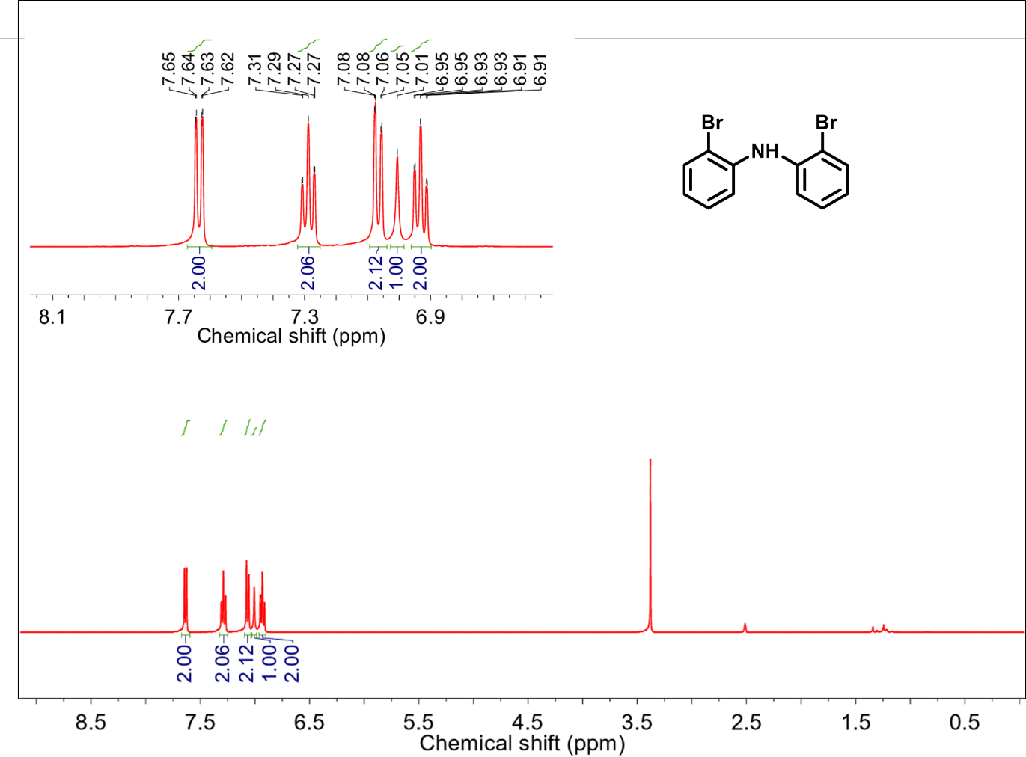

Figure S18. ¹H NMR spectrum of 1 in CDCl₃ (400 MHz, 25 °C).

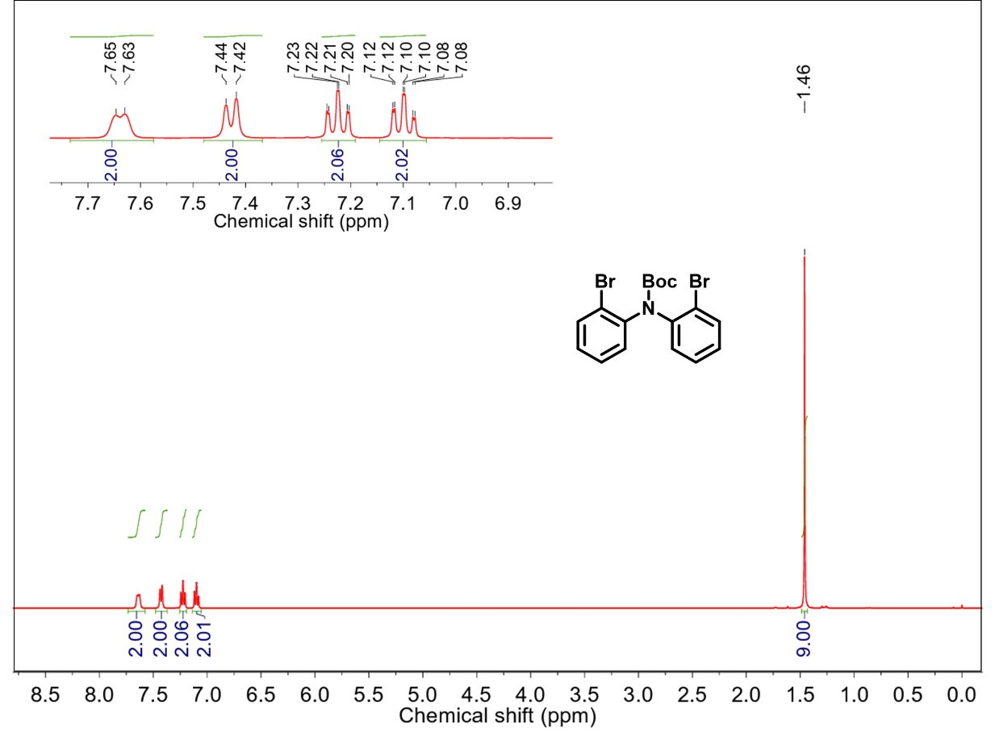
Figure S19. ¹H NMR spectrum of 2 in CDCl₃ (400 MHz, 25 °C).

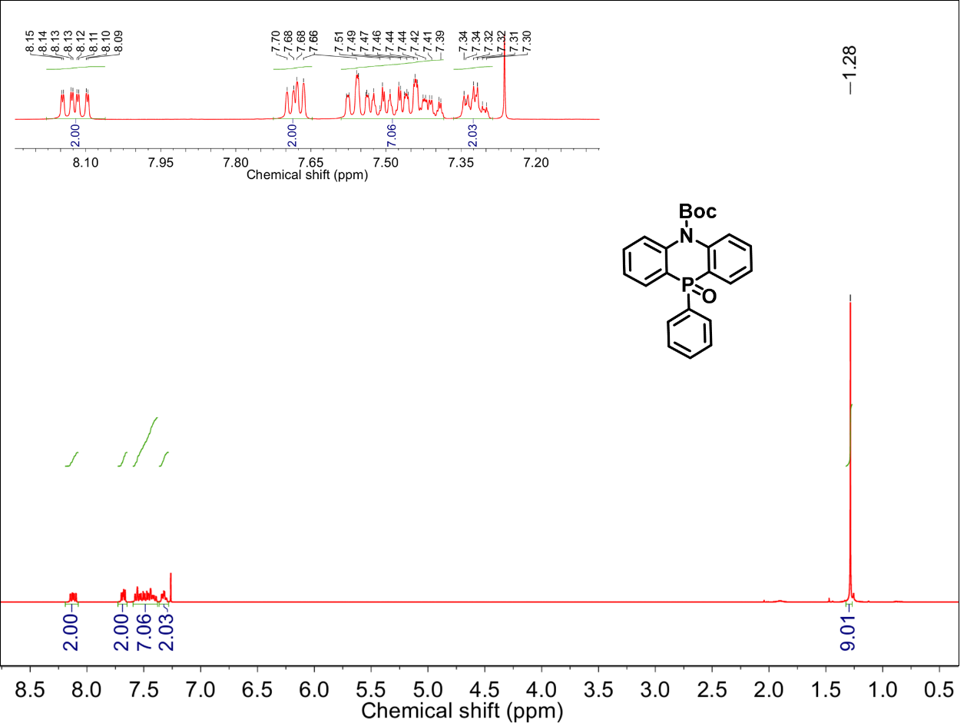
Figure S20. ¹H NMR spectrum of 3a in CDCl₃ (400 MHz, 25 °C).

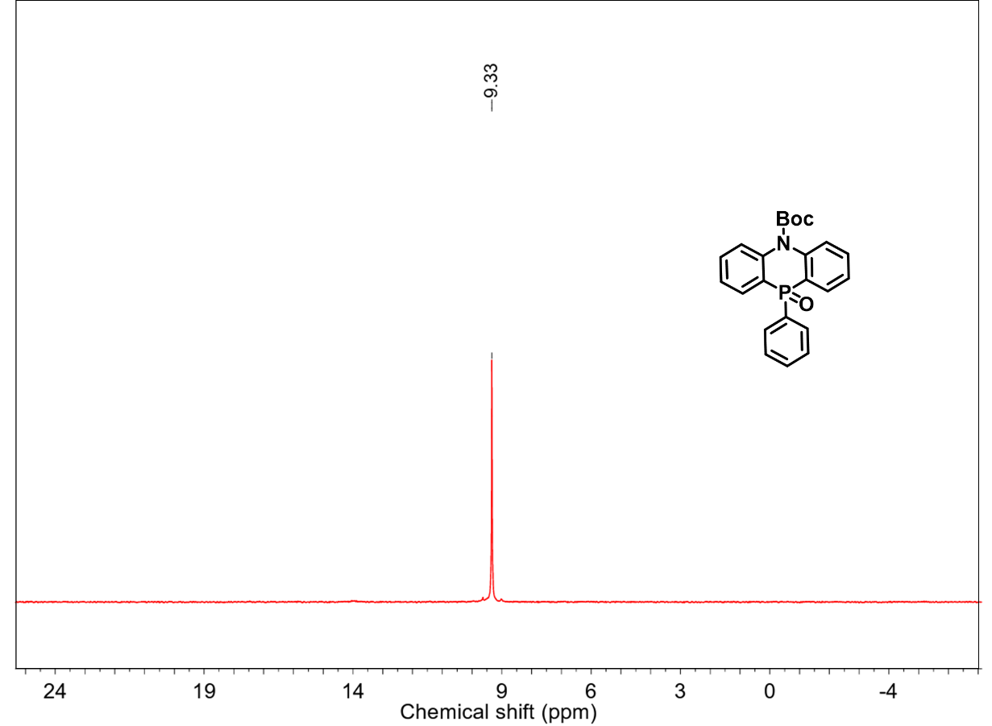
Figure S21. ³¹P NMR spectrum of 3a in CDCl₃ (400 MHz, 25 °C).

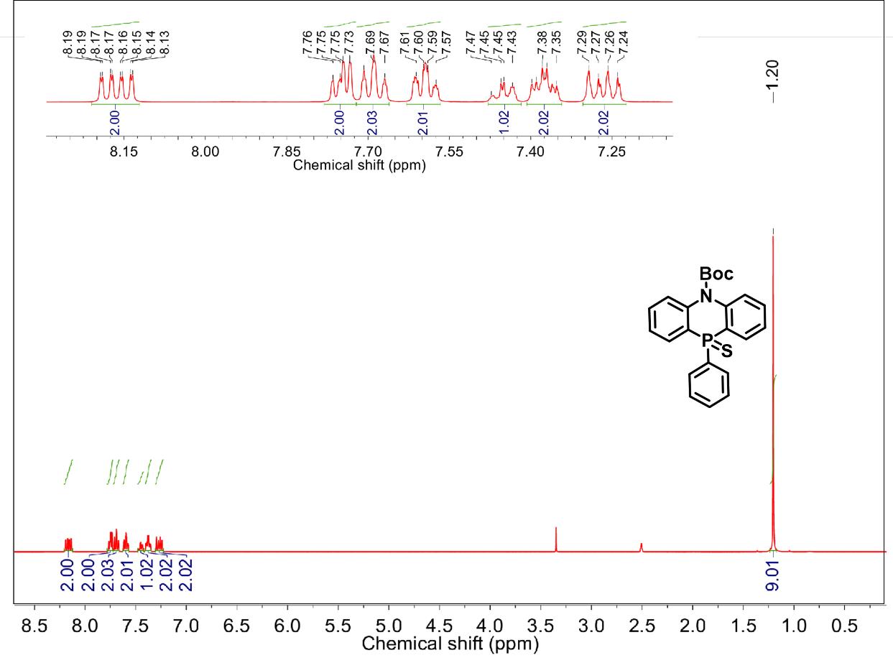
Figure S22. ¹H NMR spectrum of 3b in DMSO_{d6} (400 MHz, 25 °C).

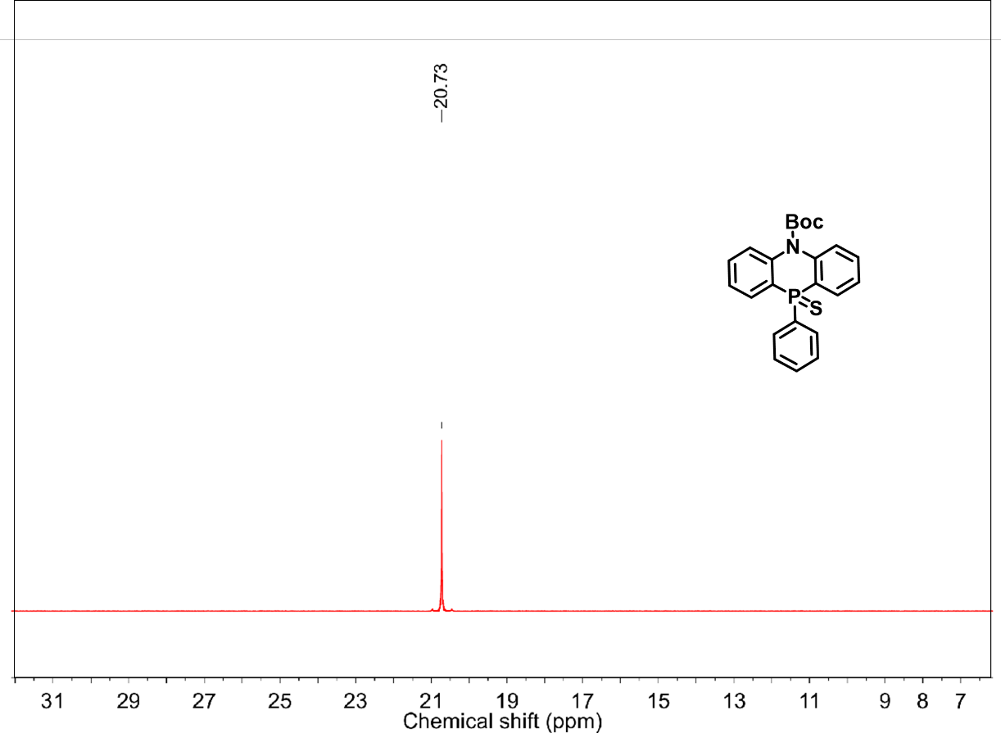

Figure S23. ³¹P NMR spectrum of 3b in DMSO_{d6} (400 MHz, 25 °C).

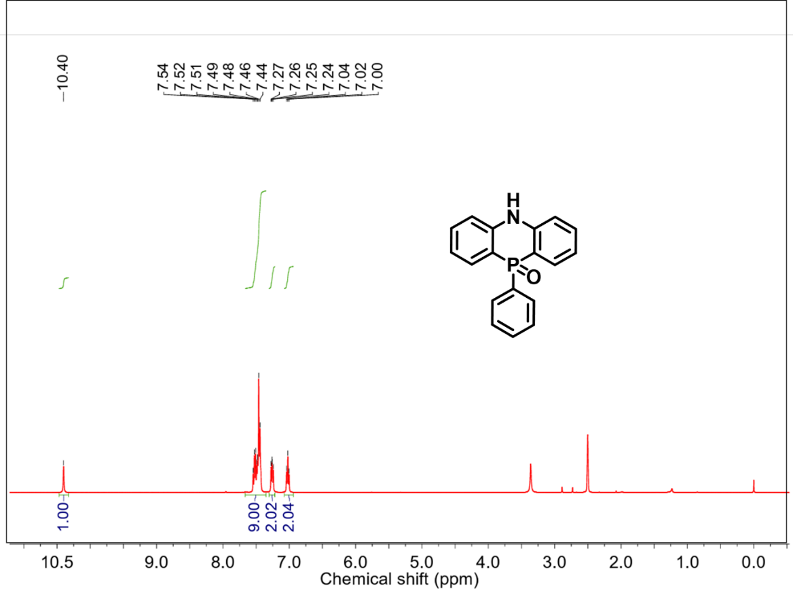
Figure S24. ¹H NMR spectrum of NPO in DMSO_{d6} (400 MHz, 25 °C).

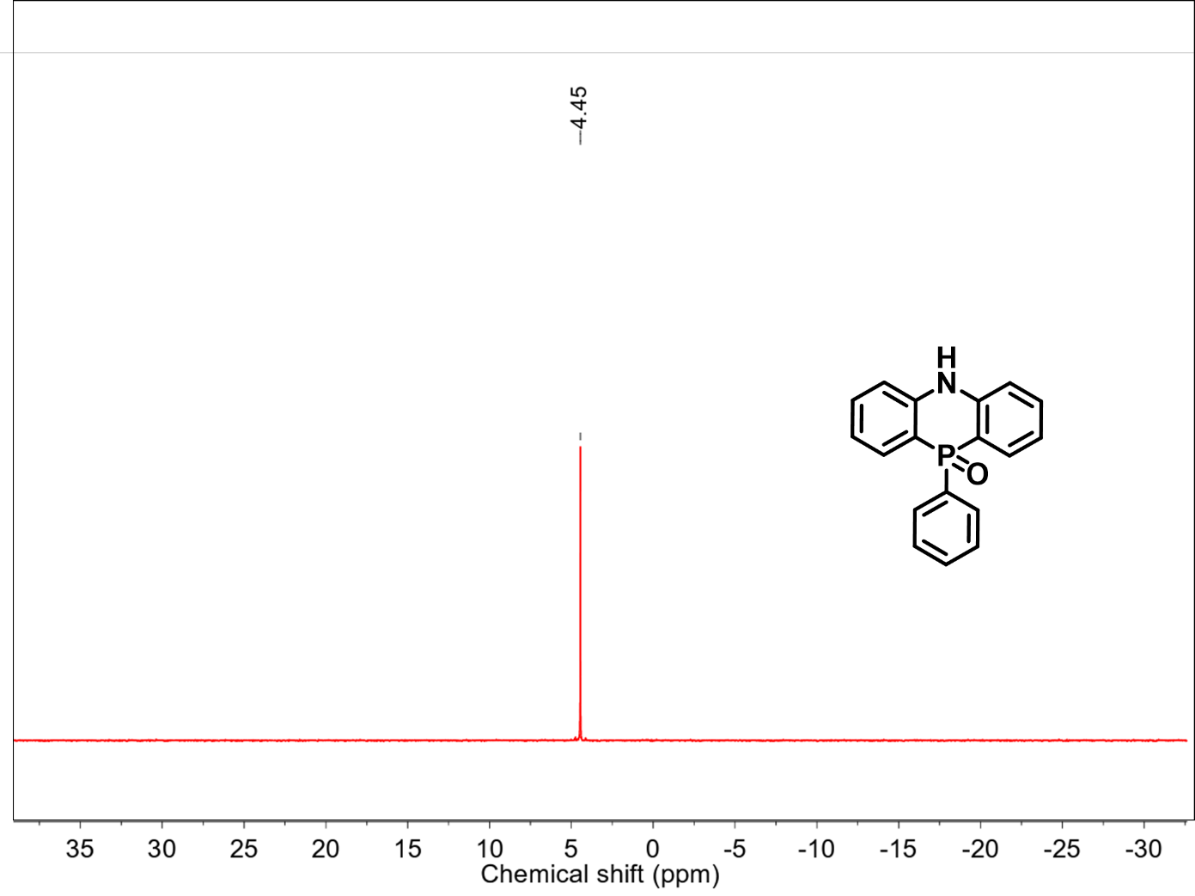
Figure S25. ³¹P NMR spectrum of NPO in DMSO_{d6} (400 MHz, 25 °C).

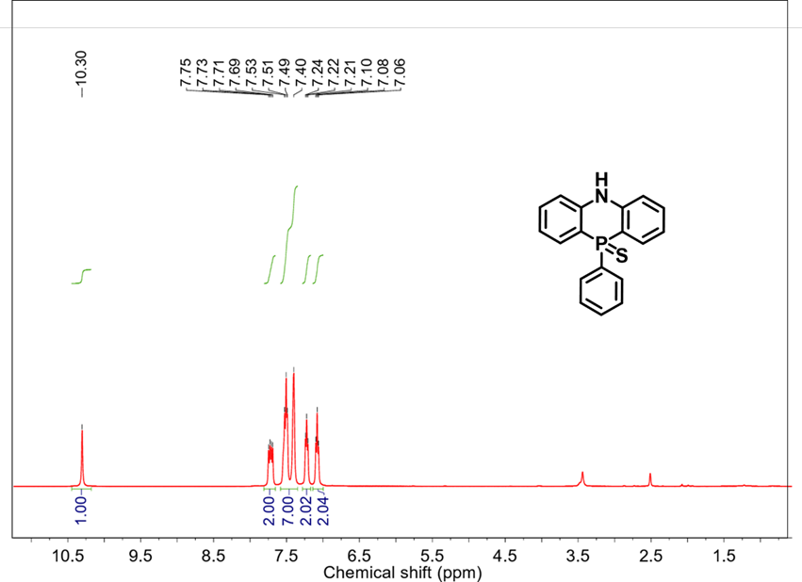
Figure S26. ¹H NMR spectrum of NPS in DMSO_{d6} (400 MHz, 25 °C).

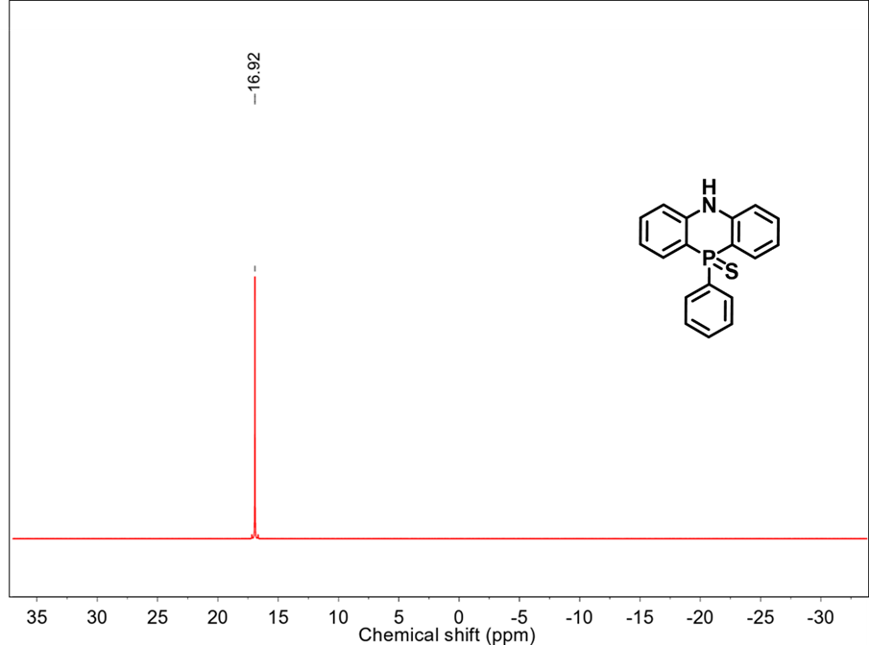

Figure S27. ³¹P NMR spectrum of NPS in DMSO_{d6} (400 MHz, 25 °C).

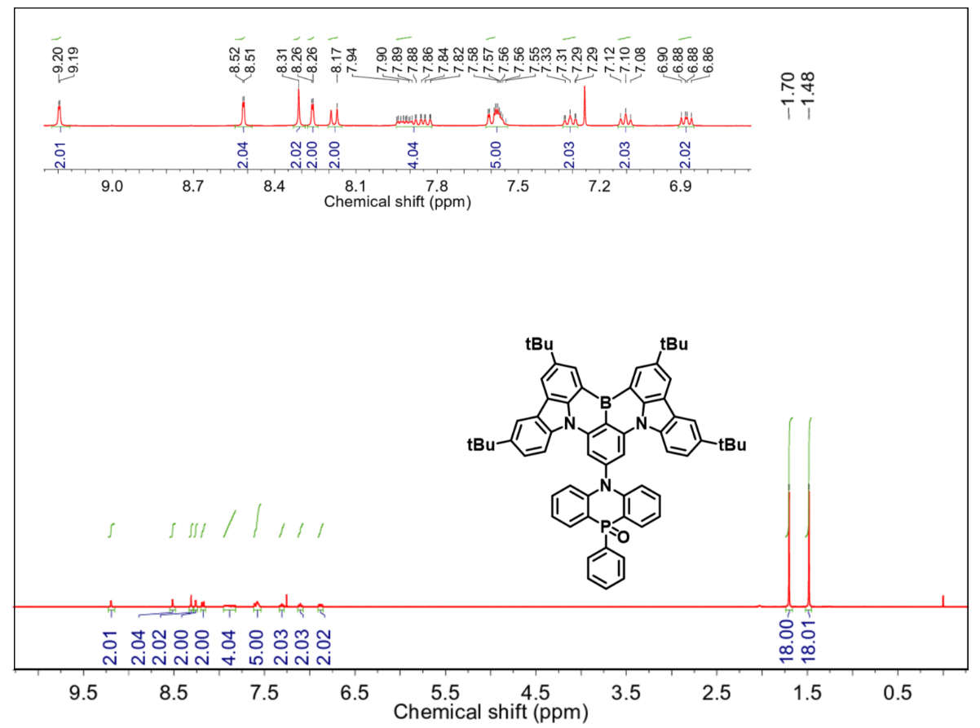
Figure S28. ¹H NMR spectrum of BNCz-NPO in CDCl₃ (400 MHz, 25 °C).

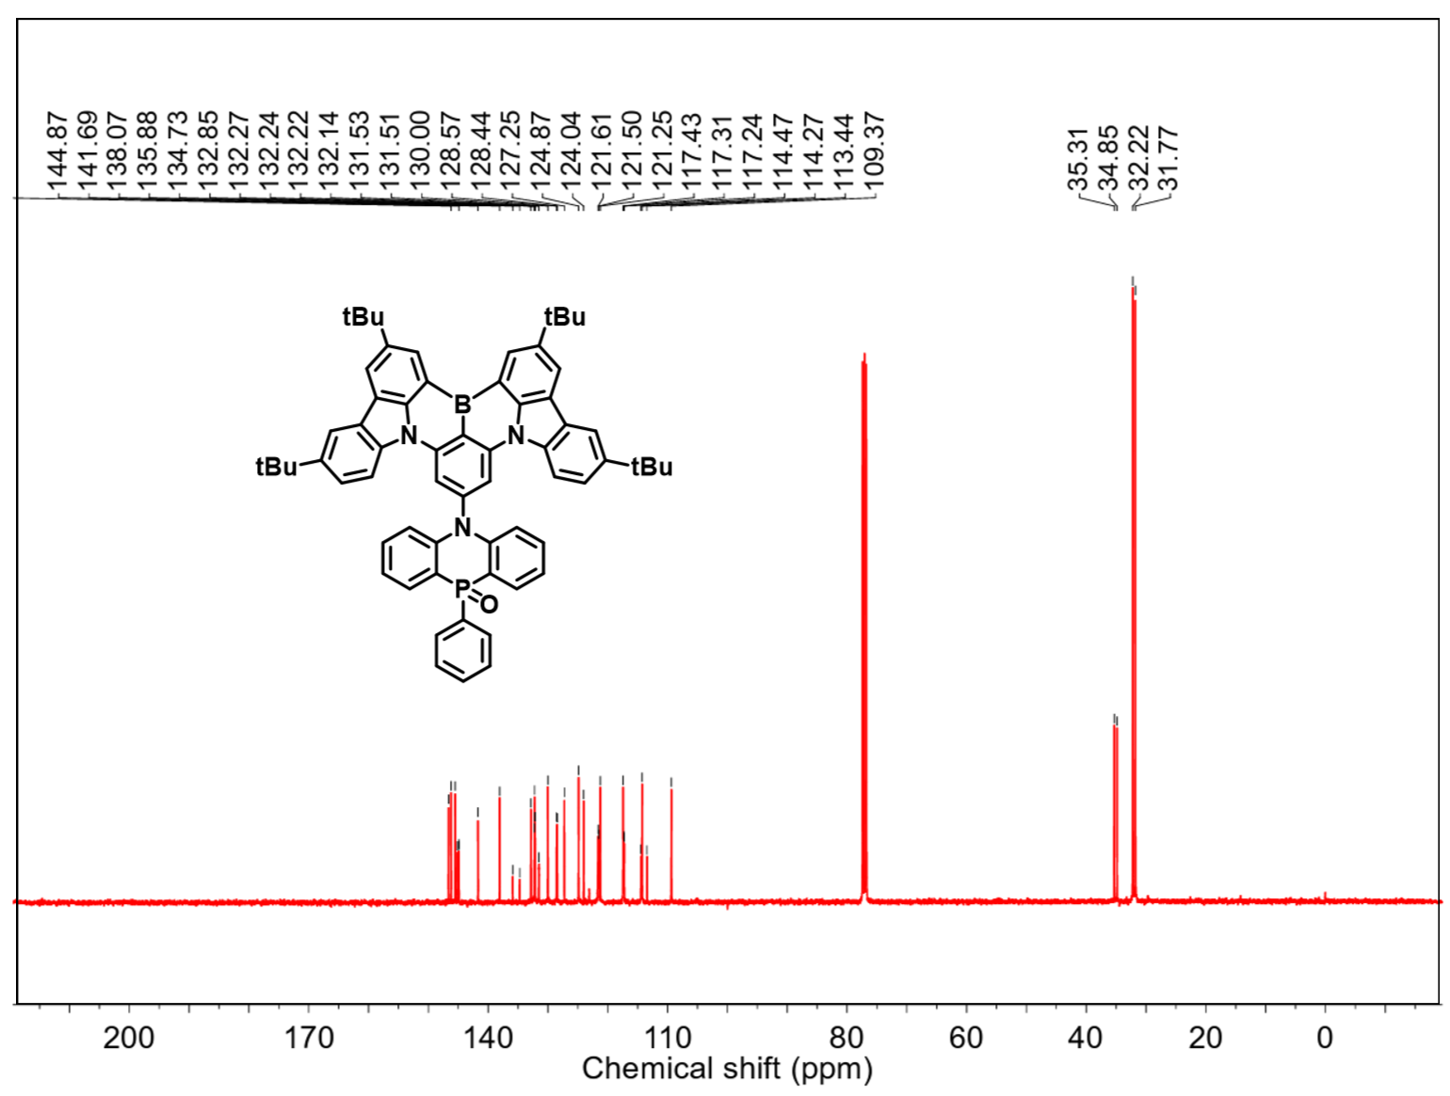
Figure S29. ¹³C NMR spectrum of BNCz-NPO in CDCl₃ (400 MHz, 25 °C).

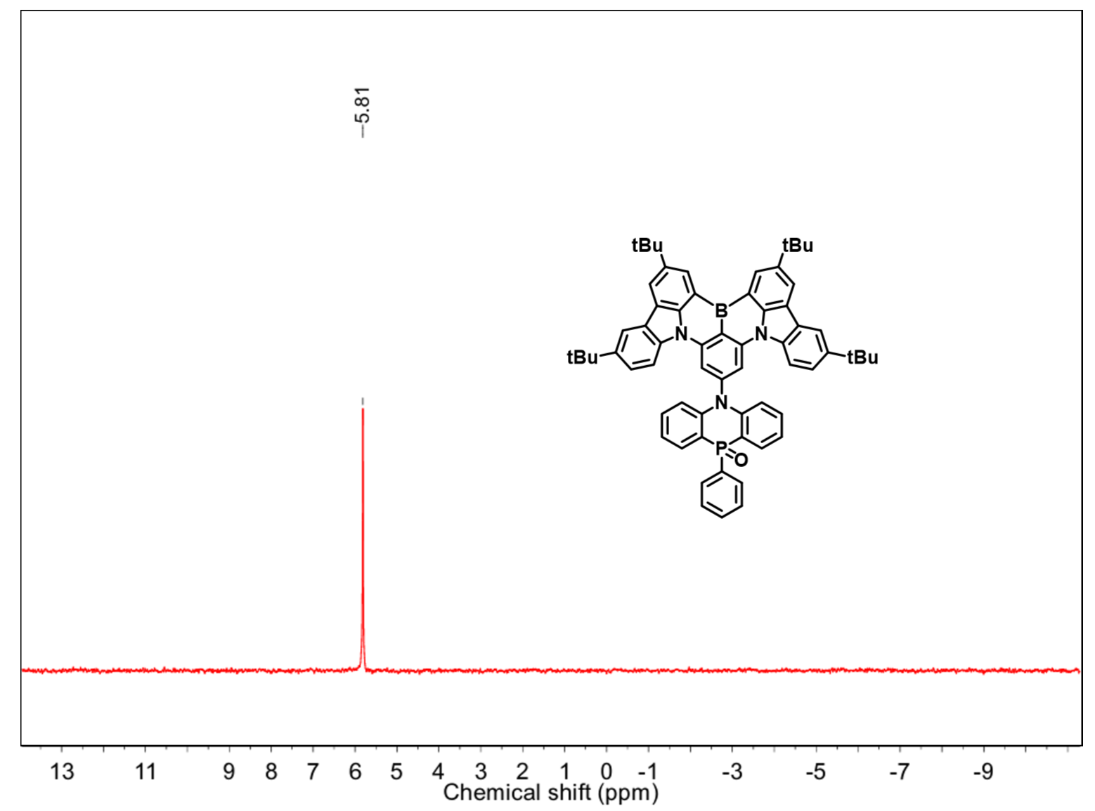
Figure S30. ³¹P NMR spectrum of BNCz-NPO in CDCl₃ at 25 °C.

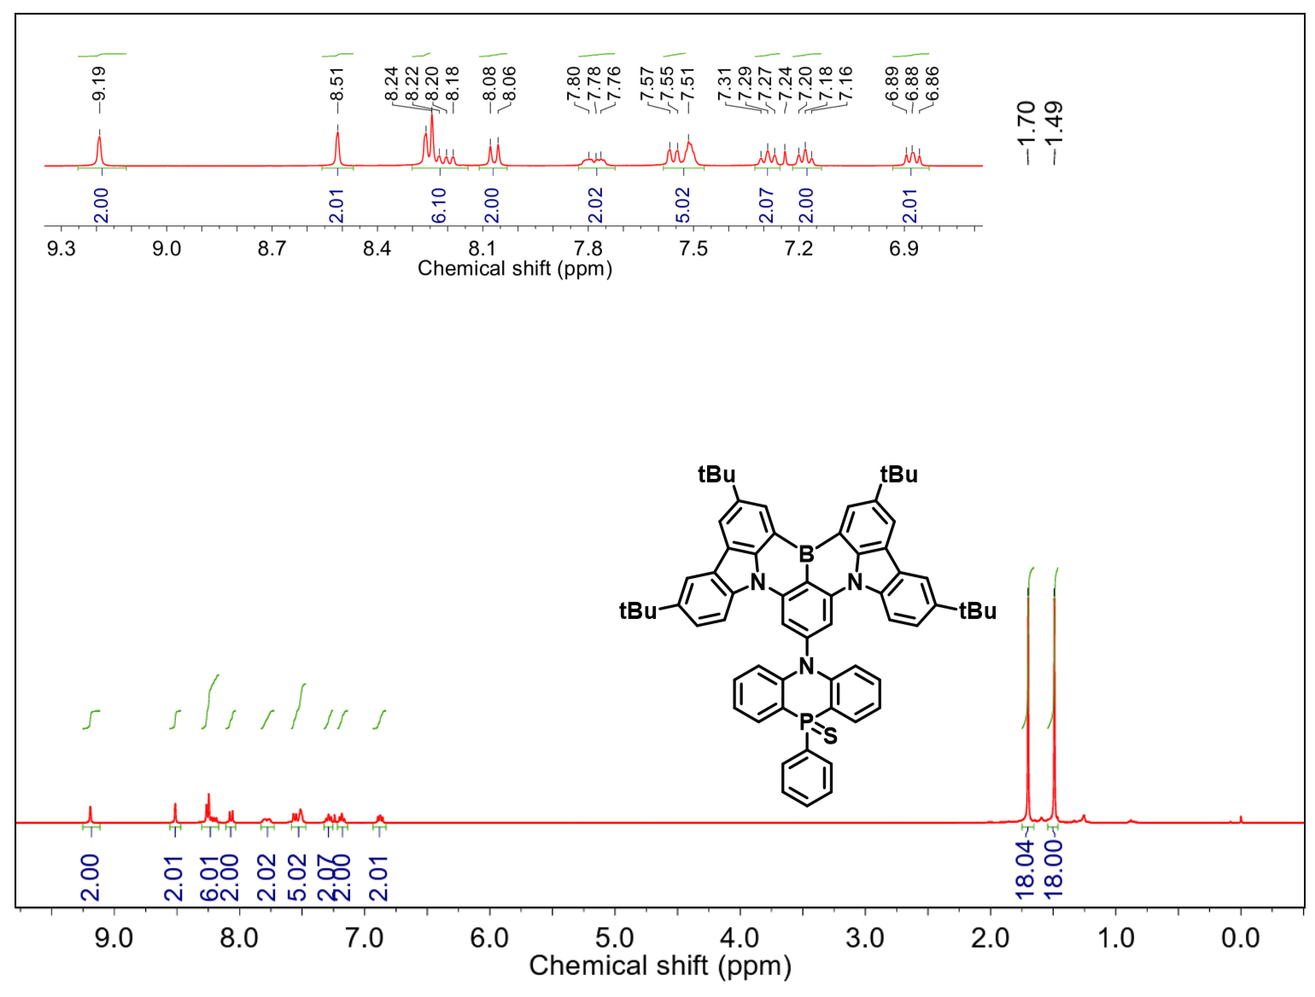
Figure S31. ¹H NMR spectrum of BNCz-NPS in CDCl₃ (400 MHz, 25 °C).
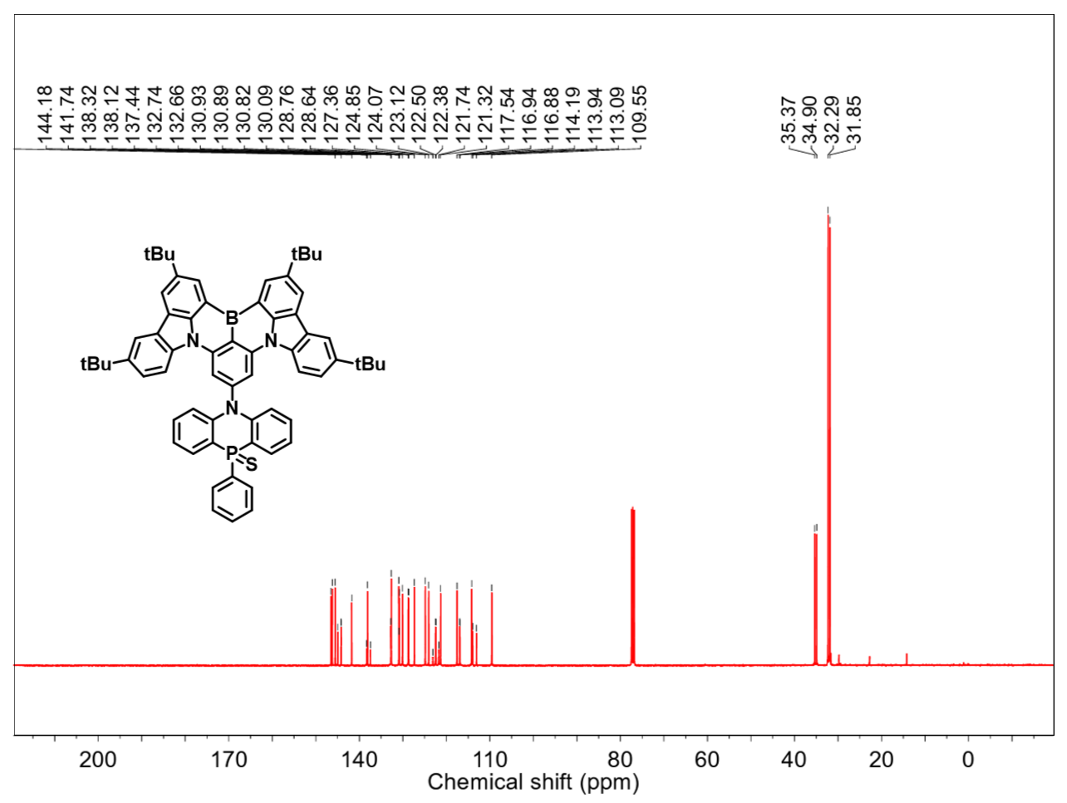
Figure S32. ¹³C NMR spectrum of BNCz-NPS in CDCl₃ (400 MHz, 25 °C).

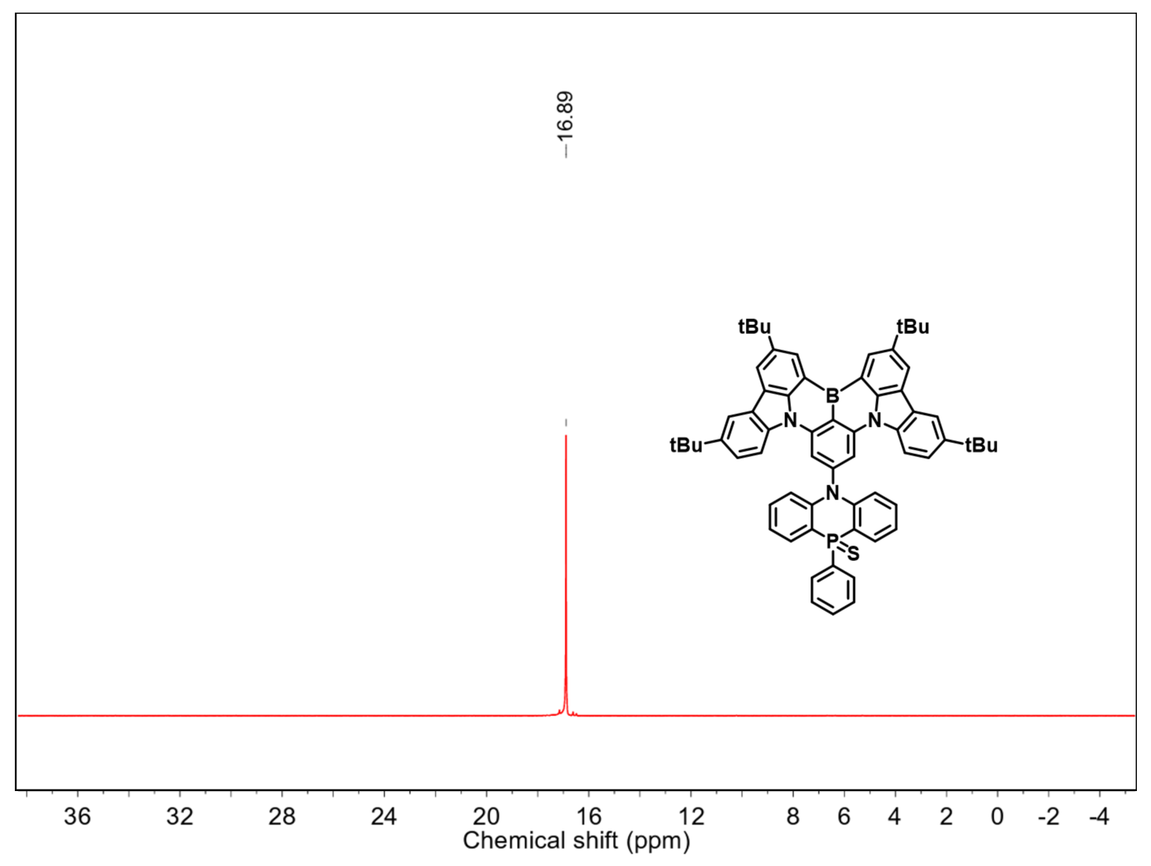
Figure S33. ³¹P NMR spectrum of BNCz-NPS in CDCl₃ at 25 °C.

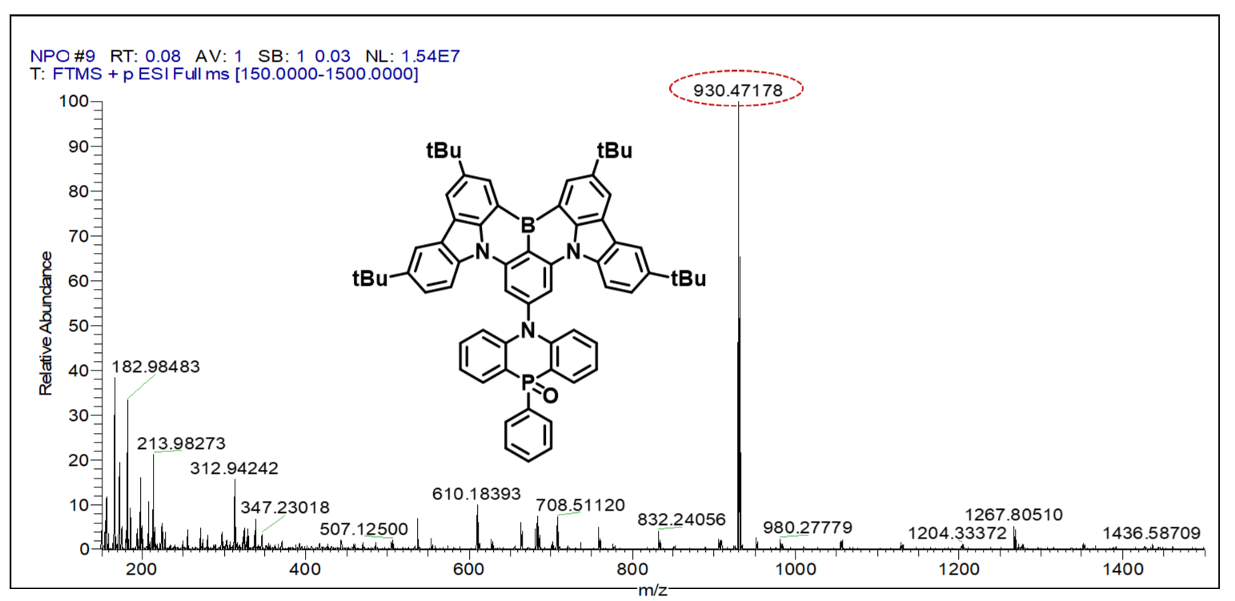
Figure S34. HRMS spectrum of BNCz-NPO.

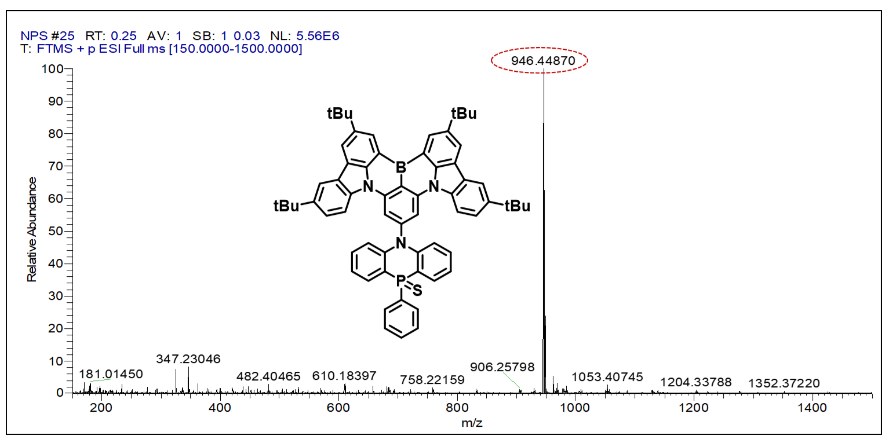
Figure S35. HRMS spectrum of BNCz-NPS.

References
[1] Gaussian 16, Revision A.03, M. J. Frisch, G. W. Trucks, H. B. Schlegel, G. E. Scuseria, M. A. Robb, J. R. Cheeseman, G. Scalmani, V. Barone, G. A. Petersson, H. Nakatsuji, X. Li, M. Caricato, A. V. Marenich, J. Bloino, B. G. Janesko, R. Gomperts, B. Mennucci, H. P. Hratchian, J. V. Ortiz, A. F. Izmaylov, J. L. Sonnenberg, D. Williams-Young, F. Ding, F. Lipparini, F. Egidi, J. Goings, B. Peng, A. Petrone, T. Henderson, D. Ranasinghe, V. G. Zakrzewski, J. Gao, N. Rega, G. Zheng, W. Liang, M. Hada, M. Ehara, K. Toyota, R. Fukuda, J. Hasegawa, M. Ishida, T. Nakajima, Y. Honda, O. Kitao, H. Nakai, T. Vreven, K. Throssell, J. A. Montgomery, Jr., J. E. Peralta, F. Ogliaro, M. J. Bearpark, J. J. Heyd, E. N. Brothers, K. N. Kudin, V. N. Staroverov, T. A. Keith, R. Kobayashi, J. Normand, K. Raghavachari, A. P. Rendell, J. C. Burant, S. S. Iyengar, J. Tomasi, M. Cossi, J. M. Millam, M. Klene, C. Adamo, R. Cammi, J. W. Ochterski, R. L. Martin, K. Morokuma, O. Farkas, J. B. Foresman, and D. J. Fox, Gaussian, Inc., Wallingford CT, 2016.
[2] W. Humphrey, A. Dalke, K. Schulten, J. Mol. Graphics 1996, 14, 33.
[3] T. Lu, F. Chen, J. Comput. Chem. 2012, 33, 580
[4] K. Masui, H. Nakanotani, C. Adachi, Org. Electron. 2013, 14, 2721.
[5] X. Xiao, B. Lei, D. Wu, Z. Bin. Chem. Commun., 2023, 59, 6556.
[6] Y. Xu, J. Han, N. Li, Z. Huang, J. Miao and C. Yang, J. Mater. Chem. C, 2023, DOI: 10.1039/D3TC02574H.
[7] M. Yang, S. Shikita, H. Min, I. S. Park, H. Shibata, N. Amanokura, T. Yasuda, Angew. Chem. Int. Ed. 2021, 60, 23142.
[8] X. Yan, Z. Li, Q. Wang, Y. Qu, Y. Xu, Y. Wang, J. Mater. Chem. C, 2022, 10, 15408
[9] X. Huang, Y. Xu, J. Miao, Y. Jing, S. Wang, Z. Ye, Z. Huang, X. Cao and C. Yang, J. Mater. Chem. C, 2023, 11, 11885.
[10] J. H. Kim, W. J. Chung, J. Kim, J. Y. Lee, Mater. Today Energy 2021, 21, 100792.
[11] Y. Wang, Y. Duan, R. Guo, S. Ye, K. Di, W. Zhang, S. Zhuang, L. Wang, Org. Electron. 2021, 97, 106275.
[12] Y. Wang, K. Di, Y. Duan, R. Guo, L. Lian, W. Zhang, L. Wang, Chem. Eng. J. 2022, 431, 133221.
[13] Y. Qiu, H. Xia, J. Miao, Z. Huang, N. Li, X. Cao, J. Han, C. Zhou, C. Zhong, C. Yang, ACS ACS Appl. Mater. Interfaces 2021, 13, 59035.
[14] J. Park, J. Moon, J. Lim, J. Woo, S. S. Yoon, J. Y. Lee, J. Mater. Chem. C, 2022, 10, 12300.
[15] J. Park, J. Lim, J. H. Lee, B. Jang, J. H. Han, S. S. Yoon, J. Y. Lee, ACS Appl. Mater. Interfaces 2021, 13, 45798.
[16] E. Ravindran, H. E. Baek, H. W. Son, J. H. Park, Y. H. Kim, M. C. Suh, Adv. Funct. Mater. 2023, 33, 2213461.
[17] T. Hatakeyama, K. Shiren, K. Nakajima, S. Nomura, S. Nakatsuka, K. Kinoshita, J. Ni, Y. Ono, T. Ikuta, Adv. Mater. 2016, 28, 2777.
[18] S. Oda, W. Kumano, T. Hama, R. Kawasumi, K. Yoshiura, T. Hatakeyama, Angew. Chem. Int. Ed. 2020, 60, 2882.
[19] H. J. Cheon, Y. S. Shin, N. H. Park, J. H. Lee, Y. H. Kim, Small 2022, 18, 2107574.
[20] J. Bian, S. Chen, L. Qiu, R. Tian, Y. Man, Y. Wang, S. Chen, J. Zhang, C. Duan, C. Han, H. Xu, Adv. Mater. 2022, 34,2110547.
[21] I. S. Park, H. Min, T. Yasuda, Angew. Chem. Int. Ed. 2022, 61, e202205684.
[22] Q. Li, Y. Wu, X. Wang, Q. Yang, J. Hu, R. Zhong, S. Shao, L. Wang, Chem. Eur. J. 2022, 28, e202104214.
[23] T. Hua, J. Miao, H. Xia, Z. Huang, X. Cao, N. Li, C. Yang, Adv. Funct. Mater. 2022, 32, 2201032.
[24] X. Liang, Z. P. Yan, H. B. Han, Z. G. Wu, Y. X. Zheng, H. Meng, J. L. Zuo, W. Huang, Angew. Chem. Int. Ed. 2018, 57, 11316.
[25] Y. Zhang, D. Zhang, J. Wei, Z. Liu, Y. Lu, L. Duan, Angew. Chem. Int. Ed. 2019, 58, 16912.
[26] S. Oda, B. Kawakami, R. Kawasumi, R. Okita, T. Hatakeyama, Organic Letters 2019, 21, 9311.
[27] Y.-H. He, F.-M. Xie, H.-Z. Li, K. Zhang, Y. Shen, F. Ding, C.-Y. Wang, Y.-Q. Li, J.-X. Tang, Mater. Chem. Front.2023, 7, 2454.
[28] H. Mubarok, A. Amin, T. Lee, J. Jung, J. H. Lee, M. H. Lee, Angew. Chem. Int. Ed. 2023, 62, e202306879.
[29] X. Cai, Y. Pu, C. Li, Z. Wang, Y. Wang, Angew. Chem. Int. Ed. 2023, 62, e202304104.
[30] J. Jin, C. Duan, H. Jiang, P. Tao, H. Xu, W. Y. Wong, Angew. Chem. Int. Ed. 2023, 62, e202218947.
[31] X. Wang, Y. Zhang, H. Dai, G. Li, M. Liu, G. Meng, X. Zeng, T. Huang, L. Wang, Q. Peng, D. Yang, D. Ma, D. Zhang, L. Duan, Angew. Chem. Int. Ed. 2022, 61, e202206916.
[32] X. Lv, J. Miao, M. Liu, Q. Peng, C. Zhong, Y. Hu, X. Cao, H. Wu, Y. Yang, C. Zhou, J. Ma, Y. Zou, C. Yang, Angew. Chem. Int. Ed. 2022, 61, e202201588.
[33] S. Oda, B. Kawakami, Y. Yamasaki, R. Matsumoto, M. Yoshioka, D. Fukushima, S. Nakatsuka, T. Hatakeyama, J. Am. Chem. Soc. 2021, 144, 106.
[34] G. Meng, H. Dai, T. Huang, J. Wei, J. Zhou, X. Li, X. Wang, X. Hong, C. Yin, X. Zeng, Y. Zhang, D. Yang, D. Ma, G. Li, D. Zhang, L. Duan, Angew. Chem. Int. Ed. 2022, 61, e202207293.
[35] K. Stavrou, S. Madayanad Suresh, D. Hall, A. Danos, N. A. Kukhta, A. M. Z. Slawin, S. Warriner, D. Beljonne, Y. Olivier, A. Monkman, E. Zysman‐Colman, Adv. Opt. Mater. 2022, 10. 2200688
[36] K. Matsui, S. Oda, K. Yoshiura, K. Nakajima, N. Yasuda, T. Hatakeyama, J. Am. Chem. Soc. 2017, 140, 1195.
[37] Y. Kondo, K. Yoshiura, S. Kitera, H. Nishi, S. Oda, H. Gotoh, Y. Sasada, M. Yanai, T. Hatakeyama, Nat. Photonics 2019, 13, 678.
[38] H. Tanaka, S. Oda, G. Ricci, H. Gotoh, K. Tabata, R. Kawasumi, D. Beljonne, Y. Olivier, T. Hatakeyama, Angew. Chem. Int. Ed. 2021, 60, 17910.
[39]K. Rayappa Naveen, H. Lee, R. Braveenth, K. Joon Yang, S. Jae Hwang, J. Hyuk Kwon, Chem. Eng. J. 2022, 432, 134381.
[40] I. S. Park, M. Yang, H. Shibata, N. Amanokura, T. Yasuda, Adv. Mater. 2022, 34. 2107951
[41] G. Liu, H. Sasabe, K. Kumada, H. Arai, J. Kido, Chem. Eur. J. 2022, 28, e202201605.
[42] M. Nagata, H. Min, E. Watanabe, H. Fukumoto, Y. Mizuhata, N. Tokitoh, T. Agou, T. Yasuda, Angew. Chem. Int. Ed. 2021, 60, 20280.
[43] K. R. Naveen, J. H. Oh, H. S. Lee, J. H. Kwon, Angew. Chem. Int. Ed. 2023, 62. e202306768.
[44] M. Yang, I. S. Park, T. Yasuda, J. Am. Chem. Soc. 2020, 142, 19468.

