Supporting Information

Effective use of models in intelligence-to-decision workflows within and across One Health sectors

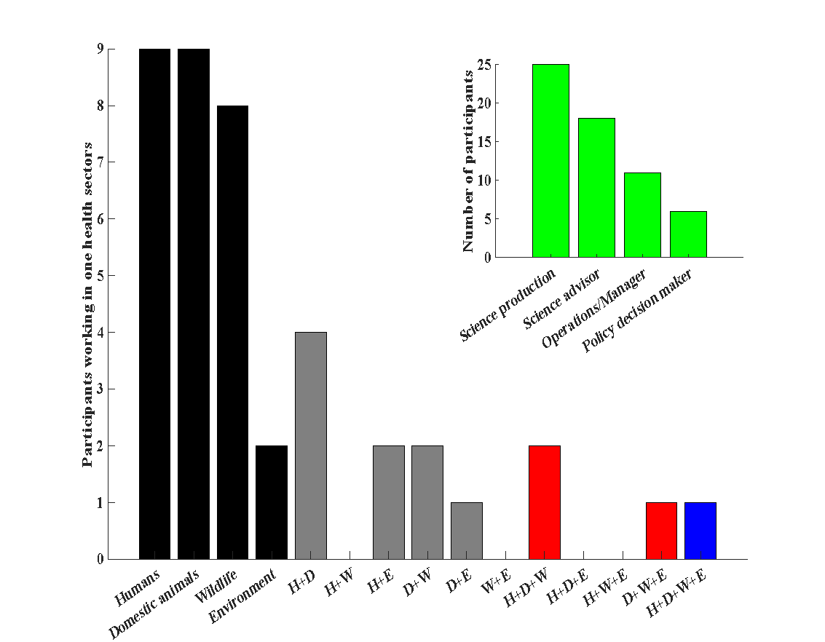
Figure S1. Study design. Main: Number of participants that mentioned working across different One Health sectors (mutually exclusive categories, N = 41). H: humans; D: domestic animals; W: wildlife, and E: Environment. Inset: Number of professionals in different professional roles working across one (black), two (grey), three (red), or all four (blue) sectors of One Health.

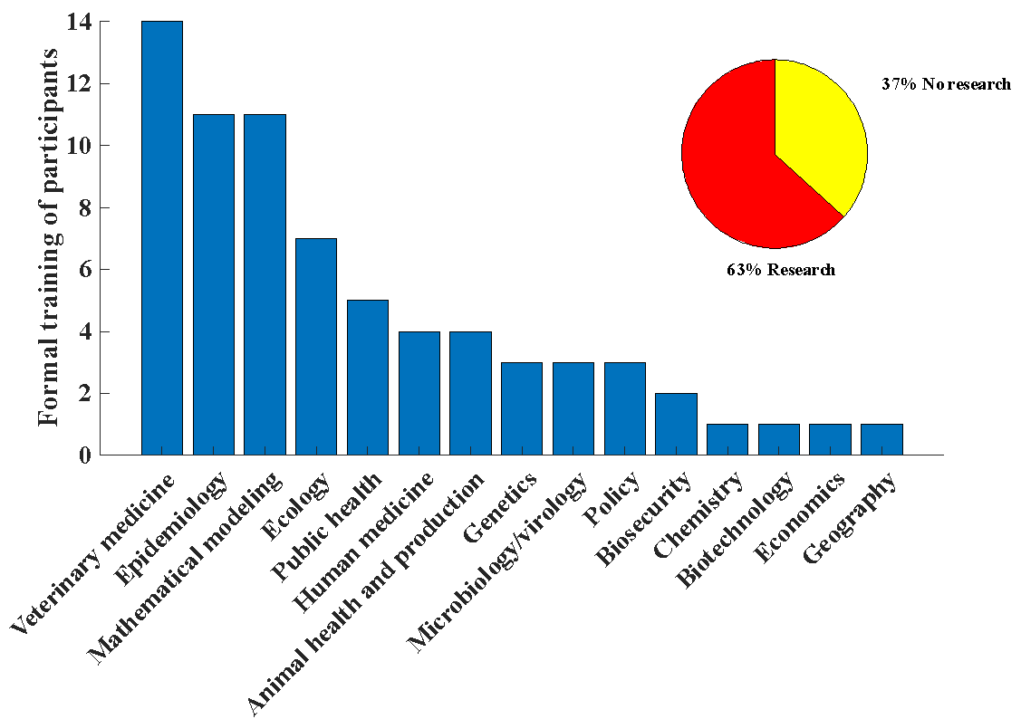
Figure S2. Count of participants with formal training in different disciplines (some were trained in multiple disciplines). Inset: Proportion that had some training in research (pie chart).

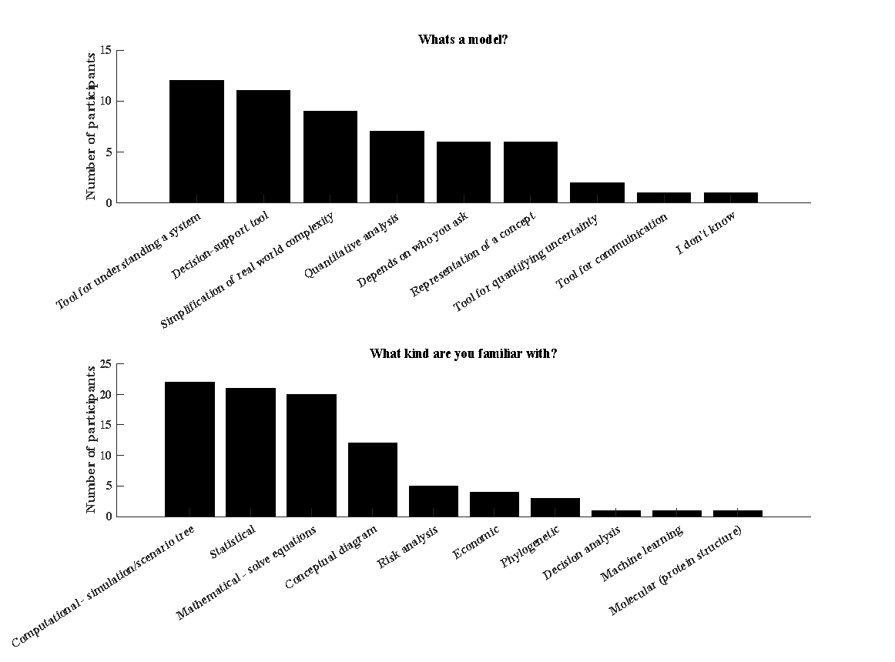
Figure S3. Number of participants defining models in different ways (top). Number of participants familiar with different modeling techniques (bottom). Some participants had multiple definitions and are familiar with multiple methods (i.e., sum of the bars > 41).

Text S1. Interview guide.
Participants were provided with the following definition for One Health.
One Health is an integrated, unifying approach that aims to sustainably balance and optimize the health of people, animals, and ecosystems (Adisasmito et al. 2022). It recognizes the health of humans, domestic and wild animals, plants, and the wider environment (including ecosystems) are closely linked and interdependent. The approach mobilizes multiple domains, disciplines, and communities at varying levels of society to work together to foster well-being and tackle threats to health and ecosystems, while addressing the collective need for healthy food, water, energy, and air, taking action on climate change and contributing to sustainable development. Example issues that can be tackled with a One Health lens include include emerging diseases, climate change impacts on ecosystems, wildlife management, or regulating new pest or disease control products (e.g., transmissible vaccines, gene drive products).

The interview plan was generally as follows, but was adjusted based on the individual’s background and evolved throughout the study based on interviewee responses. In this study, we excluded data from the topic ‘Contextual thoughts about One Health’ as we report these results separately.
Expertise in One Health and modeling tools
· What is your professional background?
· How would you describe your role in One Health management or policy decisions?
· What professionals do you work with routinely? Do they have a science background?
Contextual thoughts about One Health
· What are the biggest challenges facing One Health management/policy making/decision making?
· What are some solutions to these challenges?
· How are priorities determined in One Health sectors? What factors come into play?
· What are some opportunities and barriers to incorporating science in decision making in One Health?
· What kind of science or technology do you think is most needed in One Health? Why or why not?
· What professionals are most needed in One Health?
Experience with models for decision making
· What is a model to you? What kind of models are you familiar with?
· How do you think models can be most useful for guiding decision making in One Health (or your domain)?
· How often do you think they actually get used in practice?
· Can you think of a situation where you integrated science from models into a decision process [in One Health]? Describe that situation to me. What was your role in the process? What gave you confidence that the model was useful or not?
· How critical was the model for informing the decision? Could you have answered your questions another way?
· Sometimes models are used to shape decisions, while other times they are used to support decisions that have already been made. What have you experienced? What do you think of this?
· What recommendations do you have for effective use of models on One Health decision making?
Diversity and inclusion
· Consultation with Māori groups is a statutory requirement for decision making in New Zealand in many cases, such as under the Resource Management Act, Pae Ora (Healthy Futures) Act 2022, and the Conservation Act. How do you engage with Māori groups (iwi, hapu) in your work? What are the challenges and solutions of this engagement?
Final question
· Is there something we didn’t ask you but should have to best address our research objectives?

References

Adisasmito, W. B. et al. One Health: A new definition for a sustainable and healthy future. Plos Pathog 18, e1010537 (2022)

