Supporting information

Mitochondrial DNA in bronchoalveolar lavage fluid is associated with the prognosis of idiopathic pulmonary fibrosis

Jun Fukihara, Koji Sakamoto, Yoshiki Ikeyama, Taiki Furukawa, Ryo Teramachi, Kensuke Kataoka, Yasuhiro Kondoh, Naozumi Hashimoto, and Makoto Ishii

Results
Serum-mtDNA and survival from AE-IPF
Using time-dependent receiver operating characteristic analyses, a serum mitochondrial DNA (mtDNA) level of 2520.0 copies/µL and a nucleolar DNA (nucDNA) level of 36.0 copies/µL to predict 6-month survival were identified as optimal cut-off values (sensitivity, specificity and area under the curve (AUC) of serum-mtDNA and -nucDNA were 0.714, 0.409 and 0.471, and 1.000, 0.182 and 0.541, respectively). However, even at those optimal cut-off values, serum-mtDNA and nucDNA at the time of the first acute exacerbation (AE) were not correlated with survival time after the diagnosis of AE, both before (data not shown) and after adjusting for age, sex, and partial pressure of arterial oxygen/fraction of inspiratory oxygen that were recorded within 6 months before the diagnosis of AE (for a cut-off of mtDNA ≥2794.3 copies/µL, hazard ratio: 1.030; 95% confidence interval: 0.460–2.307; p=0.94. For a cut-off of nucDNA ≥42.0 copies/µL, hazard ratio: 1.826; 95% confidence interval: 0.468–7.123; p=0.39).

Table S1. Prognostic values of BALF-mtDNA and nucDNA at the time of AE
 | Hazard ratio (95%CI) | P
Model 1  mtDNA ≥ 11194.3 copies/µL  nucDNA ≥ 602.6 copies/µL  Model 2  mtDNA ≥ 11194.3 copies/µL  nucDNA ≥ 602.6 copies/µL | 2.533 (1.123–5.715)  1.014 (0.414–2.485)  2.513 (1.081–5.843)  1.411 (0.557–3.572) | 0.03  0.98  0.03  0.47
Model 1 was adjusted by age, sex, and serum C-reactive protein levels. Model 2 was adjusted by age, sex and baseline forced vital capacity and diffusing capacity of lung for carbon monoxide. BALF: bronchoalveolar lavage fluid; mtDNA: mitochondrial DNA; nucDNA: nucleolar DNA; AE: acute exacerbation; 95%CI: 95% confidence interval.

Figure S1
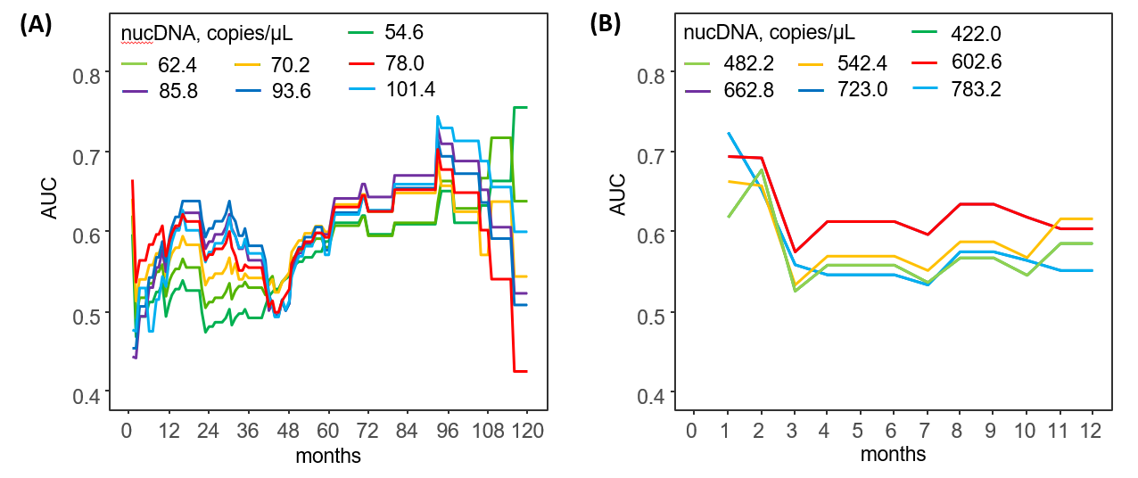

Changes in AUC values over time from a stable state (A) or the time of AE (B) for each cutoff value of BALF-nucDNA. AUC: area under the curve; AE: acute exacerbation; BALF: bronchoalveolar lavage fluid; nucDNA: nucleolar DNA.

