Supplementary Material

Table S1. Agro-climatic characteristics of the test environments during the 2019-2021 cropping years in the three regions of Iran.
Location | Year | Minimum Temperature (°C)
Location | Year | Sep | Oct | Nov | Dec | Jan | Feb | Mar |  | Apr | May | Jun | Jul
Mashhad | 2019-2020 | 5.3 | -2.2 | -3.8 | -12 | -4.6 | -3 | -0.8 |  | 9.2 | 14.2 | 16 | 16.9
Karaj | 2019-2020 | 9.5 | -2 | -0.7 | -4.9 | -10.4 | -2.3 | 0 |  | 5.6 | 12.1 | 14.3 | 14.9
Hamadan | 2019-2020 | 3 | -8.5 | -10.9 | -12 | -15.9 | -7.2 | -3.8 |  | 2 | 6.9 | 8.3 | 11.9
Mashhad | 2020-2021 | 1.4 | -4.3 | -7.2 | -8.6 | -8.3 | -7.8 | 1.5 |  | 11.4 | 15.6 | 17.4 | 15.2
Karaj | 2020-2021 | 5 | 2.4 | -3.4 | -6.9 | -7.4 | -5 | -1.40 |  | 8.50 | 11.10 | 15.60 | 16.80
Hamadan | 2020-2021 | -1.7 | -3.6 | -8.5 | -11.2 | -12.3 | -8.8 | -6.60 |  | 2.80 | 6.00 | 11.40 | 12.00
 |  | Maximum Temperature (°C)
Mashhad | 2019-2020 | 37.2 | 18.6 | 18 | 21.8 | 22.6 | 25.2 | 24.1 |  | 33.7 | 40.1 | 41.4 | 39.4
Karaj | 2019-2020 | 35.1 | 18.9 | 14.7 | 14 | 18.8 | 20.9 | 20.9 |  | 28.4 | 37.5 | 38.6 | 40.1
Hamadan | 2019-2020 | 30.8 | 17.5 | 14.1 | 10.1 | 14.8 | 20 | 29.2 |  | 35.1 | 42.3 | 36.6 | 38.1
Mashhad | 2020-2021 | 27.7 | 28.6 | 19.6 | 23.1 | 26 | 24 | 32.6 |  | 35.7 | 41.5 | 43.2 | 39.7
Karaj | 2020-2021 | 31.9 | 24.6 | 12.6 | 14 | 19.8 | 21.6 | 28.1 |  | 34.5 | 39.3 | 40.8 | 40
Hamadan | 2020-2021 | 30.7 | 24.4 | 11.6 | 17 | 17.9 | 20.2 | 26.9 |  | 32.4 | 39 | 37.3 | 38.7
 |  | Average Temperature (°C)
Mashhad | 2019-2020 | 18.6 | 9.5 | 5.8 | 3.9 | 3.9 | 9.8 | 10.9 |  | 19.5 | 26.7 | 27.8 | 27.8
Karaj | 2019-2020 | 19.5 | 9.6 | 6 | 3.9 | 3.9 | 10 | 10.2 |  | 17.2 | 25.4 | 26.5 | 27.2
Hamadan | 2019-2020 | 16.9 | 5.8 | 1.4 | 0 | 0 | 6.1 | 8 |  | 14.2 | 20.5 | 23.5 | 24.9
Mashhad | 2020-2021 | 15 | 19.6 | 3.8 | 4.5 | 9 | 8.3 | 16.6 | 21.7 |  | 28.3 | 16.5 | 9.3
Karaj | 2020-2021 | 17.8 | 13.8 | 4.5 | 3.5 | 7.9 | 7.8 | 15.4 | 21.3 |  | 26.6 | 18.3 | 10.3
Hamadan | 2020-2021 | 14.3 | 11.6 | 2.4 | 0.5 | 3.9 | 4.8 | 11 | 16.5 |  | 21 | 15.3 | 7.1
 |  | Precipitation (mm)
Mashhad | 2019-2020 | 2.3 | 17.9 | 8.4 | 41.7 | 9.3 | 26.7 | 141.5 | 37.1 |  | 0.5 | 3.7 | 1.4
Karaj | 2019-2020 | 4.9 | 103.6 | 30.2 | 38.2 | 16.6 | 117.5 | 94.4 | 53.7 |  | 2 | 0 | 0.8
Hamadan | 2019-2020 | 15.8 | 38.1 | 55.6 | 13.6 | 10.8 | 97.9 | 115.6 | 41.3 |  | 4 | 0 | 0
Mashhad | 2020-2021 | 0 | 12.1 | 26.5 | 4.6 | 0 | 28.9 | 6 | 16.5 |  | 0 | 1.3 | 0
Karaj | 2020-2021 | 9.7 | 18.4 | 99.9 | 25.3 | 56.1 | 23 | 0.4 | 15.4 |  | 9.1 | 2 | 2.1
Hamadan | 2020-2021 | 6 | 12 | 106.7 | 2.2 | 75.4 | 113.7 | 6.6 | 7.3 |  | 1.6 | 0 | 1.8

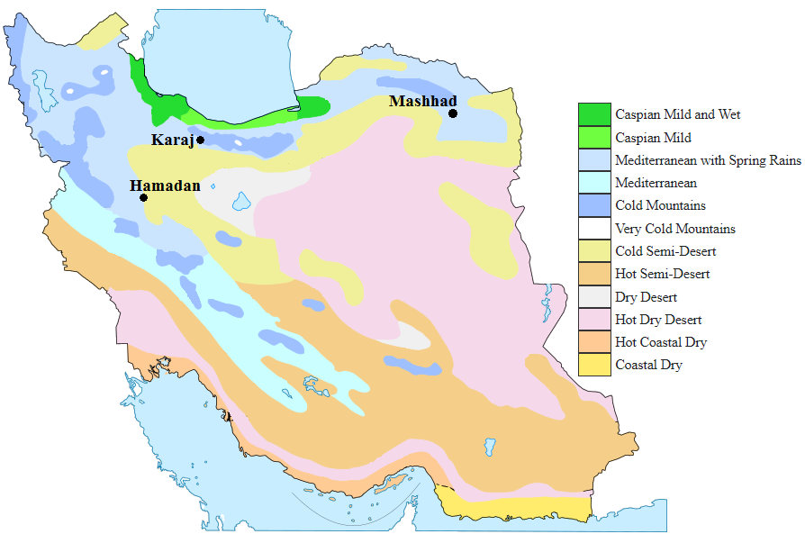

Figure S1. Agro-climatic zone map indicating the test locations in the present study (Pour-Aboughadareh et al. 2023).

