CT state carrier storage-triggered TADP in an organic scintillator
Qiu-Chen Peng^{1,#}, Yu-Bing Si^{1,#}, Qi Yang¹, Jia-Wang Yuan¹, Zi-Ying Gao¹ Kai Li^{1,}*, Yi Zhao², Shuang-Quan Zang^{1,}* and Ben Zhong Tang^{3,}*

^{1.} Tianjian Laboratory of Advanced Biomedical Sciences, Institute of Advanced Biomedical Sciences, Henan Key Laboratory of Crystalline Molecular Functional Materials, College of Chemistry, Zhengzhou University, Zhengzhou 450001, China.
^{2.} State Key Laboratory of Physical Chemistry of Solid Surfaces, iChEM, Fujian Provincial Key Lab of Theoretical and Computational Chemistry, and College of Chemistry and Chemical Engineering, Xiamen University, Xiamen 361005, China
^{3.} School of Science and Engineering, Shenzhen Institute of Aggregate Science and Technology, The Chinese University of Hong Kong, Shenzhen (CUHK-Shenzhen), Shenzhen, 518172, China.

*Corresponding author. Email: likai@zzu.edu.cn; zangsqzg@zzu.edu.cn; tangbenz@cuhk.edu.cn

Table of Contents
1. Experimental......................................................................................................S3
1.1 Reagents............................................................................................................S3
1.2 Apparatus..........................................................................................................S3
1.3 Synthesis............................................................................................................S4
1.4 X-ray crystallography..........................................................................................S5
1.5 X-ray emission measurements............................................................................S6
1.6 Calculation of light yield....................................................................................S6
1.7 X-ray dosage detection.........................................................................................S7
1.8 Photoconductive gain measurements..................................................................S8
1.9 Temperature-dependent radioluminescence measurements............................S9
1.10 Fabrication of flexible scintillation devices.....................................................S9
1.11 X-ray imaging...................................................................................................S10
1.12 Caption of videos...............................................................................................S10
2. Selected spectra and data referred in the paper..............................................S11
3. Theoretical calculation........................................................................................S23
4. References..........................................................................................................S31

1. Experimental
1.1 Reagent
Unless otherwise stated, all raw materials of analytical grade were commercially available and do not need to be purified. (3-Bromopropyl)triphenylphosphonium bromide, N,N-dimethylaniline were purchased from Alpha Chemical Co., Zhengzhou, China. All the other materials including solvents of analytical grade, and phosphate buffer were purchased from Sinopharm Chemical Reagent Beijing Co., Beijing, China. Commercial scintillators of EJ-200, anthracene, CaF₂:Eu, Bi₄Ge₃O₁₂, and Ce:YAP were purchased from EPIC Crystal Co., Suzhou China. SYLGARD 184 silicone elastomer (containing curing agent) was purchased from Alpha Chemical Co., Zhengzhou, China.

1.2 Apparatus
Single-crystal X-ray diffraction (SCXRD) measurements were performed on a Bruker D8 VENTURE diffractometer with Mo-Kα radiation (λ = 0.71073 Å) at 300 K. Bruker 600 Avance NMR spectrometer was used to collect the nuclear magnetic resonance (NMR). Rigaku MiniFlex diffractometer (Cu-Kα; λ = 1.54178 Å; 2θ range of 3-50°) was used to collect the powder X-ray diffraction (PXRD) data in air at room temperature. Scanning electron microscope (SEM) measurements were collected via Zeiss Sigma 500. HORIBA FluoroLog-3 fluorescence spectrometer with integrating sphere (BaSO₄) was used to collect photoluminescence quantum yields (PLQY). X-ray excited luminescence (XEL) and photoluminescence spectra at different temperatures were recorded using an Edinburgh FS5 fiber optic fluorescence spectrometer with a variable temperature attachment, a xenon lamp source and a miniature X-ray source (Moxtek Inc.). Photoconductive gain was measured by Keysight-B1500A semiconductor parameter analyzer. Stress-strain curves and cyclic tensile test data were obtained by SENS-UTM4103 electronic universal testing machine. The contact Angle between the water drop and the film was measured by the Powereach-JC2000C1 contact angle measuring instrument. Photographs of X-ray or UV-induced luminescence and X-ray imaging were acquired with a digital camera (Nikon, D850 coupled with AF-S Micro-Nikkor 105 mm 2.8G or AF-S Micro-Nikkor 40 mm 2.8G) in an all-manual mode.

1.3 Synthesis
The synthesis method of TPP-3C2B:DMA is referred to the previous literature¹. 2 g (4.3 mmol) TPP-3C2B was dissolved in 50 mL of dichloromethane. Afterwards, 10.75 mL (86 mmol) of DMA was dissolved in 50 mL of ethyl acetate and spread over the dichloromethane solution containing TPP-3C2B. After standing for 24 hours, colorless and transparent millimeter level crystals of TPP-3C2B:DMA can be obtained with a yield of 90% (based on TPP-3C2B) (Fig. 1e).
The stratified solution was left standing for 12 hours, then transferred to an ultrasound cleaner for 20 minutes. White powder was formed gradually during this process. The white powder deposited at the bottom of the beaker was filtered, colorless and transparent microcrystals of TPP-3C2B:DMA can be obtained with a yield of 80% (based on TPP-3C2B) (Supplementary Fig. 1a).
50 mg microcrystals of TPP-3C2B:DMA was put into 7 mL centrifuge tube. 2 mL n-hexane and 5 small steel balls with a diameter of 0.3 cm were added. Nanocrystals can be obtained by grinding samples for 3 cycles with a ball mill (Supplementary Fig. 1b). The parameters of each cycle are: ball milling time 100 s, ball milling frequency 50 Hz, interval time 30 s, ball milling times 60 times.
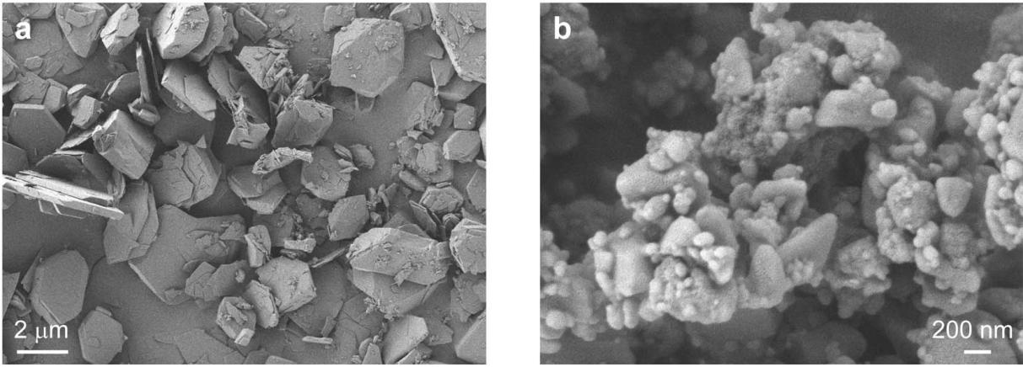
Supplementary Fig. 1 ⎪ SEM images of microcrystals (a) and nanocrystals (b).
1.4 X-ray crystallography
Data collection and reduction were performed using the program APEX3 software package. All the structures were solved with direct methods (SHELXS)² and refined by full-matrix least squares on F² using OLEX2³, which utilizes the SHELXL-2015 module⁴. All the atoms were refined anisotropically. Hydrogen atoms were placed in calculated positions refined using idealized geometries and assigned fixed isotropic displacement parameters. Structure refinement was handled with different strategies according to the electron density distribution. The detailed information of the crystal data and refinement results are summarized in Supplementary Table 1.
Supplementary Table 1. Crystal data and structure refinements of TPP-3C2B and TPP-3C2B:DMA.
 | TPP-3C2B | TPP-3C2B:DMA
Empirical formula | C₂₁H₂₁Br₂P | C₂₁H₂₁Br₂P
Formula weight | 464.17 | 464.17
Temperature/K | 300 | 300
Crystal system | monoclinic | monoclinic
Space group | P2₁/c | P2₁/c
a/Å | 11.1719(3) | 11.169(3)
b/Å | 10.1634(2) | 10.175(3)
c/Å | 17.6180(4) | 17.659(5)
α/° | 90 | 90
β/° | 104.9720(10) | 105.034(10)
γ/° | 90 | 90
Volume/Å³ | 1932.52(8) | 1938.2(10)
Z | 4 | 4
ρ_{calc}g/cm³ | 1.595 | 1.591
μ/mm^{‒1} | 4.277 | 4.265
F(000) | 928.0 | 928.0
Crystal size/mm³ | 0.3×0.2×0.1 | 0.3×0.2×0.1
Radiation | MoKα (λ = 0.71073 Å) | MoKα (λ = 0.71073 Å)
2θrange for data collection/° | 5.274 to 55.07 | 5.266 to 55.104
Index ranges | -14 ≤ h ≤ 14, -13 ≤ k ≤ 13,  -22 ≤ l ≤ 22 | -14≤ h ≤ 14, -13 ≤ k ≤ 13,  -22 ≤ l ≤ 22
Reflections collected | 44986 | 52614
Independent reflections | 4437 [R_{int} = 0.0565, R_{sigma} = 0.0267] | 4442 [R_{int} = 0.0775, R_{sigma} = 0.0353]
Data/restraints/parameters | 4437/30/227 | 4442/6/227
Goodness-of-fit on F² | 1.042 | 1.037
Final R indexes [I>=2σ (I)] | R₁ = 0.0305, wR₂ = 0.0708 | R₁ = 0.0351, wR₂ = 0.0842
Final R indexes [all data] | R₁ = 0.0401, wR₂ = 0.0753 | R₁ = 0.0467, wR₂ = 0.0895
CCDC | 2323219 | 2323220
1.5 X-ray emission measurements
The sample is pressed into identical sheets by an infrared mold, which make them has same surface and thickness (0.5 mm). All the measurements are carried out under the same X-ray source (Moxtek Inc. target material: tungsten), the settings such as slit, temperature, etc., are same. Based on this method, the XEL of the samples are compared.

1.6 Calculation of light yield
The calculation method of light yield is referred to the previous literature⁵.
For elements, the X-ray absorption coefficient is related to the atomic number:
$$=\frac{ρZ^{4}}{AE^{3}} (1)$$
Where μ is X-ray attenuation efficiency, ρ is the density of the acting medium, Z is the atomic number of the acting medium, and E is the energy of the X-ray photoelectron.
To get the light yield of a scintillator, X-ray attenuation efficiency (α) should be first calculated by Eq 2:
$$α=c\left(ε\right)×ρ (2)$$
Where c (ε) is the photon cross section function obtained from XCOM web database (https://www.nist.gov/pml/xcom-photon-cross-sections-database), ε is the corresponding X-ray photon energy (keV), ρ is the density of the scintillator.
The X-ray attenuation efficiency (AE) is calculated using Eq 3:
$$AE\left(ε,d\right)=\left(1-e^{-c\left(ε\right)ρd}\right)×100\% (3)$$
where d is the thickness of the scintillator.
The X-ray attenuation efficiency versus scintillator thickness for the entire X-ray photon energy range (from 0 to 50 keV) is obtained from Eq 4:
$$AE\left(d\right)=\int_{0}^{50}{\frac{AE\left(ε,d\right)×R\left(ε\right)dε}{\left(\int_{0}^{50}{R\left(ε\right)dε}\right)}} (4)$$
where R(ε) is the X-ray output spectrum of our tube 50 kV and the unit of ε is keV.
The commercial scintillator of BGO and TPP-3C2B:DMA were compressed into wafers with a thickness of 0.5 mm using a hydraulic press, respectively. The XEL spectra were tested under the same conditions and the corresponding photon counts (XEL_{measured}) were obtained by integrating the steady-state XEL spectra. The normalized emissive photon counts ($XEL_{normalized}$) is calculated using Eq 5:
$$XEL_{normalized}=\frac{XEL_{measured}}{AE(d)} (5)$$
The light yield of scintillator samples (LY_{TPP-3C2B:DMA}) can be calculated by the following Eq 6:
$${LY}_{TPP-3C2B:DMA}={LY}_{BGO}×\frac{{XEL}_{normalized}(TPP-3C2B:DMA)}{{XEL}_{normalized}(BGO)} (6)$$
Where the LY_{BGO} is the light yield of BGO (10000 photons MeV⁻¹), and XEL_{normalized} (TPP-3C2B:DMA) and XEL_{normalized} (BGO) represent the emissive photon counts of TPP-3C2B:DMA and BGO normalized to the respective X-ray attenuation efficiencies at a thickness of 0.5 mm (Supplementary Fig. 8).

1.7 X-ray dosage detection
XEL spectra of the scintillator were obtained with varied X-ray dosage from 0.688 μGy s⁻¹ to 278.0 μGy s⁻¹. The radiation dose of X-ray is controlled by changing the current and voltage of miniature X-ray source (Moxtek Inc. target material: silver). The relationship between the current and voltage of miniature X-ray source and the corresponding radiation dose is shown in Supplementary Table 2. The limit of detection (LOD) was calculated by LOD = $\frac{3σ}{k}$, where σ is the standard deviation calculated by repeated tests of background signals for eleven times, and k is the slope of linear fitting curve.

Supplementary Table 2. Relationship between dose rate and voltage/current of X-ray source.
Voltage (kV) | Current (μA) | Dose rate (μGy s⁻¹)
10 | 5 | 0.68844
20 | 5 | 4.5830
30 | 5 | 9.6410
40 | 5 | 11.912
50 | 5 | 17.375
50 | 10 | 34.750
50 | 20 | 69.500
50 | 30 | 104.250
50 | 40 | 139.000
50 | 50 | 173.750
50 | 60 | 208.500
50 | 70 | 243.250
50 | 80 | 278.000

1.8 Photoconductive gain measurements
The photoconductive gain measurements were measured by using a semiconductor parameter analyzer (Keysight-B1500A) and a miniature X-ray tube (Moxtek Inc. target material: tungsten). Current-voltage curves were measured in the dark, under UV light and under X-ray irradiation, respectively (tube voltage: 50 kV, tube current dose rate: 100 μA). To fix the crystal and connect the probes well for the measurements, drops of colloidal silver paste were placed on opposite sides of the crystal as the electrodes (Fig. 3e inset and Supplementary Fig. 17 inset). Relevant experimental equipment is shown in the Supplementary Fig. 2.
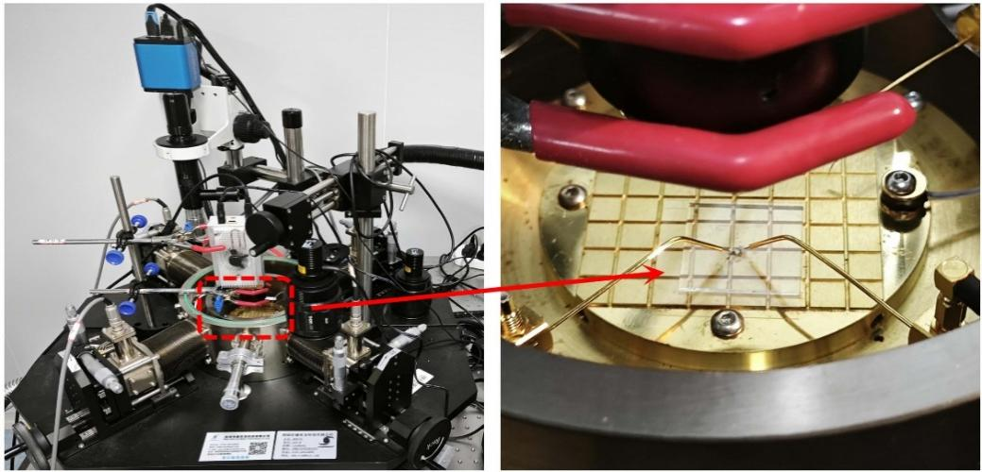
Supplementary Fig. 2 ⎪ Device for photoconductive gain measurements.

1.9 Temperature-dependent radioluminescence measurements
The temperature-dependent radioluminescence measurements are carried out by connecting the INSTEC temperature control system (HCS621GXY), X-ray tubes (Moxtek Inc. target material: tungsten) and fluorescence spectrometers with a special liquid light guide. The relevant experimental equipment is shown in the Supplementary Fig. 3.
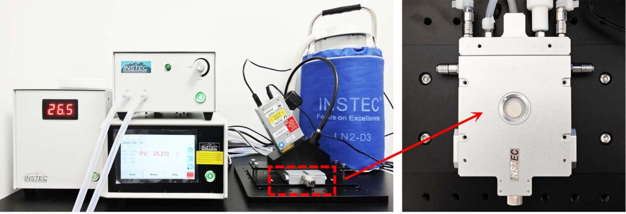
Supplementary Fig. 3 ⎪ Device for temperature-dependent radioluminescence measurements.

1.10 Fabrication of a flexible scintillation screen
First, premix SYLGARD 184 silicone elastomer and curing agent in a mass ratio of 10:1. The TPP-3C2B:DMA (10 wt %) was then uniformly dispersed in the n-hexane solution, and then added to the premixed polymer matrix, and stirred vigorously to form the mixture gel. The gel mixture was then placed in a plexiglas mold (5 cm × 5 cm × 1 mm or 10 cm × 10 cm × 1 mm) and heated for 2 hours at 85 °C using a high-precision glue maker to solidify. After the mixture gel was cooled to room temperature, it was peeled from the mold to form smooth and flat scintillator screen.

1.11 X-ray imaging
The system consists of a miniature X-ray source (Moxtek Inc. target material: tungsten), a scintillator screen, and a digital camera. During the imaging process, the sample was placed between the X-ray source and scintillator screen, and the digital camera was used to collect pictures from the other side of the scintillator screen. X-ray memory imaging can remove the X-ray source after X-ray has irradiated the object. The photo of the device is shown in Supplementary Fig. 4.
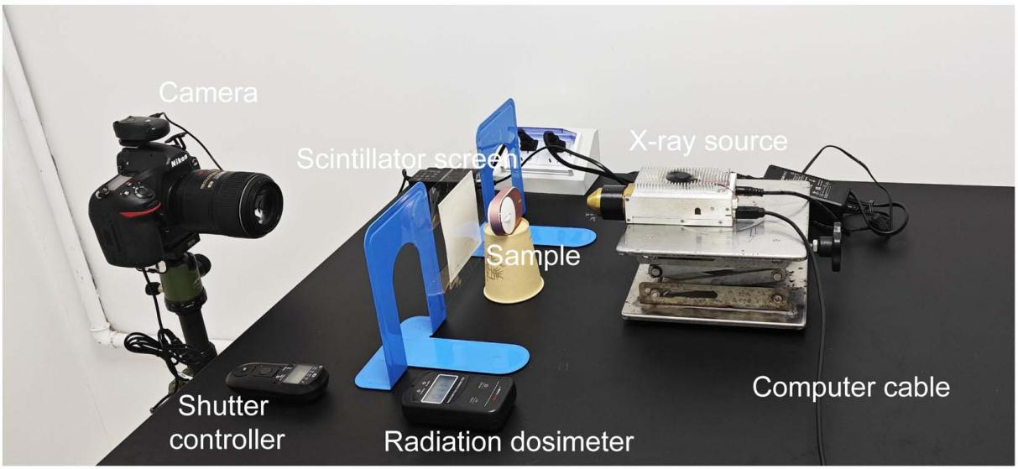
Supplementary Fig. 4 ⎪ Device for X-ray imaging.

1.12. Caption of videos
Video 1. The afterglow of TPP-3C2B:DMA crystals under X-ray excitation.
Video 2. X-ray afterglow imaging of metal artefact with the words of “Zhengzhou University”.
Video 3. X-ray afterglow imaging of capacitor encapsulated in capsule.
Video 4. X-ray afterglow imaging of melon seed.
2. Selected spectra and data referred in the paper

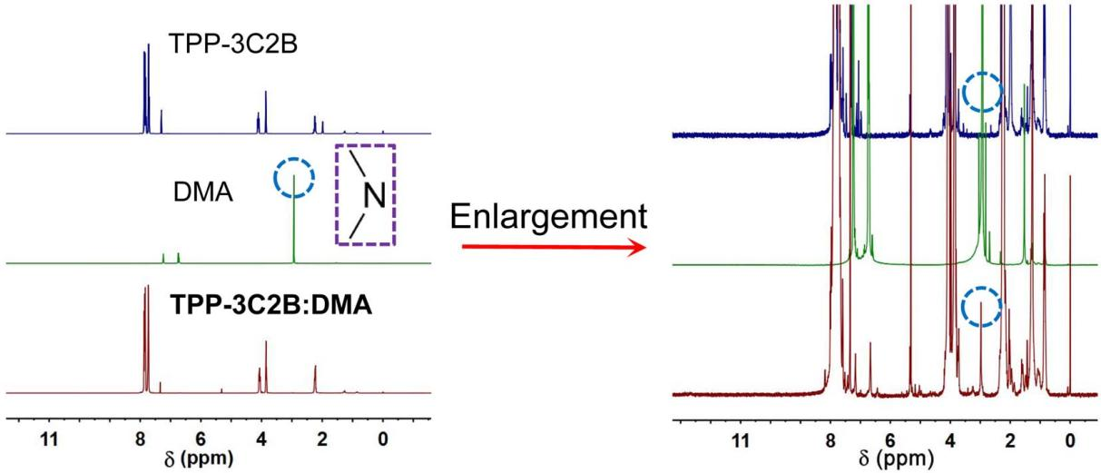
Supplementary Fig. 5 ⎪ ¹H-NMR spectra of TPP-3C2B, DMA and TPP-3C2B:DMA.

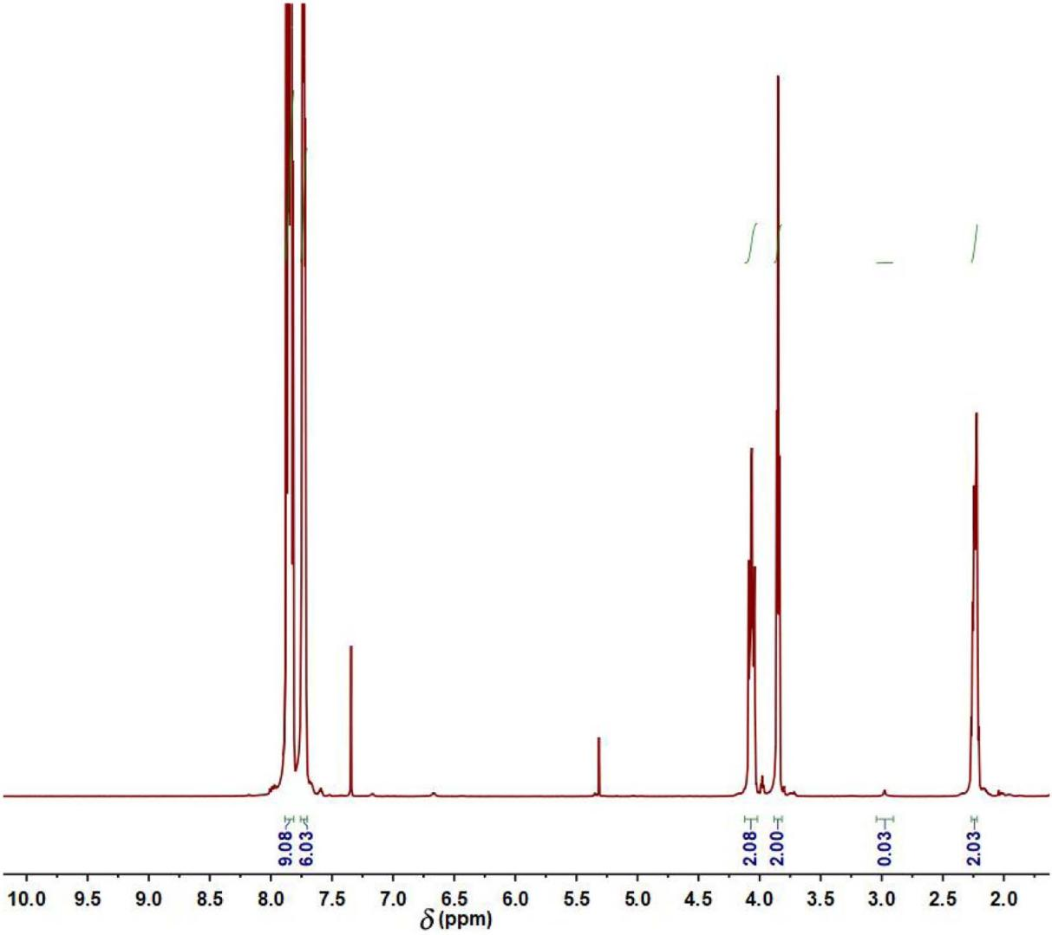
Supplementary Fig. 6 ⎪ ¹H-NMR spectra of TPP-3C2B:DMA.
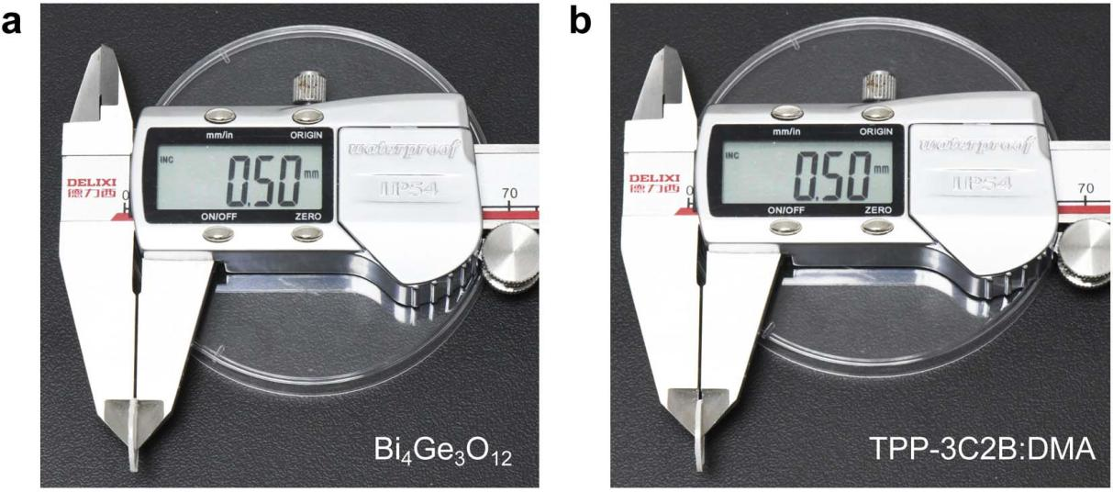
Supplementary Fig. 7 ⎪ The thickness of BGO standard (a) and TPP-3C2B (b) used in light yield measurement.

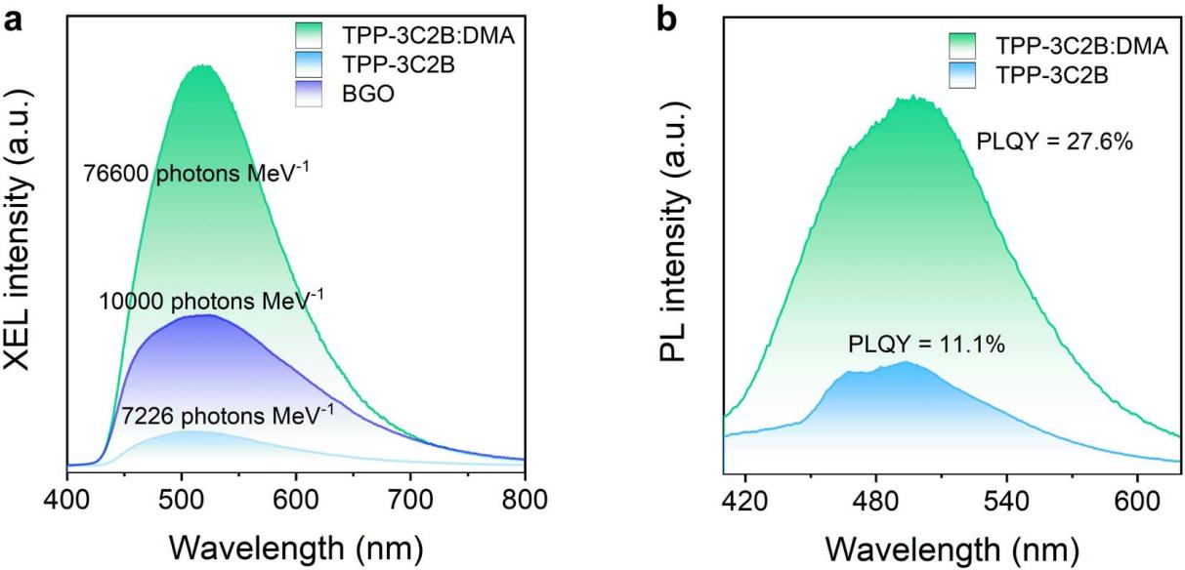
Supplementary Fig. 8 ⎪ a, The XEL spectra of TPP-3C2B:DMA, TPP-3C2B and BGO with the same thickness and cross-sectional area (thickness = 0.5 mm). b, The PL spectra and photoluminescent quantum yield (PLQY) of TPP-3C2B:DMA and TPP-3C2B.
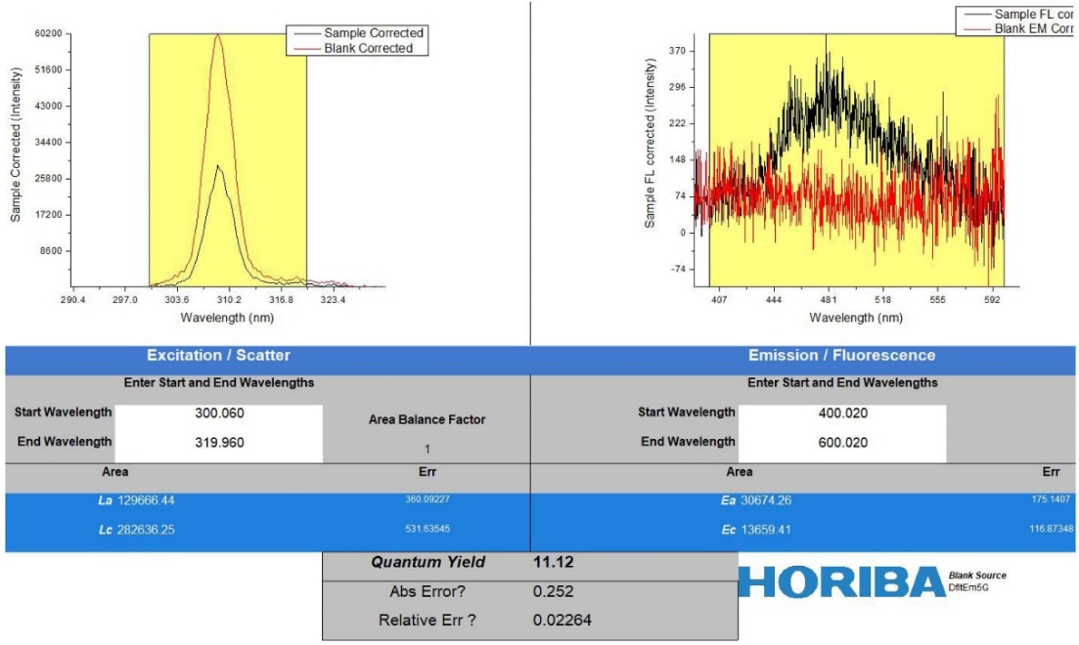
Supplementary Fig. 9 ⎪ PLQY of TPP-3C2B.

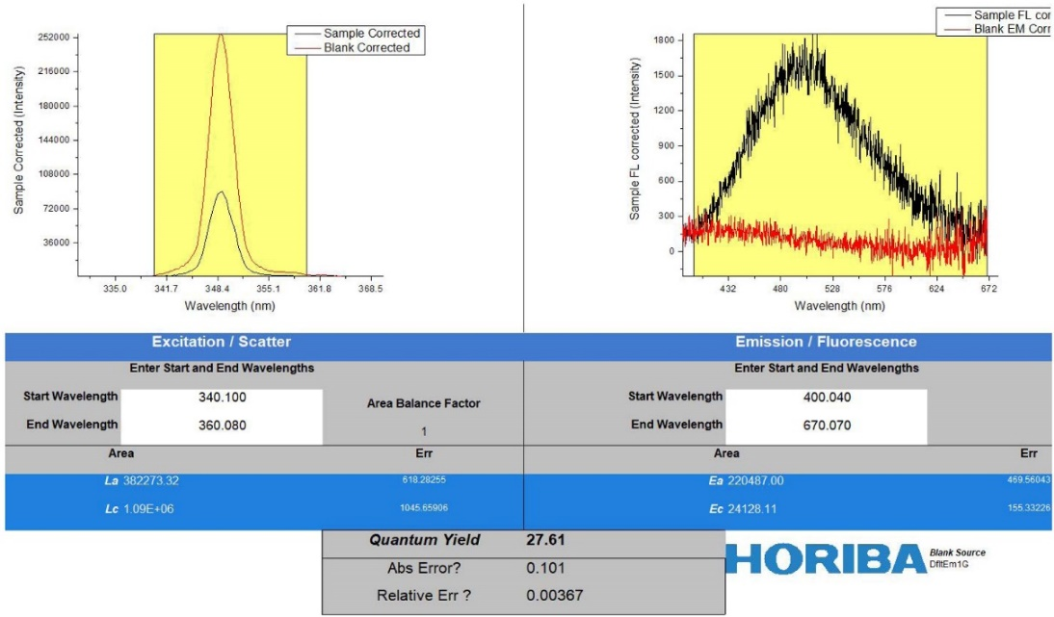
Supplementary Fig. 10 ⎪ PLQY of TPP-3C2B:DMA.

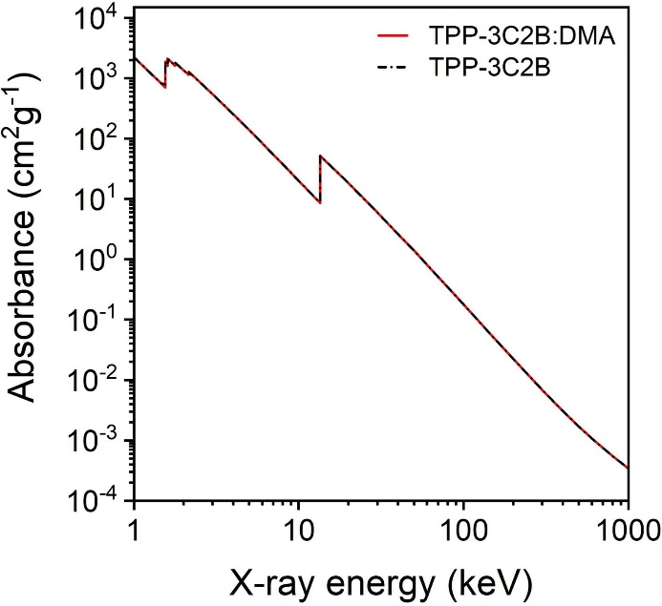
Supplementary Fig. 11 ⎪ The variation of X-ray attenuation efficiency with X-ray energy of TPP-3C2B:DMA and TPP-3C2B.

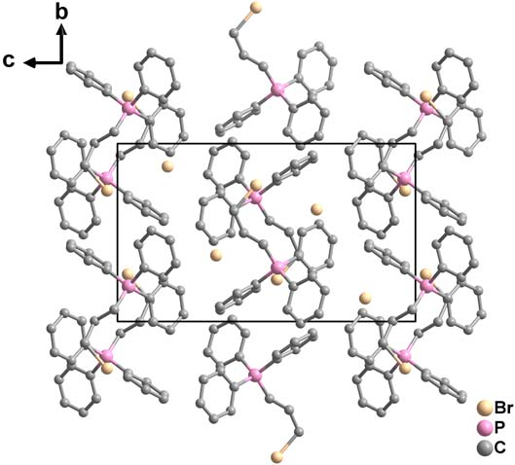
Supplementary Fig. 12 ⎪ The crystal packing of TPP-3C2B.
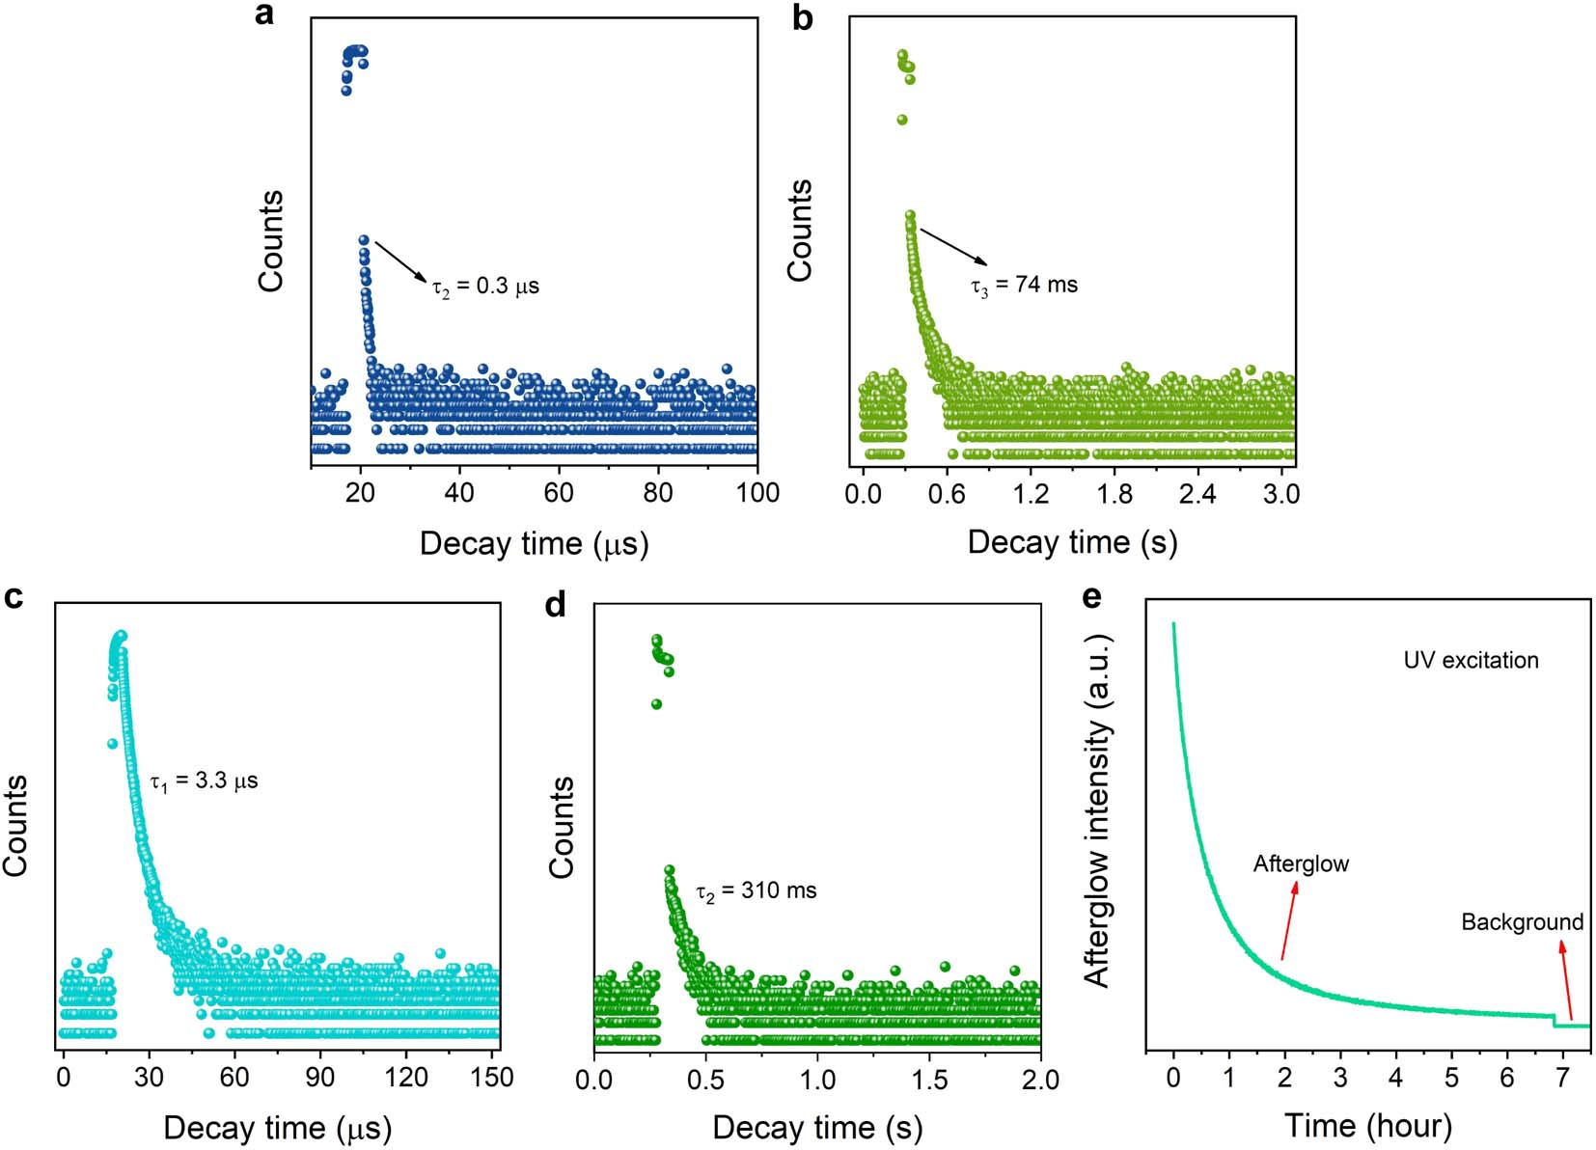
Supplementary Fig. 13 ⎪ Luminescence lifetime decay curves of TPP-3C2B (a-b) and TPP-3C2B:DMA (c-e).

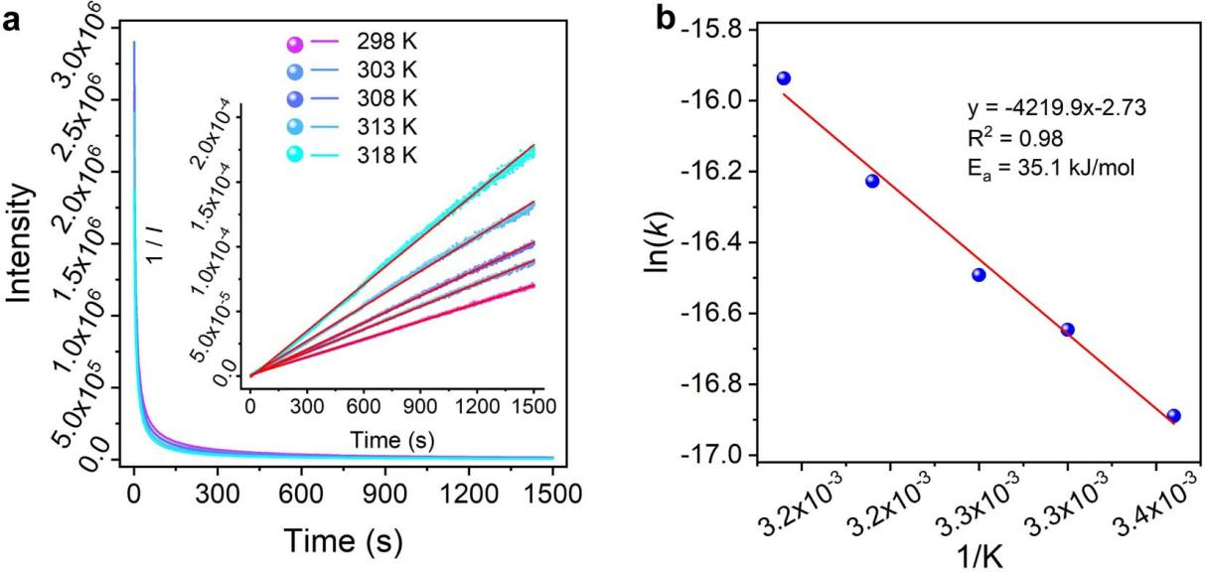
Supplementary Fig. 14 ⎪ a, Time-dependent emission decay curves of TPP-3C2B:DMA at different temperatures after UV excitation was stopped. Inset: The curves were fitted with second-order reaction dynamics to calculate the rate constants (k). b, The rate constants were fitted with Arrhenius expressions.

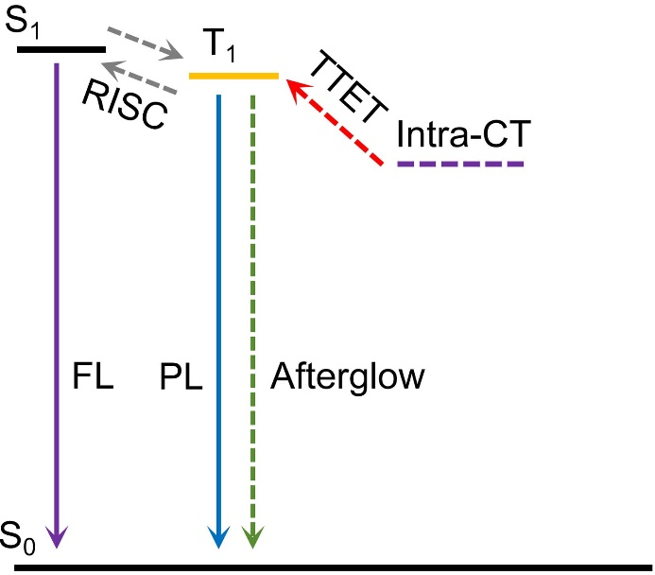
Supplementary Fig. 15 ⎪ Energy diagram and photophysical processes of the TPP-3C2B after excitation.

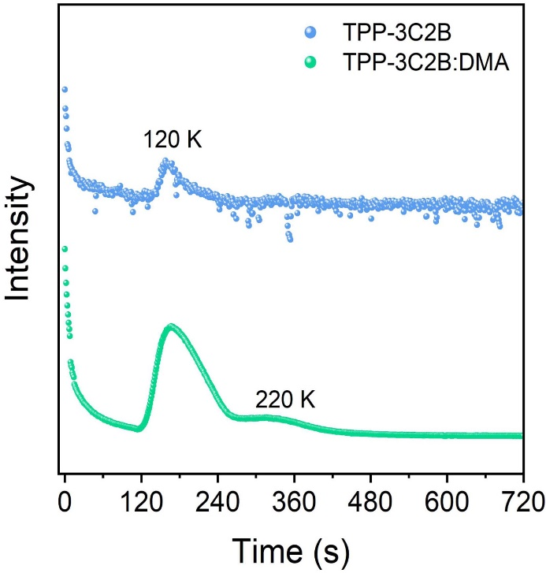
Supplementary Fig. 16 ⎪ Afterglow intensity of TPP-3C2B:DMA and TPP-3C2B after UV light excitation with thermal stimulation. The sample were excited with UV light for 200 s then the curves are recorded.
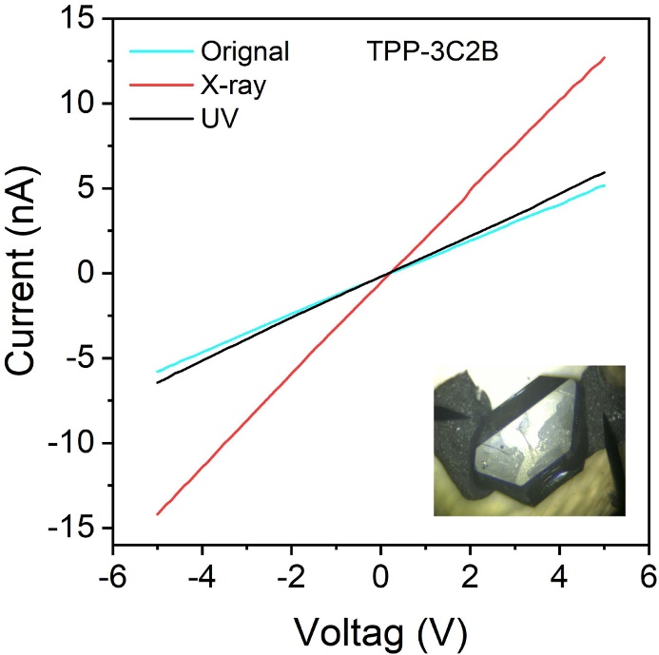
Supplementary Fig. 17 ⎪ The current-voltage curves of TPP-3C2B under dark, UV light, and X-ray irradiation.

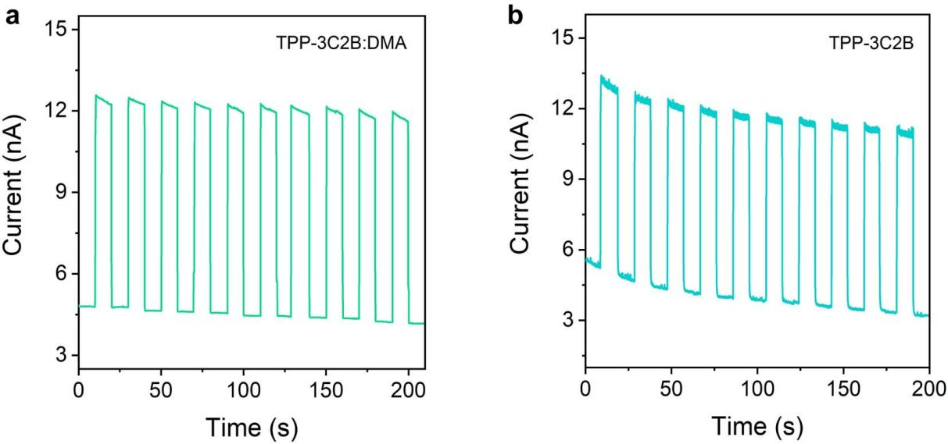
Supplementary Fig. 18 ⎪ Current and periodic changes of TPP-3C2B:DMA (a) and TPP-3C2B (b) under X-ray irradiation with a constant voltage of 5 V.

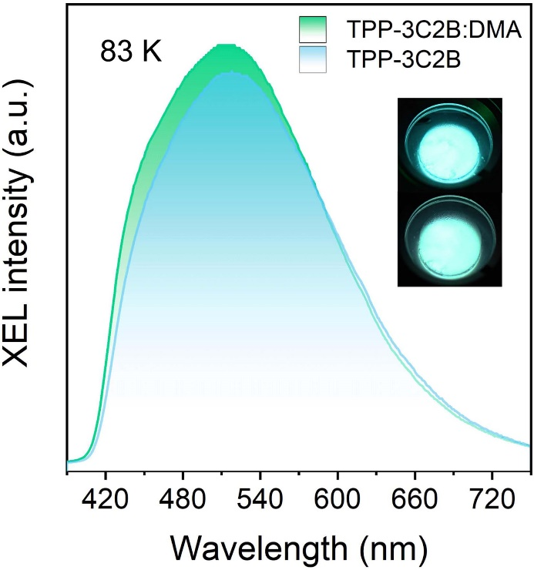
Supplementary Fig. 19 ⎪ The XEL spectra of TPP-3C2B:DMA and TPP-3C2B at 83 K.

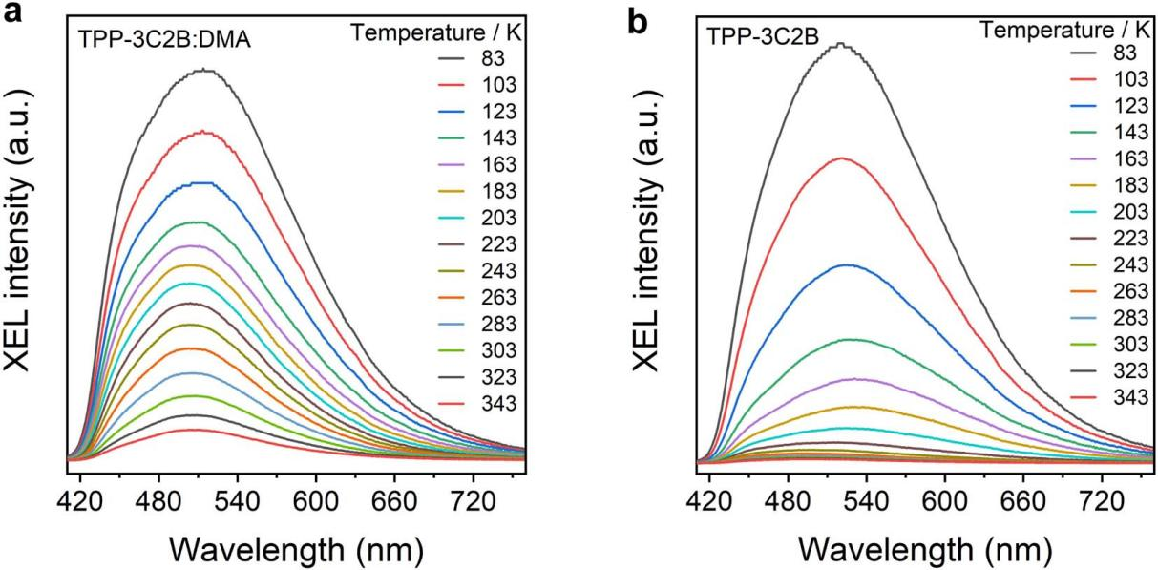
Supplementary Fig. 20 ⎪ Temperature-dependent XEL spectra of TPP-3C2B:DMA and TPP-3C2B.

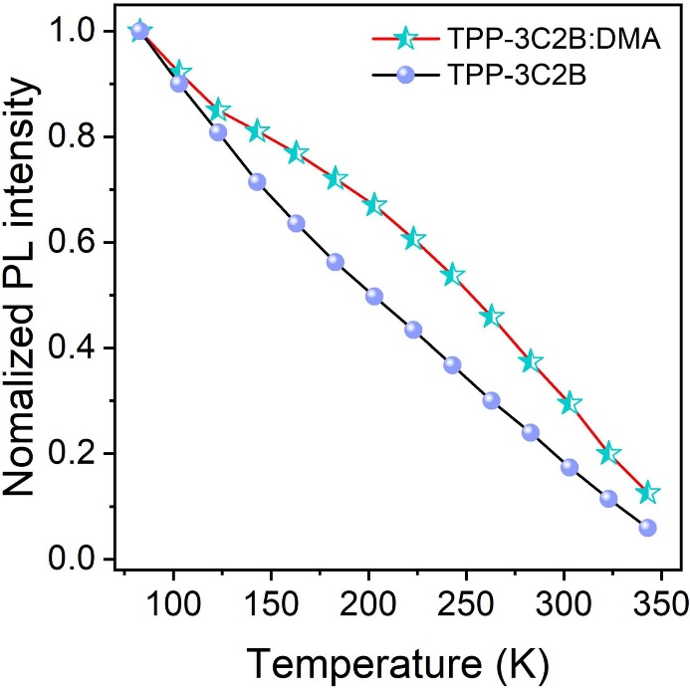
Supplementary Fig. 21 ⎪ Temperature-dependent PL intensity of TPP-3C2B:DMA and TPP-3C2B at 510 nm.

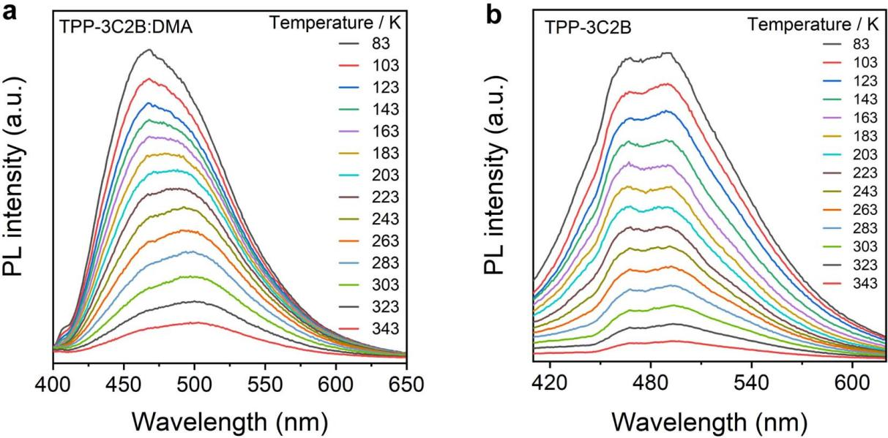
Supplementary Fig. 22 ⎪ Temperature-dependent PL spectra of TPP-3C2B:DMA and TPP-3C2B.

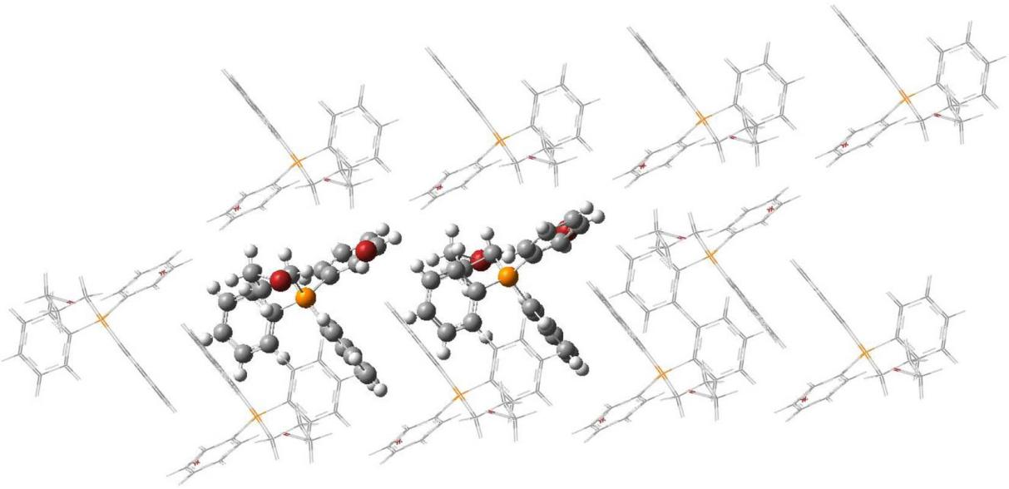
Supplementary Fig. 23 ⎪ QM/MM model of TPP-3C2B:DMA.

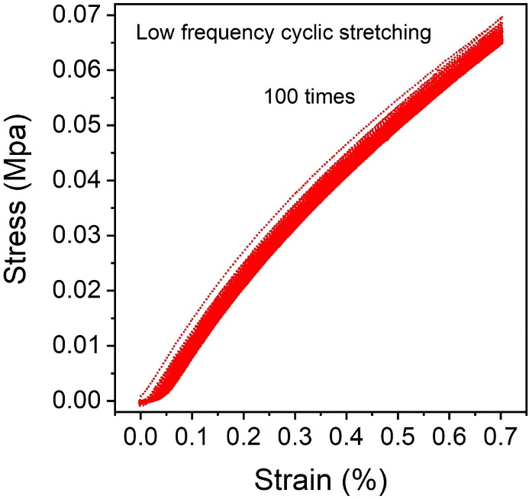
Supplementary Fig. 24 ⎪ Stress-strain curve corresponding to low-frequency cyclic stretching (clamping distance = 15 mm, tensile rate = 20 mm min⁻¹, tensile strength = 0.7 MPa).

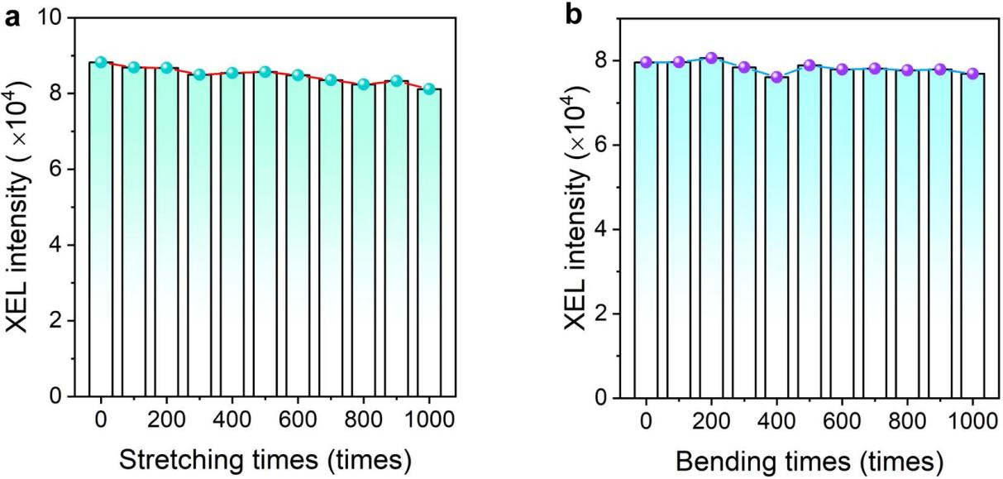
Supplementary Fig. 25 ⎪ XEL intensity of the scintillator screen at 510 nm after stretching (a) and bending (b) for different times.

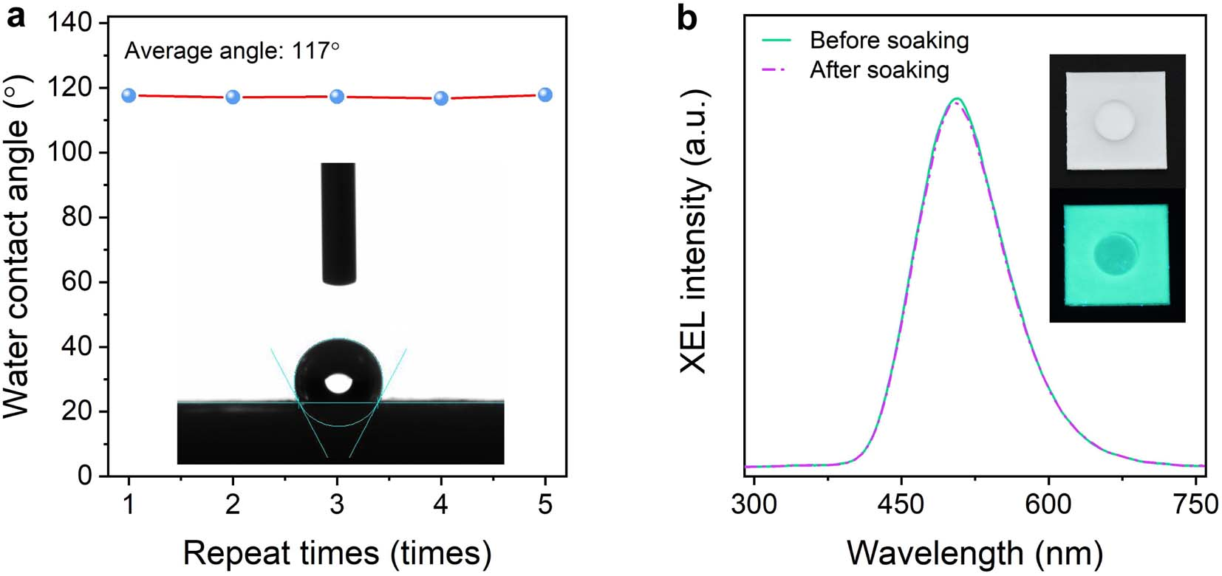
Supplementary Fig. 26 ⎪ a, Interface contact angle between the scintillator screen and water droplet. b, XEL spectra of the scintillator screen before and after contact with water. Inset: photographs of the screen with water droplet under daylight and X-ray.

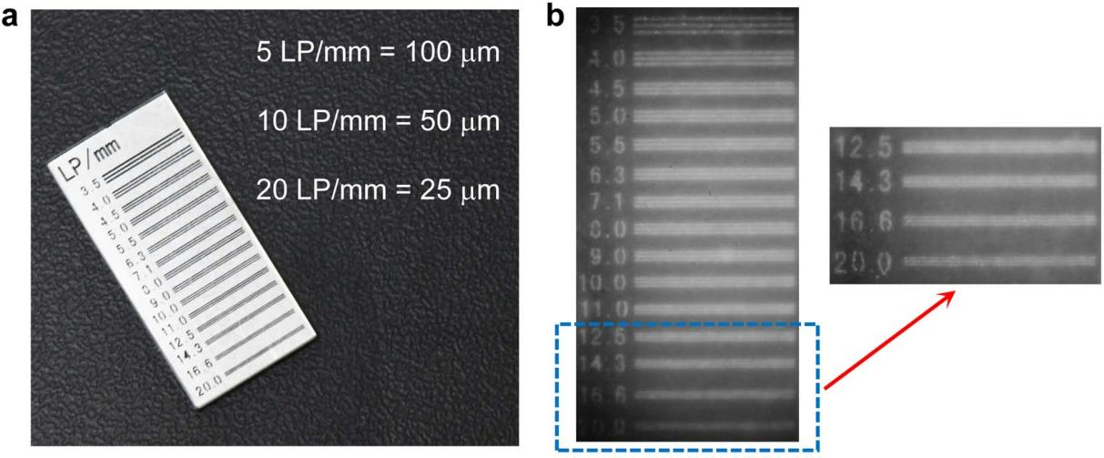
Supplementary Fig. 27 ⎪ a, X-ray high-resolution linear mask and corresponding resolution of the line pair. b, Imaging resolution of scintillator screen.

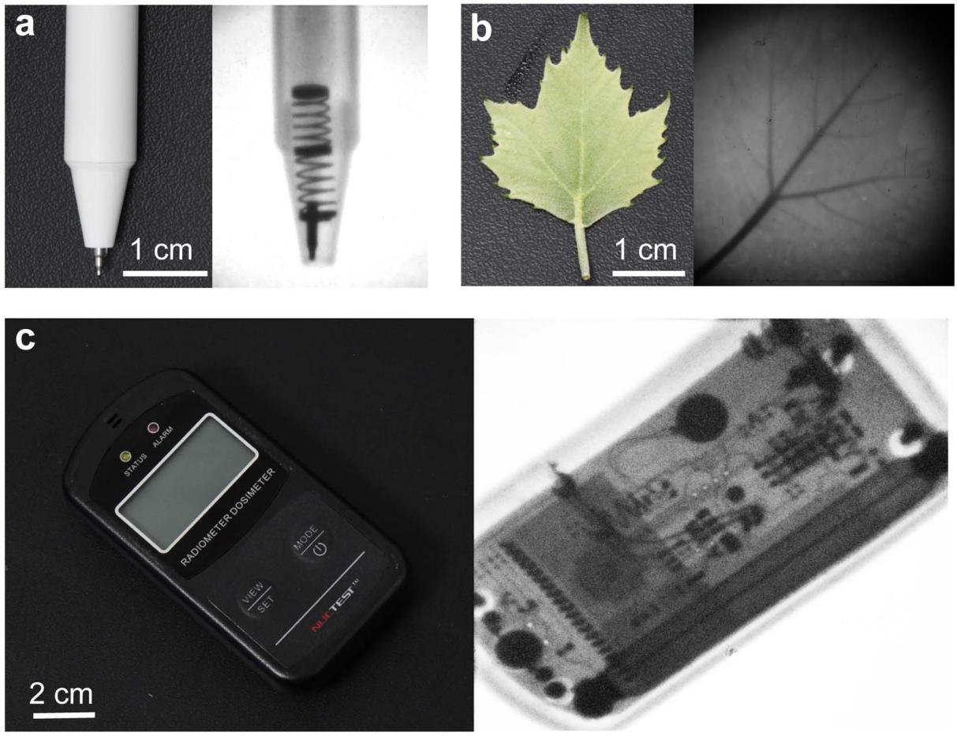
Supplementary Fig. 28 ⎪ Imaging photographs of ballpoint pen, sycamore leaves and radiation dose alarm.

3. Theoretical Calculations
The study aimed to enhance the understanding of the organic scintillator’s photophysical characteristics. To achieve this, the ground state of TPP-3C2B was optimized through Density Functional Theory (DFT), utilizing the PBE0/def2-SVP level within the Gaussian 16 software suite⁶. The scintillator monomer’s inherent flexibility was accounted for by employing a two-layer ONIOM approach to accurately assess the electronic structures within the crystal matrix. Within this framework, a select cluster at the crystal’s core was processed as the “QM layer” using the PBE0/def2-SVP level. Concurrently, surrounding molecules were classified as the “MM layer” and analyzed using the Universal Force Field (UFF). This was complemented by an electronic embedding technique that integrated the MM region's partial charges directly into the QM Hamiltonian⁷.
When examining the doped system of TPP-3C2B, the ONIOM model was once more utilized, this time considering two TPP-3C2B molecules and one DMA molecule within the QM region, with an additional 20 TPP-3C2B molecules in the MM region. To simulate the excitation energy transfer states between DAA³ and D³AA, localized triplet states were constructed through Constrained Density Functional Theory (CDFT) ⁸, utilizing the same theoretical level of PBE0/def2-SVP in Q-Chem software⁹. Additionally, the spin-orbit coupling matrix elements were determined using the ORCA 5.0.3 software¹⁰, relying on the PBE0 functional and the DKH-def2-TZVP basis set. Complementary to these calculations, Mulliken charge and spin population analyses were conducted, with results visualized using the VMD and Multiwfn programs^{11,12}.

Supplementary Table 3. The spin-orbit coupling matrix element of the lowest 10 singlet and triplet excited states at the PBE0/def2-SVP theoretical level (in cm⁻¹).
 | S₁ | S₂ | S₃ | S₄ | S₅ | S₆ | S₇ | S₈ | S₉ | S₁₀
T₁ | 142.236 | 1116.24 | 1117.55 | 25.49 | 13.84 | 28.73 | 18.97 | 12.44 | 14.00 | 2.61
T₂ | 1115.30 | 141.39 | 1113.36 | 21.52 | 25.04 | 38.24 | 27.05 | 15.13 | 16.75 | 4.19
T₃ | 1116.96 | 1113.00 | 17.27 | 22.85 | 25.39 | 38.82 | 23.28 | 33.87 | 32.70 | 6.14
T₄ | 25.18 | 21.72 | 16.22 | 23.32 | 1122.46 | 72.95 | 222.71 | 1094.41 | 49.51 | 3.53
T₅ | 22.28 | 20.86 | 20.43 | 1117.90 | 18.69 | 119.33 | 187.73 | 1093.57 | 102.81 | 3.98
T₆ | 27.06 | 24.26 | 18.44 | 61.48 | 38.00 | 158.51 | 1090.93 | 233.89 | 1114.06 | 18.03
T₇ | 40.24 | 25.68 | 22.16 | 268.61 | 239.06 | 1075.92 | 165.41 | 75.49 | 1088.45 | 11.38
T₈ | 22.05 | 13.21 | 32.75 | 1088.84 | 1087.39 | 265.63 | 33.13 | 6.53 | 223.44 | 0.49
T₉ | 39.33 | 15.41 | 31.05 | 57.98 | 79.77 | 1112.95 | 1096.51 | 190.09 | 35.57 | 13.39
T₁₀ | 1.78 | 1.82 | 1.20 | 3.23 | 3.19 | 21.8 | 13.26 | 2.88 | 8.45 | 21.81

Supplementary Table 4. Mulliken Net Atomic Charges and Spin for Triplet Localized on DMA and TPP-3C2B.
Atom | Charge (a.u.) | Spin (a.u.)
1 Br | -0.480736 | 0.283556
2 Br | -0.172277 | -0.000024
3 P | 0.523376 | -0.000247
4 C | -0.083778 | 0.000003
5 H | 0.088169 | 0.000002
6 H | 0.126097 | 0.000041
7 C | -0.031957 | -0.000018
8 H | 0.064638 | 0.000003
9 H | 0.058053 | 0
10 C | -0.172655 | 0.000309
11 H | 0.111006 | -0.001619
12 H | 0.113825 | 0.000001
13 C | -0.163629 | 0.00003
14 C | 0.012241 | 0.000027
15 H | 0.042323 | -0.000015
16 C | -0.014095 | -0.000008
17 H | 0.044936 | 0.000004
18 C | -0.001735 | 0.000017
19 H | 0.035478 | -0.000001
20 C | -0.016573 | -0.000011
21 H | 0.031308 | 0
22 C | -0.01535 | 0.000027
23 H | 0.031649 | 0.000008
24 C | -0.20822 | 0.000022
25 C | 0.01593 | 0.000653
26 H | 0.055992 | -0.000681
27 C | -0.013342 | -0.000054
28 H | 0.039872 | 0.000003
29 C | -0.001003 | 0.000051
30 H | 0.037224 | 0.000005
31 C | -0.014768 | -0.000046
32 H | 0.034134 | 0.000004
33 C | -0.006253 | 0.000056
34 H | 0.042867 | 0
35 C | -0.12646 | 0.002074
36 C | 0.021057 | 0.001066
37 H | 0.059474 | -0.000074
38 C | -0.011688 | -0.00017
39 H | 0.037543 | 0.000011
40 C | 0.005632 | 0.000263
41 H | 0.030629 | -0.000016
42 C | -0.011488 | -0.000238
43 H | 0.026411 | 0.000008
44 C | -0.004416 | 0.00057
45 H | 0.032878 | -0.000029
46 Br | -0.637201 | 0.000925
47 Br | -0.141754 | 0.000226
48 P | 0.480073 | 0.145314
49 C | -0.077742 | 0.000702
50 H | 0.083701 | 0.000692
51 H | 0.107478 | -0.000968
52 C | -0.07556 | -0.001341
53 H | 0.074467 | -0.001282
54 H | 0.070484 | 0.001192
55 C | -0.146852 | 0.024938
56 H | 0.112658 | 0.005559
57 H | 0.071112 | 0.000533
58 C | -0.265044 | 0.19325
59 C | -0.059175 | 0.277573
60 H | -0.001605 | -0.014655
61 C | -0.030568 | -0.165501
62 H | -0.00168 | 0.005569
63 C | -0.09143 | 0.469373
64 H | -0.006678 | -0.024843
65 C | -0.041684 | -0.077227
66 H | -0.001303 | 0.001159
67 C | -0.022909 | 0.156258
68 H | 0.01584 | -0.009139
69 C | -0.225168 | 0.013664
70 C | 0.017867 | 0.003465
71 H | 0.051425 | 0.000161
72 C | -0.022789 | 0.003615
73 H | 0.030713 | 0.000584
74 C | -0.005669 | -0.001172
75 H | 0.024201 | 0.000012
76 C | -0.021435 | 0.006823
77 H | 0.02281 | -0.000276
78 C | 0.002683 | -0.000358
79 H | 0.051962 | -0.001623
80 C | -0.148365 | -0.018321
81 C | -0.005481 | 0.008326
82 H | 0.021427 | -0.000268
83 C | -0.017587 | 0.002232
84 H | 0.0231 | -0.000073
85 C | -0.004008 | -0.000431
86 H | 0.024159 | -0.000012
87 C | -0.010147 | 0.006795
88 H | 0.025259 | -0.000282
89 C | 0.025696 | -0.001137
90 H | 0.044083 | 0.000143
91 C | -0.045728 | 0.170171
92 C | 0.155357 | -0.088407
93 C | -0.022493 | 0.171449
94 C | -0.02645 | -0.107368
95 C | 0.00739 | 0.208661
96 C | -0.02652 | -0.102963
97 H | 0.047253 | -0.009704
98 H | 0.032153 | -0.007855
99 H | 0.036484 | 0.003953
100 H | 0.033947 | -0.009923
101 H | 0.035443 | 0.003777
102 N | -0.305861 | 0.381006
103 C | 0.049929 | -0.026267
104 H | 0.065973 | 0.000513
105 H | 0.093365 | 0.028245
106 H | 0.102924 | 0.024378
107 C | 0.047748 | 0.018053
108 H | 0.064122 | 0.002951
109 H | 0.088526 | 0.013141
110 H | 0.074752 | 0.03045

Supplementary Table 5. Mulliken Net Atomic Charges and Spin for Triplet Localized on TPP-3C2B.
Atom | Charge (a.u.) | Spin (a.u.)
1 Br | -0.60019 | 0.013085
2 Br | -0.113177 | 0.000527
3 P | 0.525362 | 0.077745
4 C | -0.085116 | 0.00136
5 H | 0.092518 | 0.000009
6 H | 0.09028 | 0.001739
7 C | -0.043226 | 0.00275
8 H | 0.054558 | -0.000168
9 H | 0.074343 | -0.000158
10 C | -0.181339 | -0.003802
11 H | 0.118707 | -0.000339
12 H | 0.093202 | -0.002731
13 C | -0.225542 | 0.06534
14 C | -0.013478 | 0.059693
15 H | 0.025955 | -0.003678
16 C | -0.018117 | -0.035667
17 H | 0.023199 | 0.000761
18 C | -0.032673 | 0.16769
19 H | 0.022627 | -0.009009
20 C | -0.014131 | -0.058448
21 H | 0.024928 | 0.00188
22 C | -0.012507 | 0.094471
23 H | 0.032167 | -0.005233
24 C | -0.192905 | 0.00006
25 C | -0.017031 | 0.044112
26 H | 0.050275 | -0.00239
27 C | -0.012283 | -0.02228
28 H | 0.034691 | 0.000931
29 C | -0.008909 | 0.044533
30 H | 0.028729 | -0.002411
31 C | -0.021298 | -0.000049
32 H | 0.025806 | -0.000272
33 C | -0.000356 | 0.008554
34 H | 0.034408 | -0.000641
35 C | -0.157031 | 0.018574
36 C | 0.006446 | 0.012572
37 H | 0.041829 | -0.001096
38 C | -0.025918 | -0.007277
39 H | 0.02755 | 0.000441
40 C | -0.016804 | 0.016038
41 H | 0.032787 | -0.000867
42 C | -0.020081 | -0.001053
43 H | 0.037962 | 0.000339
44 C | 0.046904 | 0.004444
45 H | 0.035783 | -0.000082
46 Br | -0.211292 | 0.721907
47 Br | -0.009005 | 0.259497
48 P | 0.487646 | 0.130422
49 C | -0.100916 | -0.002763
50 H | 0.110863 | 0.008991
51 H | 0.126936 | 0.002707
52 C | -0.023217 | 0.001169
53 H | 0.089732 | -0.000414
54 H | 0.063204 | -0.000287
55 C | -0.218956 | -0.000324
56 H | 0.092322 | -0.001903
57 H | 0.139988 | 0.002762
58 C | -0.162277 | 0.005806
59 C | 0.000438 | 0.057736
60 H | 0.036701 | -0.003366
61 C | -0.014736 | -0.035422
62 H | 0.039353 | 0.001373
63 C | -0.015501 | 0.095747
64 H | 0.018764 | -0.005076
65 C | -0.016121 | -0.037902
66 H | 0.020265 | 0.00141
67 C | -0.026434 | 0.058316
68 H | 0.023948 | -0.002648
69 C | -0.195616 | 0.012719
70 C | 0.000467 | 0.050196
71 H | 0.045243 | -0.002735
72 C | -0.012605 | -0.031425
73 H | 0.029497 | 0.001203
74 C | -0.017445 | 0.083763
75 H | 0.028035 | -0.0044
76 C | -0.017737 | -0.019494
77 H | 0.027829 | 0.000594
78 C | -0.013495 | 0.032003
79 H | 0.045336 | -0.001932
80 C | -0.156295 | 0.02013
81 C | -0.011746 | 0.052917
82 H | 0.041754 | -0.002915
83 C | -0.012155 | -0.033396
84 H | 0.025366 | 0.001503
85 C | -0.016676 | 0.092398
86 H | 0.024087 | -0.004887
87 C | -0.01542 | -0.031833
88 H | 0.022616 | 0.001229
89 C | -0.011437 | 0.049289
90 H | 0.02607 | -0.001895
91 C | -0.092406 | 0.000052
92 C | 0.195905 | 0.000073
93 C | -0.076415 | -0.000045
94 C | -0.046607 | -0.000165
95 C | -0.021442 | 0.000065
96 C | -0.023424 | -0.000071
97 H | -0.006873 | -0.000007
98 H | 0.013949 | -0.000529
99 H | 0.00342 | 0.00039
100 H | 0.000128 | -0.000001
101 H | 0.00903 | 0.000003
102 N | -0.406116 | -0.00006
103 C | 0.067536 | -0.000037
104 H | 0.042476 | 0.000001
105 H | 0.03663 | 0.000008
106 H | 0.049887 | 0.000019
107 C | 0.053106 | 0.000032
108 H | 0.034084 | 0.000002
109 H | 0.081918 | -0.00054
110 H | 0.028935 | 0.000042

4. References
- P. Alam, N. L. C. Leung, J. Liu, T. S. Cheung, X. Zhang, Z. He, R. T. K. Kwok, J. W. Y. Lam, H. H. Y. Sung, I. D. Williams, C. C. S. Chan, K. S. Wong, Q Peng & B. Z. Tang. Two are better than one: a design principle for ultralong-persistent luminescence of pure organics. Adv. Mater., 2020, 32, 20011026.
- Sheldrick, G. M. A short history of SHELX. Acta Cryst. A, 2008, 64, 112.
- O. V. Dolomanov, L. J. Bourhis, R. J. Gildea, J. A. K. Howard & H. Puschmann. OLEX2: acomplete structure solution, refinement and analysis program. J. Appl. Cryst., 2009, 42, 339.
- G. M. Sheldrick. Crystal structure refinement with SHELXL. Acta Cryst. C, 2015, 71, 3.
- W. Ma, Y. Su, Q. Zhang, C. Deng, L. Pasquali, W. Zhu, Y. Tian, P. Ran, Z. Chen, G. Yang, G. Liang, T. Liu, H. Zhu, P. Huang, H. Zhong, K. Wang, S. Peng, J. Xia, H. Liu, X. Liu, Y. M. Yang. Thermally activated delayed fluorescence (TADF) organic molecules for efficient X-ray scintillation and imaging. Nat. Mater., 2022, 21, 210-216.
- M. J. Frisch, G. W. Trucks, H. B. Schlegel, G. E. Scuseria, M. A. Robb, J. R. Cheeseman, G. Scalmani, V. Barone, G. A. Petersson, H. Nakatsuji, et al., Gaussian, Inc., Wallingford CT, Gaussian 16 (Revision A.03) 2016.
- S. Dapprich, I. Komáromi, K. Byun, K. Morokuma, M. Frisch, A New ONIOM Implementation in Gaussian 98. 1. The calculation of energies, gradients and vibrational frequencies and electric field derivatives. J. Mol. Struct. (Theochem)., 1999, 462, 1-21.
- Q. Wu, T. V. Voorhis, Direct calculation of electron transfer parameters through constrained density functional theory, J Phys Chem A., 2006, 110, 9212-9218.
- Y. Shao, Z. Gan, E. Epifanovsky, A. T. B. Gilbert, M. Wormit, J. Kussmann, A. W. Lange, A. Behn, J. Deng, X. Feng et al., Advances in molecular quantum chemistry contained in the Q-Chem 4 program package. Mol. Phys., 2015, 113, 184-215.
- F. Neese, Software update: The ORCA Program System-Version 5.0. Wiley Interdiscip. Rev. Comput. Mol. Sci., 2022, 12, e1606.
- W. Humphrey, A. Dalke, K. Schulten, VMD - visual molecular dynamics, J. Molec. Graphics, 1996, 14, 33-38.
- T. Lu, F. Chen, Multiwfn: A multifunctional wavefunction analyzer. J. Comput. Chem., 2012, 33, 580-592.

