Supplementary Figure 1: K-mer analysis of 4 diploids and 6 tetraploid genomes with 71-mers.
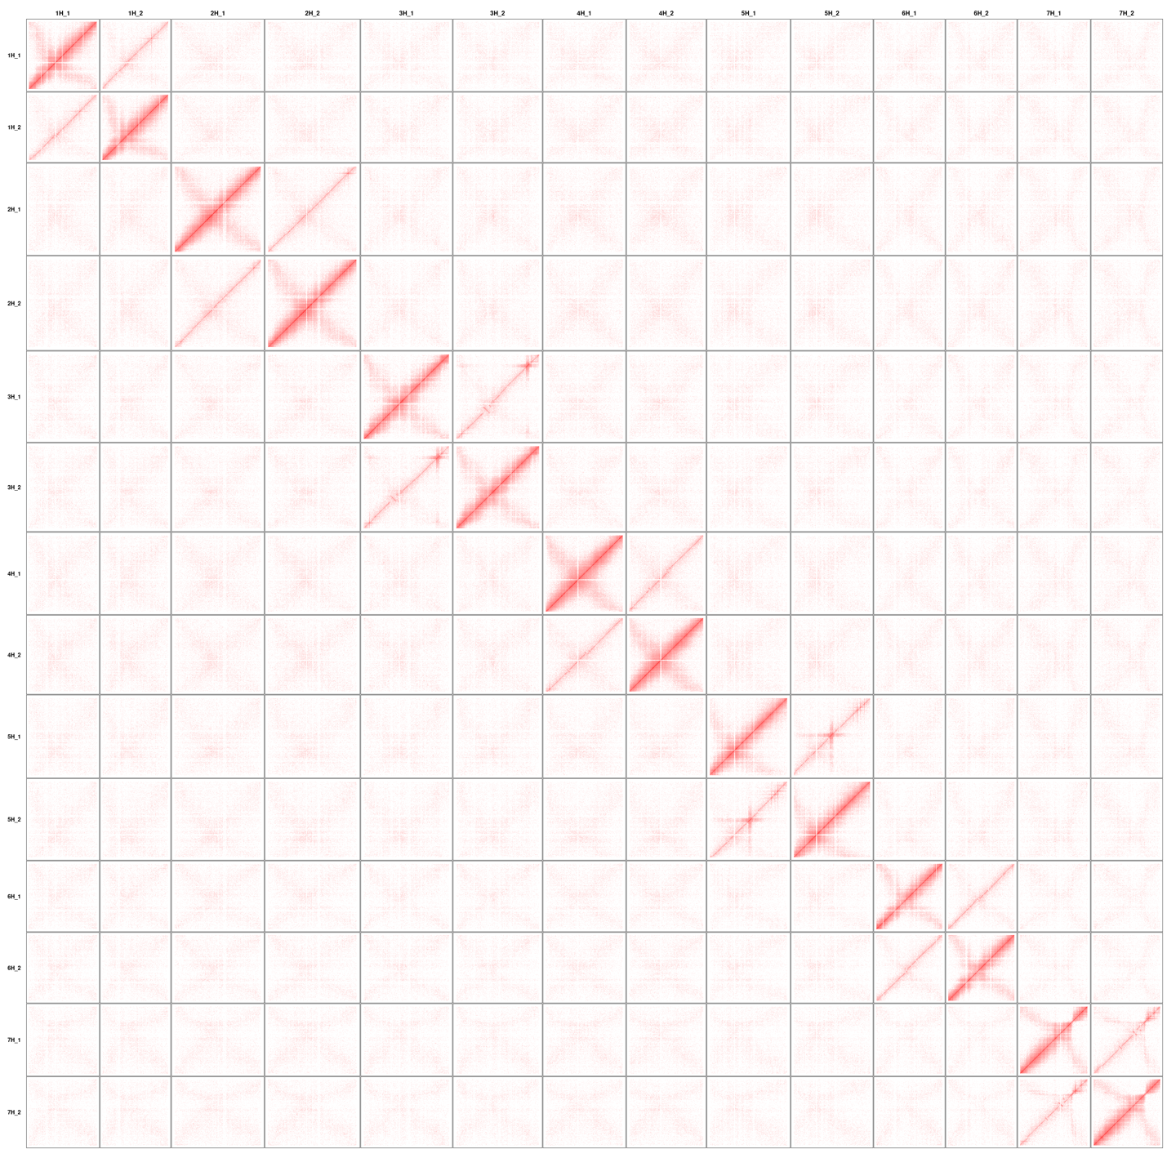
Supplementary Figure 2: FB20-005-1 Hi-C contact matrix. The intensity of pixels represents the normalized count of Hi-C links between 1 Mb windows on all chromosomes and haplotypes.

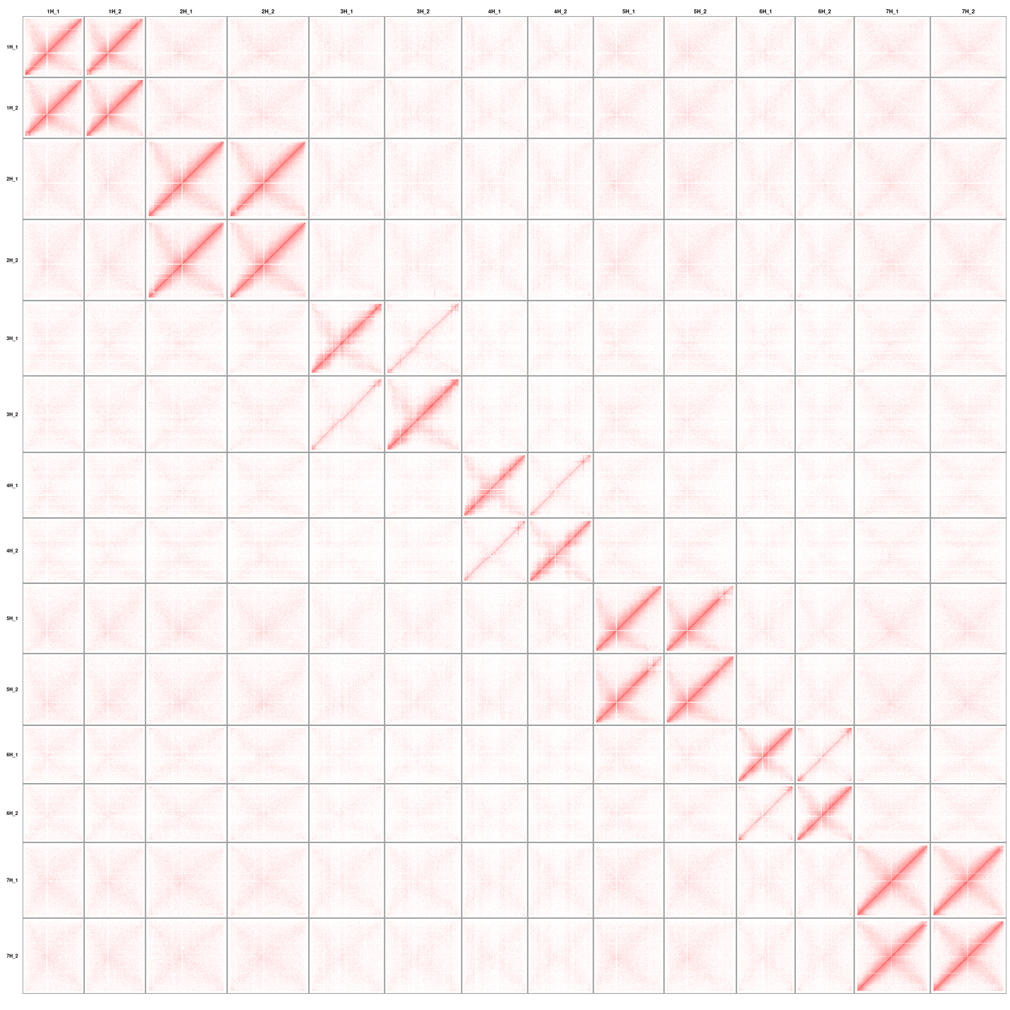
Supplementary Figure 3: FB20-029-7 Hi-C contact matrix.
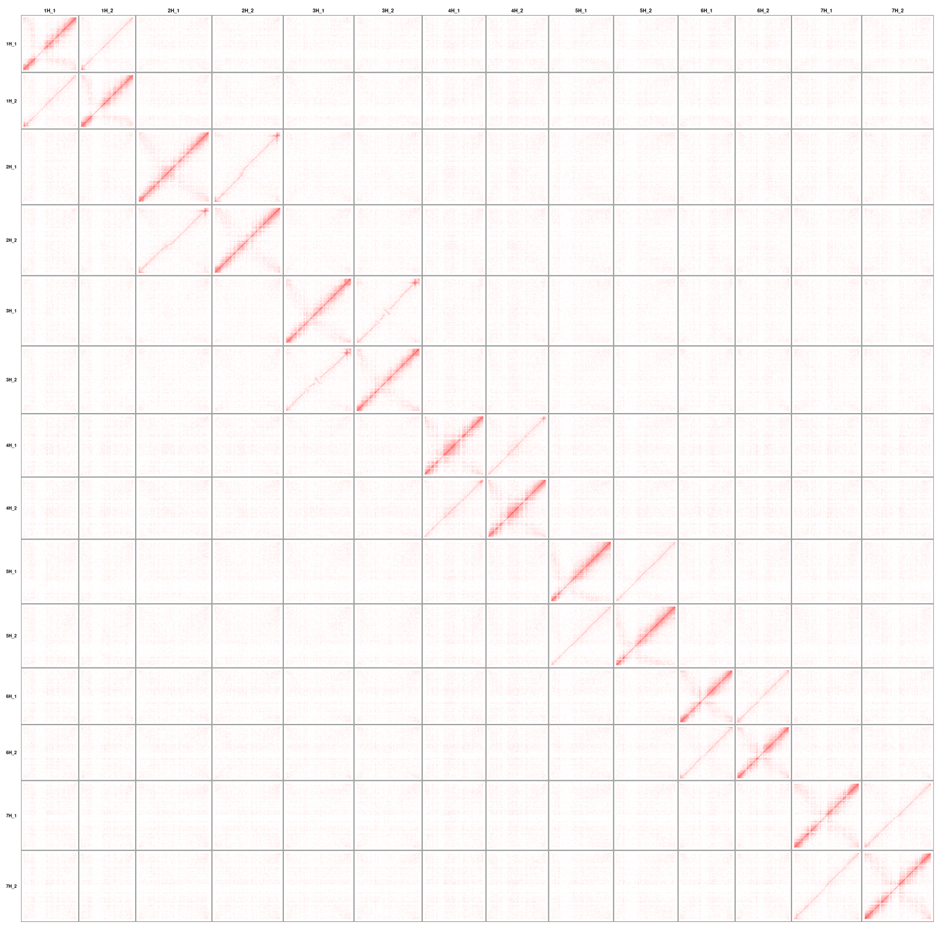
Supplementary Figure 4: PI365428 Hi-C contact matrix.
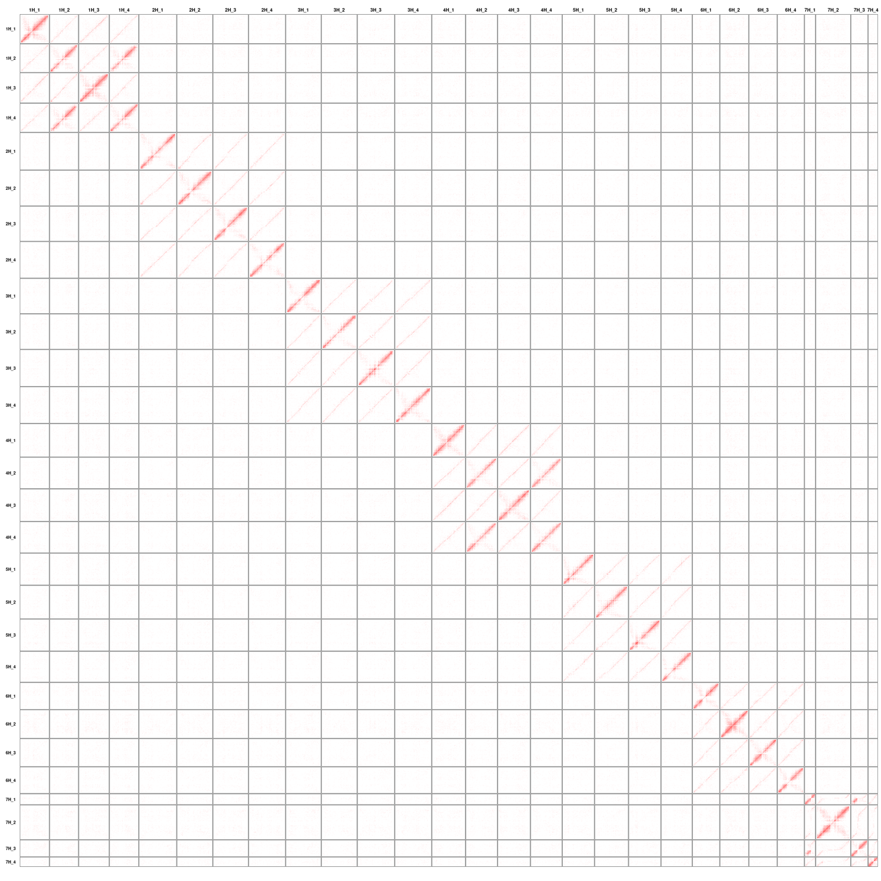
Supplementary Figure 5: FB19-001-1 Hi-C contact matrix.
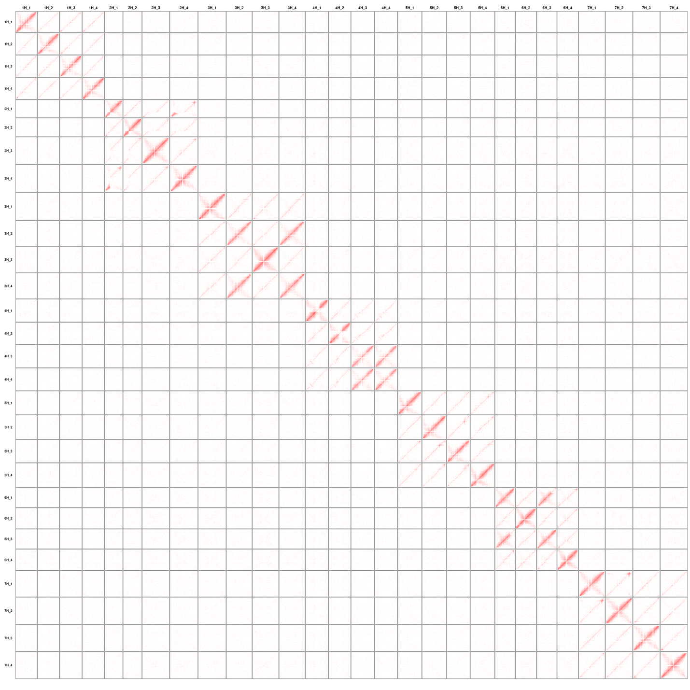
Supplementary Figure 6: GRA2256-1 Hi-C contact matrix.


Supplementary Figure 7: A17 Hi-C contact matrix.
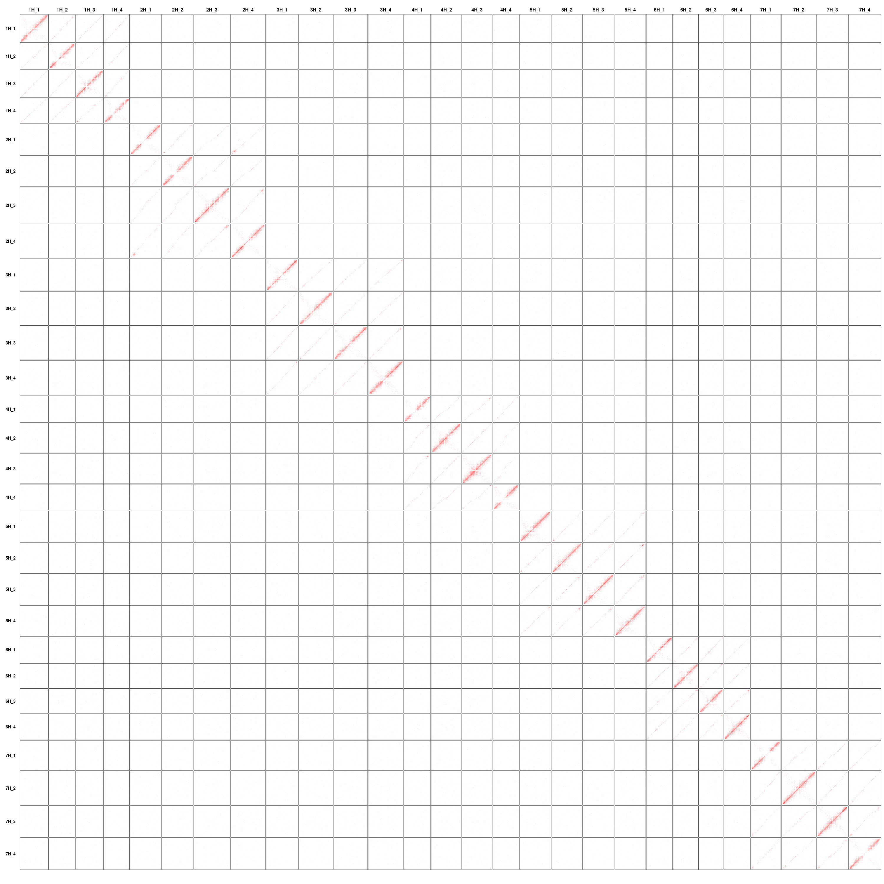
Supplementary Figure 8: A40 Hi-C contact matrix.
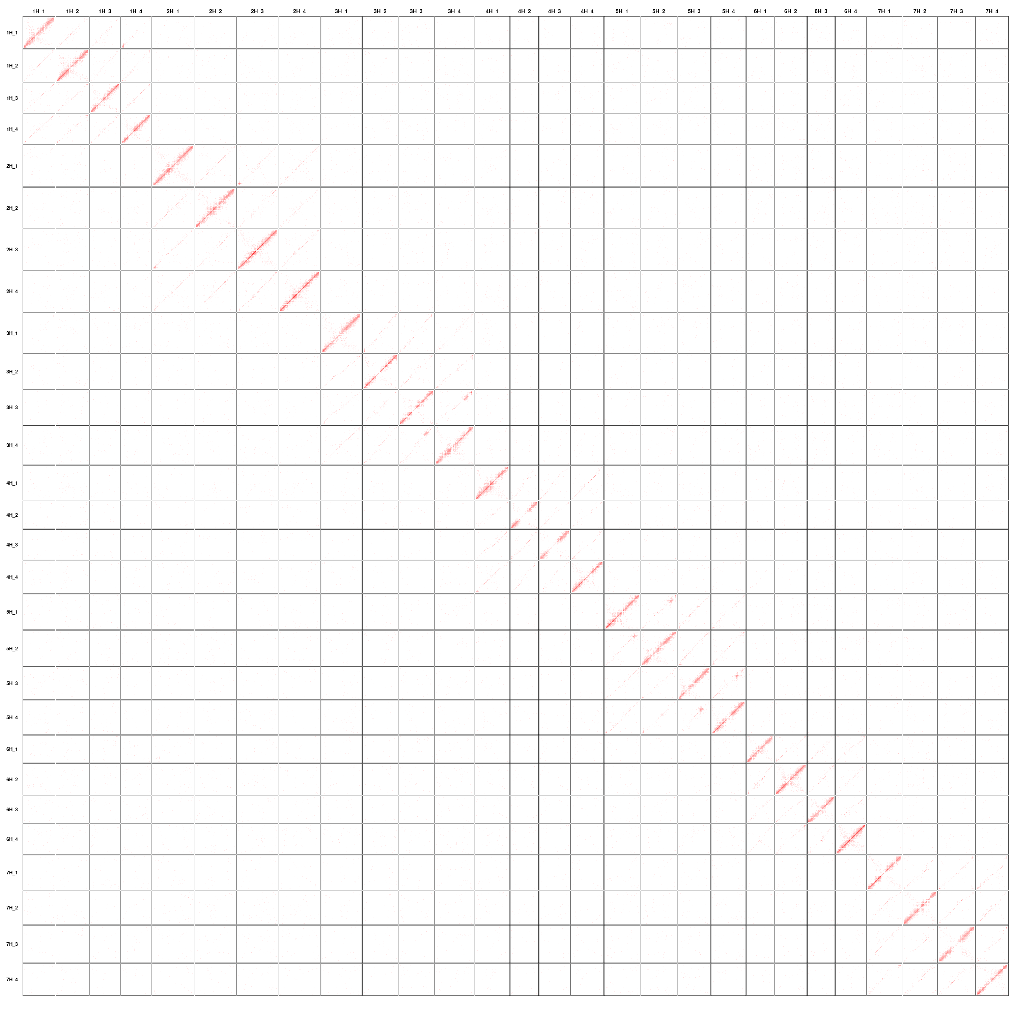
Supplementary Figure 9: A42 Hi-C contact matrix.

Supplementary Figure 10: Estimation of local genome size change rates based on alignment in chr1H between H. bulbosum haplotype 1 and H. vulgare cv. Morex. (a) Genome alignment between H. bulbosum haplotype 1 and Morex on chromosome 1H. (b) Alignments were fitted to a generalized additive model (GAM). (c) Estimated genome size change rate along the chromosome. The black horizontal line refers to the genome size change rate equal to 1 (no change).

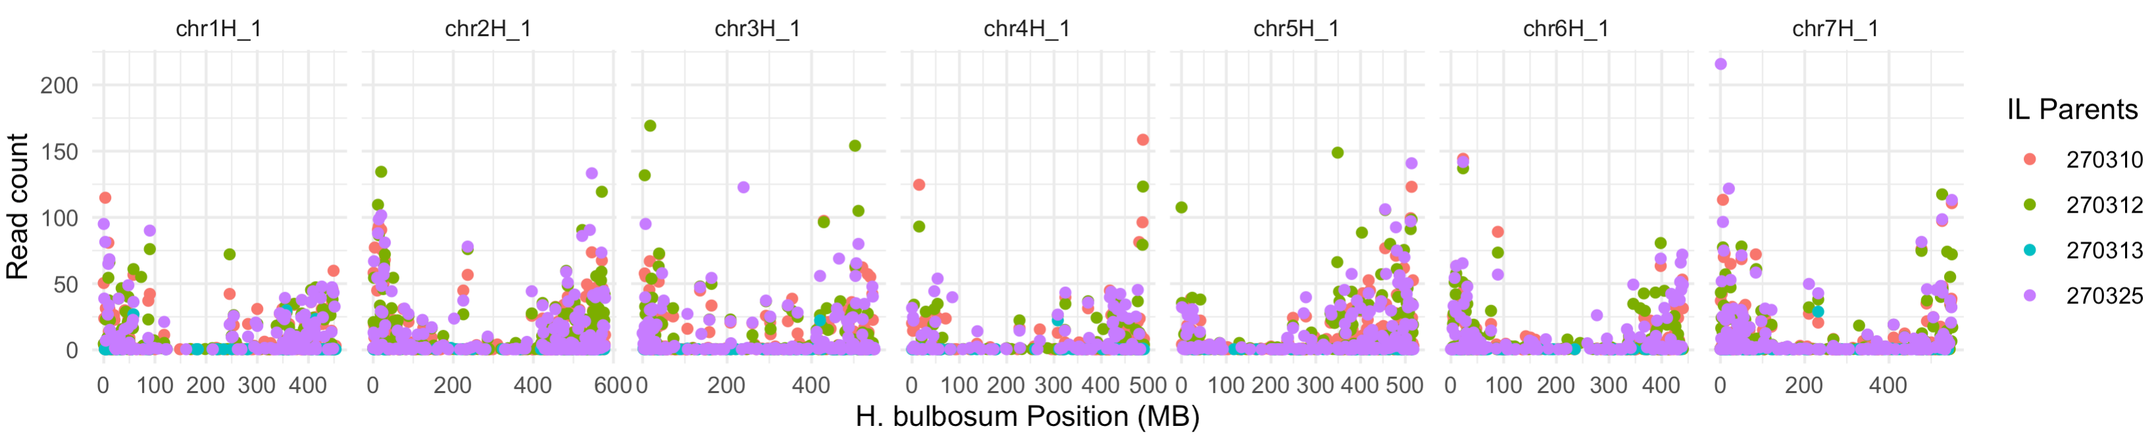Supplementary Figure 11. Distribution of read counts of barley parents of introgression lines aligned to the H. bulbosum genome.

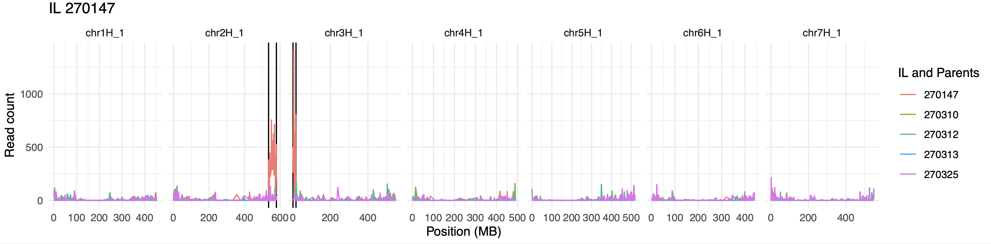
Supplementary Figure 12. An example of identifying introgressed regions for introgression line sample 270147.

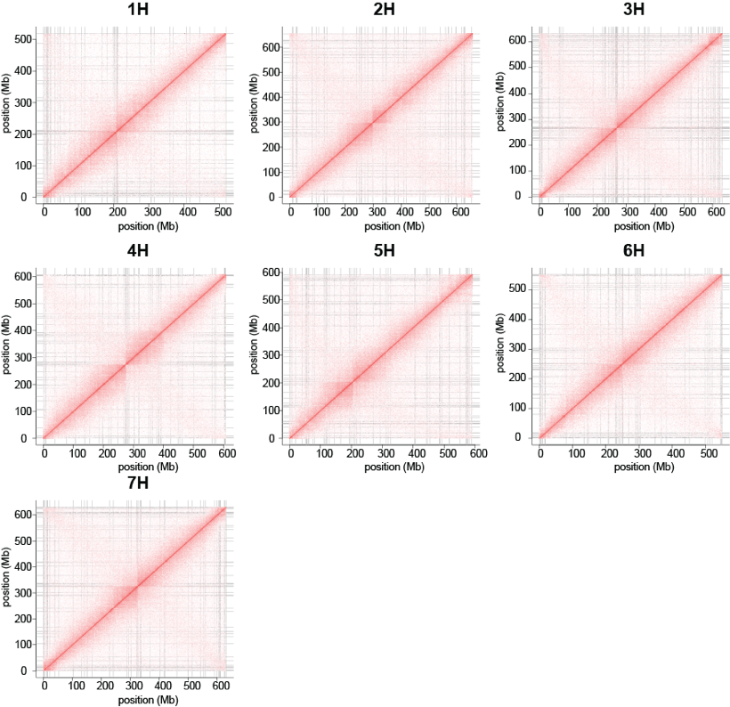

Accession | N50 | Assembly size (bp) | unanchored contsize (bp) | Busco (embryophyta_odb9)
JKI-5215 | 28,413,266 | 4,271,127,017 | 76,377,195 | 96.60%

Supplementary Figure 13. JKI-5215 Hi-C contact matrix and assembly summary statistics.
Supplementary Figure 14. A17 assembly separation in the introgressed region of JK-5215. (a) and (b) PCA clustering of the matrix of Hi-C links connecting the ends of contigs, i.e. those mapped to within 2 Mb of either contig end. Chromosome 3H of the tetraploid clone A17 is shown. Colors correspond to different haplotypes. R3 corresponds to contigs which are in the region of A17 haplotype 3 collinear to the JKI-5215 introgressed region. R4 corresponds to contigs which are in the region of A17 haplotype4 collinear to the JKI-5215 introgressed region. (c) PCA separation on haplotype 3 and haplotype 4 of A17 chromosome 3H after pseudomolecule construction and manual curation. R3 and R4 are the same as in (a) and (b). (d) Hi-C contact matrix of the region of A17 collinear to the JKI-5215 introgressed region.

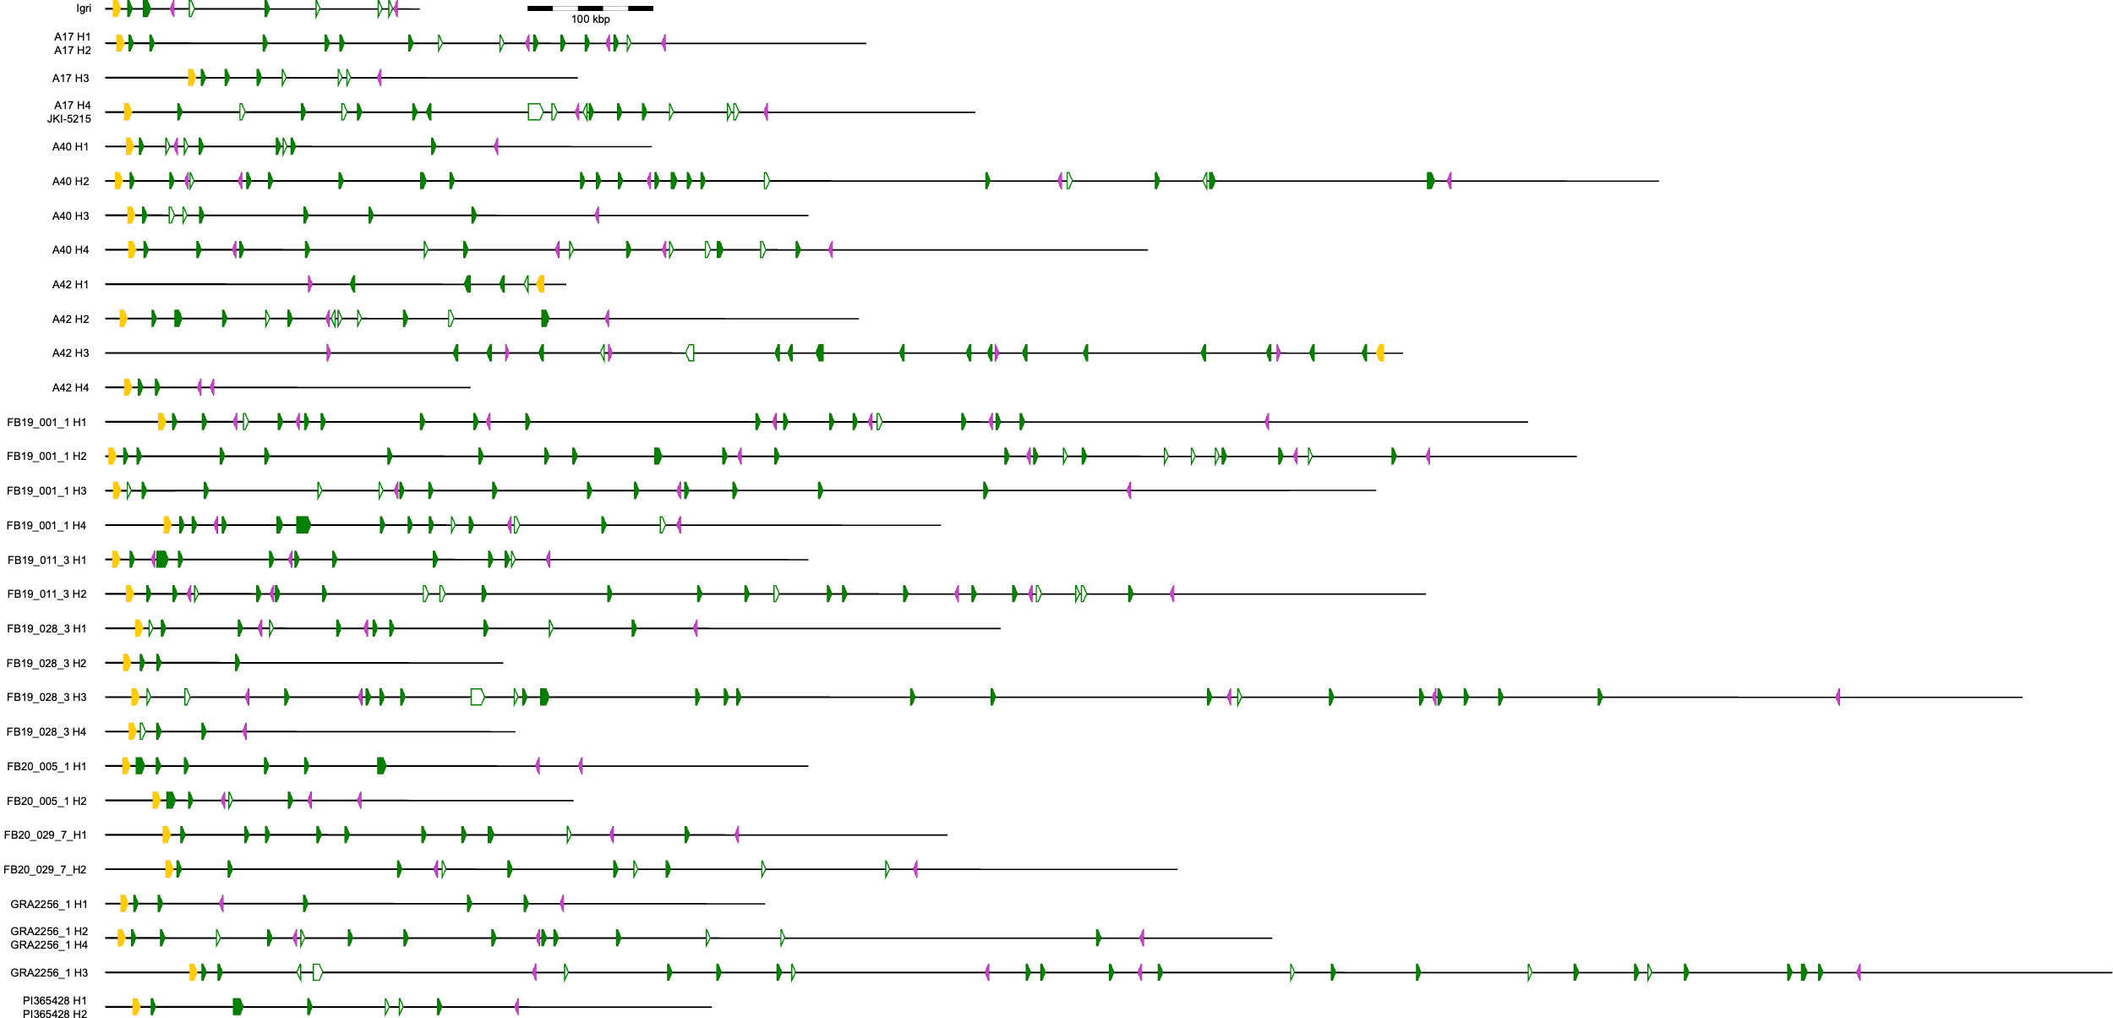
Supplementary Figure 15. Gene content of the Ryd4^{Hb} locus in the H. bulbosum pangenome. The color code is: yellow – SFGH1, purple – APGG2, green – CC-NBARC-LRR genes as defined by NLR-annotator. Details on the genes are given in Supplementary Table 13.

