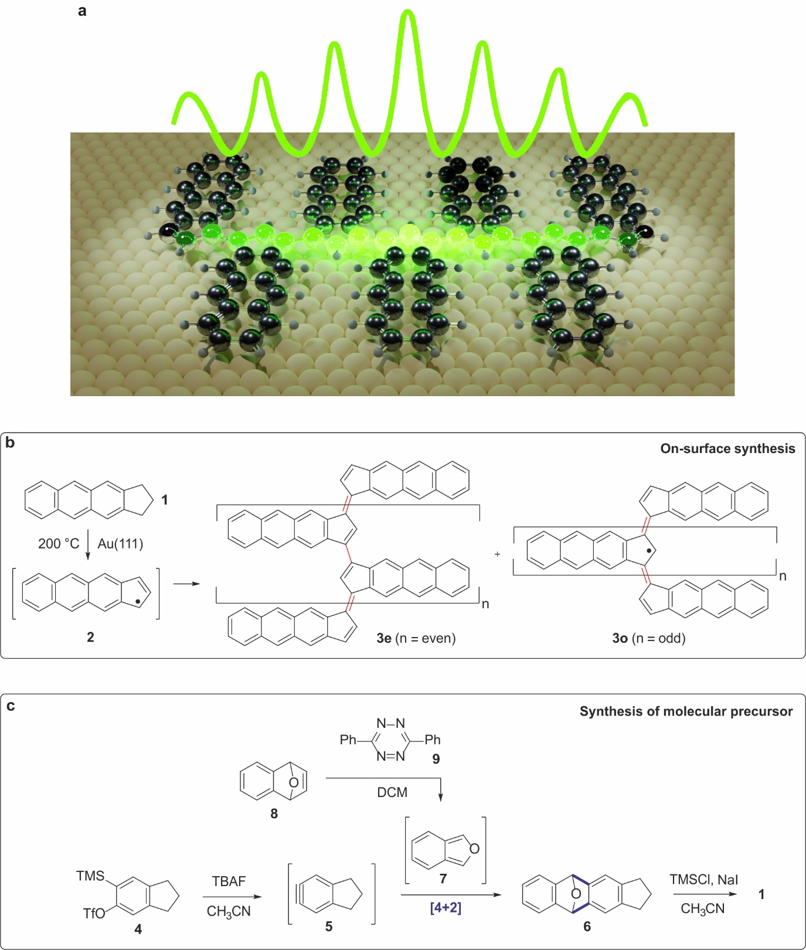
Scheme 1 | Solution synthesis of precursor 1 and on-surface synthesis of polymer 3. a, Delocalization of a soliton in a π-conjugated polymer simply by chemical design. b, Scheme of the polymerization of 1 into polymer 3 through the formation and homocoupling of intermediate 2 upon adsorption on Au(111) held at room temperature and subsequent annealing to 200 ºC. c, Solution synthesis of precursor 1.

