SUPPORTING INFORMATION
Designing highly delocalized solitons by harnessing
the structural parity of π-conjugated polymers
Kalyan Biswas¹, Jesús Janeiro², Aurelio Gallardo^{1,3}, Marco Lozano³, Ana Barragán¹, Berta Álvarez², Diego Soler-Polo³, Oleksandr Stetsovych³, Andrés Pinar Solé³, José M. Gallego⁴, Dolores Pérez², Rodolfo Miranda¹, José I. Urgel*^{,1}, Pavel Jelínek*^{,3}, Diego Peña*^{,2} and David Écija*^{,1}
¹IMDEA Nanoscience, C/ Faraday 9, Campus de Cantoblanco, 28049 Madrid, Spain
²Centro Singular de Investigación en Química Biolóxica e Materiais Moleculares (CiQUS) and Departamento de Química Orgánica, Universidade de Santiago de Compostela, 15782 Santiago de Compostela, Spain
³Institute of Physics of the Czech Academy of Science, CZ-16253 Praha, Czech Republic
⁴Instituto de Ciencia de Materiales de Madrid (ICMM), CSIC, Cantoblanco, 28049 Madrid, Spain
* Address correspondence to these authors
TABLE OF CONTENTS
- 1. Experimental details for the synthesis of precursor 1.
- 2. Self-assembly of precursor 1 on Au(111).
- 3. Statistics of length and structural parity of polymer 3.
- 4. Extra hydrogenation of the backbone of polymer 3.
- 5. Tip-induced removal of extra hydrogen from odd-membered polymer 3o.
- 6. Bond length analysis of DFT optimized structures of even- and odd-membered polymers 3.
- 7. Structural details of even- and odd-membered polymers 3 using nc-AFM.
- 8. Additional QM/MM MD and CI-NEB calculations.
- 9. Correlation between topographic contrast of the backbone and the structural parity of polymers 3.
- 10. DI/dV spectra obtained using different STM tips for various polymers 3.
- 11. Electronic structure of a 10-membered and a 9-membered polymer 3.
- 12. Enlarged high resolution spectra of few odd-membered polymers 3o.
- 13. Experimental point spectroscopy d²I/dV² using nickelocene (NiCp2)-functionalized tips of a 9-membered and an 8-membered polymer 3.
- 14. Theoretical modelling of the adsorption geometry and electronic structure of an odd-membered polymer 3e on Au(111).
- 15. Spatial distribution of soliton in odd-membered polymers 3o.
- 16. Soliton delocalization.
- 17. References

- Experimental details for the synthesis of precursor 1.

General methods for synthesis and characterization in solution
All reactions were carried out under argon using oven-dried glassware. THF, CH₂Cl₂ (DCM) and CH₃CN were purified by a MBraun SPS-800 Solvent Purification System. Commercial reagents were purchased from ABCR GmbH or Sigma-Aldrich.
An anhydrous stock solution of TBAF (1M in CH₃CN) was prepared as described in literature¹. TLC was performed on Merck silica gel 60 F254 and chromatograms were visualized with UV light (254 and 365 nm). Column chromatography was performed on Merck silica gel 60 (ASTM 230-400 mesh). NMR spectra were recorded on a Varian Mercury-300 or Varian Inova 500 instrument. Low resolution mass spectra (EI) were obtained at 70 eV on a HP-5988 A instrument, while MALDI-TOF were determined on a Bruker Autoflex instrument. 1,4-Dihydro-1,4-epoxynaphthalene (8)² and 6-(trimethylsilyl)-2,3-dihydro-1H-inden-5-yl trifluoromethanesulfonate (4)³ were synthesized following reported procedures. Figure S1 shows the synthetic route followed to obtain compound 1.

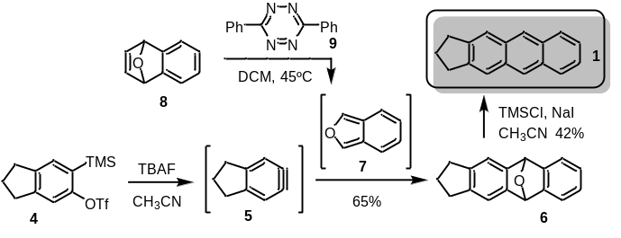

Figure S1 | Synthesis of 2,3-dihydro-1H-cyclopenta[b]anthracene (1).

Synthesis of 2,3,5,10-tetrahydro-1H-5, 10-epoxyciclopenta[b]anthracene (6)
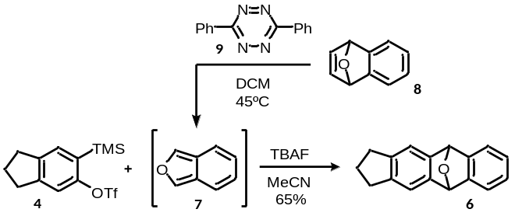

A mixture of 1,4-dihydro-1,4-epoxynaphthalene (8, 121.4 mg, 0.84 mmol) and 3,6-di(pyridin-2-yl)-1,2,4,5-tetrazine (9, 198.9 mg, 0.84 mmol) in dry CH₂Cl₂ (11 mL) were stirred at 45°C for 90 min. Then, triflate 4 (150 mg, 0.44 mmol) was added and a solution of tetrabutylammonium fluoride (1M in CH₃CN, 173.8 mg, 0.66 mmol) was dropwise added. The reaction mixture was stirred at 45°C for 16h. Then, the solvent was removed under reduced pressure and the product was purified by column chromatography (SiO₂, hexane/AcOEt , 4:1) to isolate compound 6 as a white solid (61.4 mg, 59%). ¹H-NMR (300 MHz, CDCl₃), δ: 7.36 – 7.21 (m, 2H), 7.18 (s, 2H), 7.00 (m, 2H), 6.00 (s, 2H), 2.83 – 2.77 (m, 4H), 2.09 – 2.02 (m, 2H) ppm. ¹³C-NMR-DEPT (75 MHz, CDCl₃), δ: 148.52 (2xC), 146.62 (2xC), 141.77 (2xC), 125.81 (2xCH), 120.12 (2xCH), 116.93 (2xCH), 82.76 (2xCH), 32.56 (2xCH₂), 25.54 (CH₂) ppm. HRMS (APCI-DIP-TOF) for C₁₇H₁₄O ([M+H⁺]) Calcd.: 235.1117; Found: 235.1180.

Synthesis of 2,3-dihydro-1H-cyclopenta[b]anthracene (1)

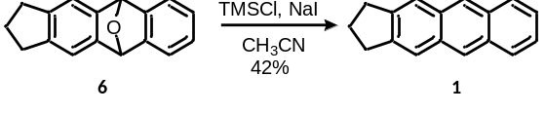
To a stirred solution of compound 6 (37 mg, 0.15 mmol) in dry CH₃CN (1.6 mL), freshly distilled TMSCl (0.12 mL, 0.95 mmol) and NaI (142 mg, 0.95 mmol) were added. The mixture was stirred at rt for 3h. Then, the solvent was evaporated under reduce pressure and the product was purified by column chromatography (SiO₂, hexane/AcOEt, 9:1), affording anthracene 1 as a white solid (14.5 mg, 42%). ¹H-NMR (300 MHz, CDCl₃), δ: 8.32 (s, 2H), 7.96 (dd, J = 6.4, 3.3 Hz, 2H), 7.80 (s, 2H), 7.41 (dd, J = 6.6, 3.2 Hz, 2H), 3.09 (t, J = 7.4 Hz, 4H), 2.30 – 2.01 (m, 2H) ppm. ¹³C-NMR-DEPT (75 MHz, CDCl₃), δ: 143.55 (2xC), 131.69 (2xC), 131.28 (2xC), 128.02 (2xCH), 125.34 (2xCH), 124.74 (2xCH), 121.63 (2xCH), 32.62 (2xCH₂), 26.27 (CH₂) ppm. HRMS (APCI-DIP-TOF) for C₁₇H₁₄ ([M+H]⁺) Calcd.: 219.1168; Found: 219.1163.

Spectroscopic data

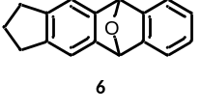

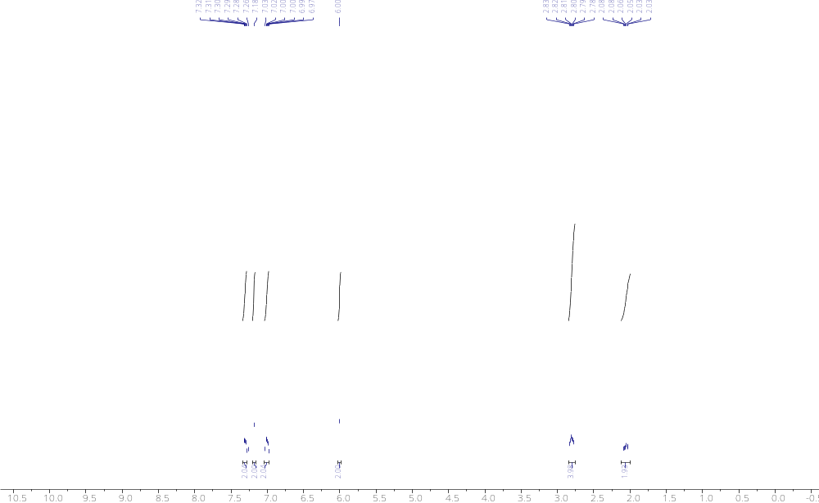
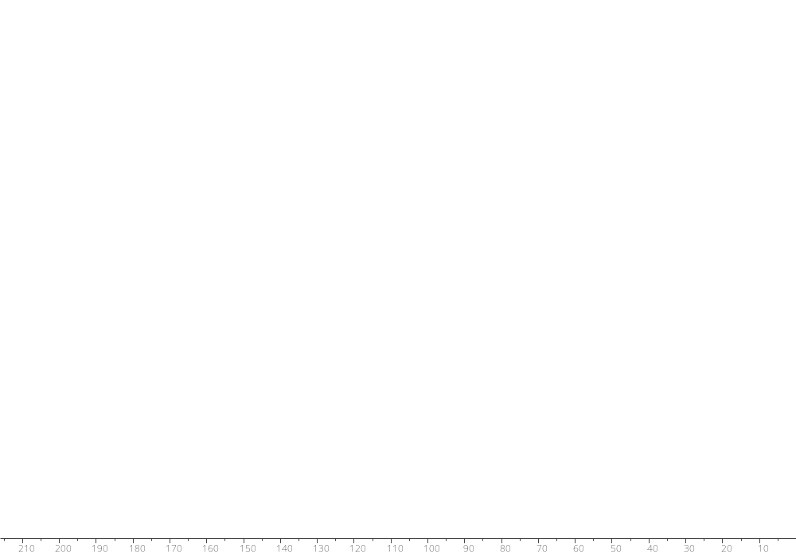

Figure S2 | ¹H NMR, ¹³C NMR and DEPT spectra of compound 5.

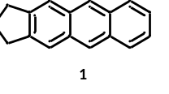

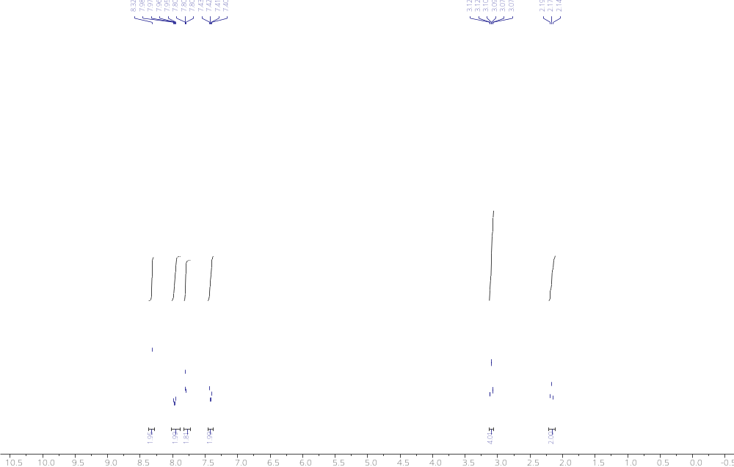
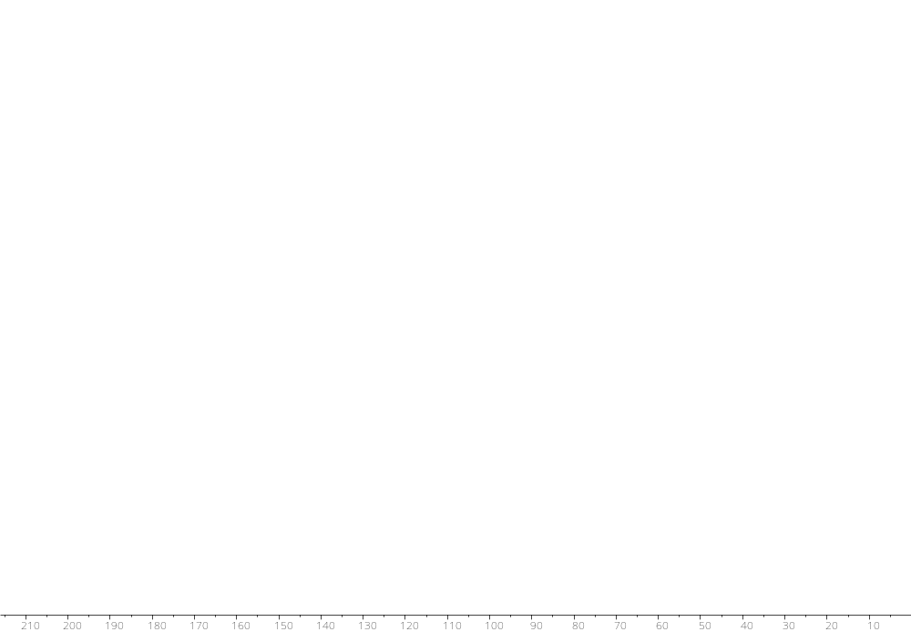

Figure S3 | ¹H NMR, ¹³C NMR and DEPT spectra of compound 1.

2. Self-assembly of precursor 1 on Au(111).
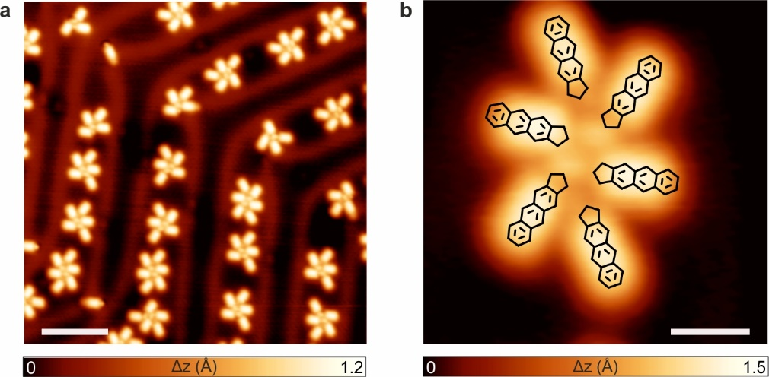
Figure S4 | Self-assembly of precursor 1 on Au(111). a, STM image of the self-assembly of 1 on the Au(111) substrate held at room temperature after deposition of a submonolayer coverage. b, High-resolution zoom-in STM image of a supramolecular hexamer with superimposed chemical sketches of precursors. a, V_{b} = -0.5 V, I_{t} = 50 pA, scale bars = 5 nm; b, V_{b} = -0.5 V, I_{t} = 50 pA, scale bars = 1 nm.

3. Statistics of length and structural parity of polymer 3.
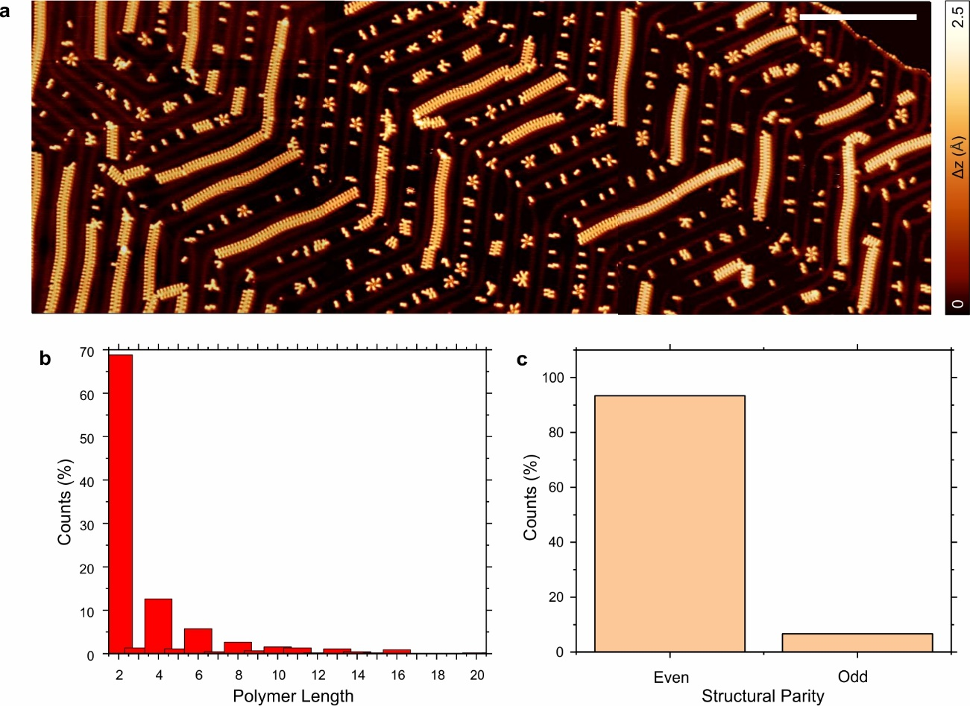
Figure S5 | Statistics of length and structural parity of polymer 3. a, Large area overview STM image after annealing a submonolayer coverage of precursor 1 on Au(111) at 200 °C for 10 minutes. V_{b}= 0.5 V, I_{t} = 10 pA, scale bar = 20 nm. b, Histogram depicting the distribution of the polymer length. c, Histogram of the structural parity (even vs. odd) of the polymer.

4. Extra hydrogenation of the backbone of polymer 3.
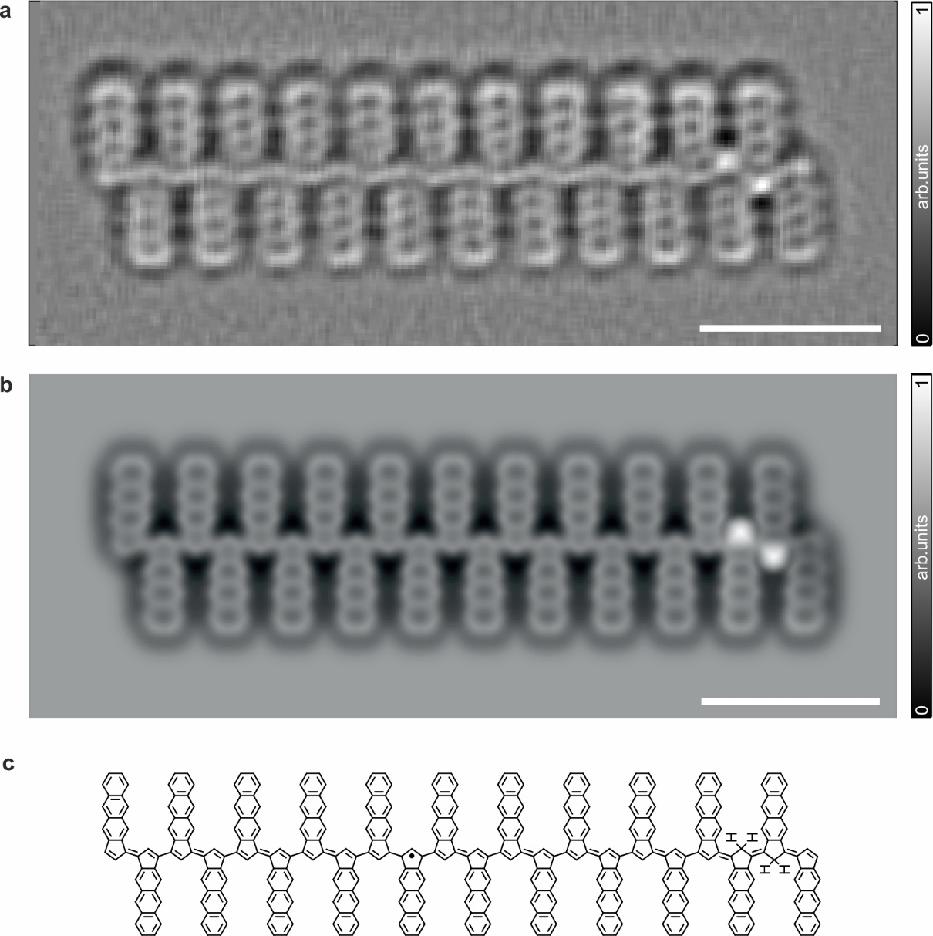
Figure S6 | Extra hydrogenation of the backbone of polymer 3. a, Constant-height frequency-shift nc-AFM image, acquired with a CO-functionalized tip, of an extra hydrogenated chain of 22 monomer units at two carbon locations (z_{offset} = 120 pm above STM set point: V_{b} =5 mV, I_{t} = 50 pA). b, Simulated nc-AFM image of a. a-b, Scale bars = 1 nm. c, Corresponding chemical structural model of b.

5. Tip-induced removal of extra hydrogen from odd-membered polymer 3o.
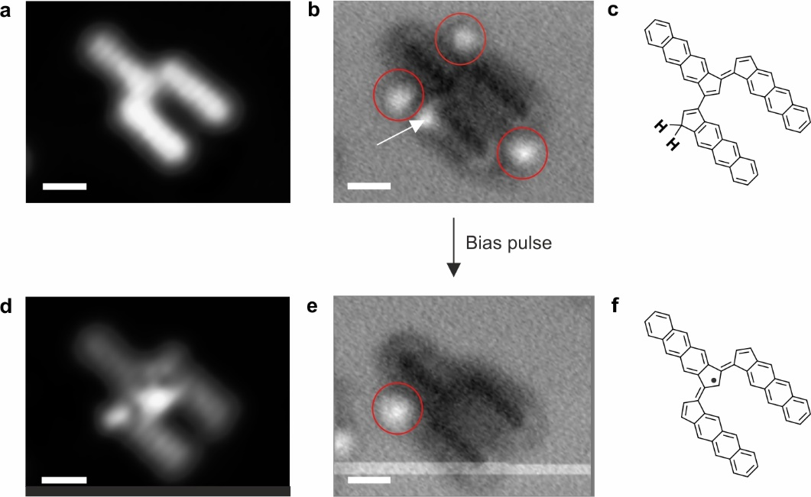
Figure S7 | Tip-induced removal of hydrogen from a doubly dehydrogenated position in a three-membered polymer. a,d, High-resolution constant-height STM images of a trimer before and after the removal of an extra hydrogen, respectively. V_{b} = 10 mV, I_{t} = 50 pA. b,e, Simultaneously acquired constant-height frequency-shift nc-AFM images with a CO-functionalized tip. The red circles highlight the presence of CO molecules on the surface. Additionally, the doubly hydrogenated position within the polymer backbone is indicated by a white arrow. Three CO molecules were surrounding the molecule before the C-H cleavage. The extra hydrogen was removed by locating the tip on top of the doubly hydrogenated position, subsequently lifting the tip 200 pm and applying 1.8V until the current dropped and the H was removed. After the C-H cleavage, one CO still remains close to the molecule, and importantly now the trimer displays the soliton. Scale bars = 0.5 nm. c,f, Chemical structural model of a,b and d,e, respectively.

6. Bond length analysis of DFT optimized structures of even- and odd-membered polymers 3.
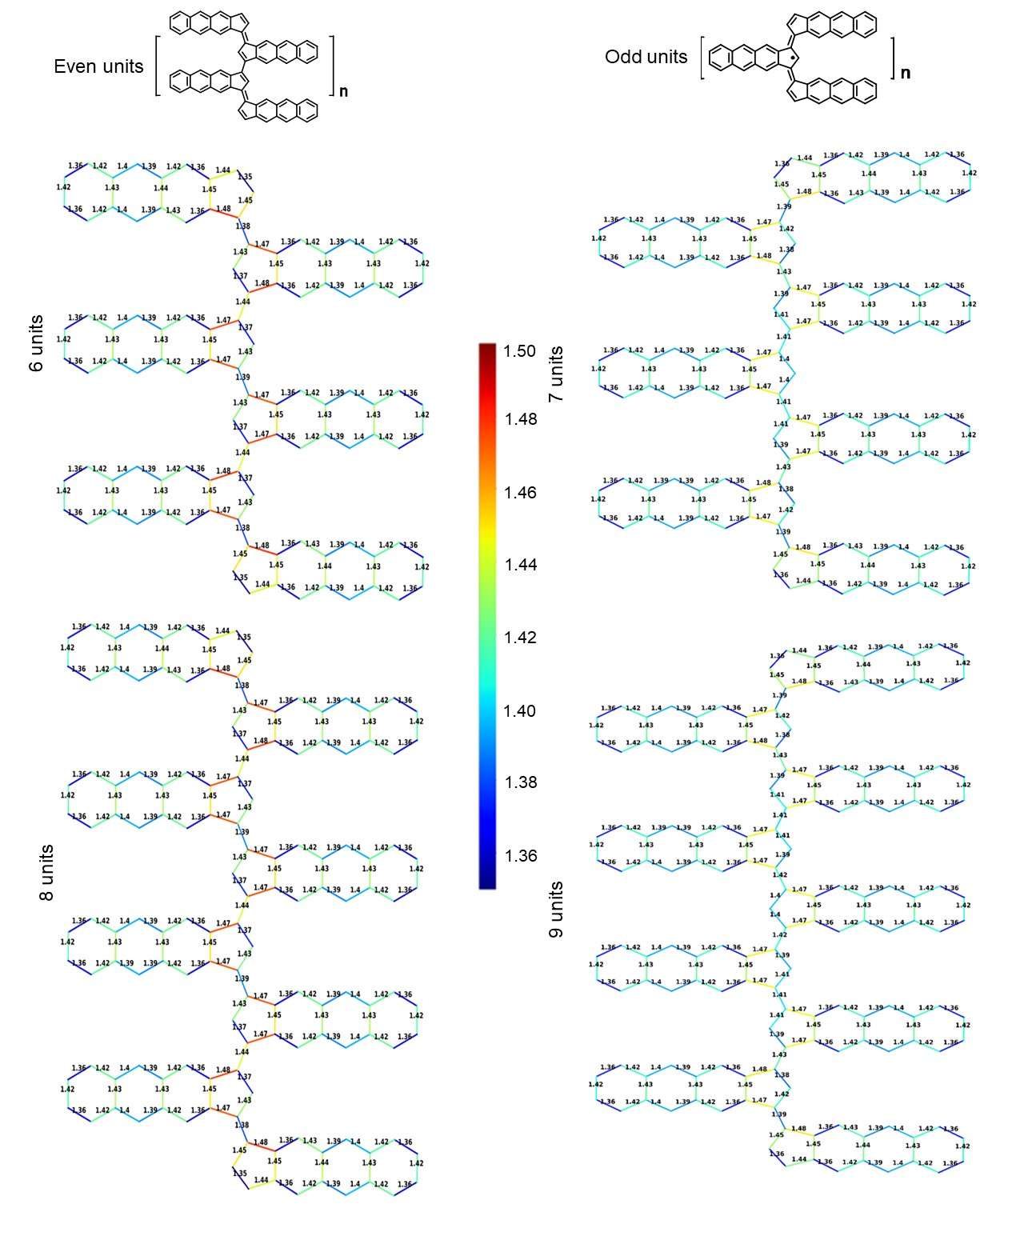
Figure S8 | Bond length analysis of even- and odd-membered polymers. Bond lengths were calculated using the hybrid B3LYP functional and plotted in the selected color range (1.35 to 1.50 Å).

7. Structural details of even- and odd-membered polymers 3 using nc-AFM.

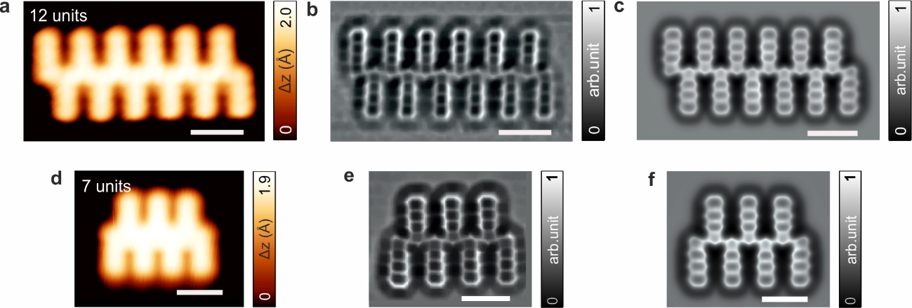
Figure S9 | Structural details of even- and odd-membered polymers 3 using nc-AFM. a,d, High-resolution STM images, acquired with a CO-functionalized tip, of isolated 12-membered and 7-membered polymer, respectively. V_{b} = 5 mV, I_{t} = 50 pA, scale bars = 1 nm. b,e, Constant-height frequency-shift nc-AFM images of a and d, respectively, acquired with a CO-functionalized tip. b, V_{b} = 5 mV, I_{t} = 50 pA; e, V_{b} = 10 mV, I_{t} = 50 pA. Scale bars = 1 nm. c,f, Simulated nc-AFM images with a CO-tip for the corresponding nc-AFM images of b,e using an optimized molecular structure obtained from total energy DFT calculations. Scale bars = 1 nm.

8. Additional QM/MM MD and CI-NEB calculations.
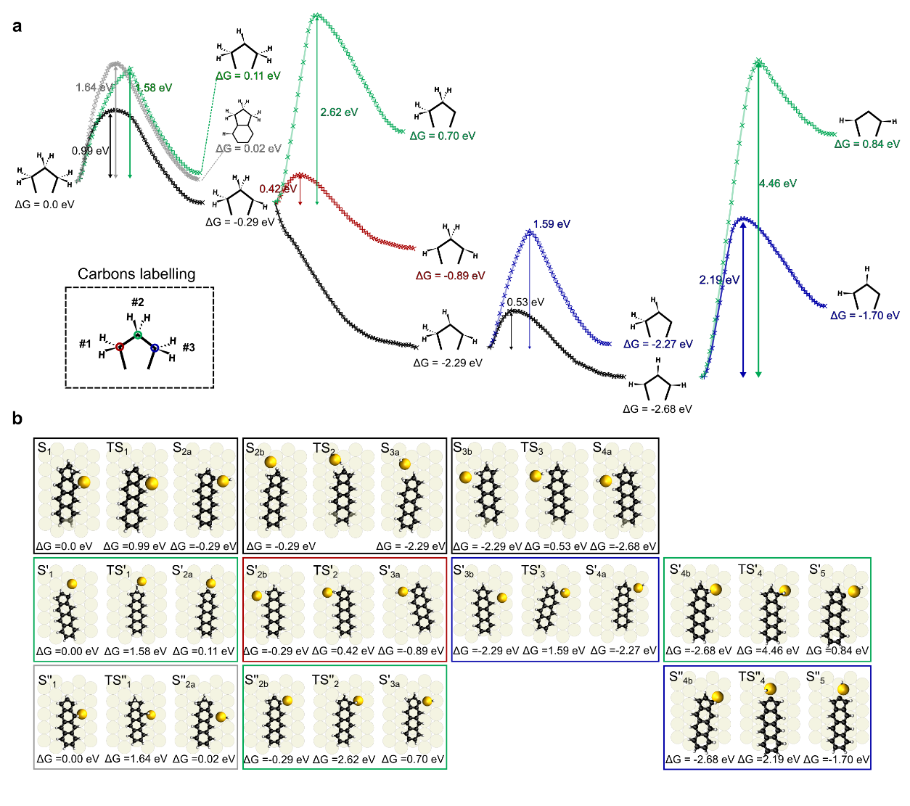
Figure S10 | Free energy barriers and structures of the initial, intermediate, and final stages of alternative considered reaction pathways for certain stages of the C-H cleavage processes shown in Fig.2. a, Concatenation of the most favorable energy barrier (black line) as shown in Figure 2 of the main manuscript, compared with all the explored alternative reaction pathways. The alternative processes are depicted in red, green and blue, corresponding to C-H cleavage of the carbons #1, #2 and #3, or in grey for the C-H cleavage of a carbon on a benzene ring. b, Initial, transitional and final structures of all the free energy barriers shown in panel a.
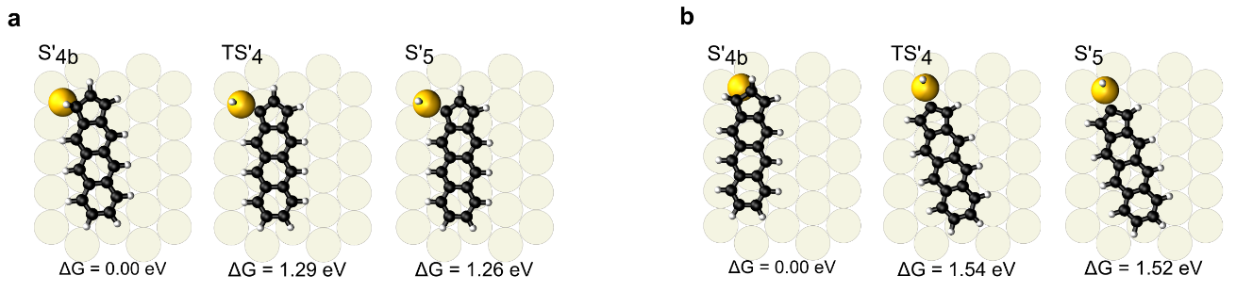
Figure S11 | Energy barriers for the C-H cleavage process shown in Fig. S10 recalculated with CI-NEB including a DFT described substrate for comparison. The inclusion of a DFT calculated substrate allows the charge transference between the molecules and the substrate, lowering the energy barrier of the process.
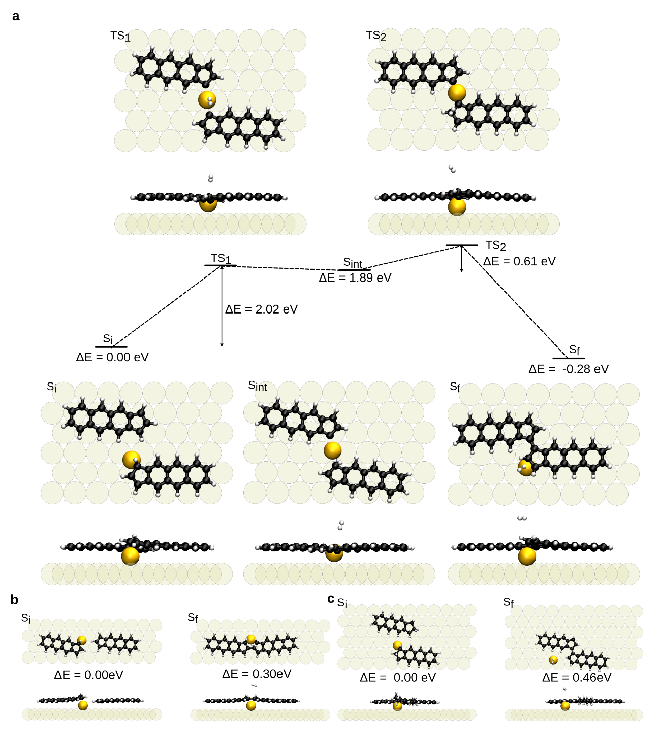
Figure S12 | Proposed alternatives to the dimerization process. a, Polymerization process, similar to the shown in Fig. 2e where the C-H cleavage of the carbons occurs in a simultaneous way. This alternative will present a potential energy barrier of 2.02 eV for the complete process of creation of the organo-metallic bond between the molecules and the two C-H cleavages that are necessary for its formation, instead of the two proposed barriers of 1.28eV and 1.17eV proposed in Fig. 2e for such purpose. b, Energy balance of the polymerization occurring through the carbons at the apex of the five-member carbon ring, which would lead to the creation of linear dimers instead of the experimentally observed chains. This process was found to be thermodynamically not favorable. c, Energy balance of the polymerization occurring from intermediates ${S2}_{a}$ after the first C-H cleavage. This process was found to be thermodynamically not favorable.
9. Correlation between the topographic contrast of the backbone and the structural parity of polymers 3.
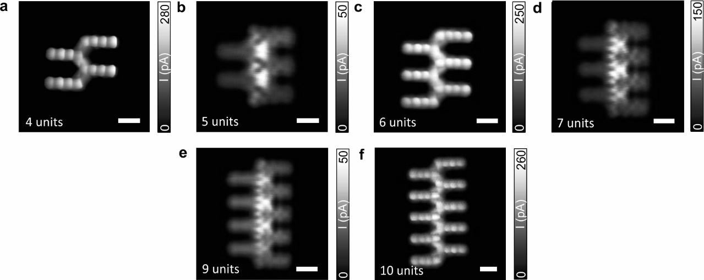
Figure S13 | Correlation between topographic contrast of the polymer backbone and structural parity. a-f, High-resolution constant-height STM images with a CO-functionalized tip of even- and odd-membered polymers V_{b} = 5 mV; I_{t} = 50 pA; z_{offset} = 70 pm, 200 pm, 70 pm, 150 pm, 180 pm, and 80 pm, respectively. Scale bars = 0.5 nm.

10. DI/dV spectra obtained using different STM tips for various polymers.
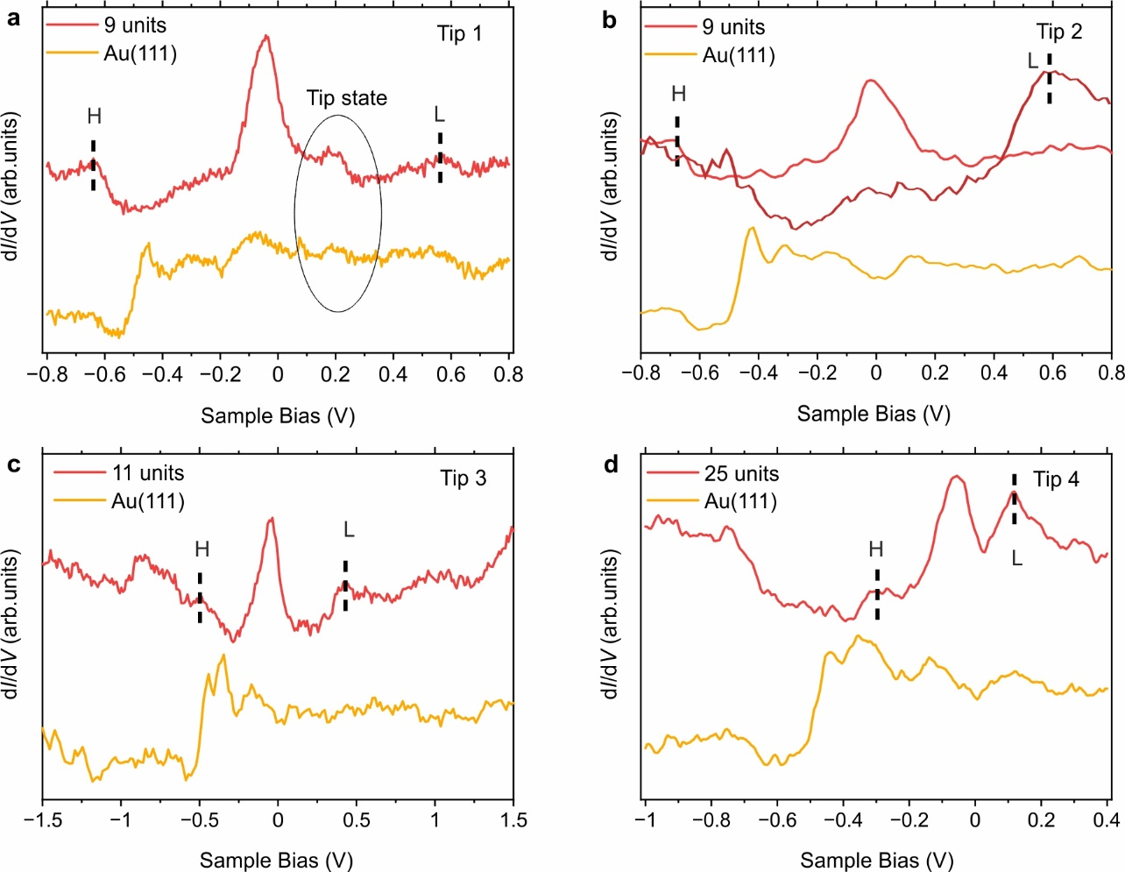
Figure S14 | DI/dV spectra obtained using different STM tips for various odd-membered polymers. The dI/dV spectra for 3, 5, 7, and 9-membered polymers in Figure 3j were acquired using Tip 1, revealing a kink at around 0.2 V in the spectra attributed to the tip state. However, this kink is not observed in the spectra that were obtained with Tip 2 for a 9-membered polymer (panel b) and with Tip 3 or Tip 4 for the 11- and 25-membered polymers, panels c and d, respectively.

11. Electronic structure of a 10-membered and a 9-membered polymer 3.
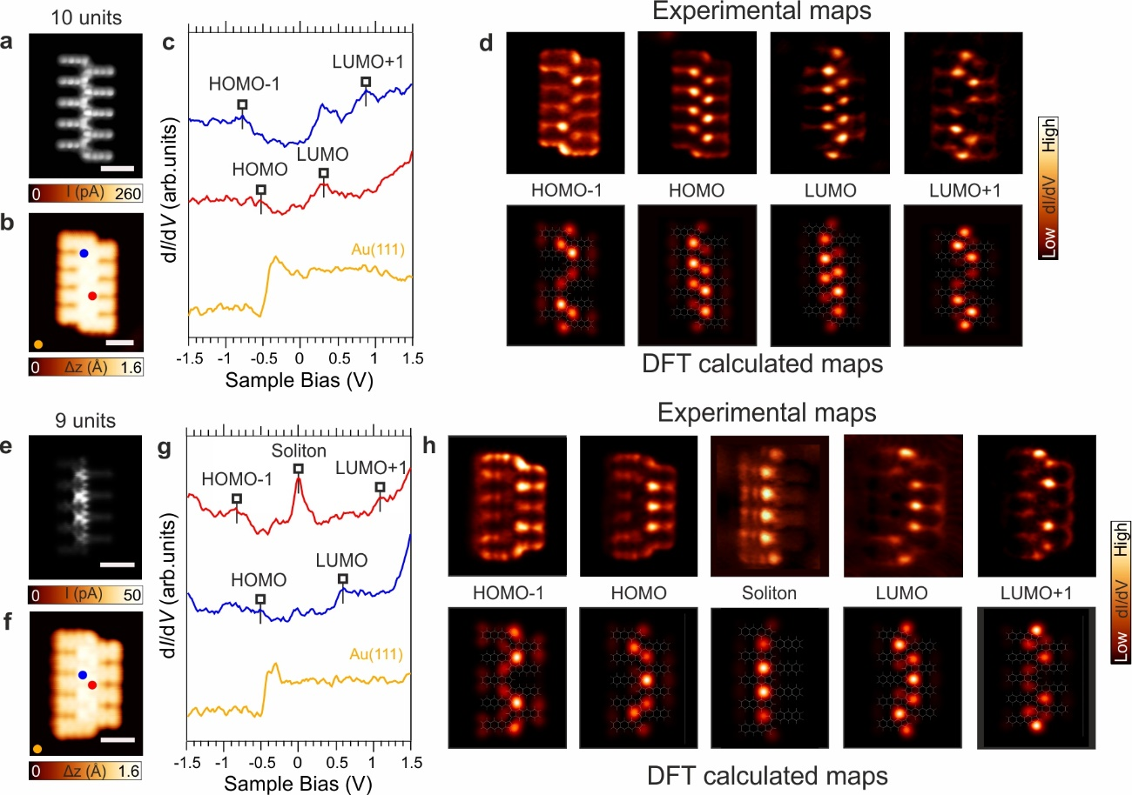
Figure S15 | Electronic structure of a 10-membered and a 9-membered oligo-naphthoindenylidene polymer. a,e, Constant-height high-resolution STM images of an even-membered and an odd-membered polymer acquired with a CO-functionalized tip, respectively. V_{b} = 5 mV, scale bars = 0.5 nm. b,f, High-resolution constant-current STM images of a 10-membered and a 9-membered polymer acquired with a CO-functionalized tip, respectively. V_{b} = −2.0 V, I_{t} = 100 pA, scale bars = 0.5 nm. c,g, dI/dV spectra of 10-membered and 9-membered polymer acquired at the positions indicated by the colored circles in b,f, respectively. Reference spectra taken on the bare Au(111) surface is depicted in orange and the acquisition positions marked with an orange circle. Open feedback parameters for dI/dV spectra of b,e: V_{b} = −2.0 V, I_{t} = 100 pA, V_{rms} = 20 mV. d,h, Constant-current dI/dV maps acquired with a CO-tip and corresponding DFT-calculated maps (tip-sample height = 5 Å) at the energy corresponding to the distinct frontier orbitals. HOMO – 1 (V_{b} = −0.87 V, I_{t} = 250 pA), HOMO (V_{b} = −0.56 V, I_{t} = 250 pA), LUMO (V_{b} = 0.25 V, I_{t} = 250 pA), and LUMO + 1 (V_{b} = 0.77 V, I_{t} = 250 pA); HOMO – 1 (V_{b} = −0.80 V, I_{t} = 250 pA), HOMO (V_{b} = −0.5 V, I_{t} = 250 pA), Soliton (V_{b} = −0.10 V, I_{t} = 70 pA), LUMO (V_{b} = 0.60 V, I_{t} = 250 pA), and LUMO + 1 (V_{b} = 1.10 V, I_{t} = 250 pA); with V_{rms} = 20 mV.

12. Enlarged high resolution spectra of few odd-membered polymer 3.
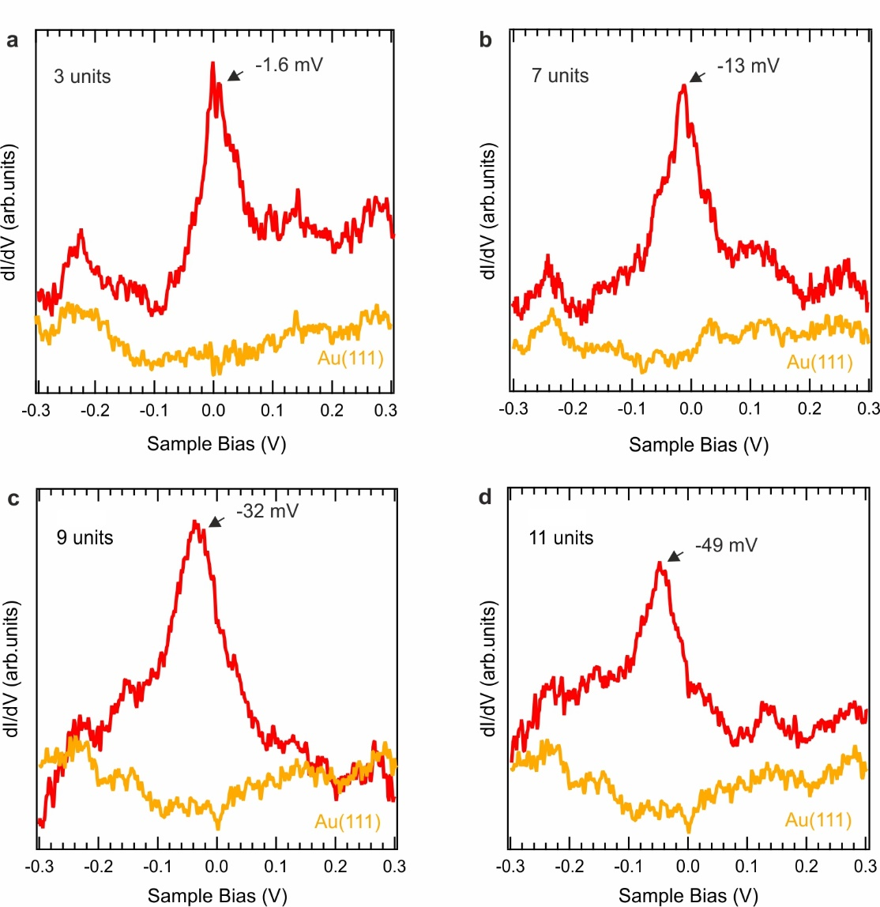
Figure S16 | Enlarged high resolution spectra of a few odd-membered oligo naphthoindenylidene polymers. a-d, dI/dV spectra of selected polymers of different lengths. Set points for STS: V_{b} = −0.3 V, I_{t} = 500 pA, V_{rms} = 2 mV. The position of the soliton peak, which is located close to the Fermi energy, is denoted by an arrow in the graphs.

13. Experimental d²I/dV² point spectroscopy using nickelocene (NiCp2)-functionalized tips on a 9-membered and 8-membered polymer 3.
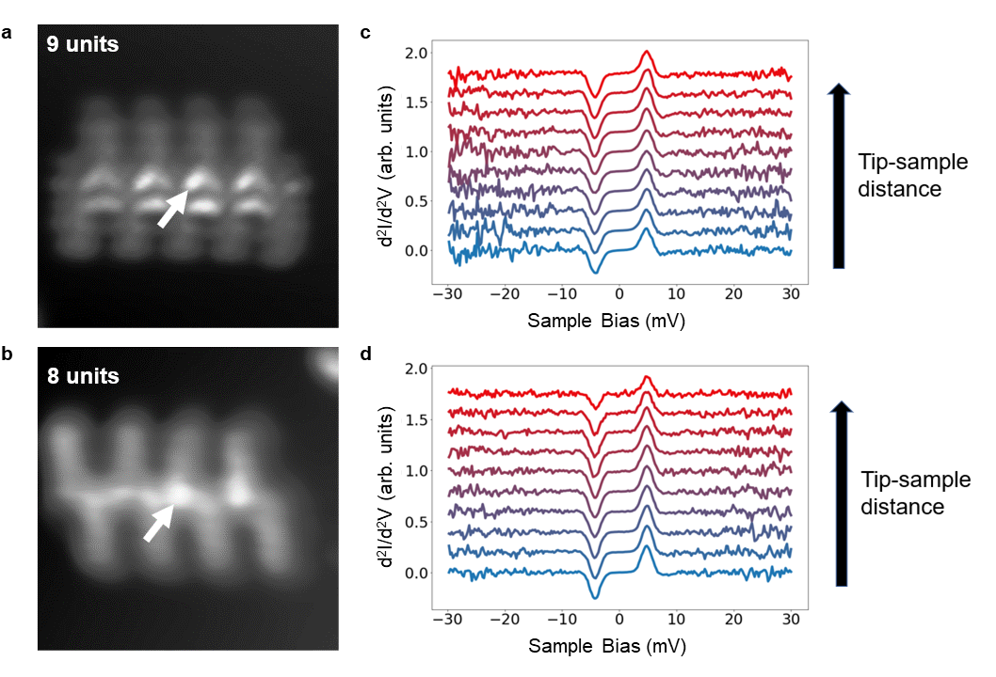
Figure S17 | Experimental d²I/dV² point spectroscopy using nickelocene (NiCp2)-functionalized tips of a 9-membered and 8-membered naphthoindenylidene polymer. a,b, Constant-height ultra-high resolution STM images of a 9-membered and 8-membered naphthoindenylidene polymer, respectively. c,d, A series of d²I/dV² spectra was obtained using a scanning-probe tip terminated with NiCp2 on a 9-membered and 8-membered naphthoindenylidene polymer at different tip–sample distances. To take the spectra the tip was brought closer to the sample about 1.5-2 Å from the minima of the AFM frequency shift profile with the NiCp2 profile. Tip-sample distance was increased in steps of 20 pm. The white arrows indicate the position of the acquired point spectroscopy in a,b. The spectra remain unaltered as the tip-sample distance varies for both odd- and even-membered polymers, showing absence of the magnetic exchange interaction between nickelocene and polymer⁴. Therefore, in the case of 9-membered polymer, it indicates that a radical soliton state (S=1/2) is quenched by charge transfer between the polymer and substrate.

14. Theoretical modelling of the adsorption geometry and electronic structure of an odd-membered polymer 3o on Au(111).

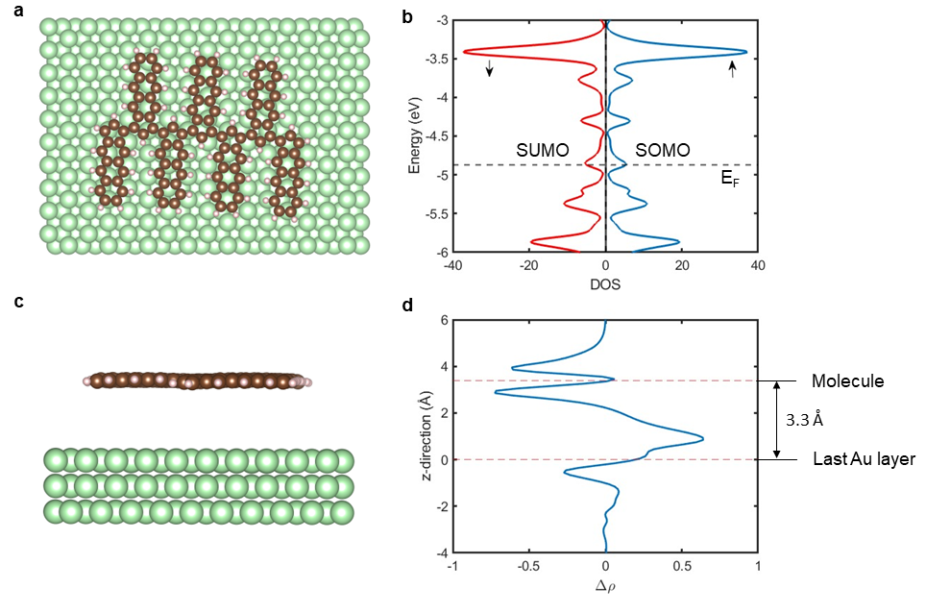
To provide more insight into the interaction between the even-membered polymer and the metallic Au(111) substrate, we carried out the total energy DFT calculations as well as a single impurity Anderson model describing charge transfer between a localized singly occupied soliton state and wide metallic surface band. In particular, we will demonstrate that the absence of a radical soliton state in the odd-membered polymers on Au(111) surface is caused by charge transfer from the molecular soliton state to the metallic substrate inducing the mixed-valence regime.
Figure S18. Theoretical modelling of the adsorption geometry and electronic structure of an odd-membered polymer 3o on Au(111). a, Molecule relaxed on the surface from top view. b, Density of States projected on Carbon atoms for the polymer on the surface, spin resolved. SOMO and SUMO levels are indicated as well as Fermi level of the Au(111) surface (dashed line). c, Molecule relaxed on surface from sideview. d, Charge density transfer integrated and projected on z-direction showing substantial charge transger .

We have performed the total energy DFT calculations using GGA-PBE (Perdew-Burke- Ernzerhof) exchange-correlation functional⁵, including scalar relativistic corrections to the kinetic energy of all atoms at the zeroth-order regular approximation with the packet AIMS⁶ for a seven-membered oligo-naphthoindenylidene polymer on Au(111) surface. The metallic Au(111) surface was presented by a periodic slab consisting of three Au layers with 480 atoms, see Figure S18a and S18c, where only the last Au layer was kept fixed. The atomic structure was fully optimized until the residual forces were below the threshold of 10⁻³ eV/ Å. The ground state is obtained under self-consistency criteria at differences below 10⁻⁶ eV for the total energy and 10⁻³ eV for the sum of the Kohn-Sham eigenvalues. The Brillouin zone was sampled with the Γ-point only. According to the total energy DFT calculations, the polymer adopts a planar configuration with the optimal height of approximately 3.3 Å above the Au(111) surface, see Figure S18c.

Figure S18b shows the density of states (DOS) projected on carbon atoms, while Figure S18d displays an analysis of charge transfer across molecule/metal interface. The position of SOMO/SUMO frontiers orbitals is indicated together with the Fermi energy of the surface (dashed line). We observe that SOMO and SUMO orbitals become degenerated and pinned at the Fermi level, which causes the mixed valence regime. Consequently, the presence of the valence regime suppresses the net spin of the soliton state.

In addition, we carried out a numerical analysis of the single impurity Anderson model (SIAM) to understand the emergence of the mixed-valence regime accompanied by the suppression of the net spin related to the soliton orbital of even-membered polymers.

In the model, we consider a single molecular orbital (SOMO) representing the soliton state coupled with an effective chain comprising 5 connecting sites. This model will be represented by a Hamiltonian of the form

$\hat{H} = {\hat{H}}_{imp }+ {\hat{H}}_{chain }+ {\hat{H}}_{int }$.

Here the impurity is nothing but, ${\hat{H}}_{imp }=U {{\hat{d}}^{†}}_{↑}{{\hat{d}}^{†}}_{↓}{\hat{d}}_{↓}{\hat{d}}_{↑}+ ∆ \sum_{σ}{{{\hat{d}}^{†}}_{σ}{\hat{d}}_{σ}}$, with U being the coulombic repulsion in the SOMO orbital, $U \sim 2.5 eV$ in our case. ${{\hat{d}}^{†}}_{σ}$ and ${\hat{d}}_{σ}$ are the creation and annihilation operators in the level with spin σ, and Δ represents the energy level of the impurity. The other terms read,

${\hat{H}}_{chain }= -T \sum_{m=1, σ}^{N-1}{{{\hat{c}}^{†}}_{m+1, σ}{\hat{c}}_{m, σ}}+ ε\sum_{m=1,σ}^{N}{{{\hat{c}}^{†}}_{m,σ}{\hat{c}}_{m,σ}}$,

${\hat{H}}_{int }=-t\sum_{σ}{{{\hat{c}}^{†}}_{1,σ}}{\hat{d}}_{σ}+h.c$.

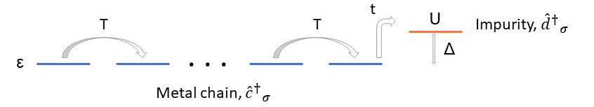
Hamiltonian ${\hat{H}}_{chain }$represents the chain by a one-electron Hamiltonian parametrized by a hopping between sites T and an on-site energy $ε$ for each site. This last term characterizes the Fermi energy of the metal. For simplicity, we shall consider it equal to zero so that the energy distance between the impurity level and metal will be determined by variable ∆. Hamiltonian ${\hat{H}}_{int }$describes the interaction of the impurity level with the chain. It is represented by a hopping t between the impurity level and the first site of the chain, as illustrated in Figure S19.

Figure S19 | Scheme of the singly impurity Anderson model. It is depicted the coupling between the metal, represented by a linear chain, and the impurity level with an on-site repulsion U at energy Δ respect to the chain.

Next, we perform a parametric study of this model to account for the different regimes solving in each situation the total Hamiltonian by exact diagonalization. For the sake of simplicity, we will consider a fixed inter-site hopping T = 0.2 eV. This value has shown to be good enough to describe a metallic behavior for the finite chain.

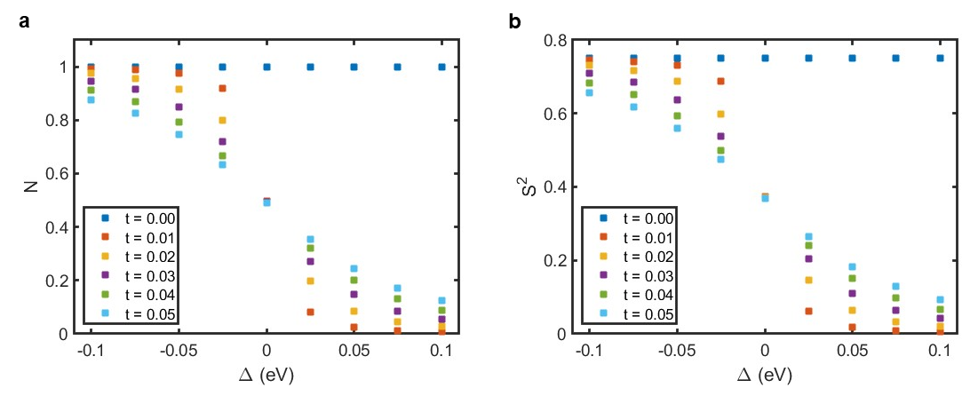
Figure S20 displays a variation of the occupancy (N) and the net spin (S²) of the impurity level for its different alignments with respect to the Fermi level of the metallic chain. We varied the parameter ∆ in the range of -100 meV to 100 meV, mimicking the movement of the impurity level across the Fermi level. Over this range, we see how different couplings affect the population of the impurity as well as its spin value and how they are perfectly correlated. For t = 0.00, as was expected, there is only one electron at the impurity level, and the spin value corresponds to a pure radical duplet state (S² = 0.75). Switching on the interaction t, the population starts to change. When the impurity level is below the Fermi energy, the mixing increases with the coupling t, and it becomes stronger the closer the impurity level approaches the Fermi level of the metallic surface, i.e. ∆ → 0. Also, a change in t is much more significant close to the limit ∆ = 0 rather than far from the Fermi level. Once the impurity level is pinned near the Fermi level, charge fluctuations in/out of the metal keep half occupancy in the impurity, promoting the mixed valence regime. Finally, moving towards positive values ∆, at some point, we can recover the spin as a good quantum number again, even despite relatively large interaction t. However, in this case, S² = 0 and N = 0, i.e., the impurity discharges.
Figure S20 | Variation of occupancy and net spin of the impurity level. Number of electrons, a, and spin value b, in the molecule level as function of ∆ for different couplings t and U = 2.5 eV.

Since the in-gap soliton state observed in the experiment appears near the Fermi level, we computed the DOS for the complete system chain plus an impurity. Figures S21a-c display calculated DOS for small negative values ∆ approaching the Fermi level and a weak hybridization t = 0.03eV. Despite the weak coupling t, we observe the emergence of the mixed-valence regime accompanied by the charge transfer (N<1) and loss of radical character (S² < 0.75) of the soliton state when it approaches the Fermi level. Figures S21d-f show the effect keeping constant a small negative value of ∆ and increasing the coupling t, which causes a stronger hybridization of the soliton state with the substrate. Figure S21b represents a situation very similar to what is observed in the experiment, with the impurity spin already lost.
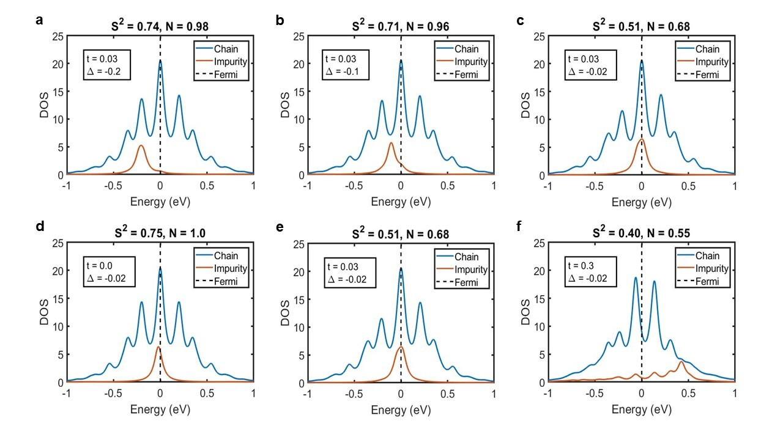
Figure S21 | Calculated Density of States of the impurity model for different alignments to the Fermi energy and interaction with the surface. Panels a-c display the calculated density of states (DOS) for different alignments ∆ of the impurity level to the Fermi level (vertical dashed line) for constant coupling t = 0.03 eV between the soliton state and substrate as well as the occupancy (N) and the expected spin value (S²) for the soliton state. The calculations demonstrate that approaching the soliton state close to the Fermi level causes the formation of the mixed-valence regime, accompanied by the charge transfer (N<1) and loss of radical character of the soliton state (S²<<0.75). Panels d-f display how DOS and values N and S² change with increasing coupling t between the soliton state and substrate for the alignment ∆ = - 0.02 eV of the soliton case to the Fermi level(see panel c). We observe that increasing coupling t mixes the soliton state with the electronic states of the substrate accompanied by the broadening of the soliton state (orange line) and charge transfer. Consequently, the radical character of the soliton state is quenched.

15. Spatial distribution of soliton in odd-membered polymers 3o.
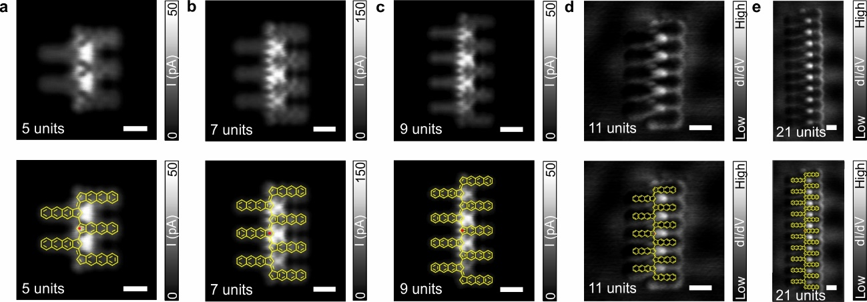
Figure S22 | Spatial distribution of soliton in odd-membered polymers 3o. a-c, High-resolution constant-height STM images of selected odd-membered polymers 3o obtained using a CO-functionalized tip. Scanning parameters: V_{b} = 5 mV; I_{t} = 50 pA; with z_{offset} = 200 pm, 150 pm, 180 pm, for a-c, respectively. d-e, dI/dV maps acquired near Fermi for 11-membered polymer (V_{b} = -50 mV, I_{t} = 50 pA, V_{rms}= 20 mV) and a 21-membered polymer (V_{b} = -80 mV, I_{t} = 70 pA, V_{rms}= 20 mV), respectively. Scale bars = 0.5 nm. In the bottom panels we have superimposed the chemical sketch of the different polymers.

16. Soliton delocalization

Here we discuss the localization of the soliton along the backbone chain for distinct archetype polymers. We compare the soliton localization, including the seminal polyacetylene polymer as well as and different derivatives of bi(acenoindenylidene) polymers with increasing monomer size, as indicated in Figure S23. In particular, we are interested in the dependence of the soliton delocalization as a function of the intrinsic band gap of the infinite polymers.
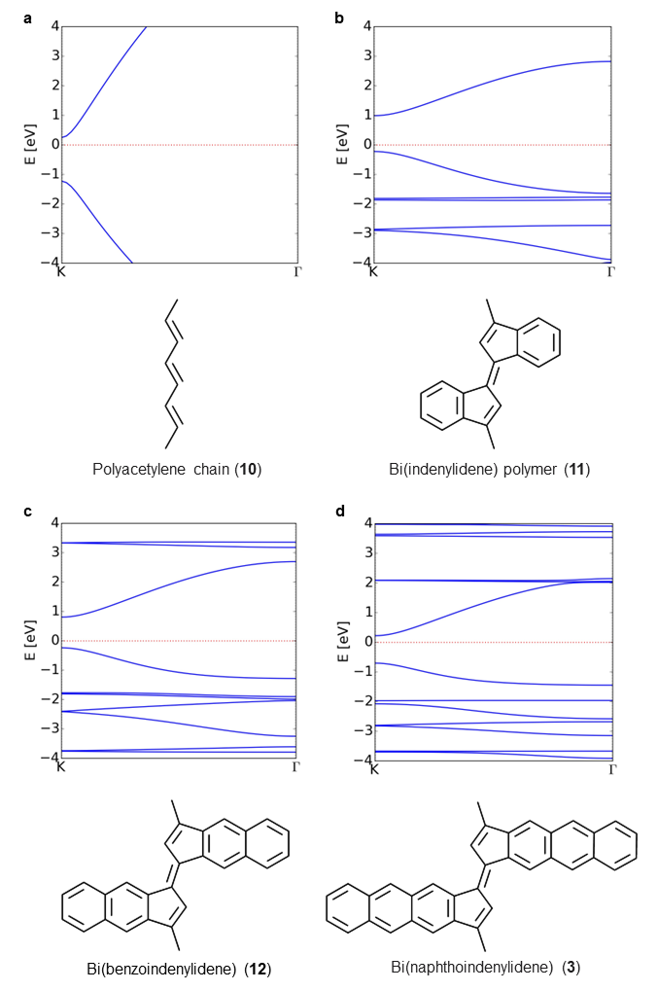

Figure S23 | Band structures of polymers featuring polyacetylene longitudinal backbones. a, Polyacetylene chain (10) (E_{g}=1.47 eV); b, Indenylidene polymer (11) (E_{g}=1.21 eV); c, Benzoindenylidene polymer (12) (E_{g}=1.04 eV); d, Naphthoindenylidene polymer (3) (E_{g}=0.92 eV). Systems depicted in b-d, represent the unit cell as two monomers in “opposition”, while in a, 4 units cells are plot.
Figure S23 displays the band structure of the selected polymers obtained from DFT calculations using PBE0 XC-functional⁷. We observe that polyacetylene features the largest band gap of 1.47 eV, while for cyclopentene-based polymers, the band gap decreases with an increasing number of attached benzene units until 0.92 eV in the last case. As shown in reference ⁸ this gap directly defines the delocalization length of the soliton formed in the finite odd-membered polymers.
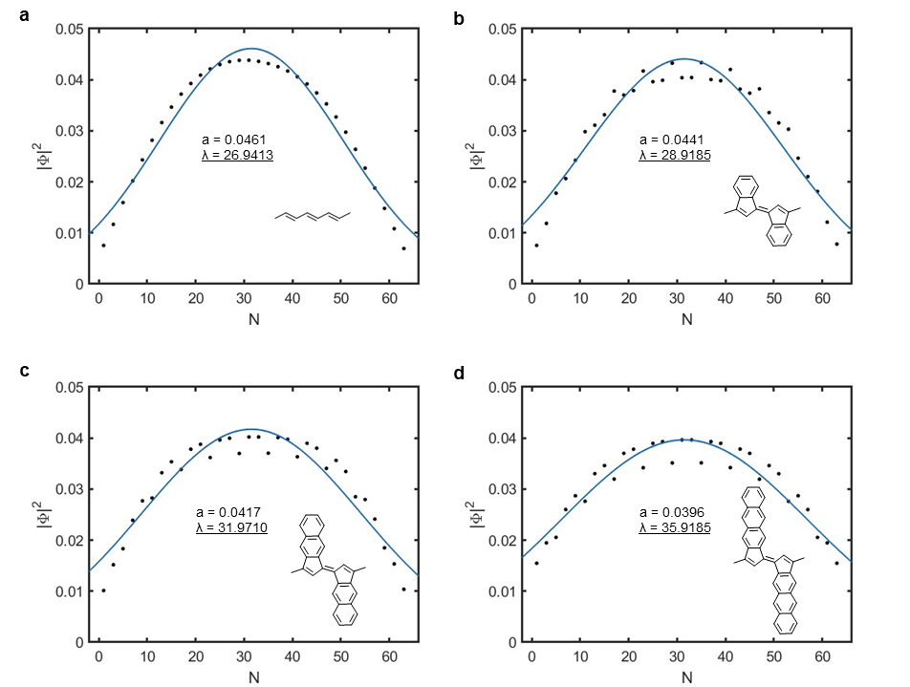
Figure S24 | Decay length of the soliton state for different polymers of increasing monomer size. The polymers consist of 63 carbon atoms in the backbone skeleton for a, Polyacetylene (10); b, Polymer 11; c, Polymer 12; d, Polymer 3. Black dots represent values of square wave-function at carbon atoms. Blue line displays the optimal Gaussian fit. The optimal parameters are listed in the graph. The wavefunctions were normalized on the backbone and are localized in the carbon atoms.

Figure S24 illustrates the soliton localization of different polymers under the study consisting of the same number of backbone atoms. To compare directly the soliton localization, we fitted the squared value of the soliton wavefunction to a Gaussian function of the form $f\left(x\right)=a exp⁡\left({\left(\frac{x-b}{λ}\right)}^{2}\right)$ , where the parameter λ represents the decay length which describes the delocalization of the soliton, see Figure S24. It is worth to mention that the wavefunctions are localized at the carbon sites. Thus, the length of polymers is given in terms of C-C bond units, as well as the resulting localization length in Figure S25.
Figure S25 illustrates the decay length for the different polymers as a function of the band gap for an infinite system. The graph shows that the magnitude of the band gap is inversely proportional the delocalization length. For large band gaps we observe stronger localization of the soliton state, as predicted by Su et al⁸.
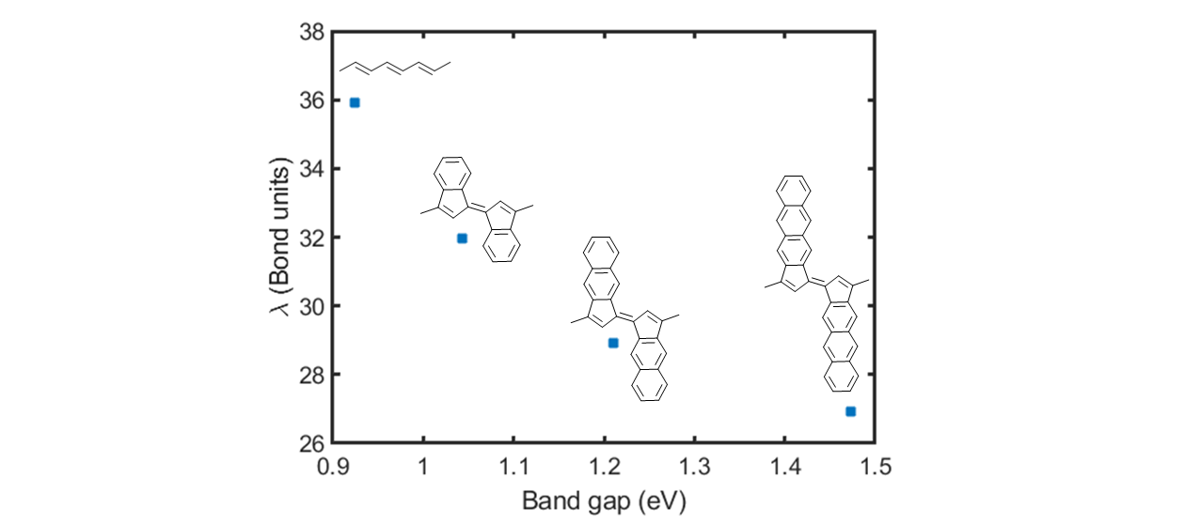
Figure S25 | Decay length of soliton versus energy gap. Graph displaying the decay length of selected polymers shown in Figure S24 as a function of the energy gap in the infinite system for polymers of the same size (63 backbone carbons, i.e. 21 monomers).
17. References
1 Yoshioka, E. & Miyabe, H. Insertion of arynes into the carbon–oxygen double bond of amides and its application into the sequential reactions. Tetrahedron 68, 179-189, (2012).
2 Kelleghan, A. V. et al. Safety Assessment of Benzyne Generation from a Silyl Triflate Precursor. Org. Lett. 22, 1665-1669, (2020).
3 Wan, C. et al. Benzyne Polyfunctionalization via a Tandem C–C σ-Bond Insertion and Photo-Nazarov Cyclization. Org. Lett. 24, 7276-7281, (2022).
4 Verlhac, B. et al. Atomic-scale spin sensing with a single molecule at the apex of a scanning tunneling microscope. Science 366, 623-627, (2019).
5 Perdew, J. P., Burke, K. & Ernzerhof, M. Generalized Gradient Approximation Made Simple. Phys. Rev. Lett. 77, 3865-3868, (1996).
6 Blum, V. et al. Ab initio molecular simulations with numeric atom-centered orbitals. Comput. Phys. Commun. 180, 2175-2196, (2009).
7 Perdew, J. P., Ernzerhof, M. & Burke, K. Rationale for mixing exact exchange with density functional approximations. J. Chem. Phys. 105, 9982-9985, (1996).
8 Su, W. P., Schrieffer, J. R. & Heeger, A. J. Soliton excitations in polyacetylene. Phys. Rev. B 22, 2099-2111, (1980).

