Supplementary Information of Evidence of electron interaction with an unidentified bosonic mode in superconductor CsCa₂Fe₄As₄F₂
Peng Li¹, Sen Liao¹, Zhicheng Wang², Huaxun Li³, Jiakang Zhang¹, Ziyuan Chen¹, Zhicheng Jiang⁴, Zhengtai Liu⁵, Lexian Yang⁶, Linwei Huai¹, Junfeng He^{1,7}, Shengtao Cui⁸, Zhe Sun⁸, Yilin Wang¹, Yajun Yan¹, Guanghan Cao³, Dawei Shen⁸, Juan Jiang^{1†}, Donglai Feng^{1, 8, 9, 10†}

¹Shool of Emerging Technology and Department of Physics, University of Science and Technology of China, Hefei 230026, China
²Key Laboratory of Quantum Materials and Devices of Ministry of Education, School of Physics, Southeast University, Nanjing 211189, China
³School of Physics, Zhejiang University, Hangzhou 310058, China
⁴State Key Laboratory of Functional Materials for Informatics, Shanghai Institute of Microsystem and Information Technology (SIMIT), Chinese Academy of Sciences, Shanghai 200050,
China
⁵Shanghai Synchrotron Radiation Facility, Shanghai Advanced Research Institute, Chinese Academy of Sciences, Shanghai 201210, China
⁶State Key Laboratory of Low Dimensional Quantum Physics, Department of Physics, Tsinghua University, Beijing 100084, China
⁷CAS Key Laboratory of Strongly-coupled Quantum Matter Physics, University of Science and Technology of China, Hefei, Anhui 230026, China
⁸National Synchrotron Radiation Laboratory, School of Nuclear Science and Technology, and New Cornerstone Science Laboratory, University of Science and Technology of China, Hefei, 230026, China
⁹Collaborative Innovation Center of Advanced Microstructures, Nanjing, 210093, China
¹⁰Shanghai Research Center for Quantum Sciences, Shanghai, 201315, China

Supplementary figures

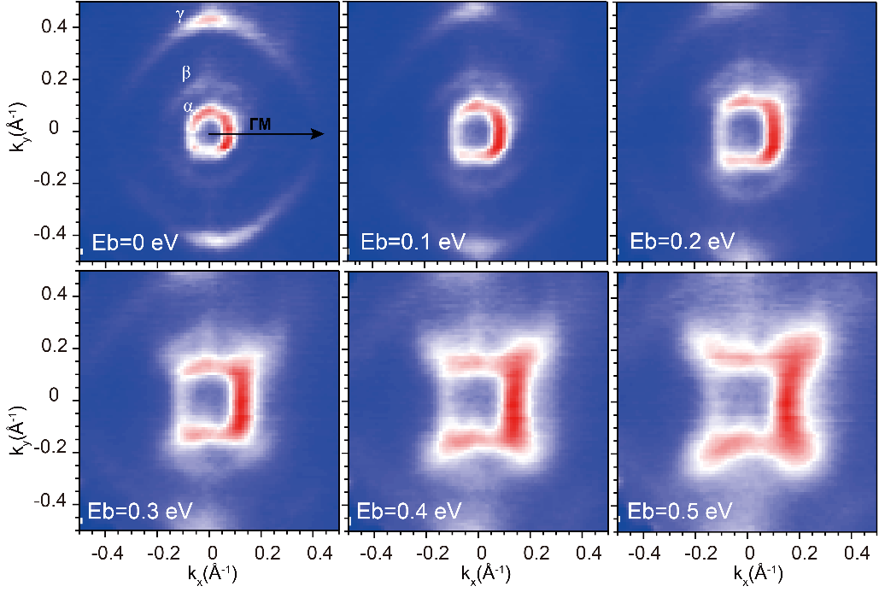
FIG. S1. Fermi surface contours of the hole pockets at several binding energies using photoenergy of 23 eV. The black arrow indicates the $Γ-Μ$ direction. $α$, $β$ and $γ$ are used to identify the three hole pockets. No obvious bilayer-splitting behavior can be resolved which might due to the weak interlayer coupling in this system and the splitting of these bands is beyond our experimental resolution.

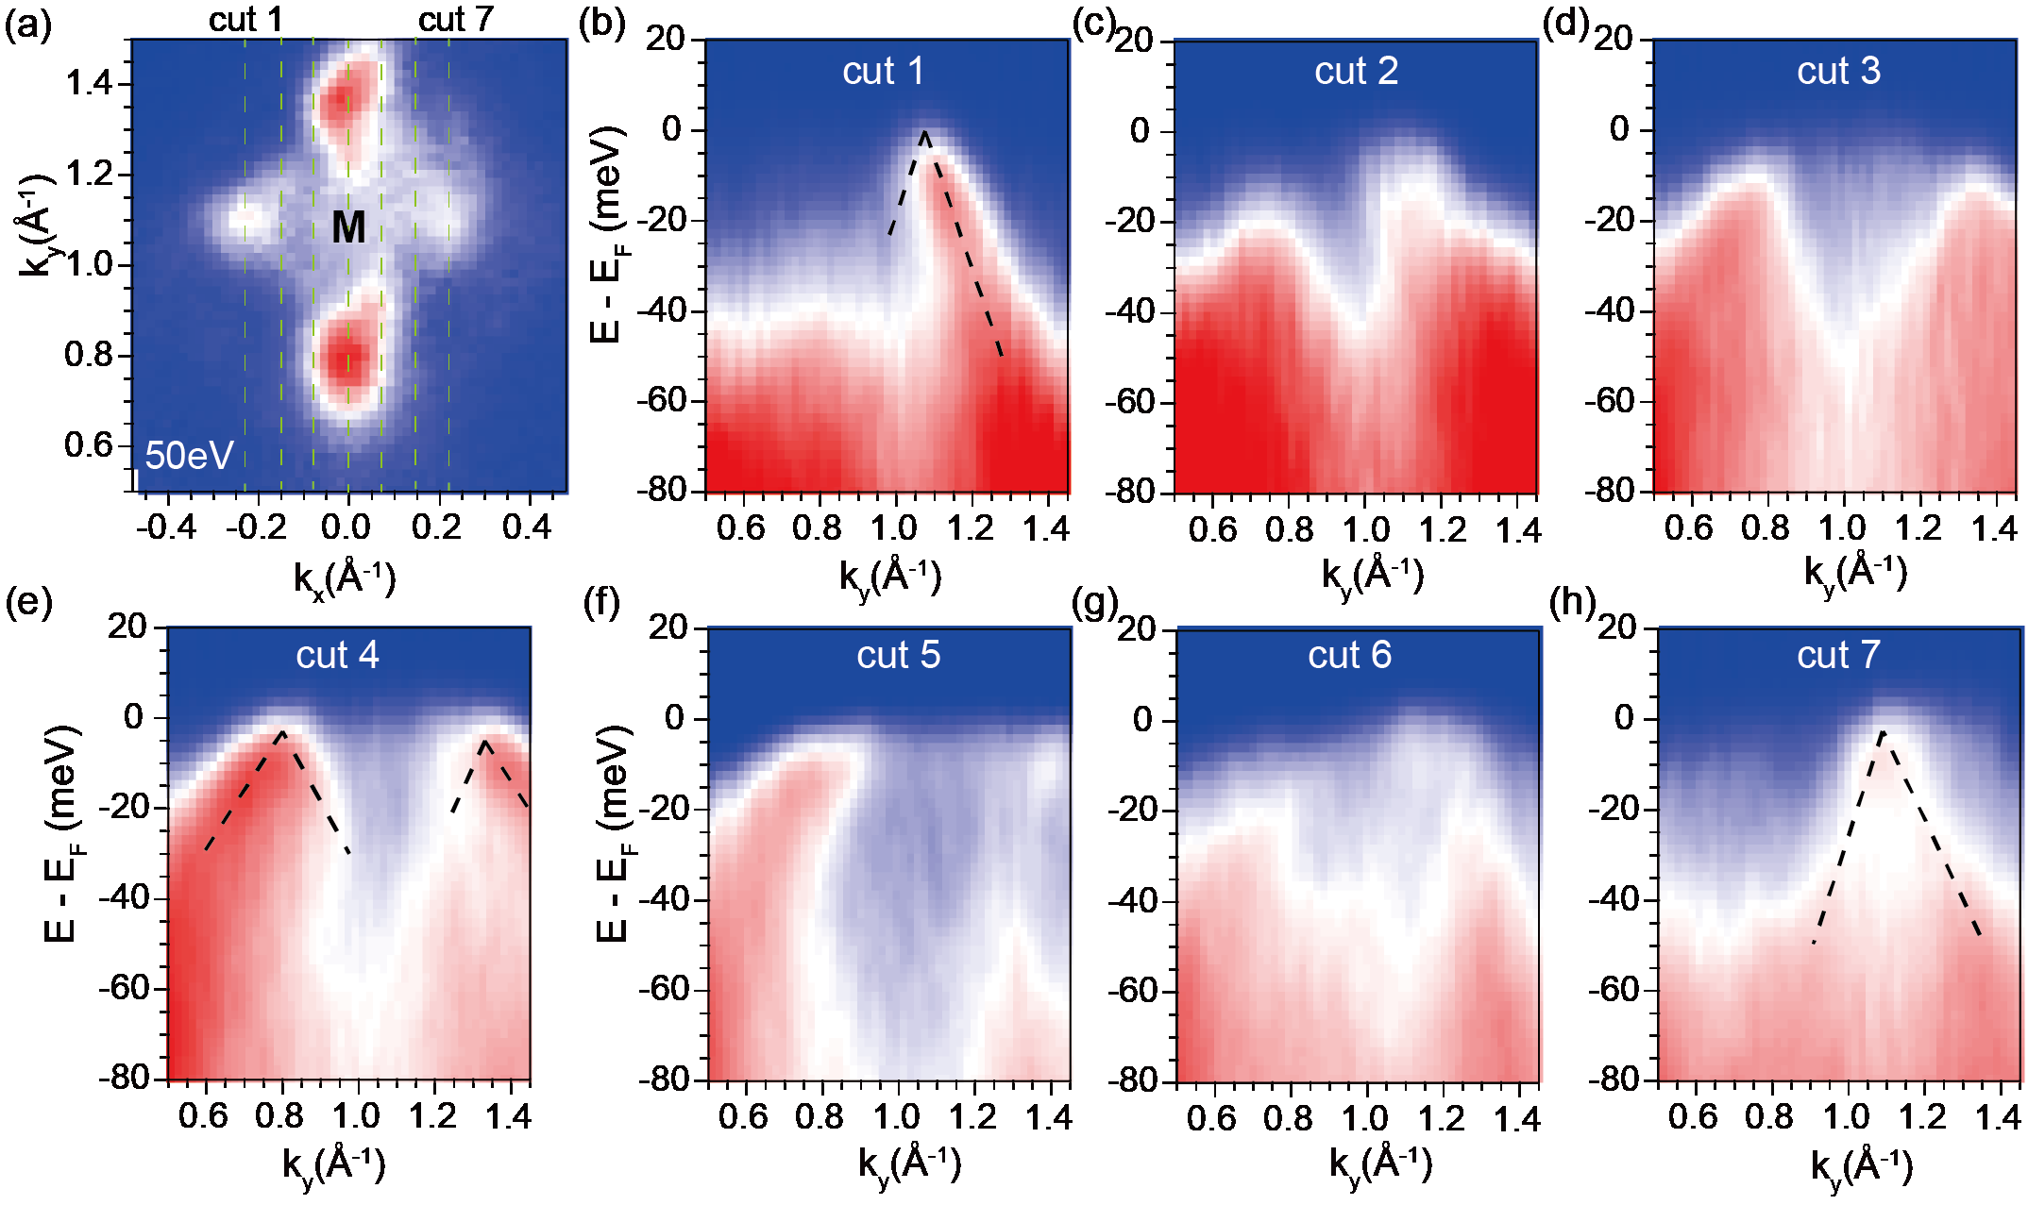
FIG. S2. Band structure around the M point. (a) The Fermi surface map shows four hot spots-like structure near the M point, and there is nearly no pocket at the M point. (b) to (h) Spectra extracted from cut 1 to cut 7, as the green dashed lines in Fermi surface map, indicate hole-like dispersion of the hotspot and nearly no bands at the M point.

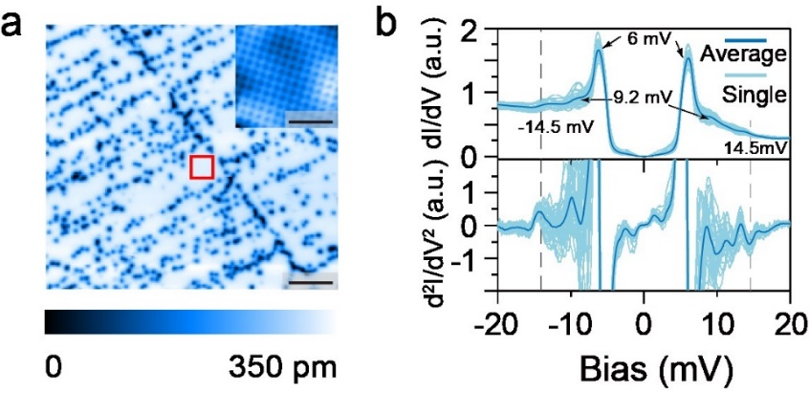
FIG. S3. Surface topography and tunnelling spectrum of CsCa₂Fe₄As₄F₂ with superconducting Nb tip. (a) Typical topographic image on the half Cs-terminated surface (Setpoint: V_{b}=1 V, I=10 pA), the red rectangle indicates the position of inset. Inset shows the atomically resolved image of Cs $\sqrt{2}×\sqrt{2}$ reconstruction (Setpoint: V_{b}=12 mV, I=1 nA). The scale bars for the entire region and inset are 15 nm and 3 nm, respectively. (b) Superconducting spectra and corresponding inelastic spectra for the upper and lower panels, respectively (Setpoint: V_{b}=20 mV, I=500 pA, modulation= 1 mV), the vivid blue curve represents the spatially averaged dI/dV spectra of canal blue curves collected in the region in (a). Two superconducting gaps are resolved at $±$6 mV and $±$9.2 mV here the gap of the tip ( $Δ_{tip}$) is around 1.4 mV, indicating multigap sizes of 4.6 meV and 7.8 meV of the sample. This is slightly different from the 5~6 meV gap resolved by our ARPES measurement. Moreover, a pair of spatially homogenous modes located at $±$14.5 mV (with $Δ_{tip}+Δ_{Sample}$= 6 mV) are marked by the vertical dashed line, which cannot be interpreted by any superconducting gaps, potentially indicating a bosonic mode around 8.5 meV which is consistent with our ARPES result. One could notice that there also exist some other tiny peaks without any symmetry between positive and negative bias which needs to be further clarified.

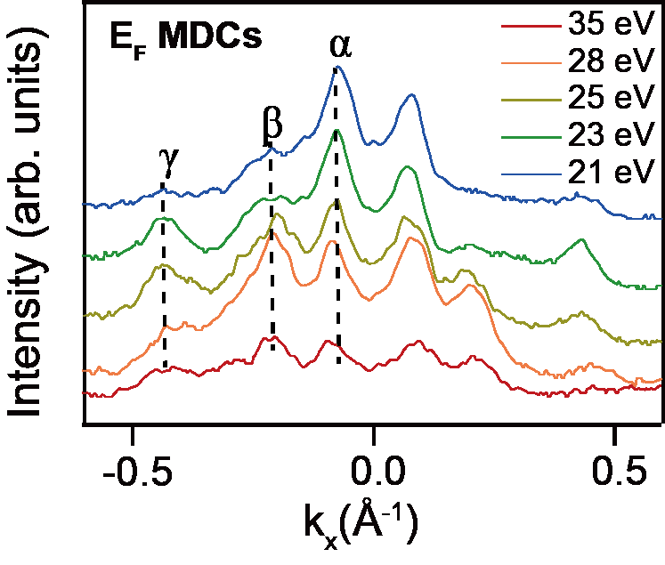
FIG. S4. Quasi-two dimensional electronic structure. Photon energy dependence of the MDCs at the Fermi level along the $Γ-Μ$ direction which reveals the quasi-two dimensional electronic structure of CsCa₂Fe₄As₄F₂. The photoenergy range of 21eV to 35eV is sufficient to traverse the entire Brillouin zone (BZ).
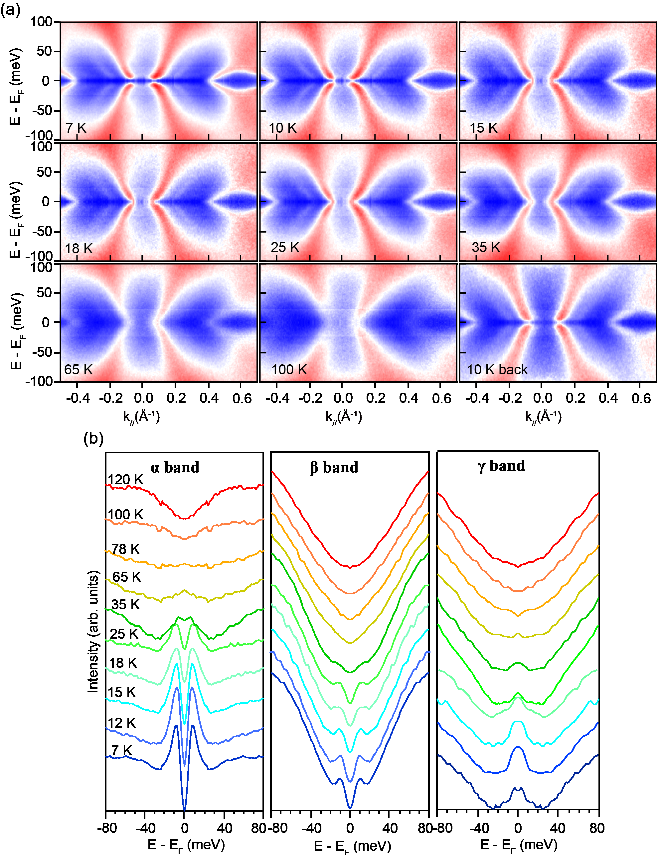
FIG. S5. Temperature evolution of the superconducting gaps in distinct bands using photoenergy of 23 eV. (a) Symmetrized ARPES spectra along the $Γ-Μ$ direction which are thermally cycled above T_{C} and then cooled back to 10 K. (b) The corresponding symmetrized EDCs on the $α$, $β$ and $γ$ bands at various temperatures. The gaps of $α$, and $β$ bands are closed above T_{C}, however, a possible tiny gap of the $γ$ band is beyond our energy resolution.

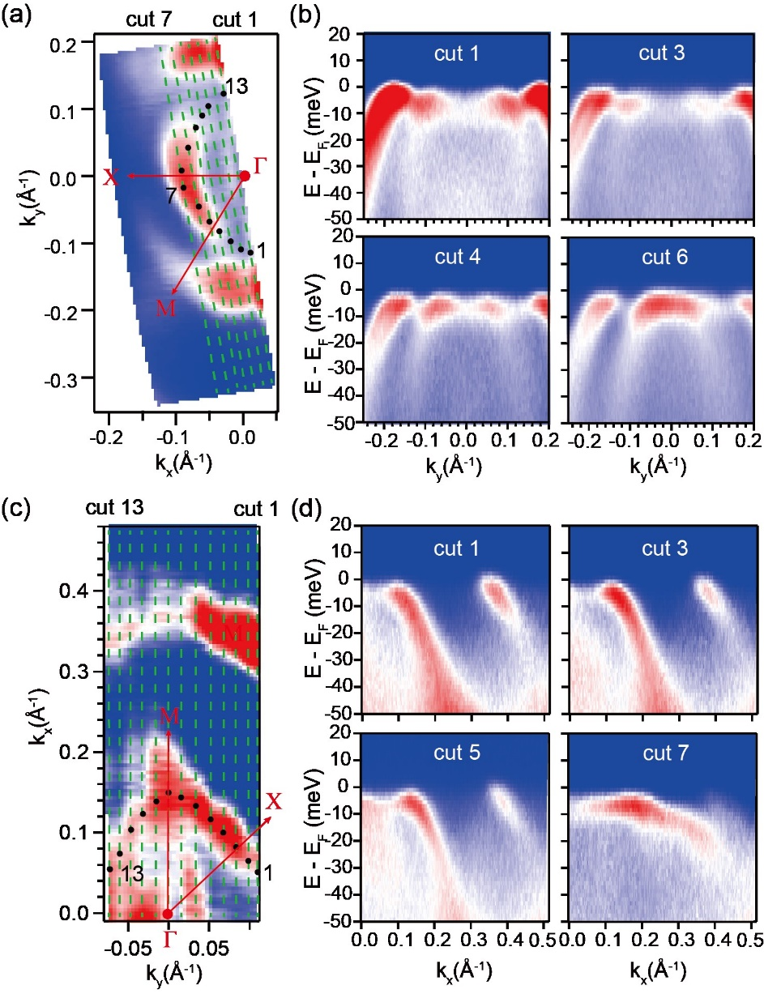
FIG. S6. Fermi surface maps and representative spectra along several cut directions. (a) The Fermi surface map measured at 7K using 7eV laser source, 13 data points are used to identify the in-plane distribution of superconducting gap size in the $α$ band. (b) Several spectra from cuts 1, 3, 4, 6 were presented. The bilayer splitting of the $β$ band is consistent with previous report in KCa₂Fe₄As₄F₂. However, no obvious splitting behavior in the $α$ band has been detected. (c), (d) Similar to (a) and (b), the Fermi surface maps and spectra are focused on the $β$ band. These data points are used to construct Fig. 2 in the main text.

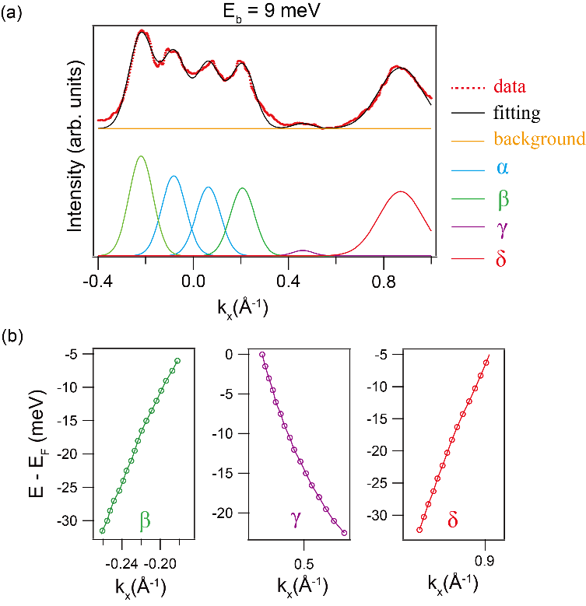
FIG. S7. Fitting MDC of the ARPES spectrum. (a) Multi-peak fittings of MDC at a representative binding energy of 9 meV below Fermi energy. (b) The extracted peak positions of the $β$, $γ$ and $δ$ bands present a smooth behavior, in contrast to that of the $α$ band.

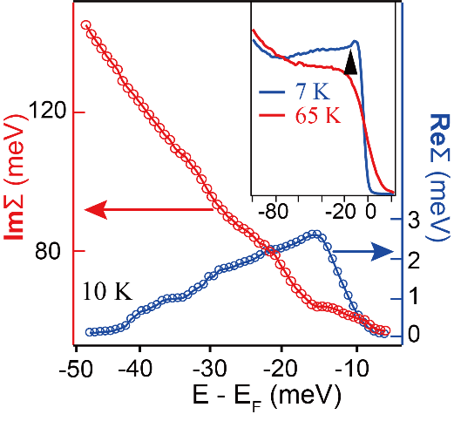
FIG. S8. Self-energy analysis of the $α$ band which shows the kink energy position of 15 meV in both $ReΣ$ and $ImΣ$. The inset plots the comparison of the integrated EDCs of the $α$ band below and above T_{c}, respectively. The solid triangle indicates a dip feature. The integrated EDC of the $α$ band measured at 7 K presents a dip-like structure at 15 meV, which is in sharp contrast to the smooth curve at 65 K.

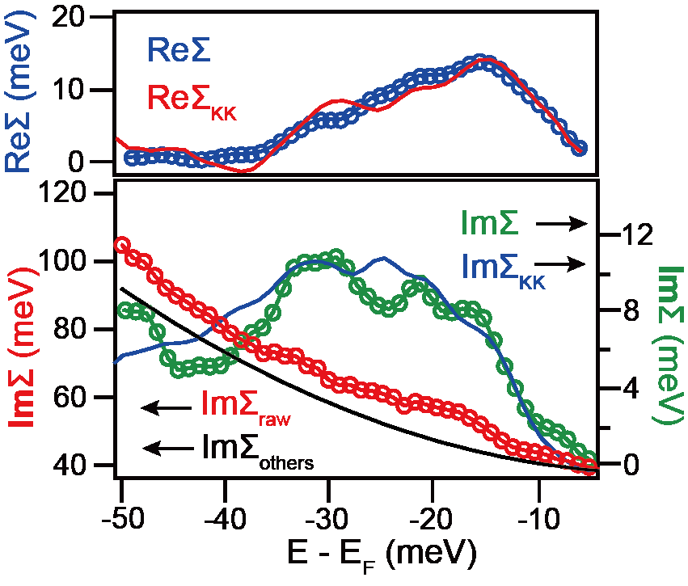
FIG. S9. The KK transformation analysis of the self-energy. The upper panel shows Re∑ and the KK transformation of Im∑ in the lower panel (red curve). The lower panel shows Im∑_{raw} from the FWHM of MDCs peaks (red circles), the background (Im∑_{others}, black curve), Im∑ (Im∑_{raw} - Im∑_{others}) and the KK transformation of Re∑ in the upper panel (blue curve). Both Re∑ and Im∑ match well with each other under the KK transformation, indicating the self-consistency of the extracted self-energies. Re∑ appears a broad feature with the maximum at 15 meV below Fermi level.

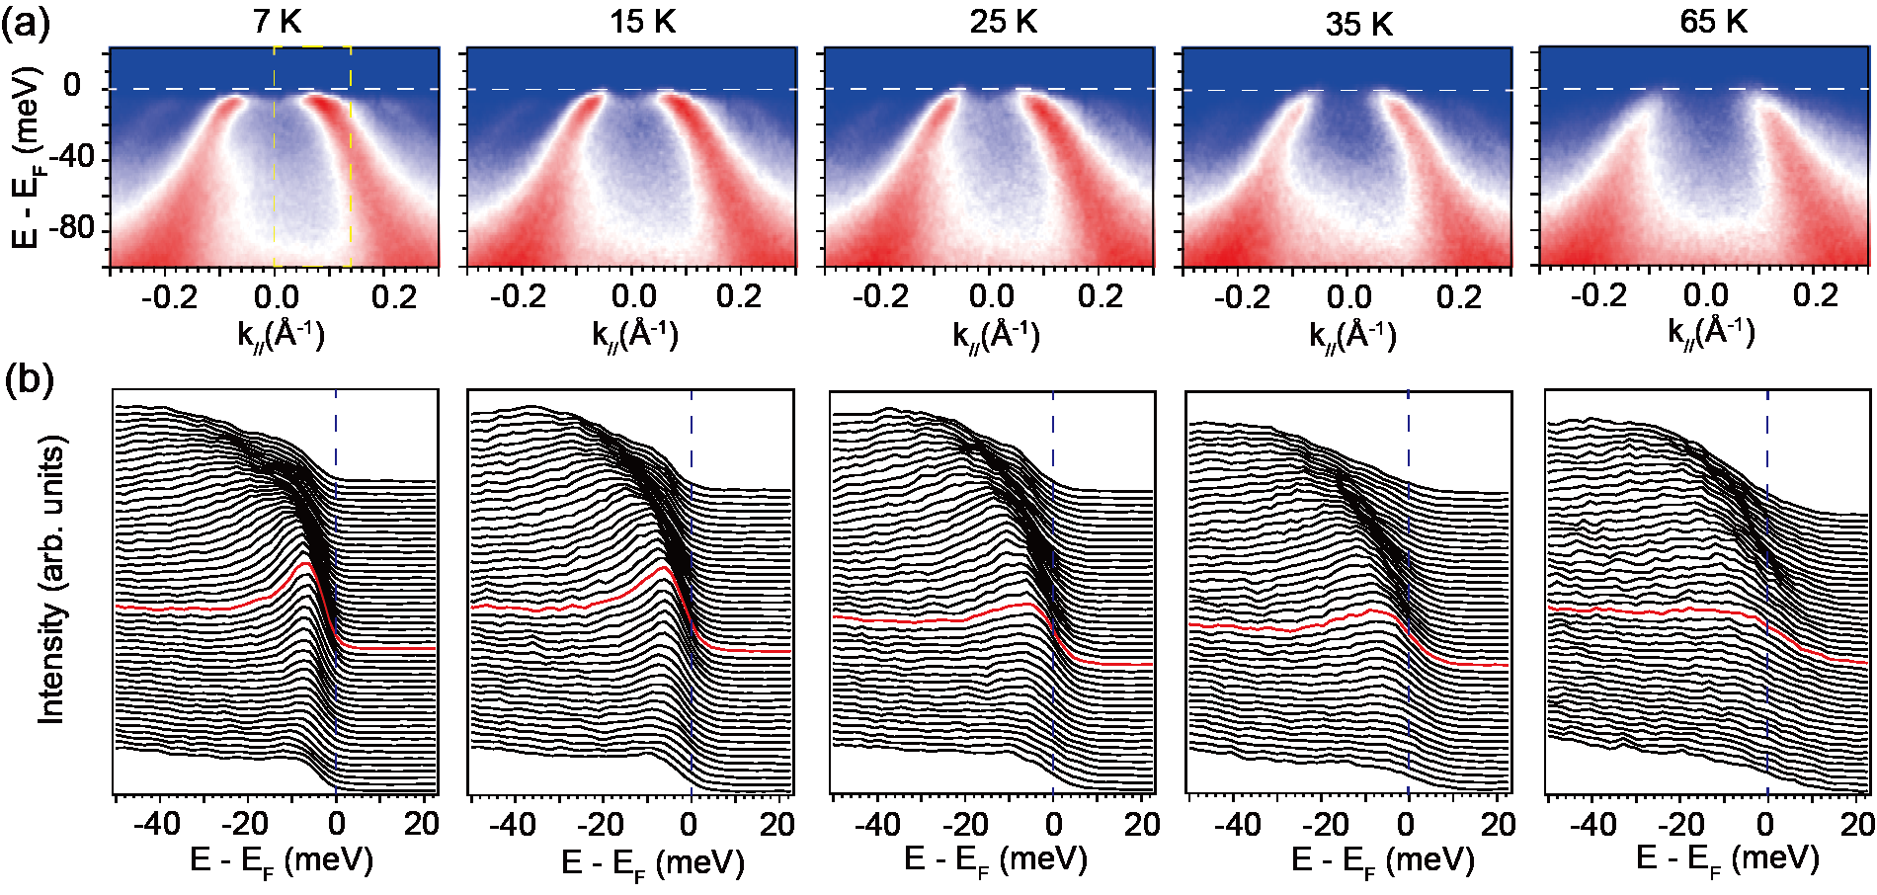
FIG. S10. The temperature evolution of the kink at the $α$ band. The upper part illustrates the raw spectra at several temperatures, where obvious kink structures in the $α$ band can be found below T_{C}. The white dashed lines indicate the Fermi level. The lower part shows the EDCs images extracted from the yellow dashed rectangular region of each the corresponding temperatures. The red curves represent the EDCs at k_{F}. Clear coherence peak is formed below T_{C}.

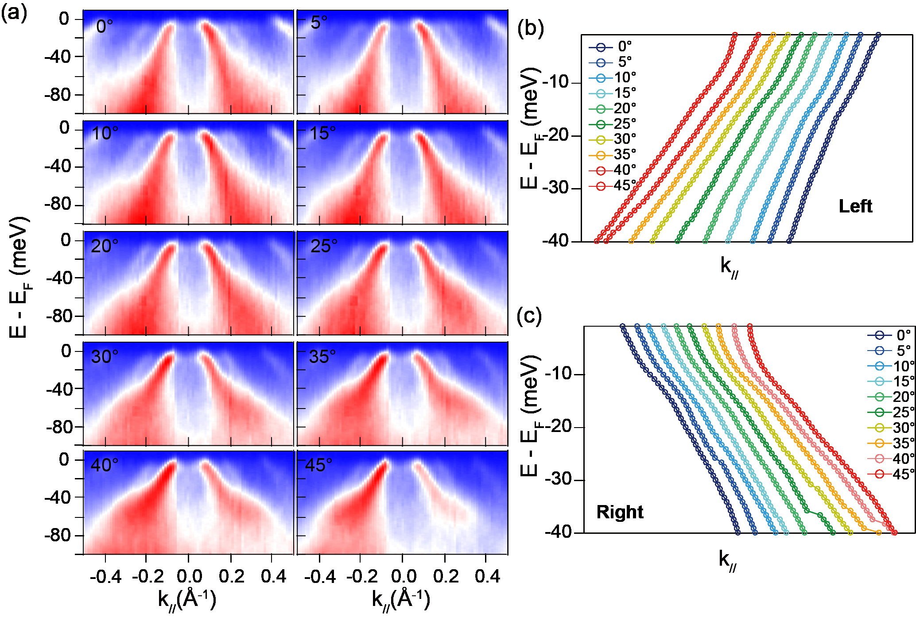
FIG. S11. Band dispersions vary from the $Γ-Μ$ direction ($0^{∘}$) to the $Γ-Χ$ (${45}^{∘}$) direction. (a) The ARPES spectra show kinks at the $α$ band within ${25}^{∘}$ and there is no kink along the $Γ-Χ$ direction. (b) and (c) The extracted MDC peak positions from both the left and right parts of the $α$ band with momentum shifts are presented in the right part, providing further evidence for the distribution of the kink with angles.

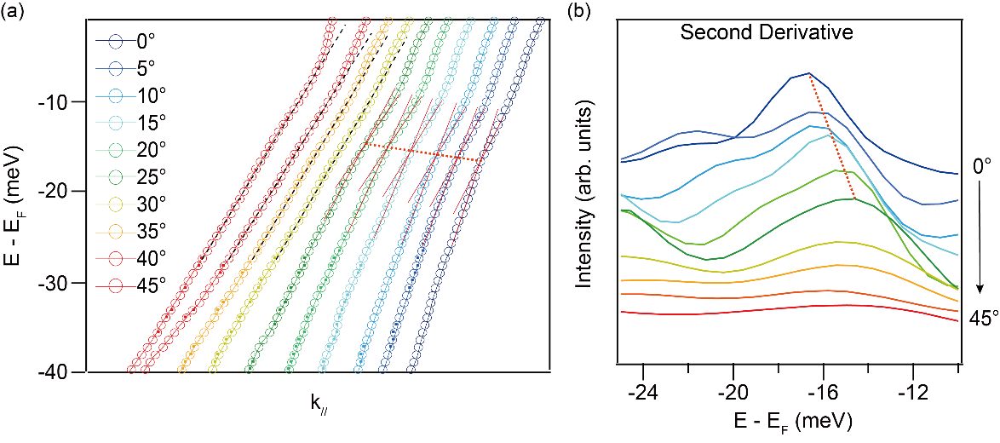
FIG. S12. The analysis of the kink positions of Fig. 4c in the main figure. (a) The enlarged view of the graph of Fig. 4c. The solid red lines crossing indicate the positions of the kinks and the red dashed line is the guide for the evolution of the kinks. (b) Second derivative analysis of the curves in (a). The peaks indicate the kink position and the red dashed line is the guide for the evolution of the kinks.

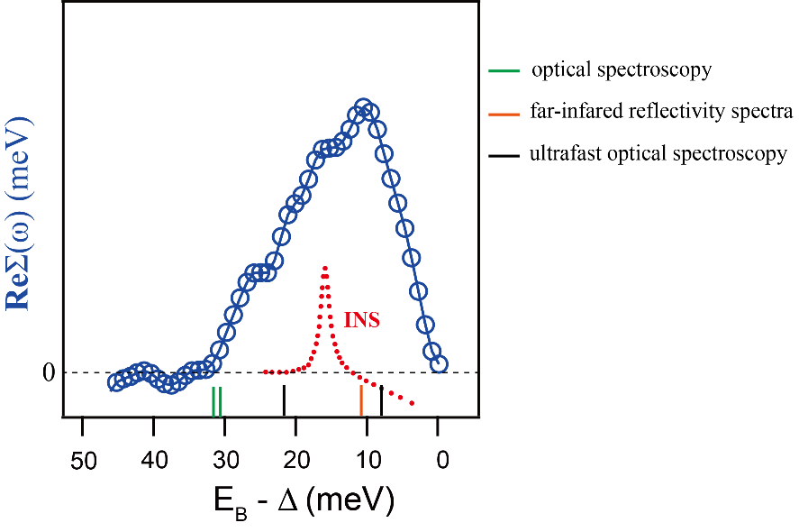
FIG. S13. Real part of self-energy (Re∑) subtracted by the superconducting gap is compared with certain phonon modes detected from other experiments and resonance mode in INS experiment. The INS experiment reported a quite sharp resonance located at around 15 meV. Numerous phonon modes were reported in optical spectroscopy at at 31 meV and 33 meV, far-infrared reflectivity spectroscopy at 11.2 meV and ultrafast optical spectroscopy at 8.1 meV and 22.8 meV.

