Searching Prognostic Hub Genes for the Management of Gliomagenesis through Transcriptome Profiling
Poornimaa Murali¹, Muthu Kumar Thirunavukkarasu², Priyanka Ramesh³, Shanthi Veerappapillai¹ and Ramanathan Karuppasamy¹*
¹Department of Biotechnology, School of Bio Sciences and Technology, Vellore Institute of Technology, Vellore, Tamil Nadu, India.
²School of Sciences and Humanities, SR University, Warangal, Telangana - 506371, India.
³Bioinformatics Core, College of Agriculture, Agriculture research and graduate education, Purdue University, West Lafayette, Indiana, United States 47907
*Corresponding author. Email: kramanathan@vit.ac.in; Phone: 0416-2202625

Supplementary Figures
Figure legends
Fig. S1: The principal component analysis (PCA) plot of samples (mRNAseq_693 dataset) retrieved from the CCGA dataset
Fig. S2: Hierarchical tree clustering between control and different glioma grades
Fig. S3: Box-plot analyses of five hub genes a) TP53 b) SRC c) CDK1 d) UBA52 e) UBB using GEPIA2 server tool. GBM tissues (n = 163) and LGG tissues (n = 518) are represented in blue color and noncancerous tissues present in both GBM and LGG tissues are represented in grey (n = 207); a red asterisk denotes a p-value <0.01
Fig. S4: Top fold enrichment pathways analysis of (a) Biological process (b) Cellular Component (c) Molecular functions and (d) KEGG
Fig. S5: Schematic illustration of (a) mitophagy and (b) cell cycle pathway generated using ShinyGO. The overexpressed genes are highlighted in red color

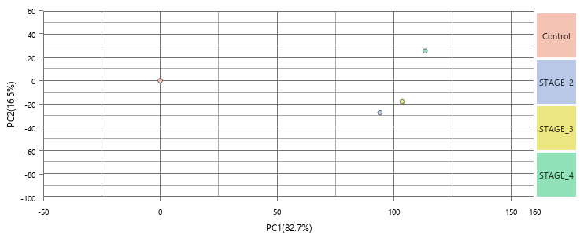
Fig. S1: The principal component analysis (PCA) plot of samples (mRNAseq_693 dataset) retrieved from the CCGA dataset.

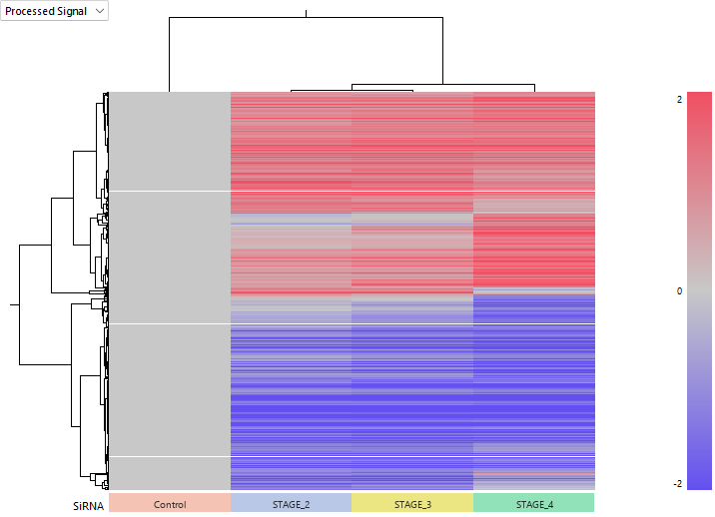

Fig. S2: Hierarchical tree clustering between control and different glioma grades of average samples.

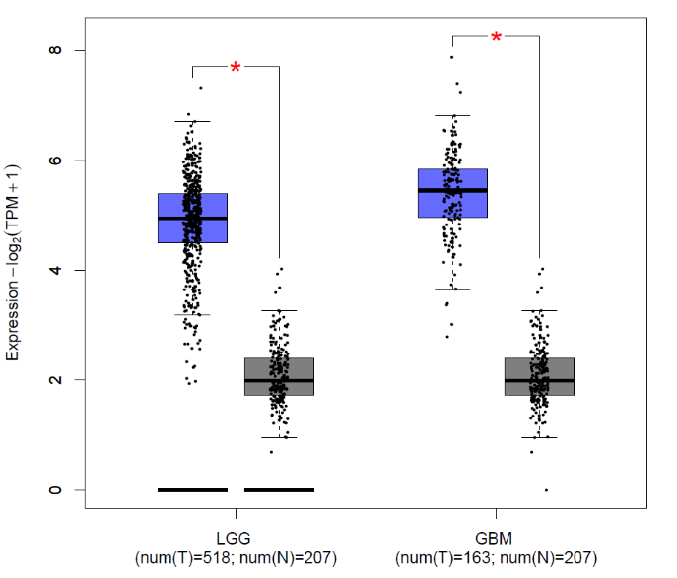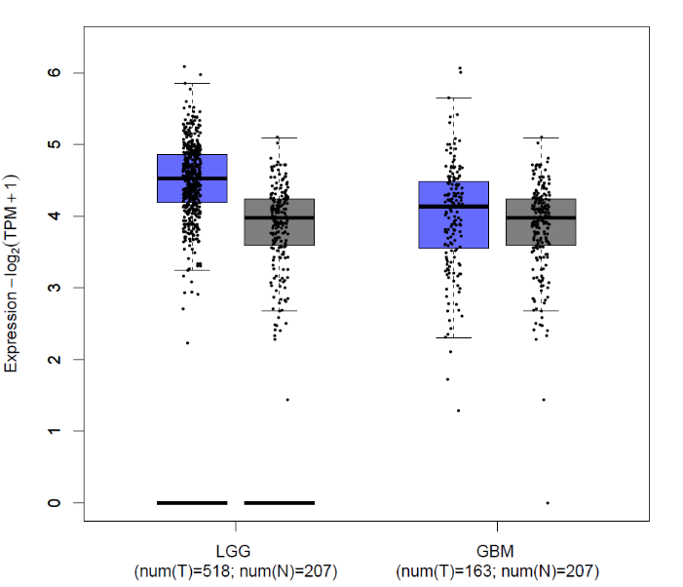
(a) (b)
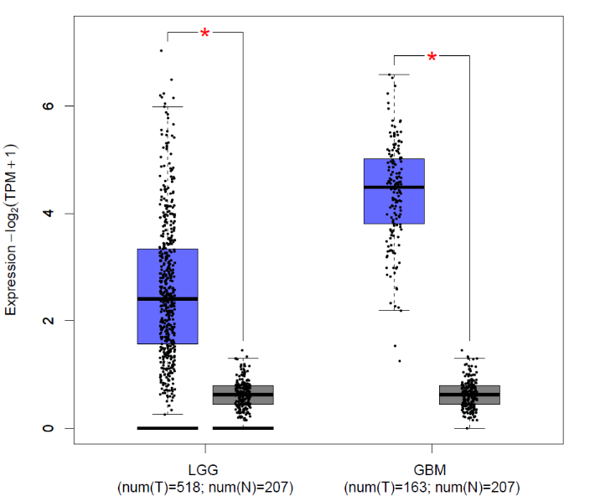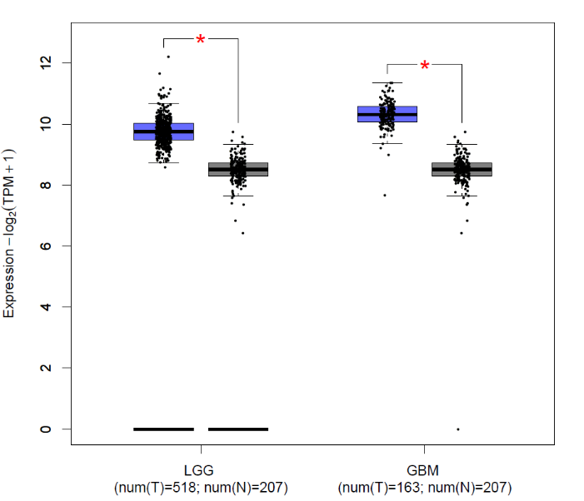
(c) (d)
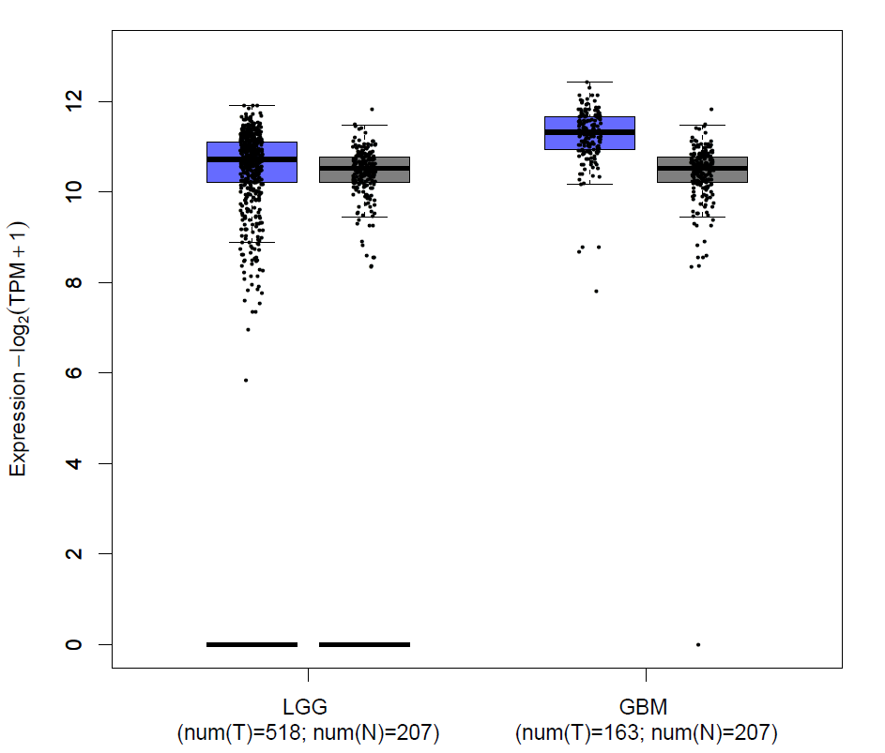
(e)
Fig. S3: Box-plot analyses of five hub genes (a) TP53 (b) SRC (c) CDK1 (d) UBA52 (e) UBB using GEPIA2 server tool. GBM tissues (n = 163) and LGG tissues (n = 518) are represented in blue color and noncancerous tissues present in both GBM and LGG tissues are represented in grey (n = 207); a red asterisk denotes a p-value <0.01.

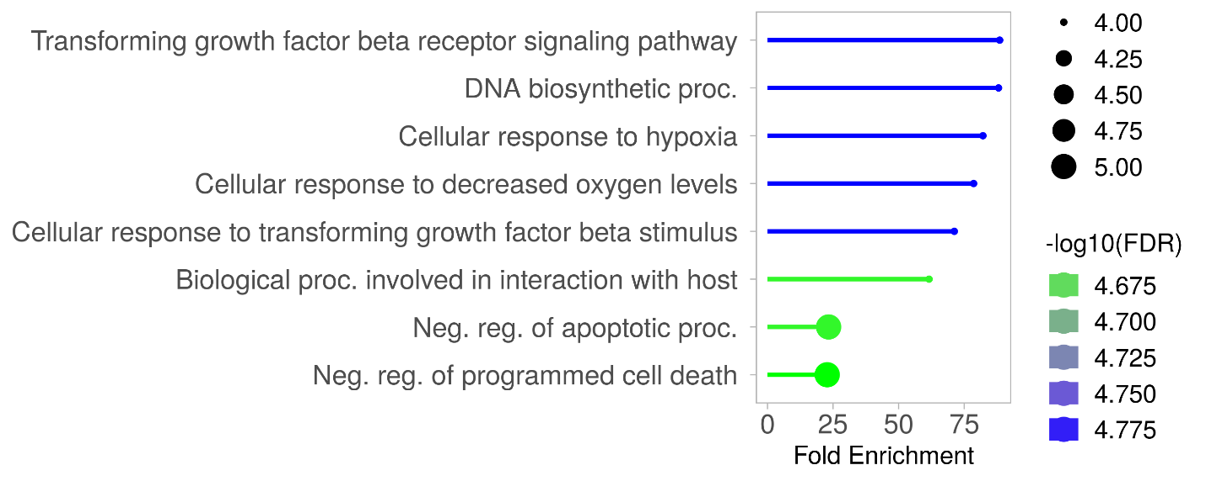
(a)
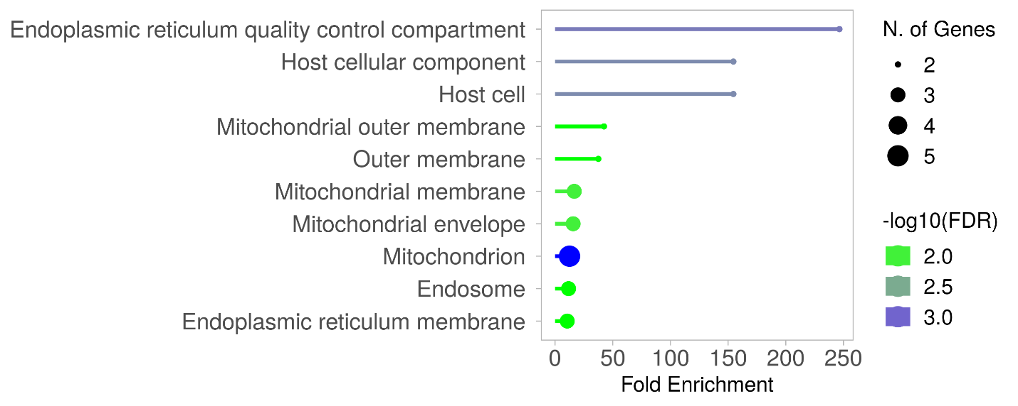
(b)

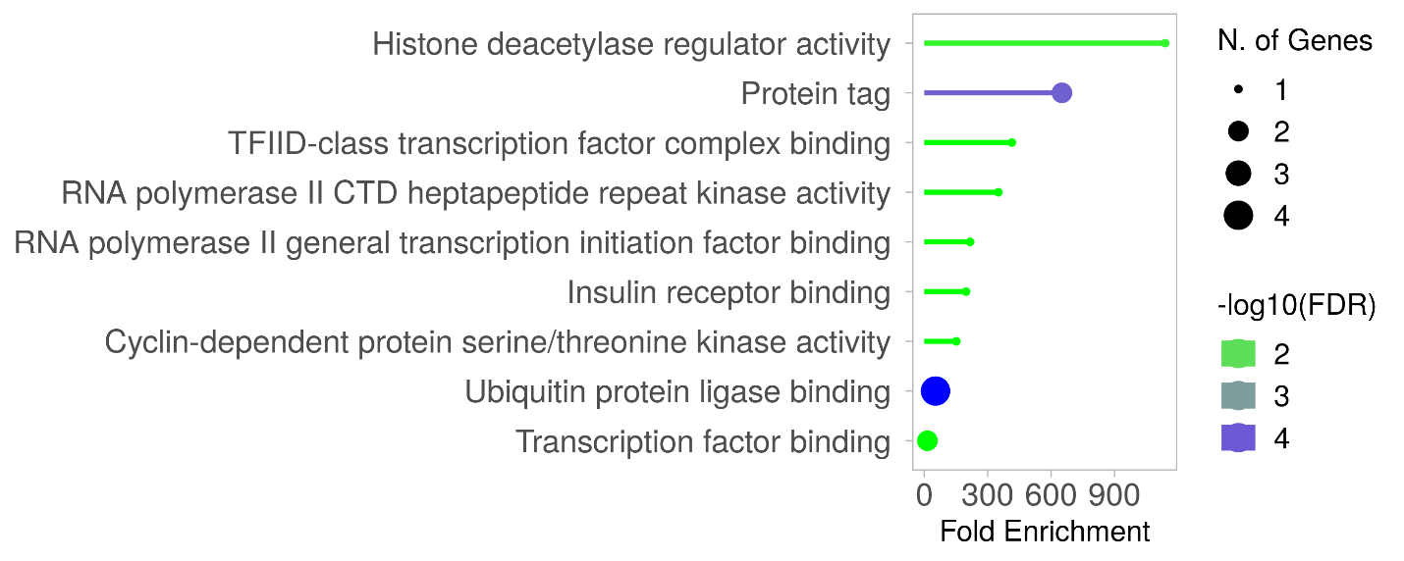
(c)

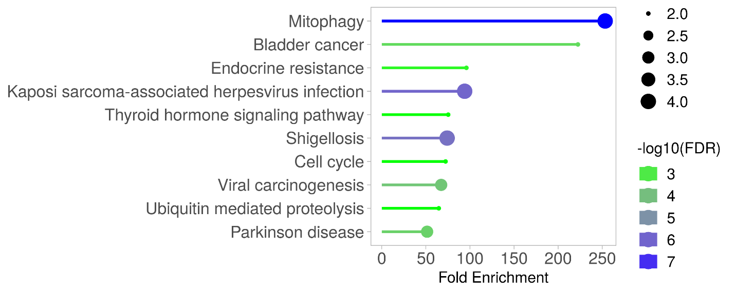
(d)

Fig. S4: Top fold enrichment pathways analysis of (a) Biological process (b) Cellular Component (c) Molecular functions and (d) KEGG

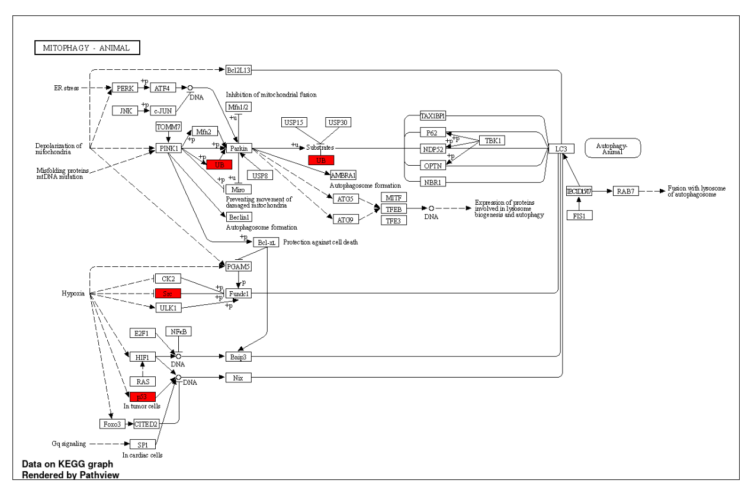

(a)

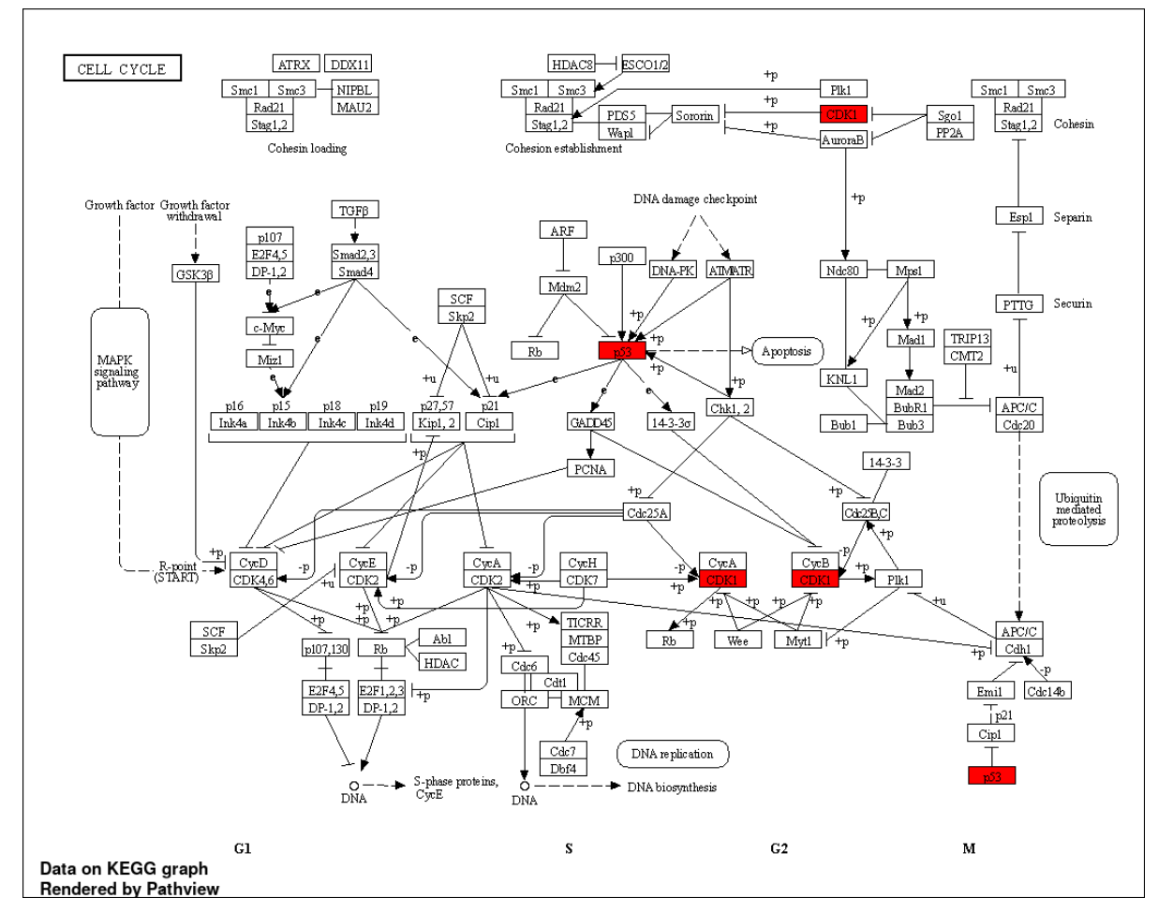
(b)

Fig. S5: Schematic illustration of (a) mitophagy and (b) cell cycle pathway generated using ShinyGo. The lower expressed genes are highlighted in red color.

