Supplementary information. If your article has accompanying supplementary file/s please state so here.
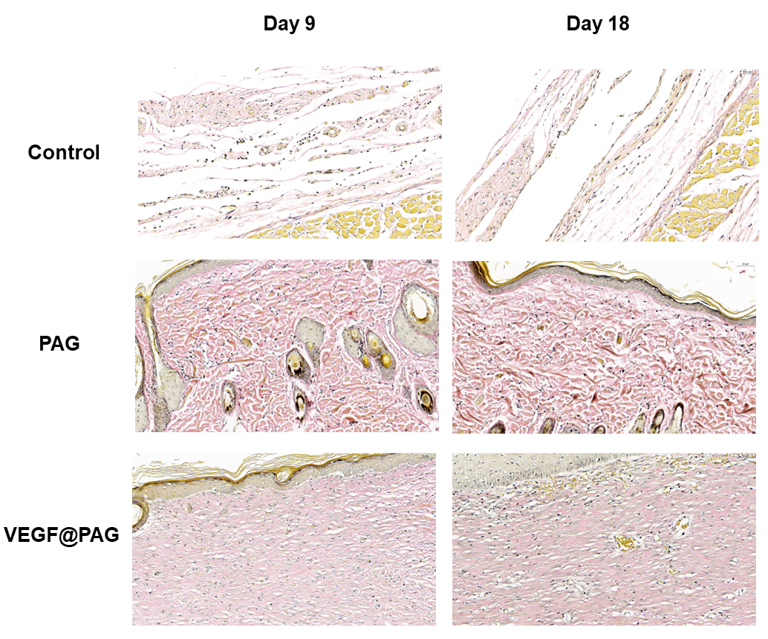
Fig. S1 Representative images of EVG staining of the infected site after postoperative days 9 and 18.
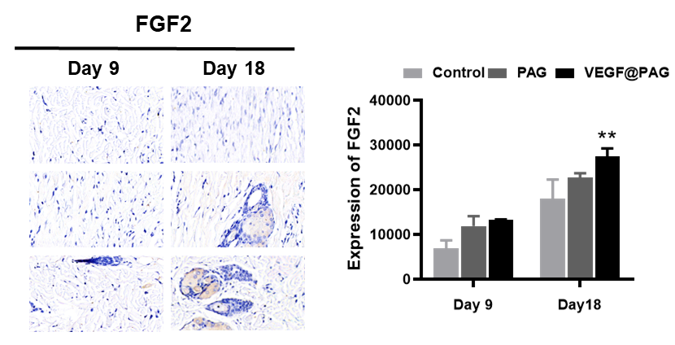
Fig. S2 FGF2 were increased in wound areas with the VEGF@PAG treatment after 9 and 18 days and quantitative analysis.

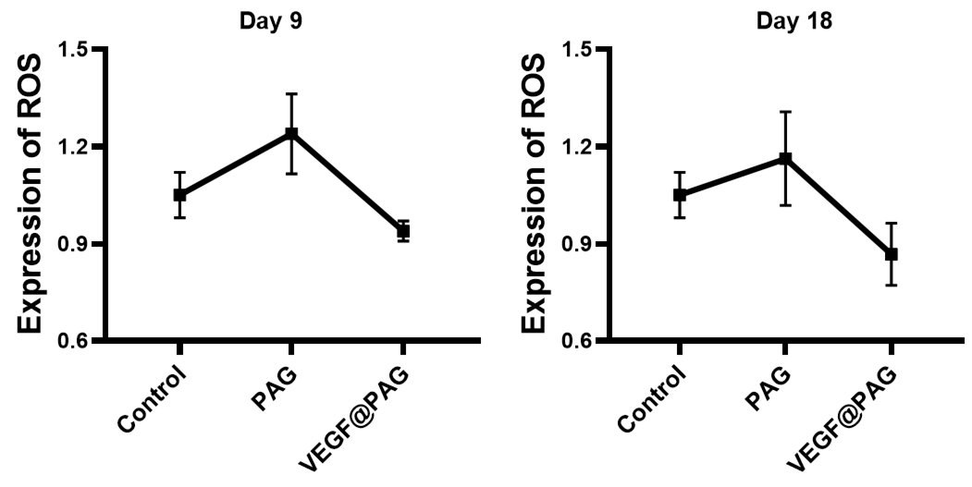
Fig. S3 Changes in the expression of ROS in the wound on the day 9 and 18 of treatment.

