Supplementary Information for
“Electrical De-poling and Re-poling of Relaxor-PbTiO3 Piezoelectric Single Crystals without Heat Treatment”

Hwang-Pill Kim¹, Mao-Hua Zhang², Bo Wang³ , Huaiyu Wu¹, Sunho Moon¹, Zhengze Xu¹,
Yohachi Yamashita^{1,4}, Jong Eun Ryu¹, Jun Liu¹, Shujun Zhang⁵, Long-Qing Chen²
and Xiaoning Jiang^{1*}

¹Department of Mechanical and Aerospace Engineering, North Carolina State University, Raleigh, NC 27695, USA
²Department of Materials Science and Engineering, Pennsylvania State University, State College, PA 16802, USA
³Materials Science Division, Lawrence Livermore National Laboratory, Livermore, CA 94550, USA
⁴Department of Human and Environmental Science, Shonan Institute of Technology, Fujisawa, Kanagawa 251-8511, Japan
⁵Australian Institute for Innovative Materials, Institute for Superconducting and Electronic Materials, North Wollongong, New South Wales, 2500, Australia

* Author to whom correspondence should be addressed: xjiang5@ncsu.edu

De-poling by direct current (DC) electric fields

In case that DC electric fields aligned with the original polarity of the ACP crystals, no depoling was observed (Figure S1) since the domain alignment was reinforced.

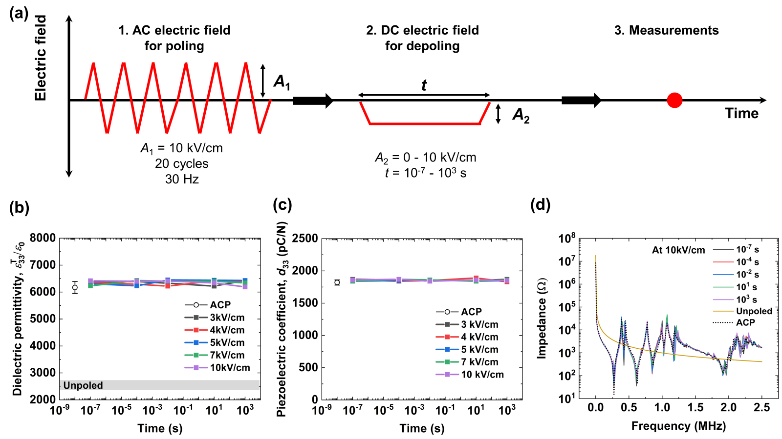

Figure S1. (a) Schematic illustrations of poling and depoling induced by AC and DC electric fields, respectively. Here, the DC electric fields were applied along the same direction of initial polarity of AC-poled crystals. (b) Dielectric permittivity (ε^{T}₃₃/ε₀), (c) piezoelectric coefficient (d₃₃), and (d) impedance spectra of the AC-poled PIN-PMN-PT single crystals under DC electric fields for depoling. The amplitude and duration time of the DC electric fields were controlled to investigate their effects on the poled state in response to external electric fields.

To investigate depoling triggered by external DC electric fields, originally AC- (ACP) and DC-poled (DCP) crystals with saturated properties were also exposed to DC electric fields that are opposite to the original polarity (Figures S2 and S3). We first optimized the properties of AC- and DC-poled crystals, and their optimum properties (AC-poling: ε^{T}₃₃/ε₀ = 6170 ± 220 and d₃₃ = 1820 ± 40 & DC-poling: ε^{T}₃₃/ε₀ = 4630 ± 100 and d₃₃ = 1400 ± 50) are denoted in the figures for better comparisons. When DC electric fields (ranged from 3 kV/cm to 10 kV/cm mimicking the application conditions) for depoling were in the same direction of initial polarity of ACP and DCP crystals, their properties were not changed regardless of the amplitude and duration time of DC electric fields (Figure S1). In the case with DC electric field applied opposite to the original poling direction, crystal properties varied with the DC electric field amplitudes and time duration. Figure S2b and S2c show ε^{T}₃₃/ε₀ and d₃₃ of AC-poled crystals, respectively, after DC electric fields opposite to initial polarity were applied. The poled crystals were partially depoled at certain duration of times, which can be determined by decreases in their properties and variations in impedance measurements. Shortly after the depoled state, the crystals were re-poled with domains along the direction of the applied DC electric fields. It should be noted that depoling at lower amplitudes was initiated when electric fields were applied for longer time. Therefore, more duration time (≥ 10 s) was required for the amplitude of 3 kV/cm, whereas considerably short time (≤ 10⁻² s) was enough to achieve a depoled state at higher electric fields which exceed their E_{c} (4.8 kV/cm, Figure S2). However, when much higher electric fields (≥ 10 kV/cm) were applied for depolarization, it was hard to find a certain depolarized state because repoled states were already induced in a short period of time (< 10⁻⁴ s). Though the relative dielectric permittivity was reduced as unpoled crystals (ε^{T}₃₃/ε₀ = 2550 ± 170), several resonant modes remained (Figure S2d). It means a completely depoled state which occurs over a short period of time cannot be easily generated using DC electric fields. And hence, we only observed the transient depoled state at specific conditions when we applied DC electric fields for depoling. Figures S3b and S3c present ε^{T}₃₃/ε₀ and d₃₃ of DCP crystals, respectively, after DC electric fields opposite to initial polarity were applied. As the E_{c} (6.8 kV/cm) of DCP crystals are larger than the ACP crystals (Figure S3b), depoling tended to be initiated by higher amplitudes of external EC electric fields at the same duration of time. The similar trends in the changes of the properties and impedance spectra were observed in the case of the DCP crystals. However, the conditions for a transient depoled state are different, implying that degrees of the depolarization are highly dependent on initial poling conditions (e.g. ACP or DCP).

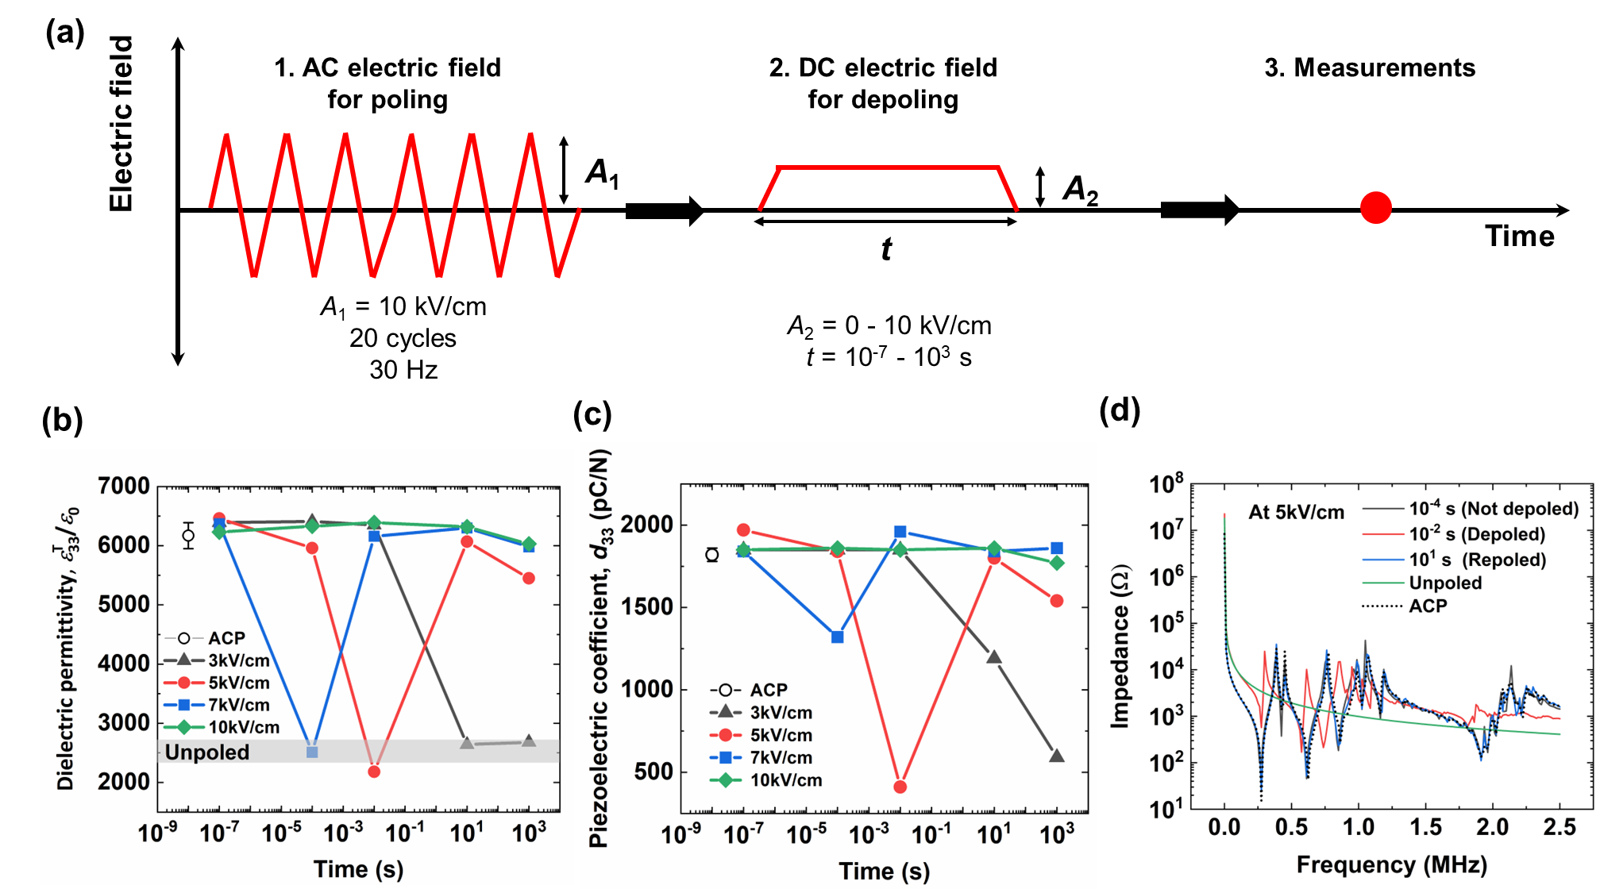

Figure S2. (a) Schematic illustrations of poling and depoling induced by AC and DC electric fields, respectively. (b) relative dielectric permittivity (ε^{T}₃₃/ε₀), (c) piezoelectric coefficient (d₃₃), and (d) impedance spectra of initially AC-poled (ACP) PIN-PMN-PT single crystals under DC electric fields for depoling. The amplitude and duration time of the DC electric fields were controlled to investigate their effects on the poled state in response to external electric fields. Though a transient depoled state can be achieved at certain amplitude and time of the electric field exposure, it is hard to find exact conditions for an almost completely depoled state using DC electric fields because depoling occurs over a very short period of time.
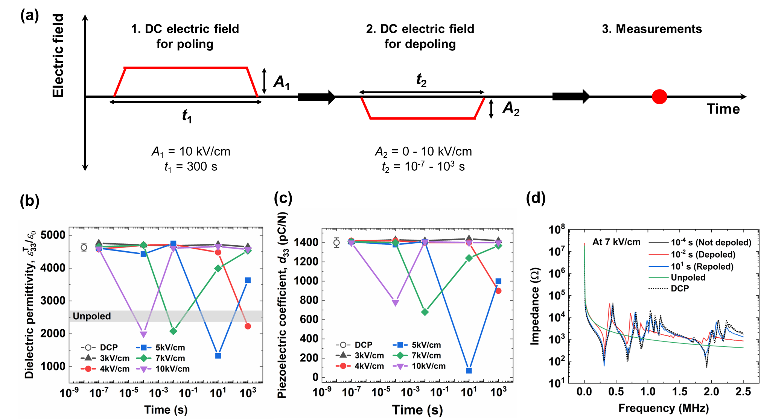

Figure S3. (a) Schematic illustrations of poling and depoling induced both by DC electric fields, (b) relative dielectric permittivity (ε^{T}₃₃/ε₀), (c) piezoelectric coefficient (d₃₃), and (d) impedance spectra of initially DC-poled (DCP) PIN-PMN-PT single crystals under DC electric fields for depoling. The amplitude and duration time of the DC electric fields were controlled to investigate their effects on the poled state in response to external electric fields. Here, we found that conditions for a depoled state are highly dependent on initial poled states; the amplitude and time for the DC (poling) – DC (depoling) case are different from the AC (poling) – DC (depoling) case shown in Figure S2.

Polarization hysteresis loops and electric fields induced current measurements
Polarization hysteresis loops and electric fields induced current measurements were conducted to study the poled and de-poled states (Figures S4, S5).

Figure S4. Polarization hysteresis loops of (a) AC-poled and (b) DC-poled PIN-PMN-PT crystals during 10 successive bi-polar cycles at 1 Hz. Electric field induced current curves of (c) AC-poled and (d) DC-poled PIN-PMN-PT crystals during 10 successive bi-polar cycles at 1 Hz.

Figure S5. (a) Polarization hysteresis loops and (b) electric field induced current curves of AC-poled PIN-PMN-PT crystals during 10 successive bi-polar cycles at 1 Hz. Here, a condition for fully depoled states was used to measure these ferroelectric properties (peak amplitude of 4 kV/cm, 10 cycles and 1 Hz).

Phase field simulation
Material properties used in the simulation are given in Table S1. The simulated domain structures of the unpoled, AC poled and Dc poled crystals are shown in Figure S6. Evolution of the domain structures of an AC-poled crystal sample exposed to an AC electric field with amplitude of ~0.85E_{c} can be found in the video file.
Supplementary Table 1. Material coefficients of PMN-30PT employed for phase-field simulations.

Coefficient | Value | Coefficient | Value
a₁ | (2.295T −935.9) × 10⁵ J mC⁻² | c₁₁ | 1.92 × 10¹⁰ J m⁻³
a₁₁ | (−0.3775T +457.7) × 105 J m⁵C⁻⁴ | c₁₂ | 5.29 × 10¹⁰ J m⁻³
a₁₂ | 6.075 × 10⁷ J m⁵C⁻⁴ | c₄₄ | 7.14 × 10¹⁰ J m⁻³
a₁₁₁ | 2.57 × 10⁷ J m⁹C⁻⁶ | Q₁₁ | 0.084 m⁴C⁻²
a₁₁₂ | 6.95 × 10⁹ J m⁹C⁻⁶ | Q₁₂ | −0.025 m⁴C⁻²
a₁₂₃ | 13.13 × 10⁹ J m⁹C⁻⁶ | Q₄₄ | 0.035 m⁴C⁻²
P | 0.50 Cm⁻² | g₁₁ | 0.1 × 10⁻¹⁰ J m³C⁻²
T_{C} | 408 K | g₁₂ | −0.1 × 10⁻¹⁰ J m³C⁻²
к | 50 | g₄₄ | 0.1 × 10⁻¹⁰ J m³C⁻²

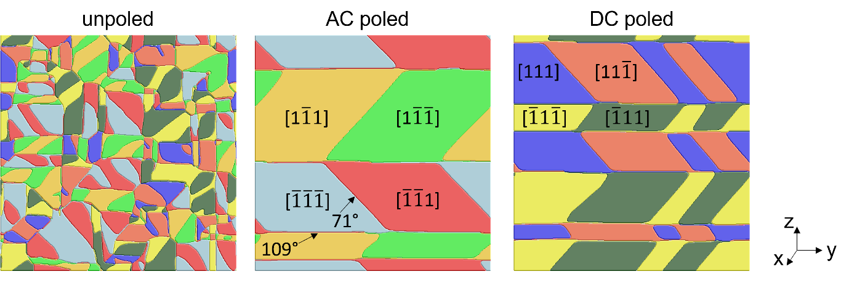
Figure S6. Simulated domain structures of the studied materials in the (a) unpoled state, (b) AC-poled state, and (c) DC-poled state. The 180° domains in the unpoled state are eliminated in the AC-poled and DC-poled samples, resulting in a mixture of 71° and 109° domain walls. The domains with identical polarization vectors have the same colors. The horizontal layers of the poled samples are separated by a set of 109° domain walls parallel to the (001) plane, and within each layer the 71° domain walls are approximately parallel to (011) planes. The AC-poled sample has a significantly lower domain wall density than that of the DC-poled sample.

Demonstration of reversible poling and depoling of PIN-PMN-PT single crystals in device
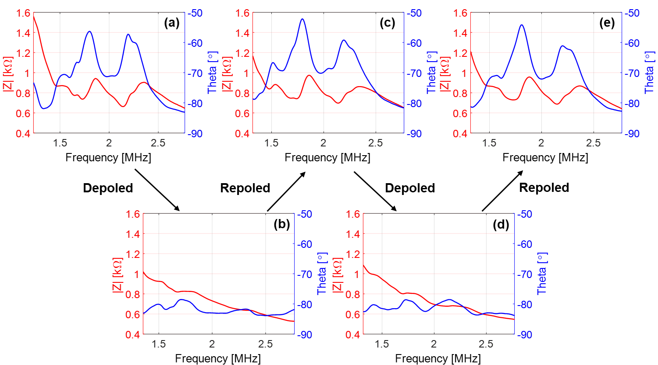

Figure S7. Impedance/phase spectra of the transducer at the different stages of the in-device depoling and repoling processes under AC electric fields: (a) Original status (AC poled), (b) First depoled state, (c) First repoled state, (d) Second depoled state, and (e) Second repoled state. The device showed consistent electrical impedance of 800 Ω @ 2 MHz ((a),(c),(e)). The capacitance varied from 484 pF to 457 pF after the second repoling, which indicates a negligible deviation of 5%. The device also showed negligible resonances at de-poled states ((b)&(d))

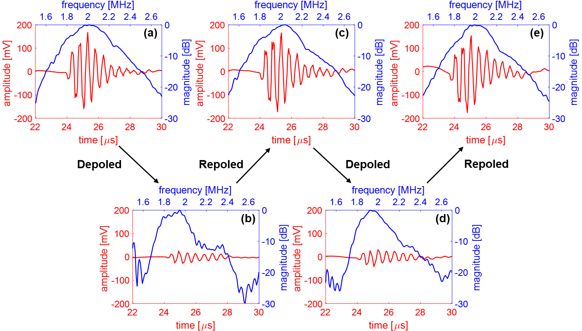
Figure S8. Pulse/echo response at different stages of the in-device depoling and repoling processes under AC electric fields: (a) Original status (AC poled), (b) First depoled state, (c) First repoled state, (d) Second depoled state, and (e) Second repoled state. The device showed a consistent waveform after each re-poling process (a)(c)(e). Compared with the depoled states ((b)(d), averaged 40 mV_{pp}), the re-poled sample showed a significant sensitivity difference ((c) and (e), averaged 361 mVpp). It is noted that after the second repoling, the peak-to-peak value increased from 327 mV to 397 mV, which may be due to the transducer/hydrophone alignment error during the test.

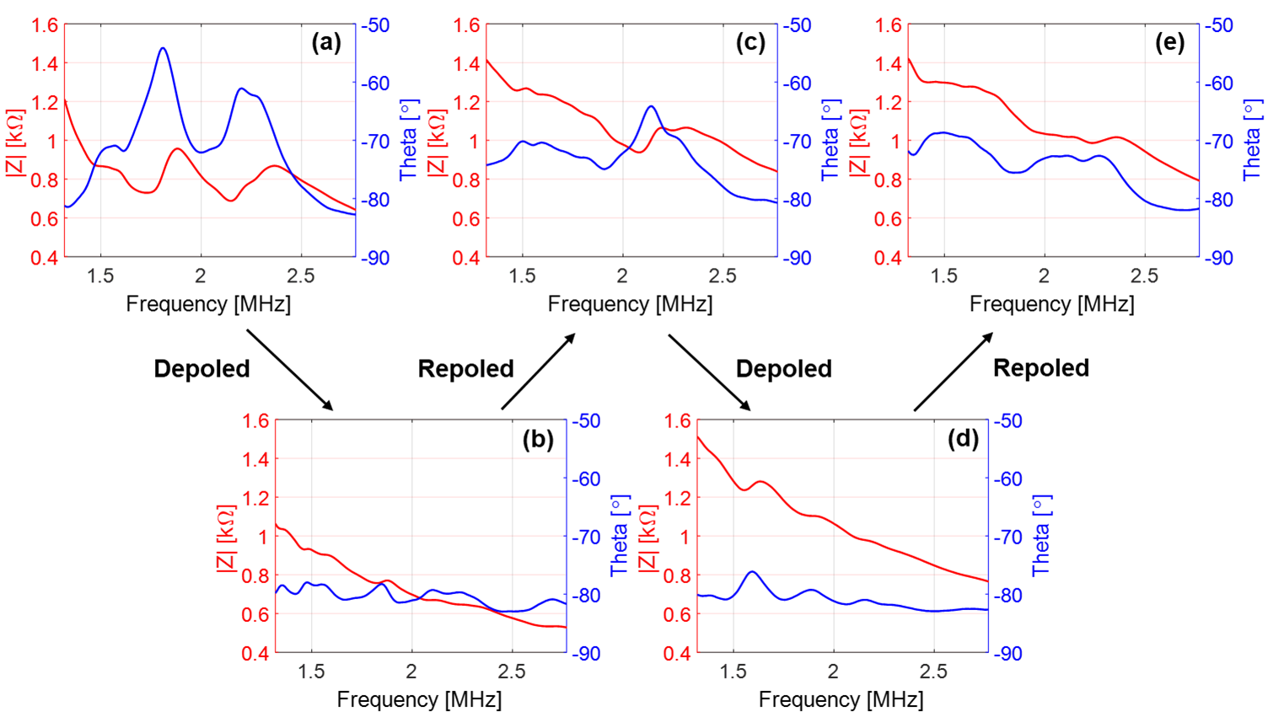

Figure S9. Impedance/phase spectra of the transducer at different stages of in-device depoling and repoling processes under DC electric fields: (a) Original status (DC-poled), (b) First depoling, (c) First repoling, (d) Second depoling, and (e) Second repoling. The re-poled sample (c)(e) showed a significant difference compared with the original results (a). The capacitance dropped dramatically by 49.6% and the dielectric loss increased from 0.2% to 1.9%, indicating the partial failure of the device after DC electric fields induced depoling/repoling processes.

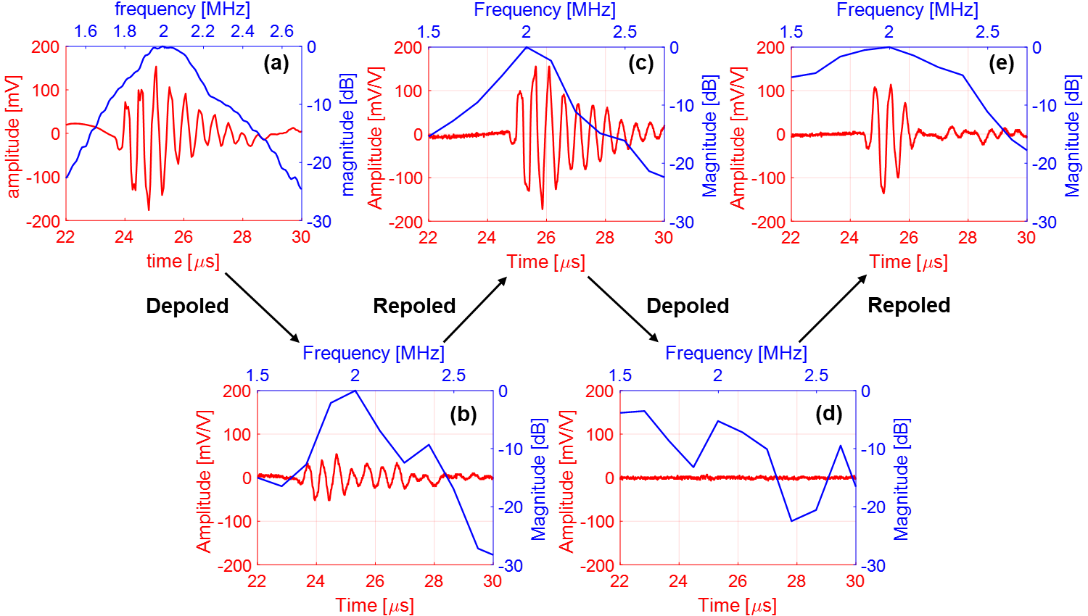
Figure S10. Pulse/echo responses of the transducers at different stages of in-device depoling and repoling processes under DC electric fields: (a) Original status (DC-poled), (b) First depoling, (c) First repoling, (d) Second depoling, and (e) Second repoling. The peak-to-peak voltage dropped from 396 mV (a) to 250 mV (e), or by 36.8%, after the second repoling.



Supplementary Video 1. Evolution of the domain structures of an AC-poled sample exposed to an AC electric field with amplitude of ~0.85E_{c}. The layered structures in the poled state are converted to the unpoled state with multiple domains after AC electric field cycling.

