Supplementary Information for

Enabling biocontained plant virus transmission studies through establishment of an axenic whitefly (Bemisia tabaci) colony on plant tissue culture

Natalie S. Thompson, David Krum, Yun-Ru Chen, Mariela C. Torres, Marena A. Trauger, Dalton Strike, Zachary Weston, Jane E. Polston, Wayne R. Curtis*

* Corresponding author; email: wrc2@psu.edu

Supplementary Movie Files

Supplementary Movie 1. Surface sterilization of leaves with whitefly eggs, swirl technique shown.
Supplementary Movie 2. Whiteflies captured in GA7 tissue culture device, seen at the top of the coupled containers.

Supplementary Figures
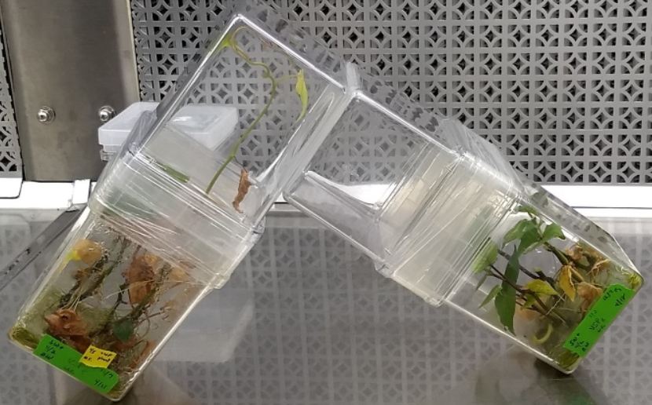
Supplementary Figure 1. L-Shaped Device. Early transfer prototype created by connecting two GA7 couplers together with a hole. The L-shape allows for fresh plants to be swapped in below easily.

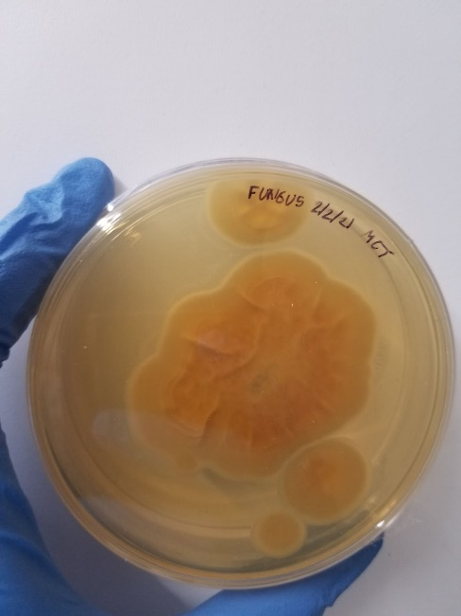
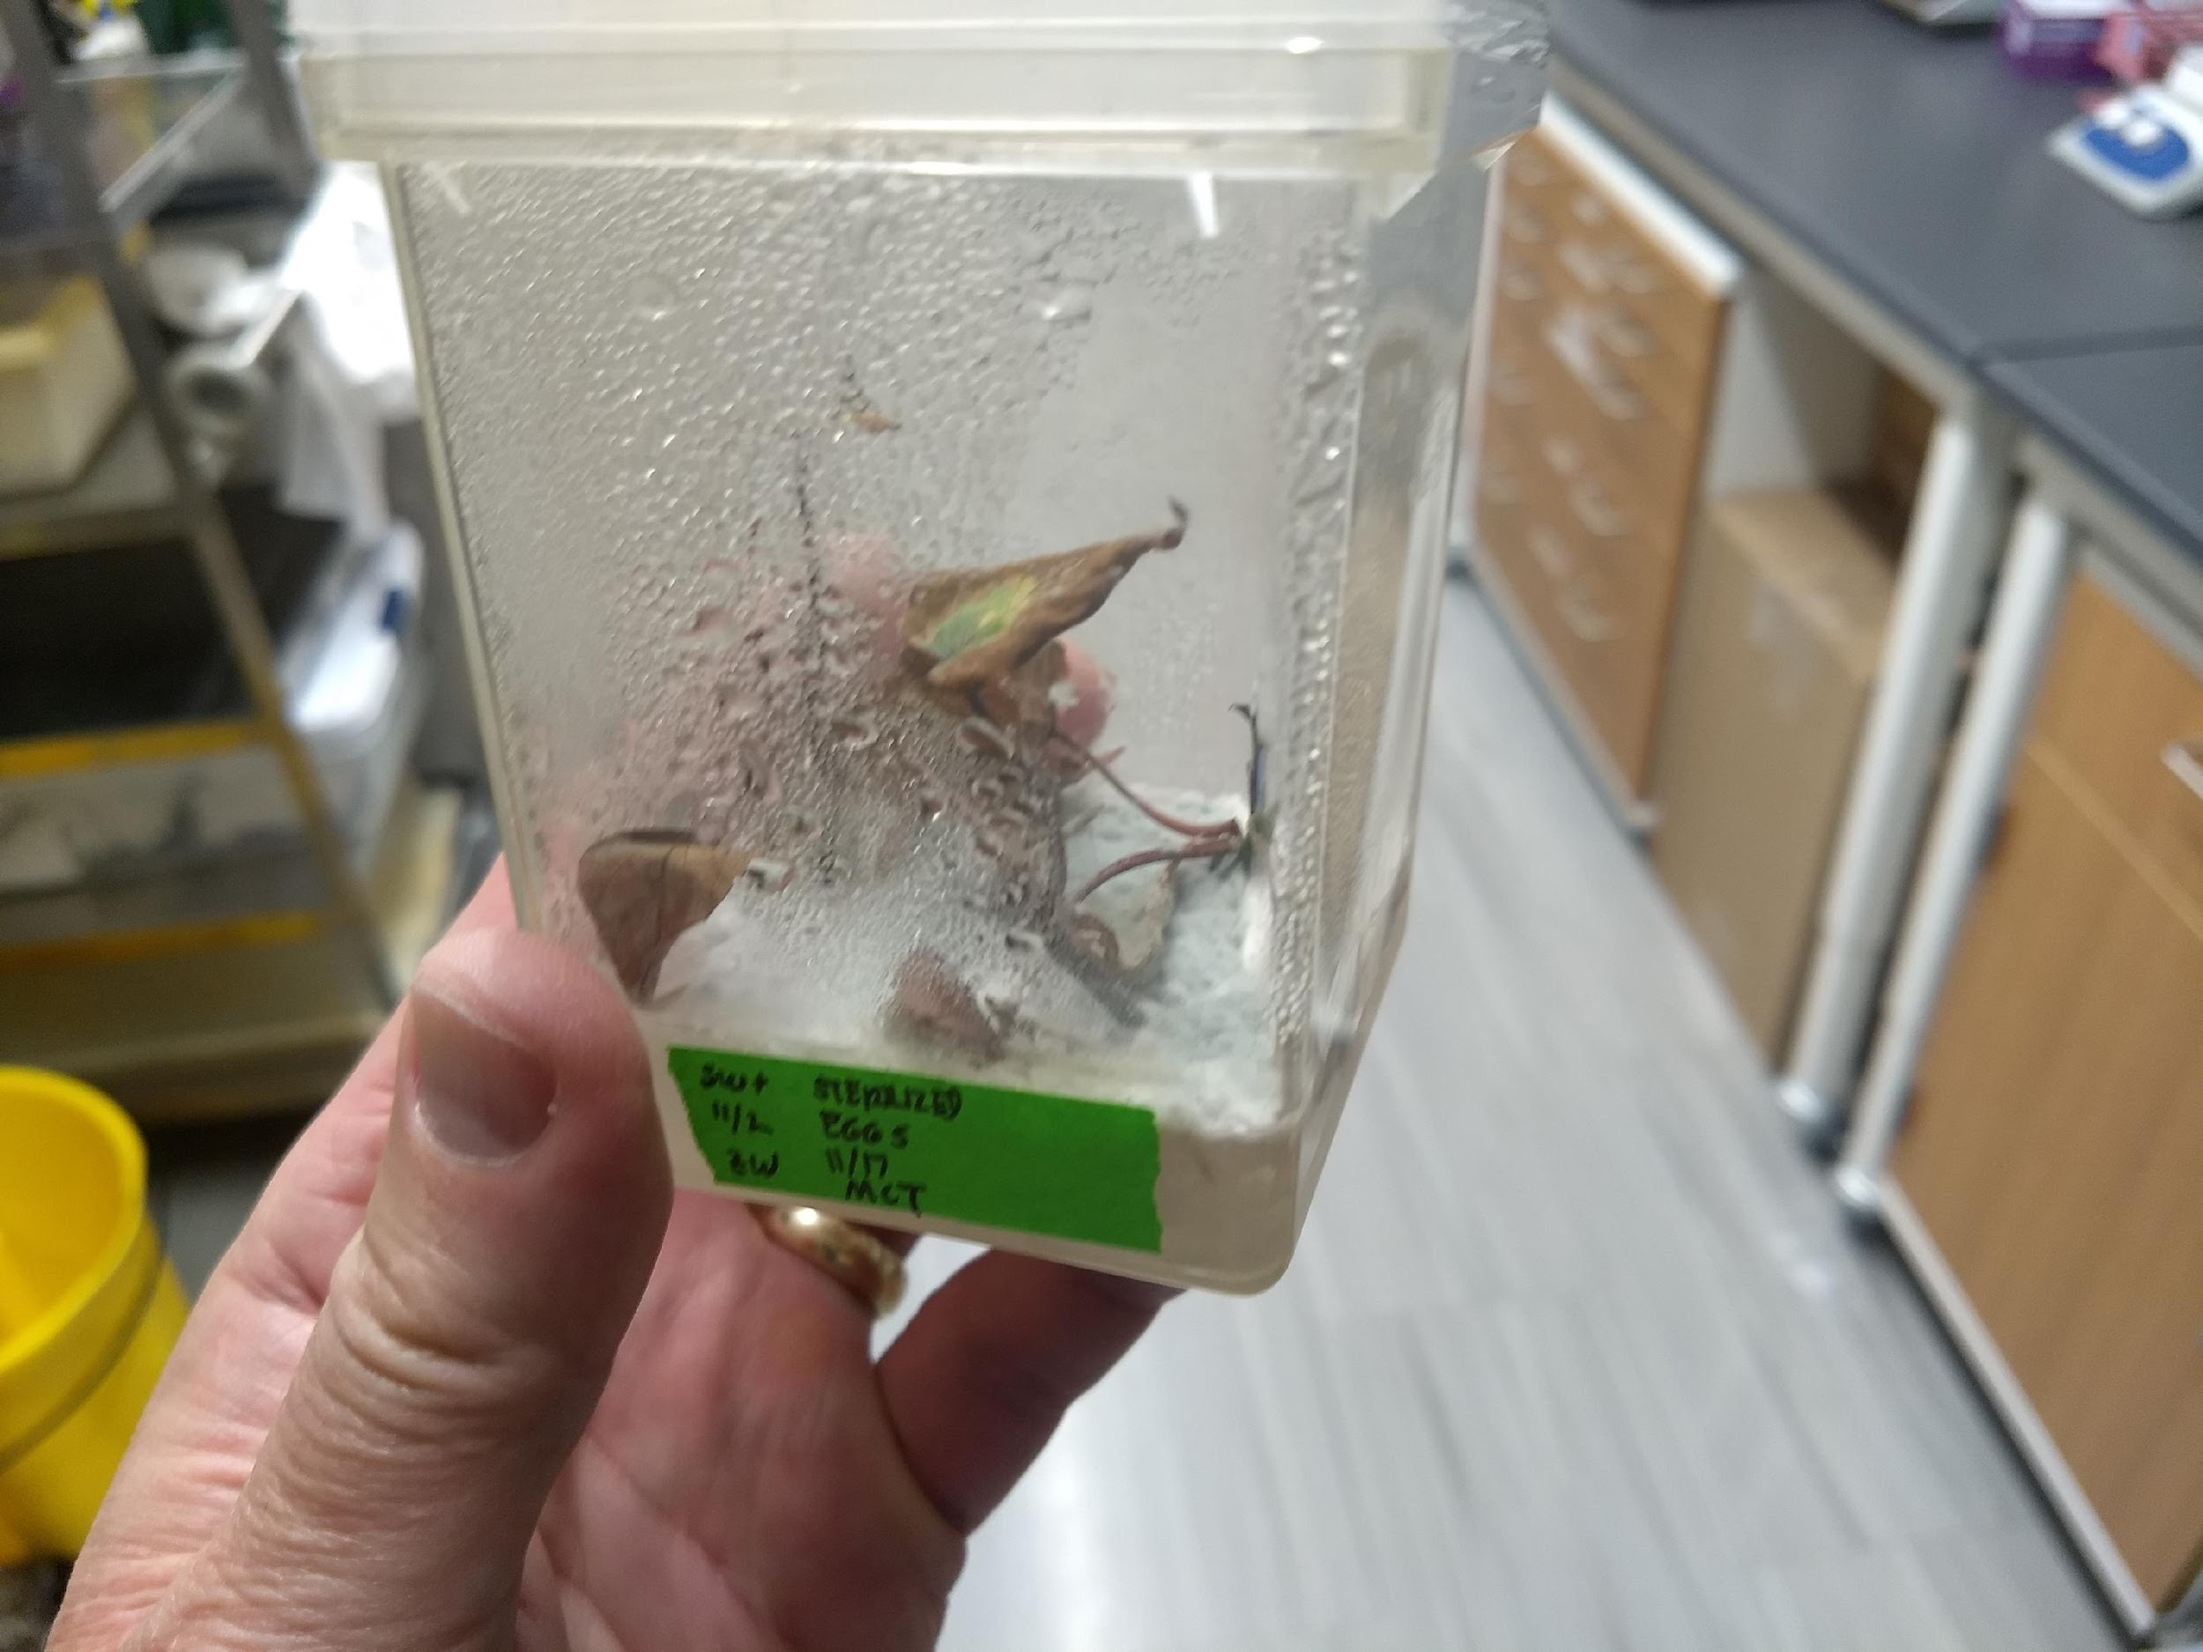
Supplementary Figure 2. Systemic Fungal Infection. (A) early transfer attempts were prone to fungal infection and as a result later methodology involved ‘outracing’ infection by only letting the whiteflies lay eggs for 1-3 days. (B) Systemic fungus grown on a PDA plate.
A
B

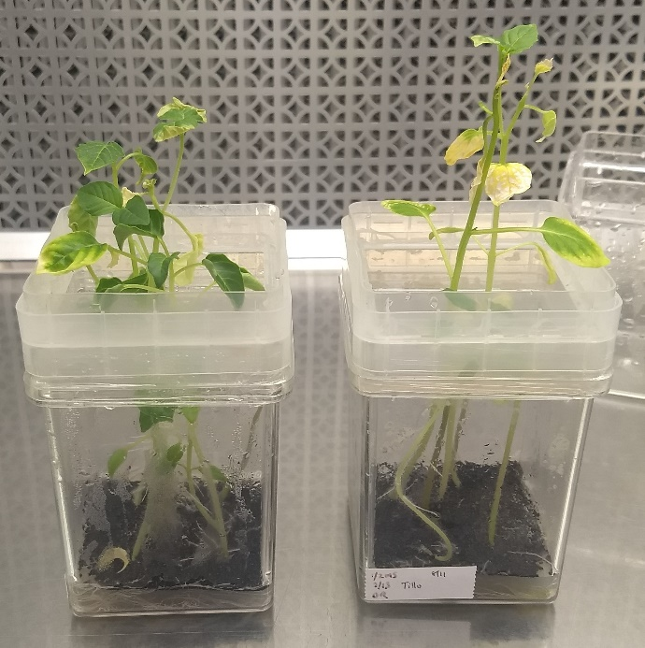
Supplementary Figure 3. Tomatillo height comparison. Comparison of tomatillo grown on a gyratory shaker (left) and tomatillo grown in normal laboratory conditions (right). Shaking reduced leaf senescence and only mildly reduced the height but the retention of initial leaves resulted in a higher whitefly count.

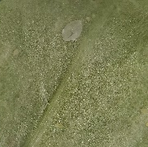
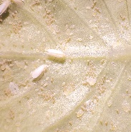
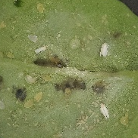
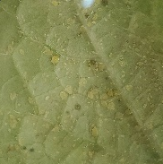
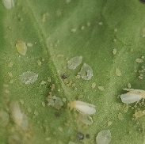
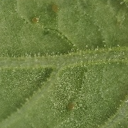
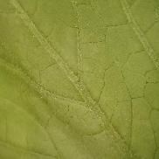
Supplementary Figure 4. Alternative Host Screen. Close-up shots of the 27 different plant species tested for whitefly proliferation.
Broccoli
Cabbage
Arabidopsis
Acorn squash
Kabocha squash
Cucumber
Radish
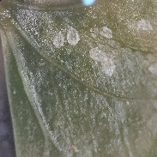
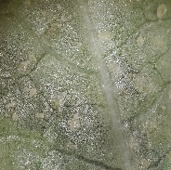
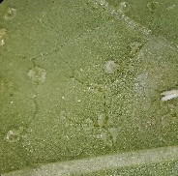
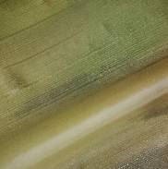
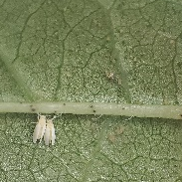
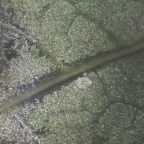
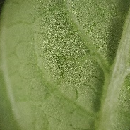
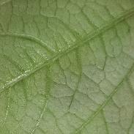
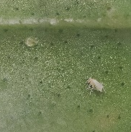
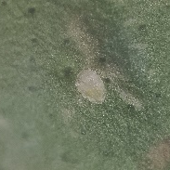
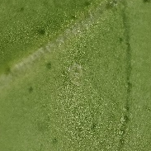
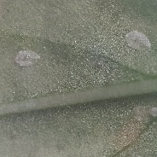
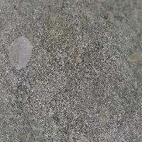
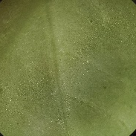
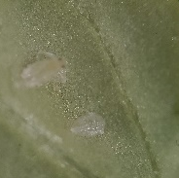
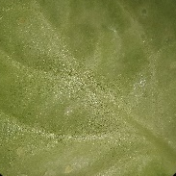
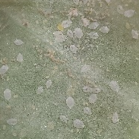
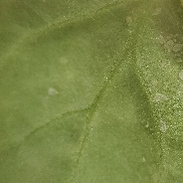
Cotton
Rotundata
Okra
Sweet Potato
Cayenensis
Corn
Jalapeno
Tomatillo
WT NB
ASKO
Bell Pepper
Tomato
Tobacco
Pomegranate
Lemon
Grapefruit
Orange
Cow pea
String bean
Pea
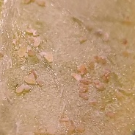
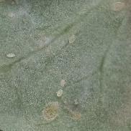
Monocots

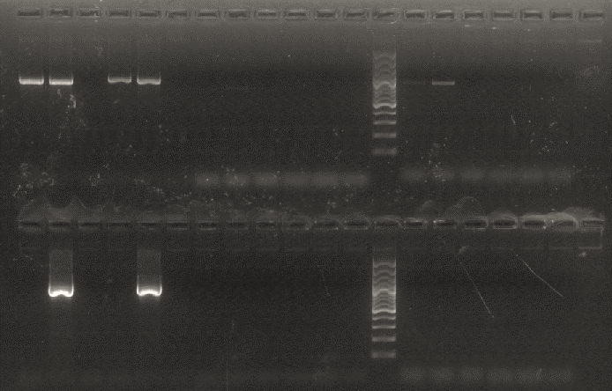
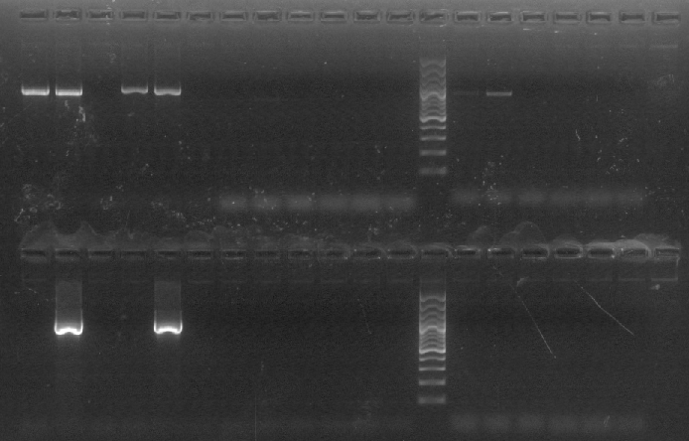
Supplementary Figure 5. Endosymbiont PCR Screen. PCR screen for common whitefly endosymbionts in the axenic colony (axenic, A) and our non-axenic (potted, P) colony. Both colonies were negative for Wolbachia, Cardinium, and Arsenophonus. The potted colony contains Portiera but the axenic colony does not. They both contain Rickettsia and were positive for the “control” gene, mtCOI.
A
P
(-)
A
P
(-)
A
P
(-)
A
P
(-)
A
P
(-)
A
P
(-)
Rickettsia
Wolbachia
mtCOI
Portiera
Cardinium
Arsenophonus

Supplementary Figure 6. Screened cage. Cage used to house our potted whitefly colony.
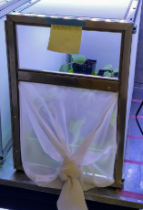
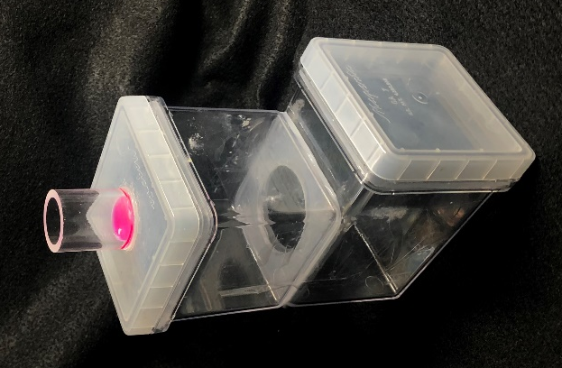
Supplementary Figure 7. Membrane feeding device. Feeding assembly build with PTFE membrane cut-out under 1” acrylic tube inserted onto lid of GA7. Whiteflies were added to the central containers and dyed sucrose solution was added on-top of the membrane.

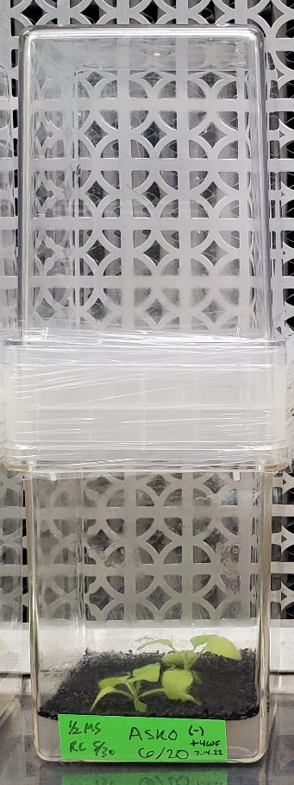
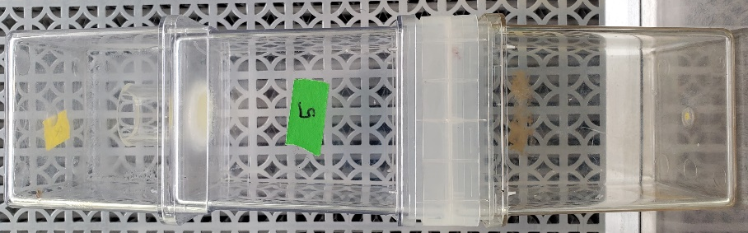
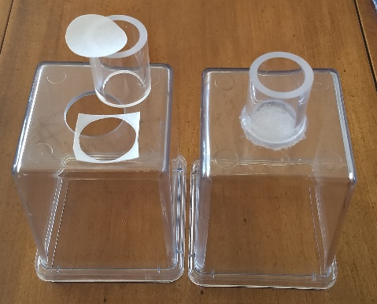
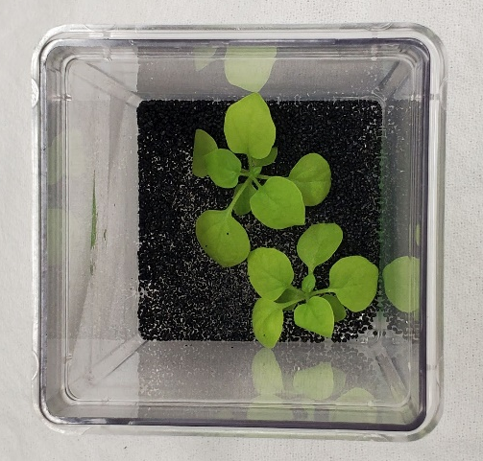
Supplementary Figure 8. Virus suspension feeding and transmission overview. A. Feeding assembly build with PTFE membrane cut-out under 1” acrylic tube inserted through polycarbonate GA7. B. Whiteflies feeding on filer-sterilized virus suspension in buffer and sucrose solution (and yellow food coloring to attract WF). top inverted GA7 slows evaporation of virus suspension. C. Picture of host N. benthamiana (ASKO) plants after condensation is removed and autoclaved black sand added to prepare for addition of whiteflies. D. ASKO host plant with virus containing whiteflies added for virus transmission.
D
C
A
B

Supplementary Tables

Supplementary Table 1: Alternative hosts for the axenic whiteflies - data sheet
Plant | Picture  (top) | Picture  (side) | Plant  picture | Observations | Optimal Seed #
Cabbage | 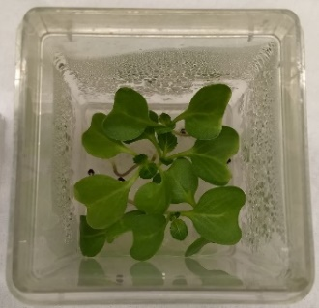 | 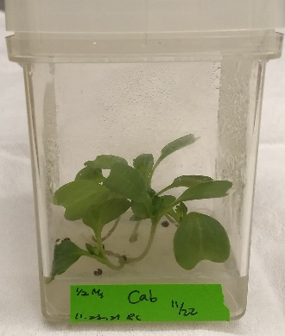 | 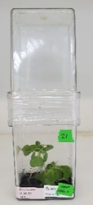 | Great size for growth in tissue vessel. Leaf senescence happens very slowly. | 4-6
Broccoli | 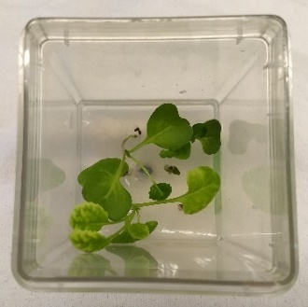 | 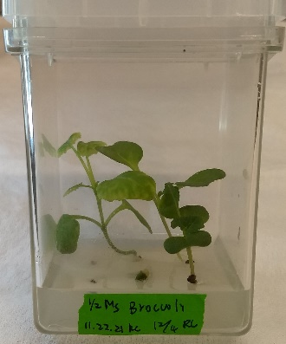 | 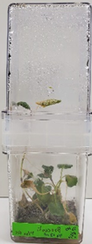 | Great size for growth in tissue vessel. Leaf senescence happens very slowly. | 4-6
Cotton | 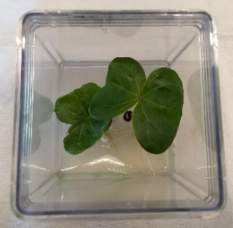 | 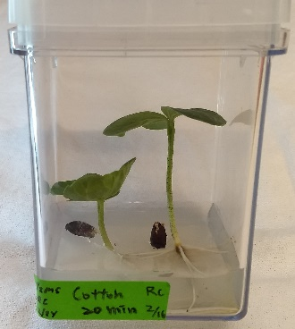 | 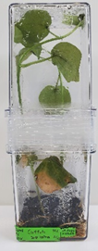 | Very large leaves which were initially good for whiteflies but it quickly outgrew the two GA7 combined height | 2
Corn | 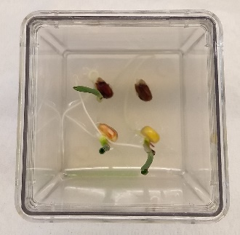 | 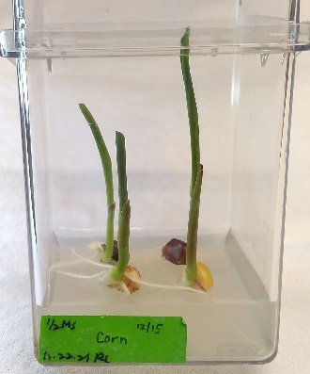 | 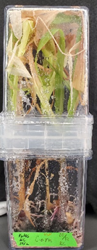 | Quickly outgrew the height of the two GA7’s. Monocot. | 2-4
Cucumber | 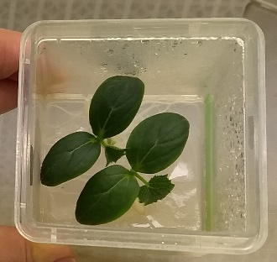 | 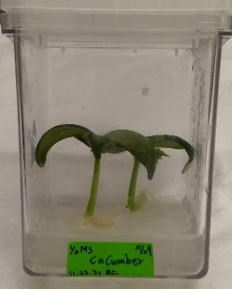 | 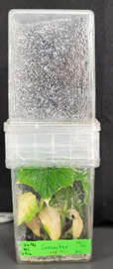 | Nice compact, large cotyledon growth | 2
Leopard Melon | 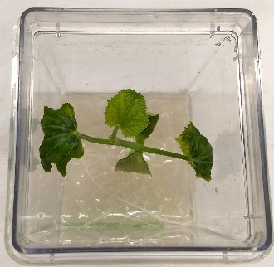 | 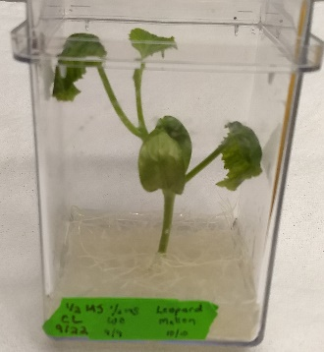 |  | Compact, nice leaf size. | 1
Acorn Squash | 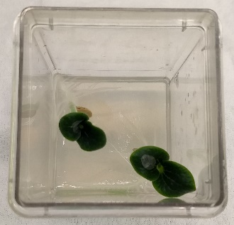 | 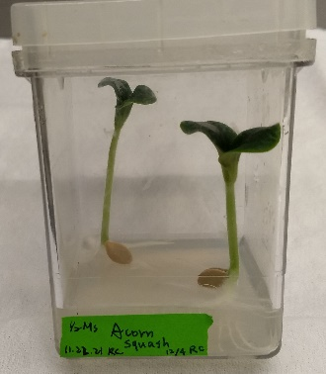 | 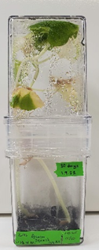 | Vine, outgrew GA7’s quickly | 2
Kabocha | 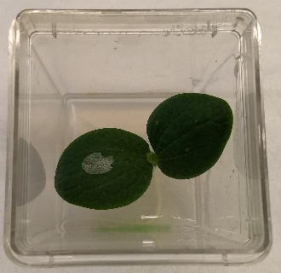 | 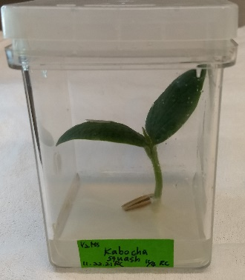 | 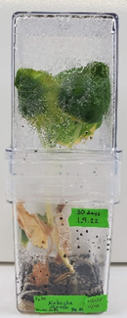 | Great cotyledon size and leaf area. | 1
Pea | 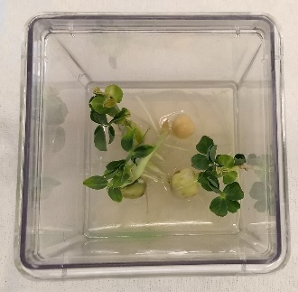 | 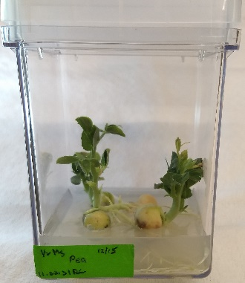 | 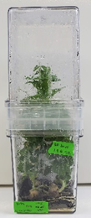 | Small leaves, worked well as a whitefly host. | 3-4
CowPea | 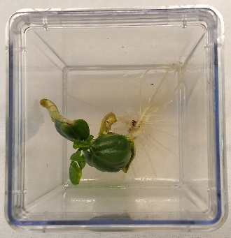 | 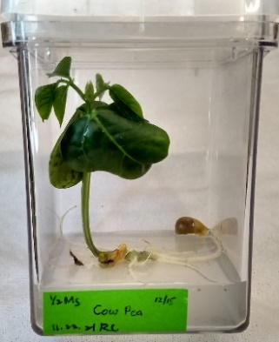 | 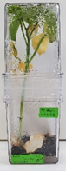 | Grew far to quickly and too tall but the leaves were a great size. | 1
Soy | 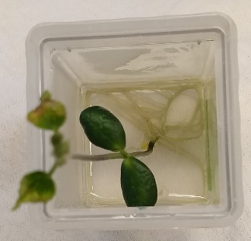 | 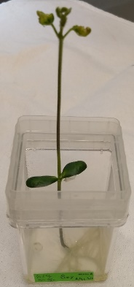 |  | Grew very high very quickly. Small leaves | 1
String Bean | 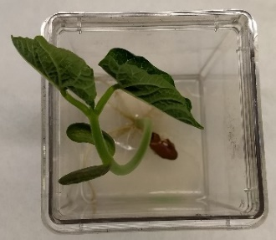 | 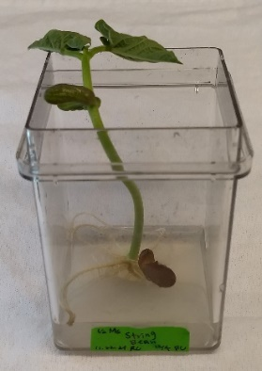 | 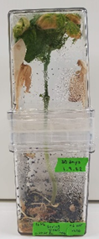 | Grew far to quickly and too tall but the leaves were a great size. | 1
Bell Pepper | 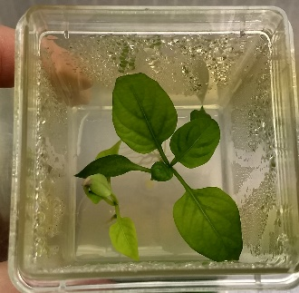 |  | 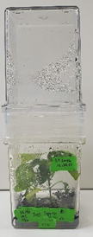 | Slow grower. Great final plant size | 2-3
Jalapeno | 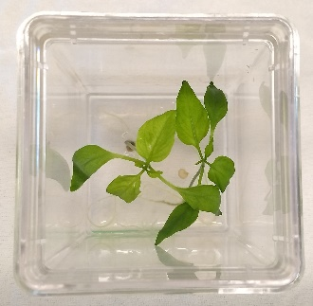 | 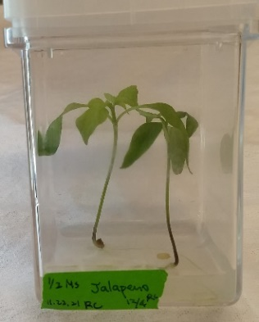 | 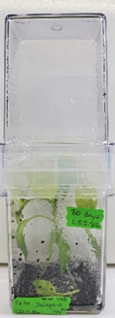 | Narrow leaves but good final plant size. | 2-4
Tomato | 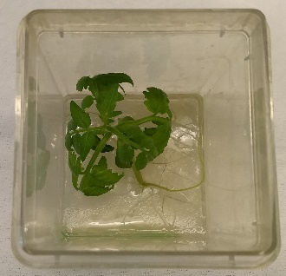 | 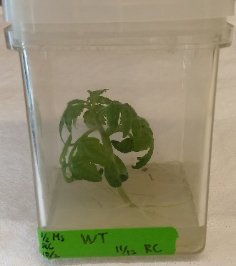 | 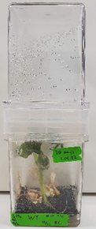 | One plant per GA7 minimized the leaves curling and allowed larger expansion. Trichomes were hard for the whiteflies to feed through. | 1
Nicotiana tabacum | 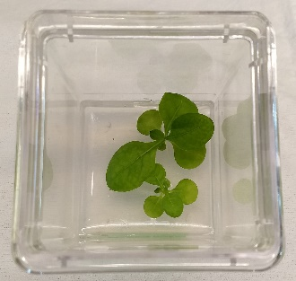 | 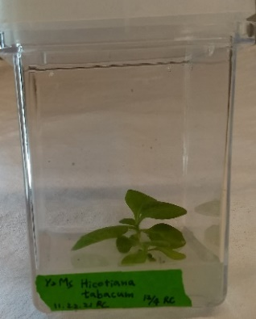 | 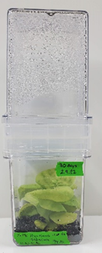 | Great leaf and final plant size | 2-5
Nicotiana benthamiana | 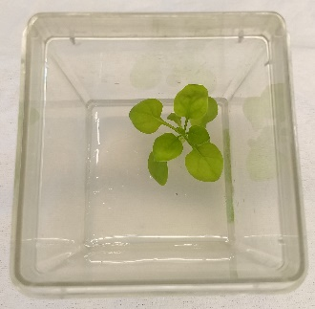 | 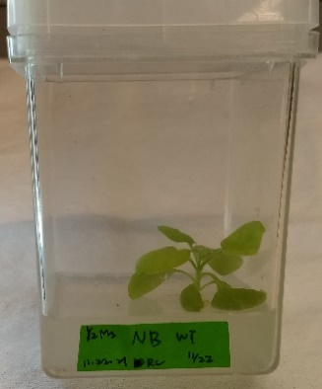 | 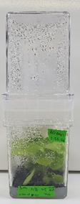 | Great leaf and final plant size | 2-5
Acyl-sugar knockout Nicotiana benthamiana | 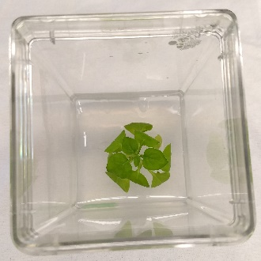 | 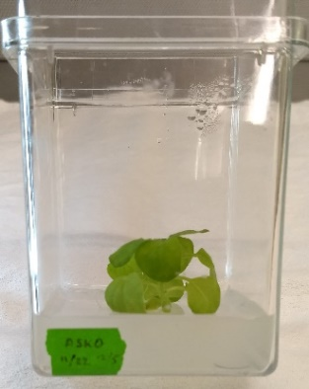 | 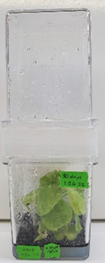 | Great leaf and final plant size. The acyl-sugar knockout variety had much larger fecundity of the whiteflies. | 2-5
Okra | 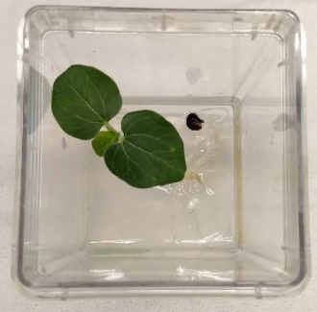 | 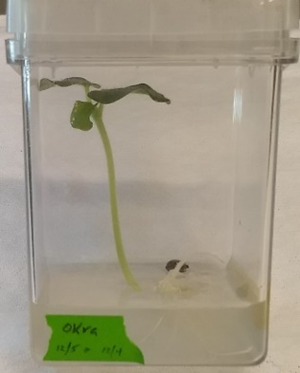 | 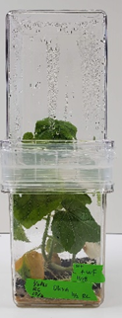 | Roots pushed the seed out of the media but the final plant size was good. | 1
Radish | 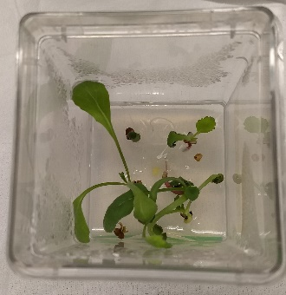 | 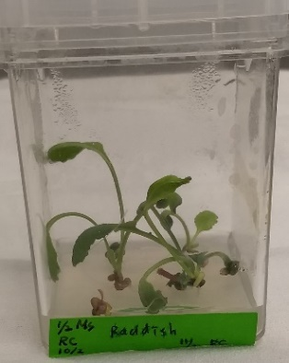 | 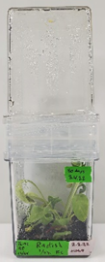 | Narrow leaves but height of the plant was good. | 2-5
Sweet Potato | 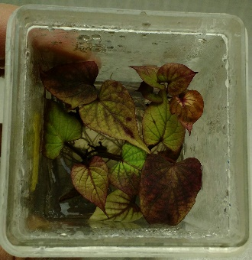 | 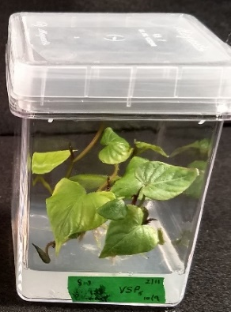 |  | Great in tissue culture. Needs to be subcultured once every couple of months. | 3-4
Yam (Ro) | 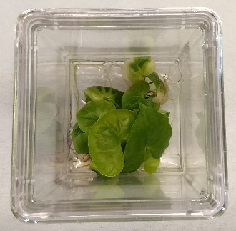 | 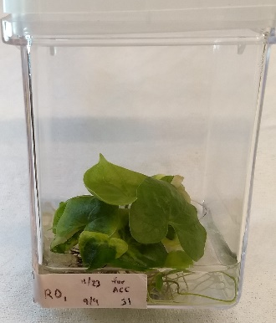 | 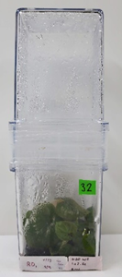 | Monocot (Dioscorea); Great in tissue culture. Needs to be subcultured once every couple of months. | 3-4
Yam (Ca) | 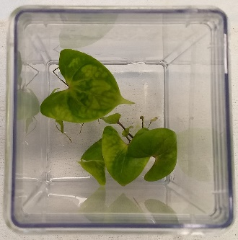 | 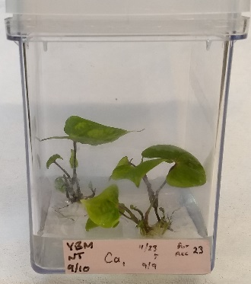 | 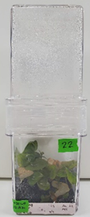 | Monocot (Dioscorea); Great in tissue culture. Needs to be subcultured once every couple of months. | 3-4
Greenbriar | 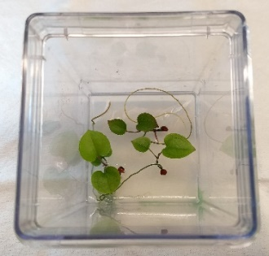 | 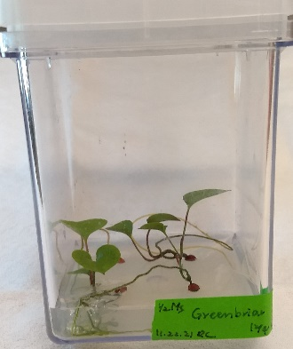 |  | Struggled with germination. It grew very slowly and leaf size was very small; Monocot | 4
Orange | 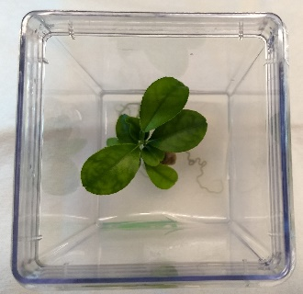 | 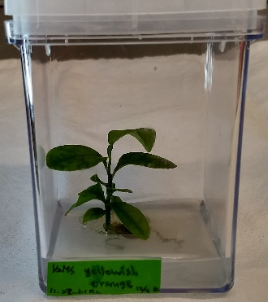 | 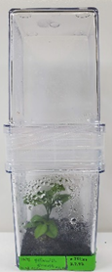 | Great leaf size and height. | 1-2
Lemon | 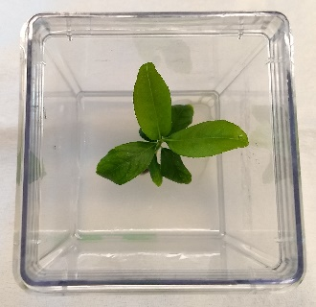 | 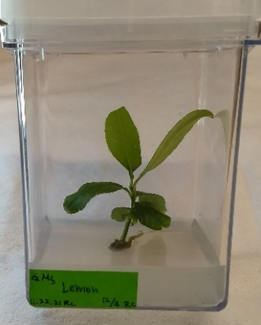 | 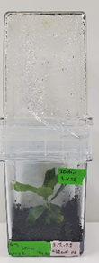 | Great leaf size and height. | 1-2
Grapefruit | 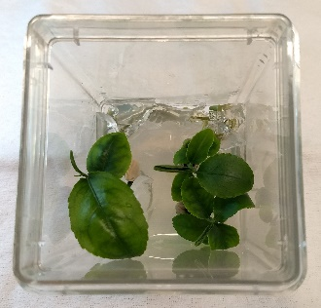 | 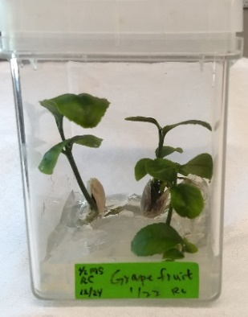 | 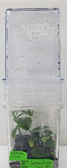 | Great leaf size and height. | 1-2
Arabidopsis | 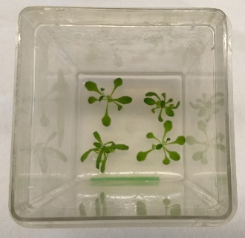 | 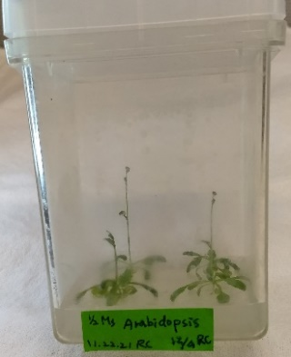 | 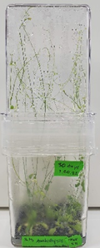 | Very small leaves did not work for whiteflies in tissue culture and it bolted quickly which was too high for the GA7 combo. | 4
Pomegranate | 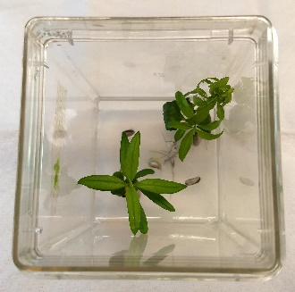 | 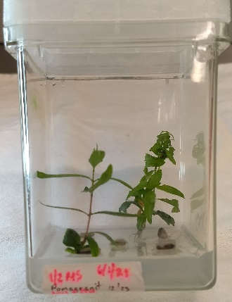 | 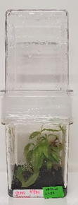 | Great height but leaves were very narrow. | 1-2

Supplementary Table 2: SWeet Potato Shoot Medium (SW) media recipe
 | [final] | [stock] | prep / L | / 250 mL
Sucrose | 30 g/L | -- | 30 g | 7.5 g
MS Macronutrients (10x) |  |  | 100 mL | 25 mL
NH₄NO₃ (ammonium nitrate) | 1.65 g/L | 16.5 g/L
KNO₃ (potassium nitrate) | 1.9 g/L | 19 g/L
CaCl₂∙2H₂0 ^{(A)} | 0.44 g.L | 4.4 g/L ^{(A)}
MgSO₄∙7H₂0 ^{(B)} | 0.37 g/L | 3.7 g/L ^{(B)}
KH₂PO₄ (potassium phosphate monobasic) | 0.17 g/L | 1.7 g/L
MS Micronutrients (1000x) |  |  | 1 mL | 0.25 mL
MnSO₄∙H₂O ^{(C)} (manganous sulfate) |  | 16.9 g/L ^{(C)}
ZnSO₄∙7H₂0 |  | 8.6 g/L
H₃BO₃ (boric acid) |  | 6.2 g/L
KI (potassium iodide) |  | 0.83 g/L
Na₂MoO₄∙2H₂0 (sodium molybdate) |  | 0.25 g/L
CuSO₄∙5H₂0 ^{(D)} |  | 0.025 g/L ^{(D)}
CoCl₂∙6H₂0 |  | 0.025 g/L
Fe-EDTA∙[2H₂0] ^{(E)} (iron-EDTA) | 40.3 mg / L | 4.0 g/L (4.0 mg/mL) | 10 mL | 2.5 mL
MS vitamins Thiamine-HCl | 0.1 mg/L | 0.1 g/L (0.1 mg/mL) | 1 mL | 0.25 mL
Nicotinic acid | 0.5 mg/L | 0.5 g/L (0.5 mg/mL)
Pyridoxine | 0.5 mg/L | 0.5 g/L (0.5 mg/mL)
Inositol | 100 mg/L | 10 g/L (10 mg/mL) | 10 mL | 2.5 mL
Glycine | 2 mg/L | 0.2 g/L (0.2 mg/mL) | 10 mL | 2.5 mL
Kinetin | 0.5 mg/L | 50 mg/L (.05 mg/mL) | 10 mL | 2.5 mL
pH = 5.7 (record initial pH)
Agar (granulated ‘cheep’ stuff) | 6 g/L |  | 6 g | 1.5 g
Add BAP from frozen stocks after Autoclaving 30 min
BAP (6-benzylaminopurine) | 0.5 mg/L | 10 g/L (10 mg/mL) | 50 L | 12.5 L

Supplementary Table 3: MS Tomato Root Induction (MS-TRI) Medium for Tomato (var. Fl. lanai) media recipe
 | [final] | [stock] | prep / L | / 250 mL
Sucrose | 30 g/L | -- | 30 g | 7.5 g
- MS Macronutrients (10x) |  |  | 100 mL | 25 mL
- NH₄NO₃ (ammonium nitrate) | 1.65 g/L | 16.5 g/L
KNO₃ (potassium nitrate) | 1.9 g/L | 19 g/L
- CaCl₂∙2H₂0 ^{(A)} | 0.44 g.L | 4.4 g/L ^{(A)}
- MgSO₄∙7H₂0 ^{(B)} | 0.37 g/L | 3.7 g/L ^{(B)}
- KH₂PO₄ (potassium phosphate monobasic) | 0.17 g/L | 1.7 g/L
- MS Micronutrients (1000x) |  |  | 1 mL | 250 μL
- MnSO₄∙H₂O ^{(C)} (manganous sulfate) |  | 16.9 g/L ^{(C)}
- ZnSO₄∙7H₂0 |  | 8.6 g/L
- H₃BO₃ (boric acid) |  | 6.2 g/L
- KI (potassium iodide) |  | 0.83 g/L
- Na₂MoO₄∙2H₂0 (sodium molybdate) |  | 0.25 g/L
- CuSO₄∙5H₂0 ^{(D)} |  | 0.025 g/L ^{(D)}
- CoCl₂∙6H₂0 |  | 0.025 g/L
Fe-EDTA∙[2H₂0] ^{(E)} (iron-EDTA) | 40.3 mg/L | 4.0 g/L (4.0 mg/mL) | 10 mL | 2.5 mL
MS vitamins Thiamine-HCl | 0.1 mg/L | 0.1 g/L (0.1 mg/mL) | 1 mL | 250 μL
Nicotinic acid | 0.5 mg/L | 0.5 g/L (0.5 mg/mL)
Pyridoxine | 0.5 mg/L | 0.5 g/L (0.5 mg/mL)
Inositol | 100 mg/L | 10 g/L (10 mg/mL) | 10 mL | 2.5 mL
Glycine | 2 mg/L | 0.2 g/L (0.2 mg/mL) | 10 mL | 2.5 mL
pH = 5.5 (record initial pH)
Agar for Plant Tissue Culture (0.6%) | 0.6 g/L | -- | 6 g | 1.5 g
Autoclave
Indole-3-Butyric Acid (IBA) | 0.05 mg/L | 25 g/L (25 mg/mL) | 2 μL | 0.5 μL
Cefotaxime | 500 mg/L | 500 g/L (500 mg/mL) | 1 mL | 250 μL
Kanamycin (if using NPT selectable marker) | 100 mg/L | 100 g/L (100 mg/mL) | 1 mL | 250 μL
Hygromycin (if using HPT selectable marker) | 20 mg/L^{(F)} | 50 g/L (50 mg/mL) | 400 μL | 100 μL

Supplementary Table 4: Primers used to assess presence of whitefly endosymbionts:
Gene | Primer sequence (5’ 3’) | Amplicon size / T_{A} | Reference
B. tabaci mtCOI | F: TTGATTTTTTGGTCATCCAGAAGT  R: TCCAATGCACTAATCTGCCATATTA | 48 °C / 800 bp | Frohlich et al. 1999
P. aleyrodidarum 16S rDNA | F: TGCAAGTCGAGCGGCATCAT  R: AAAGTTCCCGCCTTATGCGT | 54 °C / 1000 bp | Zchori-Fein and Brown 2002
Cardinium 16S rDNA | F: TACTGTAAGAAATAAGCACCGGC  R: GTGGATCACTTAACGCTTTCG | 50 °C / 400 bp | Zchori-Fein et al. 2004
Arsenophonus 23S rDNA | F: CGTTTGATGAATTCATAGTCAAA  R: GGTCCTCCAGTTAGTGTTACCCAAC | 44 °C / 900 bp | Thao and Baumann 2004
Wolbachia 16S rDNA | F: CGGGGGAAAAATTTATTGCT  R: AGCTGTAATACAGAAAGTAAA | 41 °C / 589 bp | Heddi et al. 1999
Rickettsia sp. 16S rRNA | F: GCTCAGAACGAACGCTATC  R: GAAGGAAAGCATCTCTGC | 47 °C / 589 bp | Gottlieb et al. 2006
Hamiltonella 16S rDNA | F: TGAGTAAAGTCTGGAATCTGG  R: AGTTCAAGACCGCAACCTC | 47 °C / ~700 bp | Pan et al. 2012
Fritschea 23S rDNA | F: GATGCCTTGGCATTGATAGGCGATGAAGGA  R: TGGCTCATCATGCAAAAGGCA | 54 °C / ~600 bp | Pan et al. 2012

