“Adsorption behavior and antimicrobial activity of new chitosan based functionalized nanocomposites: A case study”
Nora A. Hamad*¹, Fatma M. Salem¹, Adel A.-H. Abdel-Rahman¹, and Nasser A. Hassan²

¹Chemistry Department, Faculty of Science, Menofia University, Shebin El-Koum 32511, Egypt
² Photochemistry Department, Chemical Industries Research Institute, National Research Centre, Cairo 12622, Egypt

Name | Email | ORCID
Nora A. Hamad | nhamad059@gmail.com | 0000-0002-4195-6215
Fatma M. Salem | Fatmasalem245@gmail.com | 0009-0002-7915-1452
Adel A-H. Abdel-Rahman | adelnassar63@yahoo.com | 0000-0003-3319-8191
Nasser A. Hassan | nasserabdelhamid@hotmail.com | 0000-0003-1809-9232

*Corresponding author: Nora A. Hamad
https://orcid.org/0000-0002-4195-6215
E–mail address: nhamad059@gmail.com; Tel: +2-010-9587-6887

Scheme S1. The preparation steps of EPC and ENC.

Scheme S2. The preparation steps of MC-Cl.

Characterization of EPC:
EPC

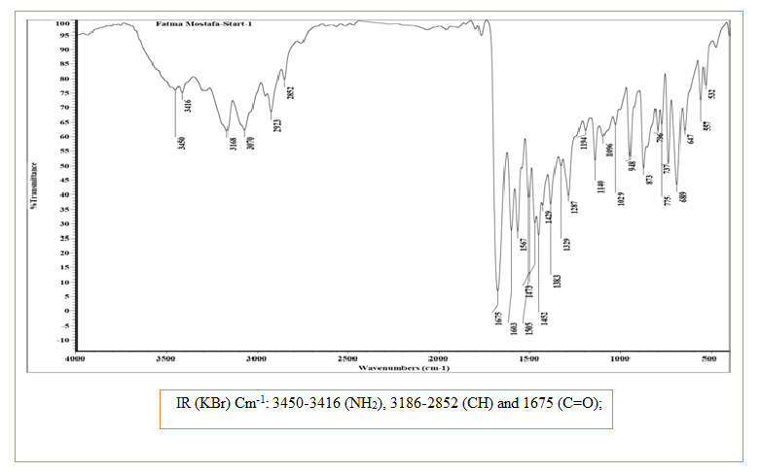

Fig.S1: FTIR spectrum of EPC.

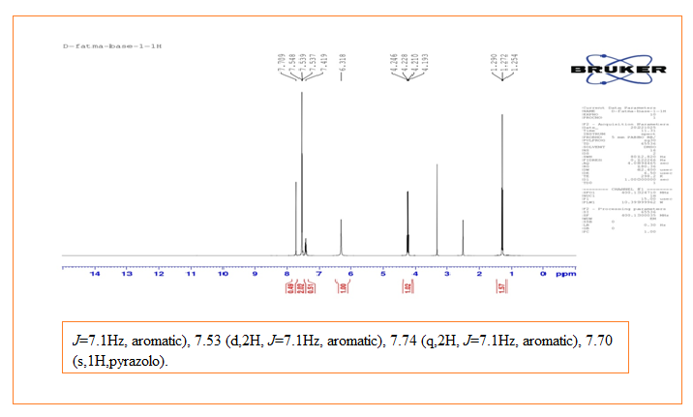

Fig.S2: ¹H -NMR spectrum of EPC.

Characterization of ENC:

ENC

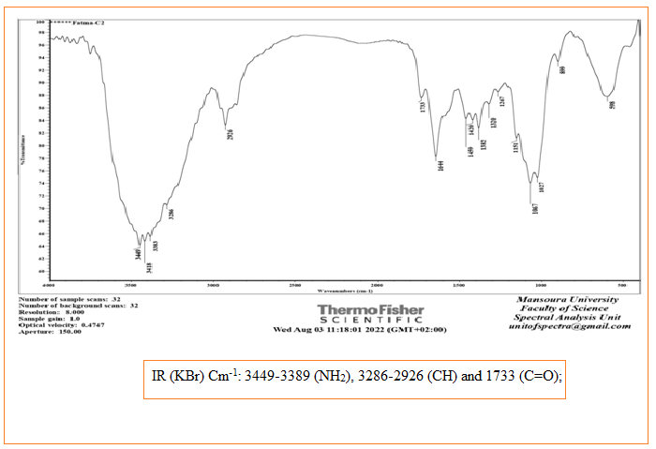

Fig.S3: FTIR spectrum of ENC.

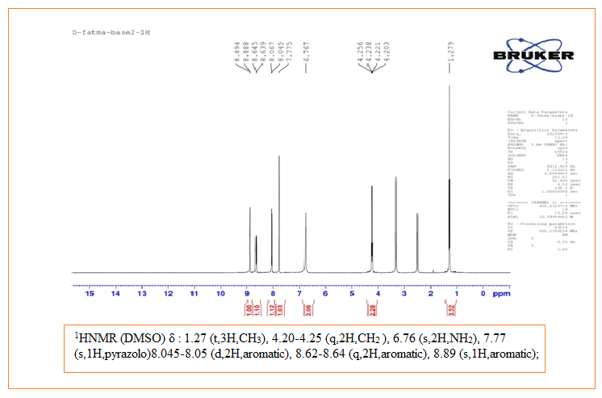
Fig.S4: ¹H -NMR spectrum of ENC.
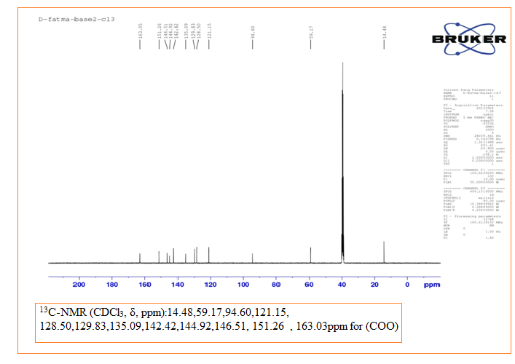
Fig.S5: ¹³C -NMR spectrum of ENC.

