Synthesis, characterization and activity evaluation of (Cu₂O or Ag₂O)-N-TiO₂ photocatalysts for E. coli inhibition and trichloroethylene degradation

Quézia de Souza Jesus Pessanhaª, Laura Merlo-Camuñas^{b}, Camila Fernanda Waltero Orjuelaª, Marcelo Domingosª, Benigno Sánchez^{b}, Maria Cristina Canela^{a*}

*Corresponding author: mccanela@uenf.br

ª Universidade Estadual do Norte Fluminense Darcy Ribeiro, Avenida Alberto Lamego, 2000, 28013-602, Campos dos Goytacazes, Rio de Janeiro, Brazil.
^{b} Centro de Investigaciones Energéticas, Medioambientales y Tecnológicas (CIEMAT), Av. Complutense, 40, 28040, Madrid, Spain.

Supplementary Information
Figure 1S. Photocatalyst band gaps: a) TiO₂ PC500, b) N-TiO₂, c) Cu₂O/N-TiO₂ and d) Ag-N-TiO₂
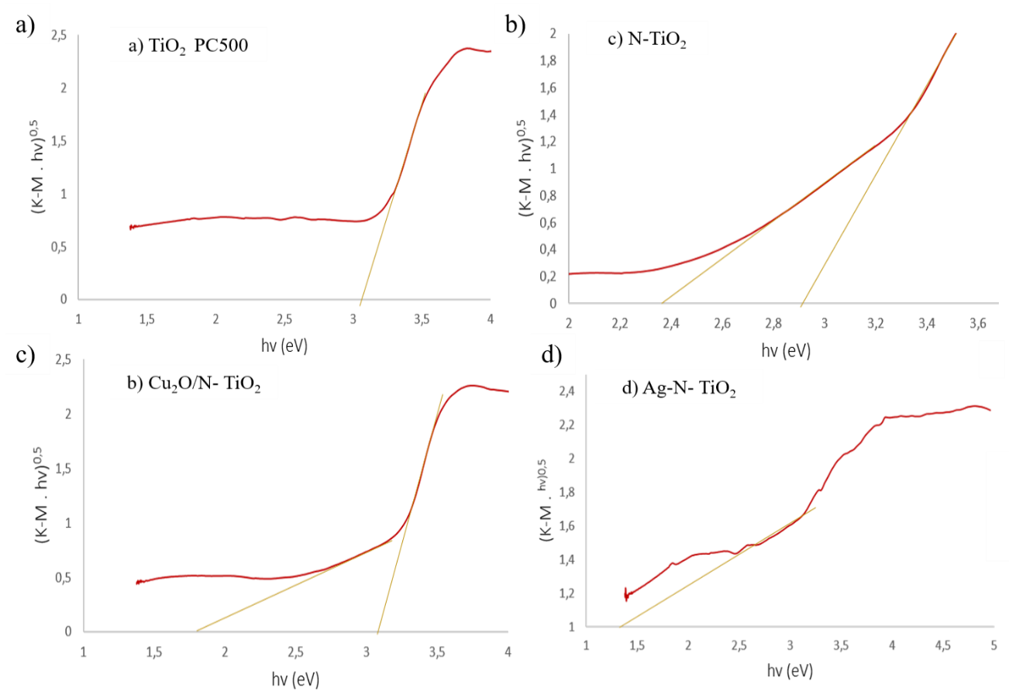

Figura 2S. Photocatalyst XPS: a) N-TiO₂, b) Cu₂O/N-TiO₂, c) Ag-N-TiO₂, d) Ag-N-TiO₂ after UV radiation tests
- N-TiO₂
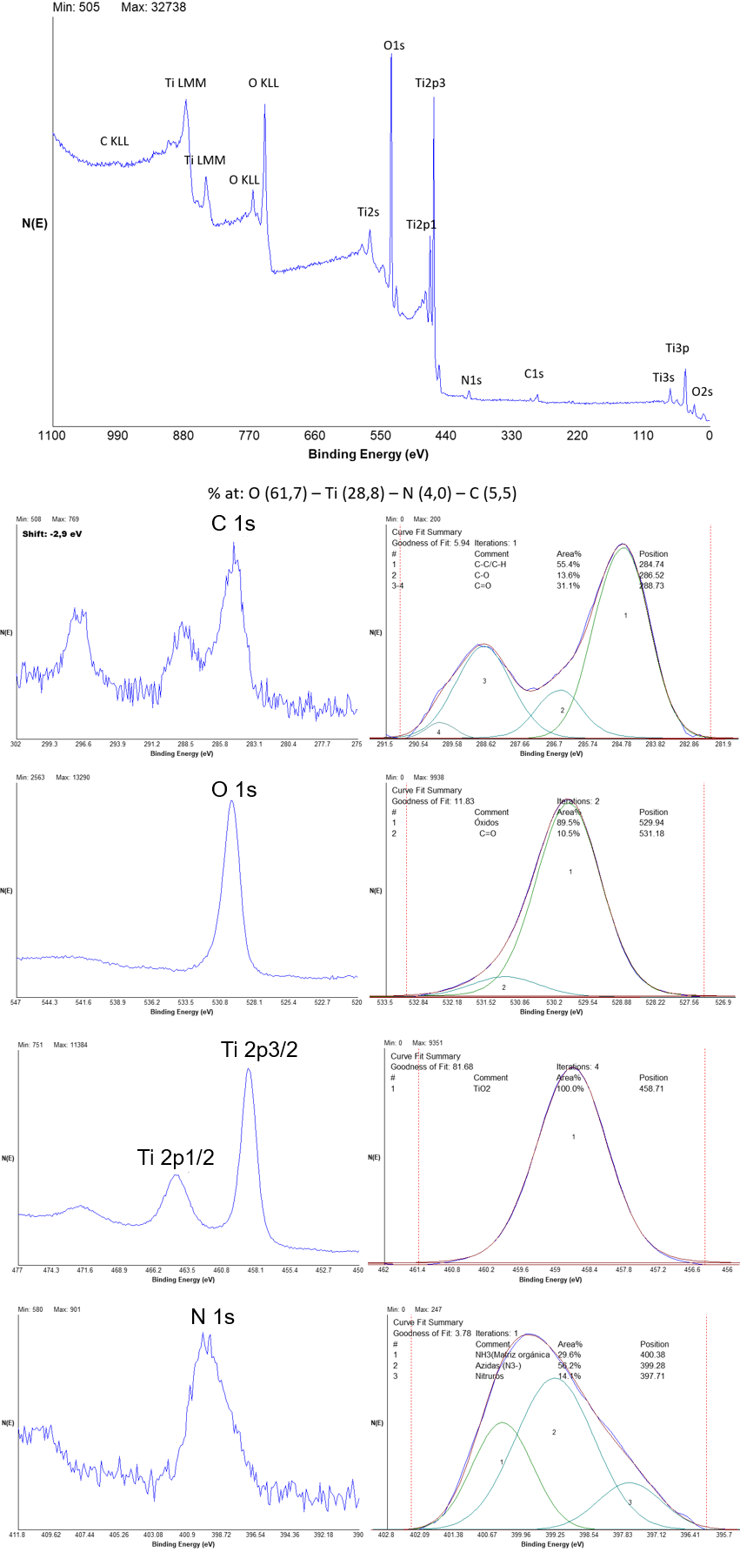
- Cu₂O/N-TiO₂
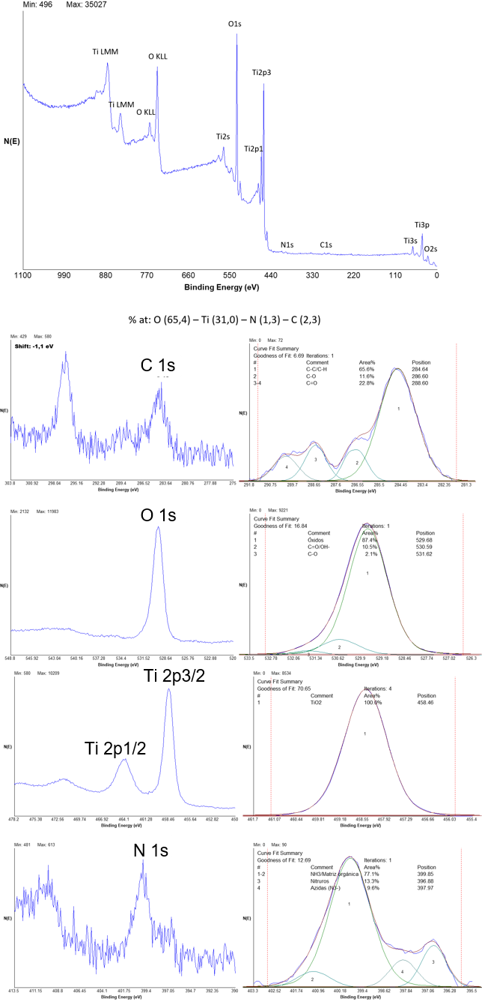
- Ag-N-TiO₂
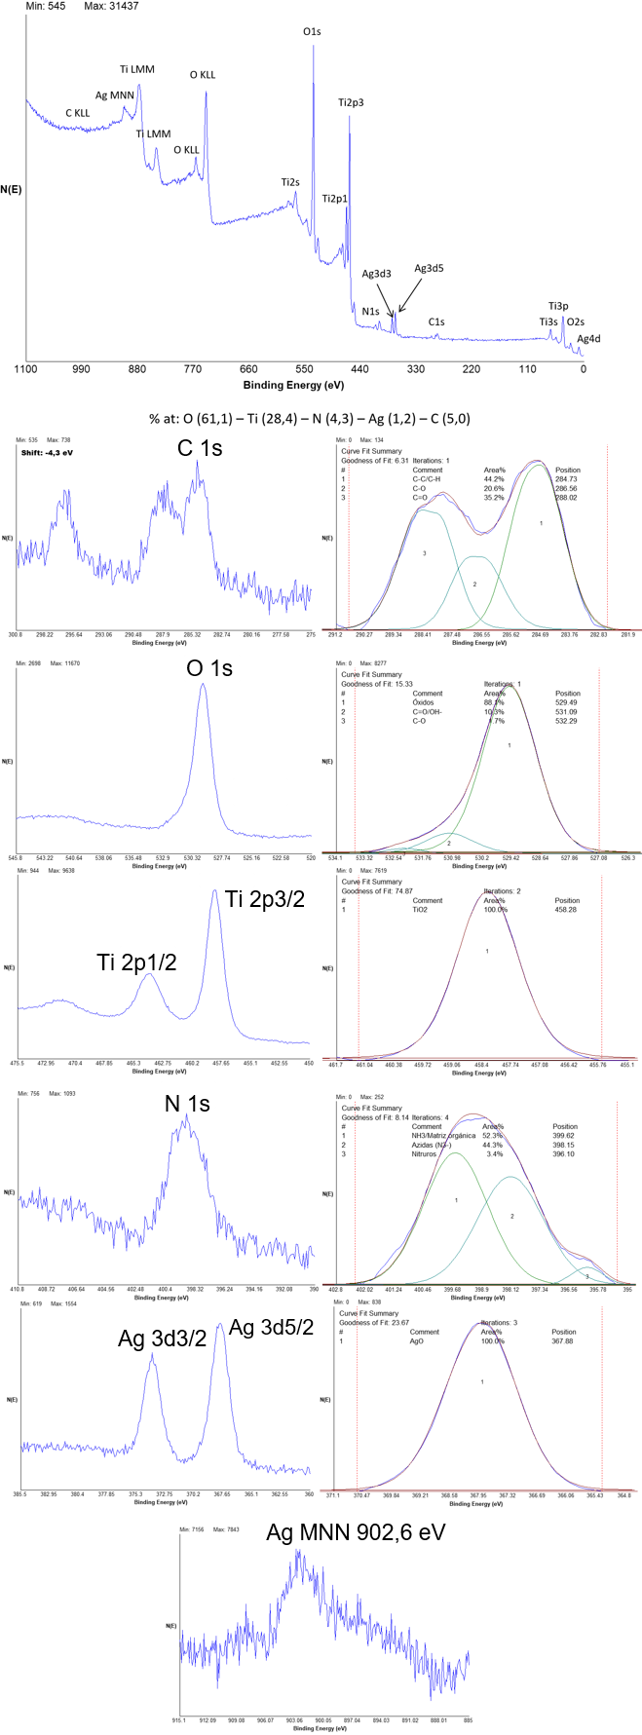
- Ag-N-TiO₂ after UV radiation test
