Supplement to

Unveiling Pandemic Patterns: A Detailed Analysis of Transmissibility and Severity Parameters Across Four COVID-19 Waves in Bogotá, Colombia

David Santiago Quevedo (1,4), N. T. Domínguez (1), Diego Fernando Perez (2), Maria Alejandra Cabrera Polanía (2), Juan David Serrano Medina (2), Felipe Segundo Abril Bermúdez (2), Diane Moyano Romero (2), Diana Sofia Rios Oliveros (2), Manuel Alfredo González Mayorga (2), Charles Whittaker (3), Zulma M. Cucunubá (1)∞

- Departamento de Epidemiología Clínica y Bioestadística. Pontificia Universidad Javeriana, Bogotá, Colombia
- Dirección de epidemiología, análisis y gestión de políticas de salud colectiva, Secretaría Distrital de Salud de Bogotá, Colombia
- MRC Centre for Global Disease Analysis, Imperial College London, London, UK
- Institute for Theoretical Physics, Utrecht University, Utrecht, Netherlands

∞ Correspondance to: zulma.cucunuba@javeriana.edu.co

Supplementary results
Table S1. Overview of confirmed cases, hospitalisations, ICUs, deaths, and maximum instantaneous reproduction number R(t) in each wave.

Wave | Start | End | Confirmed | Hospital | ICU | Deaths | R(t)
1 | 2/26/2020 | 9/25/2020 | 270929 | 30161 | 10808 | 7296 | 2.44(2.12, 2.86)
2 | 11/1/2020 | 3/1/2021 | 331060 | 24564 | 8476 | 6068 | 1.22(1.21, 1.23)
3 | 3/1/2021 | 9/14/2021 | 781860 | 42516 | 15667 | 13195 | 1.46(1.44, 1.47)
4 | 11/20/2021 | 3/24/2022 | 305481 | 8590 | 1362 | 1715 | 2.27(2.25, 2.28)

Table S2. Relative transmissibility advantage between Alpha, Delta, Gamma, Mu, and Omicron. The pivot variant corresponds to the denominator in the logarithm of the definition: $T_{w,v}=\frac{T_{w,0}}{T_{v,0}}$. Thus, the variants in the columns are $n$ times more transmissible than the pivot variant of each row.
Pivot variant | Alpha | Delta | Gamma | Mu | Omicron
Alpha | 1 | 1.84  (1.63, 2.13) | 1.35  (1.19, 1.56) | 1.45  (1.28, 1.68) | 3.92  (3.35, 4.61)
Delta | 0.55  (0.47, 0.61) | 1 | 0.73  (0.72, 0.75) | 0.79  (0.78, 0.8) | 2.13  (1.95, 2.33)
Gamma | 0.75  (0.64, 0.84) | 1.37  (1.33, 1.4) | 1 | 1.08  (1.06, 1.09) | 2.91  (2.65, 3.2)
Mu | 0.69  (0.6, 0.78) | 1.27  (1.24, 1.29) | 0.93  (0.91, 0.94) | 1 | 2.7  (2.46, 2.96)
Omicron | 0.26  (0.22, 0.3) | 0.47  (0.43, 0.51) | 0.34  (0.31, 0.38) | 0.37  (0.34, 0.41) | 1

Table S3. Probability density functions for the estimation of epidemiological distributions. The parameter S of the Gen. Log-normal distribution is defined as de following infinite sum: $S=\sum_{j=1}^{∞ }{}(rσ)^{j}[1+(-1)^{j}]2^{j/g}Γ ((j+1)/s)/Γ(j+1)$, where $r=1$ for the mean, and $r=2$ for the variance[1]. The abbreviations LN and GLN stand for Log-normal and Generalized Log-normal, respectively.

PDF$(y|{\{q}_{i}\})$ | Mean | Variance
Exponential$(y|\{β\})=exp(-βy)$ | $β$ | $β^{2}$
Gamma$(y|\{α, β\})= \frac{β^{α}}{Γ(α)}y^{α-1}exp(-βy)$ | $α/β$ | $α/β^{2}$
Weibull$(y|\{α, σ\})=\frac{α}{σ}{\left(\frac{y}{σ}\right)}^{α-1}exp\left(-{\left(\frac{y}{σ}\right)}^{α}\right)$ | $\frac{σ}{Γ(1+1/α)}$ | $\left(Γ(1+2/α)-Γ(1+1/α)^{2}\right)$
LN$(y|\{μ, σ\})=\frac{1}{\sqrt{2π}σ}\frac{1}{y}exp\left(-\frac{1}{2}{\left(\frac{logy-μ}{σ}\right)}^{2}\right)$ | $exp\left(μ+\frac{σ^{2}}{2}\right)$ | $\left[exp\left(σ^{2}\right)-1\right]exp\left(2μ+σ^{2}\right)$
GLN$(y|\{μ, σ, g\})=\frac{1}{y}\frac{g}{2^{(g+1)/g}σΓ\left(1/g\right)}exp\left(-\frac{1}{2}{\left|\frac{logy-μ}{σ}\right|}^{2}\right)$ | $exp(μ)\left[1+\frac{S}{2Γ(1/g)}\right]$ | $exp(2μ)\left[1+\frac{S}{2Γ(1/g)}\right]-mean^{2}$

Table S4. Bayes factors $2log(B_{ij})$ for the models fitted to the epidemiological distributions. Rows contain the comparison of the models specified in each column with respect to the best model. Notice that, in every case with found strong evidence in favor of the Gen. Log-normal. In most of the cases we found evidence in favor of the Generalized Log-Normal distribution as the best model, except for the onset-to-death distributions, for which the best model is the Gamma. Notice that, we used the representation $2log(B_{ij})$ for reporting the Bayes factor, following the usual notation[2],[3]. Thus, the null cells of the table correspond to the best model, and the non-null cells contain the Bayes factors between the best model and the rest of them.

Delay time | Gamma | LN | Weibull | Exponential | GLN
ICU stay | 603.17 | 55.64 | 1766.67 | 4610.71 | 0
Hosp. stay | 13804.41 | 120.81 | 17491.57 | 20120.17 | 0
Onset to ICU | 2143.06 | 384.24 | 3365.65 | 11152.66 | 0
Onset to hosp. | 3320.67 | 549.26 | 9623.35 | 36426.87 | 0
Onset to death | 0 | 658.86 | 1390.76 | 6954.73 | 366.58

Table S5. Mean and variance of the epidemiological distributions estimated from the best model.
Wave | Delay time | Mean (days) | Var (days²)
1 | Onset to hosp | 7.41 (7.35, 7.48) | 83.48 (82.57, 84.63)
2 | Onset to hosp | 7.95 (7.87, 8.04) | 94.88 (93.56, 96.35)
3 | Onset to hosp | 7.77 (7.72, 7.82) | 83.12 (82.44, 83.89)
4 | Onset to hosp | 5.54 (5.49, 5.57) | 75.56 (67.94, 78.13)
1 | Onset to ICU | 12.31 (12.22, 12.38) | 491.76 (436.25, 583.12)
2 | Onset to ICU | 10.83 (10.68, 11.01) | 260.29 (257.33, 267.71)
3 | Onset to ICU | 9.17 (9.07, 9.27) | 120.46 (118.84, 122.45)
4 | Onset to ICU | 7.84 (7.55, 8.17) | 102.49 (102.18, 107.22)
1 | Onset to death | 17.42 (17.33, 17.5) | 148.85 (143.75, 154.93)
2 | Onset to death | 18.75 (18.66, 18.84) | 169.87 (163.41, 176.47)
3 | Onset to death | 17.47 (17.42, 17.51) | 143.98 (139.88, 148.02)
4 | Onset to death | 14.87 (14.65, 15.03) | 109.71 (102.19, 118.85)
1 | Hosp. stay | 10.84 (10.72, 10.98) | 275.48 (275.43, 277.16)
2 | Hosp. stay | 8.83 (8.74, 8.93) | 151.97 (151.59, 152.91)
3 | Hosp. stay | 8.77 (8.69, 8.86) | 139.85 (138.83, 141.26)
4 | Hosp. stay | 7.85 (7.7, 8.01) | 99.6 (96.47, 103.35)
1 | ICU stay | 16.2 (15.91, 16.52) | 648.86 (638.93, 668.89)
2 | ICU stay | 15.4 (15.16, 15.67) | 546.75 (538.2, 563.37)
3 | ICU stay | 14.41 (14.25, 14.61) | 424.59 (426.1, 428.93)
4 | ICU stay | 12.4 (11.9, 13.11) | 272.68 (272.31, 294.95)

Table S6. Hospitalisation Case Ratio (HCR), ICU Case Ratio (ICU-CR), Case Fatality Ratio (CFR), Hospitalisation Fatality Ratio (HFR), ICU Fatality Ratio (ICU-FR), Hospitalisation percentage (HOSP-%), ICU admission percentage (ICU-%) and Death percentage (DEATH-%) by age-group for each wave.

Age group | Wave | HCR | ICU-CR | CFR | HFR | ICU-FR | HOSP-% | ICU-% | DEATH-%
0-9 | 1 | 0.071 (0.066, 0.076) | 0.012 (0.01, 0.014) | 0.001 (0.0, 0.001) | 0.01 (0.003, 0.017) | 0.042 (0.009, 0.075) | 2.702 (2.696, 2.708) | 1.323 (1.316, 1.33) | 0.11 (0.107, 0.112)
0-9 | 2 | 0.048 (0.044, 0.052) | 0.009 (0.007, 0.011) | 0.0 (0.0, 0.001) | 0.008 (0.0, 0.016) | 0.021 (0.0, 0.05) | 2.064 (2.058, 2.07) | 1.109 (1.102, 1.116) | 0.066 (0.064, 0.068)
0-9 | 3 | 0.029 (0.027, 0.03) | 0.004 (0.004, 0.005) | 0.0 (0.0, 0.001) | 0.017 (0.008, 0.026) | 0.067 (0.025, 0.109) | 2.063 (2.058, 2.067) | 0.862 (0.857, 0.866) | 0.121 (0.119, 0.123)
0-9 | 4 | 0.089 (0.084, 0.093) | 0.009 (0.007, 0.01) | 0.0 (0.0, 0.001) | 0.004 (0.001, 0.008) | 0.014 (0.0, 0.034) | 16.17 (16.145, 16.195) | 10.206 (10.154, 10.257) | 0.35 (0.341, 0.359)
10-19 | 1 | 0.022 (0.02, 0.024) | 0.008 (0.007, 0.009) | 0.0 (0.0, 0.001) | 0.014 (0.003, 0.025) | 0.02 (0.0, 0.042) | 1.426 (1.421, 1.43) | 1.397 (1.39, 1.404) | 0.082 (0.08, 0.084)
10-19 | 2 | 0.012 (0.011, 0.013) | 0.002 (0.002, 0.003) | 0.0 (0.0, 0.0) | 0.014 (0.0, 0.028) | 0.036 (0.0, 0.084) | 1.168 (1.164, 1.173) | 0.661 (0.655, 0.666) | 0.066 (0.064, 0.068)
10-19 | 3 | 0.005 (0.005, 0.006) | 0.001 (0.001, 0.001) | 0.0 (0.0, 0.0) | 0.041 (0.021, 0.062) | 0.101 (0.03, 0.173) | 0.854 (0.851, 0.857) | 0.44 (0.437, 0.444) | 0.114 (0.112, 0.116)
10-19 | 4 | 0.011 (0.009, 0.012) | 0.001 (0.0, 0.001) | 0.0 (0.0, 0.0) | 0.019 (0.001, 0.037) | 0.0 (0.0, 0.0) | 2.468 (2.457, 2.478) | 1.322 (1.302, 1.341) | 0.233 (0.226, 0.241)
20-29 | 1 | 0.027 (0.025, 0.028) | 0.009 (0.008, 0.01) | 0.001 (0.001, 0.001) | 0.041 (0.032, 0.051) | 0.082 (0.058, 0.105) | 5.291 (5.283, 5.3) | 4.987 (4.973, 5.0) | 0.905 (0.898, 0.912)
20-29 | 2 | 0.013 (0.012, 0.014) | 0.002 (0.002, 0.003) | 0.0 (0.0, 0.001) | 0.034 (0.023, 0.046) | 0.136 (0.085, 0.186) | 3.908 (3.9, 3.916) | 2.088 (2.079, 2.098) | 0.544 (0.538, 0.55)
20-29 | 3 | 0.009 (0.009, 0.01) | 0.002 (0.002, 0.002) | 0.001 (0.001, 0.001) | 0.088 (0.074, 0.102) | 0.195 (0.156, 0.234) | 3.824 (3.819, 3.83) | 2.489 (2.482, 2.497) | 1.084 (1.078, 1.089)
20-29 | 4 | 0.006 (0.005, 0.006) | 0.001 (0.0, 0.001) | 0.0 (0.0, 0.0) | 0.032 (0.014, 0.051) | 0.057 (0.0, 0.134) | 3.946 (3.933, 3.96) | 2.57 (2.543, 2.597) | 0.641 (0.629, 0.653)
30-39 | 1 | 0.05 (0.048, 0.051) | 0.017 (0.016, 0.018) | 0.003 (0.003, 0.004) | 0.064 (0.055, 0.072) | 0.117 (0.098, 0.137) | 9.916 (9.906, 9.927) | 9.455 (9.437, 9.473) | 2.604 (2.592, 2.616)
30-39 | 2 | 0.025 (0.024, 0.026) | 0.006 (0.005, 0.006) | 0.001 (0.001, 0.002) | 0.052 (0.042, 0.062) | 0.146 (0.113, 0.18) | 7.487 (7.476, 7.497) | 5.002 (4.988, 5.017) | 1.648 (1.638, 1.658)
30-39 | 3 | 0.024 (0.023, 0.024) | 0.008 (0.007, 0.008) | 0.003 (0.003, 0.004) | 0.14 (0.13, 0.151) | 0.266 (0.242, 0.29) | 9.603 (9.594, 9.612) | 8.266 (8.252, 8.28) | 4.343 (4.331, 4.354)
30-39 | 4 | 0.006 (0.005, 0.006) | 0.001 (0.0, 0.001) | 0.0 (0.0, 0.0) | 0.044 (0.024, 0.065) | 0.146 (0.038, 0.254) | 4.482 (4.468, 4.496) | 3.01 (2.981, 3.039) | 0.991 (0.976, 1.006)
40-49 | 1 | 0.089 (0.086, 0.092) | 0.032 (0.03, 0.033) | 0.01 (0.009, 0.011) | 0.112 (0.102, 0.121) | 0.213 (0.191, 0.234) | 13.05 (13.037, 13.062) | 12.906 (12.886, 12.926) | 6.058 (6.041, 6.076)
40-49 | 2 | 0.05 (0.048, 0.051) | 0.015 (0.014, 0.016) | 0.005 (0.004, 0.005) | 0.093 (0.082, 0.104) | 0.221 (0.192, 0.249) | 10.849 (10.837, 10.862) | 9.568 (9.548, 9.588) | 4.153 (4.137, 4.169)
40-49 | 3 | 0.051 (0.049, 0.052) | 0.02 (0.019, 0.021) | 0.01 (0.01, 0.011) | 0.199 (0.189, 0.208) | 0.316 (0.299, 0.334) | 16.126 (16.115, 16.137) | 17.189 (17.17, 17.208) | 10.33 (10.313, 10.346)
40-49 | 4 | 0.008 (0.008, 0.009) | 0.001 (0.001, 0.001) | 0.001 (0.0, 0.001) | 0.08 (0.054, 0.105) | 0.155 (0.062, 0.248) | 5.111 (5.096, 5.125) | 4.258 (4.224, 4.293) | 2.099 (2.077, 2.121)
50-59 | 1 | 0.163 (0.159, 0.167) | 0.059 (0.057, 0.062) | 0.028 (0.026, 0.029) | 0.168 (0.159, 0.178) | 0.307 (0.287, 0.326) | 20.294 (20.279, 20.308) | 20.52 (20.496, 20.544) | 14.227 (14.201, 14.253)
50-59 | 2 | 0.099 (0.096, 0.102) | 0.035 (0.034, 0.037) | 0.015 (0.014, 0.016) | 0.144 (0.134, 0.154) | 0.294 (0.272, 0.316) | 19.142 (19.126, 19.158) | 19.844 (19.817, 19.871) | 11.388 (11.362, 11.413)
50-59 | 3 | 0.092 (0.091, 0.094) | 0.038 (0.037, 0.04) | 0.024 (0.023, 0.025) | 0.26 (0.251, 0.268) | 0.4 (0.385, 0.415) | 23.02 (23.007, 23.032) | 26.068 (26.046, 26.09) | 19.303 (19.281, 19.324)
50-59 | 4 | 0.019 (0.018, 0.021) | 0.004 (0.003, 0.004) | 0.002 (0.002, 0.003) | 0.124 (0.099, 0.148) | 0.215 (0.145, 0.286) | 8.196 (8.177, 8.214) | 9.545 (9.495, 9.595) | 5.423 (5.388, 5.457)
60-69 | 1 | 0.29 (0.284, 0.296) | 0.12 (0.116, 0.124) | 0.08 (0.076, 0.084) | 0.273 (0.262, 0.284) | 0.426 (0.406, 0.445) | 20.523 (20.508, 20.537) | 23.712 (23.686, 23.737) | 23.41 (23.379, 23.441)
60-69 | 2 | 0.19 (0.186, 0.195) | 0.079 (0.076, 0.082) | 0.049 (0.046, 0.051) | 0.254 (0.242, 0.265) | 0.434 (0.414, 0.454) | 22.411 (22.394, 22.428) | 27.006 (26.975, 27.036) | 23.171 (23.137, 23.205)
60-69 | 3 | 0.156 (0.153, 0.159) | 0.067 (0.065, 0.069) | 0.056 (0.054, 0.058) | 0.359 (0.349, 0.369) | 0.51 (0.494, 0.526) | 21.126 (21.114, 21.139) | 24.708 (24.686, 24.73) | 24.456 (24.433, 24.48)
60-69 | 4 | 0.042 (0.039, 0.044) | 0.01 (0.009, 0.011) | 0.008 (0.007, 0.009) | 0.176 (0.154, 0.197) | 0.333 (0.28, 0.387) | 14.063 (14.039, 14.086) | 21.806 (21.736, 21.876) | 13.061 (13.01, 13.112)
70-79 | 1 | 0.433 (0.424, 0.442) | 0.176 (0.169, 0.184) | 0.174 (0.167, 0.181) | 0.398 (0.384, 0.412) | 0.591 (0.569, 0.613) | 15.231 (15.218, 15.244) | 17.31 (17.287, 17.332) | 25.302 (25.27, 25.333)
70-79 | 2 | 0.332 (0.324, 0.339) | 0.147 (0.141, 0.153) | 0.127 (0.121, 0.132) | 0.378 (0.364, 0.392) | 0.566 (0.544, 0.587) | 18.657 (18.642, 18.673) | 23.997 (23.968, 24.026) | 28.922 (28.886, 28.959)
70-79 | 3 | 0.25 (0.245, 0.256) | 0.098 (0.094, 0.101) | 0.12 (0.116, 0.124) | 0.477 (0.464, 0.49) | 0.634 (0.615, 0.654) | 13.574 (13.563, 13.584) | 14.355 (14.337, 14.373) | 20.902 (20.88, 20.924)
70-79 | 4 | 0.115 (0.11, 0.12) | 0.023 (0.02, 0.025) | 0.027 (0.024, 0.03) | 0.224 (0.204, 0.244) | 0.403 (0.35, 0.456) | 19.523 (19.496, 19.55) | 24.229 (24.156, 24.302) | 23.09 (23.027, 23.154)
80+ | 1 | 0.548 (0.536, 0.56) | 0.142 (0.134, 0.151) | 0.313 (0.302, 0.324) | 0.562 (0.545, 0.578) | 0.674 (0.643, 0.704) | 11.568 (11.556, 11.579) | 8.391 (8.374, 8.408) | 27.303 (27.27, 27.335)
80+ | 2 | 0.468 (0.457, 0.479) | 0.121 (0.114, 0.128) | 0.243 (0.233, 0.252) | 0.509 (0.493, 0.526) | 0.671 (0.64, 0.702) | 14.314 (14.3, 14.328) | 10.724 (10.703, 10.745) | 30.043 (30.006, 30.08)
80+ | 3 | 0.387 (0.378, 0.396) | 0.082 (0.077, 0.087) | 0.237 (0.229, 0.245) | 0.61 (0.596, 0.625) | 0.717 (0.688, 0.747) | 9.81 (9.801, 9.819) | 5.623 (5.612, 5.635) | 19.348 (19.327, 19.37)
80+ | 4 | 0.261 (0.252, 0.271) | 0.037 (0.033, 0.041) | 0.108 (0.102, 0.115) | 0.391 (0.37, 0.411) | 0.576 (0.522, 0.631) | 26.042 (26.012, 26.072) | 23.054 (22.983, 23.126) | 54.111 (54.035, 54.186)
all | 1 | 0.111 (0.11, 0.112) | 0.04 (0.039, 0.041) | 0.027 (0.026, 0.028) | 0.239 (0.235, 0.244) | 0.366 (0.357, 0.375) | - | - | -
all | 2 | 0.074 (0.073, 0.075) | 0.026 (0.025, 0.026) | 0.018 (0.018, 0.019) | 0.243 (0.238, 0.249) | 0.415 (0.404, 0.425) | - | - | -
all | 3 | 0.054 (0.054, 0.055) | 0.02 (0.02, 0.02) | 0.017 (0.017, 0.017) | 0.31 (0.305, 0.314) | 0.444 (0.436, 0.452) | - | - | -
all | 4 | 0.028 (0.028, 0.029) | 0.004 (0.004, 0.005) | 0.006 (0.005, 0.006) | 0.189 (0.18, 0.197) | 0.338 (0.313, 0.363) | - | - | -

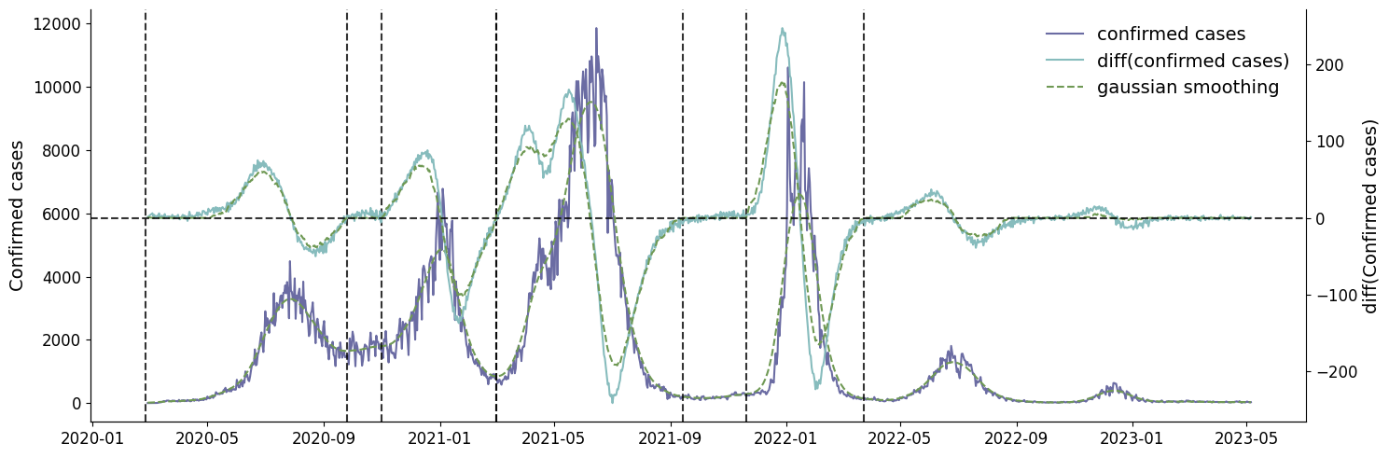
Fig. S1. New daily confirmed cases (left axis) and daily difference (right axis). In both cases, a Gaussian smoothing method was performed to avoid multiple roots around close dates. The roots selected as start and end dates of each waves are represented using black dashed lines.

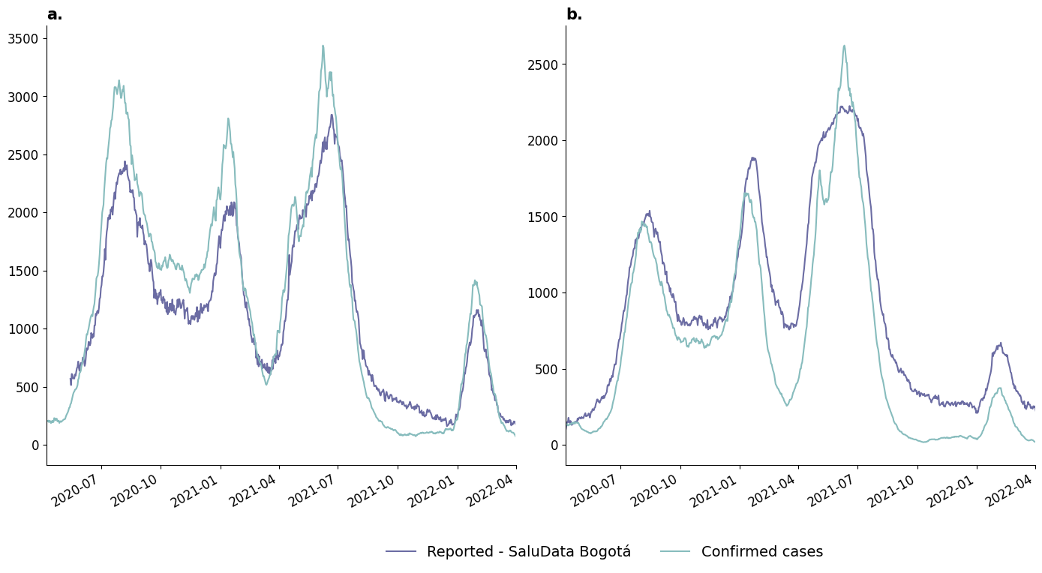
Fig. S2. Comparison between daily occupancies reported by Saludata Bogotá[4, 5] and reconstruction made using Confirmed cases dataset a) General hospital bed occupancy. b) ICU occupancy.
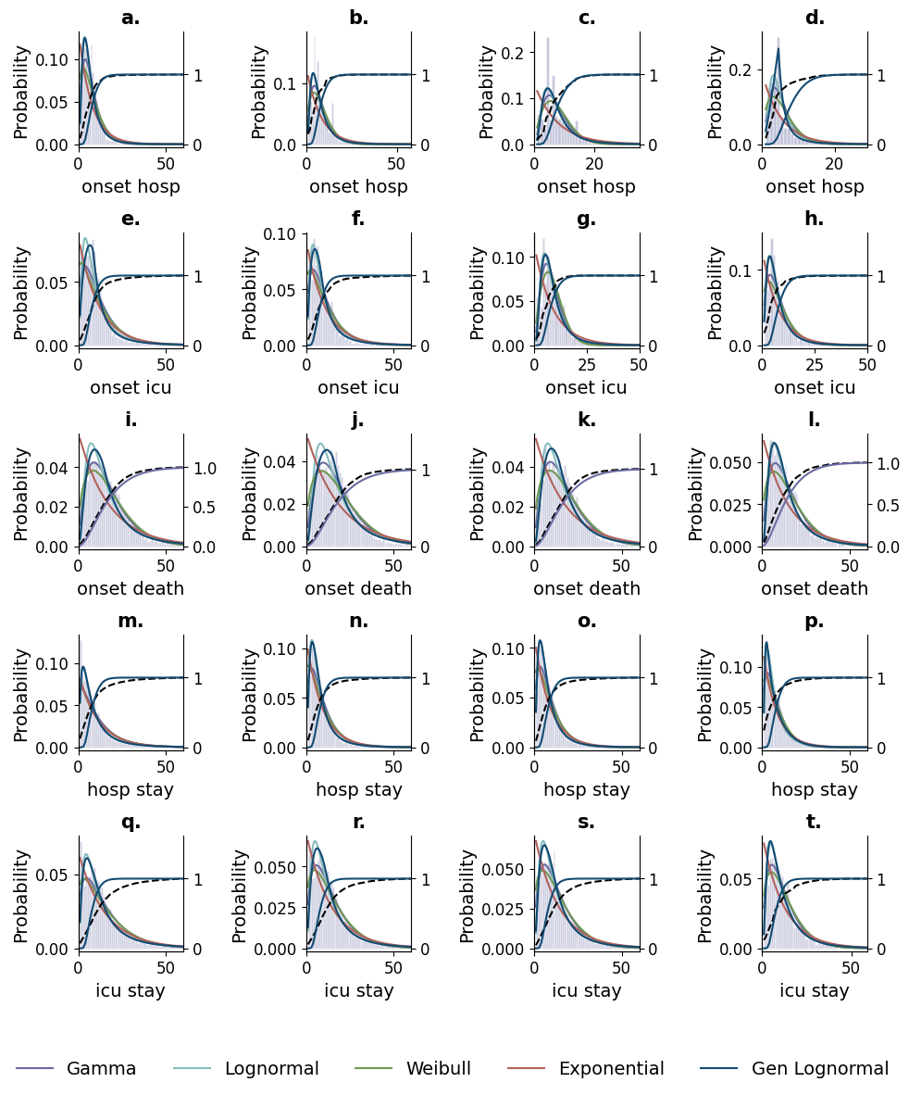
Fig. S3. Observed delay times fitted to different probability density functions. a-d) Onset to hospitalisation, e-h) Onset to ICU, i-l) Onset to death, m-p) Stay at the general hospital, q-t) ICU stay. In every case, the cumulative distribution of the data compared to the best distribution, according to the BF, is shown on the left axis. The left axis gives the probability of occurrence of each event, while the right axis shows the cumulative probability of the best model.
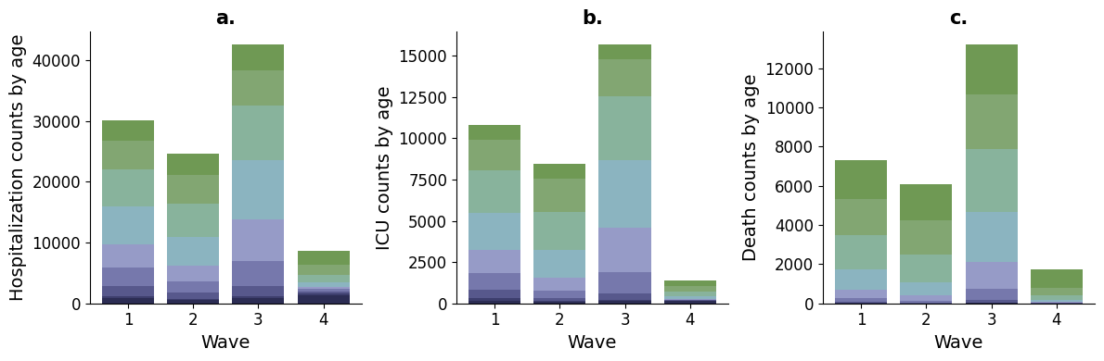
Fig. S4. Population counts for severe outcomes, disaggregated by age. a) Hospitalisations, b) ICU, c) Deaths.

Data availability
GISAID Identifier: EPI_SET_240129mb
Doi: 10.55876/gis8.240129mb

All genome sequences and associated metadata in this dataset are published in GISAID’s EpiCoV database. To view the contributors of each individual sequence with details such as accession number, Virus name, Collection date, Originating Lab and Submitting Lab and the list of Authors, visit 10.55876/gis8.240129mb

Data Snapshot
EPI_SET_240129mb is composed of 5,395 individual genome sequences. The collection dates range from 2021-03-22 to 2022-07-21; Data were collected in one countries and territories;

All sequences in this dataset are compared relative to hCoV-19/Wuhan/WIV04/2019 (WIV04), the official reference sequence employed by GISAID (EPI_ISL_402124). Learn more at https://gisaid.org/WIV04

References

1. Singh B, Sharma KK, Rathi S, Singh G. A generalized log-normal distribution and its goodness of fit to censored data. Comput Stat. 2012;27:51–67.
2. Hawryluk I, Mellan TA, Hoeltgebaum H, Mishra S, Schnekenberg RP, Whittaker C, et al. Inference of COVID-19 epidemiological distributions from Brazilian hospital data. J R Soc Interface. 2020;17:20200596.
3. Kass RE, Raftery AE. Bayes Factors. J Am Stat Assoc. 1995;90:773–95.
4. General hospital occupancy Bogotá - SaluData Bogotá. https://saludata.saludcapital.gov.co/osb/wp-content/uploads/medios/Ocupacion-Hospitalizacion-COVID-19.csv. Accessed 3 Jan 2023.
5. ICU occupancy Bogotá - Datos Abiertos Bogotá. https://datosabiertos.bogota.gov.co/dataset/ocupacion-de-camas-uci-covid-19-bogota-d-c. Accessed 3 Jan 2023.

